creating a program

simple program
- program requirements
  - statements taht define and qualify what the program needs tod o
- design constraints
  - statements that constrain the ways in which the software can be designed and implemented
- requirements are often grouped in needed and nice to have
- also distinguish between functional ( what the program does) and non functional requirements (how should the program behave) .
- functional requirements
  - program: "given a collection of lines of text (strings) stored ina file, sort them in alphabetical order, and write them to another file"
  - input formats:
    - what is the input data format, how should it be stored?
    - what is a character?
    - what seperates the lines ion the file
    - what is the input character set, most comonly one byte per character
      - things like arabic or chinese require two bytes per character, because tehe are more than 256 characters involved
    - we assume 1 byte
  - sorting
    - assume that you ahve english characters only, do you sort ascending or descending?
    - nonalphabetic characters?
    - numbers before or after letters?
    - lowercase uppercase
    - define sorting in numerical order, sorting of the file will occur in ascending order
  - speical cases, boundaries, error conditions:
    - are there special cases
    - how should we handle boundary cases such as empty lines and empty files
    - error condtions, how to handle?
    - we will not use this for our program only to specify that the file is empty.
    - errors should be signlaed to the user and the input file is not corrupted in anyway
- nonfunctional requirements
  - performance requirements
    - performance is always an issue, we say take less than one minute to sort a file of 100 lines of 100 charactgers each
  - real time requirements
    - when a program has to perform in realtime, it must complete processing iwthin the given amount oftime, performance is an issue
    - variability of running timeis also a big issue
      - example quick sort, it should run n log n, but it's worst case is n squared.
      - heap sort or merge sort could be ab etter option
  - modifability requirements
    - before writing, know the life eexpectancy of the program, whether there is any plan to modify the program
  - security requirements
    - the client org has security definitions with it's developers .., sucrity might be funcitonal ornonfunctional, a developer might argue that a system must protect against a denial of service attack in order to fufill it's mission.
  - usability requirements
    - end users of the program, the background for them need to be considered. the user, product and environemnental characteristics are gathered of the program and studied for the design of the UI.
- design constraints
  - user interface
    - what kind of user interface should the program have? CLI? or GUI? WEB based? for the sorting web based does not sound appropriate, GUI's are the norm but cli can be just as approrpiate
    - = what the user sees, feels and hears fromt mhe system
  - typical maximum input sizes
    - depending on typical input sizes, you spend time on algorithms and performanc eoptimizations.
    - small input sizes can use any algorithm, should choose the simplest one in this case.
    - for larger input you may need to use an efficient algorithm if the input does not fit on RAM.

  - platforms
    - on which platforms does it need tor un, it can include architecture, OS, available libraries
    - many languages are portable acros, makes it easy
    - always have extra cost to support a new platform.
  - schedule requirements
    - the final deadline for completing a project comes from the client
    - together with input from the technical side on feasability and cost
- design decisions
  - programming languagee
    - techincal design descision, not uncomon
  - algorithms
    - when implementing systems, you need esvarl pieces, these can be influenced by choice of algorithm
    - the short easy solution is to use a standard vacility provided by the programming language rather than implement your own
    - in many business enviornemnts, regulations could mandate specific algorithms or mathematical formulas to be used, in scientific applications the goal is to test several algorithms.

Testing
- unit testing
- acceptance testing

estimating effort
- estimate of how much time in minutes it will take you to programt his inyour favourite language and technology, to write a program that reads lines from one file and writes sorted liens to another fiel.
- step 1 estimatehow long it would take withotu interruptions
- step 2 ffactor in other time, and convert it to calendar time
  - create a new estimate wher eyou divide the entire program into seperate developmental tasks, which could be divided in several subtasks
  - estimation
    - you will write a stringsorter class with 3 public methods, for thhe sorting routine you assume that the algorithm involves finding tha lrgest element and putting it at the end of the array and then sorting the rest.
    - assume to create a method indeexofbiggest that returns the index of the biggest element
- step 3 fill in the chart and compare this estimate to the previous one.
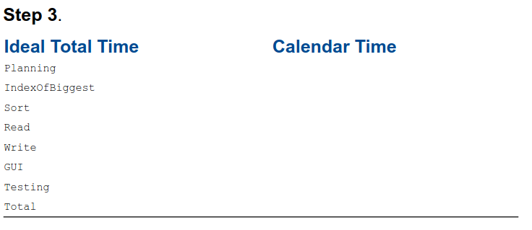
- step4 keep track of the time you actually spend on each task as well as interruptions
  - using the chart it will be more accurate, and mayb e more orless than you initially tought.

implementations
bad implementation will result in a bad program even if all otehr pieces are perfect.
- be consistent
  - in choice of names, capitalization, programming ocnventions, programming alone or not.
    - it does not matter as long as you are consistent.
  - follow established conventions of the language you are using
  - when using java, use java convention, when using c use c convention
- choose names carefully
- test before using a function or method
- know your standard library
  - it implements many common functions such as for sorting collections of data, database access, utilities for webedefv, networking, ..
  - do not reinvent th wheel
  - standard libraries are debugged well and are optimized alot
- perform a code review
  - the most effective method for reducing defects in software, show your code to toher people

- basic design
  - basic designs eperatates from the sorting funcitonality from the user interface.
- unit testing with junit
  - java unit testing framework
- implementation of stringsorter
  - see book page 44 - 53
- user interfaces
  - now that you ahve an implementation of the sorter, and if it works as intended, u build an interface now
  - we woul dlike to use it by typing command line arguments
  - java StringSorterCommandLine abc.txt abc_sorted.txt
  - see p55 for gui.
  - an input output file dialog is going to be better

building a system
- size and complexity
  - when software becomes ubiquitous the development of systems involving software also come more complex.
  - large projects involve more parts more tasks more people and more sophisticated tools.
  - they come in both breadth and depth
    - number of major functions
    - number of features within each functional area
    - number of interafces and linkages to other components or to other external systems
    - number of simulatneous users
    - number of types of data and datastructures
  - size is usually breadth and complexity is usally depth
  - see diagrasm p68 69
- techinical considerations of development and support
  - problem with design and decomposition

