Angular HTTP Client Application - SpaceX Mission Theme
Student ID: 101511990
Name: Bramjot Singh
Project Name: 101511990-lab-test2-comp3133
This document includes the required screenshots of the running application, code files, API service call, and output UI for D2L submission.

Running Application
Mission List page showing the Angular Material UI, mission cards, and launch year filter.
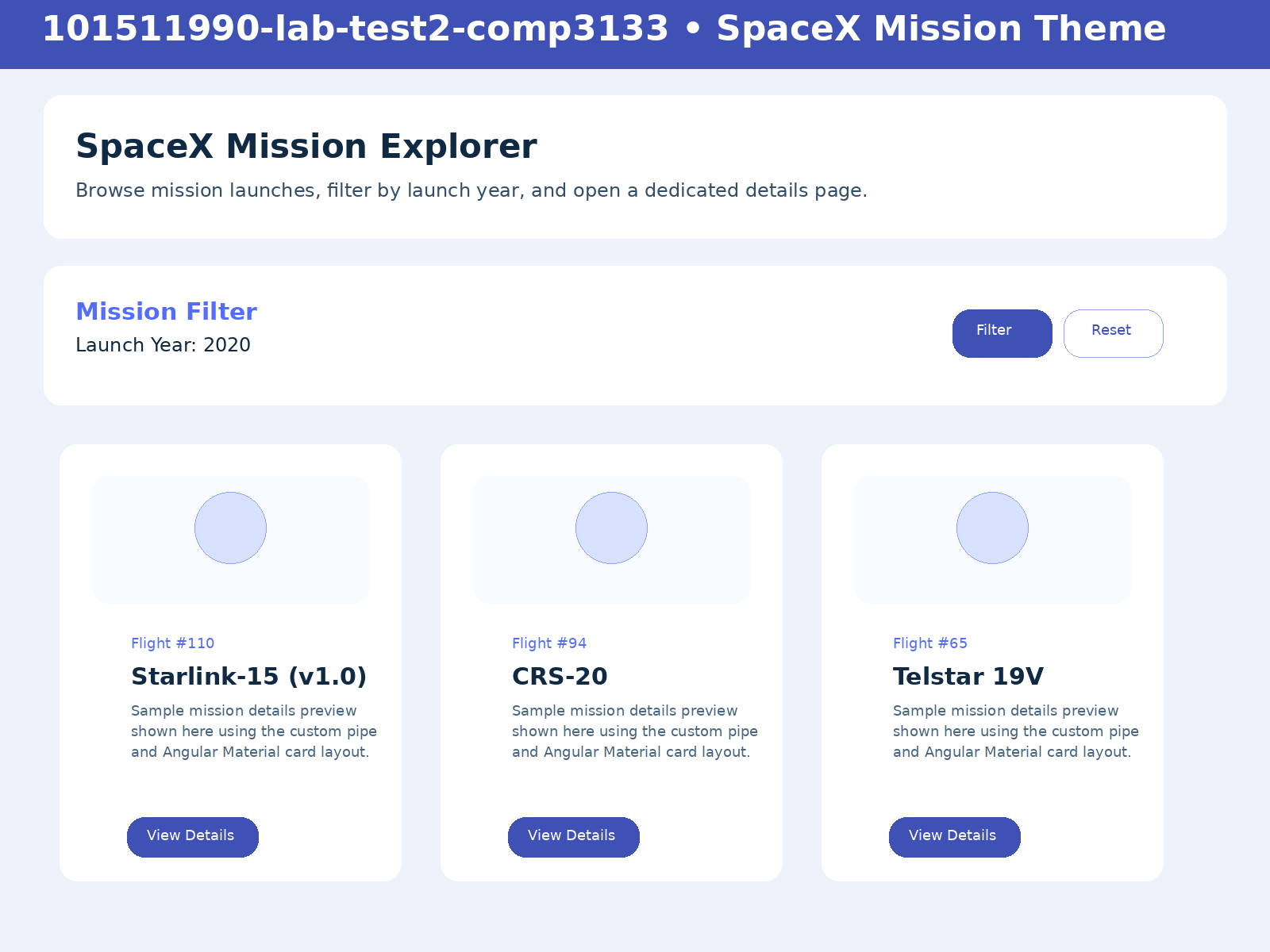
Figure: Running Application

Code Screenshot - Mission List Component
Component screenshot showing Angular imports, signals, and list logic.
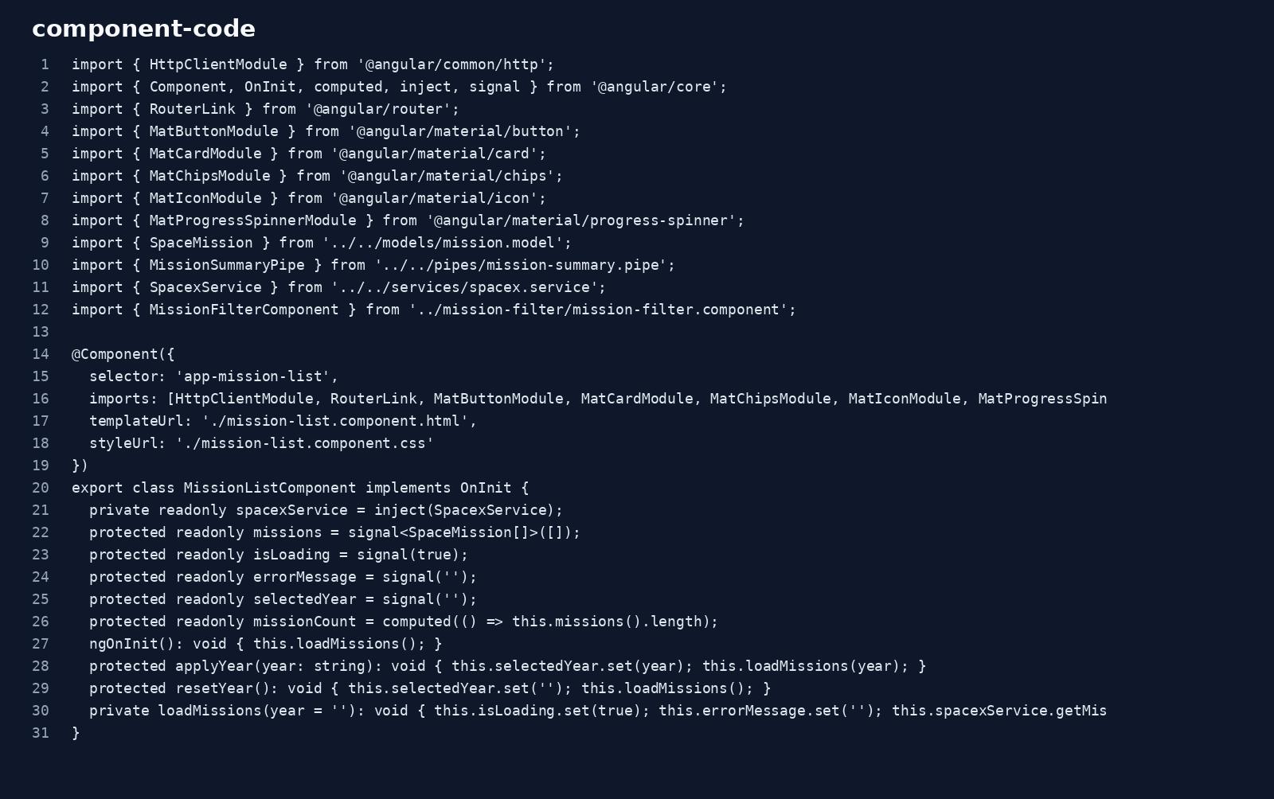
Figure: Code Screenshot - Mission List Component

Code Screenshot - SpaceX Service API Call
Service screenshot showing the HttpClient API call and mission loading logic.
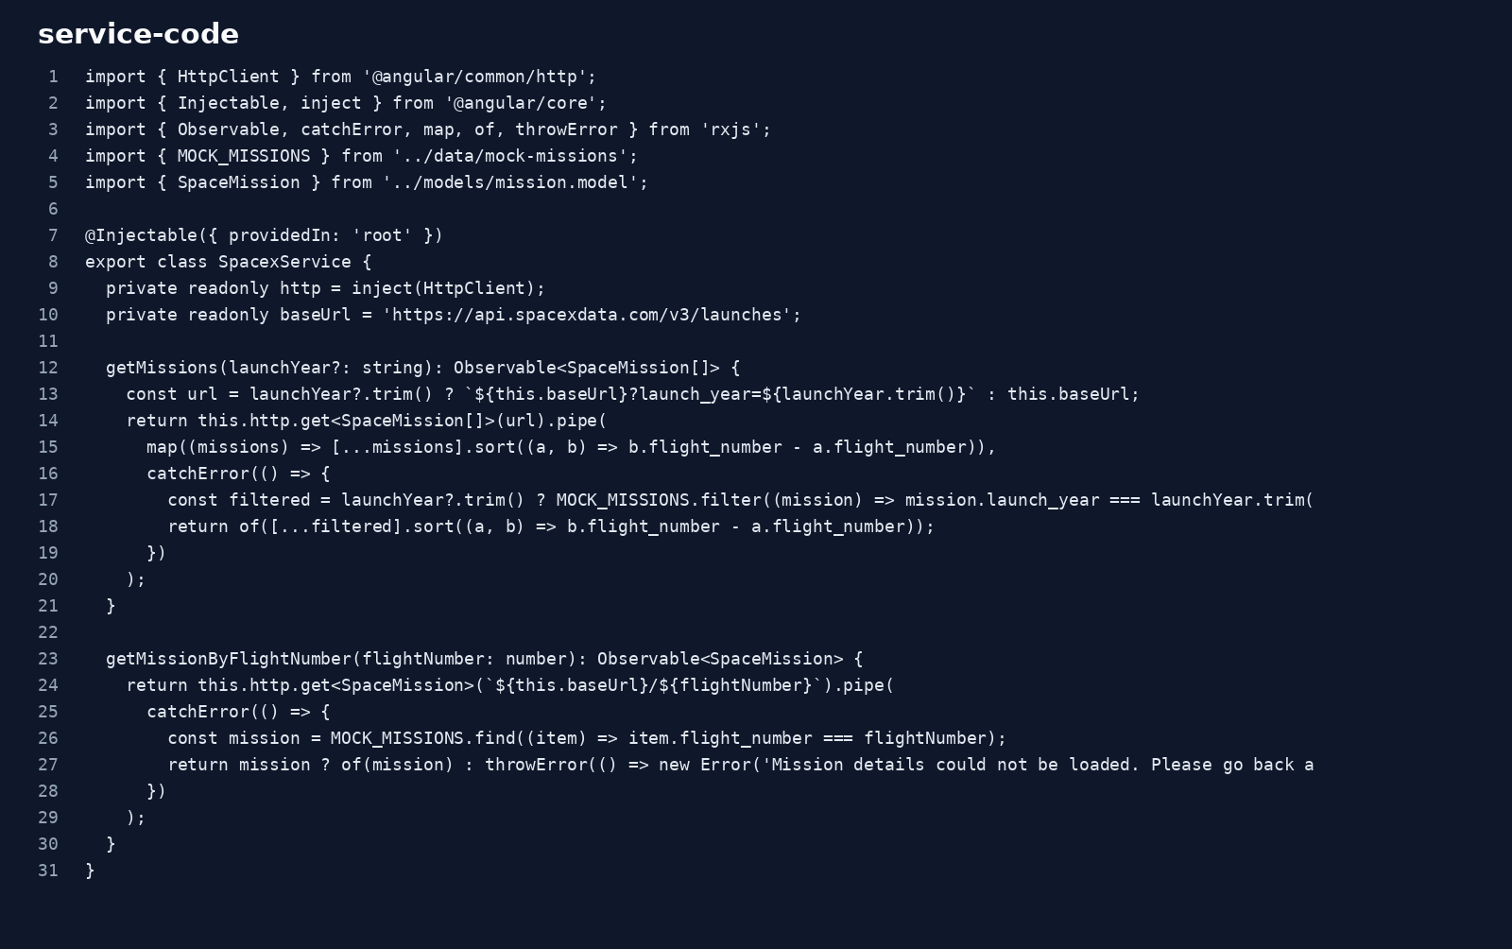
Figure: Code Screenshot - SpaceX Service API Call

Output UI - Mission Details
Mission details page screenshot showing the selected mission, status display, and useful links.
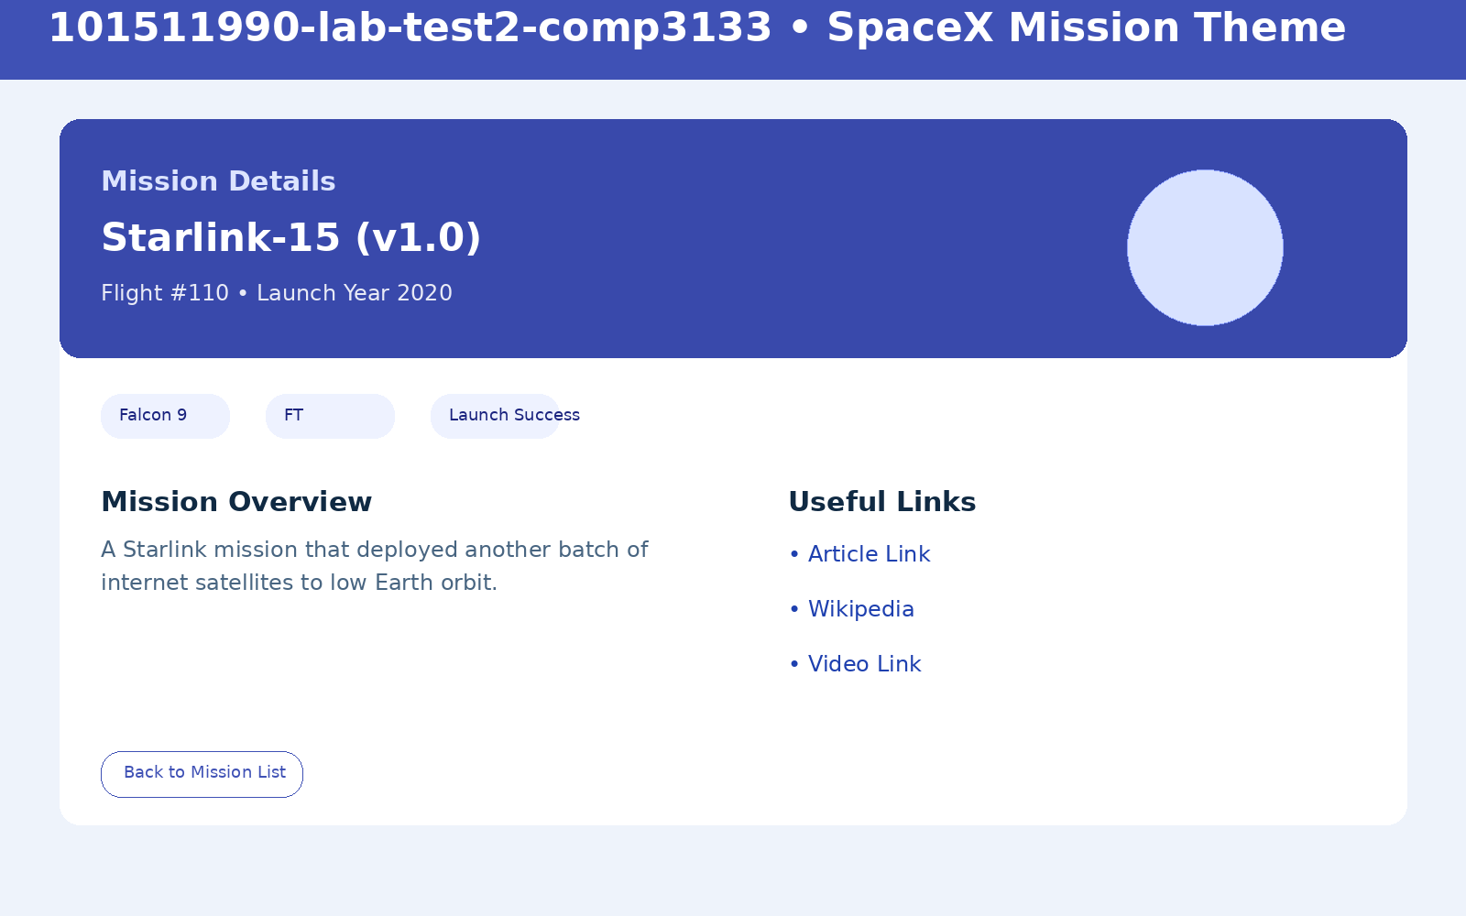
Figure: Output UI - Mission Details

Submission Reminder
- Upload the source ZIP file to D2L.
- Add your actual GitHub repository link in the submission comments.
- Add your actual Vercel or Render deployment link in the submission comments.
- You can also keep this document inside the ZIP for convenience.

