The Marginal Cost of Life

# Theory

It is not fair that average life expectancy varies greatly between countries. Life expectancy is a demographer’s prediction of how long a baby born in a certain country and year will live, on average. So, if one country has a lower life expectancy, citizens in the country die at younger ages, on average. This is map of life expectancy in 2020 by country. One can see in this map that life expectancy varies greatly between countries. This is not fair.

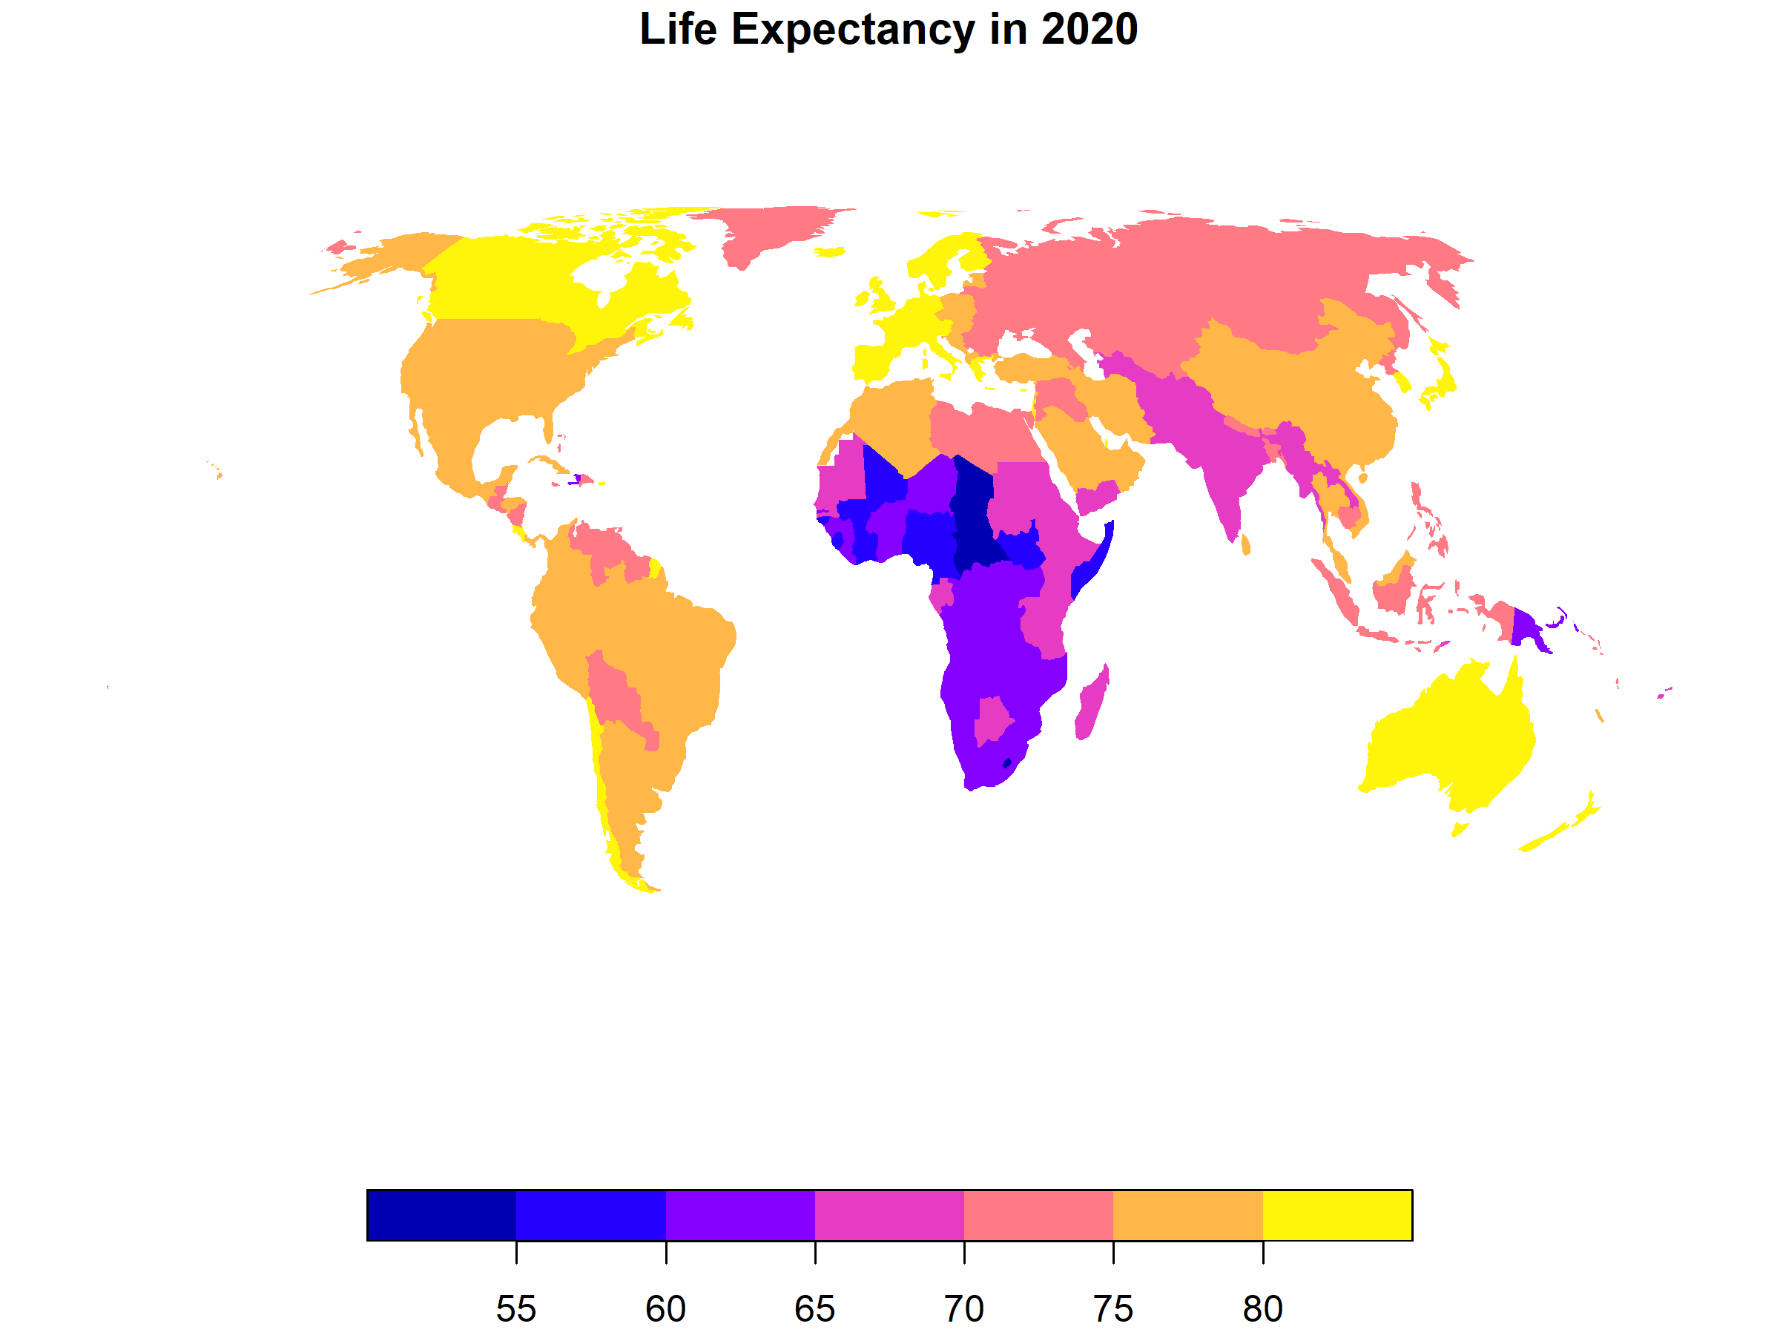

To make life expectancy the same in every country, the governments of rich countries could pay for more healthcare treatments in poor countries. I will broadly define a healthcare treatment as any action one could take to increase someone’s lifespan. Thus, nutrition programs, exercise programs, clean water, and sanitation are all healthcare treatments. The governments of rich countries could pay for more healthcare treatments in poor countries. This would reduce the mortality rates in the poor countries, and thus, increace life expectancy in poor countries. Thus, rich governments could fund healthcare treatments in poor countries until life expectancy was the same in all countries.

In this paper, I will estimate a healthcare treatment supply curve. Governments of rich countries could use this supply curve to calculate how how much it would cost to make life expectancy the same in all countries. Here, I will create a simple supply-and-demand model of healthcare treatments. I do not intend for the following model to be realistic. I will discuss several issues with the model later.

A quality-adjusted life year (QALY) is an improvement to someone’s health with the same value as an extra year of life to someone who is healthy.

I will set up the model as follows. Consider a single country in a single year with a single-payer healthcare system. There is some set of available healthcare treatments. Each treatment has a different cost-effectiveness ratio: how much the treatment costs in local currency per QALY. The government can choose which treatments to pay for. If the government chooses to pay for a treatment, the government would pay for the treatment for any citizen who needs the treatment.

First consider the “demand” side. The government has a certain willingness-to-pay to improve the health of a citizen by 1 QALY. This is the government’s cost-effectiveness threshold. The government would only pay for a treatment with a cost-effectiveness ratio less than or equal to this threshold. [TODO: cite the cost effectiness threshold for the UK]. I will assume this threshold is constant for all people of all ages within the country. If life expectancy in a country increases, I will assume that the government will not raise this threshold, and might even lower the threshold a little. This is because, after life expectancy increases, citizens can now lead more complete lives, and the citizens might then desire additional life less, on average. I will call the relationship between life expectancy and the government’s cost-effectiveness threshold the “demand curve” of healthcare treatments.

Next consider the “supply” side. If the government wants to increase the life expectancy of its citizens, the government can raise its cost-effectiveness threshold, and thus, pay for more healthcare treatments. Because the government would pay for more healthcare treatments, mortality rates would decrease, so life expectancy would increase. After the the government raises the cost-effectiveness threshold, but before the government pays for additional treatments, the cost-effectiveness ratio of additional treatments is lower than the cost-effectiveness threshold. To distinguish between the two, I will call cost-effectiveness ratio of additional (cost-effective) healthcare treatments in a country the Marginal Cost of Life, or MCL. I will call the relationship between life expectancy and the MCL the “supply curve” of healthcare treatments.

Now, consider the equilibrium of supply and demand. If the government’s cost-effectiveness threshold is greater than the MCL, the government will raise cost-effectiveness thresholds, pay for more treatments, and increase life expectancy. If the government’s cost-effectivenses threshold is less than the MCL, the government will lower cost-effectiveness thresholds, pay for less treatments, and decrease life expectancy. The equilibrium will occur where the supply curve and the demand curves meet. The location of this equilibrium will correspond to life expectancy (on the x axis) and the MCL (on the y axis). I graphed an example of this equilibrium below. I based the supply curve in the graph on the empirical results which I will discuss later. The demand curve in the graph is arbitrary.

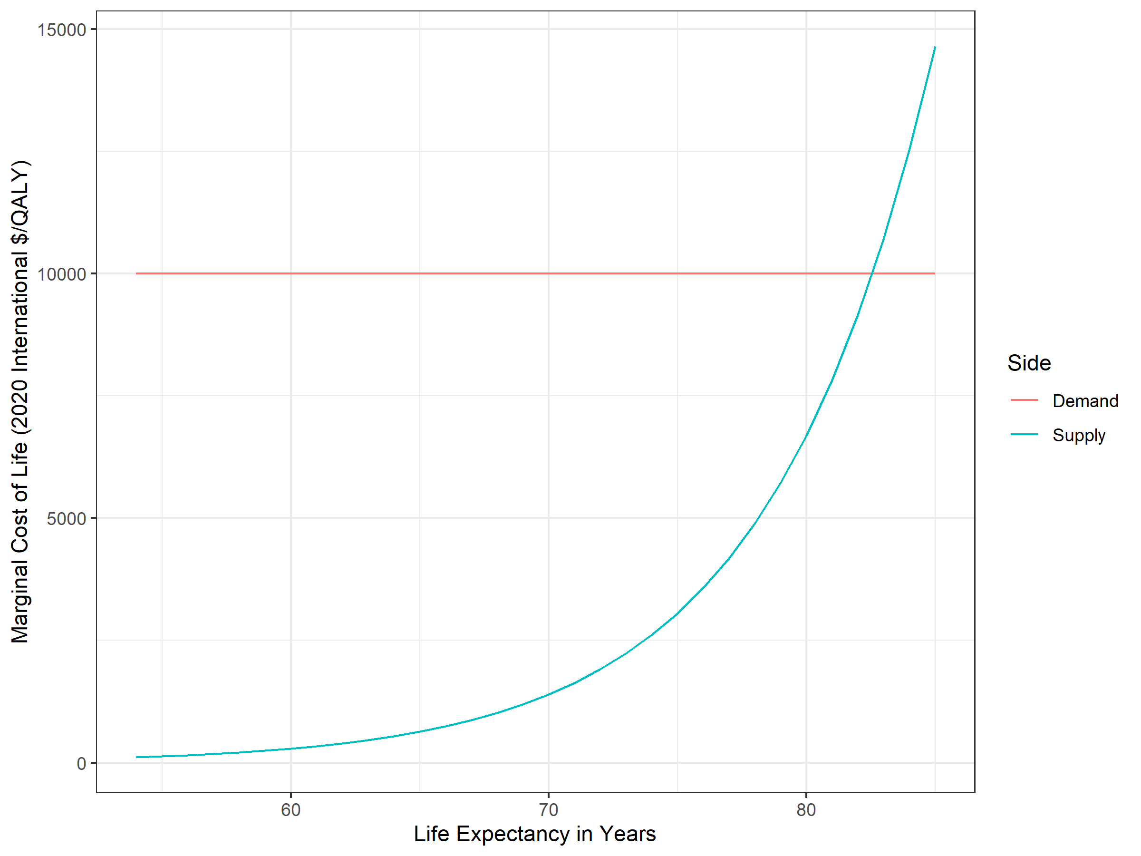

One can use the healthcare treatment supply curve to estimate the cost to raise life expectancy in a country. To increase life expectancy in a country by 1 year, a government would have to pay for additional healthcare treatments. Of course, not everyone would need healthcare treatments, so the government might pay for many treatments for some citizens and few treatments for other citizens. These healthcare treatments would all have the same cost effectiveness ratio: the MCL, in units of local currency per QALY. So the per-person cost to raise life expectancy by 1 year would be approximately equal to the MCL. To calculate total per-person cost to raise life expectancy from one age to another, one could then integrate the supply curve between the two ages. I graphed an example of such an integral below. Again, I based the supply curve in the graph on the empirical results which I will discuss later.

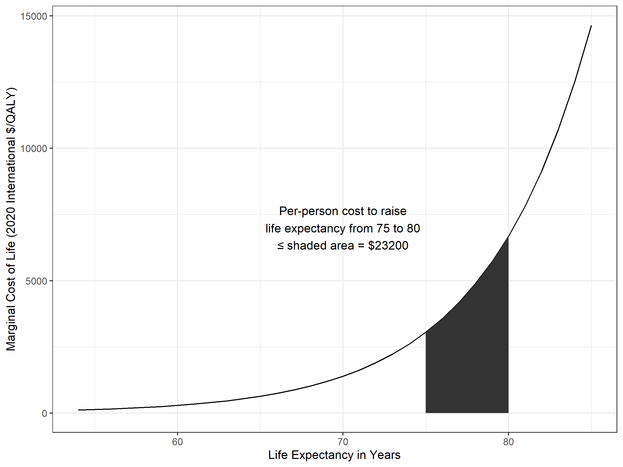

One can empirically estimate the healthcare treatment supply curve. Consider a group of several countries. The healthcare treatment demand curves for these countries would differ. This is because each government has a different ability to pay, and thus willingness to pay, for healthcare treatments. However, if all governments have access to the same healthcare technology, the supply curve of available healthcare treatments for all these countries will be identical. Each country would reach a different equilibrium, somewhere along their identical supply curves. Thus, if one knew, for each country, life expectancy and the MCL, one could trace the health-care treatment supply curve exactly, simply by plotting life expectancy and MCL for all the countries.

I can identify several problems with this model:

* Most countries have some mixture of public and private healthcare. Everyone within a country is not identical. Citizens vary in their ability to pay for, and thus willingness to pay for, healthcare treatments.
* Citizens and government healthcare systems might not know the cost-effectiveness ratios of various treatments, and thus, might not always make rational healthcare decisions.
* As researchers make healthcare discoveries, more cost-effective healthcare treatments become available.
* Some diseases are endemic to only some countries, and thus, some healthcare treatments are only effective in some countries.
* It might be more difficult, and thus, expensive, for governments to provide health-care to people in remote rural areas.

I will attempt to correct the model below for these problems.

# Methods

I used these methods to estimate a healthcare treatment supply curve.

First, I downloaded data on the cost-effectiveness of healthcare treatments from the Tufts Medical Cost-Effectiveness Analysis Registry. This is a database of all published studies on the cost-effectiveness of healthcare treatments. For each study, Tufts Medical reports

* the publication year
* the target gender of participants
* the country where the study participants live
* the publication year
* the cost-effectiveness ratio in contemporary local currency
* the currency country

I obtained purchasing parity power (PPP) adjusted exchange rates for each country and year from the World Bank’s World Development Indicators (WDI). I used these exchange rates to convert cost-effectiveness ratios in contemporary local currency / QALY to contemporary International dollars / QALY. Then, because the international dollar is pinned to the US dollar, I used the US Consumer Price Index (CPI) to convert these ratios to 2020 International dollars / QALY. To check for robustness, I also tried using nominal exchange rates instead of PPP exchange rates, and GDP deflators instead of CPIs. See the appendices for the results of these checks.

I used these published cost-effectiveness ratios as extremely rough estimates of the MCLs I discussed above. Of course, authors who published these ratios did not intend to estimate national MCLs. Instead, the authors were simply analyzing the cost-effectiveness of a healthcare treatment they were interested in and could obtain data about. Thus, these ratios are extremely rough estimates of the MCLs I discussed above. National healthcare systems and healthcare insurance companies have much better data about the marginal cost of life. They do not publish this data, but I would urge them to do so.

In addition, I downloaded data about life expectancy, and several other control variables, by country and year, from the World Bank’s World Development Indicators (WDI). I chose these control variables based on the problems in my model I discussed above. In the table below, I defined these variables and explained why I included each variable. See the appendices for more complete descriptions.

| Variable | Definition |
| --- | --- |
| Gini index | The Gini index is a measure of income inequality. It ranges from 0 (completely equal) to 1 (completely unequal). |
| Percent Health Spending Public | This is the proportion of health spending within a country that the government of the country paid for |
| Malaria Cases Per Thousand | This is the number of malaria cases per 1000 citizens at risk |
| Population Density | The number of people per square kilometer |

As important as the variables I considered are variables I did not consider. Fortunately, as I am only estimating the supply curve, I do not need to consider variables that would affect the demand for healthcare (like income per capita, for example). However, I most likely did not include all important variables related to the supply-side cost of healthcare. For this reason, one should only consider the results here as preliminary.

I decided to exclude two variables, the Gini index, and Malaria Cases per Thousand, because of missing data. I had to discard rows where the value of any variable was missing. However, the values of some control variables is missing for many countries and years. Below, for each control variable, I reported the proportion of the cost-effectiveness ratios from countries and years where/when the value is missing. I could not find suitable alternative variables with more available data in the World Development Index. I would urge the World Bank to publish complete data for all countries. However, to check for robustness, I included these two variables in an additional regression. See the appendices for the result of this check.

Proportion of data missing for control variables

| Variable | Percent Missing |
| --- | --- |
| Gini Index | 36.77% |
| Percent Health Spending Public | 12.58% |
| Malaria Cases per Thousand | 69.07% |
| Log Population Density | 0.05415% |
| Publication Year | 0% |
| Target Genders | 4.032% |

# Results

Below, I have regressed log MCLs against life expectancy below, and included several control variables. I also included a random effect for each country-year combination. I did this because of the hierarchical structure of the data. For life expectancy, and for each control variables, I have only one value for each country and year. However, for some countries and years, I have many cost-effectiveness ratios. I also included the gender of study participants as a variable that might be related to individual cost-effectness ratios. There were three values in this field: “Male” (only), “Female” (only), and “All”. Here are the full regression results.

Overview of the reduced model

| Observations | Groups | Log-restricted-likelihood |
| --- | --- | --- |
| 13949 | 1338 | -28989 |

Coefficients of the reduced model, with 95% confidence intervals

| Coefficient | Lower Bound | Estimate | Upper Bound | p-value |
| --- | --- | --- | --- | --- |
| Intercept | 12.22 | 54.9 | 97.59 | 0.01171 |
| Life Expectancy in Years | 0.141 | 0.1568 | 0.1727 | 2.963e-74 |
| Publication Year | -0.05104 | -0.02978 | -0.008525 | 0.006069 |
| Log Population Density | -0.06038 | 0.00723 | 0.07484 | 0.8339 |
| Percent Health Spending Public | 0.02115 | 0.02755 | 0.03394 | 7.454e-17 |
| Target Genders: Female | -0.2865 | -0.1942 | -0.1018 | 3.773e-05 |
| Target Genders: Male | -0.2857 | -0.1524 | -0.01904 | 0.02511 |

Standardized within-group residuals of the reduced model

| Quartile | Value |
| --- | --- |
| Minimum | -7.982 |
| First Quartile | -0.52 |
| Median | 0.02148 |
| Second Quartile | 0.5513 |
| Maximum | 10.22 |

I interpreting these coefficients as follows.

Compared to studies that target both genders, with 95% confidence, the cost-effectiveness ratios for studies that target men are between *1.904*% and *28.57*% lower. The cost-effectiveness ratios for studies that target women are between *10.18*% and *28.65*% lower. Treatments that target a single gender, that is, just male or just female subjects, are more cost-effective on average. Thus, governments could offer more cost-effective gender-targeted therapies.

When population density increases by 1%, with 95% confidence, the MCL increases by between *-0.06038*% and *0.07484*%. This is not statistically or practically significant.

When the percent of health spending that is public increases by 1%, with 95% confidence, the MCL increases by between *2.115*% and *3.394*%. MCLs are higher in countries with larger public health systems. This is surprising, because many researchers have found that single-payer is more cost effective. Perhaps governments in countries with large single-payer healthcare systems spend money more rationally and equitably, and have already paid for many low-cost treatments, leaving more high-cost treatments.

Each year, with 95% confidence, MCLs decrease by between *0.8525*% and *5.104*%. Perhaps health care is becoming more cost-effective over time as researchers discover new healthcare technology.

To raise life expectancy in a country by 1 year, with 95% confidence, a government needs to raise its cost-effectiveness threshold by between *14.1*% and *17.27*%.

I can use these results to generate the supply curve of healthcare treatments. To calculate the supply curve below, I used the median Log Population Density and Percent Health Spending Public, set Target Genders to “All”, and set the year to 2022. I also used this supply curve as the example in the introduction, where I showed how to use the curve to calculate total per-person cost to raise life expectancy.

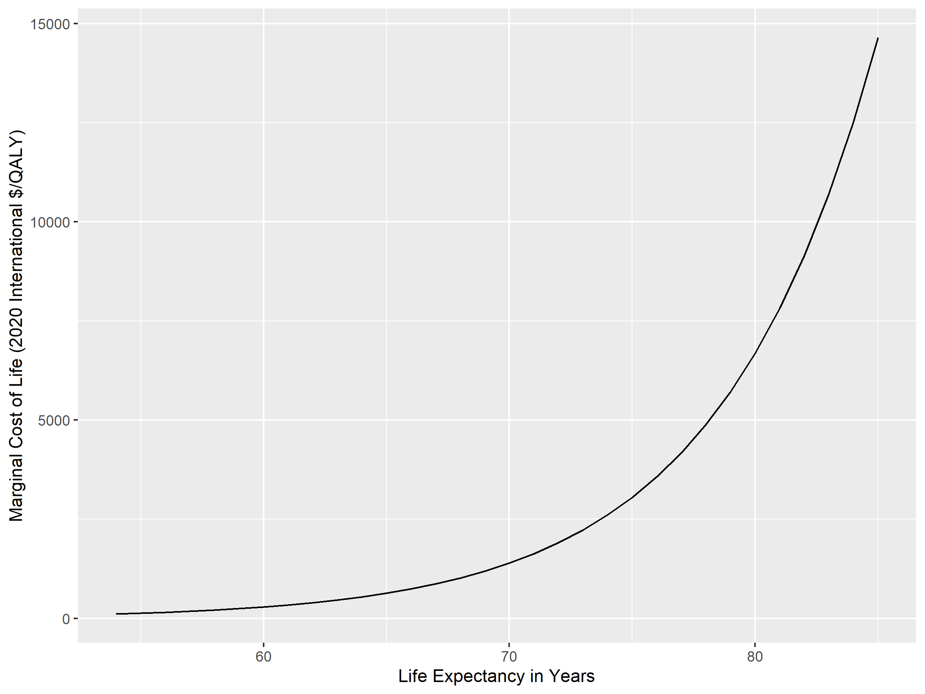

In five year increments from ages 50 to 90, in the following table, I have calculated the per person costs to raise life expectancy.

Per person costs to raise life expectency, in 5 year increments

| Life Expectancy From | Life Expectancy To | Per Person Cost in 2020 International $ |
| --- | --- | --- |
| 50 | 55 | 460 |
| 55 | 60 | 1010 |
| 60 | 65 | 2200 |
| 65 | 70 | 4830 |
| 70 | 75 | 10600 |
| 75 | 80 | 23200 |
| 80 | 85 | 50800 |
| 85 | 90 | 111000 |

## Appendix: The random effects

The countries and years with the top five and bottom 5 random effects

| Country Year | Random Effect | Order |
| --- | --- | --- |
| Chile 2019 | -4.14 | 1 |
| Vietnam 2011 | -3.324 | 2 |
| Bangladesh 2019 | -3.148 | 3 |
| Algeria 2018 | -2.879 | 4 |
| Bhutan 2018 | -2.803 | 5 |
| Nigeria 2013 | 3.255 | 1334 |
| Nigeria 2017 | 3.559 | 1335 |
| France 2006 | 3.724 | 1336 |
| United States 2003 | 3.998 | 1337 |
| South Africa 2006 | 5.654 | 1338 |

## Appendix: Example calculations

For two ratios, I will check Tufts Medical’s data for accuracy. I will also show an example calculation for two ratios. I choose two ratios, with ratio indices *21599* and *26448* . I choose these ratios because they come from the country-year with the lowest and highest random effects, respectively.

First consider a ratio from a study of people in Chile published in 2019 (DOI: 10.1186/s12903-019-0990-3). In the study, researchers capped patients’ teeth with enamel, and 6 years later, rechecked the patients’ teeth. The researchers calculated a cost effectiveness ratio of 6.48 USD per Quality Adjusted Tooth Year (QATY). They defined a QATY as follows: “a value of 1 QATY was assigned to teeth which were sound or sealed without evidence of caries after 6 years; 0.81 QATY for teeth that required fillings; and 0 QATY for extracted teeth.”

Tufts Medical incorrectly entered this ratioas as 6.48 Chilean Pesos per QALY. I do not have time to verify all of the tens of thousands of ratios, so I did not to correct it.

The PPP exchange rate for Chile in 2019 is 408 Chilean Pesos (CHP) per International $. So

$$\frac{6.48\text{ 2019 CHP}}{\text{QALY}}*\frac{\text{2019 International \$}}{408\text{ 2019 CHP}}=\frac{0.0159\text{ 2019 International \$}}{\text{QALY}}$$

By definition, an international $ is the same as the US $, USD.

The average CPI in 2020 was 259 USD per basket. The average CPI in 2019 was 256 USD per basket. So,

$$\frac{0.0159\text{ 2019 USD}}{\text{QALY}}*\frac{\text{basket}}{256\text{ 2019 USD}}*\frac{259\text{ 2020 USD}}{\text{basket}}=\frac{0.161\text{ 2020 USD}}{\text{QALY}}$$

Next, consider a study of Polio vaccines in South Africa published in 2006 (DOI 10.1016/j.vaccine.2006.05.032). The authors found studied several vaccine regimens, and found that one of the regimens had a cost-effectiveness of 61,355 USD per Disability Adjusted Life Year (DALY). A DALY and a QALY are the same; the only difference is that people typically use DALYs to refer the costs of illnesses and QALYs to refer to the benefits of treatments. Tufts Medical correctly reported the ratio. My calculations are as follows.

* **Local Contemporary Ratio**: *61355*
* **Currency Country**: United States
* **PPP Exchange Rate**: *1*
* **International Contemporary Ratio**: *61355*
* **Publication Year**: *2006*
* **CPI**: *195.3*
* **International 2020 Ratio**: *81330*

## Appendix: World Development Indicators variables information

World Development Indicators variables

| Variable | Name |
| --- | --- |
| Life Expectancy in Years | Life expectancy at birth, total (years) |
| Gini Index | Gini index |
| Percent Health Spending Public | Domestic general government health expenditure (% of current health expenditure) |
| Population Density | Population density (people per sq. km of land area) |
| Malaria Cases per Thousand | Incidence of malaria (per 1,000 population at risk) |
| Nominal Exchange Rate | Official exchange rate (LCU per US$, period average) |
| PPP Exchange Rate | PPP conversion factor, GDP (LCU per international $) |

World Development Indicators variable descriptions

| Variable | Description |
| --- | --- |
| Life Expectancy in Years | Life expectancy at birth indicates the number of years a newborn infant would live if prevailing patterns of mortality at the time of its birth were to stay the same throughout its life. |
| Gini Index | Gini index measures the extent to which the distribution of income (or, in some cases, consumption expenditure) among individuals or households within an economy deviates from a perfectly equal distribution. A Lorenz curve plots the cumulative percentages of total income received against the cumulative number of recipients, starting with the poorest individual or household. The Gini index measures the area between the Lorenz curve and a hypothetical line of absolute equality, expressed as a percentage of the maximum area under the line. Thus a Gini index of 0 represents perfect equality, while an index of 100 implies perfect inequality. |
| Percent Health Spending Public | Share of current health expenditures funded from domestic public sources for health. Domestic public sources include domestic revenue as internal transfers and grants, transfers, subsidies to voluntary health insurance beneficiaries, non-profit institutions serving households (NPISH) or enterprise financing schemes as well as compulsory prepayment and social health insurance contributions. They do not include external resources spent by governments on health. |
| Population Density | Population density is midyear population divided by land area in square kilometers. Population is based on the de facto definition of population, which counts all residents regardless of legal status or citizenship–except for refugees not permanently settled in the country of asylum, who are generally considered part of the population of their country of origin. Land area is a country’s total area, excluding area under inland water bodies, national claims to continental shelf, and exclusive economic zones. In most cases the definition of inland water bodies includes major rivers and lakes. |
| Malaria Cases per Thousand | Incidence of malaria is the number of new cases of malaria in a year per 1,000 population at risk. |
| Nominal Exchange Rate | Official exchange rate refers to the exchange rate determined by national authorities or to the rate determined in the legally sanctioned exchange market. It is calculated as an annual average based on monthly averages (local currency units relative to the U.S. dollar). |
| PPP Exchange Rate | Purchasing power parity (PPP) conversion factor is a spatial price deflator and currency converter that controls for price level differences between countries, thereby allowing volume comparisons of gross domestic product (GDP) and its expenditure components. This conversion factor is for GDP. |

World Development Indicators variable sources

| Variable | Source Organization |
| --- | --- |
| Life Expectancy in Years | (1) United Nations Population Division. World Population Prospects: 2019 Revision, or derived from male and female life expectancy at birth from sources such as: (2) Census reports and other statistical publications from national statistical offices, (3) Eurostat: Demographic Statistics, (4) United Nations Statistical Division. Population and Vital Statistics Reprot (various years), (5) U.S. Census Bureau: International Database, and (6) Secretariat of the Pacific Community: Statistics and Demography Programme. |
| Gini Index | World Bank, Poverty and Inequality Platform. Data are based on primary household survey data obtained from government statistical agencies and World Bank country departments. Data for high-income economies are mostly from the Luxembourg Income Study database. For more information and methodology, please see <http://pip.worldbank.org>. |
| Percent Health Spending Public | World Health Organization Global Health Expenditure database (<http://apps.who.int/nha/database>). The data was retrieved on January 30, 2022. |
| Population Density | Food and Agriculture Organization and World Bank population estimates. |
| Malaria Cases per Thousand | World Health Organization, Global Health Observatory Data Repository/World Health Statistics (<http://apps.who.int/ghodata/>). |
| Nominal Exchange Rate | International Monetary Fund, International Financial Statistics. |
| PPP Exchange Rate | International Comparison Program, World Bank | World Development Indicators database, World Bank | Eurostat-OECD PPP Programme. |

## Appendix: Study country and currency country replacements

Study country replacements

| Original Study Country | Study Country Replacement |
| --- | --- |
| Antigua and Barbuda | Antigua & Barbuda |
| Bosnia and Herzegovina | Bosnia & Herzegovina |
| Brunei Darussalam | Brunei |
| Cabo Verde | Cape Verde |
| Canada, Canada | Canada |
| Congo | Congo - Brazzaville |
| Congo Democratic Republic | Congo - Kinshasa |
| Côte d’Ivoire | Côte d’Ivoire |
| Czech Republic | Czechia |
| England | United Kingdom |
| England, Wales | United Kingdom |
| Federated States of Micronesia | Micronesia (Federated States of) |
| French Republic | France |
| Hong Kong | Hong Kong SAR China |
| Lao | Laos |
| Myanmar | Myanmar (Burma) |
| Sao Tome and Principe | São Tomé & Príncipe |
| Scotland | United Kingdom |
| Saint Kitts and Nevis | St. Kitts & Nevis |
| Saint Lucia | St. Lucia |
| Saint Vincent and the Grenadines | St. Vincent & Grenadines |
| Swaziland | Eswatini |
| Trinidad and Tobago | Trinidad & Tobago |
| United Kingdom, United Kingdom | United Kingdom |
| United States of America | United States |
| United States of America, United States of America | United States |
| United States of America, United States of America, United States of America | United States |
| Viet Nam | Vietnam |
| Wales | United Kingdom |
| Wales, England | United Kingdom |

Currency country replacements

| Original Currency Country | Currency Country Replacement |
| --- | --- |
| Chilean $ | Chile |
| Chilean pesos (CLP) | Chile |
| Chinese Renminbi | China |
| Cuba (Peso) | Cuba |
| Czech Republic | Czechia |
| Euro | Euro area |
| Euros | Euro area |
| France | Euro area |
| Ghana Cedis | Ghana |
| Greek | Euro area |
| Hong Kong | Hong Kong SAR China |
| Ireland | Euro area |
| Italy | Euro area |
| Myanmar | Myanmar (Burma) |
| Netherlands | Euro area |
| Polishzloty (PLN) | Poland |
| Pounds sterling | United Kingdom |
| singapore | Singapore |
| South korea | South Korea |
| Turkish Lira | Turkey |

## Appendix: Study countries and currency countries with no matches

Study countries with no single match

| Study Country |
| --- |
| South Africa, Tanzania, Uganda |
| Benin, Botswana, Burundi, Cameroon, Central African Republic, Chad, Congo Democratic Republic, Djibouti, Ethiopia, Kenya, Liberia, Madagascar, Malawi, Mali, Namibia, Niger, Nigeria, Senegal, Sierra Leone, Somalia, South Africa, Sudan, Swaziland, Tanzania, Togo, Uganda, Zimbabwe |
| Andorra, Antigua and Barbuda, Argentina, Austria, Bahamas, Bangladesh, Barbados, Belgium, Belize, Bhutan, Brazil, Chile, Colombia, Costa Rica, Croatia, Czech Republic, Denmark, Dominica, Dominican Republic, El Salvador, Finland, French Republic, Germany, Greece, Grenada, Guyana, Honduras, Iceland, India, Ireland, Israel, Italy, Jamaica, North Korea, Luxembourg, Maldives, Malta, Mexico, Monaco, Myanmar, Nepal, Netherlands, Norway, Panama, Paraguay, Portugal, San Marino, Slovenia, Spain, Saint Kitts and Nevis, Saint Lucia, Saint Vincent and the Grenadines, Suriname, Sweden, Switzerland, Trinidad and Tobago, United Kingdom, Uruguay, Venezuela |
| Algeria, Angola, Benin, Burkina Faso, Cabo Verde, Cameroon, Chad, Comoros, Equatorial Guinea, Gabon, Gambia, Ghana, Guinea, Guinea-Bissau, Liberia, Madagascar, Mali, Mauritania, Mauritius, Niger, Nigeria, Sao Tome and Principe, Senegal, Seychelles, Sierra Leone, Togo |
| Botswana, Burundi, Central African Republic, Congo Democratic Republic, Congo, Côte d’Ivoire, Eritrea, Ethiopia, Kenya, Lesotho, Malawi, Mozambique, Namibia, Rwanda, South Africa, Swaziland, Tanzania, Uganda, Zambia, Zimbabwe |
| Antigua and Barbuda, Argentina, Bahamas, Barbados, Belize, Brazil, Chile, Colombia, Costa Rica, Dominica, Dominican Republic, El Salvador, Grenada, Guyana, Honduras, Jamaica, Mexico, Panama, Paraguay, Saint Kitts and Nevis, Saint Lucia, Saint Martin (French part), Saint Vincent and the Grenadines, Suriname, Trinidad and Tobago, Uruguay, Venezuela |
| Bolivia, Ecuador, Guatemala, Haiti, Nicaragua, Peru |
| Afghanistan, Djibouti, Egypt, Iraq, Morocco, Pakistan, Somalia, Sudan, Yemen |
| Albania, Armenia, Azerbaijan, Bosnia and Herzegovina, Bulgaria, Georgia, Kyrgyzstan, North Macedonia, Poland, Romania, Slovakia, Tajikistan, Turkey, Turkmenistan, Uzbekistan |
| Belarus, Estonia, Hungary, Moldova, Russia, Ukraine |
| Indonesia, Sri Lanka, Thailand |
| Bangladesh, Bhutan, India, North Korea, Maldives, Myanmar, Nepal, Timor-Leste |
| American Samoa, Cambodia, China, Cyprus, Fiji, Kiribati, South Korea, Lao, Malaysia, Marshall Islands, Federated States of Micronesia, Mongolia, Nauru, Palau, Papua New Guinea, Philippines, Solomon Islands, Tonga, Tuvalu, Vanuatu, Viet Nam, Cook Islands, Niue |
| American Samoa, Cambodia, China, Cyprus, Fiji, Kiribati, South Korea, Malaysia, Marshall Islands, Federated States of Micronesia, Mongolia, Nauru, Palau, Papua New Guinea, Philippines, Solomon Islands, Tonga, Tuvalu, Vanuatu, Viet Nam, Cook Islands, Niue |
| Andorra, Austria, Belgium, Croatia, Czech Republic, Denmark, Finland, French Republic, Germany, Greece, Iceland, Ireland, Israel, Italy, Luxembourg, Malta, Monaco, Netherlands, Norway, Portugal, San Marino, Slovenia, Spain, Sweden, Switzerland, United Kingdom |
| Brunei Darussalam, Cambodia, Indonesia, Lao, Malaysia, Myanmar, Philippines, Singapore, Thailand, Viet Nam |
| Bahrain, Cyprus, Iran, Jordan, Kuwait, Lebanon, Libya, Oman, Qatar, Saudi Arabia, Syria, Tunisia, United Arab Emirates |
| Algeria, Angola, Benin, Botswana, Burkina Faso, Burundi, Cabo Verde, Cameroon, Central African Republic, Chad, Congo Democratic Republic, Comoros, Congo, Côte d’Ivoire, Equatorial Guinea, Eritrea, Ethiopia, Gabon, Gambia, Ghana, Guinea, Guinea-Bissau, Kenya, Lesotho, Liberia, Madagascar, Malawi, Mali, Mauritania, Mauritius, Mozambique, Namibia, Niger, Nigeria, Rwanda, Sao Tome and Principe, Senegal, Seychelles, Sierra Leone, South Africa, Swaziland, Tanzania, Togo, Uganda, Zambia, Zimbabwe |
| Bolivia, Burkina Faso, Burundi, Cambodia, Cameroon, Central African Republic, Chad, Congo Democratic Republic, Comoros, Congo, Côte d’Ivoire, Cuba, Djibouti, Eritrea, Ethiopia, Gambia, Georgia, Ghana, Guinea, Guinea-Bissau, Guyana, Haiti, Honduras, India, Indonesia, Kenya, Kiribati, North Korea, Kyrgyzstan, Lao, Lesotho, Liberia, Madagascar, Malawi, Mali, Mauritania, Moldova, Mongolia, Mozambique, Myanmar, Nepal, Nicaragua, Niger, Nigeria, Pakistan, Papua New Guinea, Rwanda, Sao Tome and Principe, Senegal, Sierra Leone, Solomon Islands, Somalia, Sri Lanka, Sudan, Tajikistan, Tanzania, Timor-Leste, Togo, Uganda, Ukraine, Uzbekistan, Viet Nam, Yemen, Zambia, Zimbabwe |
| Antigua and Barbuda, Argentina, Aruba, Bahamas, Barbados, Belize, Bolivia, Brazil, Cayman Islands, Chile, Colombia, Costa Rica, Cuba, Dominica, Dominican Republic, Ecuador, El Salvador, Grenada, Guatemala, Guyana, Haiti, Honduras, Jamaica, Mexico, Nicaragua, Panama, Paraguay, Peru, Puerto Rico, Saint Kitts and Nevis, Saint Lucia, Saint Vincent and the Grenadines, Suriname, Trinidad and Tobago, Turks and Caicos Islands, Uruguay, Venezuela, Virgin Islands of the United States |
| Afghanistan, Angola, Armenia, Azerbaijan, Bangladesh, Benin, Bhutan, Bolivia, Burkina Faso, Burundi, Cambodia, Cameroon, Central African Republic, Chad, Congo Democratic Republic, Comoros, Congo, Côte d’Ivoire, Cuba, Djibouti, Eritrea, Ethiopia, Gambia, Georgia, Ghana, Guinea, Guinea-Bissau, Guyana, Haiti, Honduras, India, Indonesia, Kenya, Kiribati, North Korea, Kyrgyzstan, Lao, Lesotho, Liberia, Madagascar, Malawi, Mali, Mauritania, Moldova, Mongolia, Mozambique, Myanmar, Nepal, Nicaragua, Niger, Nigeria, Pakistan, Papua New Guinea, Rwanda, Sao Tome and Principe, Senegal, Sierra Leone, Solomon Islands, Somalia, Sri Lanka, Sudan, Tajikistan, Tanzania, Timor-Leste, Togo, Uganda, Ukraine, Uzbekistan, Viet Nam, Yemen, Zambia, Zimbabwe |
| Antigua and Barbuda, Argentina, Bahamas, Barbados, Belize, Bolivia, Brazil, Canada, Chile, Colombia, Costa Rica, Cuba, Dominica, Dominican Republic, Ecuador, El Salvador, Grenada, Guatemala, Guyana, Haiti, Honduras, Jamaica, Mexico, Nicaragua, Panama, Paraguay, Peru, Saint Kitts and Nevis, Saint Lucia, Saint Martin (French part), Saint Vincent and the Grenadines, Suriname, Trinidad and Tobago, United States of America, Uruguay, Venezuela |
| Albania, Andorra, Armenia, Austria, Azerbaijan, Belarus, Belgium, Bosnia and Herzegovina, Bulgaria, Croatia, Czech Republic, Denmark, Estonia, Finland, French Republic, Georgia, Germany, Greece, Hungary, Iceland, Ireland, Israel, Italy, Kyrgyzstan, Luxembourg, North Macedonia, Malta, Moldova, Monaco, Netherlands, Norway, Poland, Portugal, Romania, Russia, San Marino, Slovakia, Slovenia, Spain, Sweden, Switzerland, Tajikistan, Turkey, Turkmenistan, Ukraine, United Kingdom, Uzbekistan |
| Bangladesh, Bhutan, India, Indonesia, North Korea, Maldives, Myanmar, Nepal, Sri Lanka, Thailand, Timor-Leste |
| Afghanistan, Bahrain, Cyprus, Djibouti, Egypt, Iran, Iraq, Jordan, Kuwait, Lebanon, Libya, Morocco, Oman, Pakistan, Qatar, Saudi Arabia, Somalia, Sudan, Syria, Tunisia, United Arab Emirates, Yemen |
| American Samoa, Australia, Brunei Darussalam, Cambodia, China, Cyprus, Fiji, Japan, Kiribati, South Korea, Lao, Malaysia, Marshall Islands, Federated States of Micronesia, Mongolia, Nauru, New Zealand, Palau, Papua New Guinea, Philippines, Singapore, Solomon Islands, Tonga, Tuvalu, Vanuatu, Viet Nam, Cook Islands, Niue |
| Afghanistan, Albania, Algeria, American Samoa, Angola, Argentina, Armenia, Azerbaijan, Bangladesh, Belarus, Belize, Benin, Bermuda, Bhutan, Bolivia, Bosnia and Herzegovina, Brazil, Botswana, Bulgaria, Burkina Faso, Burundi, Cabo Verde, Cambodia, Cameroon, Central African Republic, Chad, Chile, China, Colombia, Congo Democratic Republic, Comoros, Congo, Costa Rica, Côte d’Ivoire, Croatia, Cuba, Czech Republic, Djibouti, Dominica, Dominican Republic, Ecuador, Egypt, El Salvador, Equatorial Guinea, Eritrea, Estonia, Ethiopia, Fiji, Gabon, Gambia, Georgia, Ghana, Grenada, Guatemala, Guinea, Guinea-Bissau, Guyana, Haiti, Honduras, Hungary, India, Indonesia, Iran, Iraq, Jamaica, Jordan, Kazakhstan, Kenya, Kiribati, North Korea, Kyrgyzstan, Lao, Latvia, Lebanon, Lesotho, Liberia, Libya, Lithuania, North Macedonia, Madagascar, Malawi, Malaysia, Maldives, Mali, Marshall Islands, Mauritania, Mauritius, Mexico, Federated States of Micronesia, Moldova, Mongolia, Morocco, Mozambique, Myanmar, Namibia, Nepal, Nicaragua, Niger, Nigeria, Northern Mariana Islands, Oman, Pakistan, Palau, Panama, Papua New Guinea, Paraguay, Peru, Poland, Philippines, Romania, Russia, Rwanda, Samoa, Sao Tome and Principe, Saudi Arabia, Senegal, Seychelles, Sierra Leone, Slovakia, Solomon Islands, Somalia, South Africa, Sri Lanka, Saint Kitts and Nevis, Saint Lucia, Saint Vincent and the Grenadines, Sudan, Suriname, Swaziland, Syria, Tajikistan, Tanzania, Thailand, Timor-Leste, Togo, Tonga, Trinidad and Tobago, Tunisia, Turkey, Turkmenistan, Uganda, Ukraine, Uruguay, Uzbekistan, Vanuatu, Venezuela, Viet Nam, Yemen, Zambia, Zimbabwe, Cook Islands, Niue, Wallis and Futuna |
| Albania, Argentina, Australia, Bangladesh, Brazil, Canada, Colombia, Cuba, Denmark, Egypt, Ghana, India, Israel, Italy, Jordan, Malawi, Malaysia, Mexico, Netherlands, Nigeria, Pakistan, Sierra Leone, Singapore, South Africa, Sri Lanka, Thailand, Uganda, United Arab Emirates, United Kingdom, Venezuela, Yemen, Zimbabwe |
| Angola, Benin, Botswana, Burkina Faso, Burundi, Cabo Verde, Cameroon, Central African Republic, Chad, Congo Democratic Republic, Comoros, Congo, Côte d’Ivoire, Djibouti, Equatorial Guinea, Eritrea, Ethiopia, Gabon, Gambia, Ghana, Guinea, Guinea-Bissau, Kenya, Liberia, Madagascar, Malawi, Mali, Mauritania, Mozambique, Namibia, Niger, Nigeria, Rwanda, Sao Tome and Principe, Senegal, Somalia, South Africa, Sudan, Swaziland, Tanzania, Togo, Uganda, Zambia, Zimbabwe |
| Bangladesh, Bhutan, Cambodia, China, India, Indonesia, North Korea, South Korea, Lao, Malaysia, Myanmar, Nepal, Papua New Guinea, Philippines, Solomon Islands, Sri Lanka, Thailand, Timor-Leste, Vanuatu, Viet Nam |
| Argentina, Bolivia, Brazil, Chile, Colombia, Costa Rica, Cuba, Dominican Republic, Ecuador, El Salvador, Guyana, Haiti, Honduras, Mexico, Nicaragua, Panama, Paraguay, Peru, Puerto Rico, Uruguay, Venezuela |
| Afghanistan, Angola, Azerbaijan, Bangladesh, Benin, Bhutan, Burkina Faso, Burundi, Cambodia, Cameroon, Central African Republic, Chad, Congo Democratic Republic, Comoros, Congo, Côte d’Ivoire, Djibouti, Equatorial Guinea, Eritrea, Ethiopia, Gambia, Georgia, Ghana, Guinea, Guinea-Bissau, India, Indonesia, Kenya, North Korea, Kyrgyzstan, Lao, Lesotho, Liberia, Madagascar, Malawi, Mali, Mauritania, Moldova, Mongolia, Mozambique, Myanmar, Nepal, Niger, Nigeria, Pakistan, Papua New Guinea, Rwanda, Sao Tome and Principe, Senegal, Sierra Leone, Solomon Islands, Somalia, Sudan, Tajikistan, Tanzania, Timor-Leste, Togo, Uganda, Ukraine, Uzbekistan, Viet Nam, Yemen, Zambia, Zimbabwe |
| Albania, Algeria, Belarus, Bosnia and Herzegovina, Bulgaria, Cabo Verde, China, Egypt, Fiji, Iran, Iraq, Jordan, Kazakhstan, North Macedonia, Maldives, Federated States of Micronesia, Montenegro, Morocco, Namibia, Philippines, Romania, Russia, Samoa, Serbia, South Africa, Sri Lanka, Swaziland, Syria, Thailand, Tonga, Tunisia, Turkey, Turkmenistan, Vanuatu |
| Botswana, Gabon, Lebanon, Mauritius, Oman |
| Afghanistan, Albania, Algeria, Angola, Armenia, Azerbaijan, Bangladesh, Belarus, Benin, Bhutan, Bosnia and Herzegovina, Botswana, Bulgaria, Burkina Faso, Burundi, Cabo Verde, Cambodia, Cameroon, Central African Republic, Chad, China, Congo Democratic Republic, Comoros, Congo, Côte d’Ivoire, Djibouti, Egypt, Equatorial Guinea, Eritrea, Ethiopia, Fiji, Gabon, Gambia, Georgia, Ghana, Guinea, Guinea-Bissau, India, Indonesia, Iran, Iraq, Jordan, Kazakhstan, Kenya, North Korea, Kyrgyzstan, Lao, Lebanon, Lesotho, Liberia, Madagascar, Malawi, Maldives, Mali, Mauritania, Mauritius, Federated States of Micronesia, Moldova, Mongolia, Montenegro, Morocco, Mozambique, Myanmar, Namibia, Nepal, Niger, Nigeria, Oman, Pakistan, Papua New Guinea, Philippines, Romania, Russia, Rwanda, Samoa, Sao Tome and Principe, Senegal, Serbia, Sierra Leone, Solomon Islands, Somalia, South Africa, Sri Lanka, Sudan, Swaziland, Syria, Tajikistan, Tanzania, Thailand, Timor-Leste, Togo, Tonga, Tunisia, Turkey, Turkmenistan, Uganda, Ukraine, Uzbekistan, Vanuatu, Viet Nam, Yemen, Zambia, Zimbabwe |
| Kenya, Nicaragua, Russia, Viet Nam |
| Albania, Algeria, Belarus, Bosnia and Herzegovina, Cabo Verde, China, Colombia, Dominican Republic, Ecuador, Egypt, El Salvador, Fiji, Guatemala, Iran, Iraq, Jamaica, Jordan, Macao, Maldives, Marshall Islands, Federated States of Micronesia, Morocco, Namibia, Paraguay, Peru, Philippines, Samoa, Suriname, Swaziland, Syria, Thailand, Tonga, Tunisia, Turkmenistan, Vanuatu |
| Argentina, Barbados, Belize, Brazil, Botswana, Bulgaria, Chile, Costa Rica, Croatia, Czech Republic, Dominica, Equatorial Guinea, Estonia, Gabon, Grenada, Hungary, Kazakhstan, Latvia, Lebanon, Libya, Lithuania, Malaysia, Mauritius, Mexico, Montenegro, Oman, Palau, Panama, Poland, Romania, Russia, Serbia, Seychelles, Slovakia, South Africa, Saint Kitts and Nevis, Saint Lucia, Saint Vincent and the Grenadines, Trinidad and Tobago, Turkey, Uruguay, Venezuela |
| Albania, Algeria, Argentina, Barbados, Belarus, Belize, Bosnia and Herzegovina, Brazil, Botswana, Bulgaria, Cabo Verde, Chile, China, Colombia, Costa Rica, Croatia, Czech Republic, Dominica, Dominican Republic, Ecuador, Egypt, El Salvador, Equatorial Guinea, Estonia, Fiji, Gabon, Grenada, Guatemala, Hungary, Iran, Iraq, Jamaica, Jordan, Kazakhstan, Latvia, Lebanon, Libya, Lithuania, Macao, Malaysia, Maldives, Marshall Islands, Mauritius, Mexico, Federated States of Micronesia, Montenegro, Morocco, Namibia, Oman, Palau, Panama, Paraguay, Peru, Poland, Philippines, Romania, Russia, Samoa, Serbia, Seychelles, Slovakia, South Africa, Saint Kitts and Nevis, Saint Lucia, Saint Vincent and the Grenadines, Suriname, Swaziland, Syria, Thailand, Tonga, Trinidad and Tobago, Tunisia, Turkey, Turkmenistan, Uruguay, Vanuatu, Venezuela |
| Angola, Benin, Botswana, Burkina Faso, Burundi, Cabo Verde, Cameroon, Central African Republic, Chad, Congo Democratic Republic, Comoros, Congo, Côte d’Ivoire, Djibouti, Equatorial Guinea, Eritrea, Ethiopia, Gabon, Gambia, Ghana, Guinea, Guinea-Bissau, Kenya, Lesotho, Liberia, Madagascar, Malawi, Mali, Mauritania, Mauritius, Mozambique, Namibia, Niger, Nigeria, Rwanda, Sao Tome and Principe, Senegal, Seychelles, Sierra Leone, Somalia, South Africa, Sudan, Swaziland, Tanzania, Togo, Uganda, Zambia, Zimbabwe |
| Nigeria, Tanzania, Uganda |
| Dominican Republic, Nicaragua |
| Botswana, Lesotho, Namibia, South Africa, Swaziland |
| Algeria, Bangladesh, Benin, Burkina Faso, Cambodia, Cameroon, Central African Republic, Chad, Congo Democratic Republic, Comoros, Côte d’Ivoire, Eritrea, Ethiopia, Gabon, Ghana, Guinea, Haiti, India, Indonesia, Kenya, Lesotho, Liberia, Libya, Madagascar, Malawi, Mali, Mauritania, Mongolia, Morocco, Mozambique, Nepal, Niger, Nigeria, Oman, Pakistan, Philippines, Rwanda, Senegal, Sierra Leone, Sudan, Swaziland, Tanzania, Togo, Tunisia, Uganda, Viet Nam, Yemen, Zambia, Zimbabwe |
| Bolivia, Cuba, Guyana, Haiti, Honduras, Nicaragua |
| Armenia, Azerbaijan, Georgia, Kyrgyzstan, Moldova, Tajikistan, Ukraine, Uzbekistan |
| Angola, Benin, Burkina Faso, Burundi, Cameroon, Central African Republic, Chad, Congo Democratic Republic, Comoros, Congo, Côte d’Ivoire, Eritrea, Ethiopia, Gambia, Ghana, Guinea, Guinea-Bissau, Kenya, Lesotho, Liberia, Madagascar, Malawi, Mali, Mauritania, Mozambique, Niger, Nigeria, Rwanda, Sao Tome and Principe, Senegal, Sierra Leone, Tanzania, Togo, Uganda, Zambia, Zimbabwe |
| Afghanistan, Djibouti, Pakistan, Somalia, Sudan, Yemen |
| Bangladesh, Bhutan, India, Indonesia, North Korea, Myanmar, Nepal, Sri Lanka, Timor-Leste |
| Cambodia, Kiribati, Lao, Mongolia, Papua New Guinea, Solomon Islands, Viet Nam |
| Angola, Benin, Botswana, Burkina Faso, Burundi, Cabo Verde, Cameroon, Central African Republic, Chad, Congo Democratic Republic, Comoros, Côte d’Ivoire, Djibouti, Equatorial Guinea, Eritrea, Ethiopia, Gabon, Gambia, Ghana, Guinea, Guinea-Bissau, Kenya, Lesotho, Liberia, Madagascar, Malawi, Mali, Mauritania, Mozambique, Namibia, Niger, Nigeria, Rwanda, Senegal, Sierra Leone, South Africa, Sudan, Swaziland, Tanzania, Togo, Uganda, Zambia, Zimbabwe |
| Angola, Benin, Botswana, Burkina Faso, Burundi, Cabo Verde, Cameroon, Central African Republic, Chad, Congo Democratic Republic, Comoros, Côte d’Ivoire, Djibouti, Equatorial Guinea, Eritrea, Ethiopia, Gabon, Gambia, Ghana, Guinea, Guinea-Bissau, Kenya, Lesotho, Liberia, Madagascar, Malawi, Mali, Mauritania, Mozambique, Namibia, Niger, Nigeria, Rwanda, Senegal, Sierra Leone, South Africa, Sudan, Swaziland, Tanzania, Togo, Uganda, Zambia |
| Benin, Burkina Faso, Burundi, Cameroon, Central African Republic, Chad, Congo Democratic Republic, Comoros, Côte d’Ivoire, Djibouti, Ethiopia, Gambia, Ghana, Guinea, Guinea-Bissau, Kenya, Lesotho, Liberia, Madagascar, Malawi, Mali, Mauritania, Mozambique, Niger, Nigeria, Rwanda, Sao Tome and Principe, Senegal, Sierra Leone, Somalia, Sudan, Tanzania, Togo, Uganda, Yemen, Zambia, Zimbabwe |
| Afghanistan, Bangladesh, Cambodia, India, North Korea, Myanmar, Nepal, Pakistan, Papua New Guinea, Solomon Islands, Timor-Leste, Uzbekistan |
| Albania, Armenia, Belize, Bhutan, Bolivia, Cabo Verde, Congo, Egypt, El Salvador, Fiji, Georgia, Guatemala, Guyana, Honduras, Indonesia, Iraq, Moldova, Mongolia, Morocco, Paraguay, Philippines, Samoa, Sri Lanka, Swaziland, Tonga, Ukraine, Vanuatu |
| Algeria, Angola, Argentina, Azerbaijan, Belarus, Bosnia and Herzegovina, Botswana, Bulgaria, Chile, China, Colombia, Costa Rica, Dominican Republic, Ecuador, Gabon, Grenada, Iran, Jamaica, Jordan, Kazakhstan, Latvia, Lebanon, Lithuania, North Macedonia, Malaysia, Mauritius, Mexico, Montenegro, Namibia, Panama, Peru, Romania, Russia, Serbia, South Africa, Saint Lucia, Saint Vincent and the Grenadines, Thailand, Tunisia, Turkey, Turkmenistan, Uruguay, Venezuela |
| Angola, Burundi, Cameroon, Central African Republic, Chad, Congo Democratic Republic, Congo, Equatorial Guinea, Ethiopia, Liberia, Malawi, Nigeria, South Sudan, Sudan, Tanzania, Uganda |
| Afghanistan, Bangladesh, Benin, Burkina Faso, Burundi, Cambodia, Central African Republic, Chad, Congo, Eritrea, Ethiopia, Gambia, Guinea, Guinea-Bissau, Kenya, Kyrgyzstan, Liberia, Madagascar, Malawi, Mali, Mozambique, Myanmar, Nepal, Niger, Rwanda, Sierra Leone, Somalia, Tajikistan, Tanzania, Togo, Uganda, Zimbabwe |
| Angola, Armenia, Bhutan, Cameroon, Congo Democratic Republic, Djibouti, Egypt, El Salvador, Fiji, Gabon, Georgia, Ghana, Guyana, Honduras, India, Indonesia, Lesotho, Mauritania, Morocco, Nicaragua, Nigeria, Pakistan, Papua New Guinea, Paraguay, Philippines, Senegal, Sri Lanka, Sudan, Swaziland, Tunisia, Uzbekistan, Viet Nam, Zambia |
| Algeria, Belarus, Brazil, Botswana, Bulgaria, Chile, China, Colombia, Dominican Republic, Ecuador, Jamaica, Kazakhstan, Lebanon, Malaysia, Mexico, Namibia, Panama, Peru, Romania, Russia, Serbia, South Africa, Thailand, Turkey, Ukraine, Uruguay |
| Algeria, Angola, Benin, Botswana, Burkina Faso, Burundi, Cabo Verde, Cameroon, Central African Republic, Chad, Congo Democratic Republic, Comoros, Congo, Côte d’Ivoire, Djibouti, Egypt, Equatorial Guinea, Eritrea, Ethiopia, Gabon, Gambia, Ghana, Guinea, Guinea-Bissau, Kenya, Lesotho, Liberia, Libya, Madagascar, Malawi, Mali, Mauritania, Mauritius, Morocco, Mozambique, Namibia, Niger, Nigeria, Rwanda, Sao Tome and Principe, Senegal, Seychelles, Sierra Leone, Somalia, South Africa, Sudan, Swaziland, Tanzania, Togo, Tunisia, Uganda, Zambia, Zimbabwe |
| Burkina Faso, Kenya, Mozambique, Uganda, Zambia |
| Bangladesh, Cambodia, China, India, Indonesia, Lao, Malaysia, Myanmar, Philippines, Thailand, Viet Nam |
| Argentina, Belize, Bolivia, Brazil, Chile, Colombia, Costa Rica, Cuba, Dominican Republic, Ecuador, El Salvador, Guatemala, Haiti, Honduras, Mexico, Nicaragua, Paraguay, Peru, Uruguay, Venezuela |
| Afghanistan, Bangladesh, Benin, Brunei Darussalam, Burkina Faso, Cambodia, Central African Republic, Chad, Congo Democratic Republic, Comoros, Eritrea, Ethiopia, Gambia, Guinea, Guinea-Bissau, Haiti, Kenya, Kyrgyzstan, Liberia, Madagascar, Malawi, Mali, Mozambique, Myanmar, Nepal, Niger, Rwanda, Sierra Leone, Tajikistan, Tanzania, Togo, Uganda |
| Angola, Armenia, Belize, Bhutan, Bolivia, Cabo Verde, Cameroon, Congo, Côte d’Ivoire, Egypt, El Salvador, Fiji, Georgia, Ghana, Guatemala, Guyana, Honduras, India, Indonesia, Iraq, Lao, Lesotho, Mauritania, Federated States of Micronesia, Moldova, Mongolia, Morocco, Nicaragua, Nigeria, Pakistan, Papua New Guinea, Paraguay, Philippines, Samoa, Sao Tome and Principe, Senegal, Solomon Islands, Sri Lanka, Sudan, Swaziland, Syria, Timor-Leste, Tonga, Ukraine, Vanuatu, Viet Nam, Yemen, Zambia |
| Albania, Algeria, Argentina, Azerbaijan, Belarus, Bosnia and Herzegovina, Brazil, Botswana, Bulgaria, Chile, China, Colombia, Costa Rica, Dominican Republic, Gabon, Jamaica, Jordan, Kazakhstan, Lithuania, North Macedonia, Malaysia, Maldives, Mauritius, Mexico, Namibia, Panama, Peru, Romania, Russia, South Africa, Saint Lucia, Thailand, Tunisia, Turkey, Uruguay, Venezuela |
| Kenya, Mozambique, Tanzania |
| Australia, Papua New Guinea |
| Burkina Faso, Kenya, Malawi, Mali, Tanzania, Zambia |
| Zambia, Zimbabwe |
| Ecuador, United States of America |
| Austria, Belgium, Bulgaria, Croatia, Cyprus, Czech Republic, Denmark, Estonia, Finland, French Republic, Germany, Greece, Hungary, Ireland, Italy, Latvia, Lithuania, Luxembourg, Malta, Netherlands, Poland, Portugal, Romania, Slovakia, Slovenia, Spain, Sweden, United Kingdom |
| Burkina Faso, Gambia, Ghana, Mali |
| American Samoa, Bangladesh, Benin, Brazil, Brunei Darussalam, Burkina Faso, Cambodia, Cameroon, Central African Republic, Congo Democratic Republic, Comoros, Congo, Côte d’Ivoire, Dominican Republic, Egypt, Ethiopia, Fiji, French Polynesia, Ghana, Guinea, Guinea-Bissau, Guyana, Haiti, India, Indonesia, Kenya, Kiribati, Lao, Liberia, Madagascar, Malawi, Malaysia, Maldives, Mali, Marshall Islands, Federated States of Micronesia, Mozambique, Myanmar, Nepal, Niger, Nigeria, Papua New Guinea, Philippines, Samoa, Senegal, Sierra Leone, Sri Lanka, Sudan, Tanzania, Thailand, Timor-Leste, Togo, Tonga, Tuvalu, Uganda, Vanuatu, Viet Nam, Yemen, Cook Islands, Niue, Wallis and Futuna |
| Afghanistan, Argentina, Armenia, Azerbaijan, Bangladesh, Benin, Bhutan, Bolivia, Brazil, Bulgaria, Burkina Faso, Burundi, Cabo Verde, Cambodia, Cameroon, Chile, China, Colombia, Congo Democratic Republic, Côte d’Ivoire, Djibouti, Dominican Republic, Ecuador, Egypt, El Salvador, Ethiopia, Gambia, Georgia, Ghana, Guatemala, Guinea, Guyana, Haiti, Honduras, India, Indonesia, Iraq, Jordan, Kazakhstan, Kenya, Lao, Liberia, Madagascar, Malawi, Malaysia, Mali, Mauritania, Mexico, Moldova, Mongolia, Morocco, Mozambique, Myanmar, Nepal, Nicaragua, Niger, Nigeria, Pakistan, Panama, Peru, Philippines, Russia, Rwanda, Senegal, Sierra Leone, Somalia, South Africa, South Sudan, Sri Lanka, Sudan, Tajikistan, Tanzania, Thailand, Timor-Leste, Togo, Uganda, Ukraine, Uzbekistan, Venezuela, Viet Nam, Yemen, Zambia, Zimbabwe |
| Afghanistan, Algeria, Angola, Antigua and Barbuda, Argentina, Australia, Bahamas, Bangladesh, Barbados, Belize, Benin, Bhutan, Bolivia, Brazil, Botswana, Brunei Darussalam, Burkina Faso, Burundi, Cabo Verde, Cambodia, Cameroon, Central African Republic, Chad, Chile, China, Colombia, Congo Democratic Republic, Comoros, Congo, Costa Rica, Côte d’Ivoire, Djibouti, Dominica, Dominican Republic, Ecuador, Egypt, El Salvador, Equatorial Guinea, Eritrea, Ethiopia, Fiji, Gabon, Gambia, Ghana, Grenada, Guatemala, Guinea, Guinea-Bissau, Guyana, Haiti, Honduras, India, Indonesia, Iraq, Jamaica, Japan, Kenya, Kiribati, North Korea, South Korea, Lao, Lesotho, Liberia, Madagascar, Malawi, Malaysia, Maldives, Mali, Marshall Islands, Mauritania, Mauritius, Mexico, Federated States of Micronesia, Mongolia, Morocco, Mozambique, Myanmar, Namibia, Nauru, Nepal, New Zealand, Nicaragua, Niger, Nigeria, Pakistan, Palau, Panama, Papua New Guinea, Paraguay, Peru, Philippines, Rwanda, Samoa, Sao Tome and Principe, Senegal, Seychelles, Sierra Leone, Singapore, Solomon Islands, Somalia, South Africa, Sri Lanka, Saint Kitts and Nevis, Saint Lucia, Saint Vincent and the Grenadines, Sudan, Suriname, Swaziland, Tanzania, Thailand, Timor-Leste, Togo, Tonga, Trinidad and Tobago, Tuvalu, Uganda, Uruguay, Vanuatu, Venezuela, Viet Nam, Yemen, Zambia, Zimbabwe, Cook Islands, Niue |
| Angola, Benin, Botswana, Burkina Faso, Burundi, Cameroon, Central African Republic, Chad, Congo Democratic Republic, Comoros, Côte d’Ivoire, Djibouti, Equatorial Guinea, Eritrea, Ethiopia, Gabon, Gambia, Ghana, Guinea, Guinea-Bissau, Kenya, Liberia, Madagascar, Malawi, Mali, Mauritania, Mozambique, Namibia, Niger, Nigeria, Rwanda, Sao Tome and Principe, Senegal, Sierra Leone, Somalia, South Sudan, Sudan, Tanzania, Togo, Uganda, Zambia, Zimbabwe |
| Burundi, Congo Democratic Republic, Ethiopia, Kenya, Rwanda, South Sudan, Tanzania, Uganda |
| Afghanistan, Bangladesh, Benin, Bolivia, Burkina Faso, Burundi, Cambodia, Cameroon, Central African Republic, Chad, Congo Democratic Republic, Côte d’Ivoire, Eritrea, Ethiopia, Gambia, Ghana, Guinea, Guinea-Bissau, Haiti, Honduras, India, Kenya, Kyrgyzstan, Lao, Lesotho, Liberia, Madagascar, Malawi, Mali, Mauritania, Moldova, Mozambique, Nepal, Nicaragua, Niger, Pakistan, Papua New Guinea, Rwanda, Senegal, Sierra Leone, Sudan, Tajikistan, Tanzania, Togo, Uganda, Uzbekistan, Viet Nam, Yemen, Zambia, Zimbabwe |
| Cambodia, China, Fiji, Indonesia, Kiribati, South Korea, Lao, Malaysia, Marshall Islands, Federated States of Micronesia, Mongolia, Nauru, Palau, Papua New Guinea, Philippines, Samoa, Solomon Islands, Sri Lanka, Thailand, Tonga, Tuvalu, Vanuatu, Viet Nam, Cook Islands, Niue |
| Albania, Armenia, Azerbaijan, Belarus, Bosnia and Herzegovina, Bulgaria, Estonia, Georgia, Hungary, Kazakhstan, Kyrgyzstan, Latvia, Lithuania, North Macedonia, Moldova, Montenegro, Poland, Romania, Russia, Serbia, Slovakia, Tajikistan, Turkey, Turkmenistan, Ukraine, Uzbekistan |
| Algeria, Angola, Benin, Botswana, Burkina Faso, Burundi, Cabo Verde, Cameroon, Central African Republic, Chad, Congo Democratic Republic, Comoros, Congo, Côte d’Ivoire, Equatorial Guinea, Eritrea, Ethiopia, Gabon, Gambia, Ghana, Guinea, Guinea-Bissau, Kenya, Lesotho, Liberia, Madagascar, Malawi, Mali, Mauritania, Mauritius, Mozambique, Namibia, Niger, Nigeria, Rwanda, Sao Tome and Principe, Senegal, Seychelles, Sierra Leone, South Africa, Swaziland, Tanzania, Togo, Zambia, Zimbabwe |
| Antigua and Barbuda, Argentina, Bahamas, Barbados, Belize, Bolivia, Brazil, Chile, Colombia, Costa Rica, Dominica, Dominican Republic, Ecuador, El Salvador, Grenada, Guatemala, Guyana, Haiti, Honduras, Jamaica, Mexico, Nicaragua, Panama, Paraguay, Peru, Saint Kitts and Nevis, Saint Lucia, Saint Vincent and the Grenadines, Suriname, Trinidad and Tobago, Uruguay |
| China, Honduras, Iran, Iraq, Liberia, North Macedonia, Nigeria, Pakistan, Russia, Ukraine |
| Angola, Benin, Botswana, Burkina Faso, Burundi, Cabo Verde, Cameroon, Central African Republic, Chad, Congo Democratic Republic, Comoros, Congo, Côte d’Ivoire, Equatorial Guinea, Eritrea, Ethiopia, Gabon, Gambia, Ghana, Guinea, Guinea-Bissau, Kenya, Lesotho, Liberia, Madagascar, Malawi, Mali, Mauritania, Mauritius, Mozambique, Namibia, Niger, Nigeria, Rwanda, Sao Tome and Principe, Senegal, Seychelles, Sierra Leone, Somalia, South Africa, South Sudan, Sudan, Swaziland, Tanzania, Togo, Uganda, Zambia, Zimbabwe |
| Afghanistan, Angola, Armenia, Azerbaijan, Bangladesh, Benin, Bhutan, Bolivia, Burkina Faso, Burundi, Cambodia, Cameroon, Central African Republic, Chad, Congo Democratic Republic, Congo, Côte d’Ivoire, Cuba, Djibouti, Eritrea, Ethiopia, Gambia, Georgia, Ghana, Guinea, Guinea-Bissau, Guyana, Haiti, Honduras, India, Indonesia, Kenya, North Korea, Kyrgyzstan, Lao, Lesotho, Liberia, Madagascar, Malawi, Mali, Mauritania, Moldova, Mongolia, Mozambique, Myanmar, Nepal, Nicaragua, Niger, Nigeria, Pakistan, Rwanda, Senegal, Sierra Leone, Somalia, South Sudan, Sri Lanka, Sudan, Tajikistan, Tanzania, Togo, Uganda, Ukraine, Uzbekistan, Viet Nam, Yemen, Zambia, Zimbabwe |
| Angola, Benin, Burkina Faso, Burundi, Cameroon, Central African Republic, Chad, Congo Democratic Republic, Comoros, Congo, Côte d’Ivoire, Eritrea, Ethiopia, Gambia, Ghana, Guinea, Guinea-Bissau, Kenya, Lesotho, Liberia, Madagascar, Malawi, Mali, Mauritania, Mozambique, Niger, Nigeria, Rwanda, Sao Tome and Principe, Senegal, Sierra Leone, South Sudan, Swaziland, Tanzania, Togo, Uganda, Zambia, Zimbabwe |
| Bolivia, El Salvador, Guatemala, Haiti, Honduras, Nicaragua |
| Afghanistan, Djibouti, Egypt, Jordan, Morocco, Pakistan, Somalia, South Sudan, Syria, Tunisia, Yemen |
| Armenia, Georgia, Kyrgyzstan, Moldova, Tajikistan, Ukraine, Uzbekistan |
| Cambodia, Kiribati, Lao, Mongolia, Papua New Guinea, Philippines, Solomon Islands, Viet Nam |
| Afghanistan, Bangladesh, Benin, Burkina Faso, Burundi, Cambodia, Cameroon, Central African Republic, Chad, Congo Democratic Republic, Comoros, Côte d’Ivoire, Djibouti, Eritrea, Ethiopia, Gambia, Ghana, Guinea, Guinea-Bissau, Haiti, Kenya, North Korea, Kyrgyzstan, Lesotho, Liberia, Madagascar, Malawi, Mali, Mauritania, Mozambique, Myanmar, Nepal, Niger, Pakistan, Rwanda, Sao Tome and Principe, Senegal, Sierra Leone, Somalia, South Sudan, Sudan, Tajikistan, Tanzania, Togo, Uganda, Yemen, Zambia, Zimbabwe |
| Afghanistan, Angola, Armenia, Bangladesh, Benin, Bhutan, Bolivia, Burkina Faso, Burundi, Cambodia, Cameroon, Central African Republic, Chad, Congo Democratic Republic, Comoros, Congo, Côte d’Ivoire, Djibouti, Egypt, El Salvador, Eritrea, Ethiopia, Gambia, Georgia, Ghana, Guatemala, Guinea, Guinea-Bissau, Haiti, Honduras, India, Indonesia, Jordan, Kenya, Kiribati, North Korea, Kyrgyzstan, Lao, Lesotho, Liberia, Madagascar, Malawi, Mali, Mauritania, Moldova, Mongolia, Morocco, Mozambique, Myanmar, Nepal, Nicaragua, Niger, Nigeria, Pakistan, Papua New Guinea, Philippines, Rwanda, Sao Tome and Principe, Senegal, Sierra Leone, Solomon Islands, Somalia, South Sudan, Sri Lanka, Sudan, Swaziland, Syria, Tajikistan, Tanzania, Timor-Leste, Togo, Tunisia, Uganda, Ukraine, Uzbekistan, Viet Nam, Yemen, Zambia, Zimbabwe |
| Afghanistan, Guinea-Bissau |
| Lesotho, Malawi, Swaziland, Tanzania, Uganda, Zambia, Zimbabwe |
| Burkina Faso, Ghana, Kenya, Mozambique, Tanzania |
| Angola, Burkina Faso, Ethiopia, Gabon, Ghana, Kenya, Mozambique, Nigeria, Sierra Leone, South Sudan, Tanzania |
| Angola, Benin, Burkina Faso, Burundi, Cameroon, Central African Republic, Chad, Congo Democratic Republic, Congo, Côte d’Ivoire, Ethiopia, Gabon, Gambia, Ghana, Guinea, Guinea-Bissau, Kenya, Liberia, Madagascar, Mauritania, Mozambique, Namibia, Niger, Nigeria, Rwanda, Senegal, Sierra Leone, Somalia, South Africa, South Sudan, Swaziland, Tanzania, Togo, Uganda, Zambia, Zimbabwe |
| Angola, Benin, Burkina Faso, Burundi, Cameroon, Central African Republic, Chad, Congo Democratic Republic, Comoros, Congo, Côte d’Ivoire, Eritrea, Ethiopia, Guinea, Guinea-Bissau, Kenya, Lesotho, Liberia, Madagascar, Malawi, Mali, Mauritania, Mozambique, Niger, Nigeria, Rwanda, Sao Tome and Principe, Senegal, Sierra Leone, South Sudan, Tanzania, Togo, Uganda, Zambia, Zimbabwe |
| Armenia, Azerbaijan, Georgia, Kyrgyzstan, Moldova, Tajikistan, Uzbekistan |
| Bangladesh, Benin, Bhutan, Bolivia, Botswana, Burkina Faso, Cabo Verde, Cambodia, China, Colombia, Cuba, Djibouti, Dominican Republic, Ecuador, Egypt, Eritrea, Ethiopia, Gabon, Gambia, Ghana, Grenada, Guyana, Haiti, India, Indonesia, Kenya, Kyrgyzstan, Lao, Lesotho, Mauritania, Mongolia, Myanmar, Namibia, Nepal, Pakistan, Papua New Guinea, Peru, Philippines, Rwanda, Sao Tome and Principe, Senegal, Solomon Islands, South Africa, Saint Lucia, Sudan, Swaziland, Tajikistan, Tanzania, Timor-Leste, Uganda, Uruguay, Uzbekistan, Yemen, Zimbabwe |
| Ghana, Kenya, Madagascar, Nigeria, Tanzania, Uganda |
| Angola, Benin, Botswana, Burkina Faso, Burundi, Cabo Verde, Cameroon, Central African Republic, Chad, Congo Democratic Republic, Comoros, Congo, Côte d’Ivoire, Djibouti, Equatorial Guinea, Eritrea, Ethiopia, Gabon, Gambia, Ghana, Guinea, Guinea-Bissau, Kenya, Lesotho, Liberia, Madagascar, Malawi, Mali, Mauritania, Mauritius, Mozambique, Namibia, Niger, Nigeria, Rwanda, Sao Tome and Principe, Senegal, Seychelles, Sierra Leone, Somalia, South Africa, South Sudan, Sudan, Swaziland, Tanzania, Togo, Uganda, Zambia, Zimbabwe |
| Angola, Benin, Botswana, Burkina Faso, Burundi, Cabo Verde, Cameroon, Central African Republic, Chad, Congo Democratic Republic, Comoros, Congo, Côte d’Ivoire, Djibouti, Equatorial Guinea, Eritrea, Ethiopia, Gabon, Gambia, Ghana, Guinea, Guinea-Bissau, Kenya, Lesotho, Liberia, Madagascar, Malawi, Mali, Mauritania, Mauritius, Mozambique, Namibia, Niger, Nigeria, Rwanda, Sao Tome and Principe, Senegal, Seychelles, Sierra Leone, Somalia, South Africa, South Sudan, Sudan, Tanzania, Togo, Uganda, Zambia |
| Angola, Benin, Botswana, Burkina Faso, Burundi, Cabo Verde, Cameroon, Central African Republic, Chad, Congo Democratic Republic, Comoros, Congo, Côte d’Ivoire, Djibouti, Equatorial Guinea, Eritrea, Ethiopia, Gabon, Gambia, Ghana, Guinea, Guinea-Bissau, Kenya, Lesotho, Liberia, Madagascar, Malawi, Mali, Mauritania, Mauritius, Mozambique, Namibia, Niger, Nigeria, Sao Tome and Principe, Senegal, Seychelles, Sierra Leone, Somalia, South Africa, South Sudan, Swaziland, Tanzania, Togo, Uganda, Zambia, Zimbabwe |
| Brazil, Cambodia, Ethiopia, Ghana, India, Indonesia, Kenya, Malawi, Mozambique, South Africa, Tanzania, Zimbabwe |
| Kenya, Uganda |
| Austria, Belgium, Bulgaria, Croatia, Cyprus, Czech Republic, Denmark, Estonia, Finland, French Republic, Germany, Greece, Hungary, Ireland, Italy, Latvia, Lithuania, Luxembourg, Malta, Netherlands, Poland, Portugal, Romania, Slovakia, Slovenia, Spain, Sweden, Iceland, Israel, Norway, Switzerland, United Kingdom |
| United Kingdom, United States of America |
| Germany, Syria |
| French Republic, Netherlands, Belgium |
| Italy, United Kingdom |

Currency countries with no matches

| Currency Country |
| --- |
| ECU |
| Denmark/Sweden |
| Korean won |
| United Kingdom, Sweden |
| Korea |
| Colombia, Mexico, Uruguay |
| Korean Won |

## Appendix: Robustness checks

Coefficients using GDP deflators

| Coefficient | Lower Bound | Estimate | Upper Bound | p-value |
| --- | --- | --- | --- | --- |
| Intercept | 8.518 | 51.23 | 93.94 | 0.01873 |
| Life Expectancy in Years | 0.141 | 0.1568 | 0.1726 | 3.652e-74 |
| Publication Year | -0.04924 | -0.02796 | -0.006691 | 0.01002 |
| Log Population Density | -0.05977 | 0.007878 | 0.07553 | 0.8193 |
| Percent Health Spending Public | 0.0212 | 0.0276 | 0.03399 | 6.843e-17 |
| Target Genders: Female | -0.2859 | -0.1935 | -0.1012 | 4.011e-05 |
| Target Genders: Male | -0.2862 | -0.1528 | -0.0195 | 0.02467 |

Coefficients using nominal exchange rates

| Coefficient | Lower Bound | Estimate | Upper Bound | p-value |
| --- | --- | --- | --- | --- |
| Intercept | 12.23 | 54.91 | 97.6 | 0.01169 |
| Life Expectancy in Years | 0.141 | 0.1568 | 0.1727 | 2.966e-74 |
| Publication Year | -0.05105 | -0.02979 | -0.00853 | 0.006061 |
| Log Population Density | -0.06037 | 0.007234 | 0.07484 | 0.8338 |
| Percent Health Spending Public | 0.02115 | 0.02755 | 0.03394 | 7.447e-17 |
| Target Genders: Female | -0.2866 | -0.1942 | -0.1019 | 3.756e-05 |
| Target Genders: Male | -0.2857 | -0.1524 | -0.01905 | 0.0251 |

Coefficients using variables with a lot of data, excluding rows with missing data

| Coefficient | Lower Bound | Estimate | Upper Bound | p-value |
| --- | --- | --- | --- | --- |
| Intercept | -280.7 | -173.2 | -65.68 | 0.001608 |
| Life Expectancy in Years | 0.08297 | 0.1373 | 0.1917 | 1.168e-06 |
| Publication Year | 0.02915 | 0.0831 | 0.137 | 0.002662 |
| Log Population Density | -0.06319 | 0.1411 | 0.3454 | 0.175 |
| Percent Health Spending Public | 0.01952 | 0.03482 | 0.05012 | 1.105e-05 |
| Target Genders: Female | -0.4436 | -0.1762 | 0.0913 | 0.1966 |
| Target Genders: Male | 0.6171 | 1.092 | 1.566 | 6.843e-06 |
| Malaria Cases per Thousand | 2.763e-05 | 0.002628 | 0.005228 | 0.04763 |
| Gini Index | -0.008706 | 0.02138 | 0.05147 | 0.1629 |