Work Studio

  - Remove the document cards circled in figure 1 in all the tabs and remain with section below the document cards only
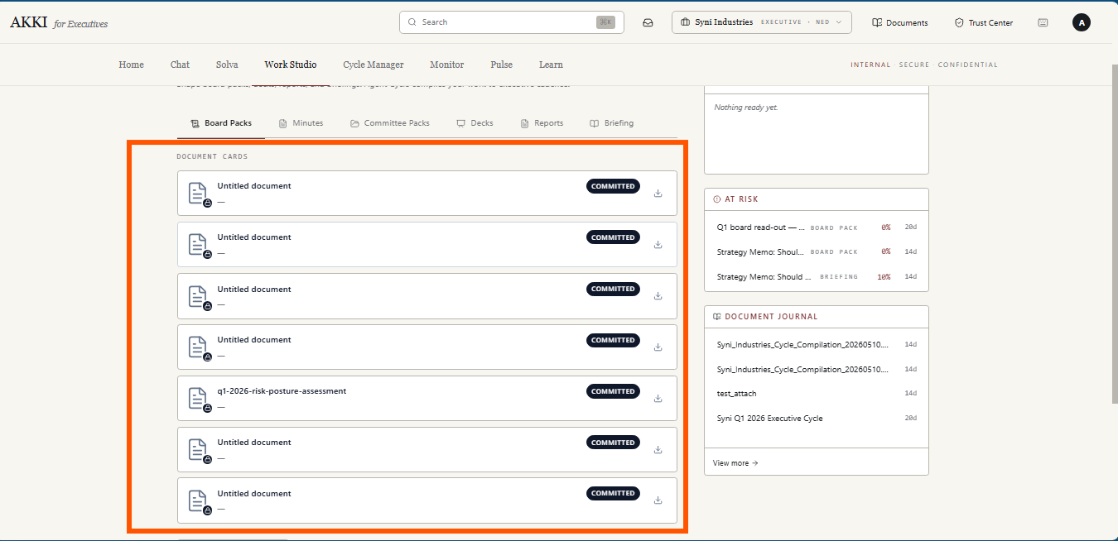
Figure 1
  - Every pack compiled by the agent using the Compile Board Pack and Compile Committee Pack buttons has a lifecycle — from the moment it is compiled by the Agent through to the point it is version-locked and committed.
The Three lifecycle states are defined and surfaced directly on every document card. These states apply exclusively to cards in the Board Packs and Committee Packs tabs. Update the cards shown in figure 2 to have:
- Status Badge - A status badge is added to every card to communicate the pack's lifecycle state at a glance. Three states are defined:
  - Draft — the document has been compiled by the Agent but has not yet been reviewed. This is the state every pack enters immediately after compilation. The badge is styled as a gray pill.
  - In Review — the pack has been opened and reviewed by the user. The badge is styled as an amber pill. How a compiled document is reviewed is described in item 3.
  - Committed — the user has version-locked the pack. No further editing is permitted on this version. The badge is styled as a dark filled pill. A small lock icon is overlaid on the bottom-right corner of the document icon to provide a second visual signal that the pack is locked.
- Confidence Score
The confidence score from the Document Intelligence model is displayed on every card as a percentage. The percentage is colour coded using consistent thresholds:
  - Above 75% — neutral colour
  - 50% to 75% — amber
  - Below 50% — red
- Download Icon
A download icon is added as a persistent action on every card regardless of lifecycle state. Clicking it downloads the pack in its source format.
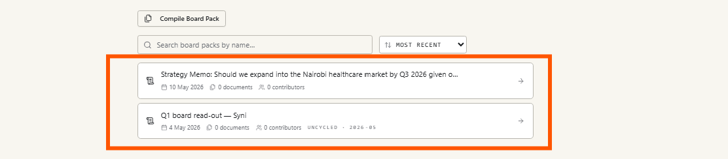
Figure 2
The Updated Card Layout therefore has:
- Row 1: Document icon (with lock overlay for Committed) — Document title — Status badge — Download icon
- Row 2: Date created · Document sources count · Contributor count · any existing metadata — Confidence score
Refer to figure 3
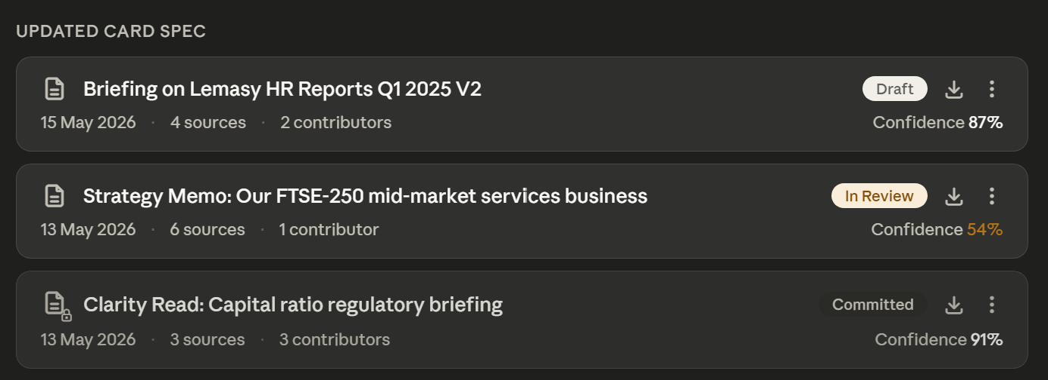
Figure 3
Clicking on the card opens the Compiled Document page described in item 3
  - Clicking a document card in the Board Packs or Committee Packs tab navigates the user to a dedicated document page. Opening the page automatically moves the compiled document card from Draft to In Review.

The document title sits at the top of the drawer and is inline editable. The user clicks the title, types the new name, and confirms with Enter or by clicking away.
A fixed bar that remains visible at all times regardless of how far the user scrolls in the document. It is split into a left group and a right group.
Left group:
- A back arrow that returns the user to the Board Packs or Committee Packs tab
- The document title, which is inline editable. The user clicks the title, types the new name, and confirms with Enter or by clicking away. A dashed underline on hover signals editability
- The status badge showing the current lifecycle state — Draft, In Review, or Committed
Right group:
- Download — downloads the document in its source format
We then have the document intelligence card that sits directly below the toolbar and remains visible at all times — it does not scroll away as the user moves through the document content. The card displays the following in a compact format:
- Number of source documents used
- Number of contributors
- Period covered by the pack
- Confidence score, colour coded — above 75% neutral, 50% to 75% amber, below 50% red
Below the document intelligence card we have the compiled document content as generated by the agent. This is the only scrollable area on the page. The user can read the document content directly on the page.
A fixed footer sits at the bottom of the page and remains visible at all times regardless of scroll position. The footer contains two areas:
- Agent Recommendation — the agent surfaces an enhancement recommendation based on its analysis of the compiled pack. This is displayed as a plain-language suggestion above the CTAs — for example "The executive summary could be strengthened with Q3 variance data from the Management Accounts."
- Three CTAs: Refine, Decline, and Commit
  - Refine — the user accepts the agent's recommendation. The agent implements the suggested changes automatically. If an additional source document is required to complete the refinement, the file upload modal opens prompting the user to upload the relevant file. Once uploaded the agent proceeds with the refinement and the document content and Document Intelligence card update to reflect the changes.
  - Decline — dismisses the agent recommendation. The recommendation text is removed from the footer.
  - Commit — version-locks the pack. A confirmation modal appears informing the user that the pack will be locked and cannot be refined further once committed. Two options are presented: Confirm and Cancel. On confirm the page closes, the user is returned to the tab, and the committed card appears at the top of the list with a pulse animation and a lock icon overlay on the document icon. The card badge updates to Committed.
The drawer also has a document intelligence section. It is displayed in a compact format directly below the title. The intelligence section shows:
- Number of source documents used
- Number of contributors
- Period covered by the pack
- Confidence score, colour coded using the same thresholds as the card — above 75% neutral, 50% to 75% amber, below 50% red
The compiled document content is displayed below the Document Intelligence section. Since pack content can be lengthy, the drawer is fully scrollable. The user can read through the content directly in the drawer without needing to download or open the document separately.
At the bottom of the drawer, the Agent surfaces enhancement recommendations based on its analysis of the compiled document. This section is always fixed and visible to the user regardless of how far they have scrolled through the document content.
Once a Board Pack or Committee Pack has been committed, the card in the tab list updates to reflect the locked state. The card displays the document title, date created, source document count, contributor count, confidence score, and a lock icon overlaid on the bottom-right corner of the document icon. The status badge updates to Committed.
The download icon remains available on the committed card as a persistent action. No other actions are available directly on the card.
Clicking the committed card navigates the user to the document page where the pack is displayed in read-only mode. The document title is locked and no longer editable. The Document Intelligence card remains visible as part of the document record. The fixed footer CTAs — Refine, Decline, and Commit — are replaced by a single Create New Version button sitting on the same line as the document title and Committed badge in the toolbar.
Clicking Create New Version generates a new card in the tab list automatically named using the next version number — for example "Q2 2026 Board Pack V2." The new card enters the list in Draft state with no lock icon. Clicking it opens the document page where the user can read, refine, and commit it following the same flow from the beginning.

  - Remove the compile a report button in figure 4
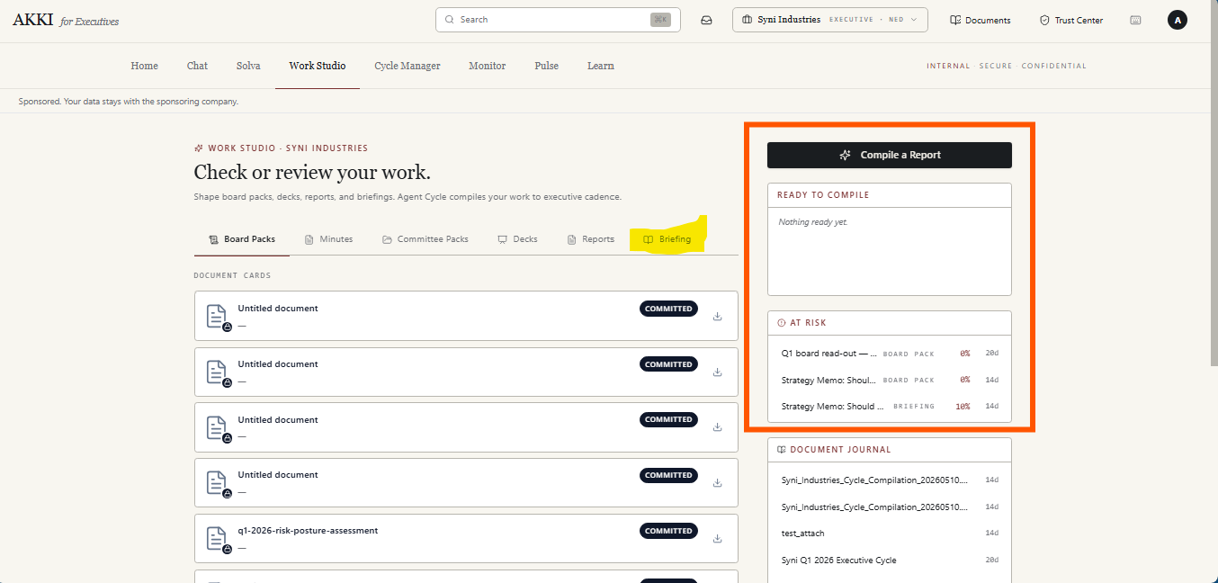
Figure 4
- Replace the Ready to Compile section with Recents. This panel surfaces the last 5 documents the user has worked on across all document types. Each entry shows the document name and how long ago it was last accessed.
  - Clicking a Board Pack or Committee Pack entry in the Recents panel navigates the user to the dedicated document page for that pack, replacing the current view. The back button returns the user to the Work Studio tab they came from.
  - Clicking a Minutes, Deck, or Report entry in the Recents panel opens the side drawer for that document, overlaying the current view without navigating away from the page.

  - Update the compile modal in figure 5 as follows:

A search bar sits directly below the "Select source items" heading, allowing the user to filter the list by document name in real time.
Below the list, a persistent inline prompt reads: "Can't find your document? Upload it here." Clicking this opens a file upload modal on top of the compile modal. The user uploads the file and clicks Save. The document is added to the Document Journal under the Upload tab and automatically appears in the Select Source Items list with its checkbox selected. The user returns to the Sources step with the uploaded document already selected
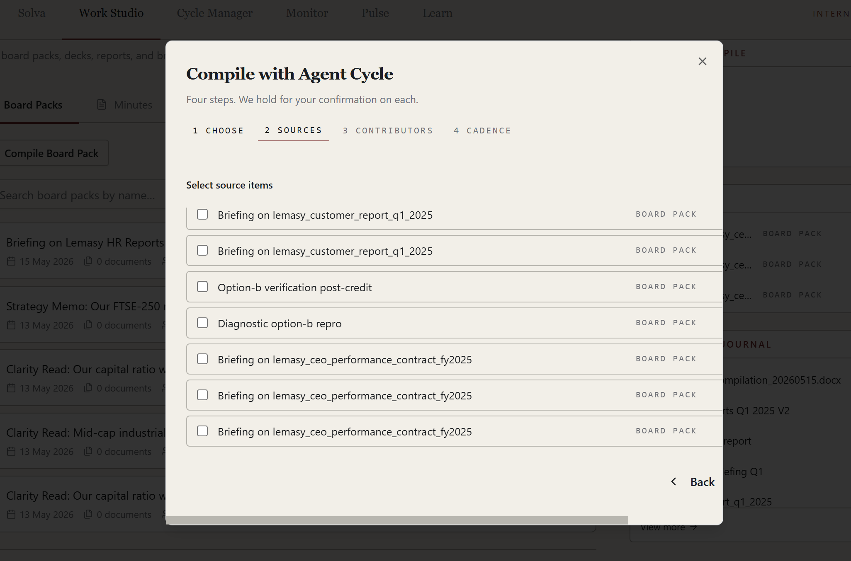
Figure 5
  - This flow applies to the Enhance function across the Minutes, Decks, and Reports tabs. The behaviour is identical across all three — only the document type referenced in the modal title and card list changes.
- The document should be enhanced as per the instruction provided as shown in the modal in figure 6. Change the modal title to be “Improve Minutes you already have” for minutes tab
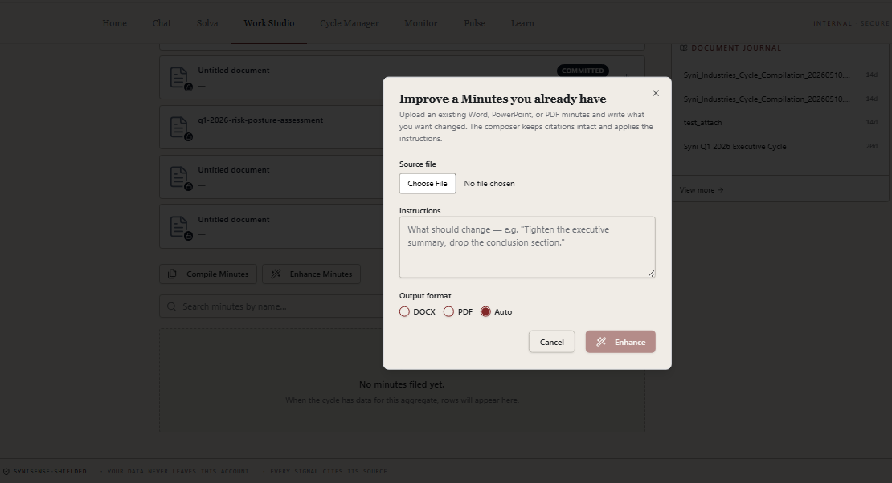
Figure 6
- Once the user clicks on enhance button in the modal in figure 6, a loading state appears and on completion, a toast notification appears at the top of the screen indicating whether the enhancement was successful or not.
- If successful, a download button appears in the modal matching the output format selected earlier. Once the user clicks download the modal closes and the enhanced document card appears at the top of the list circled in figure 7 for each tab.
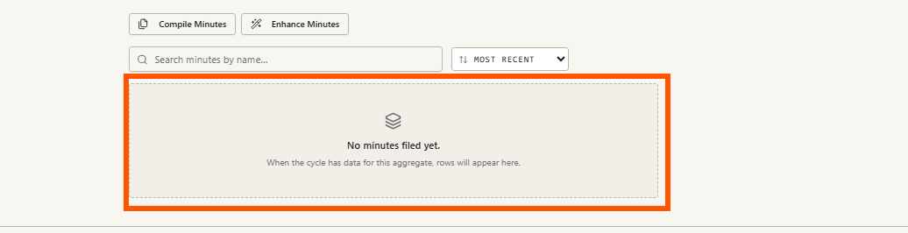
Figure 7
- The card enters with a pulse animation to draw attention before settling into the list. The card displays the document title, date created, file format (e.g. DOCX), file size, and a download icon.
The enhanced document is also added to the Document Journal under the Akki Generated tab.
- Clicking the card opens a side drawer containing:
  - An editable document title
  - A download icon
  - The Document Intelligence details for the enhanced document
The side drawer specifications are in item 7.
- If unsuccessful, the error state appears within the modal. A warning indicator and the message "Enhancement did not complete." is displayed along with a plain-language explanation of what went wrong — for example "Your instructions are too long. Please shorten them and try again." The technical error detail is not shown to the user. Two CTAs appear: "Adjust and try again" which returns the user to the editable modal with their previous inputs intact, and "Close" which dismisses the modal entirely.
  - The document intelligence in the side drawer mention in item 6 and shown in figure 8 to be update to cover the following:
- Confidence score — measures how well the enhanced output matches the user's instructions. A high score indicates the instructions were clearly interpreted and fully applied. A lower score signals that some instructions were ambiguous, partially applied, or could not be actioned.
- What was changed — a plain-language summary of the improvements made, mapped to the instructions the user provided.
- What was preserved — confirmation that citations, data references, and key figures from the original document were kept intact.
- Instructions applied — a record of the exact instructions the user submitted, providing a clear audit trail of what was asked and what was actioned.
- What was not changed and why — if any part of the instructions could not be applied, this is flagged with a plain-language explanation.

The side drawer has three CTAs at the bottom: Save, Refine, and Delete.
- The Save button remains inactive until the user edits the title — it activates as soon as a change is made.
- The Refine button allows the user to add further instructions and re-enhance the document without starting from scratch. Clicking Refine opens a compact instruction input field within the side drawer. The user types additional instructions and submits. A loading state appears, the document is re-enhanced, and the Document Intelligence details update automatically to reflect the new version. The confidence score and all intelligence details update to reflect the latest enhancement pass. The title remains editable throughout. This turns the enhancement into an iterative refinement loop, allowing the user to progressively sharpen the document across multiple passes.
- Clicking Delete triggers a confirmation modal with two options: Cancel and Delete. Any changes made in the side drawer — including title edits and deletions — are reflected immediately on the corresponding entry in the Document Journal.
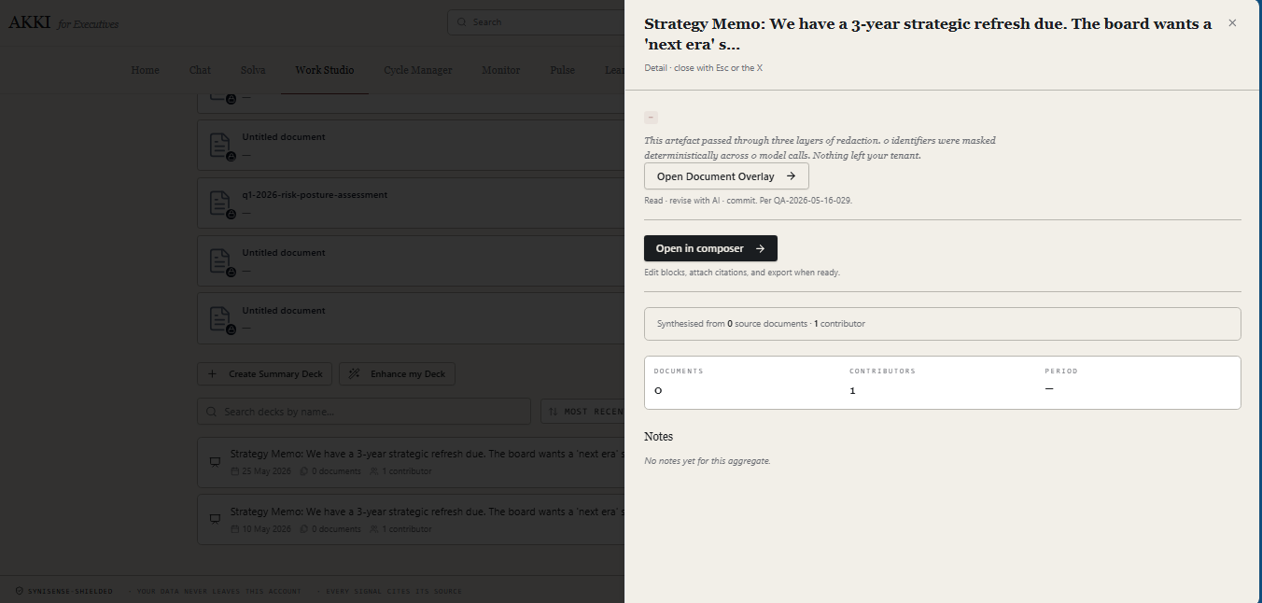
Figure 8

