RMS estate & language intelligence
A rigorous accounting and opportunity assessment · evidence cut 1 October 2026 · Royal Media Services · Owner briefing

Executive interpretation
The strongest defensible quantitative statement is narrower than an estate-wide sales claim: an authorised staged subset contains 3,958 readable-header audio files, totalling 529.34 file-duration hours and 36.52 decimal GB. A separately assembled, labelled transcript corpus contains 157,513 natural units and 27,329,904 characters from 4,521 source files. Neither statement certifies the intersection of non-English content, non-music speech, acceptable quality and external-use rights. [R07]
This is not a finding that the estate has no suitable material. It is a finding that candidate inventory and eligible corpus have not yet been reconciled. A global AI lab should receive both the positive inventory and the disqualifying uncertainties, not a headline with its qualifiers hidden in an appendix. [R07]
There is a credible near-term route to value: owner-controlled search and cited context, editorial archive workflows, specialised evaluation and carefully scoped local-language tooling. Open-source software can be released independently of raw data. Corpus licensing, broad model releases and voice products require additional evidence and permission. The options later in this report are advisory propositions, not booked revenue or authorisation to use the data. [R07]

How to read this report
Measured means a retained census, listing, header or worker record reports an observation within a stated scope. It does not mean every observation is independently certified. Derived means transparent arithmetic over those observations. Estimated means sampling, inference or an indicative tariff is involved. Proposed means a recommended design, commercial option or future work item. Unknown means the required evidence is absent; it never means zero. [R07]
Counts refer to the named snapshot, not necessarily the live estate today. The relational census was measured on 29 September 2026; listings have their own timestamps. The reporting evidence cut is 1 October 2026 at 19:12 UTC. Audio hours sum file headers; overlapping, replayed or copied recordings may represent the same underlying speech. GB and TB in this report are decimal; GiB and TiB are binary. Character counts, source bytes, training units and tokenizer-specific tokens are deliberately kept separate. [R07]
Duplication and storage rationalisation belong in Part I. Part II answers corpus quantity, content qualification and task quality; it uses the already assembled natural-unit counts and refers back to Part I for uniqueness controls rather than conflating file counts with independent examples. No destructive data operation, external release or new model training was commissioned to produce this report. [R07]

Part I · The estate is three overlapping inventories, not one clean corpus
The relational catalogue covers 20 databases and 1,006 table entries across 5 measured connections, with 377.20 GB (351.3 GiB) and an estimated 259,273,874 rows. These include operational, transaction, catalogue, log and content-related records. Their storage cannot be reported as natural-language training volume. [R01/R02]
The OBS inventory lists 22,975,591 objects occupying 143.285 TB (130.3 TiB). The NAS inventory lists 1,456,787 files occupying 47.991 TB (43.6 TiB). OBS and NAS can contain copies, off-air captures, proxies, mixed media and versions of material also described in database tables. Adding their bytes does not produce a unique-content or local-language total. [R01/R02]
The practical stewardship question is therefore which assets are authoritative, accessible, used, legally retained and valuable for specific purposes. Establish a source-of-record map before deleting copies or quoting the size of a licensable corpus. Media metadata can make the larger archive searchable without exporting raw content or assuming training rights. [R01/R02]
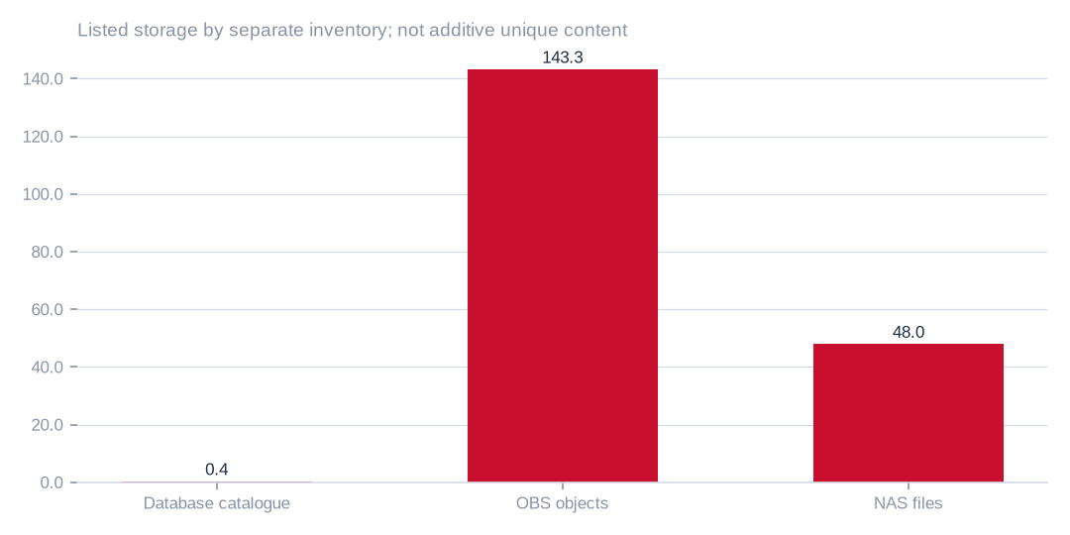
Figure: Listed storage by separate inventory; not additive unique content
[measured] Receipt R02: OBS and NAS retained listings embedded in the census; 29 September 2026. Metadata scope, not language or music analysis.

Coverage is substantial but not complete or perfectly reconciled
The census reports 5,881,277 observed rows and 638 measured table entries, compared with an estimated 259,273,874 catalogue rows. The ratio is 2.27%, but it is not a random-sample coverage probability or a basis for a single estate-wide confidence interval. Small tables were fully read; large tables used stratified keyset samples; some lacked a suitable key and used a head sample. [R01/R02]
The retained counts require an explicit reconciliation note. Complete, stratified-sample and head-sample method counts are 513, 83 and 41, totalling 637 rather than the headline 638 measured entries. The report also flags 44 failed table reads and 368 empty entries; these indicators overlap catalogue classifications and must not be forced into a mutually exclusive pie chart. The artists_app connection is reported blocked. The method-ledger discrepancy is a release issue for precise statistical claims, not a reason to discard the measured evidence. [R01/R02]
OBS coverage is 66 completed sources out of 106 listed sources; 40 are blocked or missing. That is 62.3% by source count, not by bytes or eligible hours. NAS enumeration covered 16 of 16 registered roots. Enumeration-complete still does not mean language, music, rights or semantic content were inspected. [R01/R02]

Relational readiness is uneven and is not an audio-quality assessment
Across the measured relational-table entries, the internal readiness distribution is A: 171, B: 62, C: 191, D: 189 and E: 25. These sum to 638. Their respective shares are 26.80%, 9.72%, 29.94%, 29.62% and 3.92%, subject to rounding. The denominator excludes unmeasured entries; these grades must never be applied to the audio or transcript corpus. [R01]
The grade is a heuristic stewardship index, not an external AI-lab certification. The implemented score weights completeness at 35%, exact-duplicate absence at 20%, degradation absence at 20%, freshness at 15% and absence of personal-data markers at 10%. Grade cut-offs are 85, 70, 55 and 40. Optional null fields, legitimate personal data, incomplete marker checks and unknown freshness can materially change the interpretation. Inspect the underlying column contract rather than equating every null with missing mandatory information. [R01]
Use the index to choose inspection order and remediation owners. A high grade does not establish rights or semantic usefulness; a low grade does not prove that every record is unusable. Preserve task-specific quality dimensions and coverage alongside any summary score. [R01]
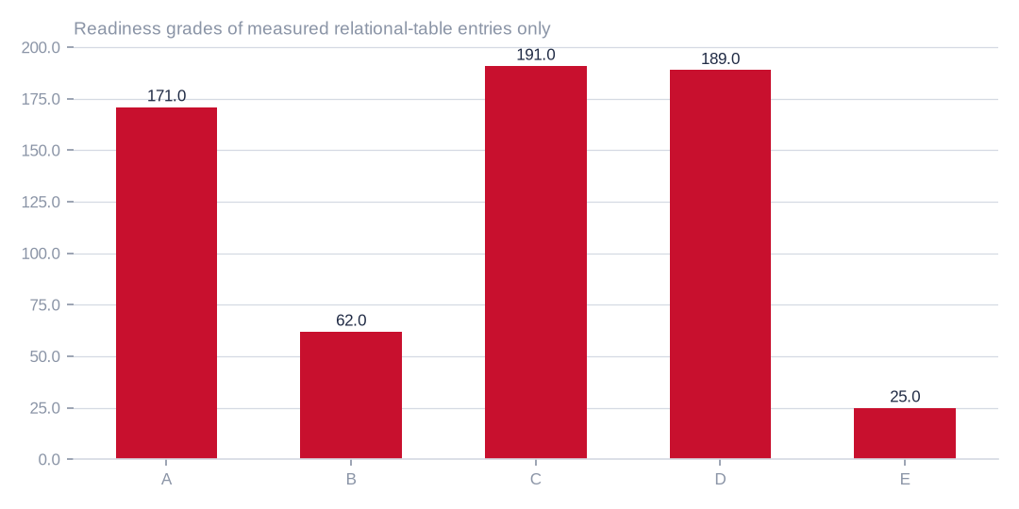
Figure: Readiness grades of measured relational-table entries only
[measured] Receipt R01: RMS estate census, eij-1b359b3cbd2e; measured 29 September 2026. Exact source hashes in the Word appendix.
 | Tables | Share (%)
A | 171.00 | 26.80
B | 62.00 | 9.72
C | 191.00 | 29.94
D | 189.00 | 29.62
E | 25.00 | 3.92
Database-estate readiness distribution; not speech or text quality
[measured] Receipt R01: RMS estate census, eij-1b359b3cbd2e; measured 29 September 2026. Exact source hashes in the Word appendix.

Quality and privacy signals are material, but their denominators differ
The headline weighted signals are 1.537% exact duplicate rows, 3.584% normalised duplicates, 22.957% degraded rows, 81.695% null-bearing rows, 71.833% personal-data-marker rows and 85.313% near-duplicate text. These measures concern different measured or sampled populations. Personal-data checking covered 1,011,330 rows. The report does not establish a common independent sampling design; the percentages cannot be multiplied by the entire estimated row inventory as if they were population parameters. [R01]
Degradation-kind signals include truncation at 21.91%, invalid format at 6.26%, placeholder content at 1.26% and whitespace anomalies at 0.94% of the relevant weighted measurement. A row may exhibit several kinds. The census also identifies 983 near-empty columns among 7,563 measured columns. These are operational leads, not proof of semantic corruption in every affected value. [R01]
The condition-byte indicators overlap. In particular, null-bearing, degraded and stale byte estimates are not disjoint partitions; an apparent zero “clean bytes” residual is not proof that no useful material exists. Recompute an exclusive condition taxonomy only after defining what completeness and fitness mean for each data product. Personal-data markers trigger minimisation and review, not an automatic blanket prohibition or legal conclusion. [R01]

Duplication has several meanings and several confidence levels
Within-table exact matching excludes the primary key. Normalised matching applies additional normalisation; near-duplicate text uses text sketches rather than semantic embeddings. The large near-duplicate-text signal may include repeated templates, boilerplate or log formats. It does not mean that the same fraction of the whole estate is safely deletable. Similarly, same-schema table overlap is a sketch-based estimate, not an authoritative row-by-row equivalence proof. [R01/R04]
The relational report identifies 71 cross-table overlap pairs, approximately 1.302 GB of within-table duplicate-byte candidates and 0.0566 GB of cross-table duplicate-byte candidates. Separately, the transcript assembly removed 2,525 repeated units before its natural-unit inventory was emitted. Those are different operations on different populations; neither should be subtracted again from the counts in Part II. [R01/R04]
For AI use, duplication has a second consequence: evaluation contamination. The same recording can appear under different files, exports, presenters or programme names. Canonical asset IDs, exact hashes, acoustic fingerprints and segment provenance should feed group-aware train/development/evaluation partitions. Removing storage copies is not sufficient to prove an independent held-out set. [R01/R04]

Object-store overlap and archive candidates offer leverage with qualifications
OBS contains 1,139,768 ETag-plus-size duplicate candidates—about 4.96% of listed objects—with 8.418 TB of estimated candidate bytes. Multipart ETags are not universal content hashes, and candidate counts are not necessarily the number of removable extra copies. Confirm canonical identity and multiplicity before converting this into a reclamation estimate. [R02]
The retained listing marks 43 sources, holding 46.054 TB, as not written for over a year. This is a write-age observation, not a read-frequency measurement. A large archive may still be heavily read for editorial retrieval, compliance or revenue. NAS duplicate content and speech durations are not established by its directory enumeration. [R02]
A conservative execution sequence is to observe access, simulate lifecycle changes, verify hashes on candidates, review contractual retention and restore obligations, then pilot a reversible tiering policy. Keep operationally required copies until ownership and recovery requirements are explicit. Do not delete a music-labelled bucket merely because music is outside the present AI use case. [R02]

Freshness and growth need field-level interpretation
The census flags 290 tables with a latest selected timestamp older than a year, representing approximately 58.132 GB. It also records future-dated or extreme historical values in some timestamp columns. Examples include dates beyond the reporting cut and sentinel-like ancient values. These can be legitimate event dates, entry errors, schema defaults or the wrong field for measuring modification age. [R01]
A selected latest timestamp is not automatically a last-write time. Validate each field’s semantics, time zone, clock behaviour and update path. Repeated identical byte counts are not proof of zero business activity; catalogue size estimates can remain flat while rows change. Likewise, small row deltas between snapshots may reflect estimates or asynchronous measurement rather than a reliable growth rate. [R01]
Define a freshness contract for each product: publication time for editorial context, last confirmed validity for reference data, transaction settlement time for operational analytics and last content observation for media. Recompute staleness under that contract. This is more actionable than applying a single age threshold to the entire estate. [R01]

Storage economics should be quoted as conditional bounds
The retained report uses reference tariffs of USD 0.1095 per database GB-month and USD 0.023 per object-storage GB-month, not the owner’s invoice. For the old-write OBS candidate alone, applying the object tariff gives a gross full-standard-storage ceiling of USD 1,059.24 per month if “GB” is decimal, or USD 986.49 if the billing unit is GiB. The retained figure follows the latter convention. Billing-unit semantics must be confirmed before presenting a payable saving. [R01/R02/R07]
Neither gross ceiling is a net archive saving: cold-tier storage, retrieval, restore operations, egress, minimum retention charges, migration effort, ongoing monitoring and service risk must be deducted. Reclamation and archival candidates can overlap; adding their separate quoted savings double counts value. Currency, region, tax, reserved commitments and effective billing rates also require reconciliation. [R01/R02/R07]
A decision model should separately show verified removable bytes, archive-eligible bytes, operational cost avoided, one-off migration cost and downside scenarios. Price it with actual owner rates. The current evidence supports a controlled cost-reduction investigation, not a guaranteed savings claim or a valuation of the language corpus. [R01/R02/R07]

Stewardship priorities should protect value before removing cost
Begin with a canonical source and access ledger, then resolve blocked high-value sources. Assign owners to large operational logs, replicated business schemas and media archives. Confirm which copies serve staging, backup, audit or contractual purposes. For each proposed action record its evidence, intended benefit, dependency, reversibility and approver. [R07]
Next, establish query and retrieval baselines before altering indexes or storage tiers. Prefix-covered indexes are candidates, not guaranteed redundant operationally: workload, statistics, uniqueness, hints and write/read balance matter. Retention windows and restore exercises should be demonstrated before archival cut-over. Only then automate a reviewed policy. [R07]
The language-data workstream should use the same identity and rights ledger, but should not wait for every general estate-cleanup item. A well-scoped, traceable local-language subset can be qualified and piloted while broader stewardship continues. Keep infrastructure savings and data-product value as separate business cases. [R07]

Part II · The precise answer is a bounded candidate inventory
Audio: 3,958 files with readable headers, 529.34 file-duration hours and 36.517 GB (34.009 GiB) in the authorised staged corpus. These files are grouped under eight local-language labels. Their content has not been independently shown to exclude English, music, silence, mixed programmes or unusable intervals. The record cannot support a certified non-English, non-music speech-hour total. [R03/R04]
Text: 157,513 natural units, 27,329,904 characters and 4,521 source files in a separately versioned transcript build covering seven labels. This establishes a labelled candidate corpus, not a human-audited non-English natural-text total, a translation corpus or a clean speech–text alignment. Text language purity, transcript fidelity and lyrical/music contamination remain unquantified. [R03/R04]
The staged-audio inspection also lists 3,939 companion transcript files occupying 37.193 MB. These companion files and the separate assembled-text population have different scope and provenance. They must not be added together as disjoint text holdings or treated as proof that every audio hour has a verified aligned transcript. [R03/R04]
The whole-estate eligible total is unknown on the present record. It is not defensible to extrapolate this staged subset to the millions of OBS/NAS objects, or to convert database bytes into language hours or tokens. The right external statement presents the candidate inventory, explains the narrower qualified slice and supplies a concrete closure programme. [R03/R04]

The audio-duration distribution is highly uneven
Six folder groups contain roughly eighty to ninety-two hours each, whereas Wanga/Luhya and Bukusu are much smaller in the staged audio snapshot. This matters operationally: a pooled metric can hide weak dialect coverage, and the smallest groups will need purposeful qualification or collection rather than proportional random sampling alone. [R03/R04]
Wanga/Luhya has 9.1942 staged hours and Bukusu has 1.0724; together they represent 1.94% of staged file duration. These are folder assignments. A linguist should validate language names, code mappings, dialect relationships and any code-switching convention before a global dataset card treats them as certified language strata. [R03/R04]
The eight audio labels and seven text labels are not contradictory: the assembled transcript build lacks a Bukusu stratum. Nor does the large number of Wanga text units prove correspondingly large aligned audio. The corpus-build populations differ and need a source-level join. [R03/R04]
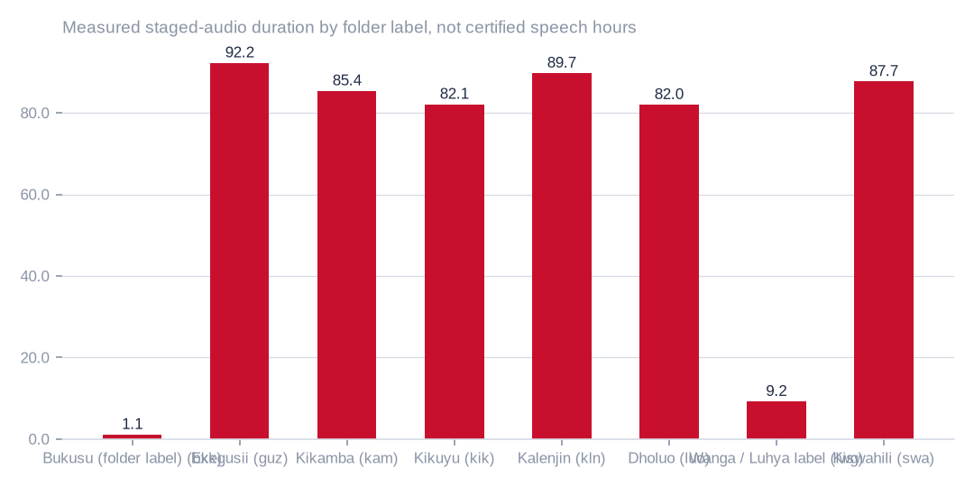
Figure: Measured staged-audio duration by folder label, not certified speech hours
[measured] Receipt R03: Staged-audio header inspection, m9j-3e0dcb1bd16e; verified receipt. Folder labels are not content verification.
 | Audio files | Hours | Audio GB | Text files | Text MB
bxk · Bukusu (folder label) | 14.00 | 1.07 | 0.07 | 0.00 | 0.00
guz · Ekegusii | 732.00 | 92.23 | 7.70 | 730.00 | 6.27
kam · Kikamba | 1,166.00 | 85.37 | 4.83 | 1,165.00 | 5.11
kik · Kikuyu | 584.00 | 82.08 | 5.50 | 583.00 | 5.46
kln · Kalenjin | 295.00 | 89.72 | 6.36 | 295.00 | 7.58
luo · Dholuo | 558.00 | 81.99 | 3.79 | 557.00 | 6.03
lwg · Wanga / Luhya label | 60.00 | 9.19 | 0.77 | 60.00 | 0.74
swa · Kiswahili | 549.00 | 87.67 | 7.49 | 549.00 | 6.00
Staged audio and companion transcript inventory; different units by column
[measured] Receipt R03: Staged-audio header inspection, m9j-3e0dcb1bd16e; verified receipt. Folder labels are not content verification.

Capture properties are measurable; quality grades are not yet established
The measured sample-rate distribution is 3,126 files at 44.1 kHz; 162 at 48 kHz; 49 at 22.05 kHz; 597 at 11.025 kHz; 22 at 16 kHz; and 2 at 32 kHz. These counts sum to the staged inventory. No unreadable headers were reported. This supports header accessibility and capture-format accounting only; it does not establish successful full decoding, low noise, intelligibility or correct transcripts. [R03]
A low sampling rate limits available bandwidth, but a high sampling rate cannot restore information already lost upstream. Container size also depends on encoding, bit depth, channels, metadata and compression—not just duration or quality. Do not assign “studio”, “telephone” or “broadcast-clean” grades from sample rate or file extension. [R03]
A proper audio-quality distribution needs full-decode success, effective bandwidth, clipped-sample share, silence and speech-active duration, loudness variability, channel consistency, noise and reverberation measures, overlapping speech, intelligibility and task-relevant human evaluation. Thresholds should be chosen for the intended task and validated on native-speaker references rather than guessed from file metadata. [R03]
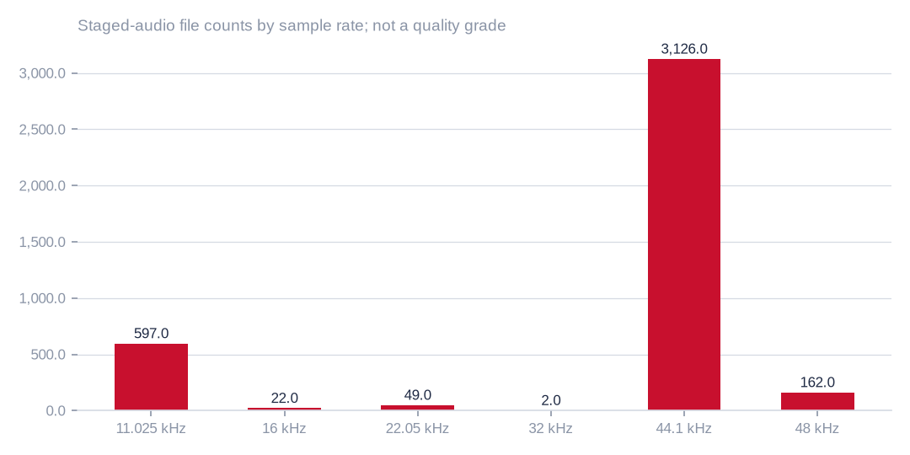
Figure: Staged-audio file counts by sample rate; not a quality grade
[measured] Receipt R03: Staged-audio header inspection, m9j-3e0dcb1bd16e; verified receipt. Folder labels are not content verification.

The waveform measurement record is incomplete and stale
The retained measurement status reports progress on 1,900 of 3,958 files, but its last heartbeat is 1 October 2026 at 04:33 UTC. At the reporting cut there is no digest-verified final result and no stored completed measurement rows in the inspected measurement record. The elapsed reporting interval means “running” must be read as last recorded state, not confirmation that the remote process is still healthy. [R06]
Consequently, no signal-to-noise, clipping, speech fraction, music fraction, studio-versus-telephone or quality-band percentages are published here. A progress counter is not an analyzable dataset, and it cannot be used as a quality denominator. Recover or complete the measurement receipt, including failures and excluded files, before publishing distributions. [R06]
The priority is not simply to finish a batch. The record must reconcile input assets, completed analyses, errors, segment durations, classification uncertainty, code/configuration hashes and the original capture inventory. The raw observables then need a task-specific interpretation layer that clearly separates automated indicators from independently established labels. [R06]

Define non-English and non-music at the segment level
Use mutually understandable content categories: local-language speech without music; English-only speech; code-switched speech; music-only; speech with music underneath; other sound; silence; and unresolved. A file can contain several categories, so file-level inclusion is too coarse for a strict speech inventory. Speech over a music bed is not automatically “non-music”; classify it separately unless the recipient explicitly accepts it. [R07]
Define the target before counting. Strict non-English speech can exclude any English-bearing segment; a local-language-dominant product can instead retain code-switched segments with token- or time-based proportions and explicit flags. These are different products and cannot share an unqualified headline. Lyric text, songs, station jingles and promotional beds also need treatment when qualifying transcripts. [R07]
Automated speech/music and language scores can prioritise review, but their errors must be measured on independent native-speaker annotations. Unknown labels stay unknown. A bucket named for music is a useful exclusion lead, not proof that music is absent elsewhere. Likewise a local-language folder can contain English quotations, presenters introducing songs or mixed programmes. [R07]

Text quantity is real, but units, characters and tokens are different
The assembled corpus is dominated by Kalenjin and Wanga-labelled text units, followed by Dholuo, Ekegusii, Kiswahili, Kikuyu and Kikamba. Unit counts reflect the assembly’s segmentation rule; they are not word counts, unique speakers or independent documents. A short sentence and a longer utterance can both count as one unit, so a row-count comparison alone does not describe training mass. [R04/R05]
The character count is an observed assembly measure. It is not UTF-8 bytes, and a generic characters-per-token divisor would not produce a defensible multilingual token inventory. Tokenisation varies by model vocabulary and language. Report tokenizer name/version, normalisation, special tokens, truncation and whether counts are unique input tokens or repeated training exposure. [R04/R05]
For context, the recorded 8B run reports 9,502,124 training-input tokens after its own preprocessing and sequence cap, including its added canary/reference material. Inspection of the worker implementation shows this field counts the tokenised input dataset, not the epoch-multiplied exposure counter. It is therefore not a whole-estate token total and should not be marketed as unrestricted natural text. [R04/R05]
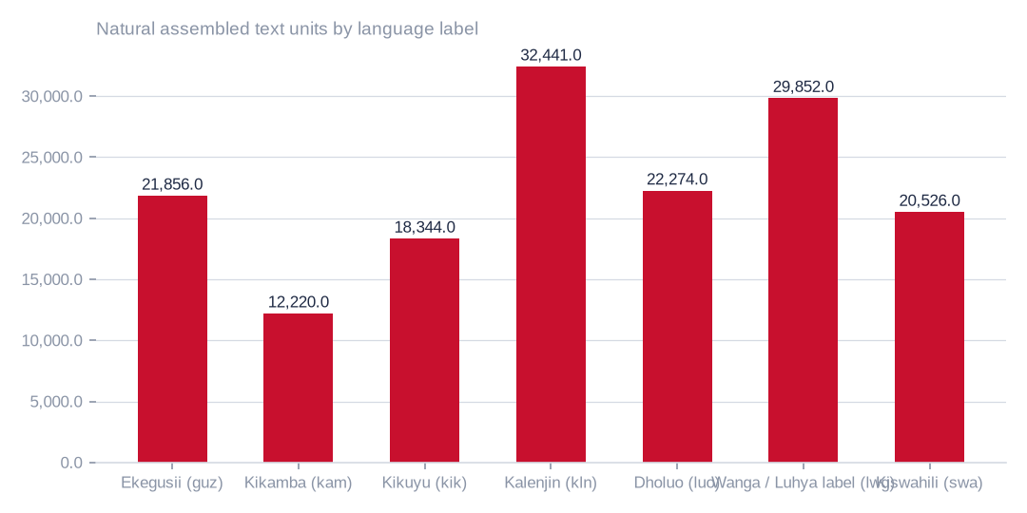
Figure: Natural assembled text units by language label
[measured] Receipt R04: RMS transcript assembly, m9j-9a46b862f339; sealed 29 September 2026. Natural units exclude added canaries.
 | Train | Dev | Held | Archive
guz · Ekegusii | 18,443.00 | 1,094.00 | 2,217.00 | 102.00
kam · Kikamba | 8,746.00 | 931.00 | 2,422.00 | 121.00
kik · Kikuyu | 13,846.00 | 924.00 | 3,573.00 | 1.00
kln · Kalenjin | 27,483.00 | 1,667.00 | 3,253.00 | 38.00
luo · Dholuo | 18,681.00 | 1,131.00 | 2,455.00 | 7.00
lwg · Wanga / Luhya label | 25,350.00 | 1,496.00 | 3,006.00 | 0.00
swa · Kiswahili | 17,435.00 | 1,037.00 | 2,054.00 | 0.00
Natural transcript partitions by language label
[measured] Receipt R04: RMS transcript assembly, m9j-9a46b862f339; sealed 29 September 2026. Natural units exclude added canaries.

The existing partitions provide useful structure, not final independence proof
Natural units are partitioned into 129,984 training units, 8,280 development units, 18,980 held-out units and 269 archive-test units. These sum to 157,513. The source records a group-disjoint split by presenter for transcripts. That is useful lineage, but a presenter-group rule is not independent proof that the same voice, programme, event or semantic content never appears across partitions. [R04]
The assembly separately records 60 inserted canaries and 80 reference canaries. They are deliberate evaluation material, not naturally occurring language inventory. Do not count them as a commercial data asset. The recorded train artefact includes them in addition to the natural training subset. [R04]
Preserve the original sealed-set digest, but recognise that repeatedly inspecting results during recipe selection changes what the set can support. A sealed set can remain byte-immutable while ceasing to be a blind final evaluation. A new independent final set, with source-, session- and speaker-aware reconciliation, is required before claiming generalisation after further selection. [R04]
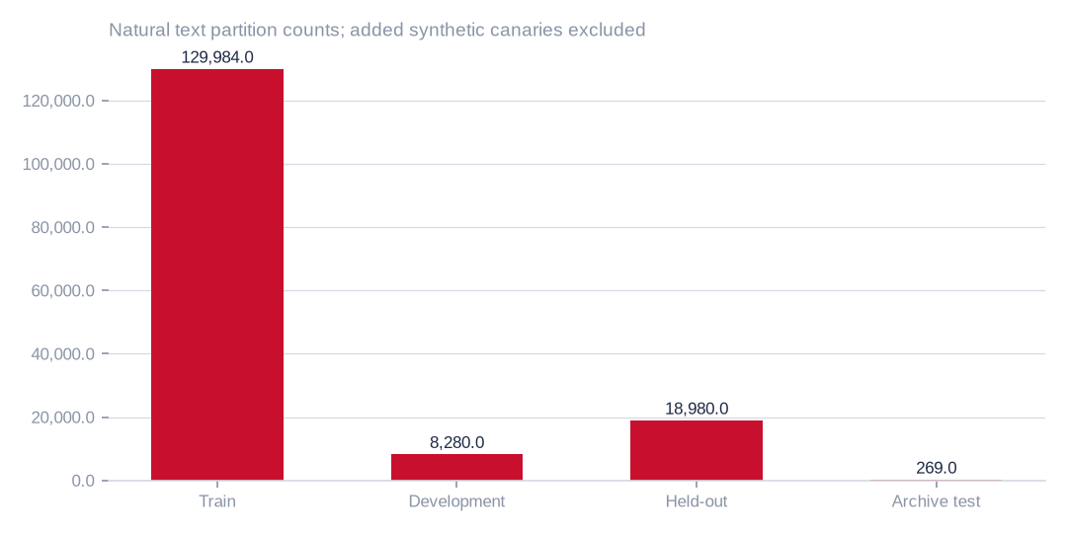
Figure: Natural text partition counts; added synthetic canaries excluded
[measured] Receipt R04: RMS transcript assembly, m9j-9a46b862f339; sealed 29 September 2026. Natural units exclude added canaries.

Transcript quality and aligned speech hours are still open
No independent word-error-rate or character-error-rate distribution has been established for the transcript corpus in the reviewed evidence. Folder language, successful assembly and high language-identification performance cannot substitute for transcript fidelity. Punctuation, diacritics, named entities, local orthography, borrowed words and code-switches deserve separate treatment. [R03/R04/R07]
Paired speech–text value requires a verified join: canonical audio ID and hash, segment start/end, transcript version, alignment confidence, annotation or ASR origin, language/dialect, speaker/session grouping, rights basis and quality state. The difference between companion-transcript counts and the assembled-text sources means the paired-hour quantity is presently unknown. Do not infer it from the smaller file count or from total header duration. [R03/R04/R07]
Create a stratified human reference with native-speaker adjudication, record annotator disagreement, and publish errors by language, dialect, acoustic condition and content type. Evaluate alignment separately from transcription. A corpus may be useful for language identification or retrieval before it is suitable for ASR supervision; release it under the narrower supported use. [R03/R04/R07]

The text model proves a narrow capability, not corpus-wide quality
The retained 8B text language-identification evaluation uses 2,800 held-out examples, with 400 per language stratum. Conditional macro accuracy among judged examples is 97.213%. The reported figure is not accuracy over every example regardless of abstention, nor does it certify grammar, factuality, translation, ASR fidelity, broad language modelling or privacy. [R05]
Kikamba records 359 correct of 393 judged, with 7 abstentions: conditional accuracy is 91.349%, coverage is 98.25%, and correct predictions as a share of all 400 presented examples are 89.75%. Kiswahili has 377 correct, 381 judged and 19 abstentions: conditional accuracy is 98.950%, coverage is 95.25%, and correct-of-all is 94.25%. A lab should see all these denominators, not just the highest-looking percentage. [R05]
The language-ID result is evidence that the staged labels carry a learnable signal. It is not independent evidence that those labels are linguistically perfect or that all source data meets an external use licence. Earlier audio runs also showed that language accuracy did not establish speaker privacy. Use these findings to design qualification work, not to imply that the broader cognition programme or a general local-language foundation model is complete. [R05]
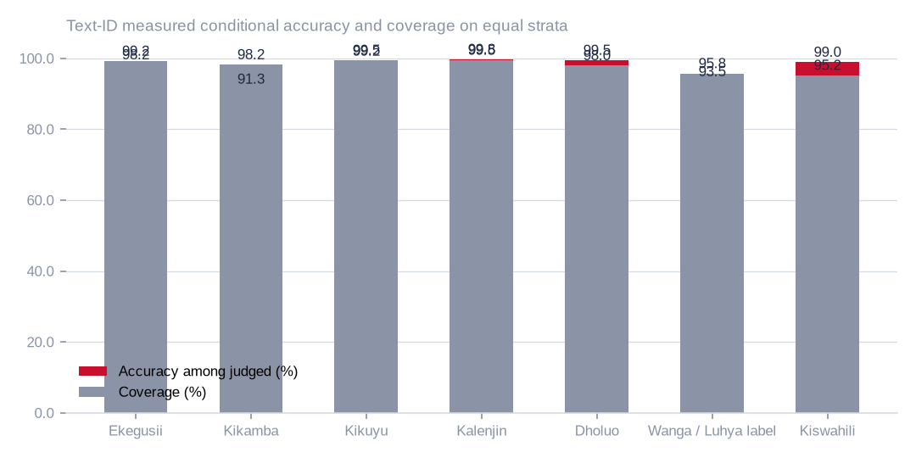
Figure: Text-ID measured conditional accuracy and coverage on equal strata
[measured] Receipt R05: Text language-ID run, m9j-74af7cef0a85; measured per-stratum results. Not an ASR or general-language certificate.

Compute eligible hours with an auditable segment ledger
For a strict speech corpus, eligible hours equal the sum of segment duration in seconds divided by 3,600, restricted to segments whose language policy, music policy, quality policy, rights basis and intended use all pass. Unresolved gates remain unresolved; they do not become pass values or count as zero-duration assets. Report known-included, known-excluded and unresolved duration separately. [R07]
The asset ledger should include source system, canonical ID, cryptographic hash, recording timestamp, duration, channel and codec properties, source rights, segment labels, confidence, annotation origin, quality indicators and all exclusions. Retain the versioned policy applied. When only a sample is annotated, distinguish the observed qualifying hours from an estimated population yield. [R07]
Use duration-weighted, stratified estimation with the actual inclusion probabilities. Cluster by programme/session or speaker where appropriate; an asset-count sample can be biased toward short files. Confidence intervals must reflect the sampling design and classifier validation, not just a binomial formula over correlated segments. No estate-wide confidence interval is claimed in this report because the necessary design and labels are not yet present. [R07]

A sampling illustration is not a substitute for the actual design
As a planning illustration only, a simple random sample of independent observations needs about 385 observations to estimate a proportion within five percentage points at approximately 95% confidence under the worst-case proportion of one half. This follows the normal-approximation expression n = z² p(1−p) / e² with z = 1.96. It is not an adopted requirement or a measured sample size for this estate. [R07]
Broadcast segments are clustered and languages are imbalanced, so effective sample size can be far smaller than the raw segment count. Rare languages, music beds, code-switching and failure cases may require deliberate oversampling. Weight results back to the population design and preserve separate per-stratum uncertainty. Confirm exact or bootstrap intervals where assumptions warrant them. [R07]
Even a sample with no detected contamination does not prove zero contamination in the population. The recipient and data owner must agree tolerances and escalation rules. The operational aim is an honest, reproducible statement of expected quality and uncertainty, not a convenient green badge. [R07]

What a global AI lab should receive
Provide a versioned data card and machine-readable manifest with source provenance; permitted and prohibited uses; recording and publication dates; language/dialect and code-switch distributions; hours and bytes by segment category; encoding and sampling properties; verified quality metrics and uncertainty; annotation and transcript provenance; rights and privacy exclusions; and known representational limitations. The data card should identify who is responsible for corrections and withdrawals. [R07/R08]
The acceptance pack should include sample selection and adjudication protocols, inter-annotator disagreement, task-specific validation, complete failure/exclusion counts, canonical split IDs, contamination controls, exact tokenizer counts where relevant, reproducible code/configuration hashes, and a documented way to reproduce the reported figures. It should distinguish source-level consent from processing agreements, model-training permissions, redistribution and public release. [R07/R08]
A lab may accept a useful research subset with declared limitations; it should not be asked to infer missing evidence from a model demo. Offer a controlled evaluation path first, with independently selected samples and a secure review process. Only widen access after the claims in the intended offer can be independently checked. [R07/R08]

Part III · Data value depends on the product and the permitted use
The following portfolio is broader than context services and open-source support. It separates enterprise service revenue, data and evaluation products, and public-interest ecosystem investment. A good option does not require every asset in the estate: a narrow, rights-cleared slice with a clear buyer and measurable benefit can be more valuable than a larger undocumented archive. [R07]
These options are proposed uses, not evidence that the current estate is already eligible for them. Several can begin with owner-controlled access and a limited qualified subset. Others depend on independent speech labels, aligned transcripts, additional permissions or new data collection. A realistic roadmap sequences those dependencies rather than treating all options as immediately launchable. [R07]
Commercial validation should identify the buyer, the workflow cost or risk being reduced, the unit of value, the service-level obligation and the cost of rights and curation. Avoid valuing the data solely by raw hours, gigabytes or model-training compute. No revenue forecast, market-size estimate or customer demand claim is asserted here. [R07]

Opportunity · Context as a service
User and problem. Enterprise assistants, newsrooms, research teams and approved local-language applications. Versioned, cited retrieval of authorised local context through a governed interface; language routing, provenance, freshness and correction are part of the product. [R07]
Practical offer. Begin with a small, rights-cleared text slice and named domains. Retain document-level access controls, source dates, quote limits, correction history and withdrawal propagation. An answer must cite evidence and abstain when coverage is weak; the service must not disguise missing local knowledge with fluent generation. [R07]
Commercial or ecosystem model. Subscription, usage or enterprise agreement; validate retention, citation utility, answer coverage and workflow savings. [R07]
Evidence of success. Retrieval relevance, faithfulness, language/dialect coverage, freshness, refusal quality and cost per accepted answer. Citation is not itself proof of truth. [R07]
Prerequisites and limits. Source rights for retrieval and excerpting; publication updates; factual review; privacy and content-access boundaries. [R07]

Opportunity · Private archive search and editorial intelligence
User and problem. RMS editorial teams and authorised institutional archive users. Search, discovery, timeline building and reusable editorial context across a curated subset of transcripts and metadata. [R07]
Practical offer. Start inside the owner boundary, where a private assistant can reduce archive-search time without exporting raw media. Preserve the distinction between archival claims and current facts. Attach programme/date context, version history and retention rules; do not turn named people in an archive into an unrestricted profiling service. [R07]
Commercial or ecosystem model. Internal productivity case first; institutional access or managed archive service where rights permit. [R07]
Evidence of success. Time to find usable evidence, recall on representative editorial tasks, false-match rate, citation completeness and corrected-record propagation. [R07]
Prerequisites and limits. Canonical asset links, editorial validation and role-based access; not every archive item is current or factually endorsed. [R07]

Opportunity · Local-language transcription, captions and media accessibility
User and problem. Broadcasters, archives, public-service content teams and accessibility programmes. Task-specific ASR, captions, alignment and searchable timecodes for qualified language/acoustic strata. [R07]
Practical offer. Use the current corpus only after a human-reference ASR and alignment audit. Treat music beds, overlap, names, local spelling and code-switches as explicit conditions. Keep native-speaker correction in the workflow and price difficult audio separately rather than promising a single accuracy level for every programme. [R07]
Commercial or ecosystem model. Per-minute processing, managed service or enterprise contract; quality-linked acceptance and rework costs determine margin. [R07]
Evidence of success. WER/CER by stratum, timing error, named-entity error, subtitle readability, review effort and turnaround time. [R07]
Prerequisites and limits. Clean paired segments, independently checked references, lawful processing and a supported rather than assumed model capability. [R07]

Opportunity · Independent local-language benchmark and evaluation service
User and problem. Model developers, global AI labs and local-language application buyers. A controlled, blind benchmark with per-language/dialect scoring, abstention and coverage, leakage checks and human adjudication. [R07]
Practical offer. Keep benchmark material out of training and routine public examples. Use a rotated independent final set after recipe selection, publish task definitions and sampling limitations, and make evaluation reproducible without disclosing restricted raw data. Separate research feedback from final adjudication. [R07]
Commercial or ecosystem model. Evaluation engagements, secure benchmark access or recurring independent assessments. [R07]
Evidence of success. Label agreement, coverage of intended strata, statistical uncertainty, contamination resistance and repeatability. [R07]
Prerequisites and limits. Independent labels and partitions; benchmark rights; conflict-of-interest controls. The current language-ID score alone is not a benchmark product. [R07]

Opportunity · Rights-cleared research corpus licensing
User and problem. AI labs and research institutions with a defined training or evaluation objective. Versioned corpus slices with a data card, manifest, permissible-use terms, correction/withdrawal process and documented quality. [R07]
Practical offer. Offer specific content categories and verified quantities rather than the whole raw estate. Licensing terms should distinguish evaluation, adaptation, foundation-model training, redistribution and derived model publication. Price the curation, assurance and update service, not just transfer volume. [R07]
Commercial or ecosystem model. Scoped licence, time-bound access, support or recurring updates, subject to actual rights and demonstrated buyer need. [R07]
Evidence of success. Qualified hours/units delivered, label quality, traceability, update reliability, withdrawal compliance and buyer acceptance. [R07]
Prerequisites and limits. Onward-use rights, contributor and programme permissions, privacy review, geographic transfer terms and verified quality. Not cleared by internal training authorisation alone. [R07]

Opportunity · Secure research enclave and compute-to-data access
User and problem. Research partners unable to receive unrestricted source copies. Approved code executes against a controlled dataset slice; reviewed metrics and permitted outputs leave the environment. [R07]
Practical offer. An enclave can reduce raw-data movement but does not remove the need for lawful purpose, output review and leakage controls. Define what models, embeddings, examples and logs may leave; monitor query patterns and cumulative disclosure, and plan revocation and destruction evidence. [R07]
Commercial or ecosystem model. Project access, managed research environment or jointly funded programme. [R07]
Evidence of success. Time to approved experiment, reproducibility, output-review quality, isolation and operating cost per engagement. [R07]
Prerequisites and limits. Approved partner and purpose, adequate controls, contractual liability and a qualified dataset. This is not a loophole around data-protection law. [R07]

Opportunity · Terminology, entities and multilingual knowledge resources
User and problem. Search, translation, education and public-service application developers. Curated local-language terminology, place/name variants, domain concepts and source-linked entity relationships. [R07]
Practical offer. A carefully curated lexicon or knowledge resource may deliver more immediate utility than a large model trained from scratch. Use native-speaker and domain review, dates and regional scope. Preserve ambiguous names and contested terminology; do not infer personal attributes or sensitive facts from co-occurrence. [R07]
Commercial or ecosystem model. Specialised reference-data service, integration or support; an appropriately licensed public subset can strengthen adoption. [R07]
Evidence of success. Term precision, language/dialect coverage, provenance, update latency and downstream search or translation gains. [R07]
Prerequisites and limits. Annotation, semantic validation and source rights. Corpus co-occurrence is not automatically factual knowledge. [R07]

Opportunity · Translation and localisation support
User and problem. Publishers, civic services, education providers and local-language content teams. Reviewed glossaries, translation memories and domain-specific assistance, with human approval for consequential content. [R07]
Practical offer. The present transcript corpus is not a verified parallel corpus. Start with terminology and controlled human translation, then commission aligned source/target material where rights permit. Evaluate meaning, dialect, register and named entities rather than relying on a single automatic similarity score. [R07]
Commercial or ecosystem model. Managed localisation, specialist tooling or domain-specific translation support. [R07]
Evidence of success. Human adequacy and fluency, terminology consistency, edit distance or review effort, and harmful mistranslation rate. [R07]
Prerequisites and limits. Parallel references, native-speaker review and domain safeguards; especially stringent review for legal, health or emergency content. [R07]

Opportunity · Specialised small models and adapters
User and problem. Enterprises and developers needing bounded local-language tasks. Language routing, archive classification or other measured narrow capabilities with an explicit supported-use envelope. [R07]
Practical offer. The existing text language-ID result is a useful starting point for a narrowly scoped adapter service. Do not claim general reasoning or foundation-model competitiveness from it. Match calibration and comparison to the selected base, qualify a fresh final evaluation and review both base-model and dataset licences before distributing weights. [R07]
Commercial or ecosystem model. Hosted inference, adaptation work, support or licensed model distribution where permitted. [R07]
Evidence of success. Per-stratum accuracy times coverage, latency, compute cost, robustness, privacy and withdrawal obligations. [R07]
Prerequisites and limits. Actual task evidence, base licence compatibility, data rights and complete admission/serving controls. [R07]

Opportunity · Aggregate media intelligence and public-interest analytics
User and problem. Editorial planning, researchers and approved institutional users. Source-linked trends, topic coverage and language-presence analysis at aggregate levels, with uncertainty and representation limits. [R07]
Practical offer. Broadcast content reflects editorial selection and audience context; it is not a random sample of public opinion. Avoid individual profiling and unsupported demographic or political inference. Publish the sampling frame, missing channels and changes in programme composition, and retain editorial review of consequential conclusions. [R07]
Commercial or ecosystem model. Research briefs, controlled analytics subscriptions or public-interest partnerships. [R07]
Evidence of success. Coverage, stability across sources/time, annotation validity, interpretability and risk of misleading population claims. [R07]
Prerequisites and limits. Content access, validated taxonomy, aggregation/privacy safeguards and a clearly bounded claim about the represented population. [R07]

Opportunity · Native-speaker annotation and data-quality services
User and problem. Corpus owners, research institutions and model developers. Adjudicated labels, transcript correction, dialect validation, quality audits and reproducible evaluation packs. [R07]
Practical offer. Build a fair, documented contributor programme with training, disagreement handling, quality review and appropriate compensation. The resulting capability can improve the owner corpus and become a service to other datasets. Avoid using an opaque model label as human ground truth or rewarding workers solely for agreement with an uncertain machine. [R07]
Commercial or ecosystem model. Project services, managed annotation operations or recurring quality assurance. [R07]
Evidence of success. Agreement and adjudication outcomes, error audits, turnaround, effective cost per accepted label and contributor retention. [R07]
Prerequisites and limits. Qualified reviewers, governance, safe handling of sensitive material and clear permitted use of contributed annotations. [R07]

Opportunity · Open-source local-language enablement and heritage access
User and problem. Local researchers, universities, developers and language communities. Open tools, schemas, evaluation harnesses and documentation; separately approved dataset or model releases where rights allow. [R07]
Practical offer. Separate open-source code, open data, model weights and a hosted service: each has a different licence and operating obligation. Begin with reusable tools and synthetic or clearly licensed demonstrations. A public heritage or educational collection requires its own source review, community participation and withdrawal/correction policy; broadcasting a voice is not consent to every downstream use. [R07]
Commercial or ecosystem model. Grant or consortium support, sponsorship, hosted/support services and partnership adoption; open-source itself is not a guaranteed revenue stream. [R07]
Evidence of success. Independent reproducibility, useful contributions, native-language adoption, responsible reuse and sustainable maintenance. [R07]
Prerequisites and limits. Licence compatibility, release-specific rights, community stewardship, hosting support and an explicit sustainability plan. [R07]

The wider portfolio extends beyond corpus sales and context APIs
The remaining options strengthen the portfolio without requiring an unqualified wholesale data release: private editorial search, terminology and knowledge resources, translation/localisation support, bounded adapters, aggregate media intelligence and native-speaker data-quality services. Several reinforce one another; annotation improves the benchmark, the benchmark strengthens the licence offer, and a curated lexicon improves retrieval and localisation. [R07]
Sequence by evidence readiness and reversibility, not by the most ambitious marketing label. An internal archive-search pilot or an open tooling release is generally easier to scope than external raw-corpus licensing or broad weight release, but neither is automatically ready: rights, accurate claims and operational support still matter. Use paid or institutionally funded pilots to test demand and delivery cost. [R07]
Avoid starting a voice-cloning product from existing broadcast voices. If synthetic voice is ever considered, use a separately commissioned, explicitly consented voice-actor programme and a distinct risk review. Similarly, synthetic training augmentation should be a labelled, auditable derived dataset with compatible teacher-model rights—not an unmarked addition to the natural-data inventory. [R07]

Context as a service needs a product contract, not just a vector index
The service contract should state the domains and languages covered, source freshness, citation behaviour, permissible excerpts, access roles, abstention policy and correction obligations. Maintain document-level permissions through retrieval and generation. A changed or withdrawn source must propagate to the index, cache and downstream response policy. [R07]
Assess retrieval separately from answer generation. A model can write fluently from the wrong source, while a correct retriever can feed an overconfident answer. Evaluate citation entailment, missing-evidence refusal, stale-context handling and local-language meaning with representative users. Distinguish access to source content from rights to train an external model on user queries or retrieved passages. [R07]
Track the unit economics of an accepted, useful answer: licensed content cost, curation, indexing refresh, inference, human escalation, support and monitoring. The service should earn a place in a real workflow rather than be positioned as a generic chatbot. A narrowly scoped pilot with correction and withdrawal capability is a stronger first offer than an unbounded “ask the estate anything” promise. [R07]

An open ecosystem and a commercial service can coexist
Release boundaries should be explicit. Code can use an open-source licence while restricted data stays private. A dataset can permit research without permitting redistribution; that is not the same as open data. Open weights still depend on base-model terms, training-data rights and downstream restrictions. A hosted API can be public to access without its code, weights or underlying data being open. [R07/R08]
A practical public-interest track is to publish schemas, data-card templates, language/dialect documentation, safe examples, evaluation methods and tooling that local teams can reproduce. Create mechanisms for native-speaker corrections and community governance. When suitable content is cleared, release a deliberately bounded subset with provenance and a contact/withdrawal process. [R07/R08]
Fund maintenance rather than only the initial launch: documentation, security updates, issue triage, evaluation refresh, contributor support and hosting all require ownership. Measure useful independent reuse, not just repository stars or download counts. Commercial support, consortium funding and hosted services can help sustainability, but their economics should be validated rather than assumed. [R07/R08]

Rights, privacy and community legitimacy constrain the offer
An internal custody or training authorisation is not evidence of external sublicensing, public redistribution, model-weight release or voice synthesis rights. Separate copyright in recordings and transcripts, performer or contributor permissions, programme and third-party content agreements, personal-data processing and cross-border transfer obligations. A music-exclusion filter does not clear all these issues. [R08/R07]
Kenya’s Data Protection Act and applicable regulations are relevant to personal-data use and transfers. The report does not certify compliance or offer a legal conclusion; counsel should assess the actual processing purpose, parties, risks, safeguards and contractual terms. Where a global lab is involved, document where data, logs, embeddings, checkpoints and derived outputs will be processed and retained. [R08/R07]
Community legitimacy matters alongside formal paperwork. Language names, dialect groupings, representational gaps, compensation, harmful downstream uses and correction rights should be discussed with qualified local contributors. Minimise unnecessary person-level data and avoid implying that “de-identified” text or embeddings cannot be re-identified. Secure access reduces some exposure but does not remove the underlying obligations. [R08/R07]

Commercial validation should precede a revenue forecast
For each option, identify a specific buyer and quantify the existing task cost or loss that the service could reduce. Run a time-bounded pilot with agreed acceptance criteria and a clear paid or funded continuation decision. Distinguish expressions of interest from signed commitments, and distinguish usage from useful outcomes. [R07]
Model contribution per delivery unit as realised price minus variable licensing, annotation, inference, storage/transfer, human review and support costs. Then deduct fixed engineering, legal, governance and maintenance costs for the full business case. The relevant unit may be an accepted answer, qualified audio minute, validated example, benchmark engagement or supported institution; raw GB is rarely the complete value unit. [R07]
Use low/base/high sensitivities for qualification yield, human review time, update frequency, query load and retention. Do not double count the same asset’s revenue across overlapping products without accounting for exclusivity, capacity, licence constraints and channel conflict. The evidence available here is insufficient for a credible total-addressable-market or revenue projection, so none is presented. [R07]

A staged programme turns the inventory into a responsible offer
First establish the coverage and identity ledger: reconcile blocked sources, snapshot dates, canonical asset relationships, permitted uses and the conflicting method counts. In parallel, recover the staged-audio measurement result and audit a language/dialect reference. Deliver a source-pinned candidate inventory, not a premature sales brochure. [R07]
Then define the intended task and acceptance policy, draw a documented stratified sample, complete independent speech/music/language annotations, assess waveform and transcript quality, and verify audio–text joins. Publish per-stratum included, excluded and unresolved duration with design-aware uncertainty. Build a fresh blind final set if models or recipes will be selected on the development material. [R07]
Next run a controlled product pilot on the qualified slice. Suitable pilot tracks include cited editorial/context retrieval, a narrowly supported adapter or an independent evaluation engagement. Keep any open-source/tooling release on a separately cleared track. Widen the offer only after the pilot demonstrates user value, unit economics, corrections and withdrawal handling. [R07]
Elapsed time and budget depend on eligible volume, annotation yield and the required languages—not on a fixed slide deadline. Commission a measured calibration for decoding, annotation and review throughput, then quote a bounded programme. Preserve stop conditions for low rights clearance, inadequate label agreement, poor smallest-stratum quality or uneconomic review load. [R07]

Decisions for the owner and prospective partner
Choose the first target use and the populations it must serve. Decide whether the initial offer is private operational use, controlled research access, a commercial licence or an open release. Agree how mixed-language and speech-over-music material will be treated, which quality dimensions matter, and who can accept the residual uncertainty. [R07]
Assign a data owner, rights lead, language/annotation lead, engineering custodian and product owner. Require one evidence pack linking the approved purpose to the relevant inventory, measurements, source rights, exclusions, model or dataset evaluation and release terms. Keep the original records and derivations so a partner can reproduce the claims. [R07]
The decision is not whether the estate is “good” or “bad”. It is which bounded slice can responsibly support which product, at what cost and with which limitations. The evidence supports proceeding with disciplined qualification and specific pilots; it does not yet support an estate-wide certified non-English, non-music corpus claim. [R07]

Coverage, limits and non-claims
Covers: Retained RMS relational census, OBS/NAS listings, an authorised staged-audio subset, a separately assembled transcript corpus and a narrow language-identification evaluation. Evidence cut: 1 October 2026, 19:12 UTC.
Cannot say | Why | What would close it
Estate-wide non-English, non-music eligible audio hours | No joined asset inventory with verified segment-level language, music and rights labels | Complete the coverage ledger and stratified content qualification
Estate-wide non-English natural-text tokens or clean aligned speech–text hours | Database storage is not natural-text volume; text and audio populations are not joined | Versioned exports, tokenizer-specific counts, alignments and independent audits
Studio/telephone quality or transcript error-rate distributions | Header properties do not establish audio quality; no final waveform/annotation certificate | Measured observables plus task-specific human-reference evaluation
External licensing, open release or realised savings and revenue | Internal custody and indicative tariffs do not establish onward rights or commercial demand | Rights review, actual invoices, retrieval charges and paid pilot validation

Appendix A · Definitions, calculations and reconciliation
Audio sums use the eight per-language-folder entries in the verified header inspection. Exact retained sum: 529.3379 hours; 36,516,920,948 bytes; 3,958 files; 3,939 companion transcript files; 37,192,774 companion transcript bytes. The source hours are already rounded per folder, so precision beyond the retained inputs is not implied. [R07]
Text natural-unit totals are the sum of train, development, held and archive-test partitions. Their sum reconciles to the reported natural-unit inventory. Canaries are reported separately. No correspondence between the standalone text build and the staged audio is assumed without an explicit join. [R07]
Quality-grade percentages divide each grade count by the measured relational-table denominator. Storage conversions use decimal GB = bytes / 10^9, TB = bytes / 10^12, GiB = bytes / 2^30 and TiB = bytes / 2^40. Percentages and display values are rounded after calculation. None of the separately observed storage inventories is treated as an additive unique-content total. [R07]
The archived tariff calculation is illustrative and conditional on the displayed reference rate and billing convention. It is not a current vendor quotation or the owner’s invoice. Economic recommendations are not a valuation, forecast or instruction to delete assets. [R07]
Language-ID conditional accuracy is correct / judged. Coverage is judged / presented, equivalent to one minus abstention rate in the retained record. Correct-of-all is correct / presented. These metrics have different interpretations and are not substituted for transcript fidelity or rights clearance. [R07]
The report contains no raw recordings, raw transcripts, row-level personal data, API credentials, access tokens or infrastructure login details. The supporting evidence has been retained internally; redistribution of this aggregate briefing should still follow the owner’s confidentiality policy. [R07]

Appendix B · Source provenance and evidence hashes
Relational and storage report. Retained source reference: estate_report.json. SHA-256: e943e0b8cab2c81b32f7ba1f778c3edf1e951b789393538fcba5b8c4239b2f1c. This hash pins the local record used for this briefing; the record’s own receipt verification is a separate property. [R07]
Staged audio header evidence. Retained source reference: m9j-3e0dcb1bd16e.json. SHA-256: 61ff6ab284b1755822438f155b11372b476c39c831bc33561c6659762b346bbc. This hash pins the local record used for this briefing; the record’s own receipt verification is a separate property. [R07]
Text assembly and seal. Retained source reference: m9j-9a46b862f339.json. SHA-256: 881784fbba7412d27252f933b1a9ab05a1565ab186e253e91259163bf32a5fd7. This hash pins the local record used for this briefing; the record’s own receipt verification is a separate property. [R07]
Text language-ID evaluation. Retained source reference: m9j-74af7cef0a85.json. SHA-256: 88f74a3b8e3c7c19da7f68cc56df3d48681fa4f5ffba9ec4504f6c9e2d9c1bb5. This hash pins the local record used for this briefing; the record’s own receipt verification is a separate property. [R07]
Incomplete measurement status. Retained source reference: m9j-c47f01c0b945.json. SHA-256: b59a442686f1df0e9732be6c2d4573688899f53e09fcee21c810498cba3884c2. This hash pins the local record used for this briefing; the record’s own receipt verification is a separate property. [R07]
Receipt | Resolves to
R01 | RMS estate census, eij-1b359b3cbd2e; measured 29 September 2026. Exact source hashes in the Word appendix.
R02 | OBS and NAS retained listings embedded in the census; 29 September 2026. Metadata scope, not language or music analysis.
R03 | Staged-audio header inspection, m9j-3e0dcb1bd16e; verified receipt. Folder labels are not content verification.
R04 | RMS transcript assembly, m9j-9a46b862f339; sealed 29 September 2026. Natural units exclude added canaries.
R05 | Text language-ID run, m9j-74af7cef0a85; measured per-stratum results. Not an ASR or general-language certificate.
R06 | Measurement status, m9j-c47f01c0b945; last retained heartbeat 1 October 2026 at 04:33 UTC. No final quality receipt.
R07 | Report analysis and explicitly labelled planning calculations, derived from the pinned evidence; not forecasts or new measurements.
R08 | Documentation and governance references: Datasheets, Data Cards, NIST AI RMF and Kenya data-protection law; full references in Word.

Appendix C · Documentation and governance references
Gebru et al., Datasheets for Datasets. Dataset motivation, composition, collection, use and maintenance. https://arxiv.org/abs/1803.09010 [R08]
Pushkarna et al., Data Cards: Purposeful and Transparent Dataset Documentation for Responsible AI. https://arxiv.org/abs/2204.01075 ; implementation playbook: https://github.com/pair-code/datacardsplaybook [R08]
NIST, AI Risk Management Framework. Voluntary risk-management framework; this report is not a conformance certification. https://www.nist.gov/itl/ai-risk-management-framework [R08]
Kenya, Data Protection Act, 2019, official ODPC-hosted text. Applicability and obligations require legal review of the actual processing arrangement. https://www.odpc.go.ke/wp-content/uploads/2024/02/TheDataProtectionAct__No24of2019.pdf [R08]
Kenya, Data Protection (General) Regulations, 2021, official ODPC-hosted text. https://www.odpc.go.ke/wp-content/uploads/2024/03/THE-DATA-PROTECTION-GENERAL-REGULATIONS-2021-1.pdf [R08]
External references were consulted as documentation and governance guidance on 1 October 2026. They do not validate the estate figures or certify rights, model performance, representativeness or legal compliance. [R08]

