Savings lie in object stores, not databases; products wait on rights
Cost-reduction and data-product choices from the RMS estate census, tenant confidential · RMS

Summary
The census read 20 holding 1006, of which 638 were measured, giving coverage of 63.4%. The estate holds 351.3 of data and index, concentrated in a single staging database. Cost savings inside databases are modest: 15.2, or 4.3% of bytes, looks reclaimable before pricing.
The larger opportunity lies in object and file stores, where all cost strategies together address 50,799.8 GiB and carry a priced monthly saving of 1,174.4 USD at reference list prices. These are estimates, and every action is proposal-only; none is authorised.
Data-product candidates, 8 in all, are held back by weak quality and personal-data exposure, and their rights are declared but not measured. We recommend taking forward the two object-store strategies after verification, deferring the small database measures, and keeping every product at specification stage.

Bytes are concentrated in one staging database
The exhibit shows data and index by database. viusasa_staging stands far above every other database, and the largest databases together hold 350.3 GiB, a share of 99.7% of the estate's 351.3.
For the owner, this means database cost work is a question about one environment. Whether that staging data is still needed is an ownership question the census cannot answer.
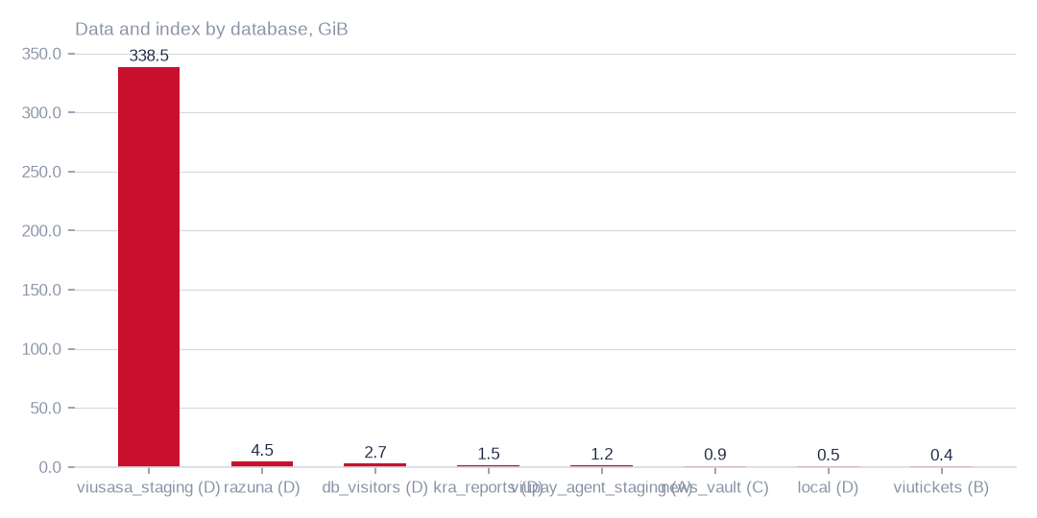
Figure: Database cost effort should concentrate on viusasa_staging, because the largest databases hold 99.7% of the estate's bytes.
[measured] Receipt R01: Estate intelligence census eij-1b359b3cbd2e, digest-verified report (measured 2026-09-29), headline aggregates and per-database measures

Quality and exposure are the main constraint
Exact duplicates are low at 1.5% of rows, but degraded rows are 23.0% and rows with empty required-looking fields are 81.7%. Personal-data markers appear in 71.8% of sampled rows, and 15.4% of bytes have not been written for over a year.
These are estimates from complete passes where tables allowed and stratified samples elsewhere. They indicate that cleansing, not de-duplication, is the main work before any product can be built.
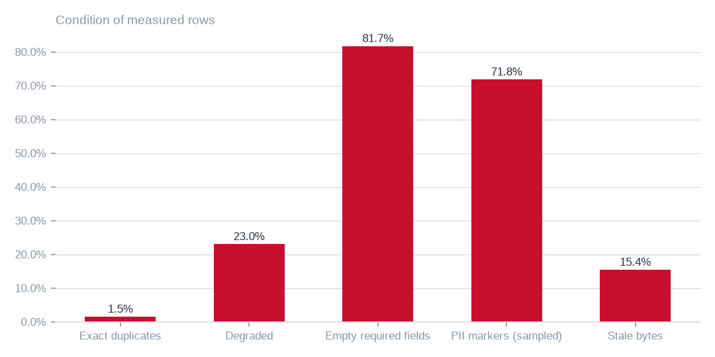
Figure: Quality and personal-data exposure, not duplication, constrain any product; exact duplicates are only 1.5% of rows.
[estimated] Receipt R01: Estate intelligence census eij-1b359b3cbd2e, digest-verified report (measured 2026-09-29), headline aggregates and per-database measures

Reclaimable bytes sit almost entirely in object stores
Moving buckets not written for over a year and reconciling duplicate objects address most of the reclaimable bytes. Together with database cold storage, the three largest strategies address 100.0% of the 50,799.8 GiB reached by all strategies.
Reclaimable bytes are not realised savings. Last write is the newest object timestamp in a listing, read frequency was not measured, and duplicate candidates share a size and an identifying label, which for multipart uploads is not a content hash.
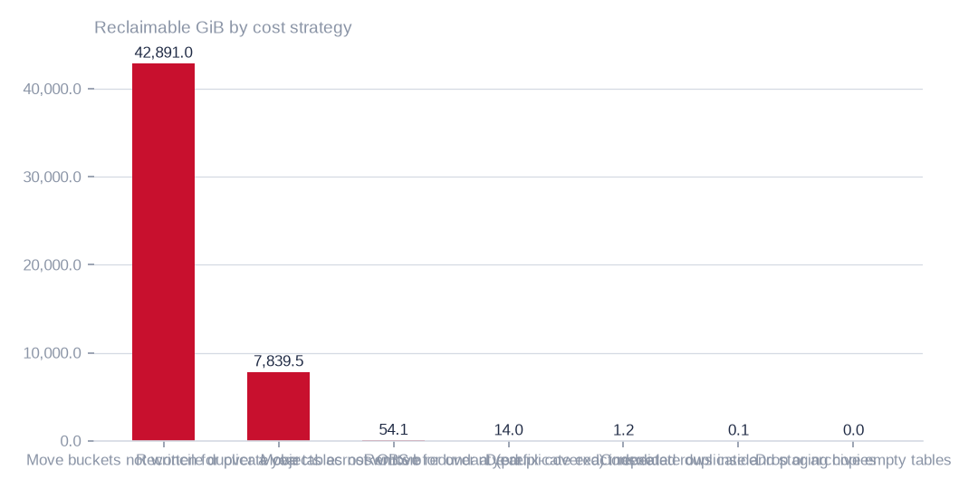
Figure: The three largest strategies address 100.0% of the 50,799.8 GiB reached by all strategies; database-only measures are small beside the object stores.
[estimated] Receipt R02: Estate intelligence census eij-1b359b3cbd2e, cost_strategies priced at reference list prices, not the owner's invoice: Huawei Cloud RDS for MySQL cloud SSD AF-Johannesburg 0.00015 USD/GB-hour x 730 h; OBS Standard 0.023 USD/GB-month

Estate size and measurement coverage
The estate holds 351.3 across 1006, with 638 measured. Database-level reclaim of 15.2 is small, and 368 are empty by row estimate. Staleness was read from timestamp columns, so tables without them may be missed.

Condition of the measured rows
Degraded rows (23.0%) and rows with empty required-looking fields (81.7%) are widespread, while exact duplicates are only 1.5%. Personal-data markers in 71.8% of sampled rows mean any external use needs de-identification or aggregation first.

Staleness, duplication and sampling
The marker rate rests on 1.0m sampled rows. Bytes not written for over a year are 15.4% of the total, and 71 of duplicate table pairs were found. Copies may be deliberate, so ownership must be confirmed before any retirement.

Three priced strategies compared
The archive-class move addresses 42,891.0 GiB for 986.5 USD a month. Duplicate-object reconciliation addresses 7,839.5 GiB for 180.3 USD. Database cold storage addresses 54.1 GiB for 5.9 USD.
All three are priced at reference list prices, not the owner's invoice, and archive-class retrieval carries its own fee. The comparison shows scale and conditions; it does not by itself settle the choice.
 | Move buckets not written for over a year to archive-class st | Reconcile duplicate objects across OBS buckets | Move tables not written for over a year to cold storage
Reclaimable gib | 42,891.0 | 7,839.5 | 54.1
Monthly saving usd | 986.5 | 180.3 | 5.9
The archive-class move offers 986.5 USD a month, duplicate reconciliation 180.3 USD and database cold storage 5.9 USD, all at list prices, not invoices.
[estimated] Receipt R02: Estate intelligence census eij-1b359b3cbd2e, cost_strategies priced at reference list prices, not the owner's invoice: Huawei Cloud RDS for MySQL cloud SSD AF-Johannesburg 0.00015 USD/GB-hour x 730 h; OBS Standard 0.023 USD/GB-month

What to do first, and why
Begin with the archive-class move, because it carries the largest saving at 986.5 USD a month; verify read frequency and retrieval fees before any transfer. Next verify duplicate objects by content before deleting, since the 7,839.5 GiB is a size-based estimate.
Defer database cold storage and the smaller database strategies, whose returns are small. Keep all 8 as specifications only until rights are bound to each candidate and personal data is removed or aggregated. Finally, grant read access to artists_app so a re-census can firm up the figures.

What cannot yet be said
Sampled ratios, unmeasured rights and licences, the unreadable artists_app connection, unmeasured file-share duplication and unreachable buckets all limit confidence. Only 638 of 1006 were measured. Each gap can be closed: a complete-pass census, rights bound to each candidate, a read grant, a fingerprinting pass and a bucket inventory reconciled with the provider.
Savings are estimates at list prices, not realised returns, and the candidates are not qualified datasets or permission for training. Nothing in this pack authorises execution.

Coverage and limits
Covers: 20 databases, 1,006 tables and 351.3 GiB measured by census eij-1b359b3cbd2e; ratios are complete-pass where the table allowed it and stratified samples elsewhere. No row value is present in this pack.
Cannot say | Why | What would close it
Duplicate, damage, empty-field and PII ratios on sampled tables | complete passes where the table allowed it, stratified samples elsewhere | a complete-pass census on the sampled tables
Rights, licences and semantic similarity | not measured; candidates are dimensional readiness only | rights declared at Connect and bound to each candidate
Connection artists_app | could not be read (MySQL GRANT pending) | owner grants read access; re-census
NAS duplication | the enumeration recorded sizes and dates, not content fingerprints | a fingerprinting pass over the NAS shares
40 of 106 OBS buckets | unreachable (NoSuchBucket / client errors) | bucket inventory reconciled with the provider

Appendix: receipts
Receipt | Resolves to
R01 | Estate intelligence census eij-1b359b3cbd2e, digest-verified report (measured 2026-09-29), headline aggregates and per-database measures
R02 | Estate intelligence census eij-1b359b3cbd2e, cost_strategies priced at reference list prices, not the owner's invoice: Huawei Cloud RDS for MySQL cloud SSD AF-Johannesburg 0.00015 USD/GB-hour x 730 h; OBS Standard 0.023 USD/GB-month
R03 | Estate intelligence census eij-1b359b3cbd2e, data_products readiness scoring (dimensions, grades, blockers)
R04 | OBS bucket enumeration census run cr-f1415e395361 (22,975,591 objects, 130.3 TiB)
R05 | NAS share enumeration census run cr-cf4eef79995b (1,456,787 files, 43.6 TiB)

