RMS estate review: cost, condition and first data products
One account of what the estate holds, costs to keep and can offer first · RMS

Summary
The estate holds 174.3 TiB, of which the object store is 74.8% and the file shares 25.0%. The 20 databases, with 1006 tables and 351.3 GiB, are 0.2% of the bytes. Cost, therefore, sits outside the databases, and any estate-wide plan has to start with object and file storage.
The priced strategies bound the monthly saving at 1,174.4 USD at reference list prices, not the owner's invoice. Nearly all of it comes from moving buckets not written for over a year to archive-class storage and from reconciling duplicate objects. Both are estimates and neither has been confirmed against read patterns or content hashes.
Database rows are seldom duplicated but often incomplete: 81.7% have empty required-looking fields and 71.8% of sampled rows carry personal-data markers. Three grade C product candidates lead, and each needs de-identification or aggregation first. Rights are settled by the owner's declaration, so that preparation is technical rather than legal.

The object store dominates the estate
Of the 174.3 TiB held, the object store accounts for 130.3 TiB and the file shares for 43.6 TiB. The databases are a very small remainder, at 0.2% of the estate. The estate-wide view therefore differs sharply from a database-only one, which would have shown 351.3 GiB and missed almost everything.
For the owner this means database tuning cannot move the cost position materially. The object store, at 74.8% of the estate, is where the bytes and the money sit, and the file shares, at 25.0%, are the second place to look.
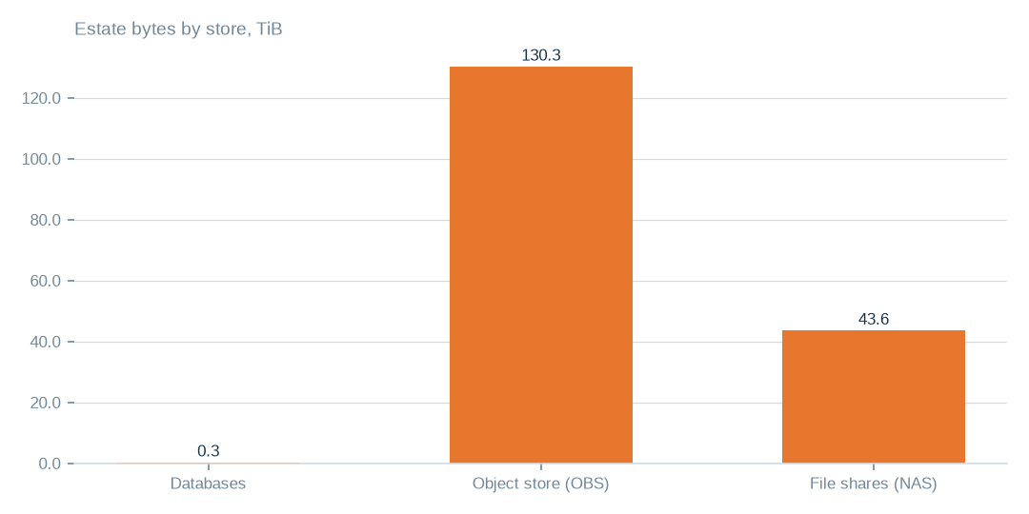
Figure: Cost and condition decisions should start with the object store, which is 74.8% of the 174.3 TiB estate.
[measured] Receipt R01: Estate intelligence census eij-1b359b3cbd2e, digest-verified report (measured 2026-09-29), headline aggregates and per-database measures

Most of the object store sits in one bucket
The largest bucket holds 86.3 TiB, which is 66.2% of the object store. The next largest buckets are each a few TiB, and those listed as cold are the ones that matter for archive savings. The largest bucket is not marked cold in the listing.
The practical consequence is that the archive saving is spread across many mid-sized cold buckets, 43 in all, rather than concentrated in one decision. The largest bucket deserves its own review of purpose and access, which this census does not provide.
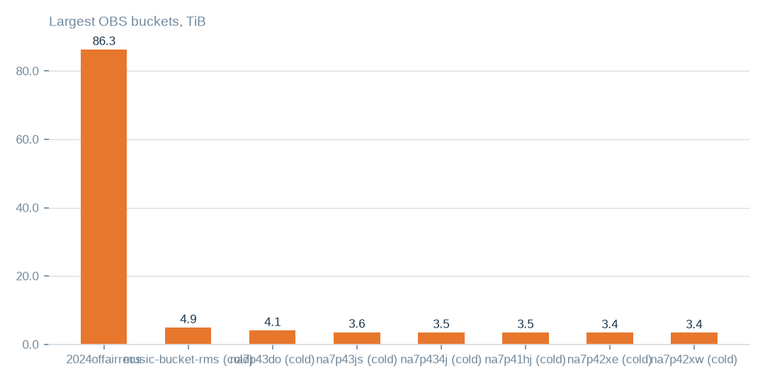
Figure: The largest bucket is not marked cold, so the archive saving comes from the many smaller cold buckets rather than from it.
[measured] Receipt R04: OBS bucket enumeration census run cr-f1415e395361 (22,975,591 objects, 130.3 TiB)

Where the bytes sit
The object store holds 130.3 TiB in 106 buckets and 23.0m objects. The file shares hold 43.6 TiB in 16 shares and 1.5m files. The databases hold 351.3 GiB, with the largest databases accounting for 99.7% of that.
Two limits apply. 40 of the 106 buckets could not be read, so the object-store figures describe the readable buckets only. File-share duplication is not measured, because the enumeration recorded sizes and dates rather than content.

Reclaimable bytes are almost all in the object store
Bytes not written for over a year are 41.9 TiB in the object store, which is 32.1% of it. Separately, 7.7 TiB are duplicate candidates, 5.0% of objects, matched on name and size rather than content. The three largest strategies address 100.0% of the bytes that all strategies reach.
Database strategies are comparatively minor. About 15.2 GiB, 4.3% of database bytes, looks reclaimable before pricing. They are worth doing for tidiness and risk reduction, but they will not change the cost position.
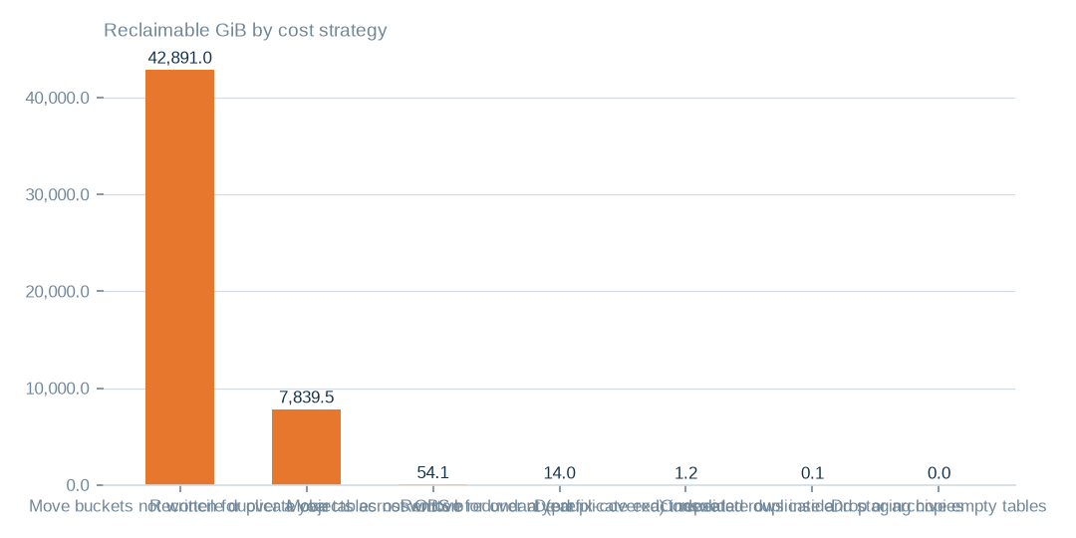
Figure: The three largest strategies address 100.0% of the bytes that all strategies reach; database tidying is small beside the object store.
[estimated] Receipt R02: Estate intelligence census eij-1b359b3cbd2e, cost_strategies priced at reference list prices, not the owner's invoice: Huawei Cloud RDS for MySQL cloud SSD AF-Johannesburg 0.00015 USD/GB-hour x 730 h; OBS Standard 0.023 USD/GB-month

Three priced moves side by side
Moving buckets not written for over a year to archive-class storage addresses 42,891.0 GiB and is estimated at 986.5 USD a month. Reconciling duplicate objects addresses 7,839.5 GiB at 180.3 USD a month. Moving cold tables addresses 54.1 GiB at 5.9 USD a month.
All three are estimates at reference list prices. The first depends on read frequency, which was not measured, and archive-class retrieval carries its own fee. The second rests on name and size matching, which for multipart uploads is not a content hash. The third counts only tables with timestamp columns. Each is a proposal only; nothing has been authorised.
 | Move buckets not written for over a year to archive-class st | Reconcile duplicate objects across OBS buckets | Move tables not written for over a year to cold storage
Reclaimable gib | 42,891.0 | 7,839.5 | 54.1
Monthly saving usd | 986.5 | 180.3 | 5.9
Monthly estimates at reference list prices, not the owner's invoice, are 986.5, 180.3 and 5.9 USD respectively.
[estimated] Receipt R02: Estate intelligence census eij-1b359b3cbd2e, cost_strategies priced at reference list prices, not the owner's invoice: Huawei Cloud RDS for MySQL cloud SSD AF-Johannesburg 0.00015 USD/GB-hour x 730 h; OBS Standard 0.023 USD/GB-month

Completeness is the dominant condition issue
Exact duplicate rows are 1.5% of rows, a low figure. Degraded rows are 23.0%, and rows with empty required-looking fields are 81.7%. Personal-data markers appear in 71.8% of the 1.0m rows sampled.
Completeness is the main constraint on what can be offered to a buyer. The personal-data markers do not block a product; they define the preparation step, which is de-identification or aggregation before release.
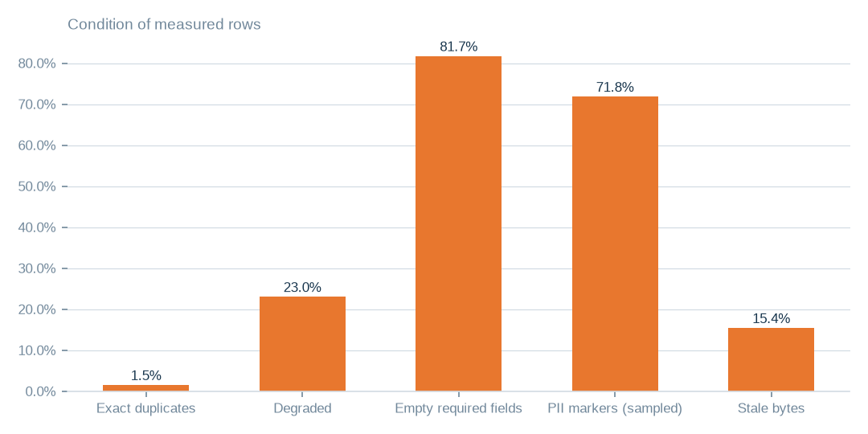
Figure: Exact duplicates are only 1.5% of rows, while 81.7% have empty required-looking fields, so cleansing effort belongs on completeness.
[estimated] Receipt R01: Estate intelligence census eij-1b359b3cbd2e, digest-verified report (measured 2026-09-29), headline aggregates and per-database measures

Database bytes are concentrated in a few places
The largest databases hold 350.3 GiB of the 351.3 GiB in the databases, which is 99.7%. One staging database dominates the series. Cleansing and cost effort can therefore be aimed at very few databases and still cover almost every database byte.
Staging copies may be deliberate, so retirement needs the owner's confirmation. The census sketches 71 duplicate table pairs, but the overlap is an estimate and not a row-level comparison.
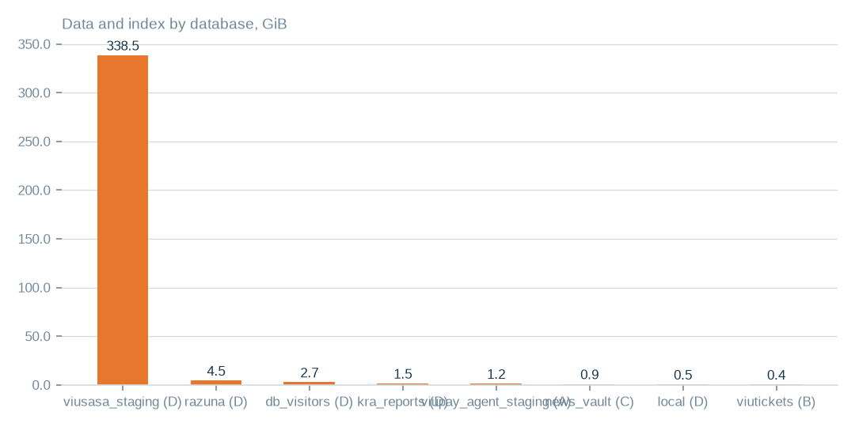
Figure: The largest databases hold 99.7% of the 351.3 GiB, so database cost and cleansing work concentrates in very few places.
[measured] Receipt R01: Estate intelligence census eij-1b359b3cbd2e, digest-verified report (measured 2026-09-29), headline aggregates and per-database measures

Condition of the rows
The estate holds 259.3m rows. Exact duplicates are 1.5%, degraded rows 23.0% and rows with empty required-looking fields 81.7%. Bytes not written for over a year are 15.4% of database bytes, dead columns are 13.0% of measured columns, and 368 tables are empty.
These ratios are estimates from complete passes where tables allowed and stratified samples elsewhere. They are reliable enough to rank preparation work, but not to set quality guarantees in a contract.

First data products and what each needs
8 candidates were scored. Reference and master-data licensing, the content catalogue and recommendation corpus, and channel and telco engagement analytics lead, all at grade C. Reference data is the sensible first product because it can be reduced to canonical fields, and channel engagement is the natural second because it aggregates by channel and period.
Each needs personal-data markers handled by de-identification or aggregation, and cleansing of empty required fields. The customer segmentation, forecasting, transaction, geospatial and civic candidates carry more markers or weaker grades and should follow once cleansing has been shown to work.

What remains unmeasured
Measures cover 638 of 1006 tables, which is 63.4%. 40 of 106 buckets were unreadable. The file shares, at 43.6 TiB, have no duplication measure. One database connection could not be read.
None of these gaps overturns the picture of where the bytes sit. They do bound the certainty of the saving estimates, which could rise or fall once the unreadable buckets and the file shares are brought into measurement.

What to do first, and why
First, check read frequency on the 43 cold buckets and approve the archive-class move, because it carries the largest estimate, 986.5 USD a month, on 41.9 TiB. Second, confirm the 7.7 TiB of duplicate candidates by content hash before deleting anything. Third, reconcile the 40 unreadable buckets with the provider.
In parallel, prepare de-identified or aggregated copies for reference data and channel engagement. Database tidying, worth 5.9 USD a month for cold tables, can run alongside but should not lead. Every move here is a proposal; nothing is authorised by this report.

What the evidence cannot yet establish
Condition ratios rest partly on samples, semantic similarity to the market is unmeasured, one database connection is unread, file-share duplication is unknown and 40 buckets are unreachable. Each closes with a defined step: a complete-pass census, a buyer-side review, a read grant and re-census, a fingerprinting pass and a bucket inventory reconciled with the provider.
Savings are estimates at reference list prices, not realised returns, and the product candidates are not qualified or sealed datasets.

Coverage and limits
Covers: The whole admitted estate as measured by census eij-1b359b3cbd2e: 20 databases and 1,006 tables (351.3 GiB), the object store and the file shares enumerated by their own census runs. Ratios are complete-pass where the table allowed it and stratified samples elsewhere. No row value is present in this pack.
Cannot say | Why | What would close it
Duplicate, damage, empty-field and PII ratios on sampled tables | complete passes where the table allowed it, stratified samples elsewhere | a complete-pass census on the sampled tables
Semantic similarity between candidate datasets and the market | not measured; candidates are dimensional readiness only | a buyer-side review of each candidate against its intended use
Connection artists_app | could not be read (MySQL GRANT pending) | owner grants read access; re-census
NAS duplication | the enumeration recorded sizes and dates, not content fingerprints | a fingerprinting pass over the NAS shares
40 of 106 OBS buckets | unreachable (NoSuchBucket / client errors) | bucket inventory reconciled with the provider

Appendix: receipts
Receipt | Resolves to
R01 | Estate intelligence census eij-1b359b3cbd2e, digest-verified report (measured 2026-09-29), headline aggregates and per-database measures
R02 | Estate intelligence census eij-1b359b3cbd2e, cost_strategies priced at reference list prices, not the owner's invoice: Huawei Cloud RDS for MySQL cloud SSD AF-Johannesburg 0.00015 USD/GB-hour x 730 h; OBS Standard 0.023 USD/GB-month
R03 | Estate intelligence census eij-1b359b3cbd2e, data_products readiness scoring (dimensions, grades, blockers)
R04 | OBS bucket enumeration census run cr-f1415e395361 (22,975,591 objects, 130.3 TiB)
R05 | NAS share enumeration census run cr-cf4eef79995b (1,456,787 files, 43.6 TiB)

