RMS estate: hours, speech and what to decide
Whole-estate forecast, strongest assets, preparation and the decisions in order · RMS

Summary
RMS holds a large multilingual speech and text archive. Scaling what the census read in every folder to every listed folder, the estate most likely holds 500,290.3 hours of media: 190,196.8 hours of speech and 341,566.0 hours of music, estimated separately and not an exact split. The ninety-five per cent forecast interval spans 212,923.5 hours, 42.6% of the forecast. Measured bytes are 175.0 TiB. Only 8.5% of the forecast hours rest on files read and judged, and 73.4% sit in buckets the census key cannot read.
The strongest assets are the languages and the text. Kiswahili (38,788.1 speech hours), Gikuyu (32,002.9) and Ekegusii (16,729.3) lead the forecast, and the news archive adds 248841 live scripts. Value concentrates: one bucket the key cannot read carries 251,976.0 forecast hours, 50.4% of the estate, while the databases are 0.2% of the bytes.
Preparation is work to do, not a reason to wait: object-read access, a restore decision, finishing the samples, checking the model readings and de-identifying product inputs. The first money path is repricing archive tiering, an upper bound of 986.5 USD a month at legacy reference prices, followed by a speech-and-text pilot. Management is asked to decide access first.

How each forecast hour is known
The chart splits the estate forecast by evidence basis. 42,454.4 hours were measured directly from folders read and judged. The largest block, 367,222.7 hours, sits in buckets the key cannot read, and a further 86,601.1 hours lie in readable folders not yet sampled. These medians are reported separately and are not an exactly additive stack.
The forecast rests on 211 donor folders read and judged, 32582 files read in full, and 2000 simulations over 1334 folder strata. The forecast-to-measured ratio is 11.8. Each basis in the table beside names the single step that turns it into measurement.
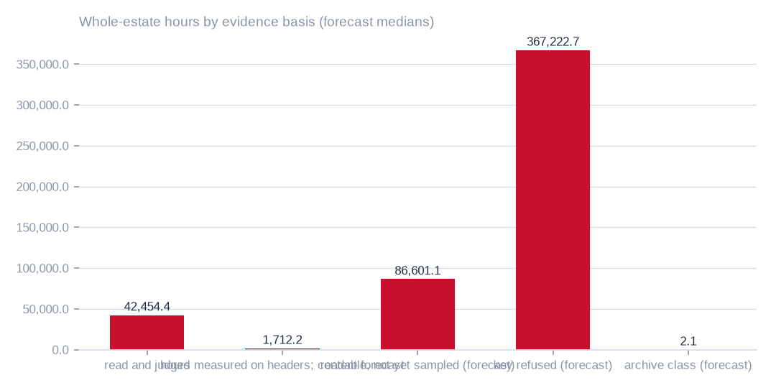
Figure: Hours measured directly (42,454.4) anchor the estimate; every other basis names one step that converts it from forecast into measurement.
[estimated] Receipt R11: Whole-estate Monte Carlo forecast over the retained content-census receipts (cr-bbf71c8d905a, cr-cb0e66bd3e24, cr-cf4eef79995b, cr-f1415e395361): 2,000 seeded simulations over 1,334 folder strata. Measured strata: normal draws around the census estimator and its standard error. Forecast strata: in each simulation a donor folder of the same media kind is drawn — every readable bucket is one witness (bucket weight ∝ √ of its files), its folders share that weight by file count, and a Gaussian kernel on log mean file size (σ = 1.0, widened until at least 3 donors carry weight) favours donors whose files look like the target's; hours = bytes × the donor's seconds per megabyte; speech, music and language hours = hours × the donor's shares. Strata are summed in every simulation; est is the median, lo–hi the 2.5th–97.5th percentiles. Intervals carry sampling and between-folder variation, not model error or the chance that refused buckets differ in kind from every readable one.

Where the forecast hours concentrate
Six of the ten largest folders or buckets by forecast hours are refused to the census key, so their hours are forecast from donors. The largest, at 251,976.0 hours, is 50.4% of the estate. The four readable entries among the ten are measured, with header probes and sampled content readings.
The owner should read this as a targeting rule. Reading the dominant refused bucket would convert 50.4% of the estate forecast into measurement, and would remove the widest single interval from the total. Volume alone is not commercial value.
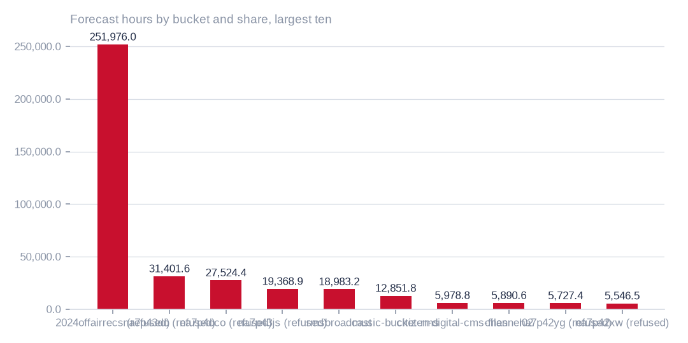
Figure: A single access grant is the highest-value preparation step, and that bucket's forecast is also the largest single source of uncertainty.
[estimated] Receipt R11: Whole-estate Monte Carlo forecast over the retained content-census receipts (cr-bbf71c8d905a, cr-cb0e66bd3e24, cr-cf4eef79995b, cr-f1415e395361): 2,000 seeded simulations over 1,334 folder strata. Measured strata: normal draws around the census estimator and its standard error. Forecast strata: in each simulation a donor folder of the same media kind is drawn — every readable bucket is one witness (bucket weight ∝ √ of its files), its folders share that weight by file count, and a Gaussian kernel on log mean file size (σ = 1.0, widened until at least 3 donors carry weight) favours donors whose files look like the target's; hours = bytes × the donor's seconds per megabyte; speech, music and language hours = hours × the donor's shares. Strata are summed in every simulation; est is the median, lo–hi the 2.5th–97.5th percentiles. Intervals carry sampling and between-folder variation, not model error or the chance that refused buckets differ in kind from every readable one.

The whole-estate forecast and its interval
The most likely holding is 500,290.3 hours of media, with 190,196.8 hours of speech (38.0%) and 341,566.0 hours of music (68.3%). Speech and music are separate estimators over separate sampled windows and need not add to the total. The forecast covers every listed folder, refused and unsampled stores included. Forecast intervals carry sampling and between-folder variation, not model error.
The object store accounts for 408,770.2 forecast hours and the file shares for 89,207.5. Only 8.5% of the hours rest on files read and judged. The tables beside show the evidence basis and each bucket and share, with its ninety-five per cent forecast interval.
T050 Whole estate by evidence basis — how much is measured and how much is forecast
Evidence basis | Folder strata | Media files | Media bytes (TiB) | Hours (95 %) | Speech hours (95 %) | Music hours (95 %) | What converts it into measurement
read and judged | 242 | 432,850 | 8.69 | 42,454 (42,272–42,634) | 23,349 (22,862–23,879) | 20,094 (19,539–20,649) | nothing — measured
hours measured on headers; content forecast | 72 | 10,277 | 0.02 | 1,712 (1,712–1,712) | 1,250 (1,159–1,325) | 448 (373–540) | finish the planned folder sample
readable, not yet sampled (forecast) | 193 | 1,209,266 | 26.01 | 86,601 (60,888–119,832) | 25,874 (16,951–37,803) | 68,111 (44,385–98,737) | the running listing, probes and sample
key refused (forecast) | 825 | 4,172,989 | 120.71 | 367,223 (284,577–492,168) | 139,340 (103,925–194,851) | 252,625 (180,107–360,559) | one object-read grant to the census key
archive class (forecast) | 2 | 584 | 0.0 | 2 (1–9) | 1 (0–7) | 1 (0–5) | an owner decision to restore sample files
Read-and-judged strata are measured; everything else is forecast from them. The rows add up to the whole estate; the last column names the one step that turns each forecast row into a measured one.
[estimated] Receipt R11: Whole-estate Monte Carlo forecast over the retained content-census receipts (cr-bbf71c8d905a, cr-cb0e66bd3e24, cr-cf4eef79995b, cr-f1415e395361): 2,000 seeded simulations over 1,334 folder strata. Measured strata: normal draws around the census estimator and its standard error. Forecast strata: in each simulation a donor folder of the same media kind is drawn — every readable bucket is one witness (bucket weight ∝ √ of its files), its folders share that weight by file count, and a Gaussian kernel on log mean file size (σ = 1.0, widened until at least 3 donors carry weight) favours donors whose files look like the target's; hours = bytes × the donor's seconds per megabyte; speech, music and language hours = hours × the donor's shares. Strata are summed in every simulation; est is the median, lo–hi the 2.5th–97.5th percentiles. Intervals carry sampling and between-folder variation, not model error or the chance that refused buckets differ in kind from every readable one.
T047 Whole-estate forecast by bucket and share — hours, speech, music and languages with 95 % forecast intervals (largest first)
Store | Bucket / share | Access | Basis | Media files | Media bytes (TiB) | Hours (95 %) | Speech hours (95 %) | Music hours (95 %) | Top languages (speech hours) | What converts the forecast into measurement
OBS | 2024offairrecs | key refused (403) | forecast | 3,178,461 | 86.73 | 251,976 (174,935–366,723) | 71,405 (43,767–117,603) | 201,667 (131,043–306,134) | Kiswahili 15,692 h; Gikuyu (Kikuyu) 11,442 h; Kalenjin 6,552 h | one object-read grant to the census key
OBS | na7p43do | key refused (403) | forecast | 384,572 | 3.98 | 31,402 (27,438–86,272) | 22,428 (10,318–60,184) | 10,243 (6,116–27,358) | Gikuyu (Kikuyu) 4,211 h; Kiswahili 3,472 h; Ekegusii (Kisii) 2,339 h | one object-read grant to the census key
OBS | na7p4oco | key refused (403) | forecast | 272,080 | 2.65 | 27,524 (24,787–57,290) | 19,151 (11,769–38,181) | 9,470 (6,366–18,798) | Gikuyu (Kikuyu) 3,556 h; Kiswahili 2,909 h; Wanga (Luhya) 2,130 h | one object-read grant to the census key
OBS | na7p43js | key refused (403) | forecast | 238,007 | 3.54 | 19,369 (17,271–41,908) | 13,856 (8,162–29,268) | 6,567 (3,914–15,050) | Gikuyu (Kikuyu) 2,598 h; Kiswahili 2,221 h; Wanga (Luhya) 1,418 h | one object-read grant to the census key
OBS | rmsbroadcast | readable | measured | 141,564 | 1.49 | 18,983 (18,951–19,017) | 13,926 (13,454–14,416) | 5,427 (4,913–5,924) | Gikuyu (Kikuyu) 2,471 h; Kiswahili 2,192 h; Ekegusii (Kisii) 1,966 h | nothing — measured
OBS | music-bucket-rms | readable | measured | 147,127 | 4.9 | 12,852 (12,676–13,027) | 2,103 (2,036–2,168) | 11,398 (11,204–11,581) | Kiswahili 391 h; Gikuyu (Kikuyu) 375 h; Kalenjin 277 h | nothing — measured
OBS | citizen-digital-cms-files | readable | measured | 44,818 | 1.09 | 5,979 (5,957–6,001) | 4,701 (4,564–4,841) | 1,263 (1,134–1,395) | Wanga (Luhya) 1,097 h; Gikuyu (Kikuyu) 1,051 h; Kiswahili 654 h | nothing — measured
NAS | channel02 | readable | forecast | 36,267 | 2.62 | 5,891 (5,072–6,870) | 1,759 (1,404–2,209) | 4,704 (3,955–5,561) | Kiswahili 392 h; Gikuyu (Kikuyu) 284 h; Kalenjin 160 h | the running listing, probes and sample
OBS | na7p42yg | key refused (403) | forecast | 23,080 | 3.28 | 5,727 (3,393–8,887) | 1,512 (1,007–3,706) | 4,496 (2,371–7,562) | Kiswahili 300 h; Gikuyu (Kikuyu) 249 h; Kalenjin 149 h | one object-read grant to the census key
OBS | na7p42xw | key refused (403) | forecast | 20,559 | 3.4 | 5,546 (2,898–10,210) | 1,438 (968–3,703) | 4,359 (2,000–8,535) | Kiswahili 275 h; Gikuyu (Kikuyu) 238 h; Kalenjin 145 h | one object-read grant to the census key
NAS | Channel13 | readable | part measured, part forecast | 27,246 | 0.27 | 5,414 (4,810–16,009) | 3,877 (2,034–10,368) | 1,550 (1,140–4,423) | Kiswahili 832 h; Gikuyu (Kikuyu) 661 h; Ekegusii (Kisii) 340 h | the running listing, probes and sample
NAS | Channel15 | readable | forecast | 99,547 | 1.99 | 5,369 (1,214–17,145) | 1,287 (410–5,312) | 4,096 (662–15,201) | Gikuyu (Kikuyu) 211 h; Kiswahili 210 h; Kalenjin 137 h | the running listing, probes and sample
NAS | Channel12 | readable | forecast | 96,648 | 1.93 | 5,313 (1,167–16,593) | 1,264 (398–5,156) | 4,114 (633–14,711) | Gikuyu (Kikuyu) 205 h; Kiswahili 201 h; Kalenjin 132 h | the running listing, probes and sample
NAS | Channel11 | readable | forecast | 96,641 | 1.93 | 5,299 (1,176–16,594) | 1,276 (398–5,157) | 4,062 (634–14,712) | Gikuyu (Kikuyu) 210 h; Kiswahili 204 h; Kalenjin 134 h | the running listing, probes and sample
NAS | channel05 | readable | forecast | 96,596 | 1.93 | 5,270 (1,171–16,599) | 1,291 (398–5,154) | 4,150 (630–14,717) | Gikuyu (Kikuyu) 211 h; Kiswahili 205 h; Kalenjin 132 h | the running listing, probes and sample
NAS | channel08 | readable | forecast | 96,382 | 1.92 | 5,262 (1,162–16,580) | 1,281 (397–5,142) | 3,957 (638–14,700) | Gikuyu (Kikuyu) 214 h; Kiswahili 204 h; Kalenjin 133 h | the running listing, probes and sample
NAS | Channel10 | readable | forecast | 96,271 | 1.92 | 5,260 (1,154–16,559) | 1,247 (396–5,137) | 4,084 (552–14,673) | Kiswahili 203 h; Gikuyu (Kikuyu) 202 h; Kalenjin 133 h | the running listing, probes and sample
NAS | channel06 | readable | forecast | 96,610 | 1.93 | 5,248 (1,164–16,596) | 1,292 (398–5,154) | 3,961 (379–14,714) | Gikuyu (Kikuyu) 211 h; Kiswahili 204 h; Kalenjin 132 h | the running listing, probes and sample
NAS | channel04 | readable | forecast | 96,579 | 1.93 | 5,246 (1,169–16,600) | 1,276 (398–5,152) | 3,964 (629–14,717) | Gikuyu (Kikuyu) 209 h; Kiswahili 204 h; Kalenjin 129 h | the running listing, probes and sample
NAS | Channel09 | readable | forecast | 96,309 | 1.92 | 5,231 (1,154–16,566) | 1,248 (397–5,139) | 4,011 (638–14,688) | Gikuyu (Kikuyu) 208 h; Kiswahili 203 h; Kalenjin 128 h | the running listing, probes and sample
NAS | Channel14 | readable | forecast | 96,654 | 1.93 | 5,225 (892–16,465) | 1,254 (398–5,157) | 3,898 (241–14,572) | Kiswahili 200 h; Gikuyu (Kikuyu) 194 h; Kalenjin 124 h | the running listing, probes and sample
NAS | channel03 | readable | forecast | 96,534 | 1.93 | 5,213 (1,168–16,594) | 1,258 (398–5,150) | 3,962 (554–14,712) | Gikuyu (Kikuyu) 209 h; Kiswahili 203 h; Kalenjin 133 h | the running listing, probes and sample
NAS | channel07 | readable | forecast | 96,602 | 1.93 | 5,212 (1,164–16,595) | 1,258 (398–5,154) | 4,066 (652–14,699) | Gikuyu (Kikuyu) 205 h; Kiswahili 204 h; Kalenjin 131 h | the running listing, probes and sample
OBS | na7p41hj | key refused (403) | forecast | 14,092 | 3.47 | 4,392 (1,619–8,141) | 1,022 (600–4,614) | 3,444 (941–6,955) | Kiswahili 185 h; Gikuyu (Kikuyu) 149 h; Dholuo (Luo) 127 h | one object-read grant to the census key
OBS | na7p434j | key refused (403) | forecast | 10,750 | 3.48 | 3,685 (1,427–8,642) | 970 (524–3,810) | 2,877 (865–7,249) | Kiswahili 169 h; Gikuyu (Kikuyu) 135 h; Dholuo (Luo) 114 h | one object-read grant to the census key
OBS | na7p43d3 | key refused (403) | forecast | 13,318 | 2.9 | 3,518 (1,757–5,980) | 952 (642–3,064) | 2,656 (1,122–4,943) | Kiswahili 172 h; Gikuyu (Kikuyu) 137 h; Dholuo (Luo) 120 h | one object-read grant to the census key
OBS | na7p42xe | key refused (403) | forecast | 12,300 | 3.44 | 2,385 (1,621–7,750) | 988 (557–3,059) | 1,581 (1,078–6,641) | Kiswahili 166 h; Dholuo (Luo) 139 h; Gikuyu (Kikuyu) 125 h | one object-read grant to the census key
OBS | news-vault | readable | measured | 72,588 | 0.11 | 1,551 (1,551–1,551) | 1,293 (1,265–1,320) | 237 (210–263) | Gikuyu (Kikuyu) 335 h; Kiswahili 309 h; Wanga (Luhya) 122 h | nothing — measured
OBS | chamgei-backup | readable | measured | 16,302 | 0.15 | 1,476 (1,476–1,476) | 142 (127–160) | 1,327 (1,311–1,343) | Kalenjin 25 h; Gikuyu (Kikuyu) 24 h; Dholuo (Luo) 18 h | nothing — measured
OBS | na7p4357 | key refused (403) | forecast | 2,228 | 1.36 | 709 (434–1,648) | 313 (162–636) | 455 (267–1,335) | Kiswahili 50 h; Ekegusii (Kisii) 49 h; Dholuo (Luo) 48 h | one object-read grant to the census key
OBS | google-transcripts | readable | measured | 3,833 | 0.03 | 530 (530–530) | 417 (408–426) | 112 (104–121) | Kalenjin 73 h; Ekegusii (Kisii) 65 h; Kiswahili 63 h | nothing — measured
OBS | na7p43df | key refused (403) | forecast | 1,071 | 1.36 | 445 (100–964) | 308 (69–444) | 86 (8–519) | Ekegusii (Kisii) 66 h; Dholuo (Luo) 66 h; Kiswahili 33 h | one object-read grant to the census key
OBS | na7p43ax | key refused (403) | forecast | 767 | 0.92 | 302 (68–654) | 209 (47–302) | 58 (2–359) | Ekegusii (Kisii) 45 h; Dholuo (Luo) 44 h; Kiswahili 22 h | one object-read grant to the census key
OBS | na7p49p9 | key refused (403) | forecast | 1,649 | 0.19 | 266 (176–415) | 82 (54–142) | 206 (123–346) | Kiswahili 16 h; Gikuyu (Kikuyu) 12 h; Dholuo (Luo) 9 h | one object-read grant to the census key
OBS | drivesdata.royalmedia | readable | measured | 538 | 0.42 | 138 (137–140) | 105 (92–118) | 50 (44–56) | Ekegusii (Kisii) 28 h; Dholuo (Luo) 27 h; Kiswahili 11 h | nothing — measured
OBS | datauploadroyalmedia.co.ke | readable | measured | 181 | 0.19 | 14 (14–14) | 10 (8–11) | 4 (2–5) | Gikuyu (Kikuyu) 3 h; Kiswahili 2 h; Ekegusii (Kisii) 1 h | nothing — measured
OBS | mar142017 | readable | measured | 17 | 0.27 | 14 (14–14) | 11 (11–11) | 2 (2–2) | Kiswahili 2 h; Ekegusii (Kisii) 2 h; Gikuyu (Kikuyu) 2 h | nothing — measured
OBS | razuna-ireland-replication-7sep2017 | readable | part measured, part forecast | 48 | 0.01 | 9 (8–9) | 4 (4–5) | 4 (4–5) | Ekegusii (Kisii) 1 h; Gikuyu (Kikuyu) 1 h; Dholuo (Luo) 1 h | the running listing, probes and sample
OBS | citizentv | readable | measured | 215 | 0.0 | 8 (8–8) | 6 (6–6) | 2 (1–2) | Kiswahili 2 h; Dholuo (Luo) 1 h; Gikuyu (Kikuyu) 1 h | nothing — measured
OBS | elections-portal | key refused (403) | forecast | 55 | 0.0 | 2 (1–5) | 0 (0–2) | 2 (0–5) | Gikuyu (Kikuyu) 0 h; Kiswahili 0 h; Kalenjin 0 h | one object-read grant to the census key
OBS | test-viusasa-bucket | archive · restore needed | forecast | 582 | 0.0 | 2 (1–9) | 1 (0–7) | 1 (0–4) | Gikuyu (Kikuyu) 0 h; Kiswahili 0 h; Ekegusii (Kisii) 0 h | an owner decision to restore sample files
OBS | viusasanews | readable | measured | 75 | 0.0 | 2 (2–2) | 1 (1–2) | 0 (0–1) | Kiswahili 0 h; Dholuo (Luo) 0 h; Kikamba (Kamba) 0 h | nothing — measured
OBS | citizen-classifieds | readable | part measured, part forecast | 41 | 0.0 | 2 (1–2) | 1 (1–2) | 0 (0–1) | Gikuyu (Kikuyu) 0 h; Kiswahili 0 h; Ekegusii (Kisii) 0 h | the running listing, probes and sample
OBS | skizaaudio | readable | measured | 114 | 0.0 | 1 (1–1) | 0 (0–0) | 1 (1–1) | — | nothing — measured
OBS | razuna.royalmedia | readable | measured | 5 | 0.0 | 1 (1–1) | 0 (0–0) | 0 (0–0) | Gikuyu (Kikuyu) 0 h; Ekegusii (Kisii) 0 h; Dholuo (Luo) 0 h | nothing — measured
OBS | edailynew | readable | measured | 29 | 0.0 | 0 (0–0) | 0 (0–0) | 0 (0–0) | Kiswahili 0 h | nothing — measured
OBS | fast-channels | archive · restore needed | forecast | 2 | 0.0 | 0 (0–0) | 0 (0–0) | 0 (0–0) | — | an owner decision to restore sample files
OBS | test-regionireland | readable | measured | 2 | 0.0 | 0 (0–0) | 0 (0–0) | 0 (0–0) | Kiswahili 0 h | nothing — measured
OBS | miss-intl-somalia | readable | measured | 7 | 0.0 | 0 (0–0) | 0 (0–0) | 0 (0–0) | — | nothing — measured
OBS | rekognition-video-console-demo-dub-917562226170-nm20tsok0pm1ea | readable | measured | 1 | 0.0 | 0 (0–0) | 0 (0–0) | 0 (0–0) | — | nothing — measured
OBS | royalmedia | readable | measured | 2 | 0.0 | 0 (0–0) | 0 (0–0) | 0 (0–0) | — | nothing — measured
Every listed bucket and share, measured or forecast, so the estate adds up. Parentheses are 95 % forecast intervals from the simulation; a measured row's interval is its sampling interval. Forecast rows borrow from readable folders of the same media kind and file size and are replaced by measurement as soon as the store can be read.
[estimated] Receipt R11: Whole-estate Monte Carlo forecast over the retained content-census receipts (cr-bbf71c8d905a, cr-cb0e66bd3e24, cr-cf4eef79995b, cr-f1415e395361): 2,000 seeded simulations over 1,334 folder strata. Measured strata: normal draws around the census estimator and its standard error. Forecast strata: in each simulation a donor folder of the same media kind is drawn — every readable bucket is one witness (bucket weight ∝ √ of its files), its folders share that weight by file count, and a Gaussian kernel on log mean file size (σ = 1.0, widened until at least 3 donors carry weight) favours donors whose files look like the target's; hours = bytes × the donor's seconds per megabyte; speech, music and language hours = hours × the donor's shares. Strata are summed in every simulation; est is the median, lo–hi the 2.5th–97.5th percentiles. Intervals carry sampling and between-folder variation, not model error or the chance that refused buckets differ in kind from every readable one.

Seven languages, ranked by forecast speech hours
The estate is forecast to hold 38,788.1 hours of Kiswahili speech, 32,002.9 of Gikuyu, 16,729.3 of Ekegusii, 16,171.4 of Kalenjin, 15,729.1 of Luo, 13,326.0 of Wanga and 10,533.6 of Kikamba. Kiswahili and Kikamba carry wide intervals relative to their medians.
In the readable scope alone Gikuyu leads Kiswahili. The forecast reverses the order because refused folders borrow from donors, and the two intervals overlap, so first place is not settled. These are model forecasts, not a human-certified language count.
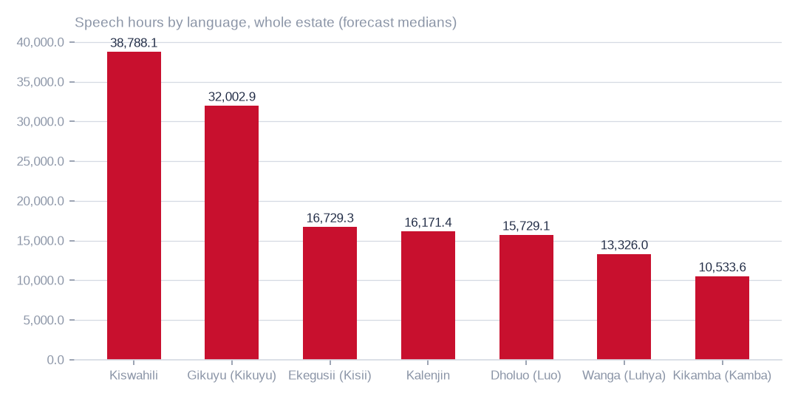
Figure: Seven languages carry forecast speech; the ranking is a model forecast, not a human-certified language inventory.
[estimated] Receipt R11: Whole-estate Monte Carlo forecast over the retained content-census receipts (cr-bbf71c8d905a, cr-cb0e66bd3e24, cr-cf4eef79995b, cr-f1415e395361): 2,000 seeded simulations over 1,334 folder strata. Measured strata: normal draws around the census estimator and its standard error. Forecast strata: in each simulation a donor folder of the same media kind is drawn — every readable bucket is one witness (bucket weight ∝ √ of its files), its folders share that weight by file count, and a Gaussian kernel on log mean file size (σ = 1.0, widened until at least 3 donors carry weight) favours donors whose files look like the target's; hours = bytes × the donor's seconds per megabyte; speech, music and language hours = hours × the donor's shares. Strata are summed in every simulation; est is the median, lo–hi the 2.5th–97.5th percentiles. Intervals carry sampling and between-folder variation, not model error or the chance that refused buckets differ in kind from every readable one.

The staged corpus as a calibration sample
The staged corpus holds 529.5 hours in 3958 files. Once music is set aside, 421.4 hours are speech and 108.2 hours are music, and 539 files are mostly music. Read by both GPUs in 1.0 GPU-hours, 82.3% of judged windows agree with the folder language and the model declined to label 10.7%.
The text model read 2245 transcripts, of which 99.4% of passages agree with the folder language; 1694 were not reached. Window agreement is lowest in the Kikamba folder. This corpus is the natural base for human calibration of the estate-wide readings.
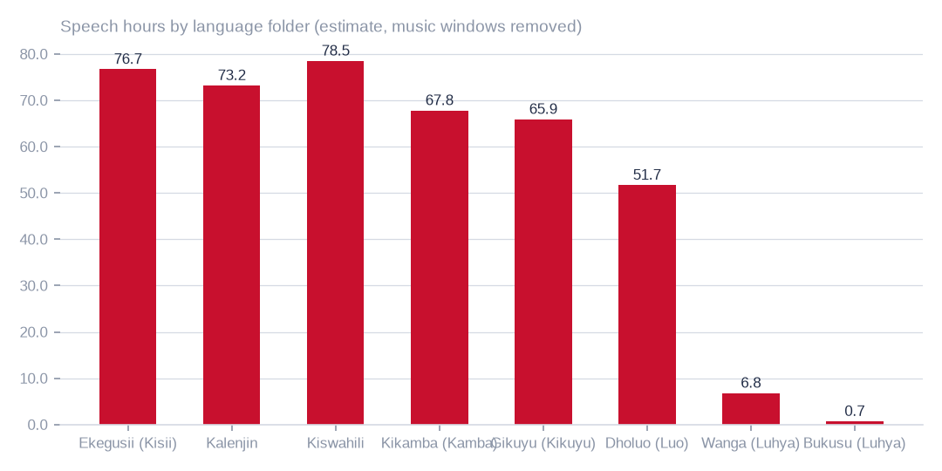
Figure: This narrow, fully read sample is the place to calibrate the models, not a substitute for the estate-wide ranking.
[estimated] Receipt R06: Estate language reading m9j-9e8fcb46a809 on akki-vm (2 GPUs, 1.034 GPU-h): audio language model lcj-7128593897d4 sha256 5c1feb8497e8…, music detector m9j-686de001bfe7 sha256 0fea3eee0393…; model readings, not human labels

Languages, stores and text as assets
Speech sits mainly in the object store (161,898.5 forecast hours) rather than the file shares (27,735.3), and 139,340.4 of the object-store speech lies in buckets the key cannot read. The folder table beside shows the largest folders; it is a subset, not a complete folder schedule.
The written word is a separate, measured asset: 248841 live scripts, 159100 distinct texts, and script text whose size in millions of characters is 189.3m, with 38.0% of rows revisions. The workbench adds 83014 recordings and 489418 segments. Station broadcast language is not a script-level reading, and the inventories are not added together.
T048 Folder-level forecast — the largest folders of the estate with 95 % forecast intervals (ranked by forecast hours)
Bucket / share | Folder | Kind | Files | Bytes (TiB) | Basis | Hours (95 %) | Speech hours (95 %) | Music hours (95 %) | Leading language (speech hours) | Donor folder (forecast rows)
2024offairrecs | Record/channel02 · 2025 | video | 192,634 | 13.89 | key refused (forecast) | 30,545 (4,539–132,574) | 5,390 (1,795–37,163) | 24,004 (1,378–117,716) | Kiswahili 900 h | citizen-digital-cms-files / (44,766 folders) · video · 2024
2024offairrecs | Record/channel01 · 2025 | video | 150,206 | 10.84 | key refused (forecast) | 23,841 (3,543–103,478) | 4,207 (1,740–29,007) | 18,736 (1,076–91,880) | Kiswahili 703 h | citizen-digital-cms-files / (44,766 folders) · video · 2024
rmsbroadcast | rmsradio/podcasts/uploads/podcasts · audio | audio | 128,167 | 1.2 | read and judged | 18,218 (18,218–18,218) | 13,151 (12,692–13,636) | 5,034 (4,535–5,532) | Gikuyu (Kikuyu) 2,353 h | —
2024offairrecs | Record/channel16 · 2025 | video | 98,705 | 7.1 | key refused (forecast) | 15,605 (2,319–67,731) | 2,840 (782–18,986) | 12,402 (704–60,140) | Kiswahili 460 h | citizen-digital-cms-files / (44,766 folders) · video · 2024
na7p43do | imported/INOORO/BACKUP/D · audio | audio | 191,240 | 0.9 | key refused (forecast) | 13,633 (10,547–68,621) | 9,845 (635–48,744) | 3,761 (1,780–19,663) | Gikuyu (Kikuyu) 1,762 h | rmsbroadcast / rmsradio/podcasts/uploads/podcasts · audio
2024offairrecs | Record/Channel15 · 2025 | video | 192,397 | 3.85 | key refused (forecast) | 10,300 (1,258–36,742) | 2,206 (773–10,300) | 7,240 (434–32,625) | Kiswahili 407 h | rmsbroadcast / rmsradio/podcasts/uploads/podcasts · video
2024offairrecs | Record/channel03 · 2025 | video | 192,721 | 3.82 | key refused (forecast) | 10,234 (1,250–36,507) | 2,240 (768–10,234) | 7,193 (432–32,415) | Kiswahili 404 h | rmsbroadcast / rmsradio/podcasts/uploads/podcasts · video
2024offairrecs | Record/Channel11 · 2025 | video | 192,243 | 3.82 | key refused (forecast) | 10,224 (1,249–36,474) | 2,162 (768–10,224) | 7,187 (431–32,386) | Kiswahili 376 h | rmsbroadcast / rmsradio/podcasts/uploads/podcasts · video
2024offairrecs | Record/Channel10 · 2025 | video | 192,385 | 3.82 | key refused (forecast) | 10,224 (1,249–36,472) | 2,162 (768–10,224) | 7,186 (431–32,385) | Kiswahili 404 h | rmsbroadcast / rmsradio/podcasts/uploads/podcasts · video
2024offairrecs | Record/channel04 · 2025 | video | 192,414 | 3.82 | key refused (forecast) | 10,223 (1,249–36,470) | 2,162 (768–10,223) | 7,186 (431–32,382) | Kiswahili 404 h | rmsbroadcast / rmsradio/podcasts/uploads/podcasts · video
2024offairrecs | Record/Channel12 · 2025 | video | 192,220 | 3.82 | key refused (forecast) | 10,215 (1,248–36,441) | 2,160 (742–10,215) | 7,180 (431–32,357) | Kiswahili 402 h | rmsbroadcast / rmsradio/podcasts/uploads/podcasts · video
2024offairrecs | Record/Channel14 · 2025 | video | 192,311 | 3.82 | key refused (forecast) | 10,212 (1,247–36,429) | 2,187 (767–10,212) | 7,178 (431–32,346) | Kiswahili 403 h | rmsbroadcast / rmsradio/podcasts/uploads/podcasts · video
2024offairrecs | Record/Channel09 · 2025 | video | 191,556 | 3.8 | key refused (forecast) | 10,172 (1,242–36,285) | 2,151 (764–10,172) | 7,150 (429–32,218) | Kiswahili 400 h | rmsbroadcast / rmsradio/podcasts/uploads/podcasts · video
2024offairrecs | Record/channel05 · 2025 | video | 182,000 | 3.61 | key refused (forecast) | 9,661 (1,180–34,465) | 2,043 (725–9,661) | 6,791 (408–30,603) | Kiswahili 382 h | rmsbroadcast / rmsradio/podcasts/uploads/podcasts · video
2024offairrecs | Record/Channel13 · 2025 · video | video | 174,070 | 3.45 | key refused (forecast) | 9,239 (1,129–32,960) | 1,979 (694–9,239) | 6,494 (390–29,266) | Kiswahili 365 h | rmsbroadcast / rmsradio/podcasts/uploads/podcasts · video
2024offairrecs | Record/channel06 · 2025 | video | 164,872 | 3.27 | key refused (forecast) | 8,755 (1,069–31,231) | 1,875 (657–8,755) | 6,154 (369–27,731) | Kiswahili 346 h | rmsbroadcast / rmsradio/podcasts/uploads/podcasts · video
na7p4oco | imported/WIMWARO/BACKUP/F · audio | audio | 85,476 | 0.5 | key refused (forecast) | 7,567 (5,854–38,087) | 5,464 (352–24,211) | 2,087 (988–10,400) | Gikuyu (Kikuyu) 978 h | rmsbroadcast / rmsradio/podcasts/uploads/podcasts · audio
na7p43do | imported/VUUKA/BACKUP/E · audio | audio | 71,696 | 0.43 | key refused (forecast) | 6,524 (5,047–32,838) | 4,711 (304–22,621) | 1,800 (852–9,037) | Gikuyu (Kikuyu) 843 h | rmsbroadcast / rmsradio/podcasts/uploads/podcasts · audio
2024offairrecs | Record/channel07 · 2025 | video | 112,821 | 2.24 | key refused (forecast) | 6,000 (733–21,404) | 1,269 (395–6,000) | 4,218 (253–19,006) | Kiswahili 220 h | rmsbroadcast / rmsradio/podcasts/uploads/podcasts · video
na7p43do | imported/VUUKA/MAIN/D · audio | audio | 65,513 | 0.39 | key refused (forecast) | 5,841 (4,519–29,403) | 4,219 (272–19,308) | 1,612 (763–8,092) | Gikuyu (Kikuyu) 755 h | rmsbroadcast / rmsradio/podcasts/uploads/podcasts · audio
citizen-digital-cms-files | (44,766 folders) · audio · 2024 | audio | 28,882 | 0.38 | read and judged | 5,700 (5,700–5,700) | 4,510 (4,374–4,648) | 1,180 (1,050–1,311) | Wanga (Luhya) 1,089 h | —
na7p43js | imported/CITIZEN RADIO/CITIZEN AUDIO SERVER/E | audio | 118,651 | 0.35 | key refused (forecast) | 5,262 (4,123–26,823) | 3,848 (248–19,250) | 1,470 (696–8,256) | Gikuyu (Kikuyu) 743 h | rmsbroadcast / rmsradio/podcasts/uploads/podcasts · audio
2024offairrecs | Record/Channel11 · 2026 | video | 90,215 | 1.8 | key refused (forecast) | 4,814 (588–17,172) | 1,018 (361–4,814) | 3,384 (203–15,248) | Kiswahili 190 h | rmsbroadcast / rmsradio/podcasts/uploads/podcasts · video
2024offairrecs | Record/Channel12 · 2026 | video | 90,173 | 1.8 | key refused (forecast) | 4,811 (588–17,162) | 1,030 (361–4,811) | 3,382 (203–15,239) | Kiswahili 190 h | rmsbroadcast / rmsradio/podcasts/uploads/podcasts · video
2024offairrecs | Record/Channel09 · 2026 | video | 89,877 | 1.79 | key refused (forecast) | 4,795 (586–17,107) | 1,027 (360–4,795) | 3,371 (202–15,190) | Kiswahili 189 h | rmsbroadcast / rmsradio/podcasts/uploads/podcasts · video
2024offairrecs | Record/Channel10 · 2026 | video | 89,832 | 1.79 | key refused (forecast) | 4,793 (586–17,099) | 1,014 (360–4,793) | 3,369 (202–15,182) | Kiswahili 189 h | rmsbroadcast / rmsradio/podcasts/uploads/podcasts · video
na7p4oco | imported/MUSYI/BACKUP/E · audio | audio | 49,815 | 0.29 | key refused (forecast) | 4,401 (3,405–22,152) | 3,178 (205–15,260) | 1,214 (575–6,180) | Gikuyu (Kikuyu) 569 h | rmsbroadcast / rmsradio/podcasts/uploads/podcasts · audio
Channel15 | Channel15 · 2026 | video | 81,958 | 1.63 | readable, not yet sampled (forecast) | 4,373 (534–15,600) | 937 (328–4,373) | 3,074 (184–13,852) | Kiswahili 173 h | rmsbroadcast / rmsradio/podcasts/uploads/podcasts · video
channel04 | channel04 · 2026 | video | 79,192 | 1.58 | readable, not yet sampled (forecast) | 4,225 (516–15,074) | 893 (317–4,225) | 2,970 (178–13,384) | Kiswahili 167 h | rmsbroadcast / rmsradio/podcasts/uploads/podcasts · video
channel03 | channel03 · 2026 | video | 79,180 | 1.58 | readable, not yet sampled (forecast) | 4,224 (516–15,070) | 905 (317–4,224) | 2,906 (178–13,381) | Kiswahili 167 h | rmsbroadcast / rmsradio/podcasts/uploads/podcasts · video
channel05 | channel05 · 2026 | video | 79,168 | 1.58 | readable, not yet sampled (forecast) | 4,224 (516–15,069) | 893 (317–4,224) | 2,969 (178–13,380) | Kiswahili 167 h | rmsbroadcast / rmsradio/podcasts/uploads/podcasts · video
channel08 | channel08 · 2026 | video | 79,175 | 1.58 | readable, not yet sampled (forecast) | 4,224 (516–15,069) | 905 (317–4,224) | 2,969 (178–13,380) | Kiswahili 167 h | rmsbroadcast / rmsradio/podcasts/uploads/podcasts · video
channel06 | channel06 · 2026 | video | 79,131 | 1.58 | readable, not yet sampled (forecast) | 4,222 (516–15,062) | 904 (317–4,222) | 2,968 (178–13,374) | Kiswahili 167 h | rmsbroadcast / rmsradio/podcasts/uploads/podcasts · video
channel07 | channel07 · 2026 | video | 79,123 | 1.58 | readable, not yet sampled (forecast) | 4,222 (516–15,061) | 893 (317–4,222) | 2,968 (178–13,373) | Kiswahili 167 h | rmsbroadcast / rmsradio/podcasts/uploads/podcasts · video
Channel09 | Channel09 · 2026 | video | 79,091 | 1.58 | readable, not yet sampled (forecast) | 4,220 (516–15,054) | 892 (317–4,220) | 2,966 (178–13,367) | Kiswahili 167 h | rmsbroadcast / rmsradio/podcasts/uploads/podcasts · video
Channel14 | Channel14 · 2026 | video | 79,081 | 1.58 | readable, not yet sampled (forecast) | 4,220 (515–15,052) | 892 (317–4,220) | 2,953 (178–13,365) | Kiswahili 155 h | rmsbroadcast / rmsradio/podcasts/uploads/podcasts · video
Channel11 | Channel11 · 2026 | video | 79,066 | 1.58 | readable, not yet sampled (forecast) | 4,219 (515–15,050) | 904 (317–4,219) | 2,965 (178–13,363) | Kiswahili 167 h | rmsbroadcast / rmsradio/podcasts/uploads/podcasts · video
Channel12 | Channel12 · 2026 | video | 79,072 | 1.58 | readable, not yet sampled (forecast) | 4,219 (515–15,049) | 904 (317–4,219) | 2,994 (178–13,362) | Kiswahili 167 h | rmsbroadcast / rmsradio/podcasts/uploads/podcasts · video
Channel10 | Channel10 · 2026 | video | 79,052 | 1.58 | readable, not yet sampled (forecast) | 4,218 (515–15,047) | 892 (317–4,218) | 2,965 (178–13,360) | Kiswahili 167 h | rmsbroadcast / rmsradio/podcasts/uploads/podcasts · video
na7p43js | imported/RAMOGI/BACKUP/D · audio | audio | 22,480 | 0.27 | key refused (forecast) | 4,029 (3,117–6,313) | 2,910 (188–3,832) | 1,112 (526–4,094) | Gikuyu (Kikuyu) 521 h | rmsbroadcast / rmsradio/podcasts/uploads/podcasts · audio
na7p4oco | imported/SULWE/BACKUP/D · audio | audio | 25,532 | 0.25 | key refused (forecast) | 3,756 (2,906–5,884) | 2,712 (175–4,212) | 1,036 (490–3,816) | Gikuyu (Kikuyu) 486 h | rmsbroadcast / rmsradio/podcasts/uploads/podcasts · audio
na7p4oco | imported/SULWE/MAIN/F · audio | audio | 23,892 | 0.24 | key refused (forecast) | 3,642 (2,818–5,706) | 2,630 (170–4,084) | 1,005 (476–3,700) | Gikuyu (Kikuyu) 471 h | rmsbroadcast / rmsradio/podcasts/uploads/podcasts · audio
2024offairrecs | Record/Channel14 · 2026 | video | 67,495 | 1.35 | key refused (forecast) | 3,601 (440–12,847) | 762 (270–3,601) | 2,531 (152–11,407) | Kiswahili 142 h | rmsbroadcast / rmsradio/podcasts/uploads/podcasts · video
na7p43js | imported/CITIZEN RADIO/BACKUP PC/F · audio | audio | 43,974 | 0.24 | key refused (forecast) | 3,564 (2,758–17,942) | 2,574 (166–12,368) | 983 (465–5,006) | Gikuyu (Kikuyu) 461 h | rmsbroadcast / rmsradio/podcasts/uploads/podcasts · audio
na7p43do | imported/VUUKA/MAIN/E · audio | audio | 14,816 | 0.22 | key refused (forecast) | 3,297 (2,551–16,595) | 2,381 (154–9,808) | 910 (430–4,014) | Gikuyu (Kikuyu) 426 h | rmsbroadcast / rmsradio/podcasts/uploads/podcasts · audio
na7p41hj | imported/RAW FOOTAGE BUP NO 8/SN 42/10.10.5.59 LIBRARY RAW FOOTAGE FROM 4TH NOV 2014 · video | video | 7,925 | 1.49 | key refused (forecast) | 2,802 (272–6,298) | 361 (78–3,978) | 2,183 (30–5,682) | Kiswahili 73 h | citizen-digital-cms-files / (44,766 folders) · video · 2024
Channel13 | (32 further folders) | audio | 8,709 | 0.17 | readable, not yet sampled (forecast) | 2,635 (2,038–13,262) | 1,903 (123–8,437) | 727 (344–3,621) | Gikuyu (Kikuyu) 341 h | rmsbroadcast / rmsradio/podcasts/uploads/podcasts · audio
na7p43js | imported/CITIZEN RADIO/BACKUP PC/E · audio | audio | 15,438 | 0.17 | key refused (forecast) | 2,587 (2,002–4,054) | 1,869 (121–2,902) | 714 (338–2,629) | Gikuyu (Kikuyu) 334 h | rmsbroadcast / rmsradio/podcasts/uploads/podcasts · audio
na7p4oco | imported/SULWE/BACKUP/F · audio | audio | 14,455 | 0.17 | key refused (forecast) | 2,529 (1,957–3,962) | 1,827 (118–2,416) | 698 (330–2,570) | Gikuyu (Kikuyu) 327 h | rmsbroadcast / rmsradio/podcasts/uploads/podcasts · audio
na7p43js | imported/CITIZEN RADIO/BACKUP PC/G · audio | audio | 9,375 | 0.14 | key refused (forecast) | 2,155 (1,668–10,850) | 1,557 (100–7,125) | 595 (281–3,027) | Gikuyu (Kikuyu) 279 h | rmsbroadcast / rmsradio/podcasts/uploads/podcasts · audio
na7p434j | imported/HD 017:16 RAW FOOTAGE/RAW FOOTAGE JULY 2016/RAW FOOTAGE JULY 2016 | video | 4,861 | 1.15 | key refused (forecast) | 2,132 (84–4,674) | 278 (58–3,067) | 1,562 (12–4,210) | Dholuo (Luo) 43 h | citizen-digital-cms-files / (44,766 folders) · video · 2024
na7p4oco | imported/SULWE/MAIN/E · audio | audio | 16,203 | 0.14 | key refused (forecast) | 2,080 (1,610–3,259) | 1,502 (97–2,333) | 574 (272–2,114) | Gikuyu (Kikuyu) 269 h | rmsbroadcast / rmsradio/podcasts/uploads/podcasts · audio
na7p42yg | (42 further folders) | video | 4,788 | 0.92 | key refused (forecast) | 1,733 (168–4,050) | 223 (48–2,461) | 1,350 (10–3,538) | Kiswahili 45 h | citizen-digital-cms-files / (44,766 folders) · video · 2024
na7p43d3 | (41 further folders) | video | 5,695 | 0.87 | key refused (forecast) | 1,679 (283–3,812) | 210 (68–2,316) | 1,496 (54–3,330) | Kiswahili 47 h | citizen-digital-cms-files / (44,766 folders) · video · 2024
na7p42xw | imported/RAW FOOTAGE BUP 17 MAGGY · 2024 · video | video | 4,856 | 0.88 | key refused (forecast) | 1,650 (160–3,855) | 212 (46–2,342) | 1,513 (18–3,368) | Kiswahili 48 h | citizen-digital-cms-files / (44,766 folders) · video · 2024
na7p42xw | imported/HD 006:2015 · 2024 · video | video | 4,171 | 0.85 | key refused (forecast) | 1,599 (67–3,492) | 206 (44–2,271) | 1,246 (9–3,228) | Kiswahili 39 h | citizen-digital-cms-files / (44,766 folders) · video · 2024
2024offairrecs | Record/channel08 · 2025 | video | 28,948 | 0.58 | key refused (forecast) | 1,540 (188–5,495) | 326 (113–1,540) | 1,060 (65–4,879) | Kiswahili 56 h | rmsbroadcast / rmsradio/podcasts/uploads/podcasts · video
na7p4oco | imported/WIMWARO/BACKUP/D · audio | audio | 14,237 | 0.09 | key refused (forecast) | 1,352 (1,046–6,808) | 977 (63–4,331) | 373 (177–1,647) | Gikuyu (Kikuyu) 175 h | rmsbroadcast / rmsradio/podcasts/uploads/podcasts · audio
news-vault | public · 2026 · audio | audio | 63,769 | 0.09 | read and judged | 1,302 (1,302–1,302) | 1,109 (1,083–1,134) | 175 (150–198) | Gikuyu (Kikuyu) 282 h | —
music-bucket-rms | swahili_gospel · 2024 | video | 13,917 | 0.67 | read and judged | 1,268 (1,194–1,342) | 164 (135–191) | 1,165 (1,068–1,256) | Kiswahili 44 h | —
Each row is one folder stratum with its listed population scaled by the sample. Measured folders carry their own sample; forecast folders name the donor folder that most often stood in for them in the simulation.
[estimated] Receipt R11: Whole-estate Monte Carlo forecast over the retained content-census receipts (cr-bbf71c8d905a, cr-cb0e66bd3e24, cr-cf4eef79995b, cr-f1415e395361): 2,000 seeded simulations over 1,334 folder strata. Measured strata: normal draws around the census estimator and its standard error. Forecast strata: in each simulation a donor folder of the same media kind is drawn — every readable bucket is one witness (bucket weight ∝ √ of its files), its folders share that weight by file count, and a Gaussian kernel on log mean file size (σ = 1.0, widened until at least 3 donors carry weight) favours donors whose files look like the target's; hours = bytes × the donor's seconds per megabyte; speech, music and language hours = hours × the donor's shares. Strata are summed in every simulation; est is the median, lo–hi the 2.5th–97.5th percentiles. Intervals carry sampling and between-folder variation, not model error or the chance that refused buckets differ in kind from every readable one.
T046 Estimated speech hours by language in the currently covered readable scope
Store | Model language | Speech hours (95 %)
OBS | Gikuyu (Kikuyu) | 4,333.6 (3,938.1–4,729.2)
OBS | Kiswahili | 3,650.2 (3,390.3–3,910.1)
OBS | Ekegusii (Kisii) | 2,729.9 (2,443.0–3,016.8)
OBS | Wanga (Luhya) | 2,702.4 (2,449.1–2,955.7)
OBS | Kalenjin | 2,182.8 (1,634.8–2,730.8)
OBS | Dholuo (Luo) | 1,762.5 (1,543.9–1,981.0)
OBS | Kikamba (Kamba) | 960.5 (861.6–1,059.4)
NAS | Kiswahili | 265.4 (256.5–274.3)
NAS | Kikamba (Kamba) | 136.2 (124.0–148.4)
NAS | Dholuo (Luo) | 48.6 (46.0–51.3)
NAS | Gikuyu (Kikuyu) | 35.9 (32.8–39.0)
NAS | Kalenjin | 14.1 (13.1–15.1)
NAS | Wanga (Luhya) | 3.1 (2.3–3.8)
NAS | Ekegusii (Kisii) | 1.8 (1.6–2.0)
All model-reported languages, separately by store; 95 % sampling intervals do not include classification error. These are not certified non-English assets. Abstentions and unsupported languages are not redistributed; inaccessible and unsampled content is excluded.
[estimated] Receipt R10: Interim tiered content census (content_sample); snapshots OBS 2026-10-03T02:33:28.832346+00:00; NAS 2026-10-03T02:33:24.807604+00:00; receipts cr-9bc59057d47c, cr-aa33fffba60e, cr-bbf71c8d905a, cr-cb0e66bd3e24, cr-cf4eef79995b, cr-f1415e395361 on akki-vm and akki-vm-ii. Resumable listing, header probes of accessible audio and a per-folder video sample (ranged reads → ffprobe), with unprobed durations extrapolated where possible; a seeded stratified sample of files per folder read byte for byte, verified against the listing and judged on every two-second window by the admitted music detector and the current audio language model; ratio estimators with finite-population correction give the 95 % intervals. Listing, probing and sampling are incomplete. Model readings, not human labels; intervals exclude model error and inaccessible or unsampled content.
T020 Audio held by language folder — what both GPUs read
Language folder | Language | Files | Hours recorded | Speech hours (est.) | Music hours (est.) | Agrees with folder | Declined to label | Transcript words
guz | Ekegusii (Kisii) | 732 | 92.2 | 76.7 | 15.6 | 86.1% | 8.3% | 662131
kln | Kalenjin | 295 | 89.8 | 73.2 | 16.6 | 89.9% | 7.1% | 747249
swa | Kiswahili | 549 | 87.7 | 78.5 | 9.2 | 78.7% | 12.9% | 725293
kam | Kikamba (Kamba) | 1166 | 85.4 | 67.8 | 17.6 | 70.9% | 13.2% | 669834
kik | Gikuyu (Kikuyu) | 584 | 82.1 | 65.9 | 16.2 | 79.8% | 15.4% | 583548
luo | Dholuo (Luo) | 558 | 82.1 | 51.7 | 30.4 | 89.5% | 6.8% | 739236
lwg | Wanga (Luhya) | 60 | 9.2 | 6.8 | 2.3 | 88.7% | 6.4% | 73194
bxk | Bukusu (Luhya) | 14 | 1.1 | 0.7 | 0.3 | 0.0% | 14.6% | 0
Hours are recorded duration; speech and music hours split those hours by the music detector; agreement is the share of labelled windows whose language matched the folder name. Model readings, not human labels.
[measured] Receipt R06: Estate language reading m9j-9e8fcb46a809 on akki-vm (2 GPUs, 1.034 GPU-h): audio language model lcj-7128593897d4 sha256 5c1feb8497e8…, music detector m9j-686de001bfe7 sha256 0fea3eee0393…; model readings, not human labels
T022 Hourly news scripts by station (news_vault.stories)
Station | Broadcast language | Live scripts | Deleted | Scripted days | First date | Last date | Scripts per scripted day | Bulletin hours per scripted day | Days with all twenty-four hours | Hour slots configured | Characters
Muuga FM | Meru | 27467 | 717 | 221 | 2022-10-16 | 2026-09-16 | 127.53 | 17.98 | 1 | 24 | 14128382
Radio Citizen | Kiswahili | 27240 | 569 | 219 | 2022-10-15 | 2026-09-16 | 126.98 | 18.18 | 43 | 28 | 22231911
Chamgei | Kalenjin | 26787 | 2486 | 224 | 2022-10-15 | 2026-09-16 | 130.68 | 18.75 | 23 | 26 | 20538503
Mulembe FM | Luhya | 22191 | 889 | 225 | 2022-10-15 | 2026-09-16 | 102.58 | 15.0 | 0 | 29 | 15496412
Wimwaro FM | Embu | 19664 | 428 | 223 | 2022-10-17 | 2026-09-16 | 90.1 | 15.76 | 0 | 24 | 12408784
Hot 96 | English | 18136 | 580 | 225 | 2022-10-15 | 2026-09-16 | 83.18 | 15.08 | 0 | 23 | 12470183
Egesa | Kisii | 17606 | 868 | 219 | 2022-10-16 | 2026-09-16 | 84.36 | 11.3 | 0 | 25 | 14458656
Musyi FM | Akamba | 17581 | 623 | 199 | 2022-10-15 | 2026-09-16 | 91.48 | 17.69 | 7 | 25 | 16521768
Sulwe FM | Bukusu | 16749 | 485 | 225 | 2022-10-15 | 2026-09-16 | 76.6 | 11.95 | 0 | 24 | 14484808
Bahari FM | Kiswahili | 16177 | 1038 | 222 | 2022-10-17 | 2026-09-16 | 77.55 | 16.8 | 0 | 25 | 12789664
Inooro FM | Kikuyu | 15376 | 298 | 209 | 2022-10-15 | 2026-09-16 | 75.0 | 15.03 | 0 | 24 | 11946715
Vuuka | Maragoli | 15336 | 377 | 222 | 2022-10-17 | 2026-09-16 | 70.78 | 14.51 | 1 | 24 | 12773790
Ramogi FM | Luo | 8013 | 822 | 222 | 2022-10-17 | 2026-09-16 | 39.8 | 6.98 | 0 | 21 | 8574493
unassigned hour | — | 518 | 26 | 31 | 2026-02-18 | 2026-08-22 | 17.55 | 3.65 | 0 | 0 | 481289
A scripted day is a calendar date with at least one script for the station; bulletin hours are the distinct hour slots scripted that day. The script texts themselves were not read; the language is the station's broadcast language as recorded in the estate.
[measured] Receipt R08: Aggregate-only database reading etx-81e10befe6e0: news_vault.stories (script, title, date, hour_id) → news_vault.hours (station_id, time, type_id) → news_vault.stations (name); news_vault.news (2022 bulletins); local.uploaded_files (language_id, audio_length, status) ← local.transcripts (file_id, start_time, end_time, transcript) ; local.folder_languages (Language, code, station)

Byte concentration in the object store
The largest bucket holds 86.7 TiB, 66.3% of the 130.8 TiB object store, and each of the next seven buckets is cold. These bytes are measured. What the largest bucket holds in hours, speech and languages is forecast, because it refuses object reads.
Concentration shows where to look first, not what it is worth. Storage volume establishes neither content quality nor revenue; the preparation chapter sets out the work that would.
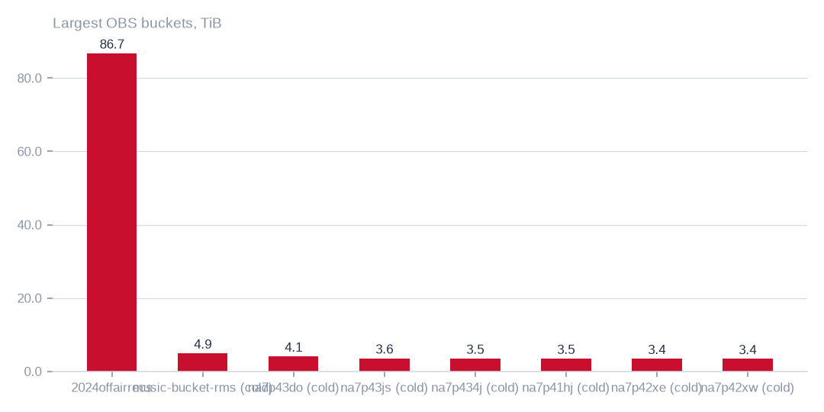
Figure: Every other bucket is small beside it, so byte concentration should be tackled starting with the dominant bucket.
[measured] Receipt R04: OBS bucket enumeration census run cr-f1415e395361 (22,997,353 objects, 130.8 TiB)

Estate bytes by store
The estate holds 175.0 TiB. The object store is 130.8 TiB (74.7%), the file shares 43.9 TiB (25.1%) and the databases 0.3 TiB (0.2%). Bytes are not invoice cost, and rounding means the stores may not reconcile exactly.
Media-store economics therefore deserve attention before database housekeeping. Database work is still worth doing for data condition and personal-data preparation, but it will not move storage cost.
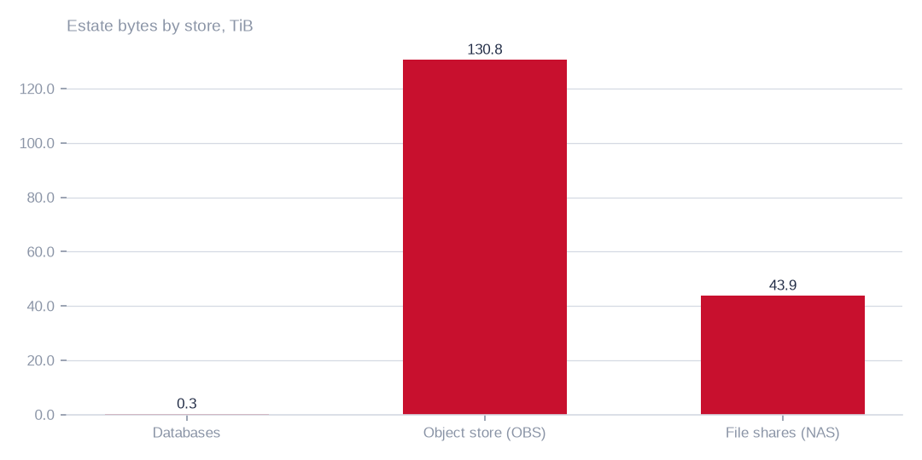
Figure: Housekeeping effort belongs on the media stores, since databases are negligible in bytes though not in personal-data preparation.
[measured] Receipt R01: Estate intelligence census eij-1b359b3cbd2e, digest-verified report (measured 2026-09-29), headline aggregates and per-database measures

Where the hours, bytes and holding costs sit
The largest bucket carries 251,976.0 forecast hours, 50.4% of the estate, in 86.7 TiB. Beyond it, 41.9 TiB across 43 buckets has not been written for over a year, and 7.7 TiB are duplicate candidates matched on size and fingerprint. Candidates are not confirmed copies.
The tables beside name the buckets, tables and shares under review. The 16 file shares hold 1.5m files, but only sizes and dates were recorded, so duplication across channel shares is not measured. In the databases, 351.3 GiB sit in 1006 tables, almost all in the largest databases (99.7%).
T010 Exact object-store buckets under review (largest first)
Bucket | Enumeration | Held (TiB) | Objects | Last write | Idle days | Duplicate candidates | Duplicate bytes (TiB, est.) | Main formats | Classification | Proposed action | Proposed destination
2024offairrecs | complete | 86.74 | 3,194,745 | 2026-10-02 | 0 | 16,634 | 0.45 | .mp4 3,151,459, .mp3 27,002, no_extension 15,706 | active — keep hot; heavy duplicate candidates | hash-confirm duplicate candidates, keep one copy | same bucket; duplicates replaced by references (proposed)
music-bucket-rms | complete | 4.93 | 152,801 | 2024-03-26 | 920 | 14,696 | 0.47 | .mp4 146,617, .txt 1,183, .flx 1,086 | cold — archive candidate; heavy duplicate candidates | verify storage class and read demand; tier only confirmed Standard bytes, never already Archive bytes | same bucket, archive storage class (proposed)
na7p43do | complete | 4.1 | 484,480 | 2024-04-04 | 912 | 197,528 | 1.67 | .mp3 326,105, .mts 39,439, .vis 39,437 | cold — archive candidate; heavy duplicate candidates | verify storage class and read demand; tier only confirmed Standard bytes, never already Archive bytes | same bucket, archive storage class (proposed)
na7p43js | complete | 3.57 | 307,998 | 2024-04-02 | 913 | 27,187 | 0.32 | .ogg 118,600, .mp3 85,079, .adf 25,484 | cold — archive candidate; heavy duplicate candidates | verify storage class and read demand; tier only confirmed Standard bytes, never already Archive bytes | same bucket, archive storage class (proposed)
na7p434j | complete | 3.5 | 15,377 | 2024-04-04 | 912 | 2,890 | 0.66 | .mov 5,427, .avi 4,258, .jpg 2,157 | cold — archive candidate | verify storage class and read demand; tier only confirmed Standard bytes, never already Archive bytes | same bucket, archive storage class (proposed)
na7p41hj | complete | 3.48 | 15,885 | 2024-03-27 | 919 | 1,852 | 0.41 | .mov 10,488, .mp4 2,347, .txt 1,519 | cold — archive candidate | verify storage class and read demand; tier only confirmed Standard bytes, never already Archive bytes | same bucket, archive storage class (proposed)
na7p42xe | complete | 3.44 | 13,965 | 2024-04-04 | 911 | 1,120 | 0.28 | .mp4 6,241, .mov 5,519, .txt 1,434 | cold — archive candidate | verify storage class and read demand; tier only confirmed Standard bytes, never already Archive bytes | same bucket, archive storage class (proposed)
na7p42xw | complete | 3.4 | 25,088 | 2024-03-31 | 915 | 2,391 | 0.32 | .mov 15,321, .txt 3,389, .avi 3,065 | cold — archive candidate | verify storage class and read demand; tier only confirmed Standard bytes, never already Archive bytes | same bucket, archive storage class (proposed)
na7p42yg | complete | 3.28 | 28,059 | 2024-03-31 | 916 | 4,197 | 0.49 | .mov 21,920, .txt 3,169, .jpg 1,446 | cold — archive candidate | verify storage class and read demand; tier only confirmed Standard bytes, never already Archive bytes | same bucket, archive storage class (proposed)
na7p43d3 | complete | 2.9 | 16,396 | 2024-03-30 | 916 | 1,395 | 0.25 | .mov 10,623, .txt 2,032, .avi 1,270 | cold — archive candidate | verify storage class and read demand; tier only confirmed Standard bytes, never already Archive bytes | same bucket, archive storage class (proposed)
na7p4oco | complete | 2.86 | 468,637 | 2024-04-03 | 912 | 166,328 | 1.01 | .mp3 218,902, .mts 36,886, .vis 36,878 | cold — archive candidate; heavy duplicate candidates | verify storage class and read demand; tier only confirmed Standard bytes, never already Archive bytes | same bucket, archive storage class (proposed)
rmsbroadcast | complete | 1.49 | 142,739 | 2024-03-24 | 922 | 5,060 | 0.05 | .mp3 127,221, .mp4 9,923, .mov 1,916 | cold — archive candidate | verify storage class and read demand; tier only confirmed Standard bytes, never already Archive bytes | same bucket, archive storage class (proposed)
Every bucket named here was enumerated object by object; the classification follows from its last write date and its duplicate-candidate count. Destinations are proposals.
[measured] Receipt R04: OBS bucket enumeration census run cr-f1415e395361 (22,997,353 objects, 130.8 TiB)
T011 Exact database tables under review, by finding
Table (database.table) | Finding | Measured detail | Strategy bytes | Proposed action
viusasa_staging.audits | not written for over a year | 666 days · 18.6 GiB | 54.1 GiB | export to compressed object storage with a schema stub (proposed); restore on demand
viusasa_staging.master_payments | not written for over a year | 438 days · 4.2 GiB | 54.1 GiB | export to compressed object storage with a schema stub (proposed); restore on demand
razuna.raz1_videos | not written for over a year | 1341 days · 3.0 GiB | 54.1 GiB | export to compressed object storage with a schema stub (proposed); restore on demand
viusasa_staging.payment_requests | not written for over a year | 664 days · 2.8 GiB | 54.1 GiB | export to compressed object storage with a schema stub (proposed); restore on demand
viusasa_staging.sms | not written for over a year | 583 days · 2.7 GiB | 54.1 GiB | export to compressed object storage with a schema stub (proposed); restore on demand
viusasa_staging.mpesa_stk_requests | not written for over a year | 724 days · 1.4 GiB | 54.1 GiB | export to compressed object storage with a schema stub (proposed); restore on demand
viusasa_staging.search_lookups | repeated rows inside the table | 5.9% repeated · 8.7 GiB | 1.2 GiB | de-duplicate in place after a keyed comparison; keep the newest row
viusasa_staging.playback_qualified_streams | repeated rows inside the table | 5.1% repeated · 4.6 GiB | 1.2 GiB | de-duplicate in place after a keyed comparison; keep the newest row
viusasa_staging.episode_views | repeated rows inside the table | 22.0% repeated · 764.0 MiB | 1.2 GiB | de-duplicate in place after a keyed comparison; keep the newest row
kra_reports.external_credit_notes | repeated rows inside the table | 25.0% repeated · 277.8 MiB | 1.2 GiB | de-duplicate in place after a keyed comparison; keep the newest row
viusasa_staging.new_episode_views | repeated rows inside the table | 66.1% repeated · 98.7 MiB | 1.2 GiB | de-duplicate in place after a keyed comparison; keep the newest row
viusasa_staging.ussd_hits | repeated rows inside the table | 8.5% repeated · 573.0 MiB | 1.2 GiB | de-duplicate in place after a keyed comparison; keep the newest row
iebc_forms/viupay.failed_jobs ↔ viupay/viupay.failed_jobs | two copies of the same table across connections | overlap 78.0% · 31.6 MiB | 54.0 MiB | name one authoritative copy; retire or redirect the other
iebc_forms/viutickets.movies ↔ viupay/viutickets.movies | two copies of the same table across connections | overlap 84.0% · 6.5 MiB | 54.0 MiB | name one authoritative copy; retire or redirect the other
iebc_forms/viutickets.ussd_hits ↔ viupay/viutickets.ussd_hits | two copies of the same table across connections | overlap 100.0% · 6.5 MiB | 54.0 MiB | name one authoritative copy; retire or redirect the other
iebc_forms/viutickets.payment_processings ↔ viupay/viutickets.payment_processings | two copies of the same table across connections | overlap 65.0% · 4.5 MiB | 54.0 MiB | name one authoritative copy; retire or redirect the other
iebc_forms/viupay.payment_requests ↔ viupay/viupay.payment_requests | two copies of the same table across connections | overlap 50.0% · 3.5 MiB | 54.0 MiB | name one authoritative copy; retire or redirect the other
iebc_forms/viutickets.movie_shows ↔ viupay/viutickets.movie_shows | two copies of the same table across connections | overlap 80.0% · 3.5 MiB | 54.0 MiB | name one authoritative copy; retire or redirect the other
ecommerce_tafaria.playbacks | index covered by a wider index | playbacks_playable_type_index covered by playbacks_playable_type_playable_id_index | 14.0 GiB | drop the covered index; measure write amplification before and after
viusasa_staging.clip_requests | index covered by a wider index | clip_requests_castr_stream_id_index covered by clip_requests_castr_stream_id_castr_clip_id_index | 14.0 GiB | drop the covered index; measure write amplification before and after
viusasa_staging.continue_watchings | index covered by a wider index | continue_watchings_user_id_index covered by continue_watchings_user_history_updated_index | 14.0 GiB | drop the covered index; measure write amplification before and after
viusasa_staging.duka_product_search_clicks | index covered by a wider index | duka_product_search_clicks_normalized_term_index covered by duka_product_search_clicks_normalized_term_product_id_unique | 14.0 GiB | drop the covered index; measure write amplification before and after
viusasa_staging.duka_search_synonyms | index covered by a wider index | duka_search_synonyms_synonym_index covered by duka_search_synonyms_synonym_canonical_unique | 14.0 GiB | drop the covered index; measure write amplification before and after
viusasa_staging.elimu_learner_badges | index covered by a wider index | elimu_learner_badges_badge_id_index covered by elimu_learner_badges_badge_id_sub_user_id_unique | 14.0 GiB | drop the covered index; measure write amplification before and after
ecommerce_tafaria.airtel_c2bs | empty table |  |  | drop after the application owner confirms it is unused
ecommerce_tafaria.airtel_ussd_pushes | empty table |  |  | drop after the application owner confirms it is unused
ecommerce_tafaria.album_track | empty table |  |  | drop after the application owner confirms it is unused
ecommerce_tafaria.albums | empty table |  |  | drop after the application owner confirms it is unused
ecommerce_tafaria.api_providers | empty table |  |  | drop after the application owner confirms it is unused
ecommerce_tafaria.article_menu | empty table |  |  | drop after the application owner confirms it is unused
ecommerce_tafaria.article_sources | empty table |  |  | drop after the application owner confirms it is unused
ecommerce_tafaria.articles | empty table |  |  | drop after the application owner confirms it is unused
viusasa_staging.playback_stagings | high share of personal-data markers | 91.0% of sampled rows |  | de-identify or aggregate before any product use; keep the master as is
viusasa_staging.telescope_entries | high share of personal-data markers | 79.0% of sampled rows |  | de-identify or aggregate before any product use; keep the master as is
viusasa_staging.audits | high share of personal-data markers | 100.0% of sampled rows |  | de-identify or aggregate before any product use; keep the master as is
viusasa_staging.sms | high share of personal-data markers | 100.0% of sampled rows |  | de-identify or aggregate before any product use; keep the master as is
viusasa_staging.ussd_hits | high share of personal-data markers | 100.0% of sampled rows |  | de-identify or aggregate before any product use; keep the master as is
viusasa_staging.playback_qualified_streams | high share of personal-data markers | 58.0% of sampled rows |  | de-identify or aggregate before any product use; keep the master as is
ecommerce_tafaria.invoices.order_id → orders | references pointing at rows that no longer exist | 100.0% orphaned of 4 sampled |  | repair or remove the dangling references; add a foreign-key check
ecommerce_tafaria.invoices.payment_id → payments | references pointing at rows that no longer exist | 100.0% orphaned of 1 sampled |  | repair or remove the dangling references; add a foreign-key check
viusasa_staging.active_users.user_id → user | references pointing at rows that no longer exist | 100.0% orphaned of 400 sampled |  | repair or remove the dangling references; add a foreign-key check
viusasa_staging.airtel_ussd_pushes.user_id → user | references pointing at rows that no longer exist | 100.0% orphaned of 400 sampled |  | repair or remove the dangling references; add a foreign-key check
viusasa_staging.article_menu.article_id → articles | references pointing at rows that no longer exist | 100.0% orphaned of 400 sampled |  | repair or remove the dangling references; add a foreign-key check
viusasa_staging.audits.user_id → user | references pointing at rows that no longer exist | 100.0% orphaned of 400 sampled |  | repair or remove the dangling references; add a foreign-key check
Each row names a table the census measured and the finding that puts it on the list; the bytes column is the strategy total the table belongs to, not the table alone.
[measured] Receipt R02: Estate intelligence census eij-1b359b3cbd2e, cost_strategies priced at reference list prices, not the owner's invoice: Huawei Cloud RDS for MySQL cloud SSD AF-Johannesburg 0.00015 USD/GB-hour x 730 h; OBS Standard 0.023 USD/GB-month
T012 Exact file shares (NAS) enumerated
Share | Enumeration | Held (TiB) | Files | Last write | Main formats | Proposed action
channel01 | complete | 6.87 | 95,122 | 2026-09-29 | .mp4 95,108, .rmd 6, .mpt 3 | fingerprint pass to measure duplication; then tier by channel
channel02 | complete | 6.87 | 95,134 | 2026-09-29 | .mp4 95,129, .db 1, .jpg 1 | fingerprint pass to measure duplication; then tier by channel
channel16 | complete | 6.81 | 94,597 | 2026-09-29 | .mp4 94,592, .db 1, .jpg 1 | fingerprint pass to measure duplication; then tier by channel
Channel15 | partial | 1.93 | 96,675 | 2026-10-02 | .mp4 96,667, .rmd 3, .db 1 | fingerprint pass to measure duplication; then tier by channel
Channel14 | partial | 1.93 | 96,660 | 2026-10-02 | .mp4 96,654, .rmd 2, .db 1 | fingerprint pass to measure duplication; then tier by channel
Channel11 | partial | 1.93 | 96,651 | 2026-10-02 | .mp4 96,641, .rmd 6, .db 1 | fingerprint pass to measure duplication; then tier by channel
Channel12 | partial | 1.93 | 96,658 | 2026-10-02 | .mp4 96,648, .rmd 6, .db 1 | fingerprint pass to measure duplication; then tier by channel
channel06 | partial | 1.93 | 96,614 | 2026-10-02 | .mp4 96,610, .db 1, .jpg 1 | fingerprint pass to measure duplication; then tier by channel
channel07 | partial | 1.93 | 96,606 | 2026-10-02 | .mp4 96,602, .db 1, .jpg 1 | fingerprint pass to measure duplication; then tier by channel
channel05 | partial | 1.93 | 96,600 | 2026-10-02 | .mp4 96,596, .db 1, .jpg 1 | fingerprint pass to measure duplication; then tier by channel
channel04 | partial | 1.93 | 96,584 | 2026-10-02 | .mp4 96,579, .db 1, .jpg 1 | fingerprint pass to measure duplication; then tier by channel
channel03 | partial | 1.93 | 96,538 | 2026-10-03 | .mp4 96,534, .db 1, .jpg 1 | fingerprint pass to measure duplication; then tier by channel
Sizes and dates were recorded; content fingerprints were not, so duplication across the channel shares is not yet measured.
[measured] Receipt R05: NAS share enumeration census run cr-cf4eef79995b (1,470,663 files, 43.9 TiB)

Readable and unreadable media files
The census has listed 5.8m media files in the object store and the file shares. In the object store, 0.4m are in readable buckets and 4.2m (120.7 TiB) are in buckets that refuse reads or need a restore. That is 90.7% of listed object-store media files. 15 buckets refuse object reads and 2 need a restore.
A grant alone does not complete measurement; the census must then probe and sample those files. Egress so far is 169.7 USD at an assumed tariff, and restores will add a retrieval fee not yet priced.
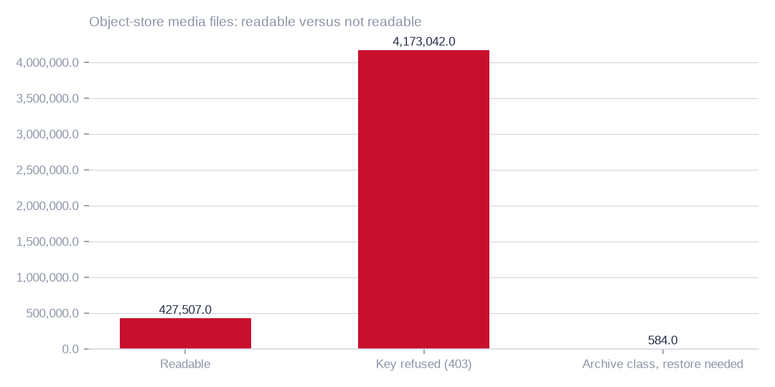
Figure: Access and restore decisions, not new analysis, convert the largest forecast block; refused, unreadable and restore-required buckets are three distinct problems.
[measured] Receipt R10: Interim tiered content census (content_sample); snapshots OBS 2026-10-03T02:33:28.832346+00:00; NAS 2026-10-03T02:33:24.807604+00:00; receipts cr-9bc59057d47c, cr-aa33fffba60e, cr-bbf71c8d905a, cr-cb0e66bd3e24, cr-cf4eef79995b, cr-f1415e395361 on akki-vm and akki-vm-ii. Resumable listing, header probes of accessible audio and a per-folder video sample (ranged reads → ffprobe), with unprobed durations extrapolated where possible; a seeded stratified sample of files per folder read byte for byte, verified against the listing and judged on every two-second window by the admitted music detector and the current audio language model; ratio estimators with finite-population correction give the 95 % intervals. Listing, probing and sampling are incomplete. Model readings, not human labels; intervals exclude model error and inaccessible or unsampled content.

Database condition and the preparation queue
On measured and sampled rows, exact duplicates are 1.5%, degraded rows 23.0% and rows with empty required-looking fields 81.7%. The last is a flag for review, not proof that every blank is invalid. 71.8% of 1.0m sampled rows carry personal-data markers, so de-identification or aggregation is a preparation step for any product.
Beyond rows, 368 tables are empty, 71 table pairs duplicate each other and dead columns are 13.0% of measured columns. This is a bounded queue and does not reopen rights.
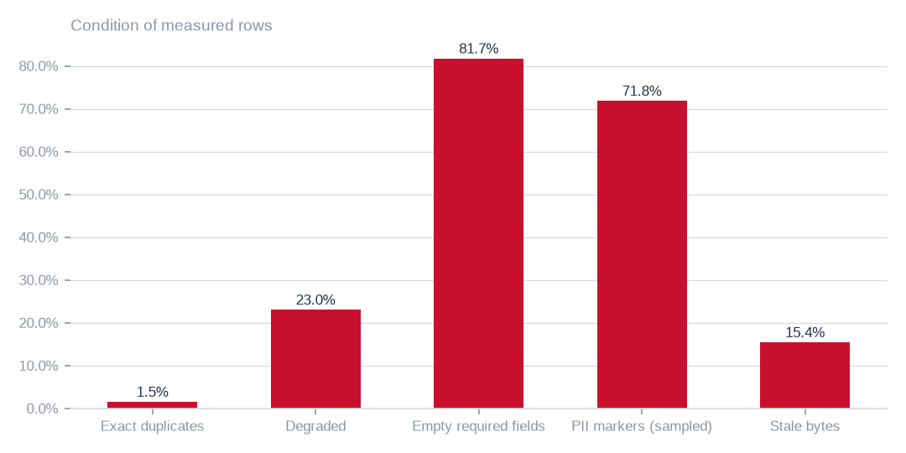
Figure: These findings direct preparation work on measured and sampled rows; they do not describe the media content and do not reopen rights.
[estimated] Receipt R01: Estate intelligence census eij-1b359b3cbd2e, digest-verified report (measured 2026-09-29), headline aggregates and per-database measures

Work that converts forecast into measurement
The work is ordered by forecast exposure. First, an object-read grant on the 15 refused buckets, which sit among the buckets holding 367,222.7 forecast hours. Second, a restore decision on the 2 archive-class buckets. Third, completing the planned samples, starting with the 86,601.1 forecast hours in readable folders not yet sampled. Fourth, human checks on the model readings. Fifth, de-identifying selected product inputs.
The coverage and donor tables beside show what each step replaces. This work improves confidence and usability and is not a reason to withhold the estate forecast.
T042 Object-store buckets the census key cannot read — counted, never estimated
Bucket | State | Media files | Audio files | Video files | Media bytes (TiB) | Bytes already in Archive class (TiB) | Refused since | Action required
2024offairrecs | key refused (403 AccessDenied) | 3,178,461 | 27,002 | 3,151,459 | 86.73 | 82.03 | 2026-10-02 17:20 | grant obs:object:GetObject to the census key (IAM or bucket policy)
na7p43do | key refused (403 AccessDenied) | 384,572 | 343,266 | 41,306 | 3.98 | 4.1 | 2026-10-02 17:50 | grant obs:object:GetObject to the census key (IAM or bucket policy)
na7p43js | key refused (403 AccessDenied) | 238,007 | 215,594 | 22,413 | 3.54 | 3.57 | 2026-10-02 17:52 | grant obs:object:GetObject to the census key (IAM or bucket policy)
na7p434j | key refused (403 AccessDenied) | 10,750 | 7 | 10,743 | 3.48 | 3.5 | 2026-10-02 17:53 | grant obs:object:GetObject to the census key (IAM or bucket policy)
na7p41hj | key refused (403 AccessDenied) | 14,145 | 4 | 14,141 | 3.47 | 3.48 | 2026-10-02 17:53 | grant obs:object:GetObject to the census key (IAM or bucket policy)
na7p42xe | key refused (403 AccessDenied) | 12,300 | 4 | 12,296 | 3.44 | 3.44 | 2026-10-02 17:53 | grant obs:object:GetObject to the census key (IAM or bucket policy)
na7p42xw | key refused (403 AccessDenied) | 20,559 | 78 | 20,481 | 3.4 | 3.4 | 2026-10-02 17:53 | grant obs:object:GetObject to the census key (IAM or bucket policy)
na7p42yg | key refused (403 AccessDenied) | 23,080 | 19 | 23,061 | 3.28 | 3.28 | 2026-10-02 17:53 | grant obs:object:GetObject to the census key (IAM or bucket policy)
na7p43d3 | key refused (403 AccessDenied) | 13,318 | 19 | 13,299 | 2.9 | 2.9 | 2026-10-02 17:53 | grant obs:object:GetObject to the census key (IAM or bucket policy)
na7p4oco | key refused (403 AccessDenied) | 272,080 | 230,813 | 41,267 | 2.65 | 2.86 | 2026-10-02 17:51 | grant obs:object:GetObject to the census key (IAM or bucket policy)
na7p4357 | key refused (403 AccessDenied) | 2,228 | 1 | 2,227 | 1.36 | 1.36 | 2026-10-02 17:54 | grant obs:object:GetObject to the census key (IAM or bucket policy)
na7p43df | key refused (403 AccessDenied) | 1,071 | 4 | 1,067 | 1.36 | 1.39 | 2026-10-02 17:53 | grant obs:object:GetObject to the census key (IAM or bucket policy)
na7p43ax | key refused (403 AccessDenied) | 767 | 0 | 767 | 0.92 | 0.92 | 2026-10-02 17:54 | grant obs:object:GetObject to the census key (IAM or bucket policy)
na7p49p9 | key refused (403 AccessDenied) | 1,649 | 0 | 1,649 | 0.19 | 0.19 | 2026-10-02 17:54 | grant obs:object:GetObject to the census key (IAM or bucket policy)
elections-portal | key refused (403 AccessDenied) | 55 | 0 | 55 | 0.0 | — | 2026-10-02 19:14 | grant obs:object:GetObject to the census key (IAM or bucket policy)
test-viusasa-bucket | Archive class · InvalidObjectState | 582 | 0 | 582 | 0.0 | 0.0 | 2026-10-02 17:54 | decide: restore (fee) or leave counted only
fast-channels | Archive class · InvalidObjectState | 2 | 0 | 2 | 0.0 | 0.0 | 2026-10-02 19:17 | decide: restore (fee) or leave counted only
Denied and restore-required buckets are listed separately. Denied buckets require an object-read grant; Archive objects that return InvalidObjectState require a restore decision and its retrieval cost. Listed files and bytes do not establish their hours or languages.
[measured] Receipt R10: Interim tiered content census (content_sample); snapshots OBS 2026-10-03T02:33:28.832346+00:00; NAS 2026-10-03T02:33:24.807604+00:00; receipts cr-9bc59057d47c, cr-aa33fffba60e, cr-bbf71c8d905a, cr-cb0e66bd3e24, cr-cf4eef79995b, cr-f1415e395361 on akki-vm and akki-vm-ii. Resumable listing, header probes of accessible audio and a per-folder video sample (ranged reads → ffprobe), with unprobed durations extrapolated where possible; a seeded stratified sample of files per folder read byte for byte, verified against the listing and judged on every two-second window by the admitted music detector and the current audio language model; ratio estimators with finite-population correction give the 95 % intervals. Listing, probing and sampling are incomplete. Model readings, not human labels; intervals exclude model error and inaccessible or unsampled content.
T045 Sampling coverage and what would improve this baseline
Store | Media files listed | Headers probed | Sample read / planned | Header / sample completion | Next evidence step
OBS | 4,601,133 | 273,981 | 32,239 / 32,349 | complete / incomplete | Finish accessible-folder samples; target wide intervals; independently check model labels and duration estimates
NAS | 1,224,886 | 8,670 | 519 / 15,413 | incomplete / incomplete | Finish accessible-folder samples; target wide intervals; independently check model labels and duration estimates
Listed media, files with header probes and files read in full are different populations. A completed source listing is not a completed sample. These counters are the banked snapshot, not a live progress indicator.
[measured] Receipt R10: Interim tiered content census (content_sample); snapshots OBS 2026-10-03T02:33:28.832346+00:00; NAS 2026-10-03T02:33:24.807604+00:00; receipts cr-9bc59057d47c, cr-aa33fffba60e, cr-bbf71c8d905a, cr-cb0e66bd3e24, cr-cf4eef79995b, cr-f1415e395361 on akki-vm and akki-vm-ii. Resumable listing, header probes of accessible audio and a per-folder video sample (ranged reads → ffprobe), with unprobed durations extrapolated where possible; a seeded stratified sample of files per folder read byte for byte, verified against the listing and judged on every two-second window by the admitted music detector and the current audio language model; ratio estimators with finite-population correction give the 95 % intervals. Listing, probing and sampling are incomplete. Model readings, not human labels; intervals exclude model error and inaccessible or unsampled content.
T049 How the forecast was built — the donor folders by media kind
Media kind | Donor strata | Donor files | Seconds per MB (10th–90th pct) | Speech share (10th–90th pct)
audio | 54 | 239,732 | 5.67–249.97 | 12.4%–88.8%
video | 157 | 189,356 | 2.09–16.54 | 7.5%–81.1%
2,000 seeded simulations over 1,334 folder strata. Measured strata: normal draws around the census estimator and its standard error. Forecast strata: in each simulation a donor folder of the same media kind is drawn — every readable bucket is one witness (bucket weight ∝ √ of its files), its folders share that weight by file count, and a Gaussian kernel on log mean file size (σ = 1.0, widened until at least 3 donors carry weight) favours donors whose files look like the target's; hours = bytes × the donor's seconds per megabyte; speech, music and language hours = hours × the donor's shares. Strata are summed in every simulation; est is the median, lo–hi the 2.5th–97.5th percentiles. Intervals carry sampling and between-folder variation, not model error or the chance that refused buckets differ in kind from every readable one.
[measured] Receipt R11: Whole-estate Monte Carlo forecast over the retained content-census receipts (cr-bbf71c8d905a, cr-cb0e66bd3e24, cr-cf4eef79995b, cr-f1415e395361): 2,000 seeded simulations over 1,334 folder strata. Measured strata: normal draws around the census estimator and its standard error. Forecast strata: in each simulation a donor folder of the same media kind is drawn — every readable bucket is one witness (bucket weight ∝ √ of its files), its folders share that weight by file count, and a Gaussian kernel on log mean file size (σ = 1.0, widened until at least 3 donors carry weight) favours donors whose files look like the target's; hours = bytes × the donor's seconds per megabyte; speech, music and language hours = hours × the donor's shares. Strata are summed in every simulation; est is the median, lo–hi the 2.5th–97.5th percentiles. Intervals carry sampling and between-folder variation, not model error or the chance that refused buckets differ in kind from every readable one.

Scale of the storage strategies
The three largest strategies address 50,785.7 GiB of the 50,800.9 GiB that all cost strategies reach. Archive tiering is the largest, at 42,891.0 GiB, then duplicate reconciliation at 7,840.5 GiB. Database tables not written for a year add 54.1 GiB, and database reclaimable bytes before pricing are 15.2 GiB.
These are bytes addressed, not bytes deleted. Strategies overlap, and duplicate candidates are not safe to remove until confirmed by content hash.
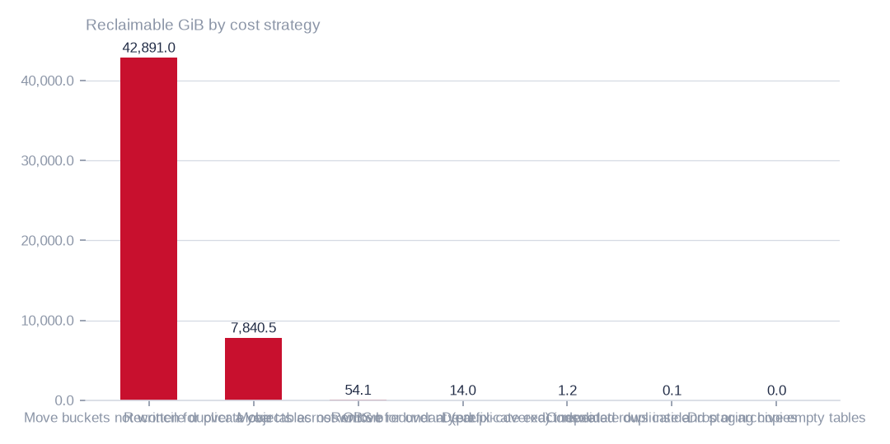
Figure: Prioritise tiering and duplicate candidates first; strategy totals overlap and measure bytes addressed, not bytes deleted or net savings.
[estimated] Receipt R02: Estate intelligence census eij-1b359b3cbd2e, cost_strategies priced at reference list prices, not the owner's invoice: Huawei Cloud RDS for MySQL cloud SSD AF-Johannesburg 0.00015 USD/GB-hour x 730 h; OBS Standard 0.023 USD/GB-month

Earn and save, side by side
Archive tiering addresses 42,891.0 GiB at up to 986.5 USD a month. Duplicate reconciliation addresses 7,840.5 GiB at up to 180.3 USD. Table tiering addresses 54.1 GiB at up to 5.9 USD. The legacy scenario total of 1,174.4 USD is an upper bound, not verified net savings, and opportunities may overlap.
In the subset with recorded storage classes, 96.0% of bytes are already archive-class, and those have no Standard-to-Archive saving left. Reprice eligible Standard bytes, with retrieval and restore costs, before relying on any figure.
On the earning side, 8 database-derived candidates exist, each needing de-identification or aggregation. A speech-and-text pilot from the leading languages is a proposal, with no revenue evidence yet, and needs buyer validation.
 | Move buckets not written for over a year to archive-class st | Reconcile duplicate objects across OBS buckets | Move tables not written for over a year to cold storage
Reclaimable gib | 42,891.0 | 7,840.5 | 54.1
Monthly saving usd | 986.5 | 180.3 | 5.9
Monthly figures are upper bounds at legacy full-Standard reference prices; reprice eligible bytes and retrieval costs before treating any as expected saving.
[estimated] Receipt R02: Estate intelligence census eij-1b359b3cbd2e, cost_strategies priced at reference list prices, not the owner's invoice: Huawei Cloud RDS for MySQL cloud SSD AF-Johannesburg 0.00015 USD/GB-hour x 730 h; OBS Standard 0.023 USD/GB-month

The decisions, in order
The decision table beside lists each decision with its source, destination or rule, responsible role and expected benefit, with money stated as an upper bound. The order matters. Access comes first because 73.4% of the forecast depends on it. A restore decision, a pilot and its owner follow. Validation of tiering and duplicates comes before any move or deletion.
The model-roles table discloses how this pack was produced. Nothing described here has been executed; every destination is a proposal for approval.
T013 Executive decisions requested — one row each
No. | Decision requested | Exact source | Action | Proposed destination or rule | Responsible role | Expected benefit | Evidence | Still to verify
D0 | Adopt the whole-estate forecast as the planning baseline for hours, speech and languages | every listed folder of the object store and the file shares (1,334 strata; 500,290 h, 95 % 412,531–625,455 h) | plan products, storage and compute on the forecast medians; convert the widest forecast rows into measurement in the order of their interval width: 2024offairrecs (191,788 h wide), na7p43do (58,834 h wide), na7p4oco (32,503 h wide) | forecast replaced by measurement bucket by bucket; no data moves (proposed) | Head of Data with the cloud account owner | one defensible number for the estate today, narrowing every census run | R11 · T047 · T050 | that each converted bucket lands inside its forecast interval; a miss means the donors did not represent it
D1 | Verify cold-bucket storage classes before approving tiering | 43 buckets, e.g. music-bucket-rms, na7p43do, na7p43js, na7p434j, na7p41hj | class metadata confirms 41.88 TiB of cold bytes already Archive and 0.0 TiB Standard in the measured subset; remaining classes are unknown, not zero | same buckets, archive storage class (proposed) | Head of Technology (storage owner) | net tiering saving unverified; historic full-Standard-price scenarios must be repriced, excluding already Archive bytes | R04 · T010 | class coverage for all cold bytes, actual prices, read demand and direct-read versus restore fees
D2 | Approve hash confirmation and removal of duplicate objects | na7p43do, na7p4oco, music-bucket-rms, 2024offairrecs (1,158,906 candidates across the store) | confirm each candidate by content hash; keep one copy per bucket; replace the rest with references or lifecycle-delete | keeper stays in its bucket; duplicates removed after confirmation (proposed) | Head of Technology with the content librarian | up to 180 USD a month at list price | R04 · T010 | content-hash confirmation; ETag plus size is not proof for multipart uploads
D3 | Instruct reconciliation of the unreadable buckets | 40 buckets, e.g. apr252017, citizen-vod, elections, feb272017, instore-radio-items | ask the provider whether each bucket exists; remove dead names from the inventory; restore access where it should exist | inventory register corrected (proposed) | Cloud account owner | an inventory the next census can trust | R04 · T015 | provider confirmation per bucket
D4 | Approve cold-table archiving in the databases | 6 tables, e.g. viusasa_staging.audits, viusasa_staging.master_payments, razuna.raz1_videos, viusasa_staging.payment_requests | export to compressed object storage with a schema stub and a pointer; restore on demand | object store, archive class, one prefix per database (proposed) | Database administrator | up to 6 USD a month at list price | R02 · T011 | application owners confirm no live reads
D5 | Decide one authoritative copy for each duplicated table pair | 71 pairs, e.g. iebc_forms/viupay.failed_jobs ↔ viupay/viupay.failed_jobs; iebc_forms/viutickets.movies ↔ viupay/viutickets.movies; iebc_forms/viutickets.ussd_hits ↔ viupay/viutickets.ussd_hits | name the master; retire or redirect the copy; add the pair to the schema register | master stays; copy retired (proposed) | Database administrator with the application owners | up to 0 USD a month at list price | R01 · T011 | which copy the applications actually write to
D6 | Approve the housekeeping list: empty tables, redundant indexes, repeated rows | 368 empty tables; redundant indexes and repeated rows named in the table list | drop confirmed-unused empty tables; drop covered indexes; de-duplicate keyed rows | no destination — removal in place after confirmation (proposed) | Database administrator | up to 2 USD a month at list price plus up to 0 USD a month at list price | R02 · T011 | application owner sign-off per table
D7 | Order a fingerprint pass over the file shares | 16 NAS shares holding 43.9 TiB (channel01 … channel16) | compute content fingerprints so duplication across channels can be measured | none yet — measurement first | Head of Technology | a measured duplication figure for the largest unmeasured store | R05 · T012 | the pass itself; nothing is known about NAS duplication today
D8 | Adopt naming and ownership rules for storage | machine-named buckets (na7p4…), channel shares, staging copies | a register naming an owner, purpose, retention and tier for every bucket, share and database; machine names mapped to purposes | register maintained by the storage owner (proposed) | Chief Operating Officer | fewer orphaned stores and faster decisions at the next census | R04 · R05 | owner confirmation for each entry
D9 | Register the language assets as governed data products | staged corpus by language folder (T020), news scripts by station (T022), transcription workbench (T023) | record each as an asset with its hours or scripts, its evidence rows and its quality signals; keep the inventories separate until a file-level join is made | governed asset register (proposed) | Head of Data with the newsroom | a licensable, evidenced inventory of non-English speech and text | R06 · R07 · R08 | overlap between the workbench and the staged corpus; language of each script
D10 | Commission the de-identified reference products the census ranks first | the three leading product candidates in the census | prepare de-identified or aggregated reference and channel datasets under an explicit target outcome and collection schema | product workspace (proposed) | Head of Data | first revenue-bearing use of the estate's data | R03 | a signed target outcome and collection schema per product
D11 | Grant the census key object read on the buckets that refuse it | 15 buckets, e.g. 2024offairrecs, na7p43do, na7p43js, na7p434j, na7p41hj, na7p42xe, na7p42xw, na7p42yg, na7p43d3, na7p4oco, na7p4357, na7p (4,173,626 media files, 120.71 TiB) | the Huawei account administrator grants obs:object:GetObject to the census IAM user on each bucket (IAM policy or bucket policy); the census re-probes every run and resumes by itself | no data moves; access only (proposed) | Cloud account owner | hours, speech and languages for the larger part of the media estate, measured instead of unknown | R10 · T042 | that the grant has landed (the next census run shows the buckets readable)
D12 | Decide whether to restore the Archive-class buckets that cannot be read directly | 2 buckets, e.g. test-viusasa-bucket, fast-channels | order a restore (restore fee, then egress) for the sample files, or leave these buckets counted only | same buckets; restored copies temporary (proposed) | Head of Technology (storage owner) | a measured reading of otherwise dark buckets, at a known retrieval cost | R10 · T042 | the restore tariff and the sample size wanted
Each decision names the exact source it rests on, the action, the proposed destination or rule, who carries it, the benefit stated as an upper bound where it is money, the evidence it rests on and what still has to be verified. Nothing here has been executed.
[estimated] Receipt R02: Estate intelligence census eij-1b359b3cbd2e, cost_strategies priced at reference list prices, not the owner's invoice: Huawei Cloud RDS for MySQL cloud SSD AF-Johannesburg 0.00015 USD/GB-hour x 730 h; OBS Standard 0.023 USD/GB-month
T036 Who wrote this pack — model roles by task strength
Role | Model | Family | Job | Measured strength
assistant | gpt-6-astra | openai | planning collaborator in Train Models: reads the run record, plans the next bounded step, proposes one action | long-horizon planning and orchestration; strict JSON; grounded figures
planner | gpt-6-astra | openai | plans and orchestrates multi-step work (document story, measurement order, task decomposition) | planning and orchestration across tools and steps
reviewer | claude-fable-5-1 | anthropic | independent review of complex outputs against source evidence and acceptance criteria; a different family from the planner | complex-task reasoning, error detection, disagreement stated plainly
writer | claude-sonnet-5-5 | anthropic | writes every sentence the reader sees from evidence tokens under the content-manager gate | evidence-grounded British-English prose that passes the figure-by-reference gate
Planner and reviewer come from different model families so the review does not share the planner's blind spots; every call crosses the Shield chokepoint. Arithmetic, evidence binding and the build stay deterministic.
[measured] Receipt R09: Model role assignments evaluated 2026-10-02: integration model catalogue plus published task benchmarks reviewed on the day; planner/reviewer families kept distinct so the review does not share the planner's blind spots. Not claimed: no independent head-to-head benchmark was run on owner data; assignments are disclosed configuration, re-evaluated when a role under-performs on its own gate

What to do first, and why
Grant the census key read access on the refused buckets, starting with the largest at 251,976.0 hours. This is the single step that most reduces uncertainty in the 500,290.3-hour forecast.
Next, complete the samples of readable folders and shares and commission human checks on the model readings. Only then reprice tiering and confirm duplicates by hash. Keep pilot approval, preparation funding and destructive execution as separate decisions, each with an owner and an evidence gate.

What the evidence cannot yet establish
The forecast of 500,290.3 hours rests on donors, with 8.5% of hours directly judged. It assumes refused buckets resemble readable folders of the same media kind and file size; if not, the truth lies outside the interval. Speech, music and language figures are model readings with sampling intervals only.
Savings, file-share duplication, script language, workbench overlap and buyer demand are also unmeasured. Each gap names its closing step: an access grant, human checks, class and demand data, fingerprinting, a text pass, a hash join or buyer review.

Plain English: the terms used in this pack
Term | What it means in this pack
Reclaimable | Space that could be removed or stored more cheaply once the check named beside it has been done. It is not space already freed, and it is not a guaranteed saving — the monthly figures are upper bounds at list prices.
Cold (not written for over a year) | Nothing new has been written to that bucket or table for more than a year, judged by the newest write date we could see. It says nothing about whether anyone still reads it — that was not measured.
Duplicate candidate | Two objects whose size and storage fingerprint (ETag) match inside the same store. For large uploads that fingerprint is not a content hash, so a candidate must be confirmed by hashing before any copy is removed.
Exact duplicate rows | Database rows that are identical in every measured column. 'Normalised' duplicates also match after trimming spaces and case.
Degraded row | A row whose worst column shows damage: text cut short, a placeholder such as 'N/A' or 'test', an invalid format, stray whitespace or garbled characters.
Empty required-looking fields | Blank values in columns whose name or pattern suggests they should always be filled (for example an identifier or a date). The database may not formally require them; the census flags them so an owner can decide.
Dead column | A column that is empty on practically every row: schema carried without data.
Personal-data marker | A sampled value that looks like an email, phone number, national ID or similar. It is a condition of the data, not a judgement about rights — the owner has declared all rights established.
Archive-class storage | A cheaper storage tier for data that is kept but rarely opened. Retrieval is slower and carries its own fee, which is why the saving is stated as an upper bound.
Proposed destination | Where this pack suggests data should live or how it should be tiered. Every destination here is a proposal for the executive to approve; this pack moved and deleted nothing.
Speech hours (estimate) | Recorded hours multiplied by the share of two-second windows the admitted music detector did not call music. Silence is set aside first.
Agrees with folder | The share of labelled windows (or transcript passages) where the model's language label matched the folder the recording was filed under. It is a model reading, not a human verification.
Declined to label | Windows where the language model's confidence fell below its threshold, so it gave no language rather than guess.
Scripted day / bulletin hour | A calendar date on which a station has at least one news script in the archive, and the distinct hour slots scripted that day. The archive does not carry a script for every hour of every day; the tables show exactly which days and hours it does.
Receipt | The retained Akki record (census run, GPU job or database reading) that every figure in this pack is traced to. The appendix lists them; the workbook carries the row-level evidence.
Whole-estate forecast | What the entire estate most likely holds, found by scaling what the census read in each folder up to that folder's full population and adding every folder together — the part that could not be read included, each one standing in for a readable folder of the same kind and file size.
Monte Carlo simulation | The estate was added up thousands of times, each time letting every uncertain folder take a different plausible value. The middle result is the forecast; the range that holds 95 % of the results is the forecast interval.
Donor folder | A folder the census read and judged that stands in for a folder it could not read: same media kind, similar file size. Its seconds per megabyte, speech share and language mix are borrowed, so the forecast is only as representative as its donors.
Forecast versus measured | Measured rows come from files actually read and judged, with a sampling interval. Forecast rows are borrowed from donors and carry a wider interval. Every table says which is which; an access grant or a finished sample turns a forecast row into a measured one.
Header-measured hours | A duration estimate based on available file headers and per-folder extrapolation for unprobed files. Probing is incomplete; some durations themselves use bitrate estimates. This is not an exact count of decoded estate hours.
95 % interval | A sampling-uncertainty range produced by a method intended to cover its target in 95 % of repeated samples under its assumptions. It does not cover model error, failed reads, unmeasured folders or inaccessible content. Whole-folder reads remove sampling error, not measurement or classification error.
Key refused (403) | The census key can list the bucket but is refused when it tries to read any object. Those files are counted but nothing about their content is estimated. The fix is an access grant on the owner's cloud account, not a change to the census.
Archive class | The cheapest storage tier. Some buckets allow direct reads of Archive objects for a retrieval fee; others answer 'restore required', and a restore must be ordered and paid for before anything can be read.

Coverage and limits
Covers: The whole admitted estate as measured by census eij-1b359b3cbd2e and the content census: 20 databases, 1,006 tables (351.3 GiB), the object store, the file shares, the staged language corpus read by both GPUs, the written-word databases read as aggregates, the tiered content census of the readable media stores (hours on the files' headers, a stratified sample read in full), and a Monte Carlo forecast that scales the read sample to every listed folder — refused and unsampled stores included — so the pack states what the whole estate holds, with 95 % forecast intervals. No row value, script or transcript text is in this pack.
Cannot say | Why | What would close it
Duplicate, damage, empty-field and PII ratios on sampled tables | complete passes where the table allowed it, stratified samples elsewhere | a complete-pass census on the sampled tables
Semantic similarity between candidate datasets and the market | not measured; candidates are dimensional readiness only | a buyer-side review of each candidate against its intended use
Connection artists_app | could not be read (MySQL GRANT pending) | owner grants read access; re-census
NAS duplication | the enumeration recorded sizes and dates, not content fingerprints | a fingerprinting pass over the NAS shares
40 of 106 OBS buckets | unreachable (NoSuchBucket / client errors) | bucket inventory reconciled with the provider
Language of each news script | the scripts were counted and sized, not read; the language shown is the station's broadcast language from the estate's own table | a text-model pass over the script column under the same aggregate-only seam
Overlap between the workbench recordings and the staged corpus | both inventories were counted on their own; no file-level join was made | a hash join of workbench file locations against the staged corpus paths
A completed high-confidence content census of every readable folder | Header probing and planned samples are incomplete; current estimates cover only strata with usable evidence, not unsampled folders or inaccessible stores | complete the existing per-folder samples; prioritise high-volume and wide-interval strata; report read failures and coverage before combining totals
Human-verified speech, music, silence and language quantities | Sampling intervals quantify random sampling uncertainty only; model errors, nonresponse and duration-estimation bias are not included. Separate estimators need not sum to the header total | independent stratified human checks including abstentions and low-confidence cases; calibrate model errors and reconcile header versus decoded durations
Estate-wide archive share and invoice-backed net tiering savings | Storage-class metadata covers only a subset; historic full-Standard-price scenarios are not updated invoice savings and omit retrieval and restore costs | collect class metadata and read demand per bucket, then reprice only confirmed eligible Standard bytes using actual storage, retrieval and restore tariffs
Hours, speech, music and languages in the 15 buckets that refuse object reads (4,173,042 media files, 120.71 TiB) | the census key lists them but every HEAD and GET returns 403 AccessDenied | an IAM or bucket-policy grant of obs:object:GetObject to the census key; the census re-probes every run and resumes by itself
Content of the 2 buckets whose objects answer InvalidObjectState | Archive class without direct read; a restore (with its fee) must precede any read | an owner decision to restore, or to leave them counted only
File-share hours and speech for the shares still listing or probing | listing and header probes run through the jump host's SFTP; reads only in the off-peak window | the running NAS chain (listing any hour; reads 20:00–06:00 EAT)
That refused buckets hold the same kind of content as the readable folders that stand in for them | the forecast borrows seconds-per-megabyte, speech share and language mix from readable folders of the same media kind and file size; a refused bucket of a different nature would sit outside the interval | the object-read grant: the census then measures those buckets and the forecast rows become measured rows

Appendix: receipts
Receipt | Resolves to
R01 | Estate intelligence census eij-1b359b3cbd2e, digest-verified report (measured 2026-09-29), headline aggregates and per-database measures
R02 | Estate intelligence census eij-1b359b3cbd2e, cost_strategies priced at reference list prices, not the owner's invoice: Huawei Cloud RDS for MySQL cloud SSD AF-Johannesburg 0.00015 USD/GB-hour x 730 h; OBS Standard 0.023 USD/GB-month
R03 | Estate intelligence census eij-1b359b3cbd2e, data_products readiness scoring (dimensions, grades, blockers)
R04 | OBS bucket enumeration census run cr-f1415e395361 (22,997,353 objects, 130.8 TiB)
R05 | NAS share enumeration census run cr-cf4eef79995b (1,470,663 files, 43.9 TiB)
R06 | Estate language reading m9j-9e8fcb46a809 on akki-vm (2 GPUs, 1.034 GPU-h): audio language model lcj-7128593897d4 sha256 5c1feb8497e8…, music detector m9j-686de001bfe7 sha256 0fea3eee0393…; model readings, not human labels
R07 | Served text language model m9j-74af7cef0a85 readings of the staged transcripts: jobs m9j-2d43ed6cf567, m9j-8cf6702f8718 (2,245 transcripts read, 3939 present)
R08 | Aggregate-only database reading etx-81e10befe6e0: news_vault.stories (script, title, date, hour_id) → news_vault.hours (station_id, time, type_id) → news_vault.stations (name); news_vault.news (2022 bulletins); local.uploaded_files (language_id, audio_length, status) ← local.transcripts (file_id, start_time, end_time, transcript) ; local.folder_languages (Language, code, station)
R09 | Model role assignments evaluated 2026-10-02: integration model catalogue plus published task benchmarks reviewed on the day; planner/reviewer families kept distinct so the review does not share the planner's blind spots. Not claimed: no independent head-to-head benchmark was run on owner data; assignments are disclosed configuration, re-evaluated when a role under-performs on its own gate
R10 | Interim tiered content census (content_sample); snapshots OBS 2026-10-03T02:33:28.832346+00:00; NAS 2026-10-03T02:33:24.807604+00:00; receipts cr-9bc59057d47c, cr-aa33fffba60e, cr-bbf71c8d905a, cr-cb0e66bd3e24, cr-cf4eef79995b, cr-f1415e395361 on akki-vm and akki-vm-ii. Resumable listing, header probes of accessible audio and a per-folder video sample (ranged reads → ffprobe), with unprobed durations extrapolated where possible; a seeded stratified sample of files per folder read byte for byte, verified against the listing and judged on every two-second window by the admitted music detector and the current audio language model; ratio estimators with finite-population correction give the 95 % intervals. Listing, probing and sampling are incomplete. Model readings, not human labels; intervals exclude model error and inaccessible or unsampled content.
R11 | Whole-estate Monte Carlo forecast over the retained content-census receipts (cr-bbf71c8d905a, cr-cb0e66bd3e24, cr-cf4eef79995b, cr-f1415e395361): 2,000 seeded simulations over 1,334 folder strata. Measured strata: normal draws around the census estimator and its standard error. Forecast strata: in each simulation a donor folder of the same media kind is drawn — every readable bucket is one witness (bucket weight ∝ √ of its files), its folders share that weight by file count, and a Gaussian kernel on log mean file size (σ = 1.0, widened until at least 3 donors carry weight) favours donors whose files look like the target's; hours = bytes × the donor's seconds per megabyte; speech, music and language hours = hours × the donor's shares. Strata are summed in every simulation; est is the median, lo–hi the 2.5th–97.5th percentiles. Intervals carry sampling and between-folder variation, not model error or the chance that refused buckets differ in kind from every readable one.

