RMS estate baseline: held, costed, and what to do first
Interim accessible-estate baseline, October 2026: findings, cost levers, first products · RMS

Summary
The estate holds 175.0 TiB: 74.7% in the object store (130.8 TiB), 25.1% in file shares (43.9 TiB) and 0.2% in databases. The object store has 23.0m objects in 106 buckets and the file shares 1.5m files in 16 shares. Databases hold 351.3 GiB across 1006 tables, of which 638 were measured. This is an interim accessible-estate baseline; the census is not complete.
41.9 TiB of the object store, 32.0%, has not been written for over a year, and 7.7 TiB are duplicate candidates not yet confirmed by content hash. The legacy reference-price scenario reaches at most 1,174.4 USD a month. It assumes full Standard price while storage classes are only partly measured, so it is not a verified saving. Database reclaim is small: 15.2 GiB, 4.3% of database bytes.
In the databases, 81.7% of rows carry empty required-looking fields and 71.8% of sampled rows carry personal-data markers; de-identification or aggregation is preparation, not a rights question. Readable object-store scope is estimated at 41,098.4 hours, excluding the separate partial file-share estimate. 90.7% of listed object-store media files cannot yet be read. Prioritise the already accessible material, verify its labels and duration estimates, and prepare a bounded product pilot; access remediation is a separate workstream.

Plain English: the terms used in this pack
Term | What it means in this pack
Reclaimable | Space that could be removed or stored more cheaply once the check named beside it has been done. It is not space already freed, and it is not a guaranteed saving — the monthly figures are upper bounds at list prices.
Cold (not written for over a year) | Nothing new has been written to that bucket or table for more than a year, judged by the newest write date we could see. It says nothing about whether anyone still reads it — that was not measured.
Duplicate candidate | Two objects whose size and storage fingerprint (ETag) match inside the same store. For large uploads that fingerprint is not a content hash, so a candidate must be confirmed by hashing before any copy is removed.
Exact duplicate rows | Database rows that are identical in every measured column. 'Normalised' duplicates also match after trimming spaces and case.
Degraded row | A row whose worst column shows damage: text cut short, a placeholder such as 'N/A' or 'test', an invalid format, stray whitespace or garbled characters.
Empty required-looking fields | Blank values in columns whose name or pattern suggests they should always be filled (for example an identifier or a date). The database may not formally require them; the census flags them so an owner can decide.
Dead column | A column that is empty on practically every row: schema carried without data.
Personal-data marker | A sampled value that looks like an email, phone number, national ID or similar. It is a condition of the data, not a judgement about rights — the owner has declared all rights established.
Archive-class storage | A cheaper storage tier for data that is kept but rarely opened. Retrieval is slower and carries its own fee, which is why the saving is stated as an upper bound.
Proposed destination | Where this pack suggests data should live or how it should be tiered. Every destination here is a proposal for the executive to approve; this pack moved and deleted nothing.
Speech hours (estimate) | Recorded hours multiplied by the share of two-second windows the admitted music detector did not call music. Silence is set aside first.
Agrees with folder | The share of labelled windows (or transcript passages) where the model's language label matched the folder the recording was filed under. It is a model reading, not a human verification.
Declined to label | Windows where the language model's confidence fell below its threshold, so it gave no language rather than guess.
Scripted day / bulletin hour | A calendar date on which a station has at least one news script in the archive, and the distinct hour slots scripted that day. The archive does not carry a script for every hour of every day; the tables show exactly which days and hours it does.
Receipt | The retained Akki record (census run, GPU job or database reading) that every figure in this pack is traced to. The appendix lists them; the workbook carries the row-level evidence.
Header-measured hours | A duration estimate based on available file headers and per-folder extrapolation for unprobed files. Probing is incomplete; some durations themselves use bitrate estimates. This is not an exact count of decoded estate hours.
95 % interval | A sampling-uncertainty range produced by a method intended to cover its target in 95 % of repeated samples under its assumptions. It does not cover model error, failed reads, unmeasured folders or inaccessible content. Whole-folder reads remove sampling error, not measurement or classification error.
Key refused (403) | The census key can list the bucket but is refused when it tries to read any object. Those files are counted but nothing about their content is estimated. The fix is an access grant on the owner's cloud account, not a change to the census.
Archive class | The cheapest storage tier. Some buckets allow direct reads of Archive objects for a retrieval fee; others answer 'restore required', and a restore must be ordered and paid for before anything can be read.

The estate is mostly object and file storage
The chart splits the estate by store. The object store and file shares together dwarf the databases, which are 0.2% of the 175.0 TiB. Cost effort therefore belongs in 130.8 TiB of buckets and 43.9 TiB of shares, not in database tables.
Size is neither value nor coverage. Bytes held say nothing about whether content has been read, is readable, or is wanted by a buyer. Later sections deal with each of those separately.
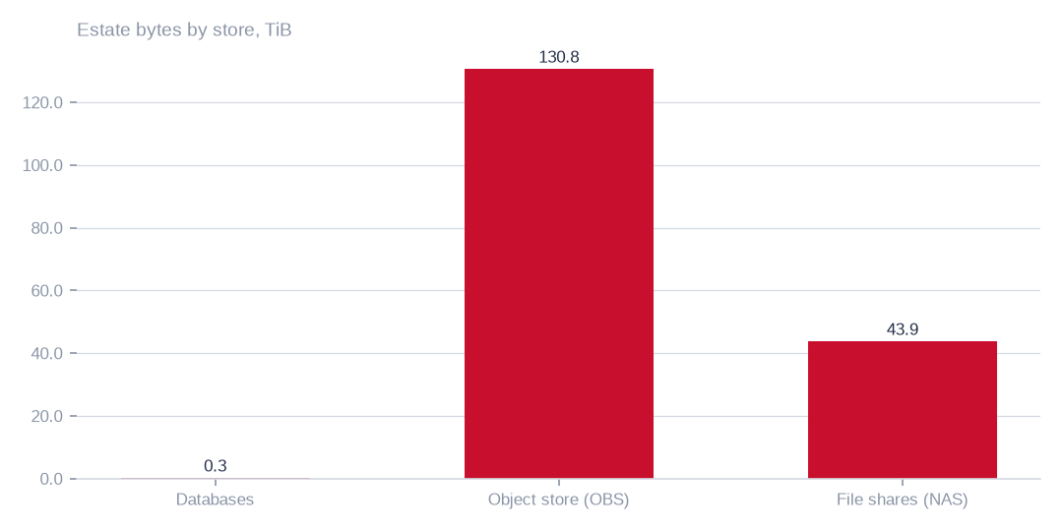
Figure: Cost and preparation effort belongs in the buckets and shares; databases are only 0.2% of the estate.
[measured] Receipt R01: Estate intelligence census eij-1b359b3cbd2e, digest-verified report (measured 2026-09-29), headline aggregates and per-database measures

One bucket dominates the object store
The largest bucket holds 86.7 TiB, which is 66.3% of the 130.8 TiB object store. Any cost or access decision about it moves the estate picture more than any other single item.
A large bucket is not proof of idleness, readability or redundancy. Read demand was not measured, so the sensible step is to gather evidence on it first, then decide.
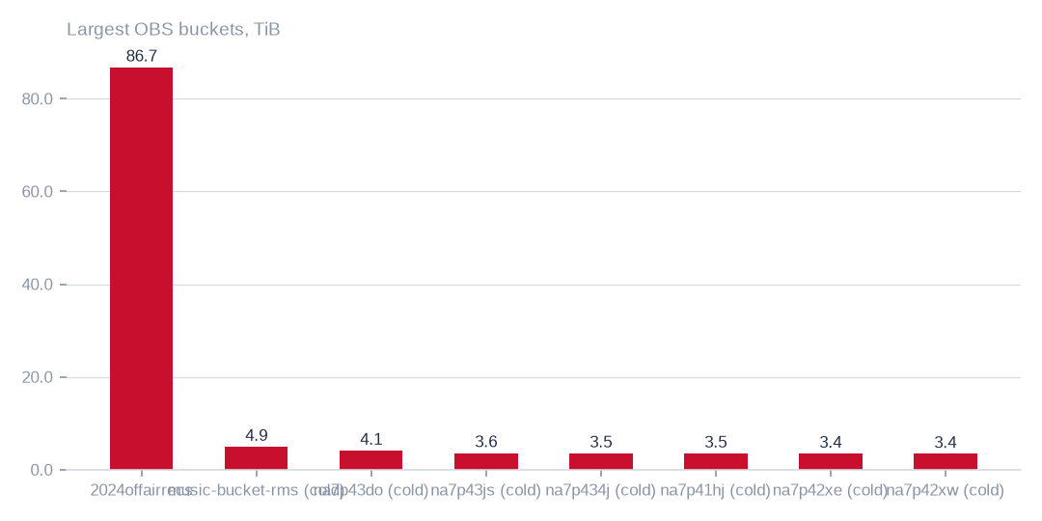
Figure: Evidence gathering should start with the largest buckets, but size alone does not show a bucket is idle, readable or safe to delete.
[measured] Receipt R04: OBS bucket enumeration census run cr-f1415e395361 (22,997,353 objects, 130.8 TiB)

Where the bytes sit
The estate totals 175.0 TiB, made up of 130.8 TiB in the object store, 43.9 TiB in file shares and 0.3 TiB in databases. These are bytes listed or measured, not content read.
For the owner, storage cost and product raw material both sit in the buckets and shares, while the databases matter mainly for condition and personal-data preparation.

What the review lists show
The registers beside this chapter name the buckets, tables and shares under review and their proposed destinations. 41.9 TiB of the object store has not been written for over a year, across 43 buckets; 7.7 TiB are fingerprint-and-size duplicate candidates. The database register identifies 368 empty tables, 71 duplicate pairs and specific cold-table candidates. Dead columns are 13.0% of measured columns.
Candidates are not confirmed copies, and file-share duplication is not measured. 40 of 106 buckets returned errors when listed and need reconciling with the provider. All destinations are proposals; nothing has been moved or deleted.
T010 Exact object-store buckets under review (largest first)
Bucket | Enumeration | Held (TiB) | Objects | Last write | Idle days | Duplicate candidates | Duplicate bytes (TiB, est.) | Main formats | Classification | Proposed action | Proposed destination
2024offairrecs | complete | 86.74 | 3,194,745 | 2026-10-02 | 0 | 16,634 | 0.45 | .mp4 3,151,459, .mp3 27,002, no_extension 15,706 | active — keep hot; heavy duplicate candidates | hash-confirm duplicate candidates, keep one copy | same bucket; duplicates replaced by references (proposed)
music-bucket-rms | complete | 4.93 | 152,801 | 2024-03-26 | 920 | 14,696 | 0.47 | .mp4 146,617, .txt 1,183, .flx 1,086 | cold — archive candidate; heavy duplicate candidates | verify storage class and read demand; tier only confirmed Standard bytes, never already Archive bytes | same bucket, archive storage class (proposed)
na7p43do | complete | 4.1 | 484,480 | 2024-04-04 | 911 | 197,528 | 1.67 | .mp3 326,105, .mts 39,439, .vis 39,437 | cold — archive candidate; heavy duplicate candidates | verify storage class and read demand; tier only confirmed Standard bytes, never already Archive bytes | same bucket, archive storage class (proposed)
na7p43js | complete | 3.57 | 307,998 | 2024-04-02 | 913 | 27,187 | 0.32 | .ogg 118,600, .mp3 85,079, .adf 25,484 | cold — archive candidate; heavy duplicate candidates | verify storage class and read demand; tier only confirmed Standard bytes, never already Archive bytes | same bucket, archive storage class (proposed)
na7p434j | complete | 3.5 | 15,377 | 2024-04-04 | 912 | 2,890 | 0.66 | .mov 5,427, .avi 4,258, .jpg 2,157 | cold — archive candidate | verify storage class and read demand; tier only confirmed Standard bytes, never already Archive bytes | same bucket, archive storage class (proposed)
na7p41hj | complete | 3.48 | 15,885 | 2024-03-27 | 919 | 1,852 | 0.41 | .mov 10,488, .mp4 2,347, .txt 1,519 | cold — archive candidate | verify storage class and read demand; tier only confirmed Standard bytes, never already Archive bytes | same bucket, archive storage class (proposed)
na7p42xe | complete | 3.44 | 13,965 | 2024-04-04 | 911 | 1,120 | 0.28 | .mp4 6,241, .mov 5,519, .txt 1,434 | cold — archive candidate | verify storage class and read demand; tier only confirmed Standard bytes, never already Archive bytes | same bucket, archive storage class (proposed)
na7p42xw | complete | 3.4 | 25,088 | 2024-03-31 | 915 | 2,391 | 0.32 | .mov 15,321, .txt 3,389, .avi 3,065 | cold — archive candidate | verify storage class and read demand; tier only confirmed Standard bytes, never already Archive bytes | same bucket, archive storage class (proposed)
na7p42yg | complete | 3.28 | 28,059 | 2024-03-31 | 915 | 4,197 | 0.49 | .mov 21,920, .txt 3,169, .jpg 1,446 | cold — archive candidate | verify storage class and read demand; tier only confirmed Standard bytes, never already Archive bytes | same bucket, archive storage class (proposed)
na7p43d3 | complete | 2.9 | 16,396 | 2024-03-30 | 916 | 1,395 | 0.25 | .mov 10,623, .txt 2,032, .avi 1,270 | cold — archive candidate | verify storage class and read demand; tier only confirmed Standard bytes, never already Archive bytes | same bucket, archive storage class (proposed)
na7p4oco | complete | 2.86 | 468,637 | 2024-04-03 | 912 | 166,328 | 1.01 | .mp3 218,902, .mts 36,886, .vis 36,878 | cold — archive candidate; heavy duplicate candidates | verify storage class and read demand; tier only confirmed Standard bytes, never already Archive bytes | same bucket, archive storage class (proposed)
rmsbroadcast | complete | 1.49 | 142,739 | 2024-03-24 | 922 | 5,060 | 0.05 | .mp3 127,221, .mp4 9,923, .mov 1,916 | cold — archive candidate | verify storage class and read demand; tier only confirmed Standard bytes, never already Archive bytes | same bucket, archive storage class (proposed)
Every bucket named here was enumerated object by object; the classification follows from its last write date and its duplicate-candidate count. Destinations are proposals.
[measured] Receipt R04: OBS bucket enumeration census run cr-f1415e395361 (22,997,353 objects, 130.8 TiB)
T011 Exact database tables under review, by finding
Table (database.table) | Finding | Measured detail | Strategy bytes | Proposed action
viusasa_staging.audits | not written for over a year | 666 days · 18.6 GiB | 54.1 GiB | export to compressed object storage with a schema stub (proposed); restore on demand
viusasa_staging.master_payments | not written for over a year | 438 days · 4.2 GiB | 54.1 GiB | export to compressed object storage with a schema stub (proposed); restore on demand
razuna.raz1_videos | not written for over a year | 1341 days · 3.0 GiB | 54.1 GiB | export to compressed object storage with a schema stub (proposed); restore on demand
viusasa_staging.payment_requests | not written for over a year | 664 days · 2.8 GiB | 54.1 GiB | export to compressed object storage with a schema stub (proposed); restore on demand
viusasa_staging.sms | not written for over a year | 583 days · 2.7 GiB | 54.1 GiB | export to compressed object storage with a schema stub (proposed); restore on demand
viusasa_staging.mpesa_stk_requests | not written for over a year | 724 days · 1.4 GiB | 54.1 GiB | export to compressed object storage with a schema stub (proposed); restore on demand
viusasa_staging.search_lookups | repeated rows inside the table | 5.9% repeated · 8.7 GiB | 1.2 GiB | de-duplicate in place after a keyed comparison; keep the newest row
viusasa_staging.playback_qualified_streams | repeated rows inside the table | 5.1% repeated · 4.6 GiB | 1.2 GiB | de-duplicate in place after a keyed comparison; keep the newest row
viusasa_staging.episode_views | repeated rows inside the table | 22.0% repeated · 764.0 MiB | 1.2 GiB | de-duplicate in place after a keyed comparison; keep the newest row
kra_reports.external_credit_notes | repeated rows inside the table | 25.0% repeated · 277.8 MiB | 1.2 GiB | de-duplicate in place after a keyed comparison; keep the newest row
viusasa_staging.new_episode_views | repeated rows inside the table | 66.1% repeated · 98.7 MiB | 1.2 GiB | de-duplicate in place after a keyed comparison; keep the newest row
viusasa_staging.ussd_hits | repeated rows inside the table | 8.5% repeated · 573.0 MiB | 1.2 GiB | de-duplicate in place after a keyed comparison; keep the newest row
iebc_forms/viupay.failed_jobs ↔ viupay/viupay.failed_jobs | two copies of the same table across connections | overlap 78.0% · 31.6 MiB | 54.0 MiB | name one authoritative copy; retire or redirect the other
iebc_forms/viutickets.movies ↔ viupay/viutickets.movies | two copies of the same table across connections | overlap 84.0% · 6.5 MiB | 54.0 MiB | name one authoritative copy; retire or redirect the other
iebc_forms/viutickets.ussd_hits ↔ viupay/viutickets.ussd_hits | two copies of the same table across connections | overlap 100.0% · 6.5 MiB | 54.0 MiB | name one authoritative copy; retire or redirect the other
iebc_forms/viutickets.payment_processings ↔ viupay/viutickets.payment_processings | two copies of the same table across connections | overlap 65.0% · 4.5 MiB | 54.0 MiB | name one authoritative copy; retire or redirect the other
iebc_forms/viupay.payment_requests ↔ viupay/viupay.payment_requests | two copies of the same table across connections | overlap 50.0% · 3.5 MiB | 54.0 MiB | name one authoritative copy; retire or redirect the other
iebc_forms/viutickets.movie_shows ↔ viupay/viutickets.movie_shows | two copies of the same table across connections | overlap 80.0% · 3.5 MiB | 54.0 MiB | name one authoritative copy; retire or redirect the other
ecommerce_tafaria.playbacks | index covered by a wider index | playbacks_playable_type_index covered by playbacks_playable_type_playable_id_index | 14.0 GiB | drop the covered index; measure write amplification before and after
viusasa_staging.clip_requests | index covered by a wider index | clip_requests_castr_stream_id_index covered by clip_requests_castr_stream_id_castr_clip_id_index | 14.0 GiB | drop the covered index; measure write amplification before and after
viusasa_staging.continue_watchings | index covered by a wider index | continue_watchings_user_id_index covered by continue_watchings_user_history_updated_index | 14.0 GiB | drop the covered index; measure write amplification before and after
viusasa_staging.duka_product_search_clicks | index covered by a wider index | duka_product_search_clicks_normalized_term_index covered by duka_product_search_clicks_normalized_term_product_id_unique | 14.0 GiB | drop the covered index; measure write amplification before and after
viusasa_staging.duka_search_synonyms | index covered by a wider index | duka_search_synonyms_synonym_index covered by duka_search_synonyms_synonym_canonical_unique | 14.0 GiB | drop the covered index; measure write amplification before and after
viusasa_staging.elimu_learner_badges | index covered by a wider index | elimu_learner_badges_badge_id_index covered by elimu_learner_badges_badge_id_sub_user_id_unique | 14.0 GiB | drop the covered index; measure write amplification before and after
ecommerce_tafaria.airtel_c2bs | empty table |  |  | drop after the application owner confirms it is unused
ecommerce_tafaria.airtel_ussd_pushes | empty table |  |  | drop after the application owner confirms it is unused
ecommerce_tafaria.album_track | empty table |  |  | drop after the application owner confirms it is unused
ecommerce_tafaria.albums | empty table |  |  | drop after the application owner confirms it is unused
ecommerce_tafaria.api_providers | empty table |  |  | drop after the application owner confirms it is unused
ecommerce_tafaria.article_menu | empty table |  |  | drop after the application owner confirms it is unused
ecommerce_tafaria.article_sources | empty table |  |  | drop after the application owner confirms it is unused
ecommerce_tafaria.articles | empty table |  |  | drop after the application owner confirms it is unused
viusasa_staging.playback_stagings | high share of personal-data markers | 91.0% of sampled rows |  | de-identify or aggregate before any product use; keep the master as is
viusasa_staging.telescope_entries | high share of personal-data markers | 79.0% of sampled rows |  | de-identify or aggregate before any product use; keep the master as is
viusasa_staging.audits | high share of personal-data markers | 100.0% of sampled rows |  | de-identify or aggregate before any product use; keep the master as is
viusasa_staging.sms | high share of personal-data markers | 100.0% of sampled rows |  | de-identify or aggregate before any product use; keep the master as is
viusasa_staging.ussd_hits | high share of personal-data markers | 100.0% of sampled rows |  | de-identify or aggregate before any product use; keep the master as is
viusasa_staging.playback_qualified_streams | high share of personal-data markers | 58.0% of sampled rows |  | de-identify or aggregate before any product use; keep the master as is
ecommerce_tafaria.invoices.order_id → orders | references pointing at rows that no longer exist | 100.0% orphaned of 4 sampled |  | repair or remove the dangling references; add a foreign-key check
ecommerce_tafaria.invoices.payment_id → payments | references pointing at rows that no longer exist | 100.0% orphaned of 1 sampled |  | repair or remove the dangling references; add a foreign-key check
viusasa_staging.active_users.user_id → user | references pointing at rows that no longer exist | 100.0% orphaned of 400 sampled |  | repair or remove the dangling references; add a foreign-key check
viusasa_staging.airtel_ussd_pushes.user_id → user | references pointing at rows that no longer exist | 100.0% orphaned of 400 sampled |  | repair or remove the dangling references; add a foreign-key check
viusasa_staging.article_menu.article_id → articles | references pointing at rows that no longer exist | 100.0% orphaned of 400 sampled |  | repair or remove the dangling references; add a foreign-key check
viusasa_staging.audits.user_id → user | references pointing at rows that no longer exist | 100.0% orphaned of 400 sampled |  | repair or remove the dangling references; add a foreign-key check
Each row names a table the census measured and the finding that puts it on the list; the bytes column is the strategy total the table belongs to, not the table alone.
[measured] Receipt R02: Estate intelligence census eij-1b359b3cbd2e, cost_strategies priced at reference list prices, not the owner's invoice: Huawei Cloud RDS for MySQL cloud SSD AF-Johannesburg 0.00015 USD/GB-hour x 730 h; OBS Standard 0.023 USD/GB-month
T012 Exact file shares (NAS) enumerated
Share | Enumeration | Held (TiB) | Files | Last write | Main formats | Proposed action
channel01 | complete | 6.87 | 95,122 | 2026-09-29 | .mp4 95,108, .rmd 6, .mpt 3 | fingerprint pass to measure duplication; then tier by channel
channel02 | complete | 6.87 | 95,134 | 2026-09-29 | .mp4 95,129, .db 1, .jpg 1 | fingerprint pass to measure duplication; then tier by channel
channel16 | complete | 6.81 | 94,597 | 2026-09-29 | .mp4 94,592, .db 1, .jpg 1 | fingerprint pass to measure duplication; then tier by channel
Channel15 | partial | 1.93 | 96,675 | 2026-10-02 | .mp4 96,667, .rmd 3, .db 1 | fingerprint pass to measure duplication; then tier by channel
Channel14 | partial | 1.93 | 96,660 | 2026-10-02 | .mp4 96,654, .rmd 2, .db 1 | fingerprint pass to measure duplication; then tier by channel
Channel11 | partial | 1.93 | 96,651 | 2026-10-02 | .mp4 96,641, .rmd 6, .db 1 | fingerprint pass to measure duplication; then tier by channel
Channel12 | partial | 1.93 | 96,658 | 2026-10-02 | .mp4 96,648, .rmd 6, .db 1 | fingerprint pass to measure duplication; then tier by channel
channel06 | partial | 1.93 | 96,614 | 2026-10-02 | .mp4 96,610, .db 1, .jpg 1 | fingerprint pass to measure duplication; then tier by channel
channel07 | partial | 1.93 | 96,606 | 2026-10-02 | .mp4 96,602, .db 1, .jpg 1 | fingerprint pass to measure duplication; then tier by channel
channel05 | partial | 1.93 | 96,600 | 2026-10-02 | .mp4 96,596, .db 1, .jpg 1 | fingerprint pass to measure duplication; then tier by channel
channel04 | partial | 1.93 | 96,584 | 2026-10-02 | .mp4 96,579, .db 1, .jpg 1 | fingerprint pass to measure duplication; then tier by channel
channel03 | partial | 1.93 | 96,538 | 2026-10-03 | .mp4 96,534, .db 1, .jpg 1 | fingerprint pass to measure duplication; then tier by channel
Sizes and dates were recorded; content fingerprints were not, so duplication across the channel shares is not yet measured.
[measured] Receipt R05: NAS share enumeration census run cr-cf4eef79995b (1,468,510 files, 43.9 TiB)
T015 Object-store buckets that could not be read
Bucket | Error returned | Proposed action
apr252017 | NoSuchBucket | reconcile with provider; remove from inventory if gone
citizen-vod | NoSuchBucket | reconcile with provider; remove from inventory if gone
elections | ClientError | reconcile with provider; remove from inventory if gone
feb272017 | NoSuchBucket | reconcile with provider; remove from inventory if gone
instore-radio-items | ClientError | reconcile with provider; remove from inventory if gone
iso-rms-storage | NoSuchBucket | reconcile with provider; remove from inventory if gone
librarydirectupload2 | NoSuchBucket | reconcile with provider; remove from inventory if gone
na7p4100 | NoSuchBucket | reconcile with provider; remove from inventory if gone
na7p410c | NoSuchBucket | reconcile with provider; remove from inventory if gone
na7p419y | NoSuchBucket | reconcile with provider; remove from inventory if gone
na7p41ab | NoSuchBucket | reconcile with provider; remove from inventory if gone
na7p41f4 | NoSuchBucket | reconcile with provider; remove from inventory if gone
na7p41j6 | NoSuchBucket | reconcile with provider; remove from inventory if gone
na7p41jk | NoSuchBucket | reconcile with provider; remove from inventory if gone
na7p42ry | NoSuchBucket | reconcile with provider; remove from inventory if gone
na7p42s5 | NoSuchBucket | reconcile with provider; remove from inventory if gone
na7p42s7 | NoSuchBucket | reconcile with provider; remove from inventory if gone
na7p42tq | NoSuchBucket | reconcile with provider; remove from inventory if gone
na7p42tz | NoSuchBucket | reconcile with provider; remove from inventory if gone
na7p435c | NoSuchBucket | reconcile with provider; remove from inventory if gone
na7p4374 | NoSuchBucket | reconcile with provider; remove from inventory if gone
na7p43d6 | NoSuchBucket | reconcile with provider; remove from inventory if gone
na7p43dj | NoSuchBucket | reconcile with provider; remove from inventory if gone
na7p43hs | NoSuchBucket | reconcile with provider; remove from inventory if gone
na7p43jw | NoSuchBucket | reconcile with provider; remove from inventory if gone
na7p49pc | NoSuchBucket | reconcile with provider; remove from inventory if gone
na7p4omz | NoSuchBucket | reconcile with provider; remove from inventory if gone
na7p4oxs | NoSuchBucket | reconcile with provider; remove from inventory if gone
na7p4oy4 | NoSuchBucket | reconcile with provider; remove from inventory if gone
na7p4oz6 | NoSuchBucket | reconcile with provider; remove from inventory if gone
obituariesdata | NoSuchBucket | reconcile with provider; remove from inventory if gone
one-signal-live-service | NoSuchBucket | reconcile with provider; remove from inventory if gone
onesignal-logos | NoSuchBucket | reconcile with provider; remove from inventory if gone
onsignal-bucket | ClientError | reconcile with provider; remove from inventory if gone
private-isos | ClientError | reconcile with provider; remove from inventory if gone
razuna-direct-access | NoSuchBucket | reconcile with provider; remove from inventory if gone
rms-acronis-backup-bucket | NoSuchBucket | reconcile with provider; remove from inventory if gone
rms-ai | NoSuchBucket | reconcile with provider; remove from inventory if gone
sdatauploadroyalmedia.co.ke | NoSuchBucket | reconcile with provider; remove from inventory if gone
seconddatauploadroyalmedia.co.ke | NoSuchBucket | reconcile with provider; remove from inventory if gone
These names are in the bucket inventory but returned an error when listed; each needs reconciling with the provider — deleted, renamed or access withdrawn.
[measured] Receipt R04: OBS bucket enumeration census run cr-f1415e395361 (22,997,353 objects, 130.8 TiB)

Where the addressable bytes are
Of the 50,800.9 GiB that all cost strategies reach, archiving buckets idle for over a year addresses 42,891.0 GiB and reconciling duplicate objects 7,840.5 GiB. Moving old database tables addresses only 54.1 GiB. The three largest strategies together address 50,785.7 GiB.
Addressed is not removed. Strategies may overlap, last-write age says nothing about reads, and part of the cold data may already sit in archive class. The chart shows where validation effort belongs, not what will be saved.
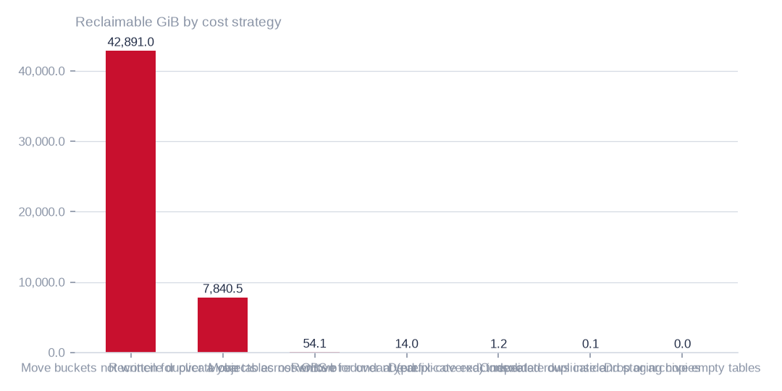
Figure: Addressed bytes are not removed bytes; strategies may overlap, and no write for a year does not show that nobody reads the data.
[estimated] Receipt R02: Estate intelligence census eij-1b359b3cbd2e, cost_strategies priced at reference list prices, not the owner's invoice: Huawei Cloud RDS for MySQL cloud SSD AF-Johannesburg 0.00015 USD/GB-hour x 730 h; OBS Standard 0.023 USD/GB-month

Three options, each conditional
Archiving buckets idle for over a year addresses 42,891.0 GiB at up to 986.5 USD a month. Reconciling duplicate objects addresses 7,840.5 GiB at up to 180.3 USD, and moving old tables to cold storage addresses 54.1 GiB at up to 5.9 USD.
All three are upper bounds at reference list prices. The legacy scenario of 1,174.4 USD assumes full Standard price while storage classes are only partly measured, and bytes already in archive class have nothing left to save. Retrieval and restore fees are not priced, duplicates are unconfirmed, and options may overlap, so the figures should not be added.
Validate storage class and read demand before the first move, and hash-confirm duplicates before the second. The third is small and worth doing only alongside other table work.
 | Move buckets not written for over a year to archive-class st | Reconcile duplicate objects across OBS buckets | Move tables not written for over a year to cold storage
Reclaimable gib | 42,891.0 | 7,840.5 | 54.1
Monthly saving usd | 986.5 | 180.3 | 5.9
Each figure is an upper bound at reference list prices; storage class, read demand and retrieval fees decide what is actually saved.
[estimated] Receipt R02: Estate intelligence census eij-1b359b3cbd2e, cost_strategies priced at reference list prices, not the owner's invoice: Huawei Cloud RDS for MySQL cloud SSD AF-Johannesburg 0.00015 USD/GB-hour x 730 h; OBS Standard 0.023 USD/GB-month

Row condition: separate signals, not one whole
The chart shows five condition measures side by side: exact duplicates at 1.5%, degraded rows at 23.0%, empty required-looking fields at 81.7%, personal-data markers in sampled rows at 71.8%, and bytes not written for over a year at 15.4%. Empty fields are the commonest row signal and exact duplicates the smallest.
These measures overlap, use different populations and include estimates, so they cannot be summed or read as shares of one whole. They indicate preparation work, not a verdict on the data.
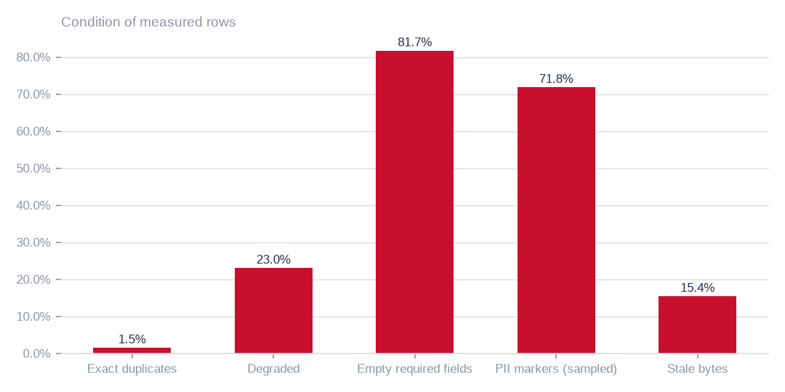
Figure: The measures overlap and use different populations, so they are separate signals, not shares of one whole.
[estimated] Receipt R01: Estate intelligence census eij-1b359b3cbd2e, digest-verified report (measured 2026-09-29), headline aggregates and per-database measures

Database bytes sit in very few databases
The largest databases hold 350.3 GiB of the 351.3 GiB, which is 99.7%. Targeted remediation there has the most operational leverage.
This exhibit is about concentration only. Database size is not a quality score, and the databases are 0.2% of the 175.0 TiB estate.
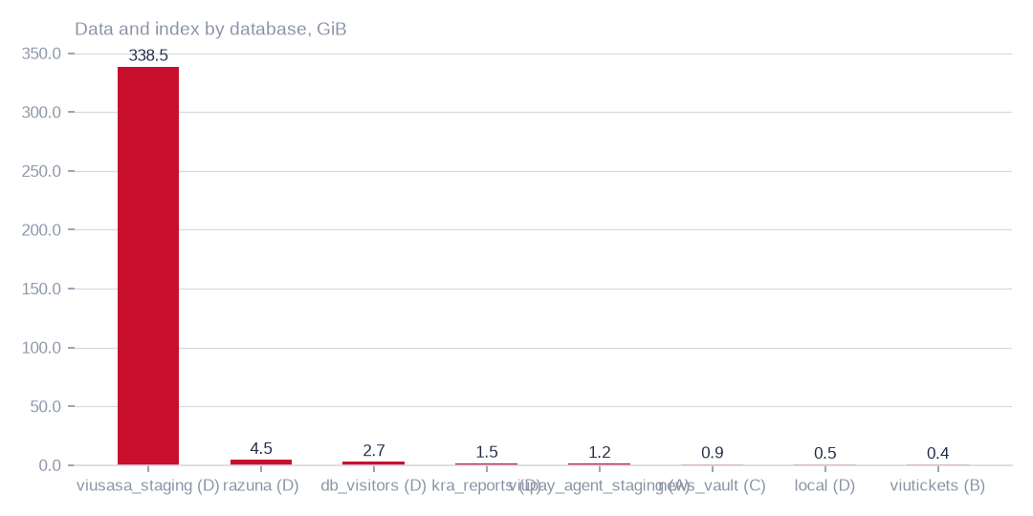
Figure: Targeted work on the largest databases has the most operational leverage; size is not a quality score or a share of the estate.
[measured] Receipt R01: Estate intelligence census eij-1b359b3cbd2e, digest-verified report (measured 2026-09-29), headline aggregates and per-database measures

What state the database rows are in
Exact duplicates are 1.5% of rows, so duplicate removal alone achieves little. The larger problems are completeness and damage: 81.7% of rows have empty required-looking fields and 23.0% are degraded. The required-looking flag is a heuristic, so the owner should decide which fields truly must be filled.
71.8% of 1.0m sampled rows carry personal-data markers. This is a measured condition, not a proven breach and not a rights question; the owner's declaration settles rights. De-identification or aggregation is a preparation step for any product. 15.4% of database bytes have not been written for over a year.

Estimated speech by language folder
Staged audio totals 529.5 recorded hours, of which an estimated 421.4 are speech once 108.2 hours of music are set aside. The chart splits speech hours by language folder; the largest folders are broadly comparable and two small folders hold very little.
These are model estimates from header duration and a music detector. They describe the staged corpus only, not every language in the estate, and are not certified speech assets.
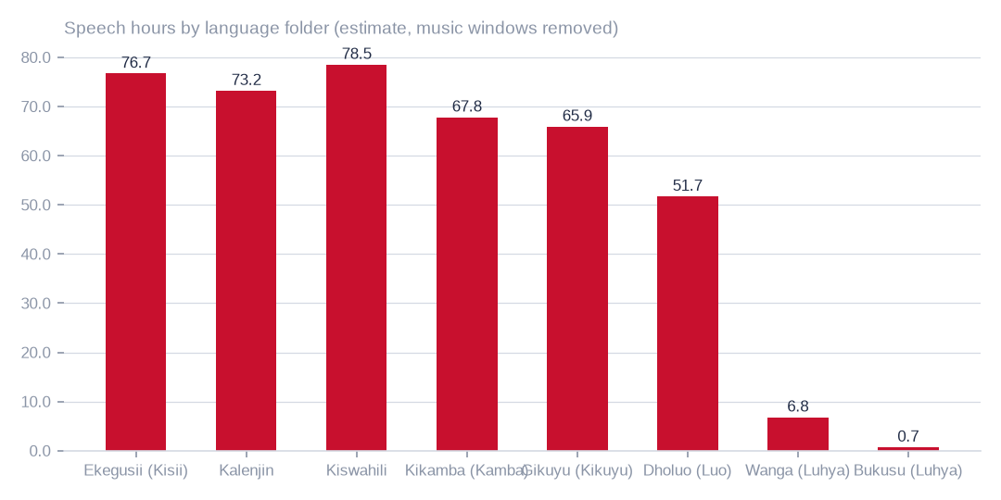
Figure: This is a bounded source for validation and preparation, not certified speech assets or an inventory of every language in the estate.
[estimated] Receipt R06: Estate language reading m9j-9e8fcb46a809 on akki-vm (2 GPUs, 1.034 GPU-h): audio language model lcj-7128593897d4 sha256 5c1feb8497e8…, music detector m9j-686de001bfe7 sha256 0fea3eee0393…; model readings, not human labels

Agreement with the folder language varies
Across all folders, 82.3% of judged windows agree with the folder language, but the chart shows the spread between folders is wide. At least one folder, with very little speech, shows no agreeing windows.
Agreement is a model reading on labelled windows, and the model declined to label 10.7% of speech windows. Low-agreement folders should go first to human review; the figure is not verified language accuracy.
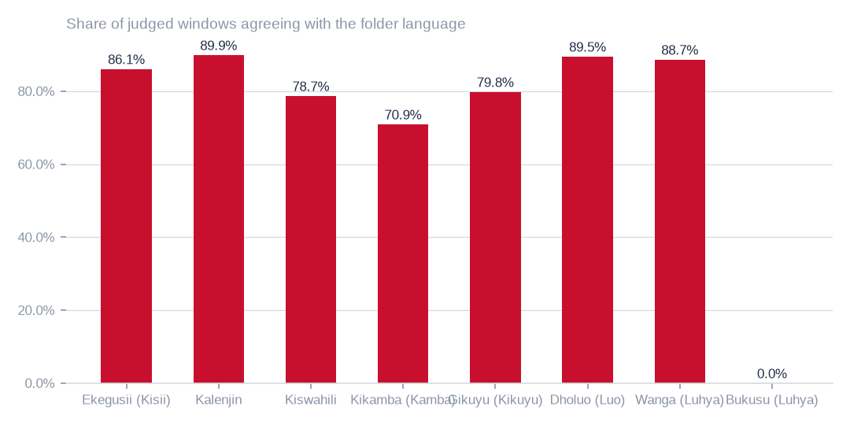
Figure: Agreement is a model reading on labelled windows, not human-verified accuracy; low-agreement folders should be checked by people first.
[measured] Receipt R06: Estate language reading m9j-9e8fcb46a809 on akki-vm (2 GPUs, 1.034 GPU-h): audio language model lcj-7128593897d4 sha256 5c1feb8497e8…, music detector m9j-686de001bfe7 sha256 0fea3eee0393…; model readings, not human labels

Staged audio: duration, speech and quality
The staged corpus holds 529.5 recorded hours in 8 language folders. Speech is 79.6% of that, an estimated 421.4 hours, with 108.2 hours of music, and 539 files are mostly music. Music filtering is therefore the first preparation step for any speech set.
Both GPUs read 3958 files in 1.0 GPU-hours. The tables beside this chapter give files, hours, agreement and quality signals by folder. Noise and intelligibility were not scored, and every reading is a model reading, not a human label.
T020 Audio held by language folder — what both GPUs read
Language folder | Language | Files | Hours recorded | Speech hours (est.) | Music hours (est.) | Agrees with folder | Declined to label | Transcript words
guz | Ekegusii (Kisii) | 732 | 92.2 | 76.7 | 15.6 | 86.1% | 8.3% | 662131
kln | Kalenjin | 295 | 89.8 | 73.2 | 16.6 | 89.9% | 7.1% | 747249
swa | Kiswahili | 549 | 87.7 | 78.5 | 9.2 | 78.7% | 12.9% | 725293
kam | Kikamba (Kamba) | 1166 | 85.4 | 67.8 | 17.6 | 70.9% | 13.2% | 669834
kik | Gikuyu (Kikuyu) | 584 | 82.1 | 65.9 | 16.2 | 79.8% | 15.4% | 583548
luo | Dholuo (Luo) | 558 | 82.1 | 51.7 | 30.4 | 89.5% | 6.8% | 739236
lwg | Wanga (Luhya) | 60 | 9.2 | 6.8 | 2.3 | 88.7% | 6.4% | 73194
bxk | Bukusu (Luhya) | 14 | 1.1 | 0.7 | 0.3 | 0.0% | 14.6% | 0
Hours are recorded duration; speech and music hours split those hours by the music detector; agreement is the share of labelled windows whose language matched the folder name. Model readings, not human labels.
[measured] Receipt R06: Estate language reading m9j-9e8fcb46a809 on akki-vm (2 GPUs, 1.034 GPU-h): audio language model lcj-7128593897d4 sha256 5c1feb8497e8…, music detector m9j-686de001bfe7 sha256 0fea3eee0393…; model readings, not human labels
T024 Audio quality signals by language folder
Language | Files | Decode failures | Silence (windows) | Music-majority files | Mixed-language files | Low-confidence files | Mean confidence | Mean length (min)
Ekegusii (Kisii) | 732 | 0 | 0.00% | 46 | 29 | 1 | 0.905 | 7.6
Kalenjin | 295 | 0 | 0.00% | 18 | 5 | 0 | 0.912 | 18.3
Kiswahili | 549 | 0 | 0.03% | 26 | 44 | 0 | 0.875 | 9.6
Kikamba (Kamba) | 1166 | 0 | 0.00% | 192 | 232 | 12 | 0.870 | 4.4
Gikuyu (Kikuyu) | 584 | 0 | 0.07% | 71 | 89 | 32 | 0.817 | 8.4
Dholuo (Luo) | 558 | 0 | 0.01% | 169 | 27 | 0 | 0.939 | 8.8
Wanga (Luhya) | 60 | 0 | 0.00% | 13 | 3 | 0 | 0.922 | 9.2
Bukusu (Luhya) | 14 | 0 | 0.00% | 4 | 11 | 0 | 0.866 | 4.6
Decode failures, digital silence, music-dominated files, mixed-language files (no language reaches sixty percent of labelled windows) and low-confidence files are the quality signals the reading can measure; noise and intelligibility were not scored.
[measured] Receipt R06: Estate language reading m9j-9e8fcb46a809 on akki-vm (2 GPUs, 1.034 GPU-h): audio language model lcj-7128593897d4 sha256 5c1feb8497e8…, music detector m9j-686de001bfe7 sha256 0fea3eee0393…; model readings, not human labels

News scripts by station
The archive holds 248841 live scripts from 13 stations, and the chart shows counts differ markedly between stations. The scripts are counted and sized, not read.
The language shown for each station is its broadcast language from the estate's own table, not a reading of the script text. A count of scripts is also not a count of unique texts, since 38.0% of rows revise an earlier script.
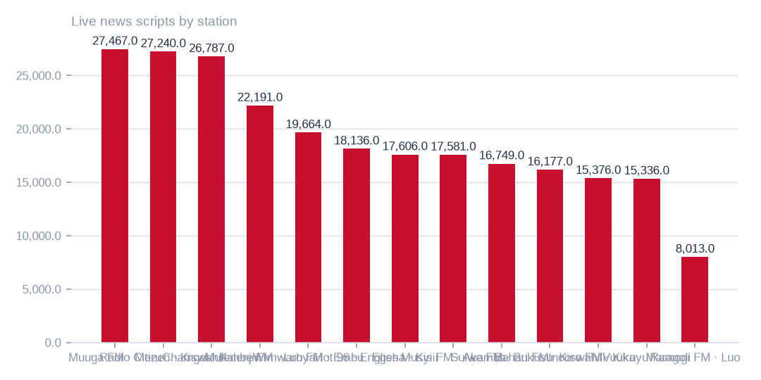
Figure: Station language is estate metadata, not a reading of each script, and script counts are not counts of unique texts.
[measured] Receipt R08: Aggregate-only database reading etx-81e10befe6e0: news_vault.stories (script, title, date, hour_id) → news_vault.hours (station_id, time, type_id) → news_vault.stations (name); news_vault.news (2022 bulletins); local.uploaded_files (language_id, audio_length, status) ← local.transcripts (file_id, start_time, end_time, transcript) ; local.folder_languages (Language, code, station)

Bulletin hours on scripted days
On the days a station has any script, the number of distinct bulletin hours varies widely between stations, as the chart shows. Some stations script most of the day and one scripts far fewer hours.
The archive is therefore useful but discontinuous. Bulletin hour slots are not recorded audio duration and do not show continuous broadcasting.
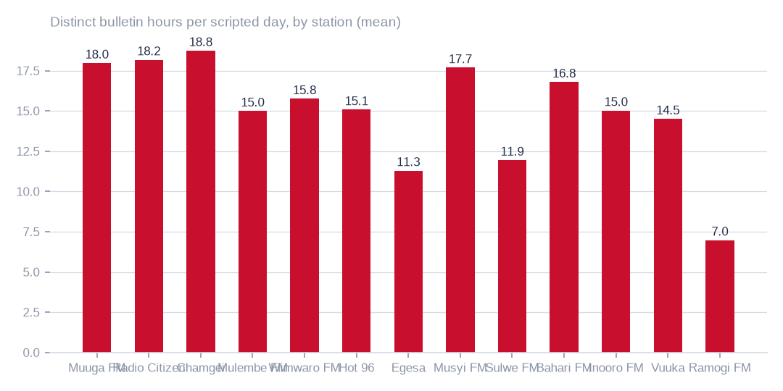
Figure: The archive is useful but discontinuous; it does not show continuous broadcasting or recorded audio duration.
[measured] Receipt R08: Aggregate-only database reading etx-81e10befe6e0: news_vault.stories (script, title, date, hour_id) → news_vault.hours (station_id, time, type_id) → news_vault.stations (name); news_vault.news (2022 bulletins); local.uploaded_files (language_id, audio_length, status) ← local.transcripts (file_id, start_time, end_time, transcript) ; local.folder_languages (Language, code, station)

Written text the estate holds
The news archive holds 248841 live scripts and 189.3m characters, but only on 226 calendar dates across 1432 days. Revisions are 38.0% of rows, 159100 distinct texts remain and 10206 rows are marked deleted, so revisions must be resolved before any corpus use.
The text model read 2245 transcripts and 99.4% of passages agree with the folder language; 1694 transcripts were not reached. The workbench registers 83014 recordings, 12,290.6 hours and 489418 segments in 13 languages. It is a separate inventory that may overlap the staged corpus, so the two are never added.
T022 Hourly news scripts by station (news_vault.stories)
Station | Broadcast language | Live scripts | Deleted | Scripted days | First date | Last date | Scripts per scripted day | Bulletin hours per scripted day | Days with all twenty-four hours | Hour slots configured | Characters
Muuga FM | Meru | 27467 | 717 | 221 | 2022-10-16 | 2026-09-16 | 127.53 | 17.98 | 1 | 24 | 14128382
Radio Citizen | Kiswahili | 27240 | 569 | 219 | 2022-10-15 | 2026-09-16 | 126.98 | 18.18 | 43 | 28 | 22231911
Chamgei | Kalenjin | 26787 | 2486 | 224 | 2022-10-15 | 2026-09-16 | 130.68 | 18.75 | 23 | 26 | 20538503
Mulembe FM | Luhya | 22191 | 889 | 225 | 2022-10-15 | 2026-09-16 | 102.58 | 15.0 | 0 | 29 | 15496412
Wimwaro FM | Embu | 19664 | 428 | 223 | 2022-10-17 | 2026-09-16 | 90.1 | 15.76 | 0 | 24 | 12408784
Hot 96 | English | 18136 | 580 | 225 | 2022-10-15 | 2026-09-16 | 83.18 | 15.08 | 0 | 23 | 12470183
Egesa | Kisii | 17606 | 868 | 219 | 2022-10-16 | 2026-09-16 | 84.36 | 11.3 | 0 | 25 | 14458656
Musyi FM | Akamba | 17581 | 623 | 199 | 2022-10-15 | 2026-09-16 | 91.48 | 17.69 | 7 | 25 | 16521768
Sulwe FM | Bukusu | 16749 | 485 | 225 | 2022-10-15 | 2026-09-16 | 76.6 | 11.95 | 0 | 24 | 14484808
Bahari FM | Kiswahili | 16177 | 1038 | 222 | 2022-10-17 | 2026-09-16 | 77.55 | 16.8 | 0 | 25 | 12789664
Inooro FM | Kikuyu | 15376 | 298 | 209 | 2022-10-15 | 2026-09-16 | 75.0 | 15.03 | 0 | 24 | 11946715
Vuuka | Maragoli | 15336 | 377 | 222 | 2022-10-17 | 2026-09-16 | 70.78 | 14.51 | 1 | 24 | 12773790
Ramogi FM | Luo | 8013 | 822 | 222 | 2022-10-17 | 2026-09-16 | 39.8 | 6.98 | 0 | 21 | 8574493
unassigned hour | — | 518 | 26 | 31 | 2026-02-18 | 2026-08-22 | 17.55 | 3.65 | 0 | 0 | 481289
A scripted day is a calendar date with at least one script for the station; bulletin hours are the distinct hour slots scripted that day. The script texts themselves were not read; the language is the station's broadcast language as recorded in the estate.
[measured] Receipt R08: Aggregate-only database reading etx-81e10befe6e0: news_vault.stories (script, title, date, hour_id) → news_vault.hours (station_id, time, type_id) → news_vault.stations (name); news_vault.news (2022 bulletins); local.uploaded_files (language_id, audio_length, status) ← local.transcripts (file_id, start_time, end_time, transcript) ; local.folder_languages (Language, code, station)
T021 Transcripts by language folder — read by the served text language model
Language folder | Language | Transcripts read | Characters | Words | Passages labelled | Agrees with folder | Files whose top label matches
guz | Ekegusii (Kisii) | 698 | 4474462 | 638478 | 3344 | 99.6% | 697
kik | Gikuyu (Kikuyu) | 298 | 1767236 | 272741 | 1323 | 99.3% | 296
luo | Dholuo (Luo) | 298 | 2347383 | 417575 | 1717 | 99.9% | 298
swa | Kiswahili | 298 | 2599230 | 411682 | 1884 | 99.6% | 298
kam | Kikamba (Kamba) | 298 | 1058430 | 173388 | 851 | 99.7% | 298
kln | Kalenjin | 295 | 4674494 | 747249 | 3258 | 99.0% | 290
lwg | Wanga (Luhya) | 60 | 491139 | 73194 | 356 | 98.3% | 59
Passages of up to fifteen hundred characters were labelled by the admitted text model; agreement is the share of passages whose label matched the folder language. Transcripts the capped pass did not reach are counted as not read.
[measured] Receipt R07: Served text language model m9j-74af7cef0a85 readings of the staged transcripts: jobs m9j-2d43ed6cf567, m9j-8cf6702f8718 (2,245 transcripts read, 3939 present)
T023 Transcription workbench by language (local.uploaded_files, local.transcripts)
Language | Code | Station | Recordings | Audio hours | Sent to transcription | With text file | Transcript segments | Transcript characters | Transcribed hours | Last processed
kiswahili | swa | Radio citizen | 4006 | 836.2 | 589 | 827 | 54516 | 4949951 | 101.0 | 2025-03-08
Bukusu | bxk | sulwe | 8223 | 806.4 | 0 | 2 | 0 | 0 | 0.0 | 2024-02-14
Kikuyu | kik | Inooro | 3640 | 670.9 | 173 | 182 | 11034 | 1050440 | 20.3 | 2025-03-08
Maragoli | mrg | Vuuka | 5503 | 559.7 | 0 | 2 | 0 | 0 | 0.0 | 2024-02-14
Embu | ebu | wimwaro | 2000 | 504.3 | 0 | 0 | 0 | 0 | 0.0 | 2024-02-13
Kalenjin | kln | Chamgei | 1280 | 500.6 | 140 | 160 | 59507 | 2628605 | 129.1 | 2025-03-08
Luo | luo | Ramogi | 3693 | 492.5 | 389 | 479 | 44184 | 2803682 | 711.1 | 2025-03-08
Kisii | guz | Egesa | 2503 | 491.0 | 390 | 412 | 44470 | 2936045 | 75.1 | 2025-03-08
luhya | lwg | mulembe | 2253 | 420.1 | 298 | 338 | 53287 | 3550675 | 7.4 | 2025-03-08
Kikuyu | kik | inooro | 853 | 401.7 | 21 | 21 | 2456 | 434679 | 9.1 | 2025-03-08
Meru | mer | muuga | 3215 | 384.2 | 0 | 0 | 0 | 0 | 0.0 | 2024-02-14
Akamba | kam | musyi | 3257 | 376.9 | 371 | 423 | 7815 | 1524452 | -26.1 | 2025-03-08
Luhya | lwg | mulembe | 3344 | 371.8 | 184 | 211 | 13849 | 955641 | 21.5 | 2025-03-08
Luo | luo | Ramogi | 3228 | 359.9 | 210 | 227 | 22805 | 1583376 | 320.6 | 2025-03-08
Maragoli | mrg | Vuuka | 3017 | 311.6 | 0 | 0 | 0 | 0 | 0.0 | 2024-02-14
Kalenjin | kln | Chamgei | 841 | 300.8 | 61 | 76 | 22301 | 969198 | 18.0 | 2025-03-08
Meru | mer | Muuga | 1973 | 282.6 | 0 | 0 | 0 | 0 | 0.0 | 2024-02-14
Embu | ebu | wimwaro | 1501 | 276.4 | 0 | 0 | 0 | 0 | 0.0 | 2024-02-13
Kikuyu | kik | inooro | 1558 | 269.7 | 85 | 89 | 5169 | 410034 | 8.6 | 2025-03-08
kisii | guz | Egesa | 1773 | 257.8 | 174 | 185 | 10237 | 1026481 | 27.9 | 2025-03-08
Kisii | guz | Egesa | 2572 | 253.3 | 205 | 234 | 10733 | 1011917 | 25.1 | 2025-03-08
Kikuyu | kik | inooro | 1139 | 237.0 | 59 | 62 | 4579 | 503323 | 11.7 | 2025-03-08
Kalenjin | kln | Chamgei | 876 | 213.7 | 112 | 138 | 30508 | 1422873 | 42.2 | 2025-03-08
Meru | mer | muuga | 1450 | 209.5 | 0 | 0 | 0 | 0 | 0.0 | 2024-02-13
Bukusu | bxk | sulwe | 2194 | 208.8 | 0 | 2 | 0 | 0 | 0.0 | 2024-02-14
Akamba | kam | musyi | 2085 | 207.5 | 335 | 382 | 6465 | 1292630 | 54.3 | 2025-03-08
Akamba | kam | musyi | 2723 | 203.7 | 317 | 358 | 3086 | 772542 | 6.8 | 2025-03-08
Luo | luo | ramogi | 1353 | 198.6 | 93 | 101 | 10113 | 717724 | 120.6 | 2025-03-08
Kikuyu | kik | inooro | 674 | 191.3 | 60 | 67 | 6852 | 618011 | 12.2 | 2025-03-08
Meru | mer | muuga | 1401 | 188.3 | 0 | 0 | 0 | 0 | 0.0 | 2024-02-14
Maragoli | mrg | Vuuka | 1144 | 150.7 | 0 | 0 | 0 | 0 | 0.0 | 2024-02-14
Embu | ebu | wimwaro | 515 | 110.1 | 0 | 0 | 0 | 0 | 0.0 | 2024-02-13
Luhya | lwg | mulembe | 1218 | 109.7 | 112 | 126 | 12130 | 701860 | 22.0 | 2025-03-08
Maragoli | mrg | Vuuka | 353 | 102.1 | 0 | 0 | 0 | 0 | 0.0 | 2024-02-14
luhya | lwg | mulembe | 519 | 100.9 | 11 | 17 | 3402 | 159512 | 2.6 | 2024-11-08
kiswahili | swa | Bahari | 196 | 94.5 | 8 | 21 | 2981 | 135554 | 2.6 | 2024-11-16
Akamba | kam | musyi | 703 | 88.7 | 88 | 101 | 3428 | 416462 | -0.9 | 2025-03-08
Akamba | kam | musyi | 764 | 84.1 | 122 | 134 | 2926 | 568579 | 11.7 | 2025-03-08
Kikuyu | kik | Inooro | 707 | 83.4 | 251 | 262 | 18776 | 1326861 | 27.4 | 2025-03-11
Embu | ebu | wimwaro | 467 | 75.6 | 0 | 0 | 0 | 0 | 0.0 | 2024-02-13
kiswahili | swa | Radio citizen | 405 | 61.7 | 0 | 2 | 0 | 0 | 0.0 | 2024-02-13
Embu | ebu | wimwaro | 311 | 60.6 | 0 | 0 | 0 | 0 | 0.0 | 2024-02-13
Akamba | kam | musyi | 584 | 41.4 | 80 | 88 | 1464 | 219117 | 4.6 | 2025-03-08
Embu | ebu | wimwaro | 199 | 37.4 | 0 | 0 | 0 | 0 | 0.0 | 2024-02-13
Meru | mer | muuga | 168 | 24.3 | 0 | 0 | 0 | 0 | 0.0 | 2024-02-14
Kikuyu | kik | inooro | 363 | 24.1 | 17 | 17 | 679 | 42276 | 0.8 | 2024-10-31
kisii | guz | Egesa | 71 | 23.0 | 3 | 3 | 574 | 39543 | 0.7 | 2025-03-08
Kalenjin | kln | Chamgei | 62 | 13.1 | 8 | 10 | 2021 | 79361 | 1.7 | 2025-03-08
kiswahili | swa | Radio citizen | 61 | 9.7 | 7 | 11 | 1139 | 78331 | 0.8 | 2024-12-30
kiswahili | swa | Bahari | 76 | 8.7 | 4 | 9 | 108 | 11253 | 0.2 | 2024-11-13
The workbench registers recordings per language with their length and whether a transcript was produced; transcript hours are the summed segment spans. This is a separate inventory from the staged corpus and may overlap it — the two are not added together anywhere in this pack.
[measured] Receipt R08: Aggregate-only database reading etx-81e10befe6e0: news_vault.stories (script, title, date, hour_id) → news_vault.hours (station_id, time, type_id) → news_vault.stations (name); news_vault.news (2022 bulletins); local.uploaded_files (language_id, audio_length, status) ← local.transcripts (file_id, start_time, end_time, transcript) ; local.folder_languages (Language, code, station)

Hours held in the readable buckets
The readable buckets hold an estimated 41,098.4 hours, and the chart shows a few buckets carry most of them. 242569 files were header-probed and the rest extrapolated by each folder's seconds-per-byte.
These are header-derived estimates, not decoded hours, and some durations use bitrate estimates. Validation effort should follow scale, starting with the largest buckets.
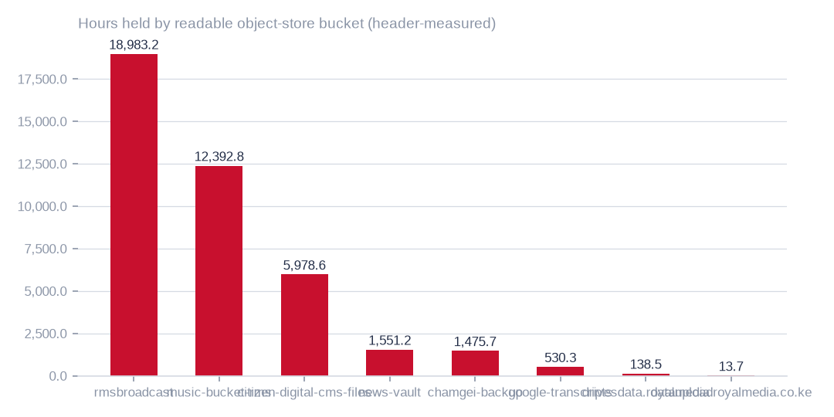
Figure: Hours rest on file headers plus per-folder extrapolation; they are not decoded hours, and validation should follow scale.
[estimated] Receipt R10: Interim tiered content census (content_sample); snapshots OBS 2026-10-03T01:40:08.564624+00:00; NAS 2026-10-03T01:38:24.195696+00:00; receipts cr-81526aa143aa, cr-8640b1cbcbc6, cr-aa33fffba60e, cr-bbf71c8d905a, cr-cf4eef79995b, cr-f1415e395361 on akki-vm and akki-vm-ii. Resumable listing, header probes of accessible audio and a per-folder video sample (ranged reads → ffprobe), with unprobed durations extrapolated where possible; a seeded stratified sample of files per folder read byte for byte, verified against the listing and judged on every two-second window by the admitted music detector and the current audio language model; ratio estimators with finite-population correction give the 95 % intervals. Listing, probing and sampling are incomplete. Model readings, not human labels; intervals exclude model error and inaccessible or unsampled content.

Estimated speech by language
Kiswahili and Gikuyu lead model-estimated speech hours in the currently covered readable scope. The object-store sample has 7523 full reads and the separate file-share sample 185. Sampling intervals exclude model error, unread folders and inaccessible content; these are not human-certified language assets.
The intervals exclude classification error. Abstentions and unsupported languages are not redistributed, and unread or inaccessible content is excluded, so the chart is a guide to where to validate, not a language inventory.
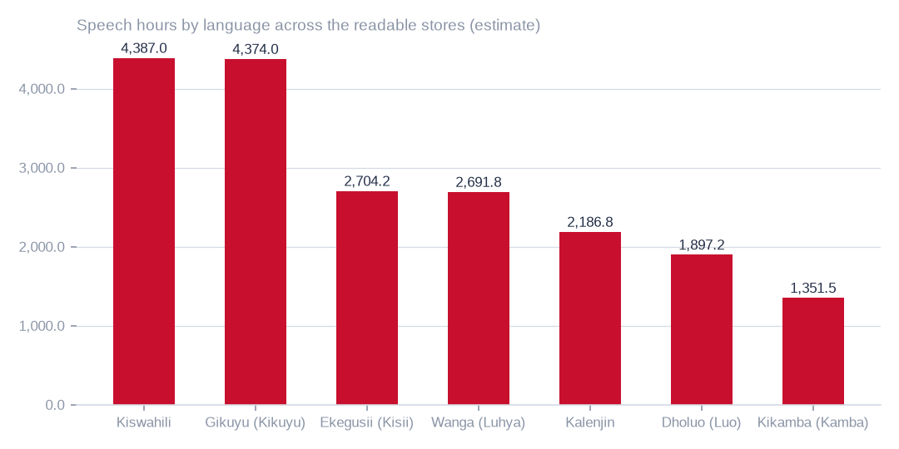
Figure: Abstentions and unsupported languages are not redistributed, and sampling intervals exclude classification error.
[estimated] Receipt R10: Interim tiered content census (content_sample); snapshots OBS 2026-10-03T01:40:08.564624+00:00; NAS 2026-10-03T01:38:24.195696+00:00; receipts cr-81526aa143aa, cr-8640b1cbcbc6, cr-aa33fffba60e, cr-bbf71c8d905a, cr-cf4eef79995b, cr-f1415e395361 on akki-vm and akki-vm-ii. Resumable listing, header probes of accessible audio and a per-folder video sample (ranged reads → ffprobe), with unprobed durations extrapolated where possible; a seeded stratified sample of files per folder read byte for byte, verified against the listing and judged on every two-second window by the admitted music detector and the current audio language model; ratio estimators with finite-population correction give the 95 % intervals. Listing, probing and sampling are incomplete. Model readings, not human labels; intervals exclude model error and inaccessible or unsampled content.

What can be read, and what cannot
Of listed object-store media files, 0.4m sit in readable buckets and 4.2m, holding 120.7 TiB, sit in buckets that require access or restoration; 90.7% are outside the currently readable scope. 15 buckets refuse object reads and 2 require a restore. Their listed files and bytes are counted, but their hours and languages remain unknown.
In the readable scope, hours are estimated at 41,098.4, with 22,464.9 speech and 19,833.7 music; speech is 54.7% of the header total. The estimators need not add to it. Sampling is unfinished, so granting access and completing the high-volume folders will improve this baseline most.
T040 Media stores — what was listed, what could be read, hours held and what the sample says (largest first)
Store | Bucket / share | Access | State | Media files | Media bytes (TiB) | Hours held (95 %) | Speech hours (95 %) | Music hours (95 %) | Top languages (speech hours) | Sample read / planned | Egress (USD)
OBS | 2024offairrecs | key refused (403) | not measurable | 3,178,461 | 86.73 | not measurable | — | — | — | 0 / 12,497 | 0.00
OBS | music-bucket-rms | readable | sample complete | 147,127 | 4.9 | 12,392.8 (11,317.5–13,468.1) | 1,844.5 (1,560.9–2,128.1) | 11,413.9 (10,175.5–12,652.4) | Gikuyu (Kikuyu) 312 h; Kalenjin 240 h; Kikamba (Kamba) 159 h | 630 / 630 | 2.27
OBS | na7p43do | key refused (403) | not measurable | 384,572 | 3.98 | not measurable | — | — | — | 0 / 981 | 0.00
OBS | na7p43js | key refused (403) | not measurable | 238,007 | 3.54 | not measurable | — | — | — | 0 / 713 | 0.00
OBS | na7p434j | key refused (403) | not measurable | 10,750 | 3.48 | not measurable | — | — | — | 0 / 1,661 | 0.00
OBS | na7p41hj | key refused (403) | not measurable | 14,145 | 3.47 | not measurable | — | — | — | 0 / 2,347 | 0.00
OBS | na7p42xe | key refused (403) | not measurable | 12,300 | 3.44 | not measurable | — | — | — | 0 / 2,915 | 0.00
OBS | na7p42xw | key refused (403) | not measurable | 20,559 | 3.4 | not measurable | — | — | — | 0 / 3,647 | 0.00
OBS | na7p42yg | key refused (403) | not measurable | 23,080 | 3.28 | not measurable | — | — | — | 0 / 3,567 | 0.00
OBS | na7p43d3 | key refused (403) | not measurable | 13,318 | 2.9 | not measurable | — | — | — | 0 / 1,111 | 0.00
OBS | na7p4oco | key refused (403) | not measurable | 272,080 | 2.65 | not measurable | — | — | — | 0 / 925 | 0.00
OBS | rmsbroadcast | readable | sample complete | 141,564 | 1.49 | 18,983.2 (18,950.7–19,015.8) | 13,928.7 (13,433.2–14,424.1) | 5,415.6 (4,921.5–5,909.6) | Gikuyu (Kikuyu) 2,473 h; Ekegusii (Kisii) 1,971 h; Kalenjin 1,527 h | 1,799 / 1,800 | 4.85
OBS | na7p4357 | key refused (403) | not measurable | 2,228 | 1.36 | not measurable | — | — | — | 0 / 1,039 | 0.00
OBS | na7p43df | key refused (403) | not measurable | 1,071 | 1.36 | not measurable | — | — | — | 0 / 369 | 0.00
OBS | citizen-digital-cms-files | readable | sample complete | 44,818 | 1.09 | 5,978.6 (5,956.4–6,000.8) | 4,700.3 (4,567.2–4,833.4) | 1,264.0 (1,131.3–1,396.7) | Gikuyu (Kikuyu) 1,058 h; Ekegusii (Kisii) 487 h; Kalenjin 196 h | 1,330 / 1,336 | 6.33
OBS | na7p43ax | key refused (403) | not measurable | 767 | 0.92 | not measurable | — | — | — | 0 / 247 | 0.00
OBS | drivesdata.royalmedia | readable | sample complete | 538 | 0.42 | 138.5 (137.4–139.6) | 104.9 (92.0–117.8) | 50.3 (44.6–56.0) | Ekegusii (Kisii) 28 h; Kalenjin 5 h; Gikuyu (Kikuyu) 5 h | 192 / 192 | 19.13
OBS | mar142017 | readable | every file read | 17 | 0.27 | 13.5 | 11.0 | 2.4 | Ekegusii (Kisii) 2 h; Gikuyu (Kikuyu) 2 h; Kalenjin 1 h | 17 / 17 | 30.00
OBS | datauploadroyalmedia.co.ke | readable | sample complete | 181 | 0.19 | 13.7 | 9.5 (8.4–10.7) | 3.8 (2.5–5.0) | Gikuyu (Kikuyu) 3 h; Ekegusii (Kisii) 1 h; Kalenjin 0 h | 30 / 30 | 5.82
OBS | na7p49p9 | key refused (403) | not measurable | 1,649 | 0.19 | not measurable | — | — | — | 0 / 1,037 | 0.00
OBS | chamgei-backup | readable | sample complete | 16,302 | 0.15 | 1,475.7 | 142.6 (126.5–158.6) | 1,327.2 (1,311.1–1,343.3) | Kalenjin 25 h; Gikuyu (Kikuyu) 24 h; Kikamba (Kamba) 9 h | 1,111 / 1,111 | 4.05
OBS | news-vault | readable | sample complete | 72,588 | 0.11 | 1,551.2 (1,551.2–1,551.3) | 1,293.3 (1,266.8–1,319.8) | 236.9 (210.3–263.6) | Gikuyu (Kikuyu) 335 h; Ekegusii (Kisii) 82 h; Kalenjin 79 h | 1,349 / 1,352 | 1.64
OBS | google-transcripts | readable | sample complete | 3,833 | 0.03 | 530.3 | 417.3 (408.5–426.1) | 112.1 (103.3–120.9) | Kalenjin 73 h; Ekegusii (Kisii) 65 h; Gikuyu (Kikuyu) 58 h | 796 / 796 | 0.95
OBS | razuna-ireland-replication-7sep2017 | readable | every file read | 48 | 0.01 | 8.5 | 4.4 | 4.1 | Ekegusii (Kisii) 1 h; Gikuyu (Kikuyu) 1 h; Kalenjin 0 h | 48 / 48 | 1.52
OBS | citizentv | readable | sample complete | 215 | 0.0 | 7.8 | 6.1 (5.9–6.3) | 1.6 (1.4–1.8) | Gikuyu (Kikuyu) 1 h; Ekegusii (Kisii) 1 h; Kalenjin 0 h | 106 / 106 | 0.28
OBS | test-regionireland | readable | every file read | 2 | 0.0 | 0.1 | 0.0 | 0.0 | Ekegusii (Kisii) 0 h; Kalenjin 0 h; Dholuo (Luo) 0 h | 1 / 2 | 0.03
OBS | razuna.royalmedia | readable | every file read | 5 | 0.0 | 0.8 | 0.5 | 0.3 | Ekegusii (Kisii) 0 h; Gikuyu (Kikuyu) 0 h; Kalenjin 0 h | 5 / 5 | 0.10
OBS | elections-portal | key refused (403) | not measurable | 55 | 0.0 | not measurable | — | — | — | 0 / 55 | 0.00
OBS | test-viusasa-bucket | archive · restore needed | not measurable | 582 | 0.0 | not measurable | — | — | — | 0 / 30 | 0.00
OBS | viusasanews | readable | sample complete | 75 | 0.0 | 1.8 | 1.3 (1.1–1.5) | 0.4 (0.2–0.6) | Kikamba (Kamba) 0 h; Gikuyu (Kikuyu) 0 h; Ekegusii (Kisii) 0 h | 33 / 33 | 0.02
OBS | citizen-classifieds | readable | every file read | 41 | 0.0 | 0.1 | 0.0 | 0.0 | Ekegusii (Kisii) 0 h; Gikuyu (Kikuyu) 0 h; Dholuo (Luo) 0 h | 5 / 41 | 0.01
OBS | edailynew | readable | every file read | 29 | 0.0 | 0.5 | 0.3 | 0.1 | Ekegusii (Kisii) 0 h; Gikuyu (Kikuyu) 0 h; Kikamba (Kamba) 0 h | 27 / 29 | 0.02
OBS | fast-channels | archive · restore needed | not measurable | 2 | 0.0 | not measurable | — | — | — | 0 / 2 | 0.00
OBS | skizaaudio | readable | sample complete | 114 | 0.0 | 1.3 | 0.1 (0.0–0.2) | 1.2 (1.1–1.2) | Gikuyu (Kikuyu) 0 h; Dholuo (Luo) 0 h; Kikamba (Kamba) 0 h | 34 / 34 | 0.01
OBS | rekognition-video-console-demo-dub-917562226170-nm20tsok0pm1ea | readable | every file read | 1 | 0.0 | 0.0 | 0.0 | 0.0 | Dholuo (Luo) 0 h; Kiswahili 0 h | 1 / 1 | 0.00
OBS | miss-intl-somalia | readable | every file read | 7 | 0.0 | 0.0 | 0.0 | 0.0 | Ekegusii (Kisii) 0 h | 7 / 7 | 0.00
OBS | royalmedia | readable | every file read | 2 | 0.0 | 0.0 | 0.0 | 0.0 | — | 2 / 2 | 0.00
NAS | Channel15 | readable | sampling | 99,547 | 1.99 | — | — | — | — | 0 / 730 | —
NAS | Channel14 | readable | sampling | 96,654 | 1.93 | — | — | — | — | 0 / 716 | —
NAS | Channel11 | readable | sampling | 96,641 | 1.93 | — | — | — | — | 0 / 715 | —
NAS | Channel12 | readable | sampling | 96,648 | 1.93 | — | — | — | — | 0 / 715 | —
NAS | channel06 | readable | sampling | 96,610 | 1.93 | — | — | — | — | 0 / 715 | —
NAS | channel07 | readable | sampling | 96,602 | 1.93 | — | — | — | — | 0 / 715 | —
NAS | channel05 | readable | sampling | 96,596 | 1.93 | — | — | — | — | 0 / 715 | —
NAS | channel04 | readable | sampling | 96,579 | 1.93 | — | — | — | — | 0 / 715 | —
NAS | channel03 | readable | sampling | 96,534 | 1.93 | — | — | — | — | 0 / 714 | —
NAS | Channel09 | readable | sampling | 96,309 | 1.92 | — | — | — | — | 155 / 713 | —
NAS | Channel10 | readable | listing | 66,415 | 1.32 | — | — | — | — | 0 / 492 | —
NAS | channel08 | readable | listing | 25,675 | 0.51 | — | — | — | — | 0 / 2,717 | —
NAS | Channel13 | readable | sampling | 27,246 | 0.27 | 2,608.5 | 1,819.9 (1,571.6–2,068.3) | 779.6 (531.2–1,027.9) | Kikamba (Kamba) 403 h; Gikuyu (Kikuyu) 104 h; Kalenjin 42 h | 30 / 115 | —
NAS | channel01 | no media | — | 0 | 0.0 | — | — | — | — | 0 / 0 | —
NAS | channel02 | no media | — | 0 | 0.0 | — | — | — | — | 0 / 0 | —
NAS | channel16 | no media | — | 0 | 0.0 | — | — | — | — | 0 / 0 | —
Interim accessible-scope baseline, not a completed census. Hours held combine available header probes with per-folder extrapolation; speech, music and language quantities are model-derived sample estimates. Parentheses show 95 % sampling intervals where available; these exclude model error, unmeasured folders and inaccessible content. Missing or zero-width intervals do not establish certainty.
[estimated] Receipt R10: Interim tiered content census (content_sample); snapshots OBS 2026-10-03T01:40:08.564624+00:00; NAS 2026-10-03T01:38:24.195696+00:00; receipts cr-81526aa143aa, cr-8640b1cbcbc6, cr-aa33fffba60e, cr-bbf71c8d905a, cr-cf4eef79995b, cr-f1415e395361 on akki-vm and akki-vm-ii. Resumable listing, header probes of accessible audio and a per-folder video sample (ranged reads → ffprobe), with unprobed durations extrapolated where possible; a seeded stratified sample of files per folder read byte for byte, verified against the listing and judged on every two-second window by the admitted music detector and the current audio language model; ratio estimators with finite-population correction give the 95 % intervals. Listing, probing and sampling are incomplete. Model readings, not human labels; intervals exclude model error and inaccessible or unsampled content.
T042 Object-store buckets the census key cannot read — counted, never estimated
Bucket | State | Media files | Audio files | Video files | Media bytes (TiB) | Bytes already in Archive class (TiB) | Refused since | Action required
2024offairrecs | key refused (403 AccessDenied) | 3,178,461 | 27,002 | 3,151,459 | 86.73 | — | first probe | grant obs:object:GetObject to the census key (IAM or bucket policy)
na7p43do | key refused (403 AccessDenied) | 384,572 | 343,266 | 41,306 | 3.98 | — | first probe | grant obs:object:GetObject to the census key (IAM or bucket policy)
na7p43js | key refused (403 AccessDenied) | 238,007 | 215,594 | 22,413 | 3.54 | — | first probe | grant obs:object:GetObject to the census key (IAM or bucket policy)
na7p434j | key refused (403 AccessDenied) | 10,750 | 7 | 10,743 | 3.48 | — | first probe | grant obs:object:GetObject to the census key (IAM or bucket policy)
na7p41hj | key refused (403 AccessDenied) | 14,145 | 4 | 14,141 | 3.47 | — | first probe | grant obs:object:GetObject to the census key (IAM or bucket policy)
na7p42xe | key refused (403 AccessDenied) | 12,300 | 4 | 12,296 | 3.44 | — | first probe | grant obs:object:GetObject to the census key (IAM or bucket policy)
na7p42xw | key refused (403 AccessDenied) | 20,559 | 78 | 20,481 | 3.4 | — | first probe | grant obs:object:GetObject to the census key (IAM or bucket policy)
na7p42yg | key refused (403 AccessDenied) | 23,080 | 19 | 23,061 | 3.28 | — | first probe | grant obs:object:GetObject to the census key (IAM or bucket policy)
na7p43d3 | key refused (403 AccessDenied) | 13,318 | 19 | 13,299 | 2.9 | — | first probe | grant obs:object:GetObject to the census key (IAM or bucket policy)
na7p4oco | key refused (403 AccessDenied) | 272,080 | 230,813 | 41,267 | 2.65 | — | first probe | grant obs:object:GetObject to the census key (IAM or bucket policy)
na7p4357 | key refused (403 AccessDenied) | 2,228 | 1 | 2,227 | 1.36 | — | first probe | grant obs:object:GetObject to the census key (IAM or bucket policy)
na7p43df | key refused (403 AccessDenied) | 1,071 | 4 | 1,067 | 1.36 | — | first probe | grant obs:object:GetObject to the census key (IAM or bucket policy)
na7p43ax | key refused (403 AccessDenied) | 767 | 0 | 767 | 0.92 | — | first probe | grant obs:object:GetObject to the census key (IAM or bucket policy)
na7p49p9 | key refused (403 AccessDenied) | 1,649 | 0 | 1,649 | 0.19 | — | first probe | grant obs:object:GetObject to the census key (IAM or bucket policy)
elections-portal | key refused (403 AccessDenied) | 55 | 0 | 55 | 0.0 | — | first probe | grant obs:object:GetObject to the census key (IAM or bucket policy)
test-viusasa-bucket | Archive class · InvalidObjectState | 582 | 0 | 582 | 0.0 | — | first probe | decide: restore (fee) or leave counted only
fast-channels | Archive class · InvalidObjectState | 2 | 0 | 2 | 0.0 | — | first probe | decide: restore (fee) or leave counted only
Denied and restore-required buckets are listed separately. Denied buckets require an object-read grant; Archive objects that return InvalidObjectState require a restore decision and its retrieval cost. Listed files and bytes do not establish their hours or languages.
[measured] Receipt R10: Interim tiered content census (content_sample); snapshots OBS 2026-10-03T01:40:08.564624+00:00; NAS 2026-10-03T01:38:24.195696+00:00; receipts cr-81526aa143aa, cr-8640b1cbcbc6, cr-aa33fffba60e, cr-bbf71c8d905a, cr-cf4eef79995b, cr-f1415e395361 on akki-vm and akki-vm-ii. Resumable listing, header probes of accessible audio and a per-folder video sample (ranged reads → ffprobe), with unprobed durations extrapolated where possible; a seeded stratified sample of files per folder read byte for byte, verified against the listing and judged on every two-second window by the admitted music detector and the current audio language model; ratio estimators with finite-population correction give the 95 % intervals. Listing, probing and sampling are incomplete. Model readings, not human labels; intervals exclude model error and inaccessible or unsampled content.
T041 Folders sampled — hours held, speech, music and languages with 95 % intervals (ranked by estimated speech hours)
Bucket / share | Folder | Files | Hours held | Speech hours (95 %) | Music hours (95 %) | Languages (speech hours) | Files read / planned | Status
rmsbroadcast | rmsradio/podcasts/uploads/podcasts · audio | 128,167 | 18,217.5 | 13,156.6 (12,665.3–13,648.0) | 5,025.7 (4,533.8–5,517.6) | Gikuyu (Kikuyu) 2,355 h; Kiswahili 1,974 h; Ekegusii (Kisii) 1,902 h | 600 / 600 | sample complete
citizen-digital-cms-files | (44,766 folders) · audio · 2024 | 28,882 | 5,700.2 | 4,509.4 (4,377.4–4,641.4) | 1,181.8 (1,049.7–1,313.8) | Wanga (Luhya) 1,089 h; Gikuyu (Kikuyu) 1,032 h; Kiswahili 617 h | 600 / 600 | sample complete
music-bucket-rms | (125 folders) · video · 2024 | 146,617 | 12,351.0 | 1,841.1 (1,557.5–2,124.6) | 11,375.8 (10,137.3–12,614.3) | Kiswahili 353 h; Gikuyu (Kikuyu) 311 h; Kalenjin 239 h | 600 / 600 | sample complete
Channel13 | Channel13 · 2026 · audio | 15,657 | 2,608.5 | 1,819.9 (1,571.6–2,068.3) | 779.6 (531.2–1,027.9) | Kiswahili 773 h; Kikamba (Kamba) 403 h; Dholuo (Luo) 136 h | 30 / 30 | sample complete
news-vault | public · 2026 · audio | 63,769 | 1,302.0 | 1,108.8 (1,084.3–1,133.3) | 175.0 (150.4–199.7) | Gikuyu (Kikuyu) 282 h; Kiswahili 270 h; Wanga (Luhya) 103 h | 600 / 600 | sample complete
rmsbroadcast | rmsradio/podcasts/uploads/podcasts · video | 13,397 | 765.7 | 772.0 (708.3–835.7) | 389.9 (343.8–436.0) | Kiswahili 223 h; Gikuyu (Kikuyu) 118 h; Ekegusii (Kisii) 69 h | 1,199 / 1,200 | sample complete
news-vault | uploads · 2024 · audio | 8,745 | 244.0 | 183.2 (173.2–193.2) | 58.0 (48.0–68.1) | Gikuyu (Kikuyu) 53 h; Kiswahili 39 h; Wanga (Luhya) 19 h | 678 / 678 | sample complete
citizen-digital-cms-files | (44,766 folders) · video · 2024 | 14,230 | 212.4 | 134.2 (117.3–151.2) | 73.3 (61.1–85.6) | Dholuo (Luo) 24 h; Kiswahili 19 h; Gikuyu (Kikuyu) 18 h | 586 / 590 | sample complete
chamgei-backup | CHAMGEI/MAIN/AUDIO O/Audio | 12,523 | 1,116.1 | 120.8 (105.2–136.4) | 991.0 (975.3–1,006.6) | Kalenjin 21 h; Gikuyu (Kikuyu) 21 h; Dholuo (Luo) 17 h | 600 / 600 | sample complete
google-transcripts | datasets/swa | 550 | 87.8 | 80.3 (78.1–82.5) | 7.4 (5.2–9.6) | Kiswahili 56 h; Dholuo (Luo) 4 h; Gikuyu (Kikuyu) 4 h | 122 / 122 | sample complete
drivesdata.royalmedia | DR007 | 330 | 99.3 | 79.2 (70.6–87.9) | 43.2 (37.7–48.6) | Ekegusii (Kisii) 22 h; Dholuo (Luo) 22 h; Kiswahili 7 h | 138 / 138 | sample complete
google-transcripts | datasets/kln | 311 | 96.3 | 77.2 (74.0–80.4) | 18.9 (15.7–22.2) | Kalenjin 64 h; Wanga (Luhya) 2 h; Gikuyu (Kikuyu) 2 h | 134 / 134 | sample complete
google-transcripts | datasets/kik | 606 | 87.7 | 70.0 (66.0–74.0) | 17.5 (13.5–21.5) | Gikuyu (Kikuyu) 48 h; Ekegusii (Kisii) 5 h; Kiswahili 2 h | 122 / 122 | sample complete
google-transcripts | datasets/guz | 676 | 85.5 | 67.6 (64.9–70.4) | 17.7 (14.9–20.5) | Ekegusii (Kisii) 52 h; Wanga (Luhya) 3 h; Kalenjin 3 h | 119 / 119 | sample complete
google-transcripts | datasets/kam | 1,061 | 81.0 | 65.0 (60.3–69.6) | 15.8 (11.1–20.5) | Kikamba (Kamba) 41 h; Ekegusii (Kisii) 6 h; Dholuo (Luo) 3 h | 112 / 112 | sample complete
google-transcripts | datasets/luo | 555 | 81.7 | 49.6 (45.5–53.7) | 32.0 (27.9–36.1) | Dholuo (Luo) 41 h; Ekegusii (Kisii) 2 h; Gikuyu (Kikuyu) 1 h | 113 / 113 | sample complete
drivesdata.royalmedia | DR005 | 208 | 39.2 | 25.6 (16.1–35.2) | 7.1 (5.4–8.9) | Ekegusii (Kisii) 6 h; Dholuo (Luo) 5 h; Kiswahili 4 h | 54 / 54 | sample complete
citizen-digital-cms-files | (44,766 folders) · audio · 2026 | 159 | 27.3 | 24.7 (23.7–25.7) | 2.6 (1.6–3.6) | Kiswahili 13 h; Gikuyu (Kikuyu) 3 h; Dholuo (Luo) 2 h | 38 / 38 | sample complete
chamgei-backup | CHAMGEI/MAIN/AUDIO O/FFOutput | 3,766 | 358.8 | 21.6 (18.1–25.1) | 335.4 (331.7–339.2) | Kiswahili 5 h; Kalenjin 4 h; Gikuyu (Kikuyu) 3 h | 498 / 498 | sample complete
citizen-digital-cms-files | (44,766 folders) · video · 2025 | 1,431 | 26.1 | 20.6 (16.1–25.2) | 5.0 (1.0–9.1) | Gikuyu (Kikuyu) 5 h; Kiswahili 3 h; Dholuo (Luo) 2 h | 35 / 36 | sample complete
datauploadroyalmedia.co.ke | imported | 181 | 13.7 | 9.5 (8.4–10.7) | 3.8 (2.5–5.0) | Gikuyu (Kikuyu) 3 h; Kiswahili 2 h; Ekegusii (Kisii) 1 h | 30 / 30 | sample complete
mar142017 | Know Zone | 11 | 10.5 | 8.6 | 1.9 | Ekegusii (Kisii) 2 h; Gikuyu (Kikuyu) 1 h; Kiswahili 1 h | 11 / 11 | read whole
google-transcripts | datasets/lwg | 60 | 9.2 | 6.8 | 2.3 | Wanga (Luhya) 6 h; Ekegusii (Kisii) 0 h; Kiswahili 0 h | 60 / 60 | read whole
citizen-digital-cms-files | (44,766 folders) · audio · 2025 | 42 | 7.0 | 6.4 | 0.7 | Kiswahili 2 h; Gikuyu (Kikuyu) 1 h; Ekegusii (Kisii) 0 h | 42 / 42 | read whole
citizen-digital-cms-files | (44,766 folders) · video · 2026 | 74 | 5.5 | 5.0 (4.8–5.2) | 0.6 (0.5–0.7) | Dholuo (Luo) 2 h; Ekegusii (Kisii) 1 h; Kiswahili 0 h | 29 / 30 | sample complete
music-bucket-rms | (125 folders) · audio · 2024 | 510 | 41.8 | 3.4 (1.5–5.4) | 38.1 (36.1–40.1) | Kiswahili 1 h; Gikuyu (Kikuyu) 1 h; Kalenjin 0 h | 30 / 30 | sample complete
razuna-ireland-replication-7sep2017 | 2 | 17 | 6.9 | 3.2 | 3.7 | Ekegusii (Kisii) 1 h; Dholuo (Luo) 0 h; Gikuyu (Kikuyu) 0 h | 17 / 17 | read whole
mar142017 | Shamba Shape Up SN 6 | 6 | 2.9 | 2.4 | 0.5 | Kiswahili 1 h; Wanga (Luhya) 0 h; Gikuyu (Kikuyu) 0 h | 6 / 6 | read whole
citizentv | wp-content · video | 139 | 1.7 | 1.2 (1.0–1.4) | 0.4 (0.2–0.6) | Kiswahili 0 h; Gikuyu (Kikuyu) 0 h; Dholuo (Luo) 0 h | 30 / 30 | sample complete
citizentv | wp-content · audio | 49 | 1.7 | 1.2 | 0.5 | Kiswahili 0 h; Gikuyu (Kikuyu) 0 h; Wanga (Luhya) 0 h | 49 / 49 | read whole
viusasanews | wp-content · video | 72 | 1.6 | 1.1 (1.0–1.3) | 0.4 (0.2–0.6) | Kiswahili 0 h; Kikamba (Kamba) 0 h; Dholuo (Luo) 0 h | 30 / 30 | sample complete
citizentv | tmp · audio | 10 | 1.3 | 1.1 | 0.2 | Kiswahili 1 h; Wanga (Luhya) 0 h; Gikuyu (Kikuyu) 0 h | 10 / 10 | read whole
citizentv | tmp · video | 3 | 0.8 | 0.7 | 0.1 | Dholuo (Luo) 0 h; Ekegusii (Kisii) 0 h; Kiswahili 0 h | 3 / 3 | read whole
google-transcripts | datasets/bxk | 14 | 1.1 | 0.7 | 0.3 | Dholuo (Luo) 0 h; Wanga (Luhya) 0 h; Ekegusii (Kisii) 0 h | 14 / 14 | read whole
citizentv | 168901 | 1 | 0.7 | 0.7 | 0.1 | Dholuo (Luo) 0 h; Ekegusii (Kisii) 0 h; Kiswahili 0 h | 1 / 1 | read whole
razuna-ireland-replication-7sep2017 | assets_old | 21 | 0.6 | 0.6 | 0.0 | Kiswahili 0 h; Gikuyu (Kikuyu) 0 h; Ekegusii (Kisii) 0 h | 21 / 21 | read whole
razuna-ireland-replication-7sep2017 | 1 | 4 | 0.8 | 0.5 | 0.3 | Ekegusii (Kisii) 0 h; Gikuyu (Kikuyu) 0 h; Dholuo (Luo) 0 h | 4 / 4 | read whole
razuna.royalmedia | razuna | 4 | 0.8 | 0.5 | 0.3 | Ekegusii (Kisii) 0 h; Gikuyu (Kikuyu) 0 h; Dholuo (Luo) 0 h | 4 / 4 | read whole
edailynew | wp-content | 29 | 0.5 | 0.3 | 0.1 | Kiswahili 0 h; Gikuyu (Kikuyu) 0 h; Ekegusii (Kisii) 0 h | 27 / 29 | read whole
news-vault | media | 1 | 2.5 | 0.3 | 2.2 | Gikuyu (Kikuyu) 0 h; Kiswahili 0 h; Kikamba (Kamba) 0 h | 1 / 1 | read whole
news-vault | uploads · 2024 · video | 7 | 0.3 | 0.3 | 0.1 | Wanga (Luhya) 0 h; Kalenjin 0 h; Ekegusii (Kisii) 0 h | 7 / 7 | read whole
viusasanews | wp-content · audio | 3 | 0.2 | 0.2 | 0.0 | Ekegusii (Kisii) 0 h; Gikuyu (Kikuyu) 0 h; Dholuo (Luo) 0 h | 3 / 3 | read whole
news-vault | public · 2026 · video | 6 | 0.2 | 0.2 | 0.0 | Kiswahili 0 h; Wanga (Luhya) 0 h; Ekegusii (Kisii) 0 h | 6 / 6 | read whole
razuna-ireland-replication-7sep2017 | 0020ED66CD1C4825A5947B4B8B80EE04 | 4 | 0.2 | 0.1 | 0.0 | Kalenjin 0 h; Kiswahili 0 h; Dholuo (Luo) 0 h | 4 / 4 | read whole
news-vault | 97be256d-f6ac-43cd-83d1-efb79060772e | 17 | 1.1 | 0.1 (0.1–0.1) | 1.0 (0.9–1.0) | Gikuyu (Kikuyu) 0 h; Kikamba (Kamba) 0 h; Dholuo (Luo) 0 h | 15 / 17 | sample complete
citizentv | 1 | 1 | 0.2 | 0.1 | 0.1 | Dholuo (Luo) 0 h; Kiswahili 0 h; Kikamba (Kamba) 0 h | 1 / 1 | read whole
news-vault | livewire-tmp · audio | 8 | 0.2 | 0.1 | 0.1 | Kalenjin 0 h; Gikuyu (Kikuyu) 0 h; Kiswahili 0 h | 8 / 8 | read whole
citizentv | 10 | 1 | 0.1 | 0.1 | 0.0 | Kiswahili 0 h; Gikuyu (Kikuyu) 0 h; Wanga (Luhya) 0 h | 1 / 1 | read whole
citizentv | 11 | 1 | 0.1 | 0.1 | 0.0 | Kiswahili 0 h; Gikuyu (Kikuyu) 0 h; Wanga (Luhya) 0 h | 1 / 1 | read whole
citizentv | 12 | 1 | 0.1 | 0.1 | 0.0 | Kiswahili 0 h; Gikuyu (Kikuyu) 0 h; Wanga (Luhya) 0 h | 1 / 1 | read whole
citizentv | 168873 | 1 | 0.1 | 0.1 | 0.0 | Kiswahili 0 h; Wanga (Luhya) 0 h; Gikuyu (Kikuyu) 0 h | 1 / 1 | read whole
citizentv | 168874 | 1 | 0.1 | 0.1 | 0.0 | Kiswahili 0 h; Wanga (Luhya) 0 h; Gikuyu (Kikuyu) 0 h | 1 / 1 | read whole
citizentv | 168880 | 1 | 0.1 | 0.1 | 0.0 | Kiswahili 0 h; Wanga (Luhya) 0 h; Gikuyu (Kikuyu) 0 h | 1 / 1 | read whole
citizentv | 5 | 1 | 0.1 | 0.1 | 0.0 | Kiswahili 0 h; Gikuyu (Kikuyu) 0 h; Wanga (Luhya) 0 h | 1 / 1 | read whole
citizentv | 6 | 1 | 0.1 | 0.1 | 0.0 | Kiswahili 0 h; Gikuyu (Kikuyu) 0 h; Wanga (Luhya) 0 h | 1 / 1 | read whole
citizentv | 8 | 1 | 0.1 | 0.1 | 0.0 | Kiswahili 0 h; Gikuyu (Kikuyu) 0 h; Wanga (Luhya) 0 h | 1 / 1 | read whole
citizentv | 9 | 1 | 0.1 | 0.1 | 0.0 | Kiswahili 0 h; Gikuyu (Kikuyu) 0 h; Wanga (Luhya) 0 h | 1 / 1 | read whole
skizaaudio | 6981 | 110 | 1.2 | 0.1 (0.0–0.2) | 1.1 (1.1–1.2) | Gikuyu (Kikuyu) 0 h; Dholuo (Luo) 0 h; Kiswahili 0 h | 30 / 30 | sample complete
news-vault | news · audio | 2 | 0.1 | 0.1 | 0.0 | Kalenjin 0 h; Gikuyu (Kikuyu) 0 h; Kiswahili 0 h | 2 / 2 | read whole
chamgei-backup | CHAMGEI/MAIN/AUDIO O/(files) | 1 | 0.1 | 0.1 | 0.0 | Kalenjin 0 h; Kiswahili 0 h; Gikuyu (Kikuyu) 0 h | 1 / 1 | read whole
news-vault | (root) | 6 | 0.4 | 0.1 (0.1–0.1) | 0.3 (0.3–0.3) | Kiswahili 0 h; Gikuyu (Kikuyu) 0 h; Dholuo (Luo) 0 h | 5 / 6 | sample complete
Channel09 | Channel09 · 2025 | 17,218 | — | — | — | — | 127 / 127 | sample complete
Channel09 | Channel09 · 2026 | 79,091 | — | — | — | — | 28 / 586 | reading
One row per folder stratum with reads, ranked by estimated speech hours. Whole-folder reads remove sampling error only, not model or decode error. All currently supplied folder rows appear in Word and Excel; the deck is an excerpt. Unread strata have no estimate.
[estimated] Receipt R10: Interim tiered content census (content_sample); snapshots OBS 2026-10-03T01:40:08.564624+00:00; NAS 2026-10-03T01:38:24.195696+00:00; receipts cr-81526aa143aa, cr-8640b1cbcbc6, cr-aa33fffba60e, cr-bbf71c8d905a, cr-cf4eef79995b, cr-f1415e395361 on akki-vm and akki-vm-ii. Resumable listing, header probes of accessible audio and a per-folder video sample (ranged reads → ffprobe), with unprobed durations extrapolated where possible; a seeded stratified sample of files per folder read byte for byte, verified against the listing and judged on every two-second window by the admitted music detector and the current audio language model; ratio estimators with finite-population correction give the 95 % intervals. Listing, probing and sampling are incomplete. Model readings, not human labels; intervals exclude model error and inaccessible or unsampled content.
T045 Sampling coverage and what would improve this baseline
Store | Media files listed | Headers probed | Sample read / planned | Header / sample completion | Next evidence step
OBS | 4,601,133 | 242,569 | 7,523 / 40,715 | incomplete / incomplete | Finish accessible-folder samples; target wide intervals; independently check model labels and duration estimates
NAS | 1,088,056 | 7,262 | 185 / 10,487 | incomplete / incomplete | Finish accessible-folder samples; target wide intervals; independently check model labels and duration estimates
Listed media, files with header probes and files read in full are different populations. A completed source listing is not a completed sample. These counters are the banked snapshot, not a live progress indicator.
[measured] Receipt R10: Interim tiered content census (content_sample); snapshots OBS 2026-10-03T01:40:08.564624+00:00; NAS 2026-10-03T01:38:24.195696+00:00; receipts cr-81526aa143aa, cr-8640b1cbcbc6, cr-aa33fffba60e, cr-bbf71c8d905a, cr-cf4eef79995b, cr-f1415e395361 on akki-vm and akki-vm-ii. Resumable listing, header probes of accessible audio and a per-folder video sample (ranged reads → ffprobe), with unprobed durations extrapolated where possible; a seeded stratified sample of files per folder read byte for byte, verified against the listing and judged on every two-second window by the admitted music detector and the current audio language model; ratio estimators with finite-population correction give the 95 % intervals. Listing, probing and sampling are incomplete. Model readings, not human labels; intervals exclude model error and inaccessible or unsampled content.
T046 Estimated speech hours by language in the currently covered readable scope
Store | Model language | Speech hours (95 %)
OBS | Gikuyu (Kikuyu) | 4,270.2 (3,870.6–4,669.8)
OBS | Kiswahili | 3,613.5 (3,346.5–3,880.5)
OBS | Ekegusii (Kisii) | 2,699.6 (2,412.4–2,986.7)
OBS | Wanga (Luhya) | 2,682.5 (2,428.9–2,936.1)
OBS | Kalenjin | 2,145.1 (1,594.9–2,695.3)
OBS | Dholuo (Luo) | 1,761.0 (1,539.1–1,982.9)
OBS | Kikamba (Kamba) | 949.0 (844.2–1,053.8)
NAS | Kiswahili | 773.5 (639.7–907.2)
NAS | Kikamba (Kamba) | 402.5 (289.8–515.2)
NAS | Dholuo (Luo) | 136.2 (102.7–169.8)
NAS | Gikuyu (Kikuyu) | 103.8 (73.0–134.5)
NAS | Kalenjin | 41.7 (23.5–60.0)
NAS | Wanga (Luhya) | 9.3 (3.3–15.2)
NAS | Ekegusii (Kisii) | 4.6 (1.7–7.6)
All model-reported languages, separately by store; 95 % sampling intervals do not include classification error. These are not certified non-English assets. Abstentions and unsupported languages are not redistributed; inaccessible and unsampled content is excluded.
[estimated] Receipt R10: Interim tiered content census (content_sample); snapshots OBS 2026-10-03T01:40:08.564624+00:00; NAS 2026-10-03T01:38:24.195696+00:00; receipts cr-81526aa143aa, cr-8640b1cbcbc6, cr-aa33fffba60e, cr-bbf71c8d905a, cr-cf4eef79995b, cr-f1415e395361 on akki-vm and akki-vm-ii. Resumable listing, header probes of accessible audio and a per-folder video sample (ranged reads → ffprobe), with unprobed durations extrapolated where possible; a seeded stratified sample of files per folder read byte for byte, verified against the listing and judged on every two-second window by the admitted music detector and the current audio language model; ratio estimators with finite-population correction give the 95 % intervals. Listing, probing and sampling are incomplete. Model readings, not human labels; intervals exclude model error and inaccessible or unsampled content.

Storage class, reading cost and file-share progress
Storage class is known only for a subset of buckets. Within that subset 97.1% of recorded bytes are already Archive-class. Those Archive bytes cannot save again through Standard-to-Archive tiering; other bytes still need class-specific pricing. Unknown classes are excluded from the share, not assumed either way. Neither the percentage nor the savings claim extends to the whole object store.
Content reading has incurred an estimated 77.0 USD of egress at an assumed tariff, excluding Archive retrieval fees. File-share duration is a header-derived estimate of 2,608.5 hours in the covered scope, not the duration of the full-read sample. The 185 files read in full underpin the separate speech estimate of 1,819.9 hours. 13 shares remain unfinished; their unmeasured content is excluded. The sampling coverage table separates the header probes and full reads.
T044 Storage class by bucket — what is already in Archive class
Bucket | Bytes listed (TiB) | Archive class (TiB) | Archive share | Classes seen
rmsbroadcast | 1.49 | 1.49 | 100.0% | GLACIER 142,739
citizen-digital-cms-files | 1.18 | 1.16 | 98.7% | GLACIER 186,872, STANDARD 2,641
drivesdata.royalmedia | 0.42 | 0.42 | 100.0% | GLACIER 874
mar142017 | 0.27 | 0.27 | 100.0% | GLACIER 292,036
news-vault | 0.21 | 0.11 | 53.0% | GLACIER 72,637, STANDARD 118
datauploadroyalmedia.co.ke | 0.19 | 0.19 | 100.0% | GLACIER 972
chamgei-backup | 0.15 | 0.15 | 100.0% | GLACIER 29,561
google-transcripts | 0.05 | 0.05 | 100.0% | GLACIER 23,635
Read from the object listing. Objects in Archive class are cheap to keep and slow or costly to read; a bucket already in Archive class has no Standard → Archive saving left.
[measured] Receipt R10: Interim tiered content census (content_sample); snapshots OBS 2026-10-03T01:40:08.564624+00:00; NAS 2026-10-03T01:38:24.195696+00:00; receipts cr-81526aa143aa, cr-8640b1cbcbc6, cr-aa33fffba60e, cr-bbf71c8d905a, cr-cf4eef79995b, cr-f1415e395361 on akki-vm and akki-vm-ii. Resumable listing, header probes of accessible audio and a per-folder video sample (ranged reads → ffprobe), with unprobed durations extrapolated where possible; a seeded stratified sample of files per folder read byte for byte, verified against the listing and judged on every two-second window by the admitted music detector and the current audio language model; ratio estimators with finite-population correction give the 95 % intervals. Listing, probing and sampling are incomplete. Model readings, not human labels; intervals exclude model error and inaccessible or unsampled content.
T043 What the content census has cost to read so far, by bucket
Bucket | Bytes read (GB) | Egress (USD, assumed) | Files read | Read failures
mar142017 | 299.9 | 30.00 | 17 | 0
drivesdata.royalmedia | 190.4 | 19.13 | 192 | 0
citizen-digital-cms-files | 59.6 | 6.33 | 2,205 | 6
datauploadroyalmedia.co.ke | 58.1 | 5.82 | 30 | 0
chamgei-backup | 39.9 | 4.05 | 4,379 | 0
rmsbroadcast | 34.3 | 4.85 | 1,799 | 1
music-bucket-rms | 22.4 | 2.27 | 630 | 0
razuna-ireland-replication-7sep2017 | 15.2 | 1.52 | 48 | 0
google-transcripts | 9.1 | 0.95 | 796 | 0
news-vault | 6.4 | 1.64 | 1,349 | 3
citizentv | 2.7 | 0.28 | 206 | 9
razuna.royalmedia | 1.0 | 0.10 | 5 | 0
test-regionireland | 0.3 | 0.03 | 1 | 1
viusasanews | 0.2 | 0.02 | 33 | 0
edailynew | 0.2 | 0.02 | 27 | 2
citizen-classifieds | 0.1 | 0.01 | 5 | 36
skizaaudio | 0.0 | 0.01 | 114 | 0
rekognition-video-console-demo-dub-917562226170-nm20tsok0pm1ea | 0.0 | 0.00 | 1 | 0
miss-intl-somalia | 0.0 | 0.00 | 7 | 0
royalmedia | 0.0 | 0.00 | 2 | 0
Egress at an assumed 0.1 USD per GB billed to the RMS Huawei account; Archive-class direct reads carry a retrieval fee on top that is not priced here. File-share reads travel the estate uplink through the jump host and are not OBS egress.
[estimated] Receipt R10: Interim tiered content census (content_sample); snapshots OBS 2026-10-03T01:40:08.564624+00:00; NAS 2026-10-03T01:38:24.195696+00:00; receipts cr-81526aa143aa, cr-8640b1cbcbc6, cr-aa33fffba60e, cr-bbf71c8d905a, cr-cf4eef79995b, cr-f1415e395361 on akki-vm and akki-vm-ii. Resumable listing, header probes of accessible audio and a per-folder video sample (ranged reads → ffprobe), with unprobed durations extrapolated where possible; a seeded stratified sample of files per folder read byte for byte, verified against the listing and judged on every two-second window by the admitted music detector and the current audio language model; ratio estimators with finite-population correction give the 95 % intervals. Listing, probing and sampling are incomplete. Model readings, not human labels; intervals exclude model error and inaccessible or unsampled content.

Which products to prepare first
8 product candidates were scored on readiness. Reference and master data, channel engagement, time-series forecasting, transaction analytics and content catalogue are all grade C with comparable de-identification or aggregation requirements. These are alternatives for a bounded pilot, not a uniquely ready subset or a revenue ranking. Customer, geospatial and civic candidates carry additional recorded staleness or weaker-grade conditions. Select a pilot using buyer demand, preparation effort and validation of the named source tables; no buyer-side comparison has yet established a winner.
Every pilot needs de-identification or aggregation, because personal-data markers are widespread in the supporting tables. That is preparation, not a rights question. The order is a recommendation to test with buyers, not a measured commercial ranking, and audio or text extensions would be model-read and uncertified.

What the executive is asked to decide
The decisions table gives each request with its exact source, rule, responsible role and expected benefit. Cost decisions rest on 41.9 TiB of cold bytes and 7.7 TiB of duplicate candidates, both needing verification first.
Inventory decisions rest on 40 unlistable buckets, distinct from the read refusals and restore needs. Corpus preparation rests on 529.5 staged audio hours. 1,174.4 USD a month is a legacy scenario, not a budget or a realised saving. Nothing here has been executed.
T013 Executive decisions requested — one row each
No. | Decision requested | Exact source | Action | Proposed destination or rule | Responsible role | Expected benefit | Evidence | Still to verify
D1 | Verify cold-bucket storage classes before approving tiering | 43 buckets, e.g. music-bucket-rms, na7p43do, na7p43js, na7p434j, na7p41hj | class metadata confirms 2.52 TiB of cold bytes already Archive and 0.0 TiB Standard in the measured subset; remaining classes are unknown, not zero | same buckets, archive storage class (proposed) | Head of Technology (storage owner) | net tiering saving unverified; historic full-Standard-price scenarios must be repriced, excluding already Archive bytes | R04 · T010 | class coverage for all cold bytes, actual prices, read demand and direct-read versus restore fees
D2 | Approve hash confirmation and removal of duplicate objects | na7p43do, na7p4oco, music-bucket-rms, 2024offairrecs (1,158,906 candidates across the store) | confirm each candidate by content hash; keep one copy per bucket; replace the rest with references or lifecycle-delete | keeper stays in its bucket; duplicates removed after confirmation (proposed) | Head of Technology with the content librarian | up to 180 USD a month at list price | R04 · T010 | content-hash confirmation; ETag plus size is not proof for multipart uploads
D3 | Instruct reconciliation of the unreadable buckets | 40 buckets, e.g. apr252017, citizen-vod, elections, feb272017, instore-radio-items | ask the provider whether each bucket exists; remove dead names from the inventory; restore access where it should exist | inventory register corrected (proposed) | Cloud account owner | an inventory the next census can trust | R04 · T015 | provider confirmation per bucket
D4 | Approve cold-table archiving in the databases | 6 tables, e.g. viusasa_staging.audits, viusasa_staging.master_payments, razuna.raz1_videos, viusasa_staging.payment_requests | export to compressed object storage with a schema stub and a pointer; restore on demand | object store, archive class, one prefix per database (proposed) | Database administrator | up to 6 USD a month at list price | R02 · T011 | application owners confirm no live reads
D5 | Decide one authoritative copy for each duplicated table pair | 71 pairs, e.g. iebc_forms/viupay.failed_jobs ↔ viupay/viupay.failed_jobs; iebc_forms/viutickets.movies ↔ viupay/viutickets.movies; iebc_forms/viutickets.ussd_hits ↔ viupay/viutickets.ussd_hits | name the master; retire or redirect the copy; add the pair to the schema register | master stays; copy retired (proposed) | Database administrator with the application owners | up to 0 USD a month at list price | R01 · T011 | which copy the applications actually write to
D6 | Approve the housekeeping list: empty tables, redundant indexes, repeated rows | 368 empty tables; redundant indexes and repeated rows named in the table list | drop confirmed-unused empty tables; drop covered indexes; de-duplicate keyed rows | no destination — removal in place after confirmation (proposed) | Database administrator | up to 2 USD a month at list price plus up to 0 USD a month at list price | R02 · T011 | application owner sign-off per table
D7 | Order a fingerprint pass over the file shares | 16 NAS shares holding 43.9 TiB (channel01 … channel16) | compute content fingerprints so duplication across channels can be measured | none yet — measurement first | Head of Technology | a measured duplication figure for the largest unmeasured store | R05 · T012 | the pass itself; nothing is known about NAS duplication today
D8 | Adopt naming and ownership rules for storage | machine-named buckets (na7p4…), channel shares, staging copies | a register naming an owner, purpose, retention and tier for every bucket, share and database; machine names mapped to purposes | register maintained by the storage owner (proposed) | Chief Operating Officer | fewer orphaned stores and faster decisions at the next census | R04 · R05 | owner confirmation for each entry
D9 | Register the language assets as governed data products | staged corpus by language folder (T020), news scripts by station (T022), transcription workbench (T023) | record each as an asset with its hours or scripts, its evidence rows and its quality signals; keep the inventories separate until a file-level join is made | governed asset register (proposed) | Head of Data with the newsroom | a licensable, evidenced inventory of non-English speech and text | R06 · R07 · R08 | overlap between the workbench and the staged corpus; language of each script
D10 | Commission the de-identified reference products the census ranks first | the three leading product candidates in the census | prepare de-identified or aggregated reference and channel datasets under an explicit target outcome and collection schema | product workspace (proposed) | Head of Data | first revenue-bearing use of the estate's data | R03 | a signed target outcome and collection schema per product
D11 | Grant the census key object read on the buckets that refuse it | 15 buckets, e.g. 2024offairrecs, na7p43do, na7p43js, na7p434j, na7p41hj, na7p42xe, na7p42xw, na7p42yg, na7p43d3, na7p4oco, na7p4357, na7p (4,173,626 media files, 120.71 TiB) | the Huawei account administrator grants obs:object:GetObject to the census IAM user on each bucket (IAM policy or bucket policy); the census re-probes every run and resumes by itself | no data moves; access only (proposed) | Cloud account owner | hours, speech and languages for the larger part of the media estate, measured instead of unknown | R10 · T042 | that the grant has landed (the next census run shows the buckets readable)
D12 | Decide whether to restore the Archive-class buckets that cannot be read directly | 2 buckets, e.g. test-viusasa-bucket, fast-channels | order a restore (restore fee, then egress) for the sample files, or leave these buckets counted only | same buckets; restored copies temporary (proposed) | Head of Technology (storage owner) | a measured reading of otherwise dark buckets, at a known retrieval cost | R10 · T042 | the restore tariff and the sample size wanted
Each decision names the exact source it rests on, the action, the proposed destination or rule, who carries it, the benefit stated as an upper bound where it is money, the evidence it rests on and what still has to be verified. Nothing here has been executed.
[estimated] Receipt R02: Estate intelligence census eij-1b359b3cbd2e, cost_strategies priced at reference list prices, not the owner's invoice: Huawei Cloud RDS for MySQL cloud SSD AF-Johannesburg 0.00015 USD/GB-hour x 730 h; OBS Standard 0.023 USD/GB-month

What remains unmeasured
Only 638 of 1006 tables were measured, one database connection awaits a read grant, and 40 object-store buckets cannot be listed. File shares of 43.9 TiB and 1.5m files lack content fingerprints, so duplication is unmeasured. 1694 transcripts are unread and script languages are station metadata.
Each gap has a closing step: a complete-pass census, inventory reconciliation, a fingerprinting pass and a text-model pass. The authoring table discloses the models that wrote this pack; it does not establish independent accuracy or census completeness.
T036 Who wrote this pack — model roles by task strength
Role | Model | Family | Job | Measured strength
assistant | gpt-6-astra | openai | planning collaborator in Train Models: reads the run record, plans the next bounded step, proposes one action | long-horizon planning and orchestration; strict JSON; grounded figures
planner | gpt-6-astra | openai | plans and orchestrates multi-step work (document story, measurement order, task decomposition) | planning and orchestration across tools and steps
reviewer | claude-fable-5-1 | anthropic | independent review of complex outputs against source evidence and acceptance criteria; a different family from the planner | complex-task reasoning, error detection, disagreement stated plainly
writer | claude-sonnet-5-5 | anthropic | writes every sentence the reader sees from evidence tokens under the content-manager gate | evidence-grounded British-English prose that passes the figure-by-reference gate
Planner and reviewer come from different model families so the review does not share the planner's blind spots; every call crosses the Shield chokepoint. Arithmetic, evidence binding and the build stay deterministic.
[measured] Receipt R09: Model role assignments evaluated 2026-10-02: integration model catalogue plus published task benchmarks reviewed on the day; planner/reviewer families kept distinct so the review does not share the planner's blind spots. Not claimed: no independent head-to-head benchmark was run on owner data; assignments are disclosed configuration, re-evaluated when a role under-performs on its own gate

What to do first, in order
First, have the cloud administrator grant object read on 15 refused buckets and decide on restoring 2 archive buckets; this opens 4.2m files to reading. Alongside it, reconcile the 40 unlistable buckets with the provider so later cost decisions rest on a sound inventory.
Second, collect storage class and read demand for the 41.9 TiB of cold data and reprice at actual tariffs, since 1,174.4 USD is only a legacy ceiling. Hash-confirm 7.7 TiB of duplicate candidates and fingerprint the file shares before any copy is removed.
Third, prepare the pilot products with de-identification or aggregation, and finish sampling and the 1694 unread transcripts. Database reclaim is only 15.2 GiB, so it should not lead.

What the evidence cannot yet say
Row-condition ratios rest on 638 measured tables of 1006, and personal-data markers on a sample. Content in 4.2m unreadable files, 120.7 TiB, has no hours, speech or language estimate until access is granted. Sampling intervals exclude model error, so human checks including abstentions are needed.
13 file shares are still listing or probing, and duplication across shares is unmeasured. No invoice baseline exists and retrieval and restore fees are unpriced, so net savings cannot be stated. Each gap has a named closing step in the coverage ledger.

Coverage and limits
Covers: The admitted estate as measured by census eij-1b359b3cbd2e: 20 databases, 1,006 tables (351.3 GiB), the object store, the file shares, the staged language corpus read by both GPUs, the written-word databases read as aggregates, and the tiered content census of the readable media stores (hours on the files' headers, a stratified sample read in full). No row value, script or transcript text is in this pack.
Cannot say | Why | What would close it
Duplicate, damage, empty-field and PII ratios on sampled tables | complete passes where the table allowed it, stratified samples elsewhere | a complete-pass census on the sampled tables
Semantic similarity between candidate datasets and the market | not measured; candidates are dimensional readiness only | a buyer-side review of each candidate against its intended use
Connection artists_app | could not be read (MySQL GRANT pending) | owner grants read access; re-census
NAS duplication | the enumeration recorded sizes and dates, not content fingerprints | a fingerprinting pass over the NAS shares
40 of 106 OBS buckets | unreachable (NoSuchBucket / client errors) | bucket inventory reconciled with the provider
Language of each news script | the scripts were counted and sized, not read; the language shown is the station's broadcast language from the estate's own table | a text-model pass over the script column under the same aggregate-only seam
Overlap between the workbench recordings and the staged corpus | both inventories were counted on their own; no file-level join was made | a hash join of workbench file locations against the staged corpus paths
A completed high-confidence content census of every readable folder | Header probing and planned samples are incomplete; current estimates cover only strata with usable evidence, not unsampled folders or inaccessible stores | complete the existing per-folder samples; prioritise high-volume and wide-interval strata; report read failures and coverage before combining totals
Human-verified speech, music, silence and language quantities | Sampling intervals quantify random sampling uncertainty only; model errors, nonresponse and duration-estimation bias are not included. Separate estimators need not sum to the header total | independent stratified human checks including abstentions and low-confidence cases; calibrate model errors and reconcile header versus decoded durations
Estate-wide archive share and invoice-backed net tiering savings | Storage-class metadata covers only a subset; historic full-Standard-price scenarios are not updated invoice savings and omit retrieval and restore costs | collect class metadata and read demand per bucket, then reprice only confirmed eligible Standard bytes using actual storage, retrieval and restore tariffs
Hours, speech, music and languages in the 15 buckets refusing object reads: 4,173,042 listed media files; restore-required buckets are listed separately | the census key lists them but every HEAD and GET returns 403 AccessDenied | an IAM or bucket-policy grant of obs:object:GetObject to the census key; the census re-probes every run and resumes by itself
Content of the 2 buckets whose objects answer InvalidObjectState | Archive class without direct read; a restore (with its fee) must precede any read | an owner decision to restore, or to leave them counted only
File-share hours and speech for the shares still listing or probing | listing and header probes run through the jump host's SFTP; reads only in the off-peak window | the running NAS chain (listing any hour; reads 20:00–06:00 EAT)

Appendix: receipts
Receipt | Resolves to
R01 | Estate intelligence census eij-1b359b3cbd2e, digest-verified report (measured 2026-09-29), headline aggregates and per-database measures
R02 | Estate intelligence census eij-1b359b3cbd2e, cost_strategies priced at reference list prices, not the owner's invoice: Huawei Cloud RDS for MySQL cloud SSD AF-Johannesburg 0.00015 USD/GB-hour x 730 h; OBS Standard 0.023 USD/GB-month
R03 | Estate intelligence census eij-1b359b3cbd2e, data_products readiness scoring (dimensions, grades, blockers)
R04 | OBS bucket enumeration census run cr-f1415e395361 (22,997,353 objects, 130.8 TiB)
R05 | NAS share enumeration census run cr-cf4eef79995b (1,468,510 files, 43.9 TiB)
R06 | Estate language reading m9j-9e8fcb46a809 on akki-vm (2 GPUs, 1.034 GPU-h): audio language model lcj-7128593897d4 sha256 5c1feb8497e8…, music detector m9j-686de001bfe7 sha256 0fea3eee0393…; model readings, not human labels
R07 | Served text language model m9j-74af7cef0a85 readings of the staged transcripts: jobs m9j-2d43ed6cf567, m9j-8cf6702f8718 (2,245 transcripts read, 3939 present)
R08 | Aggregate-only database reading etx-81e10befe6e0: news_vault.stories (script, title, date, hour_id) → news_vault.hours (station_id, time, type_id) → news_vault.stations (name); news_vault.news (2022 bulletins); local.uploaded_files (language_id, audio_length, status) ← local.transcripts (file_id, start_time, end_time, transcript) ; local.folder_languages (Language, code, station)
R09 | Model role assignments evaluated 2026-10-02: integration model catalogue plus published task benchmarks reviewed on the day; planner/reviewer families kept distinct so the review does not share the planner's blind spots. Not claimed: no independent head-to-head benchmark was run on owner data; assignments are disclosed configuration, re-evaluated when a role under-performs on its own gate
R10 | Interim tiered content census (content_sample); snapshots OBS 2026-10-03T01:40:08.564624+00:00; NAS 2026-10-03T01:38:24.195696+00:00; receipts cr-81526aa143aa, cr-8640b1cbcbc6, cr-aa33fffba60e, cr-bbf71c8d905a, cr-cf4eef79995b, cr-f1415e395361 on akki-vm and akki-vm-ii. Resumable listing, header probes of accessible audio and a per-folder video sample (ranged reads → ffprobe), with unprobed durations extrapolated where possible; a seeded stratified sample of files per folder read byte for byte, verified against the listing and judged on every two-second window by the admitted music detector and the current audio language model; ratio estimators with finite-population correction give the 95 % intervals. Listing, probing and sampling are incomplete. Model readings, not human labels; intervals exclude model error and inaccessible or unsampled content.

