Depot automation programme: decision pack
Board paper for the meeting of 14 October 2026 · Northline Logistics

Summary
Volume growth is outrunning the manual network's cost base. Revenue grew 20.2% over two years while operating margin fell 2.2pp.
Three automation options are costed; simple payback runs from 3.2 to 3.3 years. Every option stays inside the FY27 headcount ceiling of 2,140. This paper sets out the evidence for each path; the decision is for the board.

1. The margin problem is structural
Margin has declined in each of the last two years. Manual depots cost 20.4% more per parcel than the network average.
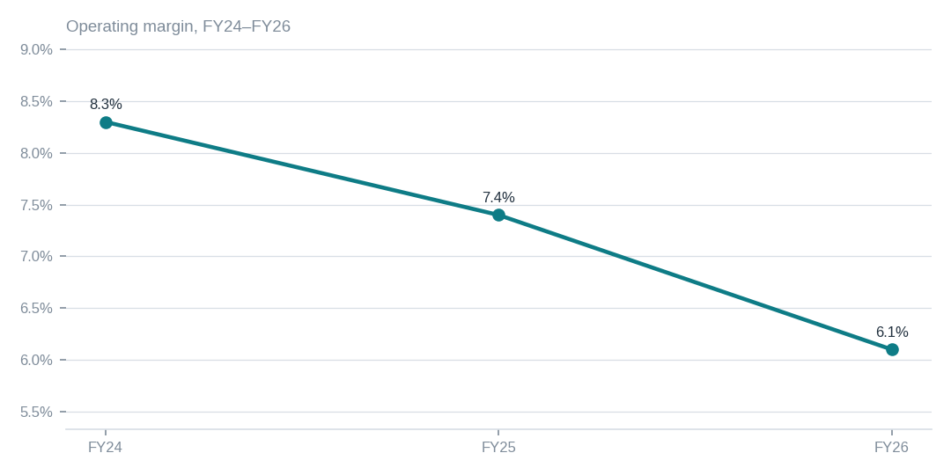
Figure: Revenue grew 20.2% over two years while operating margin fell 2.2pp
[measured] Receipt R01: Northline management accounts FY24–FY26, P&L summary, rows 4–9
 | GBP per parcel
Manual (6 sites) | 1.71
Semi-automated (3 sites) | 1.38
Automated (1 site) | 0.94
Cost per parcel by depot type
[measured] Receipt R02: Depot cost ledger export 2026-09-12, cost-per-parcel by site

2. Three paths, each inside the headcount ceiling
Three automation options are costed; simple payback runs from 3.2 to 3.3 years. Lead time of 11 months means the earliest saving lands in FY28 on any full-automation path.
 | Full automation, 6 manual sites | Phased: 3 sites now, 3 in FY28 | Semi-automate all 6 sites
Capex (GBPm) | 48.0 | 26.0 | 19.5
Annual saving (GBPm) | 14.6 | 7.9 | 6.1
Simple payback (years) | 3.3 | 3.3 | 3.2
Lead time (months) | 11 | 11 | 7
Headcount change (FTE) | -310 | -160 | -120
Costed options; all figures estimated, receipts in appendix
[estimated] Receipt R03, R04: Vendor quotations Q3-2026 (Kardex, Swisslog, Dematic), capex schedules; Operations planning model v7, tab 'Savings', signed off by COO 2026-09-18
Every option stays inside the FY27 headcount ceiling of 2,140.

3. Coverage and limits
Covers: FY24–FY26 actuals for all ten depots and vendor-quoted capex for the six manual sites.
Cannot say | Why | What would close it
Savings beyond year three | outside scope of the COO model | extend the operations planning model to a five-year horizon
Implementation risk by vendor | not measured; no reference-site visits completed | two reference-site visits per shortlisted vendor before contract
Union consultation timeline | rights-restricted until the consultation notice is issued | HR to confirm notice date

Appendix: receipts
Receipt | Resolves to
R01 | Northline management accounts FY24–FY26, P&L summary, rows 4–9
R02 | Depot cost ledger export 2026-09-12, cost-per-parcel by site
R03 | Vendor quotations Q3-2026 (Kardex, Swisslog, Dematic), capex schedules
R04 | Operations planning model v7, tab 'Savings', signed off by COO 2026-09-18
R05 | Board paper BP-2026-07, approved headcount ceiling

