Estate intelligence — eij-1b359b3cbd2e
Commission-close paper for the estate owner · RMS

Summary
351.3 GiB sit in 20 databases and 1006 tables. 259.3m rows are held; 71 table pairs duplicate each other.
About 15.2 GiB (4.3% of database bytes) looks reclaimable in the databases before pricing. Rights are declared at Connect, not measured by the census; every candidate is aggregate or de-identified. This paper sets out the measured evidence; the decision is the estate owner's.

1. What the estate holds and how it is conditioned
The largest databases hold 99.7% of the estate's bytes. Exact duplicates are 1.5% of rows; degraded rows 23.0%; empty required fields 81.7%.
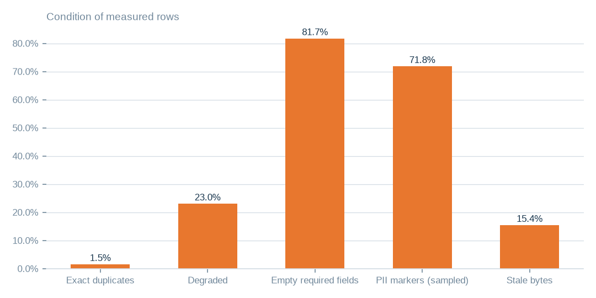
Figure: Measures cover 63.4% of tables; the remaining ratios are estimated from stratified samples
[estimated] Receipt R01: Estate intelligence census eij-1b359b3cbd2e, digest-verified report (measured 2026-09-29), headline aggregates and per-database measures
 | GiB
viusasa_staging (D) | 338.50
razuna (D) | 4.50
db_visitors (D) | 2.70
kra_reports (D) | 1.50
viupay_agent_staging (A) | 1.20
news_vault (C) | 0.90
local (D) | 0.50
viutickets (B) | 0.40
Data and index by database
[measured] Receipt R01: Estate intelligence census eij-1b359b3cbd2e, digest-verified report (measured 2026-09-29), headline aggregates and per-database measures
71.8% of 1.0m sampled rows carry PII markers. 15.4% of bytes have not been written for over a year; 368 tables are empty. Dead columns are 13.0% of measured columns.

2. What it costs to keep
About 15.2 GiB (4.3% of database bytes) looks reclaimable in the databases before pricing. Priced strategies bound the monthly saving at 1,174.4 USD at reference list prices.
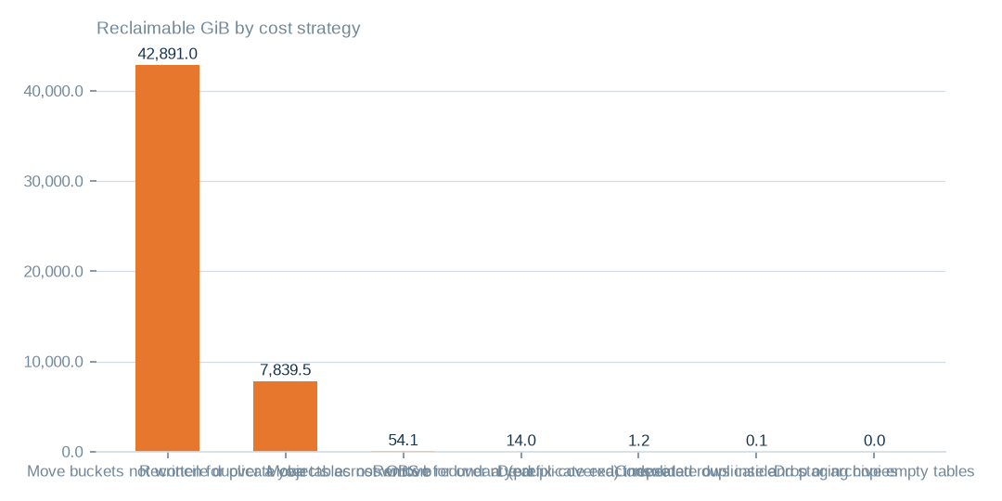
Figure: Three strategies address 100.0% of the 50,799.8 GiB that all cost strategies reach
[estimated] Receipt R02: Estate intelligence census eij-1b359b3cbd2e, cost_strategies priced at reference list prices, not the owner's invoice: Huawei Cloud RDS for MySQL cloud SSD AF-Johannesburg 0.00015 USD/GB-hour x 730 h; OBS Standard 0.023 USD/GB-month
 | Move buckets not written for over a year to archive-class st | Reconcile duplicate objects across OBS buckets | Move tables not written for over a year to cold storage
Bytes addressed (GiB) | 42,891.0 | 7,839.5 | 54.1
Monthly saving (USD) | 986.5 | 180.3 | 5.9
Share of bytes addressed | 84.4% | 15.4% | 0.1%
Costed strategies; all figures estimated at reference list prices, receipts in appendix
[estimated] Receipt R02: Estate intelligence census eij-1b359b3cbd2e, cost_strategies priced at reference list prices, not the owner's invoice: Huawei Cloud RDS for MySQL cloud SSD AF-Johannesburg 0.00015 USD/GB-hour x 730 h; OBS Standard 0.023 USD/GB-month

3. What the data can do
8 product candidates rank by rows, readiness and dimensions. Rights are declared at Connect, not measured by the census; every candidate is aggregate or de-identified.
Reference and master-data licensing: grade C, 87 tables, 123,394,159 rows (est.); blockers: 62.0% of supporting tables carry PII markers: de-identify or aggregate before any release · use rights are declared at Connect, not measured: a release needs its own grant and purpose.
Content catalogue, recommendation and licensing corpus: grade C, 98 tables, 157,855,990 rows (est.); blockers: 74.0% of supporting tables carry PII markers: de-identify or aggregate before any release · use rights are declared at Connect, not measured: a release needs its own grant and purpose.
Channel / telco engagement analytics (USSD, SMS, app): grade C, 57 tables, 116,781,903 rows (est.); blockers: 79.0% of supporting tables carry PII markers: de-identify or aggregate before any release · use rights are declared at Connect, not measured: a release needs its own grant and purpose.

4. Coverage and limits
Covers: 20 databases, 1,006 tables and 351.3 GiB measured by census eij-1b359b3cbd2e; ratios are complete-pass where the table allowed it and stratified samples elsewhere. No row value is present in this pack.
Cannot say | Why | What would close it
Duplicate, damage, empty-field and PII ratios on sampled tables | complete passes where the table allowed it, stratified samples elsewhere | a complete-pass census on the sampled tables
Rights, licences and semantic similarity | not measured; candidates are dimensional readiness only | rights declared at Connect and bound to each candidate
Connection artists_app | could not be read (MySQL GRANT pending) | owner grants read access; re-census
NAS duplication | the enumeration recorded sizes and dates, not content fingerprints | a fingerprinting pass over the NAS shares
40 of 106 OBS buckets | unreachable (NoSuchBucket / client errors) | bucket inventory reconciled with the provider

Appendix: receipts
Receipt | Resolves to
R01 | Estate intelligence census eij-1b359b3cbd2e, digest-verified report (measured 2026-09-29), headline aggregates and per-database measures
R02 | Estate intelligence census eij-1b359b3cbd2e, cost_strategies priced at reference list prices, not the owner's invoice: Huawei Cloud RDS for MySQL cloud SSD AF-Johannesburg 0.00015 USD/GB-hour x 730 h; OBS Standard 0.023 USD/GB-month
R03 | Estate intelligence census eij-1b359b3cbd2e, data_products readiness scoring (dimensions, grades, blockers)
R04 | OBS bucket enumeration census run cr-f1415e395361 (22,975,591 objects, 130.3 TiB)
R05 | NAS share enumeration census run cr-cf4eef79995b (1,456,787 files, 43.6 TiB)

