Commission close — estate intelligence eij-1b359b3cbd2e
Commission-close paper for the estate owner · RMS

Summary
The census ran under CP-CENSUS-ESTATE-INTELLIGENCE on runtime akki-vm for 15.5 minutes and closed partial. 638 of 1006 tables were measured (63.4%): 513 by complete pass, 83 by stratified sample, 41 by head sample; 44 failed.
3 of 6 connections completed, 2 were partial and 1 blocked. The delivered result is partial: artists_app blocked (MYSQL_ACCESS_DENIED_1045).
The result receipt is digest-verified; the Ledger records admit, gate and converge. The report holds aggregates, sketches and hashes only; no row value was retained or returned. The decision to accept and close, or to hold, is the estate owner's.

1. What was delivered
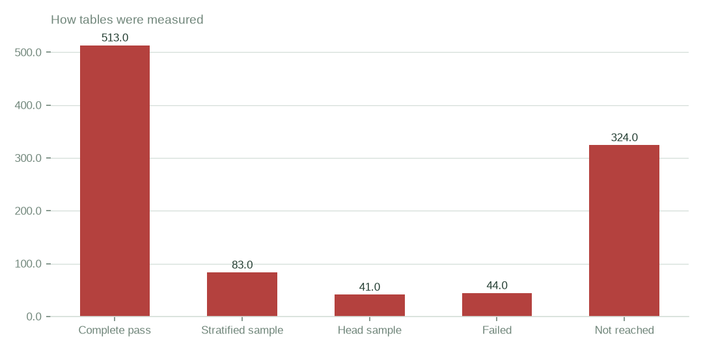
Figure: Complete passes cover 51.0% of tables; 4.4% of tables failed
[measured] Receipt R01: Estate intelligence job record eij-1b359b3cbd2e: submitted 2026-09-29T18:56:40Z by principal 6ab56dd48894abb269135ca2, runtime akki-vm, code 90322d4a826d, result receipt digest-verified (d9c99a632278)
 | Tables
iebc_forms (complete) | 630.00
artists_app (blocked) | 0.00
viupay (complete) | 123.00
citizen_digital (partial) | 64.00
citizen-pulse (partial) | 77.00
Razuna (Library Content) & N (complete) | 112.00
Tables measured by connection
[measured] Receipt R02: Estate intelligence report v3 for eij-1b359b3cbd2e, built 2026-09-30T03:41:37Z; connection table and coverage notes
351.3 GiB across 20 databases were measured in 15.5 minutes. Measured usage: 15.5 minutes wall clock and 5.9m rows read on akki-vm; jump host measured; GPU host held aggregates only.

2. Evidence
The result receipt is digest-verified; the Ledger records admit, gate and converge. Lawful basis: 20260922T014000Z census admit; scope: census only: aggregates, sketches and hashes; no row values retained or returned.
The executive dossier was composed by gpt-5-mini from 17679 tokens in and 4583 tokens out, receipt rcp-f3b244641843.
Object storage enumeration reached 106 buckets; 40 were unreachable.

3. What remains open
The delivered result is partial: artists_app blocked (MYSQL_ACCESS_DENIED_1045).
artists_app: blocked — MYSQL_ACCESS_DENIED_1045 (GRANT pending, owner dependency); 0 tables reached.
citizen_digital: partial — 5 tables failed; 64 tables reached.
citizen-pulse: partial — 39 tables failed; 77 tables reached.

4. Coverage and limits
Covers: Delivery of census eij-1b359b3cbd2e: 638 of 1006 tables, 6 connections, wall clock, Ledger rows, receipts and the dossier composition. Everything here is read from the job record and the digest-verified report.
Cannot say | Why | What would close it
Connection artists_app | MYSQL_ACCESS_DENIED_1045 (GRANT pending, owner dependency) | owner grants access; re-census
Ratios on sampled tables | stratified or head samples where complete passes were not possible | a complete-pass census on those tables
44 failed tables | the worker could not measure them in this run | re-census with the recorded errors addressed
Languages, rights and semantic similarity | not measured by this census | rights declared at Connect; a language and similarity pass

Appendix: receipts
Receipt | Resolves to
R01 | Estate intelligence job record eij-1b359b3cbd2e: submitted 2026-09-29T18:56:40Z by principal 6ab56dd48894abb269135ca2, runtime akki-vm, code 90322d4a826d, result receipt digest-verified (d9c99a632278)
R02 | Estate intelligence report v3 for eij-1b359b3cbd2e, built 2026-09-30T03:41:37Z; connection table and coverage notes
R03 | Lawful basis admit 20260922T014000Z_LAWFUL_BASIS_ADMIT_CENSUS3.json (sha256 37d1508d4ea9); governing artifact CP-CENSUS-ESTATE-INTELLIGENCE version eij-1b359b3cbd2e
R04 | Ledger rows led-398166457377, led-4e9f184f9601, led-6067b8b42dc7: admit:admitted → gate:warm → converge:terminate_success
R05 | Executive dossier receipt rcp-f3b244641843: gpt-5-mini via emergent, 17679 tokens in / 4583 out, prompt 354fd68cd5d4
R06 | OBS bucket enumeration census run cr-f1415e395361 (22,975,591 objects, 130.3 TiB)
R07 | NAS share enumeration census run cr-cf4eef79995b (1,456,787 files, 43.6 TiB)

