Estate-wide intelligence: cut, fix and prepare first
Databases, object store, file shares and language holdings, for one owner decision · RMS

Summary
The estate holds 174.3 TiB, almost all of it in the object store (130.3 TiB) and file shares (43.6 TiB). The databases hold 351.3 GiB. The owner has declared all rights established, so this pack concerns cost, condition and preparation.
Priced strategies bound the monthly saving at 1,174.4 USD at list prices, led by tiering of cold buckets at 986.5 USD. These are upper bounds, not invoice savings, and read use of the cold data was not measured.
Database rows need completeness repair and de-identification or aggregation before products use them. Reference data and the content catalogue are the proposed first products. Nothing has been moved, deleted or released.

Plain English: the terms used in this pack
Term | What it means in this pack
Reclaimable | Space that could be removed or stored more cheaply once the check named beside it has been done. It is not space already freed, and it is not a guaranteed saving — the monthly figures are upper bounds at list prices.
Cold (not written for over a year) | Nothing new has been written to that bucket or table for more than a year, judged by the newest write date we could see. It says nothing about whether anyone still reads it — that was not measured.
Duplicate candidate | Two objects whose size and storage fingerprint (ETag) match inside the same store. For large uploads that fingerprint is not a content hash, so a candidate must be confirmed by hashing before any copy is removed.
Exact duplicate rows | Database rows that are identical in every measured column. 'Normalised' duplicates also match after trimming spaces and case.
Degraded row | A row whose worst column shows damage: text cut short, a placeholder such as 'N/A' or 'test', an invalid format, stray whitespace or garbled characters.
Empty required-looking fields | Blank values in columns whose name or pattern suggests they should always be filled (for example an identifier or a date). The database may not formally require them; the census flags them so an owner can decide.
Dead column | A column that is empty on practically every row: schema carried without data.
Personal-data marker | A sampled value that looks like an email, phone number, national ID or similar. It is a condition of the data, not a judgement about rights — the owner has declared all rights established.
Archive-class storage | A cheaper storage tier for data that is kept but rarely opened. Retrieval is slower and carries its own fee, which is why the saving is stated as an upper bound.
Proposed destination | Where this pack suggests data should live or how it should be tiered. Every destination here is a proposal for the executive to approve; this pack moved and deleted nothing.
Speech hours (estimate) | Recorded hours multiplied by the share of two-second windows the admitted music detector did not call music. Silence is set aside first.
Agrees with folder | The share of labelled windows (or transcript passages) where the model's language label matched the folder the recording was filed under. It is a model reading, not a human verification.
Declined to label | Windows where the language model's confidence fell below its threshold, so it gave no language rather than guess.
Scripted day / bulletin hour | A calendar date on which a station has at least one news script in the archive, and the distinct hour slots scripted that day. The archive does not carry a script for every hour of every day; the tables show exactly which days and hours it does.
Receipt | The retained Akki record (census run, GPU job or database reading) that every figure in this pack is traced to. The appendix lists them; the workbook carries the row-level evidence.

The object store and file shares dominate the estate
Of 174.3 TiB, the object store holds 130.3 TiB (74.8%) and file shares 43.6 TiB (25.0%). Databases are 0.2% of the estate. Store totals are rounded, so they should not be read as an exact reconciliation.
The consequence is plain: carrying-cost work belongs with storage at scale. Databases matter for reuse value, not for bytes.
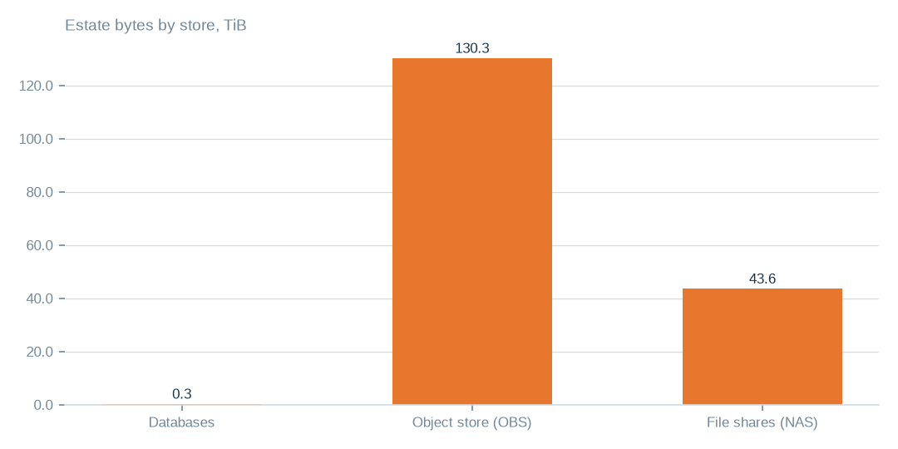
Figure: Cost attention belongs to storage scale; the databases, at 0.3 TiB, matter for reuse value rather than for bytes.
[measured] Receipt R01: Estate intelligence census eij-1b359b3cbd2e, digest-verified report (measured 2026-09-29), headline aggregates and per-database measures

One bucket holds most of the object store
The largest bucket holds 86.3 TiB, 66.2% of the 130.3 TiB in the object store. Several of the next largest buckets are marked cold, meaning nothing new has been written for over a year.
Size alone does not show waste, and no-write age does not show absence of reads. The table of buckets under review gives each bucket's last write and proposed action.
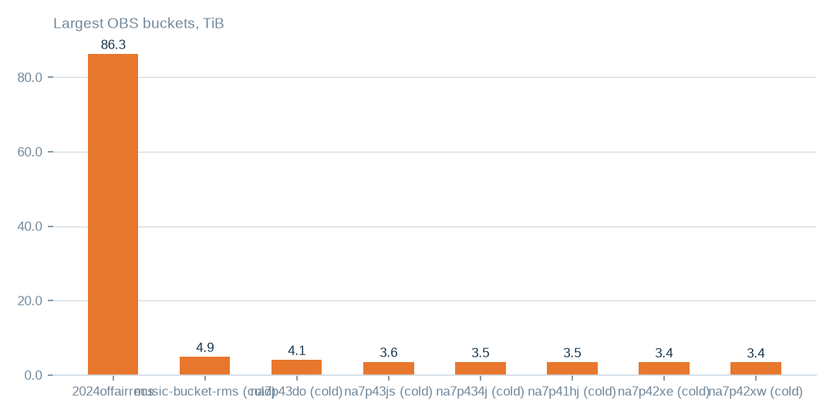
Figure: Review the largest buckets first, but size alone does not show waste; the table of buckets under review gives each one's last write.
[measured] Receipt R04: OBS bucket enumeration census run cr-f1415e395361 (22,975,591 objects, 130.3 TiB)

Where the whole estate sits
The estate holds 174.3 TiB across three kinds of store. The object store holds 130.3 TiB in 106 buckets and 23.0m objects; file shares hold 43.6 TiB in 16 shares and 1.5m files; databases hold 351.3 GiB in 20 databases and 1006 tables.
40 buckets could not be read, so the object-store figure covers readable buckets only. This is measured coverage, not a complete account of inaccessible sources.

The exact sources under review
41.9 TiB of the object store has not been written for over a year, across 43 buckets. 7.7 TiB, 5.0% of objects, are duplicate candidates matched on size and fingerprint, which for large uploads is not a content hash.
The tables beside this chapter name each bucket, database table, file share and unreadable bucket. Database strategy bytes are strategy totals rather than table sizes, file-share duplication is unmeasured, and unreadable buckets need reconciling with the provider, not assuming deleted.
T010 Exact object-store buckets under review (largest first)
Bucket | Enumeration | Held (TiB) | Objects | Last write | Idle days | Duplicate candidates | Duplicate bytes (TiB, est.) | Main formats | Classification | Proposed action | Proposed destination
2024offairrecs | complete | 86.3 | 3,174,515 | 2026-09-29 | 0 | 16,589 | 0.45 | .mp4 3,131,277, .mp3 27,002, no_extension 15,658 | active — keep hot; heavy duplicate candidates | hash-confirm duplicate candidates, keep one copy | same bucket; duplicates replaced by references (proposed)
music-bucket-rms | complete | 4.93 | 152,801 | 2024-03-26 | 916 | 14,696 | 0.47 | .mp4 146,617, .txt 1,183, .flx 1,086 | cold — archive candidate; heavy duplicate candidates | lifecycle rule Standard → Archive after read-log check | same bucket, archive storage class (proposed)
na7p43do | complete | 4.1 | 484,480 | 2024-04-04 | 908 | 197,528 | 1.67 | .mp3 326,105, .mts 39,439, .vis 39,437 | cold — archive candidate; heavy duplicate candidates | lifecycle rule Standard → Archive after read-log check | same bucket, archive storage class (proposed)
na7p43js | complete | 3.57 | 307,998 | 2024-04-02 | 909 | 27,187 | 0.32 | .ogg 118,600, .mp3 85,079, .adf 25,484 | cold — archive candidate; heavy duplicate candidates | lifecycle rule Standard → Archive after read-log check | same bucket, archive storage class (proposed)
na7p434j | complete | 3.5 | 15,377 | 2024-04-04 | 908 | 2,890 | 0.66 | .mov 5,427, .avi 4,258, .jpg 2,157 | cold — archive candidate | lifecycle rule Standard → Archive after read-log check | same bucket, archive storage class (proposed)
na7p41hj | complete | 3.48 | 15,885 | 2024-03-27 | 915 | 1,852 | 0.41 | .mov 10,488, .mp4 2,347, .txt 1,519 | cold — archive candidate | lifecycle rule Standard → Archive after read-log check | same bucket, archive storage class (proposed)
na7p42xe | complete | 3.44 | 13,965 | 2024-04-04 | 907 | 1,120 | 0.28 | .mp4 6,241, .mov 5,519, .txt 1,434 | cold — archive candidate | lifecycle rule Standard → Archive after read-log check | same bucket, archive storage class (proposed)
na7p42xw | complete | 3.4 | 25,088 | 2024-03-31 | 911 | 2,391 | 0.32 | .mov 15,321, .txt 3,389, .avi 3,065 | cold — archive candidate | lifecycle rule Standard → Archive after read-log check | same bucket, archive storage class (proposed)
na7p42yg | complete | 3.28 | 28,059 | 2024-03-31 | 912 | 4,197 | 0.49 | .mov 21,920, .txt 3,169, .jpg 1,446 | cold — archive candidate | lifecycle rule Standard → Archive after read-log check | same bucket, archive storage class (proposed)
na7p43d3 | complete | 2.9 | 16,396 | 2024-03-30 | 912 | 1,395 | 0.25 | .mov 10,623, .txt 2,032, .avi 1,270 | cold — archive candidate | lifecycle rule Standard → Archive after read-log check | same bucket, archive storage class (proposed)
na7p4oco | complete | 2.86 | 468,637 | 2024-04-03 | 908 | 166,328 | 1.01 | .mp3 218,902, .mts 36,886, .vis 36,878 | cold — archive candidate; heavy duplicate candidates | lifecycle rule Standard → Archive after read-log check | same bucket, archive storage class (proposed)
rmsbroadcast | complete | 1.49 | 142,739 | 2024-03-24 | 918 | 5,060 | 0.05 | .mp3 127,221, .mp4 9,923, .mov 1,916 | cold — archive candidate | lifecycle rule Standard → Archive after read-log check | same bucket, archive storage class (proposed)
Every bucket named here was enumerated object by object; the classification follows from its last write date and its duplicate-candidate count. Destinations are proposals.
[measured] Receipt R04: OBS bucket enumeration census run cr-f1415e395361 (22,975,591 objects, 130.3 TiB)
T011 Exact database tables under review, by finding
Table (database.table) | Finding | Measured detail | Strategy bytes | Proposed action
viusasa_staging.audits | not written for over a year | 666 days · 18.6 GiB | 54.1 GiB | export to compressed object storage with a schema stub (proposed); restore on demand
viusasa_staging.master_payments | not written for over a year | 438 days · 4.2 GiB | 54.1 GiB | export to compressed object storage with a schema stub (proposed); restore on demand
razuna.raz1_videos | not written for over a year | 1341 days · 3.0 GiB | 54.1 GiB | export to compressed object storage with a schema stub (proposed); restore on demand
viusasa_staging.payment_requests | not written for over a year | 664 days · 2.8 GiB | 54.1 GiB | export to compressed object storage with a schema stub (proposed); restore on demand
viusasa_staging.sms | not written for over a year | 583 days · 2.7 GiB | 54.1 GiB | export to compressed object storage with a schema stub (proposed); restore on demand
viusasa_staging.mpesa_stk_requests | not written for over a year | 724 days · 1.4 GiB | 54.1 GiB | export to compressed object storage with a schema stub (proposed); restore on demand
viusasa_staging.search_lookups | repeated rows inside the table | 5.9% repeated · 8.7 GiB | 1.2 GiB | de-duplicate in place after a keyed comparison; keep the newest row
viusasa_staging.playback_qualified_streams | repeated rows inside the table | 5.1% repeated · 4.6 GiB | 1.2 GiB | de-duplicate in place after a keyed comparison; keep the newest row
viusasa_staging.episode_views | repeated rows inside the table | 22.0% repeated · 764.0 MiB | 1.2 GiB | de-duplicate in place after a keyed comparison; keep the newest row
kra_reports.external_credit_notes | repeated rows inside the table | 25.0% repeated · 277.8 MiB | 1.2 GiB | de-duplicate in place after a keyed comparison; keep the newest row
viusasa_staging.new_episode_views | repeated rows inside the table | 66.1% repeated · 98.7 MiB | 1.2 GiB | de-duplicate in place after a keyed comparison; keep the newest row
viusasa_staging.ussd_hits | repeated rows inside the table | 8.5% repeated · 573.0 MiB | 1.2 GiB | de-duplicate in place after a keyed comparison; keep the newest row
iebc_forms/viupay.failed_jobs ↔ viupay/viupay.failed_jobs | two copies of the same table across connections | overlap 78.0% · 31.6 MiB | 54.0 MiB | name one authoritative copy; retire or redirect the other
iebc_forms/viutickets.movies ↔ viupay/viutickets.movies | two copies of the same table across connections | overlap 84.0% · 6.5 MiB | 54.0 MiB | name one authoritative copy; retire or redirect the other
iebc_forms/viutickets.ussd_hits ↔ viupay/viutickets.ussd_hits | two copies of the same table across connections | overlap 100.0% · 6.5 MiB | 54.0 MiB | name one authoritative copy; retire or redirect the other
iebc_forms/viutickets.payment_processings ↔ viupay/viutickets.payment_processings | two copies of the same table across connections | overlap 65.0% · 4.5 MiB | 54.0 MiB | name one authoritative copy; retire or redirect the other
iebc_forms/viupay.payment_requests ↔ viupay/viupay.payment_requests | two copies of the same table across connections | overlap 50.0% · 3.5 MiB | 54.0 MiB | name one authoritative copy; retire or redirect the other
iebc_forms/viutickets.movie_shows ↔ viupay/viutickets.movie_shows | two copies of the same table across connections | overlap 80.0% · 3.5 MiB | 54.0 MiB | name one authoritative copy; retire or redirect the other
ecommerce_tafaria.playbacks | index covered by a wider index | playbacks_playable_type_index covered by playbacks_playable_type_playable_id_index | 14.0 GiB | drop the covered index; measure write amplification before and after
viusasa_staging.clip_requests | index covered by a wider index | clip_requests_castr_stream_id_index covered by clip_requests_castr_stream_id_castr_clip_id_index | 14.0 GiB | drop the covered index; measure write amplification before and after
viusasa_staging.continue_watchings | index covered by a wider index | continue_watchings_user_id_index covered by continue_watchings_user_history_updated_index | 14.0 GiB | drop the covered index; measure write amplification before and after
viusasa_staging.duka_product_search_clicks | index covered by a wider index | duka_product_search_clicks_normalized_term_index covered by duka_product_search_clicks_normalized_term_product_id_unique | 14.0 GiB | drop the covered index; measure write amplification before and after
viusasa_staging.duka_search_synonyms | index covered by a wider index | duka_search_synonyms_synonym_index covered by duka_search_synonyms_synonym_canonical_unique | 14.0 GiB | drop the covered index; measure write amplification before and after
viusasa_staging.elimu_learner_badges | index covered by a wider index | elimu_learner_badges_badge_id_index covered by elimu_learner_badges_badge_id_sub_user_id_unique | 14.0 GiB | drop the covered index; measure write amplification before and after
ecommerce_tafaria.airtel_c2bs | empty table |  |  | drop after the application owner confirms it is unused
ecommerce_tafaria.airtel_ussd_pushes | empty table |  |  | drop after the application owner confirms it is unused
ecommerce_tafaria.album_track | empty table |  |  | drop after the application owner confirms it is unused
ecommerce_tafaria.albums | empty table |  |  | drop after the application owner confirms it is unused
ecommerce_tafaria.api_providers | empty table |  |  | drop after the application owner confirms it is unused
ecommerce_tafaria.article_menu | empty table |  |  | drop after the application owner confirms it is unused
ecommerce_tafaria.article_sources | empty table |  |  | drop after the application owner confirms it is unused
ecommerce_tafaria.articles | empty table |  |  | drop after the application owner confirms it is unused
viusasa_staging.playback_stagings | high share of personal-data markers | 91.0% of sampled rows |  | de-identify or aggregate before any product use; keep the master as is
viusasa_staging.telescope_entries | high share of personal-data markers | 79.0% of sampled rows |  | de-identify or aggregate before any product use; keep the master as is
viusasa_staging.audits | high share of personal-data markers | 100.0% of sampled rows |  | de-identify or aggregate before any product use; keep the master as is
viusasa_staging.sms | high share of personal-data markers | 100.0% of sampled rows |  | de-identify or aggregate before any product use; keep the master as is
viusasa_staging.ussd_hits | high share of personal-data markers | 100.0% of sampled rows |  | de-identify or aggregate before any product use; keep the master as is
viusasa_staging.playback_qualified_streams | high share of personal-data markers | 58.0% of sampled rows |  | de-identify or aggregate before any product use; keep the master as is
ecommerce_tafaria.invoices.order_id → orders | references pointing at rows that no longer exist | 100.0% orphaned of 4 sampled |  | repair or remove the dangling references; add a foreign-key check
ecommerce_tafaria.invoices.payment_id → payments | references pointing at rows that no longer exist | 100.0% orphaned of 1 sampled |  | repair or remove the dangling references; add a foreign-key check
viusasa_staging.active_users.user_id → user | references pointing at rows that no longer exist | 100.0% orphaned of 400 sampled |  | repair or remove the dangling references; add a foreign-key check
viusasa_staging.airtel_ussd_pushes.user_id → user | references pointing at rows that no longer exist | 100.0% orphaned of 400 sampled |  | repair or remove the dangling references; add a foreign-key check
viusasa_staging.article_menu.article_id → articles | references pointing at rows that no longer exist | 100.0% orphaned of 400 sampled |  | repair or remove the dangling references; add a foreign-key check
viusasa_staging.audits.user_id → user | references pointing at rows that no longer exist | 100.0% orphaned of 400 sampled |  | repair or remove the dangling references; add a foreign-key check
Each row names a table the census measured and the finding that puts it on the list; the bytes column is the strategy total the table belongs to, not the table alone.
[measured] Receipt R02: Estate intelligence census eij-1b359b3cbd2e, cost_strategies priced at reference list prices, not the owner's invoice: Huawei Cloud RDS for MySQL cloud SSD AF-Johannesburg 0.00015 USD/GB-hour x 730 h; OBS Standard 0.023 USD/GB-month
T012 Exact file shares (NAS) enumerated
Share | Enumeration | Held (TiB) | Files | Last write | Main formats | Proposed action
channel01 | complete | 6.87 | 95,122 | 2026-09-29 | .mp4 95,108, .rmd 6, .mpt 3 | fingerprint pass to measure duplication; then tier by channel
channel02 | complete | 6.87 | 95,134 | 2026-09-29 | .mp4 95,129, .db 1, .jpg 1 | fingerprint pass to measure duplication; then tier by channel
channel16 | complete | 6.81 | 94,597 | 2026-09-29 | .mp4 94,592, .db 1, .jpg 1 | fingerprint pass to measure duplication; then tier by channel
Channel15 | complete | 1.91 | 95,635 | 2026-09-29 | .mp4 95,627, .rmd 3, .db 1 | fingerprint pass to measure duplication; then tier by channel
Channel14 | complete | 1.91 | 95,615 | 2026-09-29 | .mp4 95,609, .rmd 2, .db 1 | fingerprint pass to measure duplication; then tier by channel
Channel11 | complete | 1.91 | 95,602 | 2026-09-29 | .mp4 95,592, .rmd 6, .db 1 | fingerprint pass to measure duplication; then tier by channel
Channel12 | complete | 1.91 | 95,600 | 2026-09-29 | .mp4 95,590, .rmd 6, .db 1 | fingerprint pass to measure duplication; then tier by channel
channel07 | complete | 1.91 | 95,550 | 2026-09-29 | .mp4 95,546, .db 1, .jpg 1 | fingerprint pass to measure duplication; then tier by channel
channel06 | complete | 1.91 | 95,548 | 2026-09-29 | .mp4 95,544, .db 1, .jpg 1 | fingerprint pass to measure duplication; then tier by channel
channel05 | complete | 1.9 | 95,494 | 2026-09-29 | .mp4 95,490, .db 1, .jpg 1 | fingerprint pass to measure duplication; then tier by channel
channel04 | complete | 1.9 | 95,475 | 2026-09-29 | .mp4 95,470, .db 1, .jpg 1 | fingerprint pass to measure duplication; then tier by channel
channel03 | complete | 1.9 | 95,419 | 2026-09-29 | .mp4 95,415, .db 1, .jpg 1 | fingerprint pass to measure duplication; then tier by channel
Sizes and dates were recorded; content fingerprints were not, so duplication across the channel shares is not yet measured.
[measured] Receipt R05: NAS share enumeration census run cr-cf4eef79995b (1,456,787 files, 43.6 TiB)
T015 Object-store buckets that could not be read
Bucket | Error returned | Proposed action
apr252017 | NoSuchBucket | reconcile with provider; remove from inventory if gone
citizen-vod | NoSuchBucket | reconcile with provider; remove from inventory if gone
elections | ClientError | reconcile with provider; remove from inventory if gone
feb272017 | NoSuchBucket | reconcile with provider; remove from inventory if gone
instore-radio-items | ClientError | reconcile with provider; remove from inventory if gone
iso-rms-storage | NoSuchBucket | reconcile with provider; remove from inventory if gone
librarydirectupload2 | NoSuchBucket | reconcile with provider; remove from inventory if gone
na7p4100 | NoSuchBucket | reconcile with provider; remove from inventory if gone
na7p410c | NoSuchBucket | reconcile with provider; remove from inventory if gone
na7p419y | NoSuchBucket | reconcile with provider; remove from inventory if gone
na7p41ab | NoSuchBucket | reconcile with provider; remove from inventory if gone
na7p41f4 | NoSuchBucket | reconcile with provider; remove from inventory if gone
na7p41j6 | NoSuchBucket | reconcile with provider; remove from inventory if gone
na7p41jk | NoSuchBucket | reconcile with provider; remove from inventory if gone
na7p42ry | NoSuchBucket | reconcile with provider; remove from inventory if gone
na7p42s5 | NoSuchBucket | reconcile with provider; remove from inventory if gone
na7p42s7 | NoSuchBucket | reconcile with provider; remove from inventory if gone
na7p42tq | NoSuchBucket | reconcile with provider; remove from inventory if gone
na7p42tz | NoSuchBucket | reconcile with provider; remove from inventory if gone
na7p435c | NoSuchBucket | reconcile with provider; remove from inventory if gone
na7p4374 | NoSuchBucket | reconcile with provider; remove from inventory if gone
na7p43d6 | NoSuchBucket | reconcile with provider; remove from inventory if gone
na7p43dj | NoSuchBucket | reconcile with provider; remove from inventory if gone
na7p43hs | NoSuchBucket | reconcile with provider; remove from inventory if gone
na7p43jw | NoSuchBucket | reconcile with provider; remove from inventory if gone
na7p49pc | NoSuchBucket | reconcile with provider; remove from inventory if gone
na7p4omz | NoSuchBucket | reconcile with provider; remove from inventory if gone
na7p4oxs | NoSuchBucket | reconcile with provider; remove from inventory if gone
na7p4oy4 | NoSuchBucket | reconcile with provider; remove from inventory if gone
na7p4oz6 | NoSuchBucket | reconcile with provider; remove from inventory if gone
obituariesdata | NoSuchBucket | reconcile with provider; remove from inventory if gone
one-signal-live-service | NoSuchBucket | reconcile with provider; remove from inventory if gone
onesignal-logos | NoSuchBucket | reconcile with provider; remove from inventory if gone
onsignal-bucket | ClientError | reconcile with provider; remove from inventory if gone
private-isos | ClientError | reconcile with provider; remove from inventory if gone
razuna-direct-access | NoSuchBucket | reconcile with provider; remove from inventory if gone
rms-acronis-backup-bucket | NoSuchBucket | reconcile with provider; remove from inventory if gone
rms-ai | NoSuchBucket | reconcile with provider; remove from inventory if gone
sdatauploadroyalmedia.co.ke | NoSuchBucket | reconcile with provider; remove from inventory if gone
seconddatauploadroyalmedia.co.ke | NoSuchBucket | reconcile with provider; remove from inventory if gone
These names are in the bucket inventory but returned an error when listed; each needs reconciling with the provider — deleted, renamed or access withdrawn.
[measured] Receipt R04: OBS bucket enumeration census run cr-f1415e395361 (22,975,591 objects, 130.3 TiB)

Two object-store moves address nearly all reclaimable bytes
Cold-bucket tiering and duplicate reconciliation lead the strategies by a wide margin. The three largest strategies address 100.0% of the 50,799.8 GiB that all cost strategies reach.
Addressed bytes include data moved to a cheaper tier, not only data removed. Because cold means unwritten rather than unread, retrieval behaviour must be checked first.
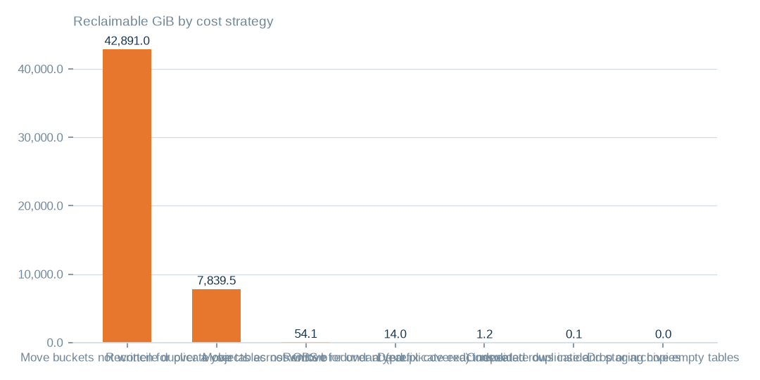
Figure: The three largest strategies address 100.0% of the 50,799.8 GiB that all strategies reach, and archive-class tiering is a cheaper tier, not deletion.
[estimated] Receipt R02: Estate intelligence census eij-1b359b3cbd2e, cost_strategies priced at reference list prices, not the owner's invoice: Huawei Cloud RDS for MySQL cloud SSD AF-Johannesburg 0.00015 USD/GB-hour x 730 h; OBS Standard 0.023 USD/GB-month

Three priced moves compared
Tiering cold buckets is bounded at 986.5 USD a month over 42,891.0 GiB. Reconciling duplicate objects is bounded at 180.3 USD over 7,839.5 GiB. Moving cold tables is bounded at 5.9 USD over 54.1 GiB.
All three are list-price estimates, not invoice figures, and no current spend baseline was supplied. Each needs its own check: read use and retrieval fees, content hashing, and timestamp coverage respectively. Overall, the priced upper bound is 1,174.4 USD a month.
 | Move buckets not written for over a year to archive-class st | Reconcile duplicate objects across OBS buckets | Move tables not written for over a year to cold storage
Reclaimable gib | 42,891.0 | 7,839.5 | 54.1
Monthly saving usd | 986.5 | 180.3 | 5.9
Monthly upper bounds at list prices are 986.5, 180.3 and 5.9 USD; each needs its own verification before action.
[estimated] Receipt R02: Estate intelligence census eij-1b359b3cbd2e, cost_strategies priced at reference list prices, not the owner's invoice: Huawei Cloud RDS for MySQL cloud SSD AF-Johannesburg 0.00015 USD/GB-hour x 730 h; OBS Standard 0.023 USD/GB-month

Completeness and damage outweigh duplication
An estimated 81.7% of rows carry empty required-looking fields and 23.0% are degraded, against 1.5% exact duplicates. 71.8% of 1.0m sampled rows carry personal-data markers.
These measures have different bases, so they overlap and must not be added. They are estimates from complete passes where tables allowed and stratified samples elsewhere, and they should not be stretched to the whole estate.
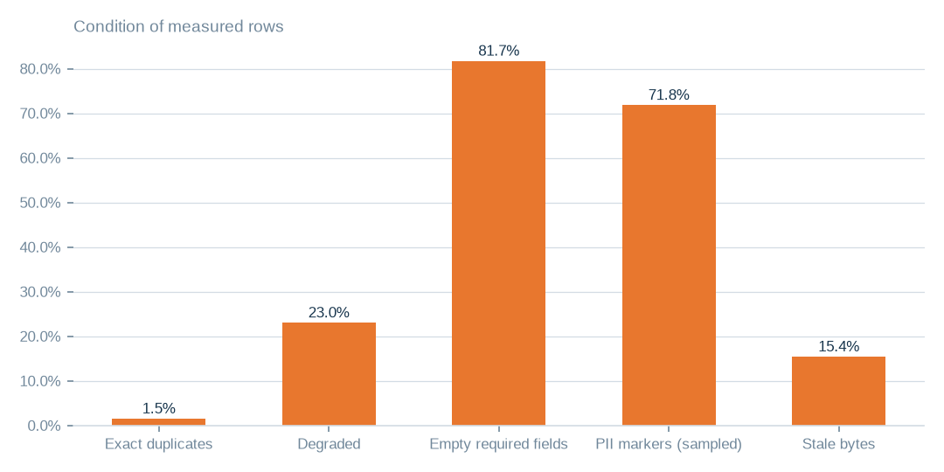
Figure: Completeness is the main repair task: 81.7% of rows carry empty required-looking fields against 1.5% exact duplicates; the bases differ, so the shares must not be added.
[estimated] Receipt R01: Estate intelligence census eij-1b359b3cbd2e, digest-verified report (measured 2026-09-29), headline aggregates and per-database measures

Database bytes are concentrated
The largest databases hold 99.7% of the 351.3 GiB in databases, so database-scale investigation should start there.
This is a prioritisation map. It does not show that the largest database causes every condition finding, nor that it holds most bytes of the whole estate.
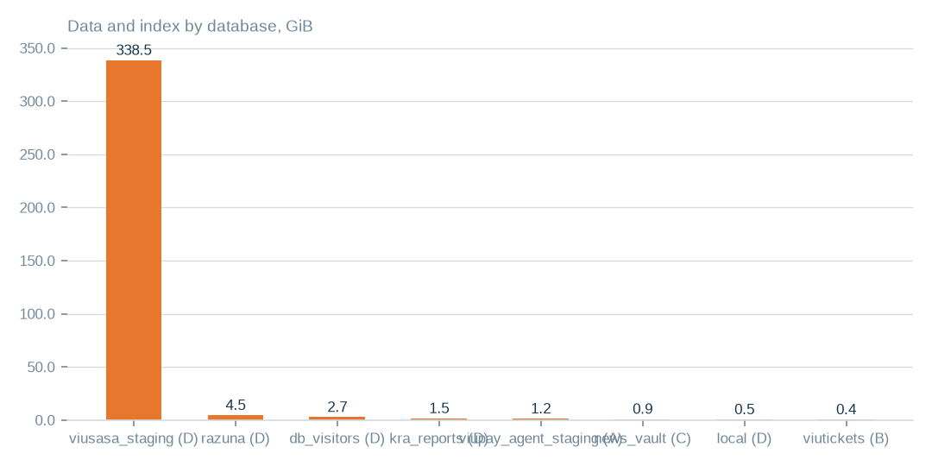
Figure: The largest databases hold 99.7% of the 351.3 GiB; treat this as a map for effort, not proof that one database causes every condition finding.
[measured] Receipt R01: Estate intelligence census eij-1b359b3cbd2e, digest-verified report (measured 2026-09-29), headline aggregates and per-database measures

What condition the rows are in
Exact duplicates are an estimated 1.5% of rows and degraded rows 23.0%. 81.7% of rows carry empty required-looking fields; these flags are heuristic, so decide per product which fields truly matter. Dead columns are 13.0% of measured columns.
71.8% of the 1.0m sampled rows carry personal-data markers. That is a measured condition to prepare for, by de-identification or aggregation, and not a rights question. 15.4% of bytes have not been written for over a year.

Speech hours by language folder
Of 529.5 recorded hours, an estimated 421.4 are speech and 108.2 are music, found by removing windows the detector called music. Six larger folders carry most of the speech.
The two smallest folders hold too little to support a pilot alone. Non-music duration is a detector-based proxy, not verified usable speech.
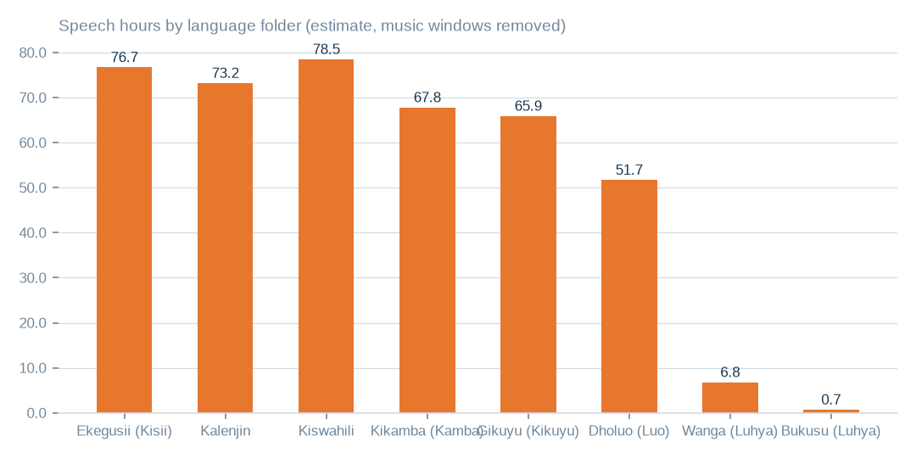
Figure: Six larger folders carry most of the speech; the two smallest folders hold too little to support a pilot on their own.
[estimated] Receipt R06: Estate language reading m9j-9e8fcb46a809 on akki-vm (2 GPUs, 1.034 GPU-h): audio language model lcj-7128593897d4 sha256 5c1feb8497e8…, music detector m9j-686de001bfe7 sha256 0fea3eee0393…; model readings, not human labels

Language agreement varies by folder
Overall 82.3% of judged windows agree with the folder language, and the model declined to label 10.7%. Agreement differs between folders, and one folder shows none.
These are model readings, not human labels. They justify a language review before packaging, not a claim about transcription accuracy or intelligibility.
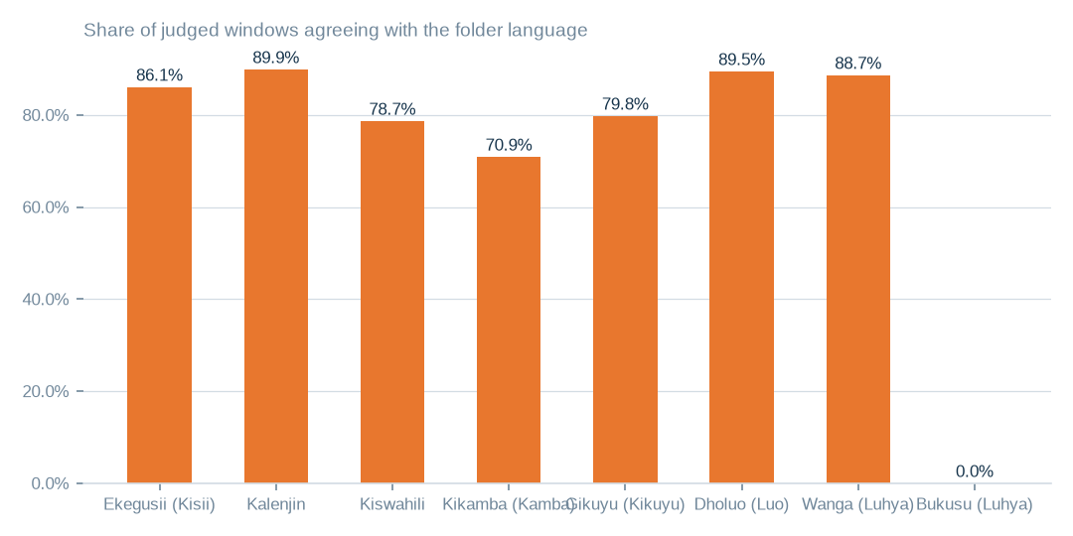
Figure: Overall 82.3% of judged windows agree with the folder; the model declined to label 10.7%. These are model readings, not human verification.
[measured] Receipt R06: Estate language reading m9j-9e8fcb46a809 on akki-vm (2 GPUs, 1.034 GPU-h): audio language model lcj-7128593897d4 sha256 5c1feb8497e8…, music detector m9j-686de001bfe7 sha256 0fea3eee0393…; model readings, not human labels

Audio condition and preparation needs
The staged corpus holds 529.5 hours in 3958 files across 8 language folders. Music is the majority in 539 files and 20.4% of windows overall; filter these before any speech product. Digital silence was 0.0% of windows.
Noise and intelligibility were not scored. For a bounded pilot, filter music, check language by folder and take a human listening sample. The reading cost 1.0 GPU-hours, so extending it is inexpensive.
T020 Audio held by language folder — what both GPUs read
Language folder | Language | Files | Hours recorded | Speech hours (est.) | Music hours (est.) | Agrees with folder | Declined to label | Transcript words
guz | Ekegusii (Kisii) | 732 | 92.2 | 76.7 | 15.6 | 86.1% | 8.3% | 662131
kln | Kalenjin | 295 | 89.8 | 73.2 | 16.6 | 89.9% | 7.1% | 747249
swa | Kiswahili | 549 | 87.7 | 78.5 | 9.2 | 78.7% | 12.9% | 725293
kam | Kikamba (Kamba) | 1166 | 85.4 | 67.8 | 17.6 | 70.9% | 13.2% | 669834
kik | Gikuyu (Kikuyu) | 584 | 82.1 | 65.9 | 16.2 | 79.8% | 15.4% | 583548
luo | Dholuo (Luo) | 558 | 82.1 | 51.7 | 30.4 | 89.5% | 6.8% | 739236
lwg | Wanga (Luhya) | 60 | 9.2 | 6.8 | 2.3 | 88.7% | 6.4% | 73194
bxk | Bukusu (Luhya) | 14 | 1.1 | 0.7 | 0.3 | 0.0% | 14.6% | 0
Hours are recorded duration; speech and music hours split those hours by the music detector; agreement is the share of labelled windows whose language matched the folder name. Model readings, not human labels.
[measured] Receipt R06: Estate language reading m9j-9e8fcb46a809 on akki-vm (2 GPUs, 1.034 GPU-h): audio language model lcj-7128593897d4 sha256 5c1feb8497e8…, music detector m9j-686de001bfe7 sha256 0fea3eee0393…; model readings, not human labels
T024 Audio quality signals by language folder
Language | Files | Decode failures | Silence (windows) | Music-majority files | Mixed-language files | Low-confidence files | Mean confidence | Mean length (min)
Ekegusii (Kisii) | 732 | 0 | 0.00% | 46 | 29 | 1 | 0.905 | 7.6
Kalenjin | 295 | 0 | 0.00% | 18 | 5 | 0 | 0.912 | 18.3
Kiswahili | 549 | 0 | 0.03% | 26 | 44 | 0 | 0.875 | 9.6
Kikamba (Kamba) | 1166 | 0 | 0.00% | 192 | 232 | 12 | 0.870 | 4.4
Gikuyu (Kikuyu) | 584 | 0 | 0.07% | 71 | 89 | 32 | 0.817 | 8.4
Dholuo (Luo) | 558 | 0 | 0.01% | 169 | 27 | 0 | 0.939 | 8.8
Wanga (Luhya) | 60 | 0 | 0.00% | 13 | 3 | 0 | 0.922 | 9.2
Bukusu (Luhya) | 14 | 0 | 0.00% | 4 | 11 | 0 | 0.866 | 4.6
Decode failures, digital silence, music-dominated files, mixed-language files (no language reaches sixty percent of labelled windows) and low-confidence files are the quality signals the reading can measure; noise and intelligibility were not scored.
[measured] Receipt R06: Estate language reading m9j-9e8fcb46a809 on akki-vm (2 GPUs, 1.034 GPU-h): audio language model lcj-7128593897d4 sha256 5c1feb8497e8…, music detector m9j-686de001bfe7 sha256 0fea3eee0393…; model readings, not human labels

News scripts by station
The archive holds 248841 live scripts from 13 stations, totalling 189.3m characters. Holdings are uneven across stations.
The language shown is the station's broadcast language from the estate's own table. The scripts were counted and sized, not read.
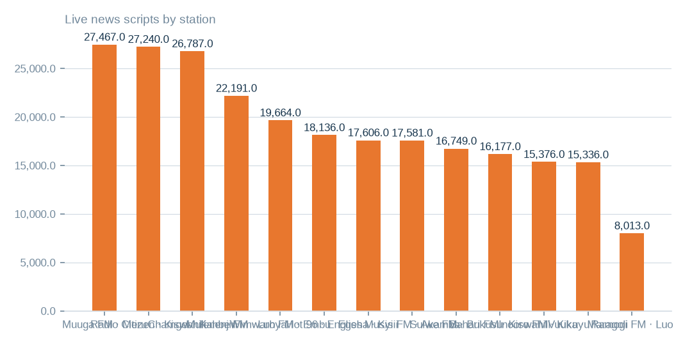
Figure: Holdings total 248841 scripts from 13 stations; the language shown is the station's broadcast language, not a reading of each script.
[measured] Receipt R08: Aggregate-only database reading etx-81e10befe6e0: news_vault.stories (script, title, date, hour_id) → news_vault.hours (station_id, time, type_id) → news_vault.stations (name); news_vault.news (2022 bulletins); local.uploaded_files (language_id, audio_length, status) ← local.transcripts (file_id, start_time, end_time, transcript) ; local.folder_languages (Language, code, station)

Bulletin hours on scripted days
Even on days that carry scripts, no station averages a full day of bulletin hours. Scripts exist on only 226 dates across a 1432-day span, 15.8% of days.
Coverage cannot therefore be assumed continuous. The day-level and hour-slot tables show exactly which days and hours exist.
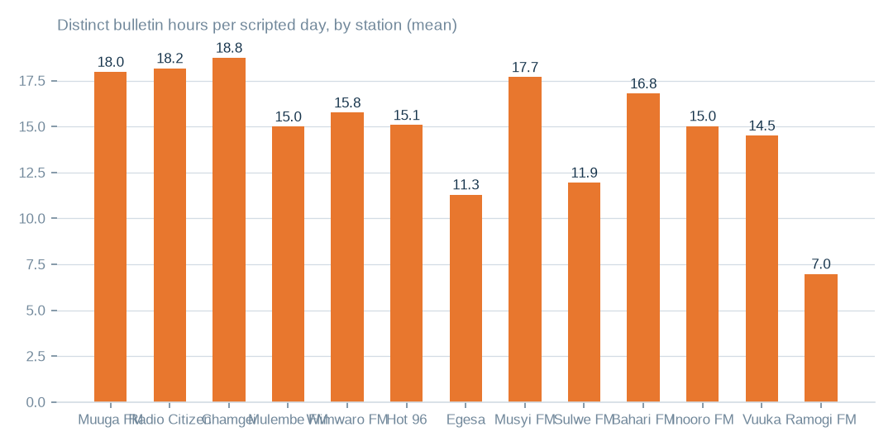
Figure: Scripts exist on only 226 dates across 1432 days (15.8%), so coverage cannot be assumed continuous; the day-level tables show exactly which hours exist.
[measured] Receipt R08: Aggregate-only database reading etx-81e10befe6e0: news_vault.stories (script, title, date, hour_id) → news_vault.hours (station_id, time, type_id) → news_vault.stations (name); news_vault.news (2022 bulletins); local.uploaded_files (language_id, audio_length, status) ← local.transcripts (file_id, start_time, end_time, transcript) ; local.folder_languages (Language, code, station)

Three text inventories, kept separate
News scripts number 248841 live rows, of which 38.0% are revisions; 159100 distinct texts remain (63.9%) and 10206 rows are marked deleted. Deduplicate before any use. The text model read 2245 transcripts, and 99.4% of passages agree with the folder language; 1694 transcripts were not reached.
The workbench registers 83014 recordings, 12,290.6 hours and 489418 segments in 13 languages. It is a separate inventory that may overlap the staged corpus, so the inventories are never added together.
T022 Hourly news scripts by station (news_vault.stories)
Station | Broadcast language | Live scripts | Deleted | Scripted days | First date | Last date | Scripts per scripted day | Bulletin hours per scripted day | Days with all twenty-four hours | Hour slots configured | Characters
Muuga FM | Meru | 27467 | 717 | 221 | 2022-10-16 | 2026-09-16 | 127.53 | 17.98 | 1 | 24 | 14128382
Radio Citizen | Kiswahili | 27240 | 569 | 219 | 2022-10-15 | 2026-09-16 | 126.98 | 18.18 | 43 | 28 | 22231911
Chamgei | Kalenjin | 26787 | 2486 | 224 | 2022-10-15 | 2026-09-16 | 130.68 | 18.75 | 23 | 26 | 20538503
Mulembe FM | Luhya | 22191 | 889 | 225 | 2022-10-15 | 2026-09-16 | 102.58 | 15.0 | 0 | 29 | 15496412
Wimwaro FM | Embu | 19664 | 428 | 223 | 2022-10-17 | 2026-09-16 | 90.1 | 15.76 | 0 | 24 | 12408784
Hot 96 | English | 18136 | 580 | 225 | 2022-10-15 | 2026-09-16 | 83.18 | 15.08 | 0 | 23 | 12470183
Egesa | Kisii | 17606 | 868 | 219 | 2022-10-16 | 2026-09-16 | 84.36 | 11.3 | 0 | 25 | 14458656
Musyi FM | Akamba | 17581 | 623 | 199 | 2022-10-15 | 2026-09-16 | 91.48 | 17.69 | 7 | 25 | 16521768
Sulwe FM | Bukusu | 16749 | 485 | 225 | 2022-10-15 | 2026-09-16 | 76.6 | 11.95 | 0 | 24 | 14484808
Bahari FM | Kiswahili | 16177 | 1038 | 222 | 2022-10-17 | 2026-09-16 | 77.55 | 16.8 | 0 | 25 | 12789664
Inooro FM | Kikuyu | 15376 | 298 | 209 | 2022-10-15 | 2026-09-16 | 75.0 | 15.03 | 0 | 24 | 11946715
Vuuka | Maragoli | 15336 | 377 | 222 | 2022-10-17 | 2026-09-16 | 70.78 | 14.51 | 1 | 24 | 12773790
Ramogi FM | Luo | 8013 | 822 | 222 | 2022-10-17 | 2026-09-16 | 39.8 | 6.98 | 0 | 21 | 8574493
unassigned hour | — | 518 | 26 | 31 | 2026-02-18 | 2026-08-22 | 17.55 | 3.65 | 0 | 0 | 481289
A scripted day is a calendar date with at least one script for the station; bulletin hours are the distinct hour slots scripted that day. The script texts themselves were not read; the language is the station's broadcast language as recorded in the estate.
[measured] Receipt R08: Aggregate-only database reading etx-81e10befe6e0: news_vault.stories (script, title, date, hour_id) → news_vault.hours (station_id, time, type_id) → news_vault.stations (name); news_vault.news (2022 bulletins); local.uploaded_files (language_id, audio_length, status) ← local.transcripts (file_id, start_time, end_time, transcript) ; local.folder_languages (Language, code, station)
T021 Transcripts by language folder — read by the served text language model
Language folder | Language | Transcripts read | Characters | Words | Passages labelled | Agrees with folder | Files whose top label matches
guz | Ekegusii (Kisii) | 698 | 4474462 | 638478 | 3344 | 99.6% | 697
kik | Gikuyu (Kikuyu) | 298 | 1767236 | 272741 | 1323 | 99.3% | 296
luo | Dholuo (Luo) | 298 | 2347383 | 417575 | 1717 | 99.9% | 298
swa | Kiswahili | 298 | 2599230 | 411682 | 1884 | 99.6% | 298
kam | Kikamba (Kamba) | 298 | 1058430 | 173388 | 851 | 99.7% | 298
kln | Kalenjin | 295 | 4674494 | 747249 | 3258 | 99.0% | 290
lwg | Wanga (Luhya) | 60 | 491139 | 73194 | 356 | 98.3% | 59
Passages of up to fifteen hundred characters were labelled by the admitted text model; agreement is the share of passages whose label matched the folder language. Transcripts the capped pass did not reach are counted as not read.
[measured] Receipt R07: Served text language model m9j-74af7cef0a85 readings of the staged transcripts: jobs m9j-2d43ed6cf567, m9j-8cf6702f8718 (2,245 transcripts read, 3939 present)
T023 Transcription workbench by language (local.uploaded_files, local.transcripts)
Language | Code | Station | Recordings | Audio hours | Sent to transcription | With text file | Transcript segments | Transcript characters | Transcribed hours | Last processed
kiswahili | swa | Radio citizen | 4006 | 836.2 | 589 | 827 | 54516 | 4949951 | 101.0 | 2025-03-08
Bukusu | bxk | sulwe | 8223 | 806.4 | 0 | 2 | 0 | 0 | 0.0 | 2024-02-14
Kikuyu | kik | Inooro | 3640 | 670.9 | 173 | 182 | 11034 | 1050440 | 20.3 | 2025-03-08
Maragoli | mrg | Vuuka | 5503 | 559.7 | 0 | 2 | 0 | 0 | 0.0 | 2024-02-14
Embu | ebu | wimwaro | 2000 | 504.3 | 0 | 0 | 0 | 0 | 0.0 | 2024-02-13
Kalenjin | kln | Chamgei | 1280 | 500.6 | 140 | 160 | 59507 | 2628605 | 129.1 | 2025-03-08
Luo | luo | Ramogi | 3693 | 492.5 | 389 | 479 | 44184 | 2803682 | 711.1 | 2025-03-08
Kisii | guz | Egesa | 2503 | 491.0 | 390 | 412 | 44470 | 2936045 | 75.1 | 2025-03-08
luhya | lwg | mulembe | 2253 | 420.1 | 298 | 338 | 53287 | 3550675 | 7.4 | 2025-03-08
Kikuyu | kik | inooro | 853 | 401.7 | 21 | 21 | 2456 | 434679 | 9.1 | 2025-03-08
Meru | mer | muuga | 3215 | 384.2 | 0 | 0 | 0 | 0 | 0.0 | 2024-02-14
Akamba | kam | musyi | 3257 | 376.9 | 371 | 423 | 7815 | 1524452 | -26.1 | 2025-03-08
Luhya | lwg | mulembe | 3344 | 371.8 | 184 | 211 | 13849 | 955641 | 21.5 | 2025-03-08
Luo | luo | Ramogi | 3228 | 359.9 | 210 | 227 | 22805 | 1583376 | 320.6 | 2025-03-08
Maragoli | mrg | Vuuka | 3017 | 311.6 | 0 | 0 | 0 | 0 | 0.0 | 2024-02-14
Kalenjin | kln | Chamgei | 841 | 300.8 | 61 | 76 | 22301 | 969198 | 18.0 | 2025-03-08
Meru | mer | Muuga | 1973 | 282.6 | 0 | 0 | 0 | 0 | 0.0 | 2024-02-14
Embu | ebu | wimwaro | 1501 | 276.4 | 0 | 0 | 0 | 0 | 0.0 | 2024-02-13
Kikuyu | kik | inooro | 1558 | 269.7 | 85 | 89 | 5169 | 410034 | 8.6 | 2025-03-08
kisii | guz | Egesa | 1773 | 257.8 | 174 | 185 | 10237 | 1026481 | 27.9 | 2025-03-08
Kisii | guz | Egesa | 2572 | 253.3 | 205 | 234 | 10733 | 1011917 | 25.1 | 2025-03-08
Kikuyu | kik | inooro | 1139 | 237.0 | 59 | 62 | 4579 | 503323 | 11.7 | 2025-03-08
Kalenjin | kln | Chamgei | 876 | 213.7 | 112 | 138 | 30508 | 1422873 | 42.2 | 2025-03-08
Meru | mer | muuga | 1450 | 209.5 | 0 | 0 | 0 | 0 | 0.0 | 2024-02-13
Bukusu | bxk | sulwe | 2194 | 208.8 | 0 | 2 | 0 | 0 | 0.0 | 2024-02-14
Akamba | kam | musyi | 2085 | 207.5 | 335 | 382 | 6465 | 1292630 | 54.3 | 2025-03-08
Akamba | kam | musyi | 2723 | 203.7 | 317 | 358 | 3086 | 772542 | 6.8 | 2025-03-08
Luo | luo | ramogi | 1353 | 198.6 | 93 | 101 | 10113 | 717724 | 120.6 | 2025-03-08
Kikuyu | kik | inooro | 674 | 191.3 | 60 | 67 | 6852 | 618011 | 12.2 | 2025-03-08
Meru | mer | muuga | 1401 | 188.3 | 0 | 0 | 0 | 0 | 0.0 | 2024-02-14
Maragoli | mrg | Vuuka | 1144 | 150.7 | 0 | 0 | 0 | 0 | 0.0 | 2024-02-14
Embu | ebu | wimwaro | 515 | 110.1 | 0 | 0 | 0 | 0 | 0.0 | 2024-02-13
Luhya | lwg | mulembe | 1218 | 109.7 | 112 | 126 | 12130 | 701860 | 22.0 | 2025-03-08
Maragoli | mrg | Vuuka | 353 | 102.1 | 0 | 0 | 0 | 0 | 0.0 | 2024-02-14
luhya | lwg | mulembe | 519 | 100.9 | 11 | 17 | 3402 | 159512 | 2.6 | 2024-11-08
kiswahili | swa | Bahari | 196 | 94.5 | 8 | 21 | 2981 | 135554 | 2.6 | 2024-11-16
Akamba | kam | musyi | 703 | 88.7 | 88 | 101 | 3428 | 416462 | -0.9 | 2025-03-08
Akamba | kam | musyi | 764 | 84.1 | 122 | 134 | 2926 | 568579 | 11.7 | 2025-03-08
Kikuyu | kik | Inooro | 707 | 83.4 | 251 | 262 | 18776 | 1326861 | 27.4 | 2025-03-11
Embu | ebu | wimwaro | 467 | 75.6 | 0 | 0 | 0 | 0 | 0.0 | 2024-02-13
kiswahili | swa | Radio citizen | 405 | 61.7 | 0 | 2 | 0 | 0 | 0.0 | 2024-02-13
Embu | ebu | wimwaro | 311 | 60.6 | 0 | 0 | 0 | 0 | 0.0 | 2024-02-13
Akamba | kam | musyi | 584 | 41.4 | 80 | 88 | 1464 | 219117 | 4.6 | 2025-03-08
Embu | ebu | wimwaro | 199 | 37.4 | 0 | 0 | 0 | 0 | 0.0 | 2024-02-13
Meru | mer | muuga | 168 | 24.3 | 0 | 0 | 0 | 0 | 0.0 | 2024-02-14
Kikuyu | kik | inooro | 363 | 24.1 | 17 | 17 | 679 | 42276 | 0.8 | 2024-10-31
kisii | guz | Egesa | 71 | 23.0 | 3 | 3 | 574 | 39543 | 0.7 | 2025-03-08
Kalenjin | kln | Chamgei | 62 | 13.1 | 8 | 10 | 2021 | 79361 | 1.7 | 2025-03-08
kiswahili | swa | Radio citizen | 61 | 9.7 | 7 | 11 | 1139 | 78331 | 0.8 | 2024-12-30
kiswahili | swa | Bahari | 76 | 8.7 | 4 | 9 | 108 | 11253 | 0.2 | 2024-11-13
The workbench registers recordings per language with their length and whether a transcript was produced; transcript hours are the summed segment spans. This is a separate inventory from the staged corpus and may overlap it — the two are not added together anywhere in this pack.
[measured] Receipt R08: Aggregate-only database reading etx-81e10befe6e0: news_vault.stories (script, title, date, hour_id) → news_vault.hours (station_id, time, type_id) → news_vault.stations (name); news_vault.news (2022 bulletins); local.uploaded_files (language_id, audio_length, status) ← local.transcripts (file_id, start_time, end_time, transcript) ; local.folder_languages (Language, code, station)

Which products to prepare first
The census scores 8 product candidates on dimensional readiness only, which establishes neither market demand nor revenue. This pack proposes reference and master-data licensing and the content catalogue and recommendation corpus as the first two, each needing canonical keys, completeness checks and de-identification or aggregation.
Aggregated channel and telco engagement analytics is the alternative if a buyer leads. The order is a planning judgement and needs a buyer-side review of each candidate against its intended use. Rights are settled and are not a gate.

The decisions requested
The executive is asked to approve verification and preparation work, each with a named source, rule and responsible role in the decisions table. The storage decisions rest on 41.9 TiB of cold object data, 7.7 TiB of duplicate candidates and 40 unreadable buckets.
The benefit is bounded at 1,174.4 USD a month at list prices; it is not current spend. The audio opportunity of 529.5 recorded hours needs filtering and language checks first. Nothing has yet been moved, deleted or released.
T013 Executive decisions requested — one row each
No. | Decision requested | Exact source | Action | Proposed destination or rule | Responsible role | Expected benefit | Evidence | Still to verify
D1 | Approve archive tiering of the cold object-store buckets | 43 buckets, e.g. music-bucket-rms, na7p43do, na7p43js, na7p434j, na7p41hj | apply a lifecycle rule Standard → Archive; keep listing metadata hot | same buckets, archive storage class (proposed) | Head of Technology (storage owner) | up to 986 USD a month at list price | R04 · T010 | read-frequency logs for ninety days before the rule applies
D2 | Approve hash confirmation and removal of duplicate objects | na7p43do, na7p4oco, music-bucket-rms, 2024offairrecs (1,139,768 candidates across the store) | confirm each candidate by content hash; keep one copy per bucket; replace the rest with references or lifecycle-delete | keeper stays in its bucket; duplicates removed after confirmation (proposed) | Head of Technology with the content librarian | up to 180 USD a month at list price | R04 · T010 | content-hash confirmation; ETag plus size is not proof for multipart uploads
D3 | Instruct reconciliation of the unreadable buckets | 40 buckets, e.g. apr252017, citizen-vod, elections, feb272017, instore-radio-items | ask the provider whether each bucket exists; remove dead names from the inventory; restore access where it should exist | inventory register corrected (proposed) | Cloud account owner | an inventory the next census can trust | R04 · T015 | provider confirmation per bucket
D4 | Approve cold-table archiving in the databases | 6 tables, e.g. viusasa_staging.audits, viusasa_staging.master_payments, razuna.raz1_videos, viusasa_staging.payment_requests | export to compressed object storage with a schema stub and a pointer; restore on demand | object store, archive class, one prefix per database (proposed) | Database administrator | up to 6 USD a month at list price | R02 · T011 | application owners confirm no live reads
D5 | Decide one authoritative copy for each duplicated table pair | 71 pairs, e.g. iebc_forms/viupay.failed_jobs ↔ viupay/viupay.failed_jobs; iebc_forms/viutickets.movies ↔ viupay/viutickets.movies; iebc_forms/viutickets.ussd_hits ↔ viupay/viutickets.ussd_hits | name the master; retire or redirect the copy; add the pair to the schema register | master stays; copy retired (proposed) | Database administrator with the application owners | up to 0 USD a month at list price | R01 · T011 | which copy the applications actually write to
D6 | Approve the housekeeping list: empty tables, redundant indexes, repeated rows | 368 empty tables; redundant indexes and repeated rows named in the table list | drop confirmed-unused empty tables; drop covered indexes; de-duplicate keyed rows | no destination — removal in place after confirmation (proposed) | Database administrator | up to 2 USD a month at list price plus up to 0 USD a month at list price | R02 · T011 | application owner sign-off per table
D7 | Order a fingerprint pass over the file shares | 16 NAS shares holding 43.6 TiB (channel01 … channel16) | compute content fingerprints so duplication across channels can be measured | none yet — measurement first | Head of Technology | a measured duplication figure for the largest unmeasured store | R05 · T012 | the pass itself; nothing is known about NAS duplication today
D8 | Adopt naming and ownership rules for storage | machine-named buckets (na7p4…), channel shares, staging copies | a register naming an owner, purpose, retention and tier for every bucket, share and database; machine names mapped to purposes | register maintained by the storage owner (proposed) | Chief Operating Officer | fewer orphaned stores and faster decisions at the next census | R04 · R05 | owner confirmation for each entry
D9 | Register the language assets as governed data products | staged corpus by language folder (T020), news scripts by station (T022), transcription workbench (T023) | record each as an asset with its hours or scripts, its evidence rows and its quality signals; keep the inventories separate until a file-level join is made | governed asset register (proposed) | Head of Data with the newsroom | a licensable, evidenced inventory of non-English speech and text | R06 · R07 · R08 | overlap between the workbench and the staged corpus; language of each script
D10 | Commission the de-identified reference products the census ranks first | the three leading product candidates in the census | prepare de-identified or aggregated reference and channel datasets under an explicit target outcome and collection schema | product workspace (proposed) | Head of Data | first revenue-bearing use of the estate's data | R03 | a signed target outcome and collection schema per product
Each decision names the exact source it rests on, the action, the proposed destination or rule, who carries it, the benefit stated as an upper bound where it is money, the evidence it rests on and what still has to be verified. Nothing here has been executed.
[estimated] Receipt R02: Estate intelligence census eij-1b359b3cbd2e, cost_strategies priced at reference list prices, not the owner's invoice: Huawei Cloud RDS for MySQL cloud SSD AF-Johannesburg 0.00015 USD/GB-hour x 730 h; OBS Standard 0.023 USD/GB-month

What remains unmeasured
Database measures cover 638 of 1006 tables, 40 buckets are unreachable, and file-share duplication is unmeasured across 1.5m files. 1694 transcripts were unread, script language was not read, and workbench overlap with the staged corpus is unjoined. One database connection awaits a read grant.
Each gap has a stated closing step: a complete-pass census, provider reconciliation, a fingerprinting pass, a text-model pass over scripts, a hash join and a read grant followed by a re-census. The table of model roles discloses authorship only.
T036 Who wrote this pack — model roles by task strength
Role | Model | Family | Job | Measured strength
assistant | gpt-6-astra | openai | planning collaborator in Train Models: reads the run record, plans the next bounded step, proposes one action | long-horizon planning and orchestration; strict JSON; grounded figures
planner | gpt-6-astra | openai | plans and orchestrates multi-step work (document story, measurement order, task decomposition) | planning and orchestration across tools and steps
reviewer | claude-fable-5-1 | anthropic | independent review of complex outputs against source evidence and acceptance criteria; a different family from the planner | complex-task reasoning, error detection, disagreement stated plainly
writer | claude-sonnet-5-5 | anthropic | writes every sentence the reader sees from evidence tokens under the content-manager gate | evidence-grounded British-English prose that passes the figure-by-reference gate
Planner and reviewer come from different model families so the review does not share the planner's blind spots; every call crosses the Shield chokepoint. Arithmetic, evidence binding and the build stay deterministic.
[measured] Receipt R09: Model role assignments evaluated 2026-10-02: integration model catalogue plus published task benchmarks reviewed on the day; planner/reviewer families kept distinct so the review does not share the planner's blind spots. Not claimed: no independent head-to-head benchmark was run on owner data; assignments are disclosed configuration, re-evaluated when a role under-performs on its own gate

What to do first, in order
Start with the cold buckets: confirm read use and retrieval fees on the 43 buckets before tiering, since the upper bound is 986.5 USD a month. Hash the 7.7 TiB of duplicate candidates before removing any copy. Then reconcile the 40 unreadable buckets and fingerprint the file shares.
In parallel, prepare reference data and the content catalogue. Keep database cleanup bounded by 15.2 GiB, 4.3% of bytes. Measure outcomes against the 1,174.4 USD bound. Responsibilities are proposed, not authorised execution.

Limits on what we can conclude
Database coverage is 638 of 1006 tables, personal-data markers come from a sample, and duplicates are candidates until hashed. The 1,174.4 USD figure is a list-price upper bound, and cold bytes may still be read.
Each limit closes with a specific check: a complete-pass census, product-specific privacy preparation, content hashing, an invoice comparison and retrieval-cost validation, and human review of language and audio usability. None of these limits reopens rights.

Coverage and limits
Covers: The admitted estate as measured by census eij-1b359b3cbd2e: 20 databases, 1,006 tables (351.3 GiB), the object store, the file shares, the staged language corpus read by both GPUs and the written-word databases read as aggregates. No row value, script or transcript text is in this pack.
Cannot say | Why | What would close it
Duplicate, damage, empty-field and PII ratios on sampled tables | complete passes where the table allowed it, stratified samples elsewhere | a complete-pass census on the sampled tables
Semantic similarity between candidate datasets and the market | not measured; candidates are dimensional readiness only | a buyer-side review of each candidate against its intended use
Connection artists_app | could not be read (MySQL GRANT pending) | owner grants read access; re-census
NAS duplication | the enumeration recorded sizes and dates, not content fingerprints | a fingerprinting pass over the NAS shares
40 of 106 OBS buckets | unreachable (NoSuchBucket / client errors) | bucket inventory reconciled with the provider
Language of each news script | the scripts were counted and sized, not read; the language shown is the station's broadcast language from the estate's own table | a text-model pass over the script column under the same aggregate-only seam
Overlap between the workbench recordings and the staged corpus | both inventories were counted on their own; no file-level join was made | a hash join of workbench file locations against the staged corpus paths

Appendix: receipts
Receipt | Resolves to
R01 | Estate intelligence census eij-1b359b3cbd2e, digest-verified report (measured 2026-09-29), headline aggregates and per-database measures
R02 | Estate intelligence census eij-1b359b3cbd2e, cost_strategies priced at reference list prices, not the owner's invoice: Huawei Cloud RDS for MySQL cloud SSD AF-Johannesburg 0.00015 USD/GB-hour x 730 h; OBS Standard 0.023 USD/GB-month
R03 | Estate intelligence census eij-1b359b3cbd2e, data_products readiness scoring (dimensions, grades, blockers)
R04 | OBS bucket enumeration census run cr-f1415e395361 (22,975,591 objects, 130.3 TiB)
R05 | NAS share enumeration census run cr-cf4eef79995b (1,456,787 files, 43.6 TiB)
R06 | Estate language reading m9j-9e8fcb46a809 on akki-vm (2 GPUs, 1.034 GPU-h): audio language model lcj-7128593897d4 sha256 5c1feb8497e8…, music detector m9j-686de001bfe7 sha256 0fea3eee0393…; model readings, not human labels
R07 | Served text language model m9j-74af7cef0a85 readings of the staged transcripts: jobs m9j-2d43ed6cf567, m9j-8cf6702f8718 (2,245 transcripts read, 3939 present)
R08 | Aggregate-only database reading etx-81e10befe6e0: news_vault.stories (script, title, date, hour_id) → news_vault.hours (station_id, time, type_id) → news_vault.stations (name); news_vault.news (2022 bulletins); local.uploaded_files (language_id, audio_length, status) ← local.transcripts (file_id, start_time, end_time, transcript) ; local.folder_languages (Language, code, station)
R09 | Model role assignments evaluated 2026-10-02: integration model catalogue plus published task benchmarks reviewed on the day; planner/reviewer families kept distinct so the review does not share the planner's blind spots. Not claimed: no independent head-to-head benchmark was run on owner data; assignments are disclosed configuration, re-evaluated when a role under-performs on its own gate

