What RMS holds, what it costs and what to build first
Estate-wide account of holdings, cost to keep, condition and first data products · RMS

Summary
RMS holds 174.3 TiB across its databases, object store and file shares. The object store holds 130.3 TiB, the file shares 43.6 TiB and the databases only 0.3 TiB. The cost question is therefore mainly an object-store question, and the largest priced lever is moving buckets not written for over a year to a cheaper tier. Of the object store, 41.9 TiB has not been written for over a year.
Estimated monthly savings across all priced strategies are bounded at 1,174.4 USD at reference list prices. This is a ceiling, not an invoice-based figure, and the current retention bill has not been established. Database clean-up is modest: 15.2 GiB is reclaimable. The database rows need preparation more than removal, because 81.7% have empty required-looking fields and 71.8% of sampled rows carry personal-data markers.
The first move is validation: confirm read demand and retrieval costs for the cold buckets, and hash-confirm the 7.7 TiB of duplicate candidates. In parallel, prepare reference data, the content catalogue and channel engagement as products. Rights are settled by the owner's declaration and condition none of this; what remains open is measurement.

Plain English: the terms used in this pack
Term | What it means in this pack
Reclaimable | Space that could be removed or stored more cheaply once the check named beside it has been done. It is not space already freed, and it is not a guaranteed saving — the monthly figures are upper bounds at list prices.
Cold (not written for over a year) | Nothing new has been written to that bucket or table for more than a year, judged by the newest write date we could see. It says nothing about whether anyone still reads it — that was not measured.
Duplicate candidate | Two objects whose size and storage fingerprint (ETag) match inside the same store. For large uploads that fingerprint is not a content hash, so a candidate must be confirmed by hashing before any copy is removed.
Exact duplicate rows | Database rows that are identical in every measured column. 'Normalised' duplicates also match after trimming spaces and case.
Degraded row | A row whose worst column shows damage: text cut short, a placeholder such as 'N/A' or 'test', an invalid format, stray whitespace or garbled characters.
Empty required-looking fields | Blank values in columns whose name or pattern suggests they should always be filled (for example an identifier or a date). The database may not formally require them; the census flags them so an owner can decide.
Dead column | A column that is empty on practically every row: schema carried without data.
Personal-data marker | A sampled value that looks like an email, phone number, national ID or similar. It is a condition of the data, not a judgement about rights — the owner has declared all rights established.
Archive-class storage | A cheaper storage tier for data that is kept but rarely opened. Retrieval is slower and carries its own fee, which is why the saving is stated as an upper bound.
Proposed destination | Where this pack suggests data should live or how it should be tiered. Every destination here is a proposal for the executive to approve; this pack moved and deleted nothing.
Speech hours (estimate) | Recorded hours multiplied by the share of two-second windows the admitted music detector did not call music. Silence is set aside first.
Agrees with folder | The share of labelled windows (or transcript passages) where the model's language label matched the folder the recording was filed under. It is a model reading, not a human verification.
Declined to label | Windows where the language model's confidence fell below its threshold, so it gave no language rather than guess.
Scripted day / bulletin hour | A calendar date on which a station has at least one news script in the archive, and the distinct hour slots scripted that day. The archive does not carry a script for every hour of every day; the tables show exactly which days and hours it does.
Receipt | The retained Akki record (census run, GPU job or database reading) that every figure in this pack is traced to. The appendix lists them; the workbook carries the row-level evidence.

Where the estate's bytes sit
The whole estate holds 174.3 TiB. The object store accounts for 130.3 TiB and the file shares for 43.6 TiB, while the databases hold 0.3 TiB. Measured by bytes, the estate is overwhelmingly unstructured and file-based.
The consequence is simple. A programme aimed at databases would touch 0.2% of the estate. Object-store and file-share decisions govern most of what is kept, and so most of what it costs to keep.
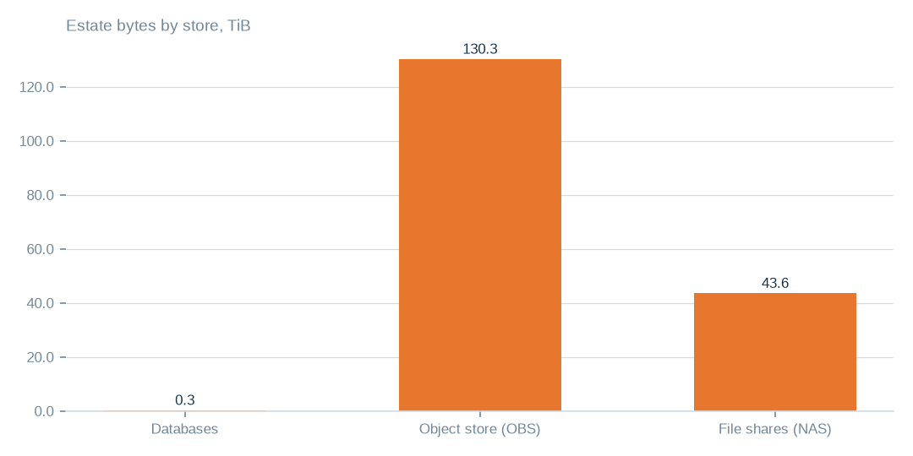
Figure: Storage priorities lie in the object store and file shares, 130.3 TiB and 43.6 TiB, against 0.3 TiB in databases.
[measured] Receipt R01: Estate intelligence census eij-1b359b3cbd2e, digest-verified report (measured 2026-09-29), headline aggregates and per-database measures

Concentration in the object store
The largest single bucket holds 86.3 TiB, which is 66.2% of the 130.3 TiB in the object store. A review that covers the largest bucket therefore covers most of the object-store estate.
Size is not a finding about condition. The largest bucket is not shown to be cold, redundant or ready to move. It is the place where one carefully checked decision carries the most weight.
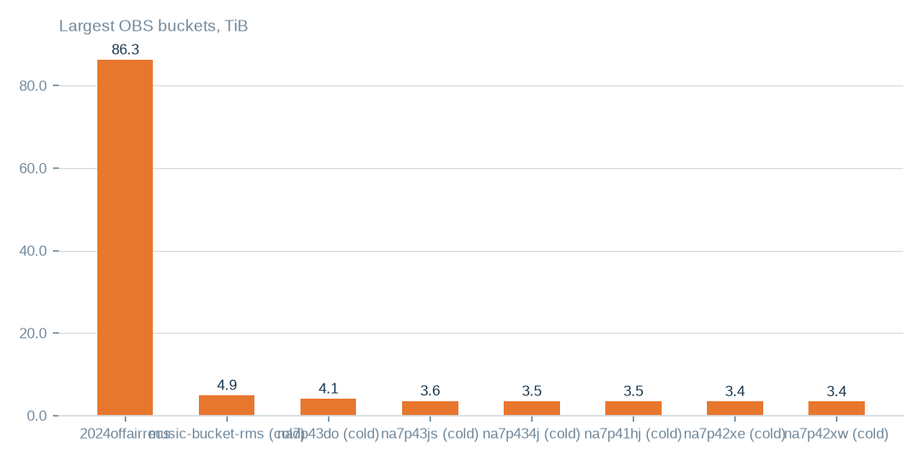
Figure: The largest bucket holds 86.3 TiB of 130.3 TiB; size alone does not make it cold, redundant or ready to move.
[measured] Receipt R04: OBS bucket enumeration census run cr-f1415e395361 (22,975,591 objects, 130.3 TiB)

Holdings across the three stores
Measured holdings total 174.3 TiB: 130.3 TiB in the object store (74.8%), 43.6 TiB on file shares (25.0%) and 0.3 TiB in databases (0.2%). Concentration within the databases should not be read as concentration across the estate.
The figure is measured but not a complete inventory. 40 of 106 object-store buckets returned errors when listed, so their contents are not in the totals. The estate is at least as large as stated.

Buckets, tables and shares under review
The table of buckets under review lists each bucket enumerated object by object, with last write, idle days, duplicate candidates, a classification and a proposed destination. 41.9 TiB has not been written for over a year, across 43 buckets, and 7.7 TiB are duplicate candidates.
Duplicate candidates match on size and storage fingerprint, which for large uploads is not a content hash. The file-share table records sizes and dates only. The database table lists findings by table; its bytes column is a strategy total, not the size of one table. The 40 buckets that could not be listed appear in their own table.
T010 Exact object-store buckets under review (largest first)
Bucket | Enumeration | Held (TiB) | Objects | Last write | Idle days | Duplicate candidates | Duplicate bytes (TiB, est.) | Main formats | Classification | Proposed action | Proposed destination
2024offairrecs | complete | 86.3 | 3,174,515 | 2026-09-29 | 0 | 16,589 | 0.45 | .mp4 3,131,277, .mp3 27,002, no_extension 15,658 | active — keep hot; heavy duplicate candidates | hash-confirm duplicate candidates, keep one copy | same bucket; duplicates replaced by references (proposed)
music-bucket-rms | complete | 4.93 | 152,801 | 2024-03-26 | 916 | 14,696 | 0.47 | .mp4 146,617, .txt 1,183, .flx 1,086 | cold — archive candidate; heavy duplicate candidates | lifecycle rule Standard → Archive after read-log check | same bucket, archive storage class (proposed)
na7p43do | complete | 4.1 | 484,480 | 2024-04-04 | 908 | 197,528 | 1.67 | .mp3 326,105, .mts 39,439, .vis 39,437 | cold — archive candidate; heavy duplicate candidates | lifecycle rule Standard → Archive after read-log check | same bucket, archive storage class (proposed)
na7p43js | complete | 3.57 | 307,998 | 2024-04-02 | 909 | 27,187 | 0.32 | .ogg 118,600, .mp3 85,079, .adf 25,484 | cold — archive candidate; heavy duplicate candidates | lifecycle rule Standard → Archive after read-log check | same bucket, archive storage class (proposed)
na7p434j | complete | 3.5 | 15,377 | 2024-04-04 | 908 | 2,890 | 0.66 | .mov 5,427, .avi 4,258, .jpg 2,157 | cold — archive candidate | lifecycle rule Standard → Archive after read-log check | same bucket, archive storage class (proposed)
na7p41hj | complete | 3.48 | 15,885 | 2024-03-27 | 915 | 1,852 | 0.41 | .mov 10,488, .mp4 2,347, .txt 1,519 | cold — archive candidate | lifecycle rule Standard → Archive after read-log check | same bucket, archive storage class (proposed)
na7p42xe | complete | 3.44 | 13,965 | 2024-04-04 | 907 | 1,120 | 0.28 | .mp4 6,241, .mov 5,519, .txt 1,434 | cold — archive candidate | lifecycle rule Standard → Archive after read-log check | same bucket, archive storage class (proposed)
na7p42xw | complete | 3.4 | 25,088 | 2024-03-31 | 911 | 2,391 | 0.32 | .mov 15,321, .txt 3,389, .avi 3,065 | cold — archive candidate | lifecycle rule Standard → Archive after read-log check | same bucket, archive storage class (proposed)
na7p42yg | complete | 3.28 | 28,059 | 2024-03-31 | 912 | 4,197 | 0.49 | .mov 21,920, .txt 3,169, .jpg 1,446 | cold — archive candidate | lifecycle rule Standard → Archive after read-log check | same bucket, archive storage class (proposed)
na7p43d3 | complete | 2.9 | 16,396 | 2024-03-30 | 912 | 1,395 | 0.25 | .mov 10,623, .txt 2,032, .avi 1,270 | cold — archive candidate | lifecycle rule Standard → Archive after read-log check | same bucket, archive storage class (proposed)
na7p4oco | complete | 2.86 | 468,637 | 2024-04-03 | 908 | 166,328 | 1.01 | .mp3 218,902, .mts 36,886, .vis 36,878 | cold — archive candidate; heavy duplicate candidates | lifecycle rule Standard → Archive after read-log check | same bucket, archive storage class (proposed)
rmsbroadcast | complete | 1.49 | 142,739 | 2024-03-24 | 918 | 5,060 | 0.05 | .mp3 127,221, .mp4 9,923, .mov 1,916 | cold — archive candidate | lifecycle rule Standard → Archive after read-log check | same bucket, archive storage class (proposed)
Every bucket named here was enumerated object by object; the classification follows from its last write date and its duplicate-candidate count. Destinations are proposals.
[measured] Receipt R04: OBS bucket enumeration census run cr-f1415e395361 (22,975,591 objects, 130.3 TiB)
T011 Exact database tables under review, by finding
Table (database.table) | Finding | Measured detail | Strategy bytes | Proposed action
viusasa_staging.audits | not written for over a year | 666 days · 18.6 GiB | 54.1 GiB | export to compressed object storage with a schema stub (proposed); restore on demand
viusasa_staging.master_payments | not written for over a year | 438 days · 4.2 GiB | 54.1 GiB | export to compressed object storage with a schema stub (proposed); restore on demand
razuna.raz1_videos | not written for over a year | 1341 days · 3.0 GiB | 54.1 GiB | export to compressed object storage with a schema stub (proposed); restore on demand
viusasa_staging.payment_requests | not written for over a year | 664 days · 2.8 GiB | 54.1 GiB | export to compressed object storage with a schema stub (proposed); restore on demand
viusasa_staging.sms | not written for over a year | 583 days · 2.7 GiB | 54.1 GiB | export to compressed object storage with a schema stub (proposed); restore on demand
viusasa_staging.mpesa_stk_requests | not written for over a year | 724 days · 1.4 GiB | 54.1 GiB | export to compressed object storage with a schema stub (proposed); restore on demand
viusasa_staging.search_lookups | repeated rows inside the table | 5.9% repeated · 8.7 GiB | 1.2 GiB | de-duplicate in place after a keyed comparison; keep the newest row
viusasa_staging.playback_qualified_streams | repeated rows inside the table | 5.1% repeated · 4.6 GiB | 1.2 GiB | de-duplicate in place after a keyed comparison; keep the newest row
viusasa_staging.episode_views | repeated rows inside the table | 22.0% repeated · 764.0 MiB | 1.2 GiB | de-duplicate in place after a keyed comparison; keep the newest row
kra_reports.external_credit_notes | repeated rows inside the table | 25.0% repeated · 277.8 MiB | 1.2 GiB | de-duplicate in place after a keyed comparison; keep the newest row
viusasa_staging.new_episode_views | repeated rows inside the table | 66.1% repeated · 98.7 MiB | 1.2 GiB | de-duplicate in place after a keyed comparison; keep the newest row
viusasa_staging.ussd_hits | repeated rows inside the table | 8.5% repeated · 573.0 MiB | 1.2 GiB | de-duplicate in place after a keyed comparison; keep the newest row
iebc_forms/viupay.failed_jobs ↔ viupay/viupay.failed_jobs | two copies of the same table across connections | overlap 78.0% · 31.6 MiB | 54.0 MiB | name one authoritative copy; retire or redirect the other
iebc_forms/viutickets.movies ↔ viupay/viutickets.movies | two copies of the same table across connections | overlap 84.0% · 6.5 MiB | 54.0 MiB | name one authoritative copy; retire or redirect the other
iebc_forms/viutickets.ussd_hits ↔ viupay/viutickets.ussd_hits | two copies of the same table across connections | overlap 100.0% · 6.5 MiB | 54.0 MiB | name one authoritative copy; retire or redirect the other
iebc_forms/viutickets.payment_processings ↔ viupay/viutickets.payment_processings | two copies of the same table across connections | overlap 65.0% · 4.5 MiB | 54.0 MiB | name one authoritative copy; retire or redirect the other
iebc_forms/viupay.payment_requests ↔ viupay/viupay.payment_requests | two copies of the same table across connections | overlap 50.0% · 3.5 MiB | 54.0 MiB | name one authoritative copy; retire or redirect the other
iebc_forms/viutickets.movie_shows ↔ viupay/viutickets.movie_shows | two copies of the same table across connections | overlap 80.0% · 3.5 MiB | 54.0 MiB | name one authoritative copy; retire or redirect the other
ecommerce_tafaria.playbacks | index covered by a wider index | playbacks_playable_type_index covered by playbacks_playable_type_playable_id_index | 14.0 GiB | drop the covered index; measure write amplification before and after
viusasa_staging.clip_requests | index covered by a wider index | clip_requests_castr_stream_id_index covered by clip_requests_castr_stream_id_castr_clip_id_index | 14.0 GiB | drop the covered index; measure write amplification before and after
viusasa_staging.continue_watchings | index covered by a wider index | continue_watchings_user_id_index covered by continue_watchings_user_history_updated_index | 14.0 GiB | drop the covered index; measure write amplification before and after
viusasa_staging.duka_product_search_clicks | index covered by a wider index | duka_product_search_clicks_normalized_term_index covered by duka_product_search_clicks_normalized_term_product_id_unique | 14.0 GiB | drop the covered index; measure write amplification before and after
viusasa_staging.duka_search_synonyms | index covered by a wider index | duka_search_synonyms_synonym_index covered by duka_search_synonyms_synonym_canonical_unique | 14.0 GiB | drop the covered index; measure write amplification before and after
viusasa_staging.elimu_learner_badges | index covered by a wider index | elimu_learner_badges_badge_id_index covered by elimu_learner_badges_badge_id_sub_user_id_unique | 14.0 GiB | drop the covered index; measure write amplification before and after
ecommerce_tafaria.airtel_c2bs | empty table |  |  | drop after the application owner confirms it is unused
ecommerce_tafaria.airtel_ussd_pushes | empty table |  |  | drop after the application owner confirms it is unused
ecommerce_tafaria.album_track | empty table |  |  | drop after the application owner confirms it is unused
ecommerce_tafaria.albums | empty table |  |  | drop after the application owner confirms it is unused
ecommerce_tafaria.api_providers | empty table |  |  | drop after the application owner confirms it is unused
ecommerce_tafaria.article_menu | empty table |  |  | drop after the application owner confirms it is unused
ecommerce_tafaria.article_sources | empty table |  |  | drop after the application owner confirms it is unused
ecommerce_tafaria.articles | empty table |  |  | drop after the application owner confirms it is unused
viusasa_staging.playback_stagings | high share of personal-data markers | 91.0% of sampled rows |  | de-identify or aggregate before any product use; keep the master as is
viusasa_staging.telescope_entries | high share of personal-data markers | 79.0% of sampled rows |  | de-identify or aggregate before any product use; keep the master as is
viusasa_staging.audits | high share of personal-data markers | 100.0% of sampled rows |  | de-identify or aggregate before any product use; keep the master as is
viusasa_staging.sms | high share of personal-data markers | 100.0% of sampled rows |  | de-identify or aggregate before any product use; keep the master as is
viusasa_staging.ussd_hits | high share of personal-data markers | 100.0% of sampled rows |  | de-identify or aggregate before any product use; keep the master as is
viusasa_staging.playback_qualified_streams | high share of personal-data markers | 58.0% of sampled rows |  | de-identify or aggregate before any product use; keep the master as is
ecommerce_tafaria.invoices.order_id → orders | references pointing at rows that no longer exist | 100.0% orphaned of 4 sampled |  | repair or remove the dangling references; add a foreign-key check
ecommerce_tafaria.invoices.payment_id → payments | references pointing at rows that no longer exist | 100.0% orphaned of 1 sampled |  | repair or remove the dangling references; add a foreign-key check
viusasa_staging.active_users.user_id → user | references pointing at rows that no longer exist | 100.0% orphaned of 400 sampled |  | repair or remove the dangling references; add a foreign-key check
viusasa_staging.airtel_ussd_pushes.user_id → user | references pointing at rows that no longer exist | 100.0% orphaned of 400 sampled |  | repair or remove the dangling references; add a foreign-key check
viusasa_staging.article_menu.article_id → articles | references pointing at rows that no longer exist | 100.0% orphaned of 400 sampled |  | repair or remove the dangling references; add a foreign-key check
viusasa_staging.audits.user_id → user | references pointing at rows that no longer exist | 100.0% orphaned of 400 sampled |  | repair or remove the dangling references; add a foreign-key check
Each row names a table the census measured and the finding that puts it on the list; the bytes column is the strategy total the table belongs to, not the table alone.
[measured] Receipt R02: Estate intelligence census eij-1b359b3cbd2e, cost_strategies priced at reference list prices, not the owner's invoice: Huawei Cloud RDS for MySQL cloud SSD AF-Johannesburg 0.00015 USD/GB-hour x 730 h; OBS Standard 0.023 USD/GB-month
T012 Exact file shares (NAS) enumerated
Share | Enumeration | Held (TiB) | Files | Last write | Main formats | Proposed action
channel01 | complete | 6.87 | 95,122 | 2026-09-29 | .mp4 95,108, .rmd 6, .mpt 3 | fingerprint pass to measure duplication; then tier by channel
channel02 | complete | 6.87 | 95,134 | 2026-09-29 | .mp4 95,129, .db 1, .jpg 1 | fingerprint pass to measure duplication; then tier by channel
channel16 | complete | 6.81 | 94,597 | 2026-09-29 | .mp4 94,592, .db 1, .jpg 1 | fingerprint pass to measure duplication; then tier by channel
Channel15 | complete | 1.91 | 95,635 | 2026-09-29 | .mp4 95,627, .rmd 3, .db 1 | fingerprint pass to measure duplication; then tier by channel
Channel14 | complete | 1.91 | 95,615 | 2026-09-29 | .mp4 95,609, .rmd 2, .db 1 | fingerprint pass to measure duplication; then tier by channel
Channel11 | complete | 1.91 | 95,602 | 2026-09-29 | .mp4 95,592, .rmd 6, .db 1 | fingerprint pass to measure duplication; then tier by channel
Channel12 | complete | 1.91 | 95,600 | 2026-09-29 | .mp4 95,590, .rmd 6, .db 1 | fingerprint pass to measure duplication; then tier by channel
channel07 | complete | 1.91 | 95,550 | 2026-09-29 | .mp4 95,546, .db 1, .jpg 1 | fingerprint pass to measure duplication; then tier by channel
channel06 | complete | 1.91 | 95,548 | 2026-09-29 | .mp4 95,544, .db 1, .jpg 1 | fingerprint pass to measure duplication; then tier by channel
channel05 | complete | 1.9 | 95,494 | 2026-09-29 | .mp4 95,490, .db 1, .jpg 1 | fingerprint pass to measure duplication; then tier by channel
channel04 | complete | 1.9 | 95,475 | 2026-09-29 | .mp4 95,470, .db 1, .jpg 1 | fingerprint pass to measure duplication; then tier by channel
channel03 | complete | 1.9 | 95,419 | 2026-09-29 | .mp4 95,415, .db 1, .jpg 1 | fingerprint pass to measure duplication; then tier by channel
Sizes and dates were recorded; content fingerprints were not, so duplication across the channel shares is not yet measured.
[measured] Receipt R05: NAS share enumeration census run cr-cf4eef79995b (1,456,787 files, 43.6 TiB)
T015 Object-store buckets that could not be read
Bucket | Error returned | Proposed action
apr252017 | NoSuchBucket | reconcile with provider; remove from inventory if gone
citizen-vod | NoSuchBucket | reconcile with provider; remove from inventory if gone
elections | ClientError | reconcile with provider; remove from inventory if gone
feb272017 | NoSuchBucket | reconcile with provider; remove from inventory if gone
instore-radio-items | ClientError | reconcile with provider; remove from inventory if gone
iso-rms-storage | NoSuchBucket | reconcile with provider; remove from inventory if gone
librarydirectupload2 | NoSuchBucket | reconcile with provider; remove from inventory if gone
na7p4100 | NoSuchBucket | reconcile with provider; remove from inventory if gone
na7p410c | NoSuchBucket | reconcile with provider; remove from inventory if gone
na7p419y | NoSuchBucket | reconcile with provider; remove from inventory if gone
na7p41ab | NoSuchBucket | reconcile with provider; remove from inventory if gone
na7p41f4 | NoSuchBucket | reconcile with provider; remove from inventory if gone
na7p41j6 | NoSuchBucket | reconcile with provider; remove from inventory if gone
na7p41jk | NoSuchBucket | reconcile with provider; remove from inventory if gone
na7p42ry | NoSuchBucket | reconcile with provider; remove from inventory if gone
na7p42s5 | NoSuchBucket | reconcile with provider; remove from inventory if gone
na7p42s7 | NoSuchBucket | reconcile with provider; remove from inventory if gone
na7p42tq | NoSuchBucket | reconcile with provider; remove from inventory if gone
na7p42tz | NoSuchBucket | reconcile with provider; remove from inventory if gone
na7p435c | NoSuchBucket | reconcile with provider; remove from inventory if gone
na7p4374 | NoSuchBucket | reconcile with provider; remove from inventory if gone
na7p43d6 | NoSuchBucket | reconcile with provider; remove from inventory if gone
na7p43dj | NoSuchBucket | reconcile with provider; remove from inventory if gone
na7p43hs | NoSuchBucket | reconcile with provider; remove from inventory if gone
na7p43jw | NoSuchBucket | reconcile with provider; remove from inventory if gone
na7p49pc | NoSuchBucket | reconcile with provider; remove from inventory if gone
na7p4omz | NoSuchBucket | reconcile with provider; remove from inventory if gone
na7p4oxs | NoSuchBucket | reconcile with provider; remove from inventory if gone
na7p4oy4 | NoSuchBucket | reconcile with provider; remove from inventory if gone
na7p4oz6 | NoSuchBucket | reconcile with provider; remove from inventory if gone
obituariesdata | NoSuchBucket | reconcile with provider; remove from inventory if gone
one-signal-live-service | NoSuchBucket | reconcile with provider; remove from inventory if gone
onesignal-logos | NoSuchBucket | reconcile with provider; remove from inventory if gone
onsignal-bucket | ClientError | reconcile with provider; remove from inventory if gone
private-isos | ClientError | reconcile with provider; remove from inventory if gone
razuna-direct-access | NoSuchBucket | reconcile with provider; remove from inventory if gone
rms-acronis-backup-bucket | NoSuchBucket | reconcile with provider; remove from inventory if gone
rms-ai | NoSuchBucket | reconcile with provider; remove from inventory if gone
sdatauploadroyalmedia.co.ke | NoSuchBucket | reconcile with provider; remove from inventory if gone
seconddatauploadroyalmedia.co.ke | NoSuchBucket | reconcile with provider; remove from inventory if gone
These names are in the bucket inventory but returned an error when listed; each needs reconciling with the provider — deleted, renamed or access withdrawn.
[measured] Receipt R04: OBS bucket enumeration census run cr-f1415e395361 (22,975,591 objects, 130.3 TiB)

Where the reclaimable bytes are
Moving idle buckets and reconciling duplicate objects dominate the addressed bytes. The three largest strategies reach 50,784.6 GiB of the 50,799.8 GiB that all strategies address. Database strategies are tiny by comparison.
Addressed bytes are not uniquely reclaimable bytes, because strategies may overlap. Tiering relocates data rather than deleting it, and no recent write does not mean no recent read. Read demand was not measured.
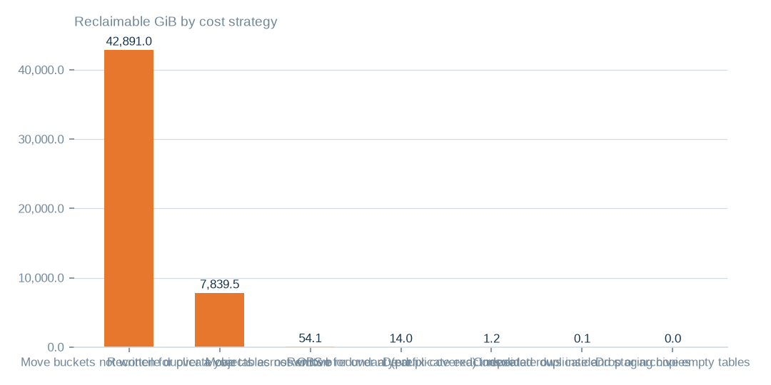
Figure: The three largest strategies address 50,784.6 GiB of the 50,799.8 GiB all strategies reach, but strategies may overlap and tiering is not deletion.
[estimated] Receipt R02: Estate intelligence census eij-1b359b3cbd2e, cost_strategies priced at reference list prices, not the owner's invoice: Huawei Cloud RDS for MySQL cloud SSD AF-Johannesburg 0.00015 USD/GB-hour x 730 h; OBS Standard 0.023 USD/GB-month

Three priced moves compared
Archive tiering of idle buckets addresses 42,891.0 GiB for up to 986.5 USD a month. It relocates rather than deletes, but retrieval carries its own fee and read frequency is unknown. Duplicate reconciliation addresses 7,839.5 GiB for up to 180.3 USD, but removal is final, so it needs content hashing first.
Cold database tables address 54.1 GiB for up to 5.9 USD, which is small. All priced strategies together are bounded at 1,174.4 USD a month at reference list prices. This is an upper bound, not the cost of keeping the estate; the invoice baseline is not established.
 | Move buckets not written for over a year to archive-class st | Reconcile duplicate objects across OBS buckets | Move tables not written for over a year to cold storage
Reclaimable gib | 42,891.0 | 7,839.5 | 54.1
Monthly saving usd | 986.5 | 180.3 | 5.9
Archive tiering is up to 986.5 USD a month, duplicate reconciliation 180.3 USD and cold tables 5.9 USD, all at list prices.
[estimated] Receipt R02: Estate intelligence census eij-1b359b3cbd2e, cost_strategies priced at reference list prices, not the owner's invoice: Huawei Cloud RDS for MySQL cloud SSD AF-Johannesburg 0.00015 USD/GB-hour x 730 h; OBS Standard 0.023 USD/GB-month

Condition of measured rows
The condition ratios point to completeness and personal-data preparation. 81.7% of rows have empty required-looking fields, 23.0% are degraded, 71.8% of sampled rows carry personal-data markers and 1.5% are exact duplicates. These measures overlap, so they should not be summed.
15.4% of bytes have not been written for over a year. The ratios rest on complete passes where tables allowed and on stratified samples elsewhere, so they are estimates.
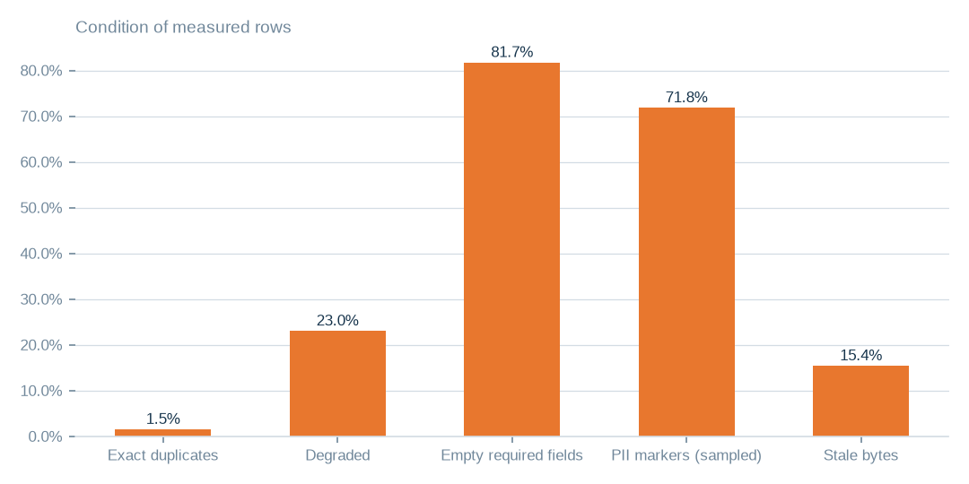
Figure: Empty fields touch 81.7% of rows and degradation 23.0%, against 1.5% exact duplicates; these overlap and must not be added together.
[estimated] Receipt R01: Estate intelligence census eij-1b359b3cbd2e, digest-verified report (measured 2026-09-29), headline aggregates and per-database measures

Database size by database
The databases hold 351.3 GiB, of which the largest hold 350.3 GiB, or 99.7%. One staging database dwarfs the rest, and the supplied grades appear beside each name.
This exhibit locates size, not quality. A large database is not shown to have the worst rows, and the databases together are a small part of the whole estate. Targeted operational review should start where the bytes are.
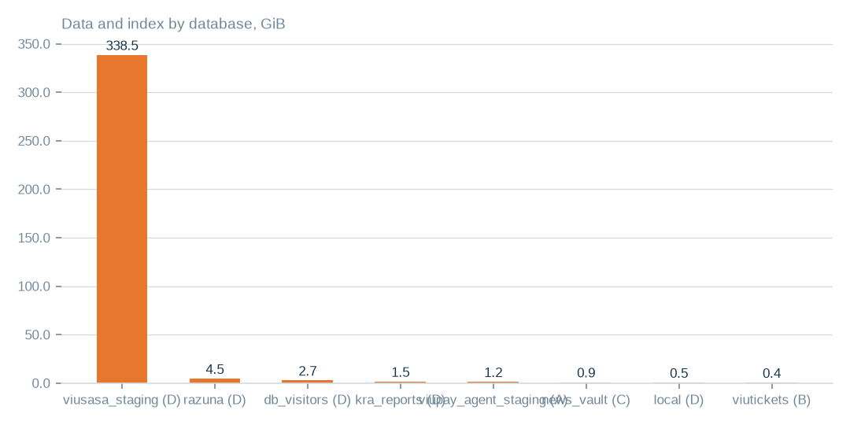
Figure: The largest databases hold 350.3 GiB of 351.3 GiB, or 99.7%; size does not show they hold the worst rows.
[measured] Receipt R01: Estate intelligence census eij-1b359b3cbd2e, digest-verified report (measured 2026-09-29), headline aggregates and per-database measures

What condition the rows are in
Exact duplication is the smallest of the condition issues, at 1.5% of rows. Degradation reaches 23.0% of rows and empty required-looking fields 81.7%. The census flags a field as required-looking from its name or pattern; the database may not require it, so this is a completeness question, not a constraint violation.
Personal-data markers appear in 71.8% of the 1.0m sampled rows. This is a condition to prepare for, through de-identification or aggregation before a product is released. It does not reopen rights, which the owner has declared settled. A missing marker does not prove the absence of personal data.

Speech hours by language folder
Six language folders carry broadly comparable estimated speech, while two are very thin. The corpus records 529.5 hours in total; an estimated 421.4 hours are speech once 108.2 hours of music are set aside.
The split uses the share of two-second windows the music detector did not call music. It is capacity for preparation, not verified clean speech, and it is not balanced coverage of languages.
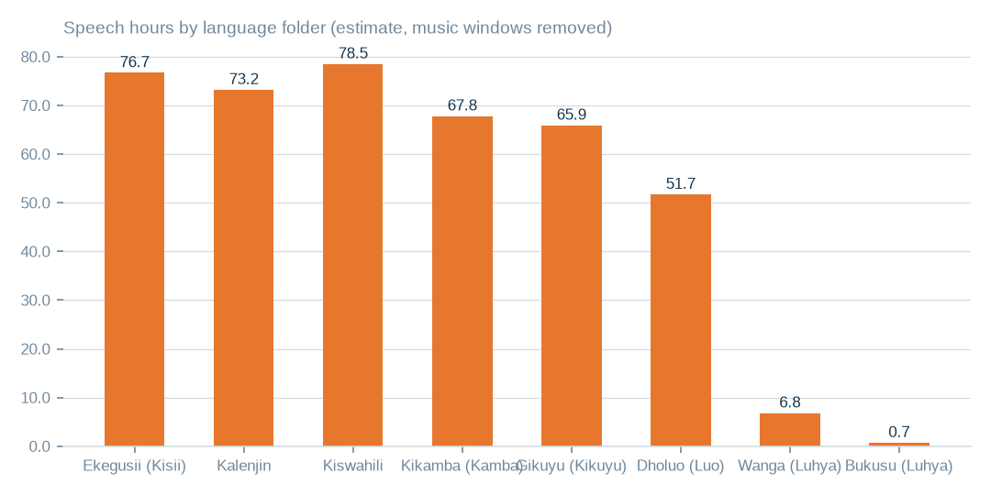
Figure: Estimated speech of 421.4 hours is preparation capacity, not verified clean speech or a balanced training set.
[estimated] Receipt R06: Estate language reading m9j-9e8fcb46a809 on akki-vm (2 GPUs, 1.034 GPU-h): audio language model lcj-7128593897d4 sha256 5c1feb8497e8…, music detector m9j-686de001bfe7 sha256 0fea3eee0393…; model readings, not human labels

Agreement with the folder language
Overall, 82.3% of judged windows agree with the language of the folder. Agreement is clearly lower for some folders, and one folder shows none, which marks where language validation should begin.
The model declined to label 10.7% of speech windows rather than guess. Agreement is a model reading on labelled windows. It is not human accuracy, transcript accuracy or intelligibility.
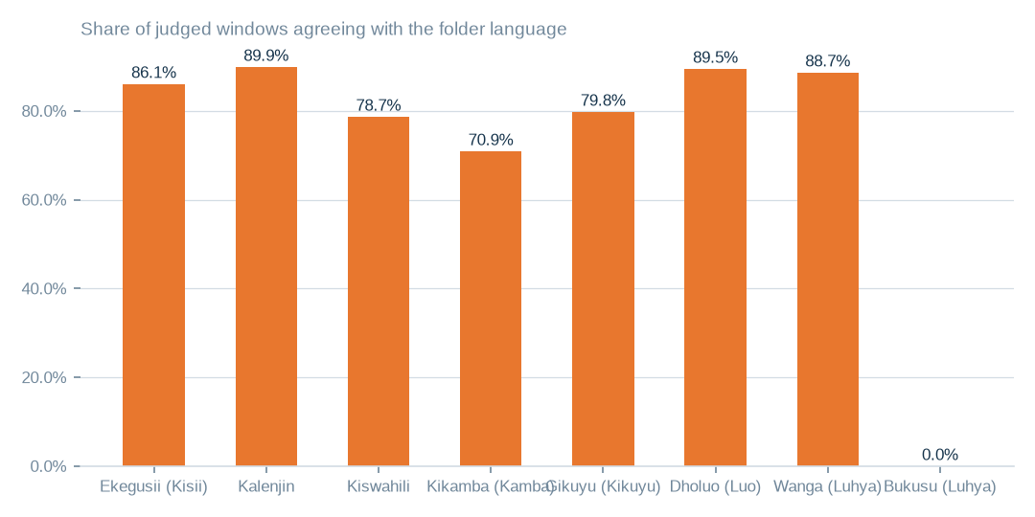
Figure: Across all folders 82.3% of judged windows agree with the folder; this is a model reading, not human accuracy.
[measured] Receipt R06: Estate language reading m9j-9e8fcb46a809 on akki-vm (2 GPUs, 1.034 GPU-h): audio language model lcj-7128593897d4 sha256 5c1feb8497e8…, music detector m9j-686de001bfe7 sha256 0fea3eee0393…; model readings, not human labels

Audio by language and condition
The staged corpus holds 529.5 recorded hours in 8 language folders across 3958 files. An estimated 421.4 hours are speech and 108.2 hours music; 20.4% of windows were called music, and 539 files are mostly music. Digital silence was 0.0% of windows.
Before any packaging, separate music, then validate language folder by folder, using the audio tables beside this chapter. Noise and intelligibility were not scored, so clean speech is not established and no dataset is ready.
T020 Audio held by language folder — what both GPUs read
Language folder | Language | Files | Hours recorded | Speech hours (est.) | Music hours (est.) | Agrees with folder | Declined to label | Transcript words
guz | Ekegusii (Kisii) | 732 | 92.2 | 76.7 | 15.6 | 86.1% | 8.3% | 662131
kln | Kalenjin | 295 | 89.8 | 73.2 | 16.6 | 89.9% | 7.1% | 747249
swa | Kiswahili | 549 | 87.7 | 78.5 | 9.2 | 78.7% | 12.9% | 725293
kam | Kikamba (Kamba) | 1166 | 85.4 | 67.8 | 17.6 | 70.9% | 13.2% | 669834
kik | Gikuyu (Kikuyu) | 584 | 82.1 | 65.9 | 16.2 | 79.8% | 15.4% | 583548
luo | Dholuo (Luo) | 558 | 82.1 | 51.7 | 30.4 | 89.5% | 6.8% | 739236
lwg | Wanga (Luhya) | 60 | 9.2 | 6.8 | 2.3 | 88.7% | 6.4% | 73194
bxk | Bukusu (Luhya) | 14 | 1.1 | 0.7 | 0.3 | 0.0% | 14.6% | 0
Hours are recorded duration; speech and music hours split those hours by the music detector; agreement is the share of labelled windows whose language matched the folder name. Model readings, not human labels.
[measured] Receipt R06: Estate language reading m9j-9e8fcb46a809 on akki-vm (2 GPUs, 1.034 GPU-h): audio language model lcj-7128593897d4 sha256 5c1feb8497e8…, music detector m9j-686de001bfe7 sha256 0fea3eee0393…; model readings, not human labels
T024 Audio quality signals by language folder
Language | Files | Decode failures | Silence (windows) | Music-majority files | Mixed-language files | Low-confidence files | Mean confidence | Mean length (min)
Ekegusii (Kisii) | 732 | 0 | 0.00% | 46 | 29 | 1 | 0.905 | 7.6
Kalenjin | 295 | 0 | 0.00% | 18 | 5 | 0 | 0.912 | 18.3
Kiswahili | 549 | 0 | 0.03% | 26 | 44 | 0 | 0.875 | 9.6
Kikamba (Kamba) | 1166 | 0 | 0.00% | 192 | 232 | 12 | 0.870 | 4.4
Gikuyu (Kikuyu) | 584 | 0 | 0.07% | 71 | 89 | 32 | 0.817 | 8.4
Dholuo (Luo) | 558 | 0 | 0.01% | 169 | 27 | 0 | 0.939 | 8.8
Wanga (Luhya) | 60 | 0 | 0.00% | 13 | 3 | 0 | 0.922 | 9.2
Bukusu (Luhya) | 14 | 0 | 0.00% | 4 | 11 | 0 | 0.866 | 4.6
Decode failures, digital silence, music-dominated files, mixed-language files (no language reaches sixty percent of labelled windows) and low-confidence files are the quality signals the reading can measure; noise and intelligibility were not scored.
[measured] Receipt R06: Estate language reading m9j-9e8fcb46a809 on akki-vm (2 GPUs, 1.034 GPU-h): audio language model lcj-7128593897d4 sha256 5c1feb8497e8…, music detector m9j-686de001bfe7 sha256 0fea3eee0393…; model readings, not human labels

News scripts by station
The archive holds 248841 live scripts from 13 stations. Station volumes range from large archives to one clearly smaller series.
The broadcast language shown is the station's own recorded language, not a label read from each script. Volume is inventory; it does not show uniqueness, because 38.0% of rows are revisions.
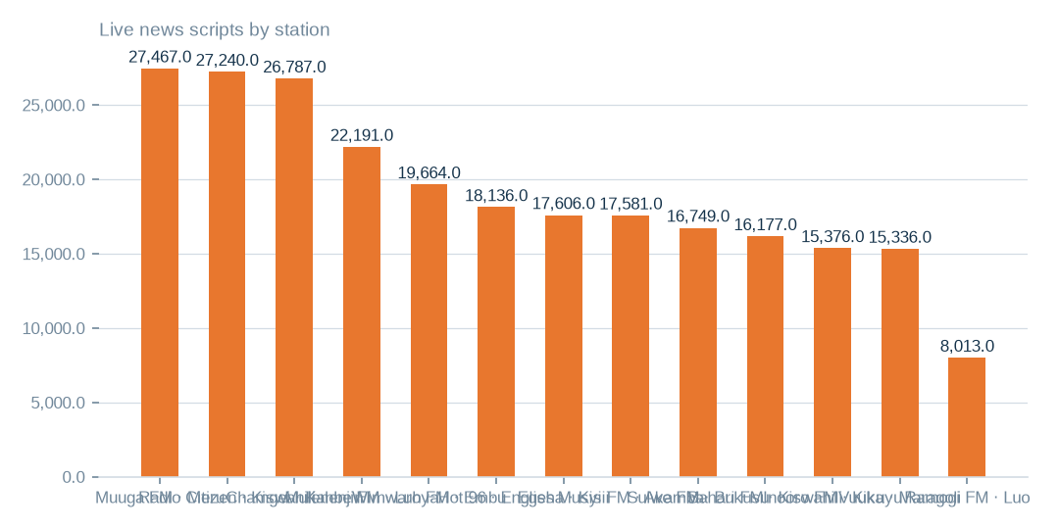
Figure: Volume is inventory, not uniqueness or continuous coverage, and the language shown is the station's recorded broadcast language.
[measured] Receipt R08: Aggregate-only database reading etx-81e10befe6e0: news_vault.stories (script, title, date, hour_id) → news_vault.hours (station_id, time, type_id) → news_vault.stations (name); news_vault.news (2022 bulletins); local.uploaded_files (language_id, audio_length, status) ← local.transcripts (file_id, start_time, end_time, transcript) ; local.folder_languages (Language, code, station)

Bulletin hours on scripted days
On days that carry a script, stations differ in how many distinct bulletin hours are scripted. The larger stations cover most of the day on those days, while one station covers far less.
These are conditional averages over scripted days only. The archive spans 1432 days but carries scripts on 226 dates, so continuous hourly coverage cannot be assumed. The supporting tables show each station, date and hour slot.
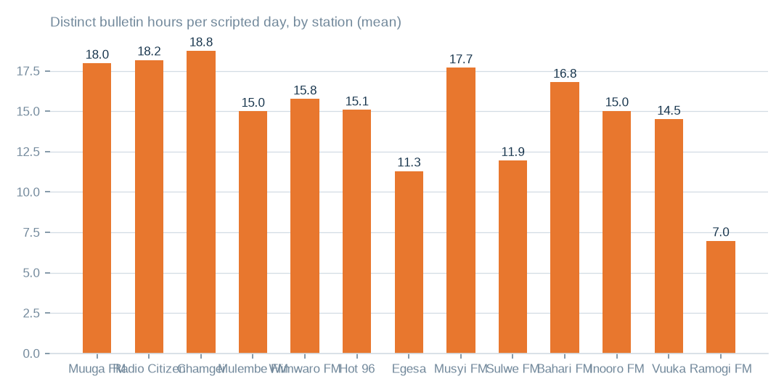
Figure: These averages hold only for days that carry a script and do not prove uninterrupted hourly coverage.
[measured] Receipt R08: Aggregate-only database reading etx-81e10befe6e0: news_vault.stories (script, title, date, hour_id) → news_vault.hours (station_id, time, type_id) → news_vault.stations (name); news_vault.news (2022 bulletins); local.uploaded_files (language_id, audio_length, status) ← local.transcripts (file_id, start_time, end_time, transcript) ; local.folder_languages (Language, code, station)

Separate text inventories
The news archive holds 248841 live scripts and 189.3m characters, with 159100 distinct texts and 10206 rows marked deleted. The staged transcripts total 4.2m words; the text model read 399 of them and found 99.6% of passages agreeing with the folder language. 3540 transcripts were not reached inside the compute cap, so that result should not be generalised.
The transcription workbench registers 83014 recordings, 12,290.6 audio hours and 489418 segments in 13 languages. It is a separate inventory from the staged corpus and may overlap it, so the two are not added together anywhere in this pack.
T022 Hourly news scripts by station (news_vault.stories)
Station | Broadcast language | Live scripts | Deleted | Scripted days | First date | Last date | Scripts per scripted day | Bulletin hours per scripted day | Days with all twenty-four hours | Hour slots configured | Characters
Muuga FM | Meru | 27467 | 717 | 221 | 2022-10-16 | 2026-09-16 | 127.53 | 17.98 | 1 | 24 | 14128382
Radio Citizen | Kiswahili | 27240 | 569 | 219 | 2022-10-15 | 2026-09-16 | 126.98 | 18.18 | 43 | 28 | 22231911
Chamgei | Kalenjin | 26787 | 2486 | 224 | 2022-10-15 | 2026-09-16 | 130.68 | 18.75 | 23 | 26 | 20538503
Mulembe FM | Luhya | 22191 | 889 | 225 | 2022-10-15 | 2026-09-16 | 102.58 | 15.0 | 0 | 29 | 15496412
Wimwaro FM | Embu | 19664 | 428 | 223 | 2022-10-17 | 2026-09-16 | 90.1 | 15.76 | 0 | 24 | 12408784
Hot 96 | English | 18136 | 580 | 225 | 2022-10-15 | 2026-09-16 | 83.18 | 15.08 | 0 | 23 | 12470183
Egesa | Kisii | 17606 | 868 | 219 | 2022-10-16 | 2026-09-16 | 84.36 | 11.3 | 0 | 25 | 14458656
Musyi FM | Akamba | 17581 | 623 | 199 | 2022-10-15 | 2026-09-16 | 91.48 | 17.69 | 7 | 25 | 16521768
Sulwe FM | Bukusu | 16749 | 485 | 225 | 2022-10-15 | 2026-09-16 | 76.6 | 11.95 | 0 | 24 | 14484808
Bahari FM | Kiswahili | 16177 | 1038 | 222 | 2022-10-17 | 2026-09-16 | 77.55 | 16.8 | 0 | 25 | 12789664
Inooro FM | Kikuyu | 15376 | 298 | 209 | 2022-10-15 | 2026-09-16 | 75.0 | 15.03 | 0 | 24 | 11946715
Vuuka | Maragoli | 15336 | 377 | 222 | 2022-10-17 | 2026-09-16 | 70.78 | 14.51 | 1 | 24 | 12773790
Ramogi FM | Luo | 8013 | 822 | 222 | 2022-10-17 | 2026-09-16 | 39.8 | 6.98 | 0 | 21 | 8574493
unassigned hour | — | 518 | 26 | 31 | 2026-02-18 | 2026-08-22 | 17.55 | 3.65 | 0 | 0 | 481289
A scripted day is a calendar date with at least one script for the station; bulletin hours are the distinct hour slots scripted that day. The script texts themselves were not read; the language is the station's broadcast language as recorded in the estate.
[measured] Receipt R08: Aggregate-only database reading etx-81e10befe6e0: news_vault.stories (script, title, date, hour_id) → news_vault.hours (station_id, time, type_id) → news_vault.stations (name); news_vault.news (2022 bulletins); local.uploaded_files (language_id, audio_length, status) ← local.transcripts (file_id, start_time, end_time, transcript) ; local.folder_languages (Language, code, station)
T021 Transcripts by language folder — read by the served text language model
Language folder | Language | Transcripts read | Characters | Words | Passages labelled | Agrees with folder | Files whose top label matches
guz | Ekegusii (Kisii) | 399 | 2694168 | 385453 | 2004 | 99.6% | 399
Passages of up to fifteen hundred characters were labelled by the admitted text model; agreement is the share of passages whose label matched the folder language. Transcripts the capped pass did not reach are counted as not read.
[measured] Receipt R07: Served text language model m9j-74af7cef0a85 readings of the staged transcripts: jobs m9j-8cf6702f8718 (399 transcripts read, 3939 present)
T023 Transcription workbench by language (local.uploaded_files, local.transcripts)
Language | Code | Station | Recordings | Audio hours | Sent to transcription | With text file | Transcript segments | Transcript characters | Transcribed hours | Last processed
kiswahili | swa | Radio citizen | 4006 | 836.2 | 589 | 827 | 54516 | 4949951 | 101.0 | 2025-03-08
Bukusu | bxk | sulwe | 8223 | 806.4 | 0 | 2 | 0 | 0 | 0.0 | 2024-02-14
Kikuyu | kik | Inooro | 3640 | 670.9 | 173 | 182 | 11034 | 1050440 | 20.3 | 2025-03-08
Maragoli | mrg | Vuuka | 5503 | 559.7 | 0 | 2 | 0 | 0 | 0.0 | 2024-02-14
Embu | ebu | wimwaro | 2000 | 504.3 | 0 | 0 | 0 | 0 | 0.0 | 2024-02-13
Kalenjin | kln | Chamgei | 1280 | 500.6 | 140 | 160 | 59507 | 2628605 | 129.1 | 2025-03-08
Luo | luo | Ramogi | 3693 | 492.5 | 389 | 479 | 44184 | 2803682 | 711.1 | 2025-03-08
Kisii | guz | Egesa | 2503 | 491.0 | 390 | 412 | 44470 | 2936045 | 75.1 | 2025-03-08
luhya | lwg | mulembe | 2253 | 420.1 | 298 | 338 | 53287 | 3550675 | 7.4 | 2025-03-08
Kikuyu | kik | inooro | 853 | 401.7 | 21 | 21 | 2456 | 434679 | 9.1 | 2025-03-08
Meru | mer | muuga | 3215 | 384.2 | 0 | 0 | 0 | 0 | 0.0 | 2024-02-14
Akamba | kam | musyi | 3257 | 376.9 | 371 | 423 | 7815 | 1524452 | -26.1 | 2025-03-08
Luhya | lwg | mulembe | 3344 | 371.8 | 184 | 211 | 13849 | 955641 | 21.5 | 2025-03-08
Luo | luo | Ramogi | 3228 | 359.9 | 210 | 227 | 22805 | 1583376 | 320.6 | 2025-03-08
Maragoli | mrg | Vuuka | 3017 | 311.6 | 0 | 0 | 0 | 0 | 0.0 | 2024-02-14
Kalenjin | kln | Chamgei | 841 | 300.8 | 61 | 76 | 22301 | 969198 | 18.0 | 2025-03-08
Meru | mer | Muuga | 1973 | 282.6 | 0 | 0 | 0 | 0 | 0.0 | 2024-02-14
Embu | ebu | wimwaro | 1501 | 276.4 | 0 | 0 | 0 | 0 | 0.0 | 2024-02-13
Kikuyu | kik | inooro | 1558 | 269.7 | 85 | 89 | 5169 | 410034 | 8.6 | 2025-03-08
kisii | guz | Egesa | 1773 | 257.8 | 174 | 185 | 10237 | 1026481 | 27.9 | 2025-03-08
Kisii | guz | Egesa | 2572 | 253.3 | 205 | 234 | 10733 | 1011917 | 25.1 | 2025-03-08
Kikuyu | kik | inooro | 1139 | 237.0 | 59 | 62 | 4579 | 503323 | 11.7 | 2025-03-08
Kalenjin | kln | Chamgei | 876 | 213.7 | 112 | 138 | 30508 | 1422873 | 42.2 | 2025-03-08
Meru | mer | muuga | 1450 | 209.5 | 0 | 0 | 0 | 0 | 0.0 | 2024-02-13
Bukusu | bxk | sulwe | 2194 | 208.8 | 0 | 2 | 0 | 0 | 0.0 | 2024-02-14
Akamba | kam | musyi | 2085 | 207.5 | 335 | 382 | 6465 | 1292630 | 54.3 | 2025-03-08
Akamba | kam | musyi | 2723 | 203.7 | 317 | 358 | 3086 | 772542 | 6.8 | 2025-03-08
Luo | luo | ramogi | 1353 | 198.6 | 93 | 101 | 10113 | 717724 | 120.6 | 2025-03-08
Kikuyu | kik | inooro | 674 | 191.3 | 60 | 67 | 6852 | 618011 | 12.2 | 2025-03-08
Meru | mer | muuga | 1401 | 188.3 | 0 | 0 | 0 | 0 | 0.0 | 2024-02-14
Maragoli | mrg | Vuuka | 1144 | 150.7 | 0 | 0 | 0 | 0 | 0.0 | 2024-02-14
Embu | ebu | wimwaro | 515 | 110.1 | 0 | 0 | 0 | 0 | 0.0 | 2024-02-13
Luhya | lwg | mulembe | 1218 | 109.7 | 112 | 126 | 12130 | 701860 | 22.0 | 2025-03-08
Maragoli | mrg | Vuuka | 353 | 102.1 | 0 | 0 | 0 | 0 | 0.0 | 2024-02-14
luhya | lwg | mulembe | 519 | 100.9 | 11 | 17 | 3402 | 159512 | 2.6 | 2024-11-08
kiswahili | swa | Bahari | 196 | 94.5 | 8 | 21 | 2981 | 135554 | 2.6 | 2024-11-16
Akamba | kam | musyi | 703 | 88.7 | 88 | 101 | 3428 | 416462 | -0.9 | 2025-03-08
Akamba | kam | musyi | 764 | 84.1 | 122 | 134 | 2926 | 568579 | 11.7 | 2025-03-08
Kikuyu | kik | Inooro | 707 | 83.4 | 251 | 262 | 18776 | 1326861 | 27.4 | 2025-03-11
Embu | ebu | wimwaro | 467 | 75.6 | 0 | 0 | 0 | 0 | 0.0 | 2024-02-13
kiswahili | swa | Radio citizen | 405 | 61.7 | 0 | 2 | 0 | 0 | 0.0 | 2024-02-13
Embu | ebu | wimwaro | 311 | 60.6 | 0 | 0 | 0 | 0 | 0.0 | 2024-02-13
Akamba | kam | musyi | 584 | 41.4 | 80 | 88 | 1464 | 219117 | 4.6 | 2025-03-08
Embu | ebu | wimwaro | 199 | 37.4 | 0 | 0 | 0 | 0 | 0.0 | 2024-02-13
Meru | mer | muuga | 168 | 24.3 | 0 | 0 | 0 | 0 | 0.0 | 2024-02-14
Kikuyu | kik | inooro | 363 | 24.1 | 17 | 17 | 679 | 42276 | 0.8 | 2024-10-31
kisii | guz | Egesa | 71 | 23.0 | 3 | 3 | 574 | 39543 | 0.7 | 2025-03-08
Kalenjin | kln | Chamgei | 62 | 13.1 | 8 | 10 | 2021 | 79361 | 1.7 | 2025-03-08
kiswahili | swa | Radio citizen | 61 | 9.7 | 7 | 11 | 1139 | 78331 | 0.8 | 2024-12-30
kiswahili | swa | Bahari | 76 | 8.7 | 4 | 9 | 108 | 11253 | 0.2 | 2024-11-13
The workbench registers recordings per language with their length and whether a transcript was produced; transcript hours are the summed segment spans. This is a separate inventory from the staged corpus and may overlap it — the two are not added together anywhere in this pack.
[measured] Receipt R08: Aggregate-only database reading etx-81e10befe6e0: news_vault.stories (script, title, date, hour_id) → news_vault.hours (station_id, time, type_id) → news_vault.stations (name); news_vault.news (2022 bulletins); local.uploaded_files (language_id, audio_length, status) ← local.transcripts (file_id, start_time, end_time, transcript) ; local.folder_languages (Language, code, station)

Which products to prepare first
The census scores 8 product candidates on readiness. Reference and master data, the content catalogue and channel engagement are each graded C. This is a basis for sequencing preparation, not proof of commercial ranking, and no revenue or market fit is shown.
Reference data needs canonical fields and completeness checks. The content catalogue needs consolidated metadata and removal of personal data. Channel engagement needs validated aggregation by channel and time. Each needs de-identification or aggregation where markers appear, and a buyer-side review of intended use before release.

The decisions requested
The decisions table gives each approval with its source, proposed rule, responsible role, expected benefit and remaining check. The first three are to validate the cold holdings of 41.9 TiB, to hash-confirm the 7.7 TiB of duplicate candidates, and to reconcile the 40 unreadable buckets.
Where a benefit is money it is an upper bound, within 1,174.4 USD a month at reference list prices. Nothing has been moved or deleted, and every destination is a proposal for approval.
T013 Executive decisions requested — one row each
# | Decision requested | Exact source | Action | Proposed destination or rule | Responsible role | Expected benefit | Evidence | Still to verify
D1 | Approve archive tiering of the cold object-store buckets | 43 buckets, e.g. music-bucket-rms, na7p43do, na7p43js, na7p434j, na7p41hj | apply a lifecycle rule Standard → Archive; keep listing metadata hot | same buckets, archive storage class (proposed) | Head of Technology (storage owner) | up to 986 USD a month at list price | R04 · T010 | read-frequency logs for ninety days before the rule applies
D2 | Approve hash confirmation and removal of duplicate objects | na7p43do, na7p4oco, music-bucket-rms, 2024offairrecs (1,139,768 candidates across the store) | confirm each candidate by content hash; keep one copy per bucket; replace the rest with references or lifecycle-delete | keeper stays in its bucket; duplicates removed after confirmation (proposed) | Head of Technology with the content librarian | up to 180 USD a month at list price | R04 · T010 | content-hash confirmation; ETag plus size is not proof for multipart uploads
D3 | Instruct reconciliation of the unreadable buckets | 40 buckets, e.g. apr252017, citizen-vod, elections, feb272017, instore-radio-items | ask the provider whether each bucket exists; remove dead names from the inventory; restore access where it should exist | inventory register corrected (proposed) | Cloud account owner | an inventory the next census can trust | R04 · T015 | provider confirmation per bucket
D4 | Approve cold-table archiving in the databases | 6 tables, e.g. viusasa_staging.audits, viusasa_staging.master_payments, razuna.raz1_videos, viusasa_staging.payment_requests | export to compressed object storage with a schema stub and a pointer; restore on demand | object store, archive class, one prefix per database (proposed) | Database administrator | up to 6 USD a month at list price | R02 · T011 | application owners confirm no live reads
D5 | Decide one authoritative copy for each duplicated table pair | 71 pairs, e.g. iebc_forms/viupay.failed_jobs ↔ viupay/viupay.failed_jobs; iebc_forms/viutickets.movies ↔ viupay/viutickets.movies; iebc_forms/viutickets.ussd_hits ↔ viupay/viutickets.ussd_hits | name the master; retire or redirect the copy; add the pair to the schema register | master stays; copy retired (proposed) | Database administrator with the application owners | up to 0 USD a month at list price | R01 · T011 | which copy the applications actually write to
D6 | Approve the housekeeping list: empty tables, redundant indexes, repeated rows | 368 empty tables; redundant indexes and repeated rows named in the table list | drop confirmed-unused empty tables; drop covered indexes; de-duplicate keyed rows | no destination — removal in place after confirmation (proposed) | Database administrator | up to 2 USD a month at list price plus up to 0 USD a month at list price | R02 · T011 | application owner sign-off per table
D7 | Order a fingerprint pass over the file shares | 16 NAS shares holding 43.6 TiB (channel01 … channel16) | compute content fingerprints so duplication across channels can be measured | none yet — measurement first | Head of Technology | a measured duplication figure for the largest unmeasured store | R05 · T012 | the pass itself; nothing is known about NAS duplication today
D8 | Adopt naming and ownership rules for storage | machine-named buckets (na7p4…), channel shares, staging copies | a register naming an owner, purpose, retention and tier for every bucket, share and database; machine names mapped to purposes | register maintained by the storage owner (proposed) | Chief Operating Officer | fewer orphaned stores and faster decisions at the next census | R04 · R05 | owner confirmation for each entry
D9 | Register the language assets as governed data products | staged corpus by language folder (T020), news scripts by station (T022), transcription workbench (T023) | record each as an asset with its hours or scripts, its evidence rows and its quality signals; keep the inventories separate until a file-level join is made | governed asset register (proposed) | Head of Data with the newsroom | a licensable, evidenced inventory of non-English speech and text | R06 · R07 · R08 | overlap between the workbench and the staged corpus; language of each script
D10 | Commission the de-identified reference products the census ranks first | the three leading product candidates in the census | prepare de-identified or aggregated reference and channel datasets under an explicit target outcome and collection schema | product workspace (proposed) | Head of Data | first revenue-bearing use of the estate's data | R03 | a signed target outcome and collection schema per product
Each decision names the exact source it rests on, the action, the proposed destination or rule, who carries it, the benefit stated as an upper bound where it is money, the evidence it rests on and what still has to be verified. Nothing here has been executed.
[estimated] Receipt R02: Estate intelligence census eij-1b359b3cbd2e, cost_strategies priced at reference list prices, not the owner's invoice: Huawei Cloud RDS for MySQL cloud SSD AF-Johannesburg 0.00015 USD/GB-hour x 730 h; OBS Standard 0.023 USD/GB-month

What is still unmeasured
Coverage stops in identifiable places. Only 638 of 1006 tables were measured; the 40 unreadable buckets are outside the totals; and the 43.6 TiB across 1.5m files on file shares has no content fingerprints. 3540 transcripts were not read, news-script language was not read, and workbench and corpus overlap is not joined.
Each gap has its closing step: a complete-pass census, provider reconciliation, a fingerprinting pass, a further text-model pass, a hash join, and buyer-side review. One connection awaits a read grant, which is a technical access step, not a question of ownership.

What to do first, in order
Begin with the object store, where the money is. Validate archive-tier moves for the 41.9 TiB not written for over a year, then hash-confirm the 7.7 TiB of duplicate candidates before any removal. Reconcile the unreadable buckets and fingerprint the file shares so the account of the estate is complete.
Alongside, prepare reference data, the content catalogue and channel engagement, with de-identification or aggregation. Then address database completeness and take the 15.2 GiB database saving, which is 4.3% of bytes, and remeasure. This is distinct from the estate-wide opportunity.

What the evidence cannot yet establish
Incomplete coverage, unconfirmed duplicates, sampled personal-data markers and reference pricing could each change a decision. Only 638 of 1006 tables were measured, 40 buckets are unreadable, and the 7.7 TiB of duplicates are candidates. The 1,174.4 USD ceiling uses list prices, not the owner's invoice.
Retrieval fees, read demand and dependency checks remain open, and neither realised savings nor product demand is established. Rights are settled and are not among the risks; each gap above is closed by a named measurement.

Coverage and limits
Covers: The whole admitted estate as measured by census eij-1b359b3cbd2e: 20 databases and 1,006 tables (351.3 GiB), the object store and the file shares enumerated by their own census runs, plus the staged language corpus read by both GPUs and the written-word databases read as aggregates. Ratios are complete-pass where the table allowed it and stratified samples elsewhere. No row value, script or transcript text is present in this pack.
Cannot say | Why | What would close it
Duplicate, damage, empty-field and PII ratios on sampled tables | complete passes where the table allowed it, stratified samples elsewhere | a complete-pass census on the sampled tables
Semantic similarity between candidate datasets and the market | not measured; candidates are dimensional readiness only | a buyer-side review of each candidate against its intended use
Connection artists_app | could not be read (MySQL GRANT pending) | owner grants read access; re-census
NAS duplication | the enumeration recorded sizes and dates, not content fingerprints | a fingerprinting pass over the NAS shares
40 of 106 OBS buckets | unreachable (NoSuchBucket / client errors) | bucket inventory reconciled with the provider
Language of each news script | the scripts were counted and sized, not read; the language shown is the station's broadcast language from the estate's own table | a text-model pass over the script column under the same aggregate-only seam
Overlap between the workbench recordings and the staged corpus | both inventories were counted on their own; no file-level join was made | a hash join of workbench file locations against the staged corpus paths

Appendix: receipts
Receipt | Resolves to
R01 | Estate intelligence census eij-1b359b3cbd2e, digest-verified report (measured 2026-09-29), headline aggregates and per-database measures
R02 | Estate intelligence census eij-1b359b3cbd2e, cost_strategies priced at reference list prices, not the owner's invoice: Huawei Cloud RDS for MySQL cloud SSD AF-Johannesburg 0.00015 USD/GB-hour x 730 h; OBS Standard 0.023 USD/GB-month
R03 | Estate intelligence census eij-1b359b3cbd2e, data_products readiness scoring (dimensions, grades, blockers)
R04 | OBS bucket enumeration census run cr-f1415e395361 (22,975,591 objects, 130.3 TiB)
R05 | NAS share enumeration census run cr-cf4eef79995b (1,456,787 files, 43.6 TiB)
R06 | Estate language reading m9j-9e8fcb46a809 on akki-vm (2 GPUs, 1.034 GPU-h): audio language model lcj-7128593897d4 sha256 5c1feb8497e8…, music detector m9j-686de001bfe7 sha256 0fea3eee0393…; model readings, not human labels
R07 | Served text language model m9j-74af7cef0a85 readings of the staged transcripts: jobs m9j-8cf6702f8718 (399 transcripts read, 3939 present)
R08 | Aggregate-only database reading etx-81e10befe6e0: news_vault.stories (script, title, date, hour_id) → news_vault.hours (station_id, time, type_id) → news_vault.stations (name); news_vault.news (2022 bulletins); local.uploaded_files (language_id, audio_length, status) ← local.transcripts (file_id, start_time, end_time, transcript) ; local.folder_languages (Language, code, station)

