*Only use the following* ***text formatting*** *(or combinations)*

Normal text

*Italic text*

**Bold text**

*Use only the following* ***headings (you need to add the numbered lists yourself)***

# 1. Heading 1

## 1.1 Heading 2

### 1.1.1 Heading 3

*Use only the following* ***bulleted list*** *formatting*

* Item 1
* Item 2
* Item 3

*Use only the following* ***numbered list*** *formatting (no multi stage possible i.e. 1.2.3)*

1. Item 1
2. Item 2
3. Item 3

*How to use links*

*Links to external content:*

[https://www.google.com](http://www.google.com) (type full url) or [ugent](https://www.ugent.be/en) (add link to text : 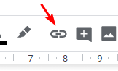)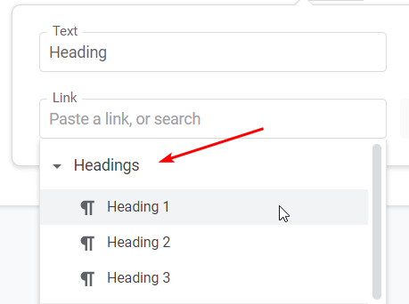

*Links to internal sections:*

* In the same document
  + Use the same link approach as for external links   
    but link to a Heading
  + e.g. Heading 1
* In another document
  + Link to <https://itp.mobi/#DOC_ID-HEADER_TEXT>  
    Where DOC_ID = 2.1.3 for example, and HEADER_TEXT = “Ethical”
  + e.g. link to [Ethical section](https://itp.mobi/#2.1.3-Ethical)

***Images*** *should be referred to by a unique id or name as they are store in the ‘assets’ folder, example:*

![UGent Logo Title][ugent-logo]

*A the end of the document add a reference like this*

[ugent-logo]: ./assets/ugent-logo.png "UGent Logo"

*Tables are allowed in this format only*

|  |  |  |
| --- | --- | --- |
| Col header 1 | Col header 2 | Col header B |
| A |  |  |
| B |  |  |