

Cambridge Assessment International Education
Cambridge International General Certificate of Secondary Education

COMPUTER SCIENCE 0478/11
Paper 1 Theory May/June 2021
MARK SCHEME

Post-Standardisation

MAXIMUM MARK: 75

Generic Marking Principles

These general marking principles must be applied by all examiners when marking candidate answers. They should be applied alongside the specific content of the mark scheme or generic level descriptors for a question. Each question paper and mark scheme will also comply with these marking principles.

GENERIC MARKING PRINCIPLE 1:
Marks must be awarded in line with:
- the specific content of the mark scheme or the generic level descriptors for the question
- the specific skills defined in the mark scheme or in the generic level descriptors for the question
- the standard of response required by a candidate as exemplified by the standardisation scripts.
GENERIC MARKING PRINCIPLE 2:
Marks awarded are always whole marks (not half marks, or other fractions).
GENERIC MARKING PRINCIPLE 3:
Marks must be awarded positively:
- marks are awarded for correct/valid answers, as defined in the mark scheme. However, credit is given for valid answers which go beyond the scope of the syllabus and mark scheme, referring to your Team Leader as appropriate
- marks are awarded when candidates clearly demonstrate what they know and can do
- marks are not deducted for errors
- marks are not deducted for omissions
- answers should only be judged on the quality of spelling, punctuation and grammar when these features are specifically assessed by the question as indicated by the mark scheme. The meaning, however, should be unambiguous.
GENERIC MARKING PRINCIPLE 4:
Rules must be applied consistently e.g. in situations where candidates have not followed instructions or in the application of generic level descriptors.
GENERIC MARKING PRINCIPLE 5:
Marks should be awarded using the full range of marks defined in the mark scheme for the question (however; the use of the full mark range may be limited according to the quality of the candidate responses seen).
GENERIC MARKING PRINCIPLE 6:
Marks awarded are based solely on the requirements as defined in the mark scheme. Marks should not be awarded with grade thresholds or grade descriptors in mind.

Please note the following further points:
Please also read the additional guidance in the mark scheme, it provides further information about how to mark the question.
Please annotate every question on your scripts. The number of ticks given must match the number of marks given. If you award a benefit of doubt (BOD) mark, this must also have a tick.
The sections in brackets in the mark scheme are not necessary in the candidates answer.
The words in bold in the mark scheme are important text that needs to be present, or some notion of it needs to be present. It doesn’t have to be the exact word, but something close to the meaning.
If a word is underlined, this exact word must be present.
A single forward slash means this is an alternative word. A double forward slash means that this is an alternative mark point.
Red text in the mark scheme is a response that we think it just about okay, but that will not be published as a response.
Ellipsis (…) on the end of one mark point and the start of the next means that the candidate cannot get the second mark point without being awarded the first one. If a MP has ellipsis at the beginning, but there are no ellipsis on the MP before it, then this is just a follow-on sentence and can be awarded without the previous mark point.
Please inform your team leader when you have submitted your standardisation scripts. They may have many examiners that they are monitoring, so may not see your submission immediately.
The mark scheme has been agreed at standardisation, so it is the AE’s responsibility to apply it. You may have differing opinions on how the paper should be marked, but the mark scheme is what has been agreed by a panel and AE’s are required to apply it.
Please mark your allocation at a steady rate. If you are not able to mark your allocation for a number of days, inform your team leader, do not wait for them to have to chase you. Please ensure that you meet the 40% deadline. If you are not close to or meeting this at the 40% deadline, some of your allocation may be reallocated. If you are going to struggle with this deadline, you must inform your team leader ASAP.
There is a blank page(s) in the exam paper. This must be annotated with a SEEN annotation, to indicate it has been checked for any further responses. Also, any blank responses must have a SEEN annotation, as every question must be annotated. If you do not annotate correctly, you may be stopped by your TL.
If a candidate writes outside the zoned area for the question, this must be linked to the response, even if it is not awarded a mark. This demonstrates at grade review that you did read this part of the response.

Question | Answer | Marks | Guidance
1(a) | One mark per each correct register. | 2
  1 | 0 | 1 | 0 | 0 | 1 | 1 | 1
  1 | 1 | 0 | 1 | 0 | 1 | 1 | 0
1(b)(i) | Any one from:  - Both addresses can be used to identify a computer/device  - Both are unique  - Both can be represented as hexadecimal  - Both addresses do not change (if IP address is static)  - Both can be represented as denary/decimal | 1 | Mark the first similarity given. If the first is not enough for a mark, then the second can be considered. If the first is incorrect, the second cannot be considered.  Represented as numbers is NE.

1(b)(ii) | Any two from:  - An IP address is assigned by the network/router/ISP, A MAC address is assigned by the manufacturer  - An IP address can be changed (if dynamic), MAC address cannot be changed (BOD rarely changes)  - IP address has 4/8 groups of values, MAC address have 6 groups/pairs of values // IP address can have different formats, MAC address has same format  - IP address is 32-bit/128-bit, MAC address is 48-bit  - IP address does not contain serial number/manufacturer number, MAC address does  - IP(v4) address is denary and MAC address is hexadecimal  - IP address identifies device on a network (BOD location of device on network), MAC address identifies the device itself (without reference to network)  - IP address is used for the internet, MAC address is used for LAN  - An IP address is used by a router (to forward data to its required destination), A MAC address is used by a switch (to forward data to its required destination) | 2 | Candidate needs to have both sides of the difference to get the mark e.g. IP point and MAC point.  Mark the first difference on the line, same as guidance given in similarities. If only half the difference given in section 1, you can read across to section 2 to see if the other half of the difference is given there.
2(a) | Any three from:  - Keyboard  - Mouse  - Microphone  - Keypad  - Touchscreen  - Touchpad  - 2D Scanner  - Digital/web camera  - Interactive whiteboard (BOD) | 3 | Mark the first device on the line.

2(b) | One mark for each correct row. | 6
  Statement | HDD | SSD | USB flash memory drive
  it has no moving parts |  | ✓ | ✓
  it is non-volatile | ✓ | ✓ | ✓
  it can use NAND gates to store data |  | ✓ | ✓
  it uses magnetic properties to store data | ✓
  it has the smallest physical size |  |  | ✓
  it has the slowest read/write speeds | ✓
2(c)(i) | Any two from:  - It cannot be inserted incorrectly  - Supports different transmission speeds  - High speed/fast/faster transmission  - Automatically detected (not connected) // automatically downloads drivers  - Powers the device (for data transfer)  - Backward compatible  - Bits less likely to be skewed/corrupted | 2 | Do not award universal connection or standard connection or industry standard.  Do not award it charges the devices. Powers it is fine.  Mark first benefit on the line.
2(c)(ii) | - Serial | 1 | Accept half-duplex or duplex.  Accept synchronous.  Mark the first transmission method given.

3(a) | One mark per each correct term in the correct order.  - Software  - Network  - Criteria  - Accept // reject  - Reject // accept  - Hacking | 6 | Only award accept/reject once.
3(b) | Any three from:  - Password  - Biometrics (device)  - Encryption  - Physical methods (e.g. locks)  - Two-factor authentication // Two-step verification  - Anti-viruses // Anti-malware  - Access rights  - Network policies // by example | 3 | Multiple physical methods can be allowed.  Do not allow Anti-spyware, that doesn’t answer the question.  Mark the first method given on a line.

4 | Any six from:  Phishing  - Legitimate looking email sent to user  - encourages user to click a link that directs user to a fake website  - User encouraged to enter personal details into a fake website // designed to obtain personal details (by example) from a user  Pharming  - Malicious code/malware is downloaded/installed // software downloaded without users knowledge  - … that re-directs user to fake website (when legitimate URL entered)  - User encouraged to enter personal details into a fake website // designed to obtain personal details (by example) from a user | 6

5 | Eight from:  - Sensor send data/readings/signal to microprocessor  - Data is converted from analogue to digital (using ADC)  - Microprocessor compares/checks data to stored values/range of values …  - … If data is greater than 30 / above the range microprocessor sends signal to open window and to turn heater off  - … If data is below 25 / below the range microprocessor sends signal to turn on heater and to close window  - … If data is between 25 and 30 / within the range no action taken  - Actuator is used to operate heater/window  - Whole process is continuous (must be obvious the whole process is continuous and not just part of it.) | 8 | Values must be plural and not singular value. Allow FT though to dependent marks if this is all that is incorrect about that MP.  Message is acceptable for signal.  Information cannot be accepted in place of data.

6(a) | One mark per each correct logic gate, with correct input:  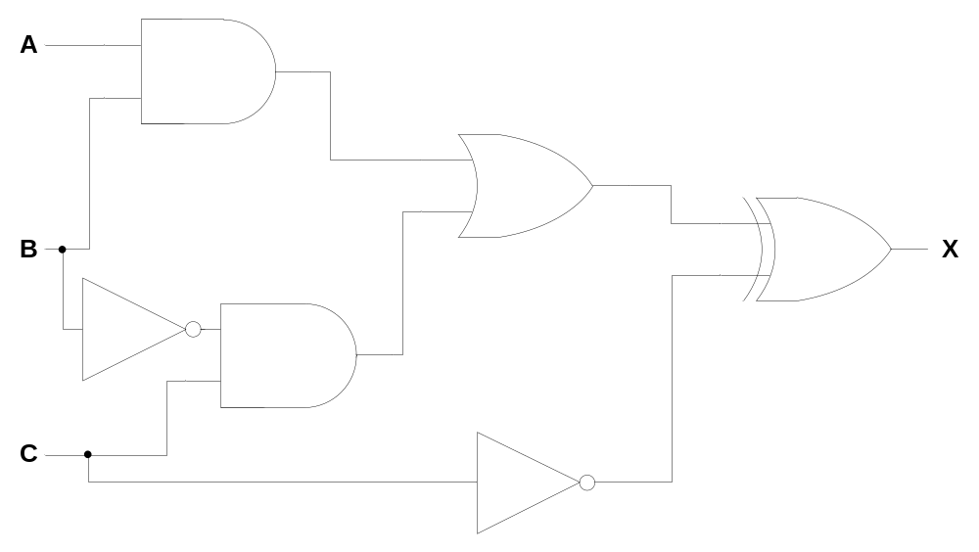 | 6 | If gate is incorrect, apply FT for next gate.
6(b) | - Row 1  - Row 3  - Row 4  - Row 5 | 4 | In any order.

7(a)(i) | Four from:  - (Compression) algorithm is used  - No data will be removed // original file can be restored  - Example of type of algorithm that would be used e.g. RLE  - Repeated patterns/sounds/notes/samples in the music are identified  - … and indexed // replaced with a value // stored with location and number of repeats  - Only the changes between amplitudes are stored  NOTE: If another lossless method is described, marks can be awarded. | 4 | Don’t allow similar sounds, it must be the same sounds.  For MP 4 - Do not allow reference to repeating words/pixels. It must be clear it is only patterns, sounds, notes or samples. Repeated data is also TV. MP5 can still be awarded though if indexing is referred to.
7(a)(ii) | Any one from:  - To provide the highest quality of music file (that compression will allow)  - The user is able to listen to the original sound file  - No loss of quality for the sound file provided | 1 | Allow each MP in reverse also.  No data lost / original file can be restored is NE, it needs to be what the benefit of this would be. The answer needs to be applied to the context.
7(a)(iii) | Any one from:  - Allow for quicker streaming speed // faster to download // faster to transmit  - Would not require as much bandwidth ( to stream)  - Does not need as much RAM / storage space  - Smoother listening experience // less lag  - Won’t use as much of data allowance | 1

7(a)(iv) | Two from:  - Streaming speed may be slower  - … and may affect listening experience // buffering may occur  - User may need more bandwidth to stream  - … that could be more expensive  - It would be a larger file (size)  - … so may take longer to upload  - … so will take up more storage space …  - … on webserver | 2
7(b) | Any four from:  - Browser sends URL to DNS  - … using HTTP/HTTPS  - IP address is found on DNS  - DNS returns IP address to the browser  - Browser sends request to web server/IP address  - Web server sends web pages back to browser  - Browser interprets/renders the HTML (to display web pages)  - Security certificates exchanged/handled | 4 | Do not allow website in place of web server.  For MP1 - Allow sending of URL to ISP.
7(c) | Two from:  - Web server has been flooded with traffic // web server has been sent many requests at once  - … so server is brought to a halt / crashes // server cannot handle all requests | 2
8(a) | - Odd  - Odd  - Even  - Even | 4

8(b) | Any one from:  - there is a transposition of bits  - it doesn’t check the order of the bits (just the sum of 1s/0s)  - even number of bits change  - incorrect bits still add up to correct parity | 1
8(c)(i) | Four from:  - Multiple bits are sent at the same time  - Uses multiple wires  - Data is sent in both directions …  - … but only one direction at a time | 4 | Do not allow cables in place of wires. Lines and channels is okay.
8(c)(ii) | Any two from:  - Bits may arrive skewed  - More expensive to setup/manufacture/purchase cable  - Limited distance  - More prone to interference/error | 2 | For MP4, do not award that error happens, they can happen anywhere. It’s that it is more likely for error to happen.

