

Cambridge Assessment International Education
Cambridge International General Certificate of Secondary Education

COMPUTER SCIENCE 0478/12
Paper 1 Theory May/June 2021
MARK SCHEME

Post-Standardisation

MAXIMUM MARK: 75

Generic Marking Principles

These general marking principles must be applied by all examiners when marking candidate answers. They should be applied alongside the specific content of the mark scheme or generic level descriptors for a question. Each question paper and mark scheme will also comply with these marking principles.

GENERIC MARKING PRINCIPLE 1:
Marks must be awarded in line with:
- the specific content of the mark scheme or the generic level descriptors for the question
- the specific skills defined in the mark scheme or in the generic level descriptors for the question
- the standard of response required by a candidate as exemplified by the standardisation scripts.
GENERIC MARKING PRINCIPLE 2:
Marks awarded are always whole marks (not half marks, or other fractions).
GENERIC MARKING PRINCIPLE 3:
Marks must be awarded positively:
- marks are awarded for correct/valid answers, as defined in the mark scheme. However, credit is given for valid answers which go beyond the scope of the syllabus and mark scheme, referring to your Team Leader as appropriate
- marks are awarded when candidates clearly demonstrate what they know and can do
- marks are not deducted for errors
- marks are not deducted for omissions
- answers should only be judged on the quality of spelling, punctuation and grammar when these features are specifically assessed by the question as indicated by the mark scheme. The meaning, however, should be unambiguous.
GENERIC MARKING PRINCIPLE 4:
Rules must be applied consistently e.g. in situations where candidates have not followed instructions or in the application of generic level descriptors.
GENERIC MARKING PRINCIPLE 5:
Marks should be awarded using the full range of marks defined in the mark scheme for the question (however; the use of the full mark range may be limited according to the quality of the candidate responses seen).
GENERIC MARKING PRINCIPLE 6:
Marks awarded are based solely on the requirements as defined in the mark scheme. Marks should not be awarded with grade thresholds or grade descriptors in mind.

Please note the following further points:
Please also read the additional guidance in the mark scheme, it provides further information about how to mark the question.
Please annotate every question on your scripts. The number of ticks given must match the number of marks given. If you award a benefit of doubt (BOD) mark, this must also have a tick.
The sections in brackets in the mark scheme are not necessary in the candidates answer.
The words in bold in the mark scheme are important text that needs to be present, or some notion of it needs to be present. It doesn’t have to be the exact word, but something close to the meaning.
If a word is underlined, this exact word must be present.
A single forward slash means this is an alternative word. A double forward slash means that this is an alternative mark point.
Red text in the mark scheme is a response that we think it just about okay, but that will not be published as a response.
Ellipsis (…) on the end of one mark point and the start of the next means that the candidate cannot get the second mark point without being awarded the first one. If a MP has ellipsis at the beginning, but there are no ellipsis on the MP before it, then this is just a follow-on sentence and can be awarded without the previous mark point.
Please inform your team leader when you have submitted your standardisation scripts. They may have many examiners that they are monitoring, so may not see your submission immediately.
The mark scheme has been agreed at standardisation, so it is the AE’s responsibility to apply it. You may have differing opinions on how the paper should be marked, but the mark scheme is what has been agreed by a panel and AE’s are required to apply it.
Please mark your allocation at a steady rate. If you are not able to mark your allocation for a number of days, inform your team leader, do not wait for them to have to chase you. Please ensure that you meet the 40% deadline. If you are not close to or meeting this at the 40% deadline, some of your allocation may be reallocated. If you are going to struggle with this deadline, you must inform your team leader ASAP.
There is a blank page(s) in the exam paper. This must be annotated with a SEEN annotation, to indicate it has been checked for any further responses. Also, any blank responses must have a SEEN annotation, as every question must be annotated. If you do not annotate correctly, you may be stopped by your TL.
If a candidate writes outside the zoned area for the question, this must be linked to the response, even if it is not awarded a mark. This demonstrates at grade review that you did read this part of the response.

Question | Answer | Marks | Guidance
1(a) | One mark per each correct binary value.  One mark per each correct hex value. | 6 | Only penalise lack of leading 0s or too many leading 0s once.  No FT is being awarded from hex to binary as question asks for both to be from the denary value.
  Denary | Hexadecimal | 8-bit binary
  49 | 31 | 00110001
  123 | 7B | 01111011
  200 | C8 | 11001000
1(b) | Any two from:  - Easier/quicker to read/write/understand // shorter to read/write  - Easier/quicker to identify errors/debug  - Takes up less screen/display space  - Less chance of making an error // fewer errors made | 2 | Must be relevant top human and not computer.  Easy/quick/short is okay for MPs 1 and 2.  Easy to use is TV.  Only mark the first benefit on the line. If the first benefit is not incorrect, you can read on to the second benefit at this point only to see if it clarifies the first.
1(c) | Any three from:  - MAC address  - URL // web address  - Assembly language  - Error codes // error messages  - IP addresses  - Locations in memory  - Memory dumps  - Unicode // ASCII // Character sets  - Hashing algorithms // encryption  - Barcodes // QR codes | 3 | Debugging is TV for MP4 or MP7.  Lower level language is NE for MP3.  Mark the first use given on the line.

2(a) | One mark per each correct row. | 6
  Statement | Magnetic  (✓) | Solid state  (✓) | Optical  (✓)
  no moving parts are used to store data |  | ✓
  pits and lands are used to store data |  |  | ✓
  data is stored on platters | ✓ |  | (✓)
  flash memory is used to store data |  | ✓
  parts are rotated to store data | ✓ |  | ✓
  data can be stored permanently | ✓ | ✓ | ✓
2(b)(i) | Any one from:  - Hard disk drive // HDD  - Magnetic tape  - Floppy disk  - Magnetic strip | 1 | BOD hard disk/drive for MP1  Mark the first storage given on the line.
2(b)(ii) | Any one from:  - CD  - DVD  - Blu-ray (disk) | 1 | Allow any version of each e.g. CD ROM, DVD RW  Mark the first storage given on the line.

2(b)(iii) | One for type of storage, two for matching justification from:  - Magnetic // HDD  - (Web server) is likely to receive many requests a day  - (Web server) will likely need to store a lot of data (and magnetic is high capacity) // a web server requires a lot of storage capacity/space  - Magnetic is cheaper to buy for storage per unit than solid state  - Magnetic is capable of more of read/write requests over time // has more longevity (long lasting) // SSD has more limited number of read/write requests (before it is no longer usable)  - Fast enough read/write speeds (do not allow fastest)  - No requirement for it to be portable, so moving parts doesn’t matter  - Solid-state // SSD  - (Web server) is likely to receive many requests a day  - (Web server) will likely need to store a lot of data (and solid-state is high capacity) // a web server requires a lot of storage capacity/space  - Solid-state is more energy efficient  - Solid-state runs cooler so won’t overheat  - Solid state has faster read/write speeds (to handle volume of traffic) | 3 | Any reference to portability for SSD is irrelevant for web server.  Any reference to noise isn’t really relevant.  If Optical or anything else incorrect is given, stop marking. If space is blank therefore no clear indication of SSD or HDD is given on first line, read the remainder of the response to see if it is clearly indicated there. If it is, the mark can be awarded along with justification.  More durable is NE for justification of magnetic as this could refer to portability also.  Don’t accept that magnetic can store more than SSD or vice-versa. Both can be bought in large enough capacity now.
2(c) | Any three from:  - Data is flashed onto (silicon) chips  - Uses NAND/NOR technology // Can use flip-flops  - Uses transistors/control gates/floating gates …  - … to control the flow of electrons  - It is a type of EEPROM technology  - When data is stored the transistor is converted from 1 to 0 / 0 to 1  - Writes (and reads) sequentially  - Uses solid-state technology | 3

3(a) | One mark for each correct logic gate with correct input.  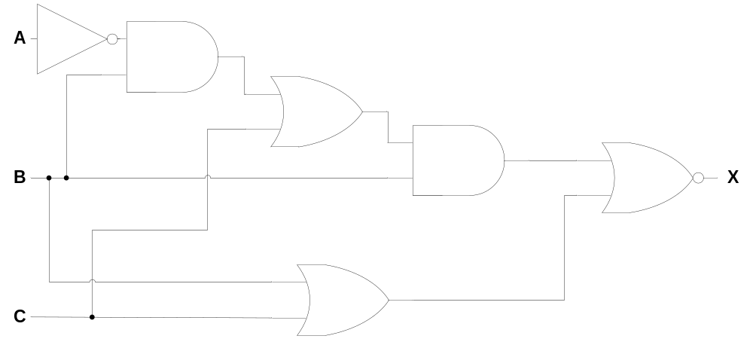 | 6 | FT can be awarded for a following correct gate as long as it has the correct direction of input.  Mark the shape of the gate and not the word in it. The gates are in the syllabus so have to be awarded.  If circles are filled in on NOT and NOR, they can be awarded.
3(b) | One mark per each correct row.  - Row 2  - Row 3  - Row 7  - Row 8 | 4 | In any order

4(a) | One mark per each correct row. | 6
  Statement | Virus  (✓) | Spyware  (✓) | Denial of service  (✓)
  captures all data entered using a keyboard |  | ✓
  can be installed onto a web server | ✓ | ✓
  prevents access to a website |  |  | ✓
  is malicious code on a computer | ✓ | ✓
  is self-replicating | ✓
  damages the files on a user’s hard drive | ✓
4(b) | Any three from:  - Phishing  - Pharming  - Hacking // cracking  - Wardriving  - Malware  - Examples of malware (other than virus and spyware) | 3 | Three different malware examples can be awarded.  Mark the first risk given on the line.

4(c) | Any three from:  - Human error  - Power failure/surge  - Hardware failure/fault/damage/error/crash/malfunction // by example  - Software failure/fault/damage/error/crash/malfunction // by example  - Fire  - Flood  - Natural disaster e.g. earthquake | 3 | Three different types of human error can be awarded.  If human error given and then an example is given as a separate point, only award 1 mark. If human error given and two examples are then given, award the examples two marks in favour of the candidate.  System, server, physical or computer malfunction/crash alone is TV.
5(a) | - Light sensor  - Motion sensor // infra-red sensor | 2 | Do not allow movement/heat sensor.  Mark the first sensor given on the line.

5(b) | Eight from:  - Sensors send data/readings/signal to microprocessor  - Data is converted to digital (Using ADC)  - Microprocessor compares/checks data to stored value(s) …  - … if one value or neither values are within range/out of range/match no action is taken  - … If both values are out of range/in range/match microprocessor sends signal to switch light on …  - … 1-minute timer is started  - Actuator used to switch on/off light  - When timer reaches 1 minute, microprocessor sends signal to switch light off  - Whole process is continuous | 8 | For MP4, candidate needs to have referred to both values being out of range. This can be done separately.  MP4 and MP5 are dependent on MP3.  MP6 is dependent on MP5.  Information cannot be accepted in place of data.  Message/order/command is acceptable in place of signal.
6(a) | Any three from:  - Webserver/website sends (cookie) file to user’s browser  - User’s payment details stored in encrypted (text) file // Data is encrypted to be stored  - Cookie file is stored by browser/on user’s HDD/SSD/computer  - When user revisits website, webserver requests cookie file // webserver can access the data stored in the cookie file (to automatically enter details)  - … and browser sends cookie file back to webserver (to automatically enter the details) | 3 | For MP1, computer is TV for Browser.  For MP1, accept any notion of data/information for the file.

6(b) | Four from:  - User doesn’t see what information is stored // Might collect data that user doesn’t know about …  - … so, user may feel their privacy is affected  - A profile could be built about the user …  - … that could expose a user’s identity // lead to identity theft  - Sensitive information stored in cookies could be intercepted in transmission …  - Other websites could gain access to the cookies stored on a user’s computer …  - Computer could be hacked / used by an unauthorised user (to obtain data stored in cookies) …  - … so, payment information/personal data (by example) could be stolen/accessed/used by a third party // lead to identity theft  - Could be used as a trojan horse …  - … and allow malware to be stored on the user’s computer | 4 | MP8 is dependent on any of the three MPs before it.  Answer needs to relate to context. Be aware of candidates that answer about the use of cookies e.g. about advertising etc, rather than the concern for the data stored in the cookies.
7(a)(i) | Any one from:  - Placement of text/image  - Margins  - Line break  - Padding  NOTE: Any relevant example of structure can be awarded | 1 | Example tag can be awarded.  Mark the first example given on the line.  Note: If <h1> tag or similar is given, this is also classed as structure as it is related to the hierarchical structure of the webpage.

7(a)(ii) | Any two from:  - Font colour  - Font style  - Font size  - Background colour  - Image size  - Border properties  NOTE: Any relevant example of presentation can be awarded | 2 | Example tag can be awarded.  Mark the first example given on the line.
7(b) | Any two from:  - Can easily change/edit the style of the webpage // Easier to edit the webpage/code  - So, CSS can be used to create a template/style sheet  - Can add new content and apply the same style easily  - Can re-use the presentation/style for other websites | 2
8 | One mark for each correct term in the correct order  - Switch  - Circuit  - Current  - Calculated  - Character  - Binary | 6

