Phase 03 — Project Design
PocketSmart AI — Your Smart Budget and Recommendation Assistant
Submitted by: [YOUR NAME] Mentor: [MENTOR NAME] Date: 24 September 2026

Table of contents
(Use Word: References → Table of Contents after opening this file.)

1. Diagrams
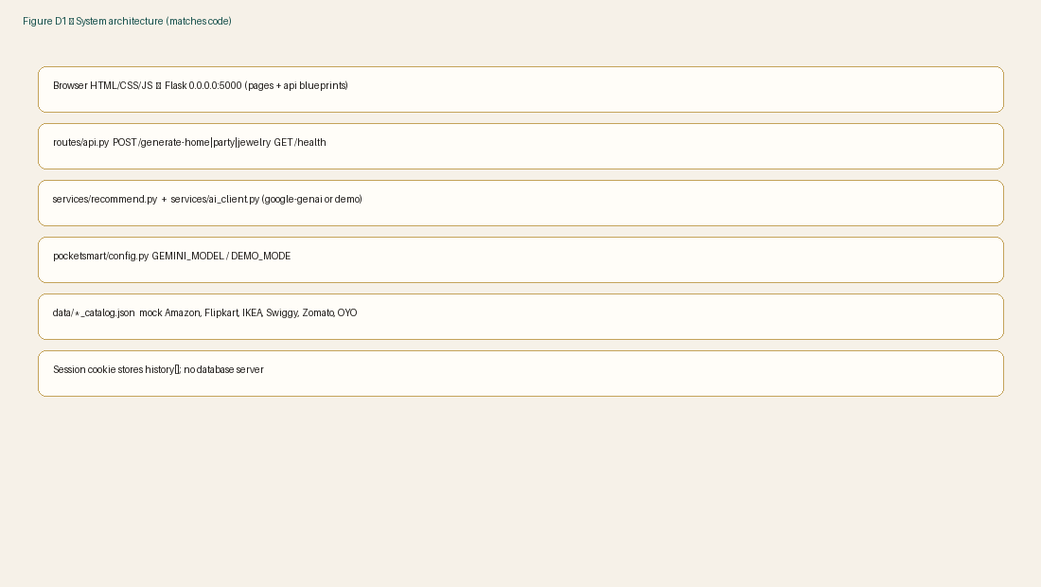
Flask process owns templates and JSON APIs; Gemini is optional.
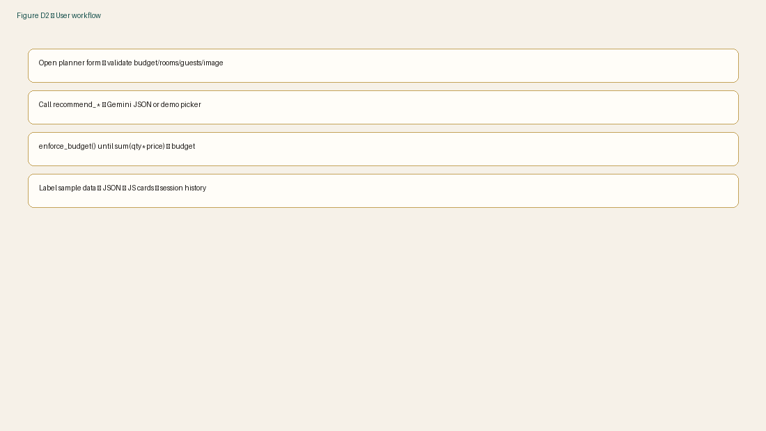
Every planner follows validate → generate → cap → display.
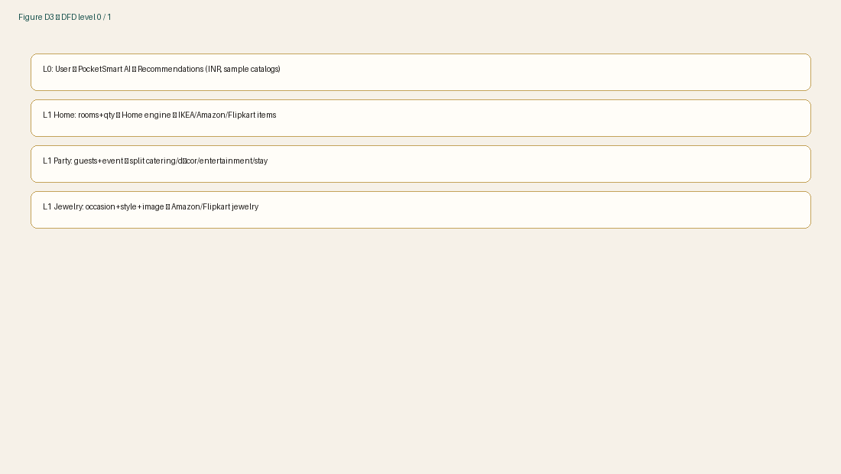
No external marketplace calls; only local JSON.
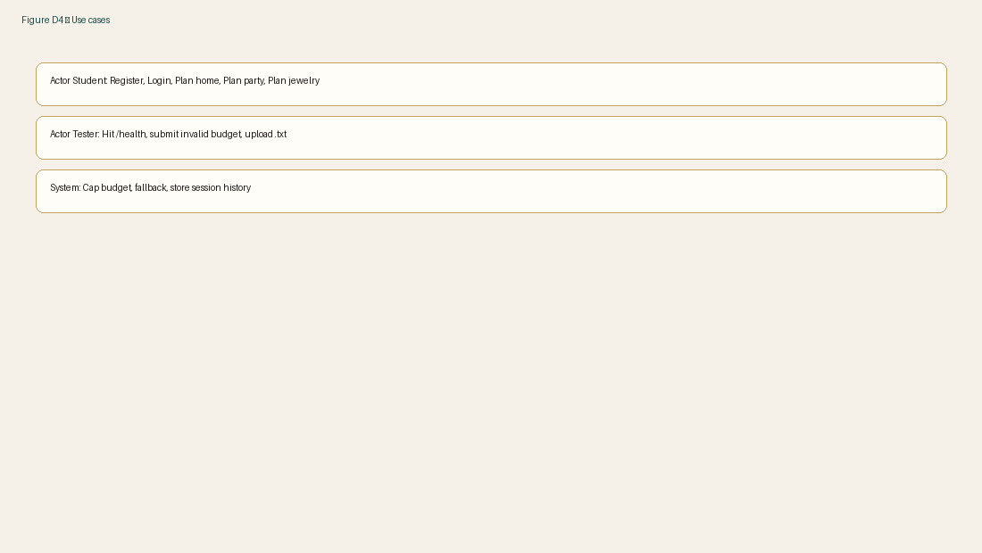
Three planners plus auth and testing actors.
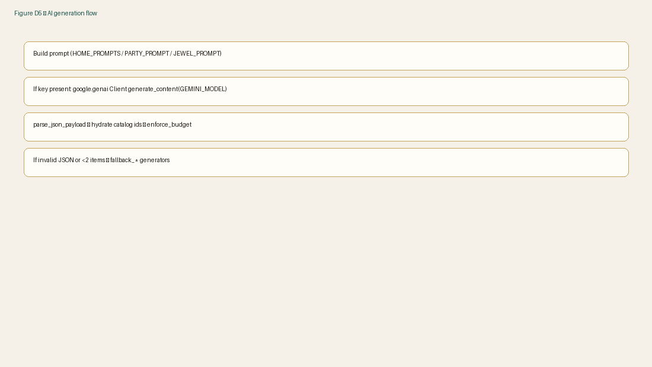
Prompts ask for JSON with catalog ids only.
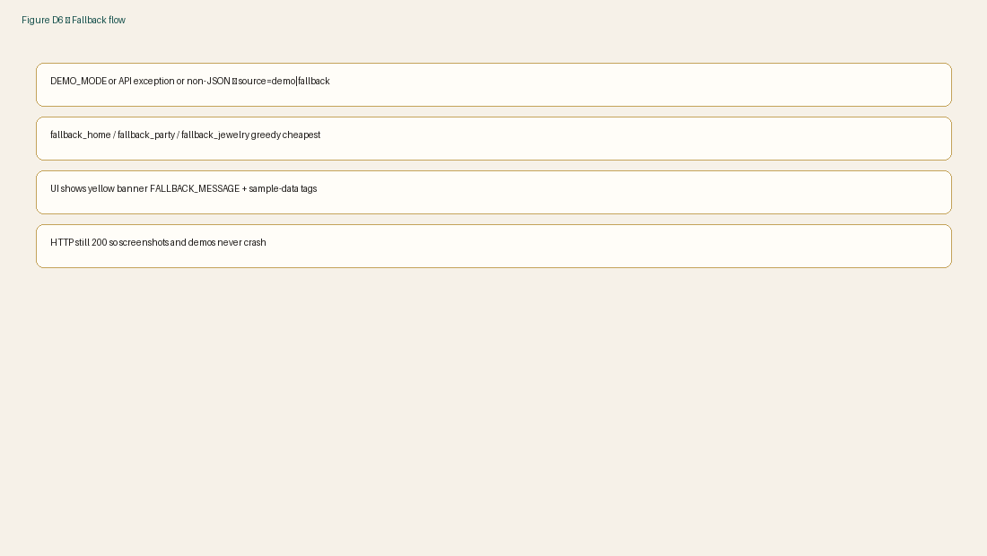
Demo mode is the default in this repository.

2. Data model
No SQL database. Session JSON: user {name,email}, history list of {planner,budget,total,summary,item_count}. Catalog item: id, name, category, price (INR), platform, url.

3. API table
Method | Route | Input | Output
GET | /health | — | mode demo|live
POST | /generate-home | budget, rooms, quantities | items, total
POST | /generate-party | budget, guests, event, venue | items, split
POST | /generate-jewelry | budget, occasion, style, file | items, outfit_analysis
POST | /auth/login | email | user
GET | /api/history | cookie | history[]
GET | /home-planner | — | HTML

4. Prompt design
HOME_PROMPTS, PARTY_PROMPT and JEWEL_PROMPT in services/recommend.py ask for JSON with catalog ids only and “Never exceed budget.”
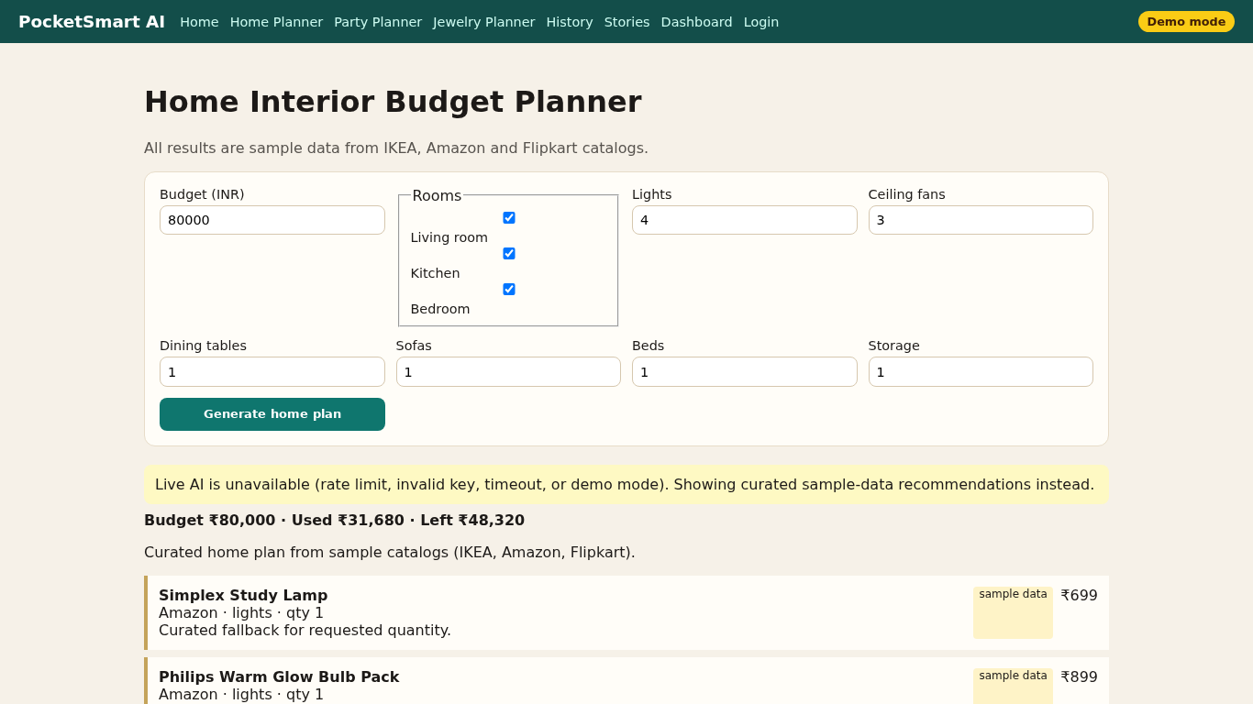
Figure 7. Home results UI corresponding to the API.

