Phase 02 — Requirement Analysis
PocketSmart AI — Your Smart Budget and Recommendation Assistant
Submitted by: [YOUR NAME] Mentor: [MENTOR NAME] Date: 24 September 2026

Table of contents
(Use Word: References → Table of Contents after opening this file.)

1. Functional requirements
ID | Description | Priority
FR-01 | POST /generate-home with budget, rooms, quantities | Must
FR-02 | POST /generate-party with budget, guests, event, venue | Must
FR-03 | POST /generate-jewelry with budget, occasion, style, optional image | Must
FR-04 | Total of items never exceeds budget | Must
FR-05 | Demo mode when GEMINI_API_KEY empty | Must
FR-06 | Fallback message if Gemini fails | Must
FR-07 | GET /health reports mode | Must
FR-08 | Reject zero/negative/too-small budgets | Must
FR-09 | Reject non-image uploads | Must
FR-10 | Session history of plans | Should

2. Non-functional requirements
Performance: demo recommendations under 2 s. Usability: 1366×768 desktop and 390×844 mobile. Security: no secrets in repo, empty .env.example. Reliability: 22/22 pytest passed (83% coverage).

3. User stories
- US-01 As Riya I enter ₹80,000 and rooms so I receive a home list under budget.
Acceptance: matching pytest and UI screenshot in docs/screenshots/.
- US-02 As Arjun I enter 40 guests and birthday so I get catering/décor/entertainment split.
Acceptance: matching pytest and UI screenshot in docs/screenshots/.
- US-03 As Nisha I upload an outfit PNG so jewelry matches colours.
Acceptance: matching pytest and UI screenshot in docs/screenshots/.
- US-04 As a tester I send budget 0 and see HTTP 400.
Acceptance: matching pytest and UI screenshot in docs/screenshots/.
- US-05 As a tester I upload notes.txt and see invalid image.
Acceptance: matching pytest and UI screenshot in docs/screenshots/.
- US-06 As a student without an API key I still use Demo mode.
Acceptance: matching pytest and UI screenshot in docs/screenshots/.
- US-07 As a user I open /history and see my last plans.
Acceptance: matching pytest and UI screenshot in docs/screenshots/.
- US-08 As ops I GET /health and see mode=demo or live.
Acceptance: matching pytest and UI screenshot in docs/screenshots/.

4. Technical requirements
Python 3.13, Flask 3.0.3, Flask-CORS 4.0.1, google-genai, Pillow 10.4, pytest 8.3. Hardware: any laptop. API key: GEMINI_API_KEY (optional). Port 5000.

5. Constraints, assumptions, dependencies
Constraint: no live scraping. Assumption: INR. Dependency: mock JSON catalogs. Gemini model ID only in pocketsmart/config.py via env.

6. Scope
In scope: three planners, demo/live Gemini, tests, docs, videos. Out of scope: payments, real Amazon APIs, IBM Watsonx, FastAPI (spec architecture is Flask).
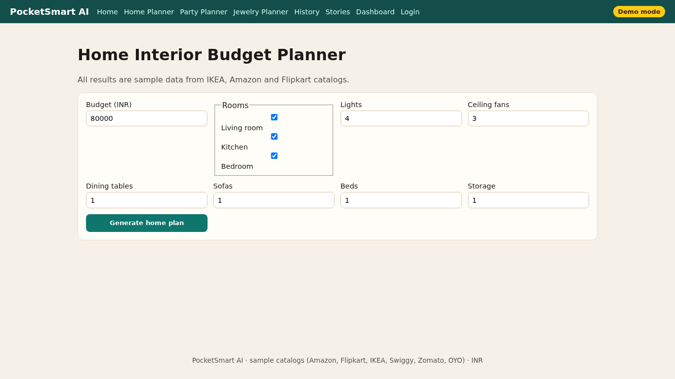
Figure 1. Home planner form implementing FR-01.

