
PROJECT NAME: PocketSmart AI: Your Smart Budget & Recommendation Assistant
TEAM ID:
A PROJECT REPORT
Submitted by

NAME | REGISTER NUMBER
Ramya B | 222503938
Kavitha G | 222503929
Rubha Sri K | 222503940
Ponni M | 222503935

In partial fulfilment for the award of the degree
of
BACHELOR
OF SCIENCE IN
COMPUTER SCIENCE WITH ARTIFICIAL INTELLIGENCE

SRIDEVI ARTS AND SCIENCE COLLEGE
KRISHNAPURAM, PONNERI-601 204

SEPTEMBER-2026

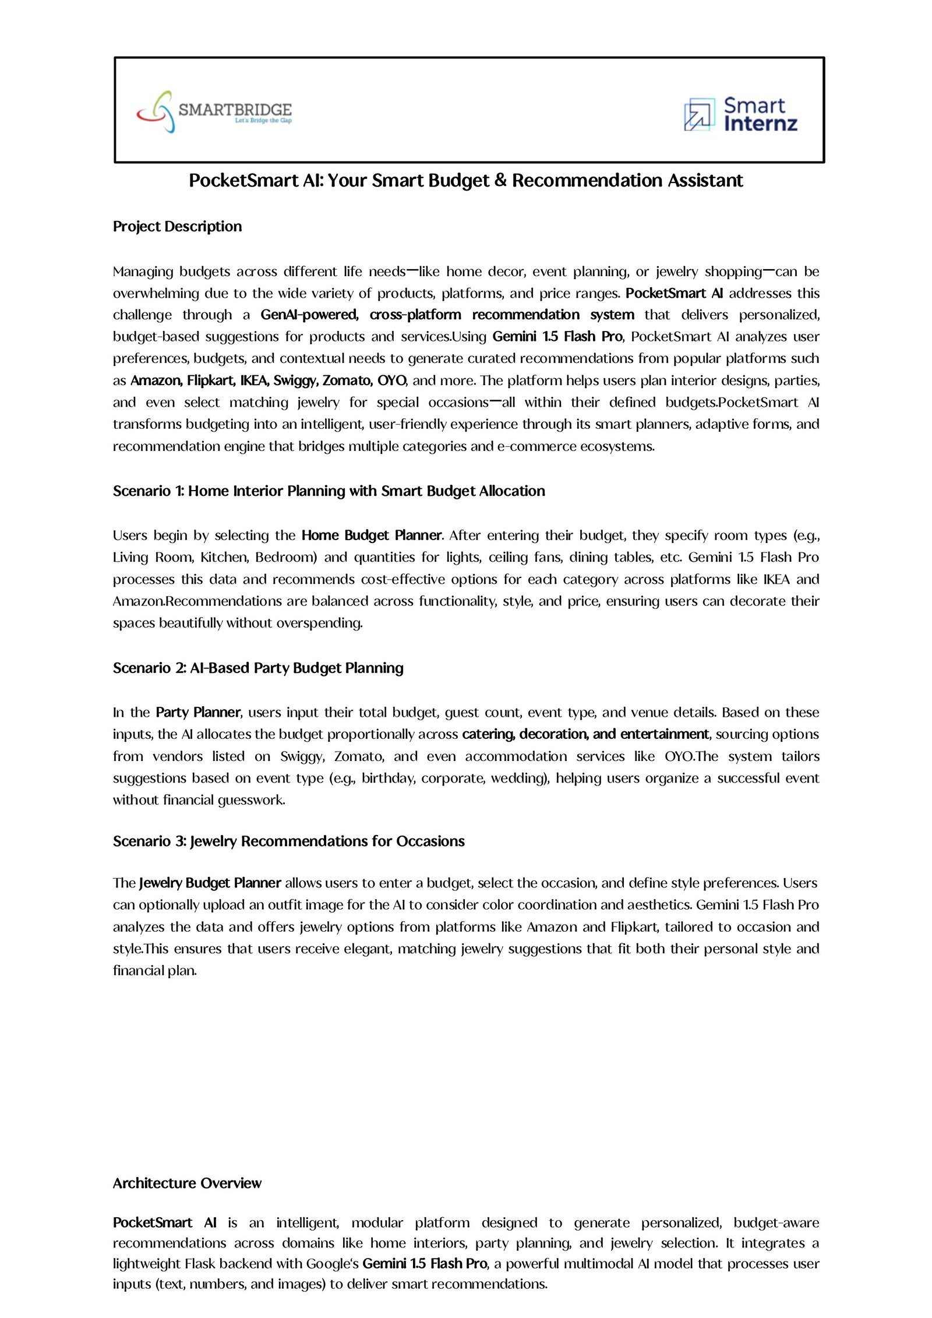

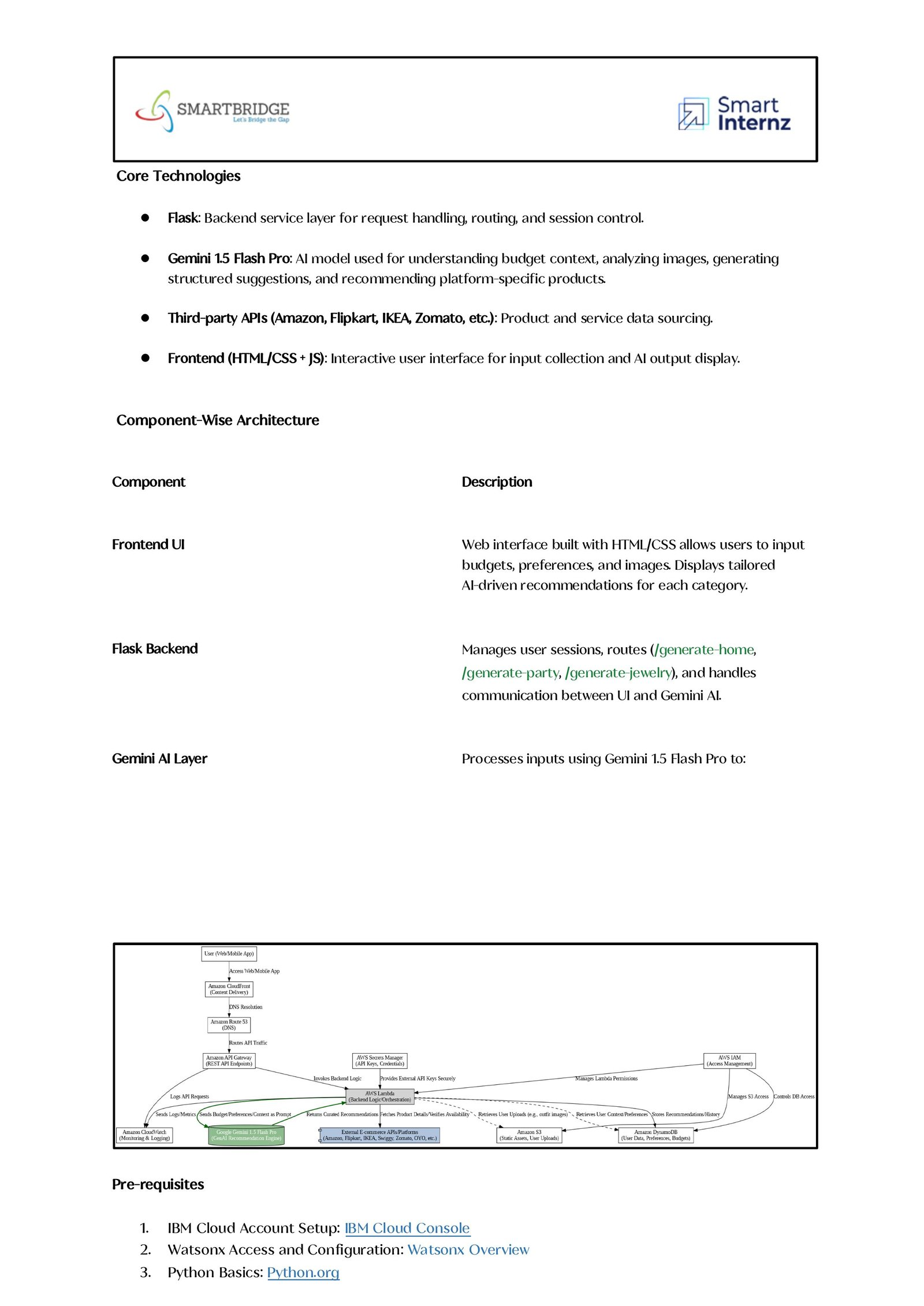

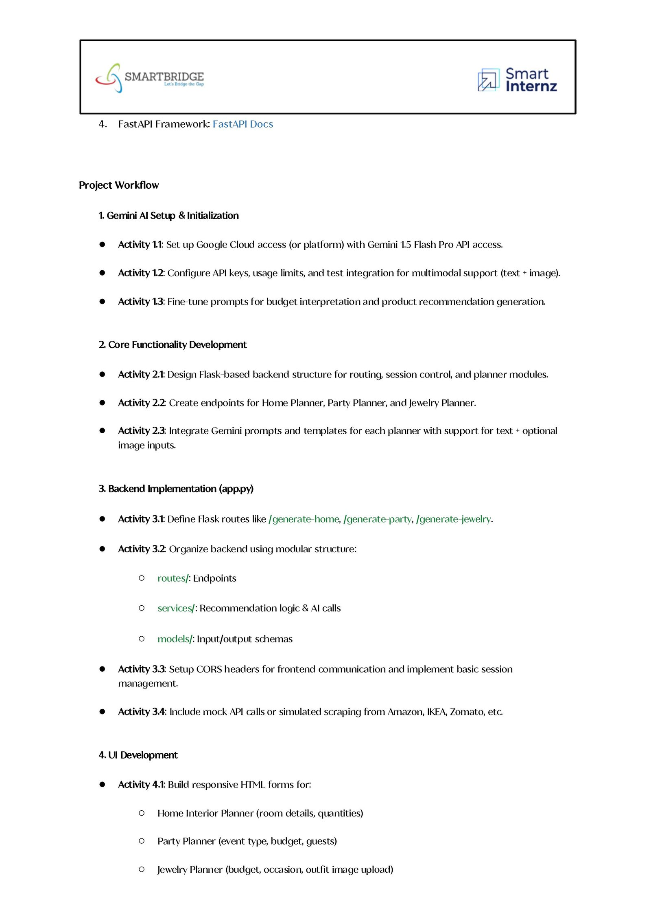

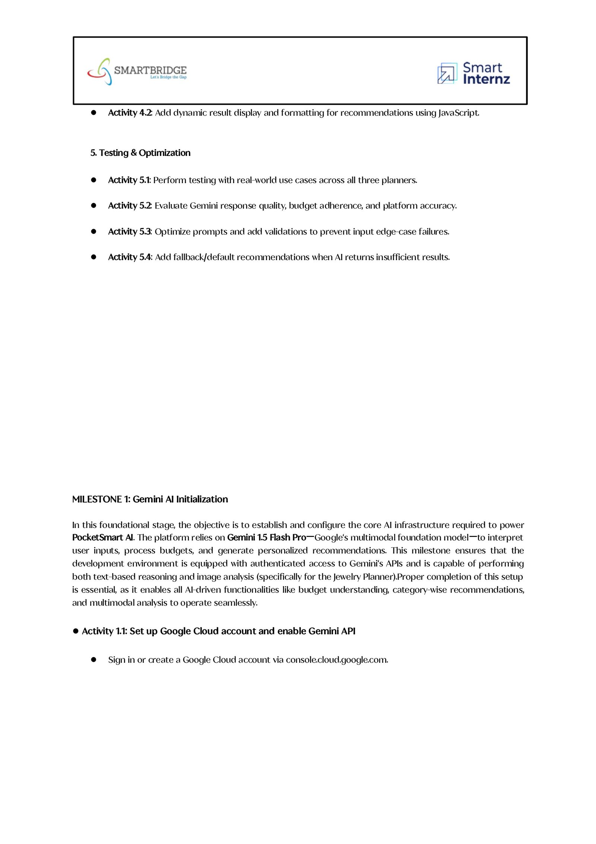

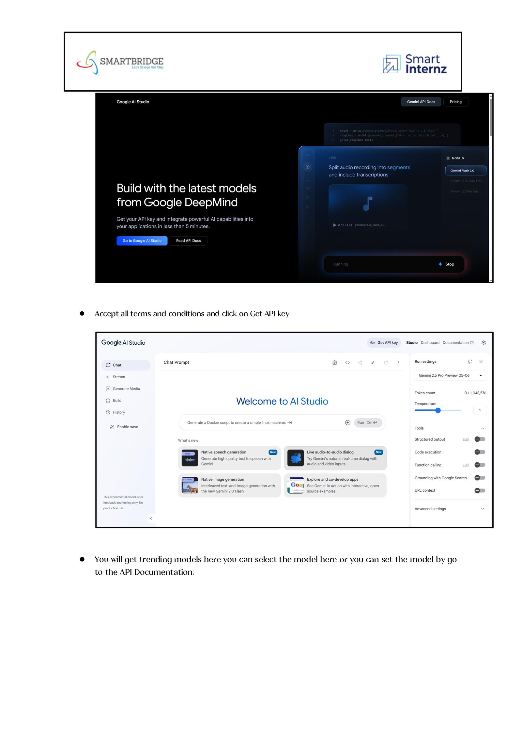

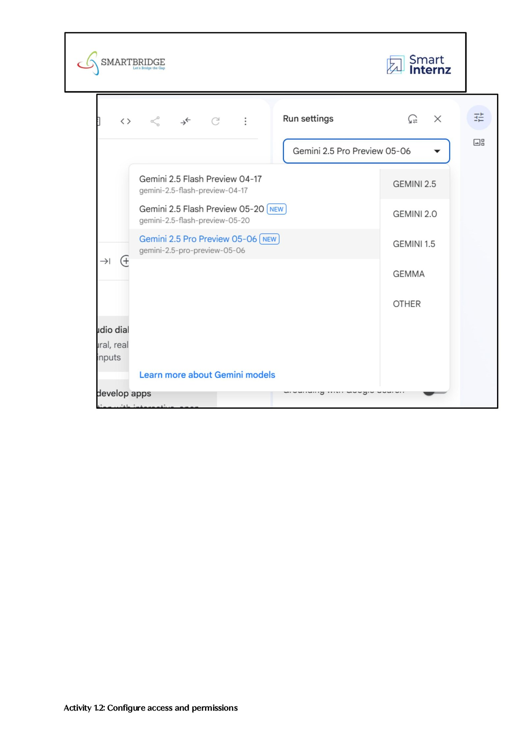

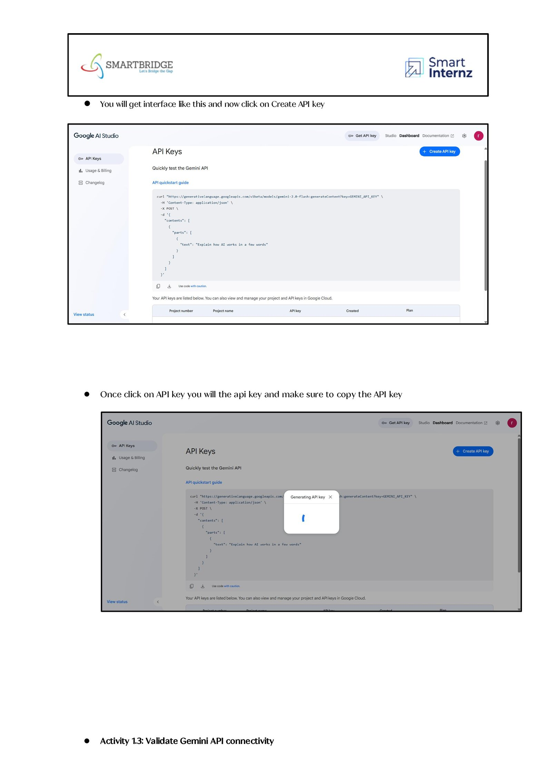

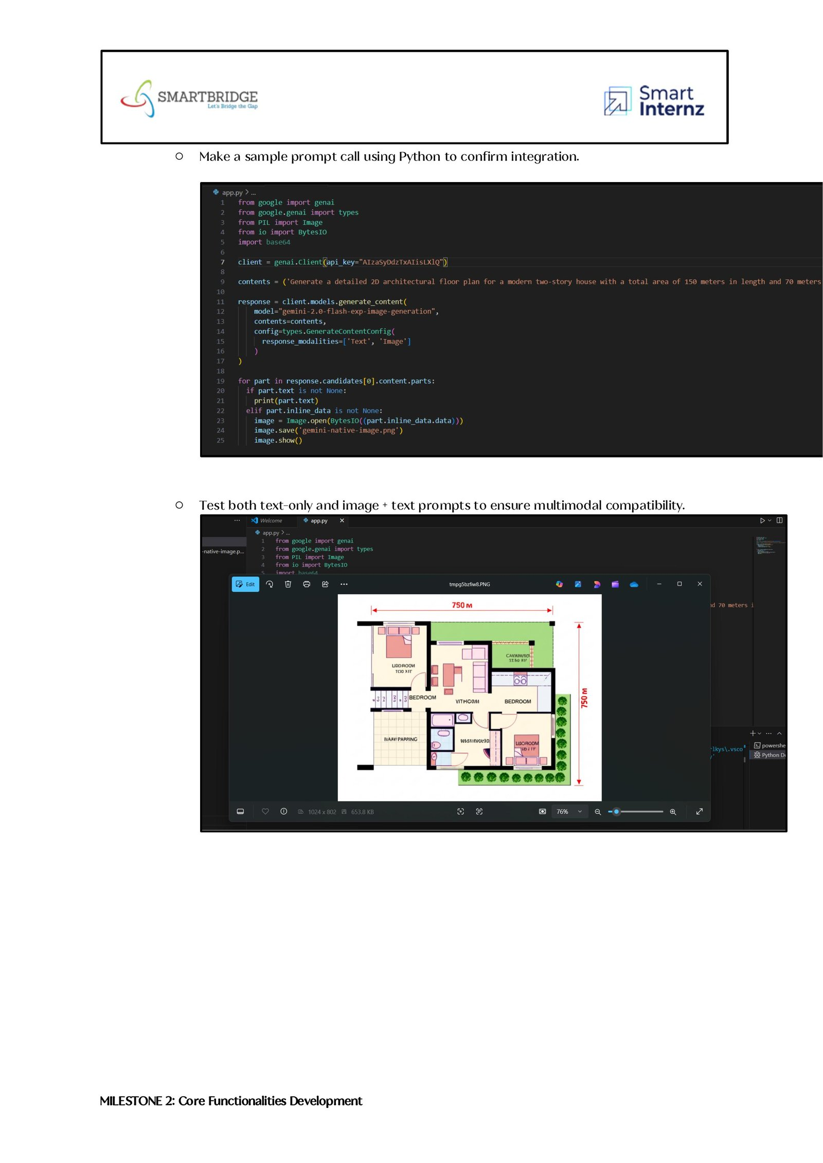

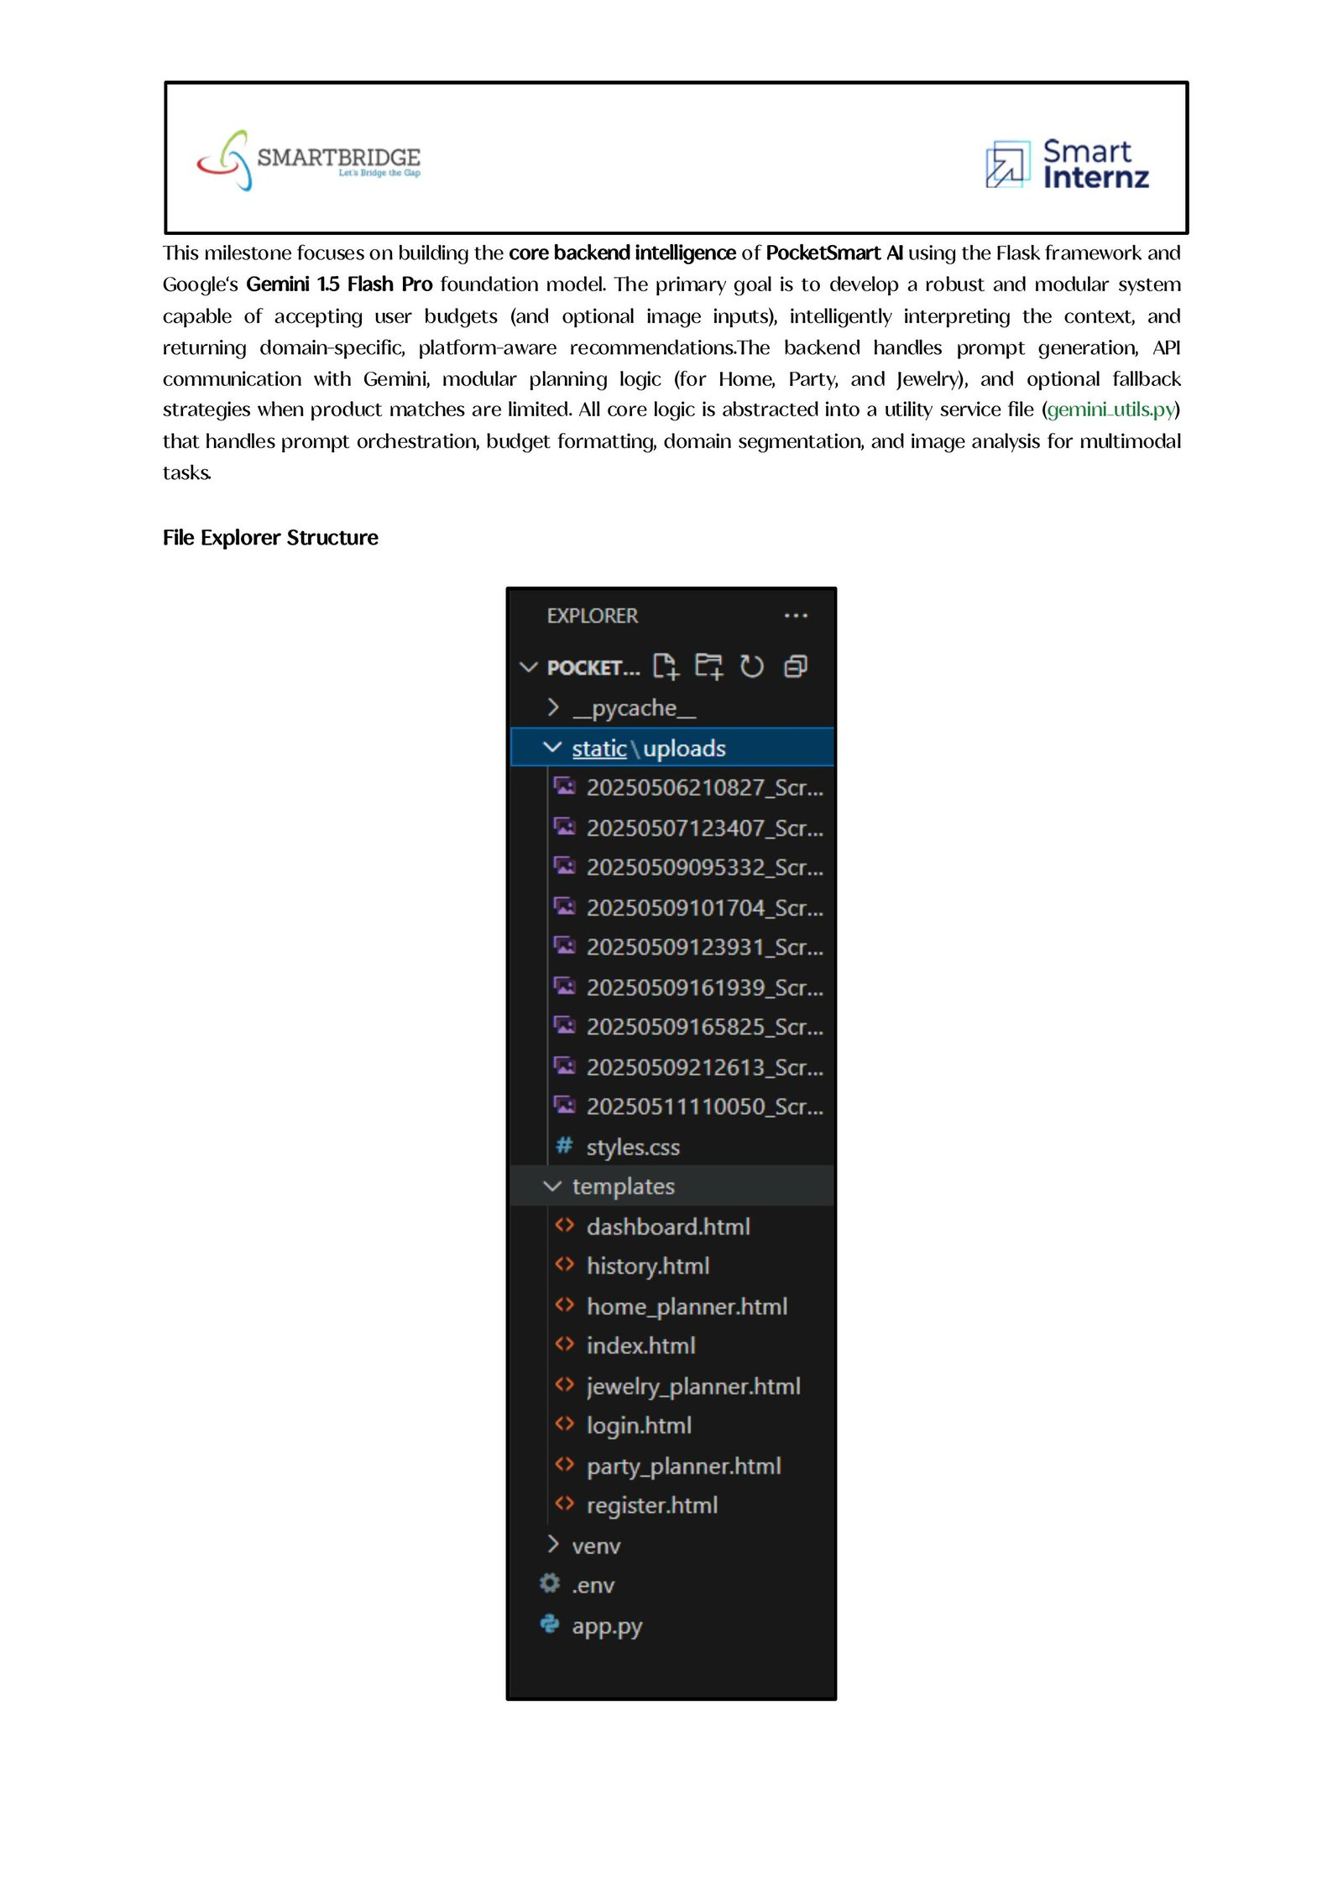

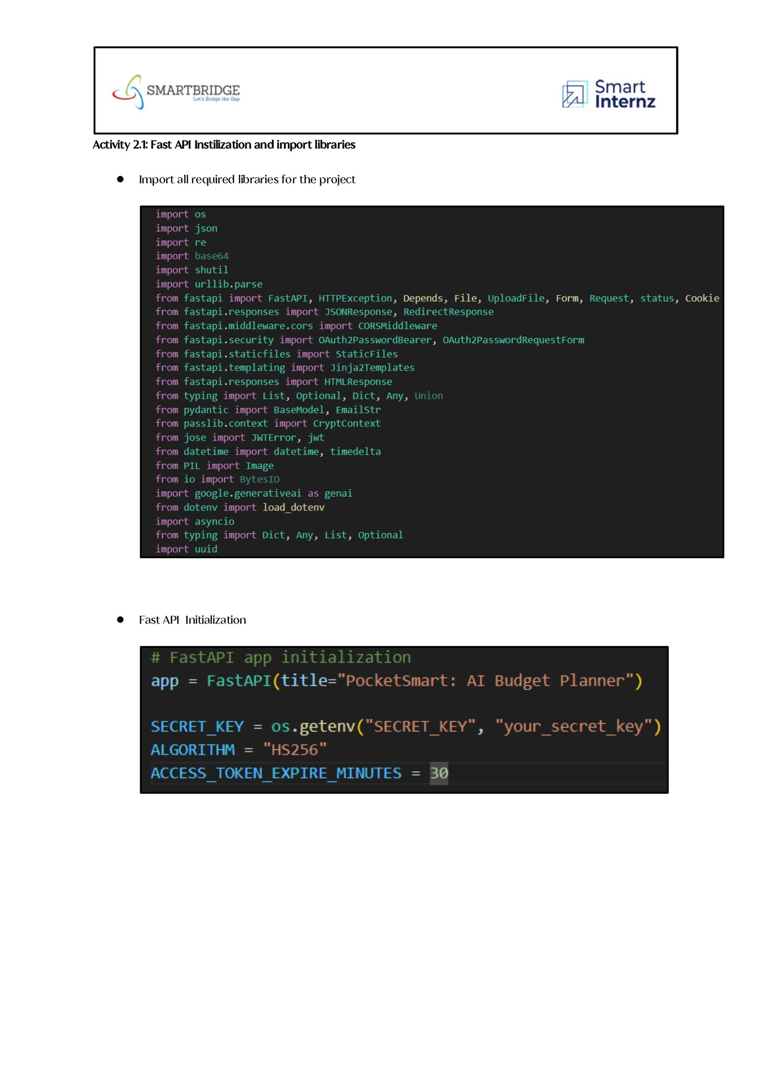

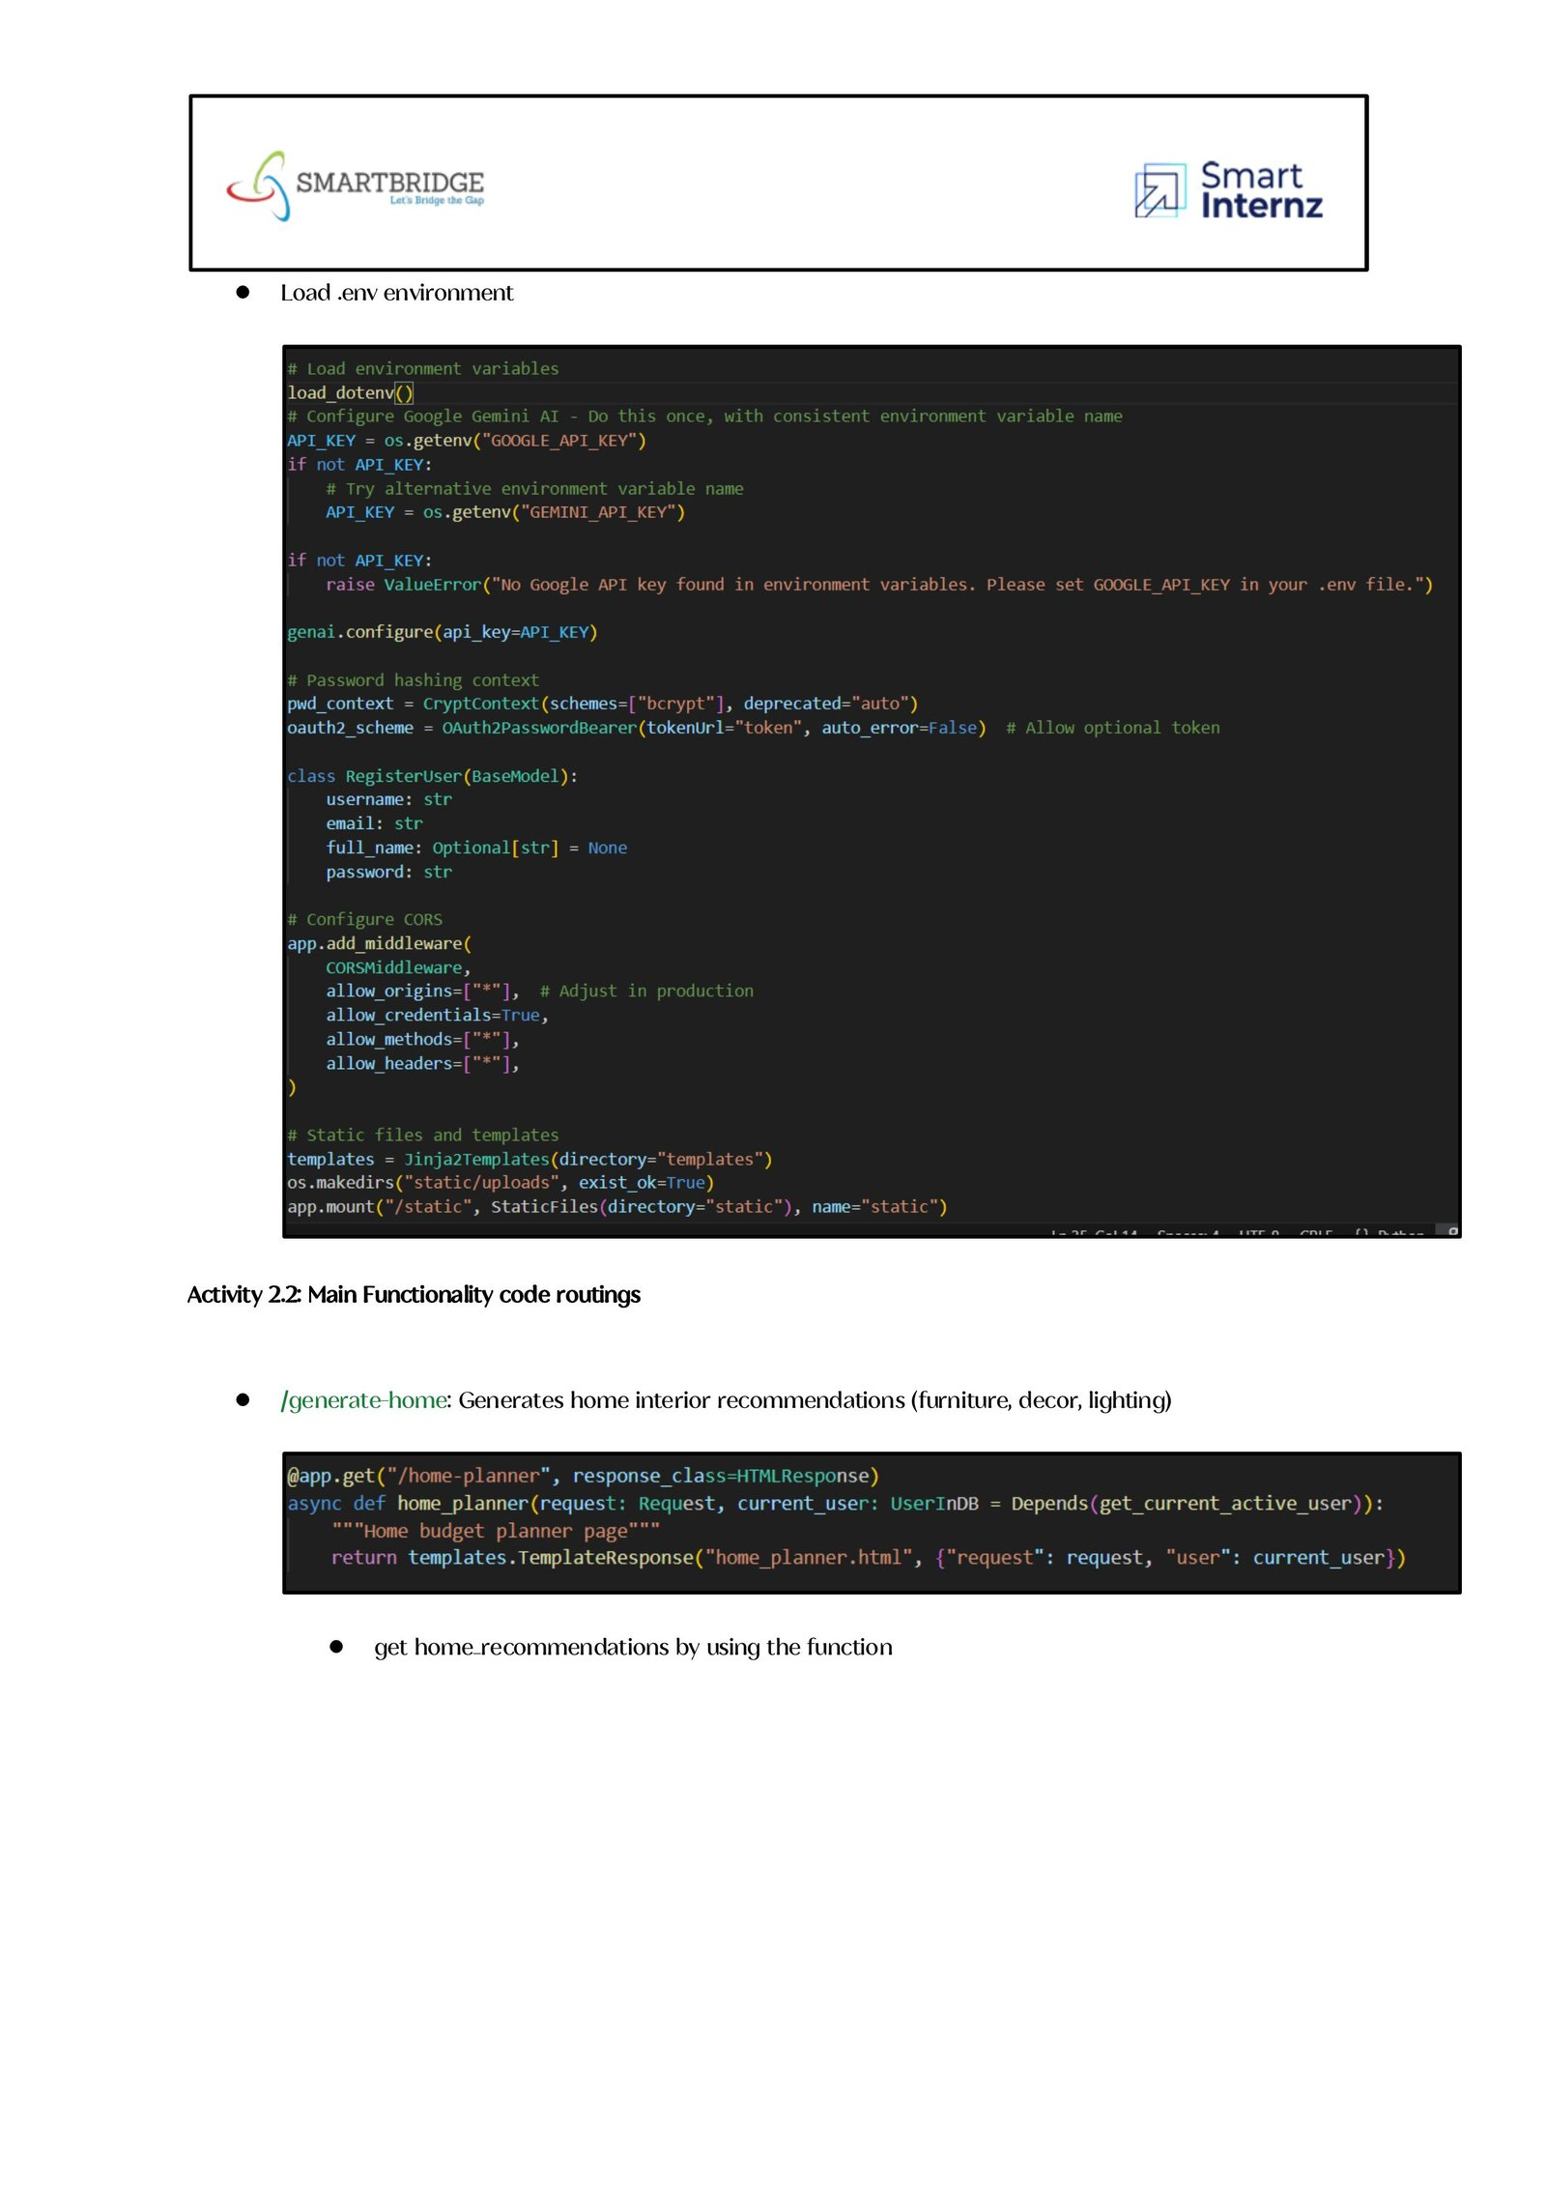

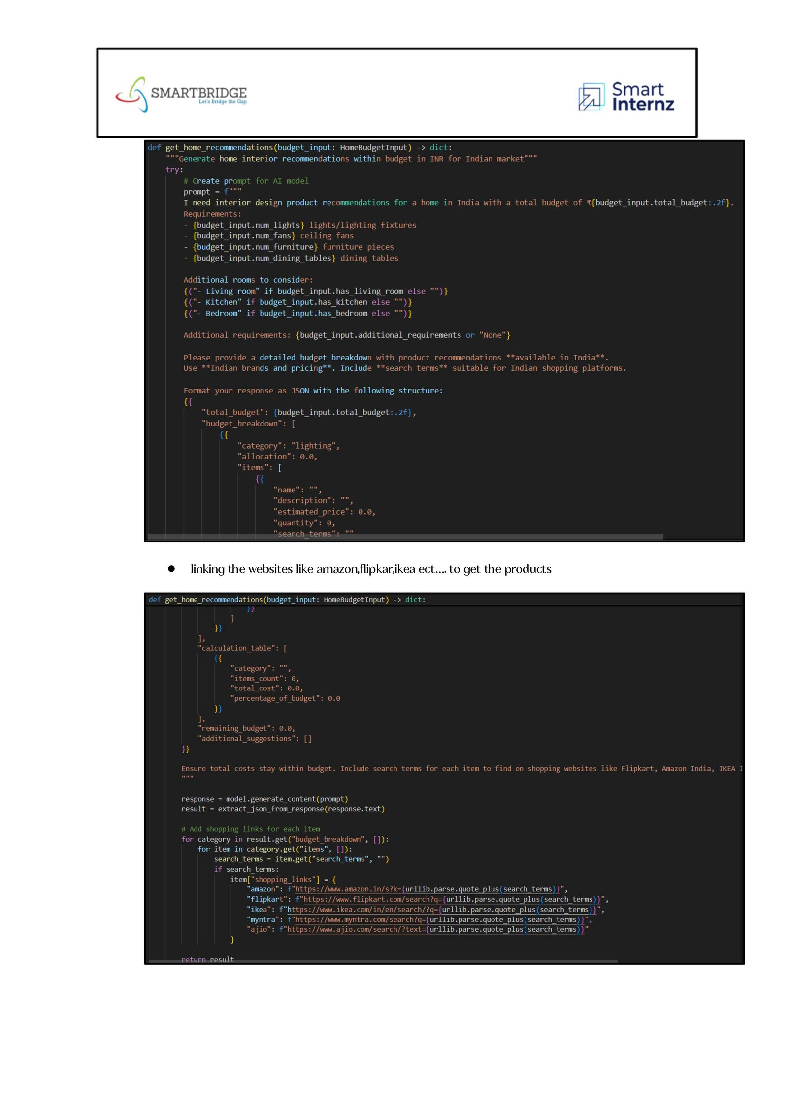

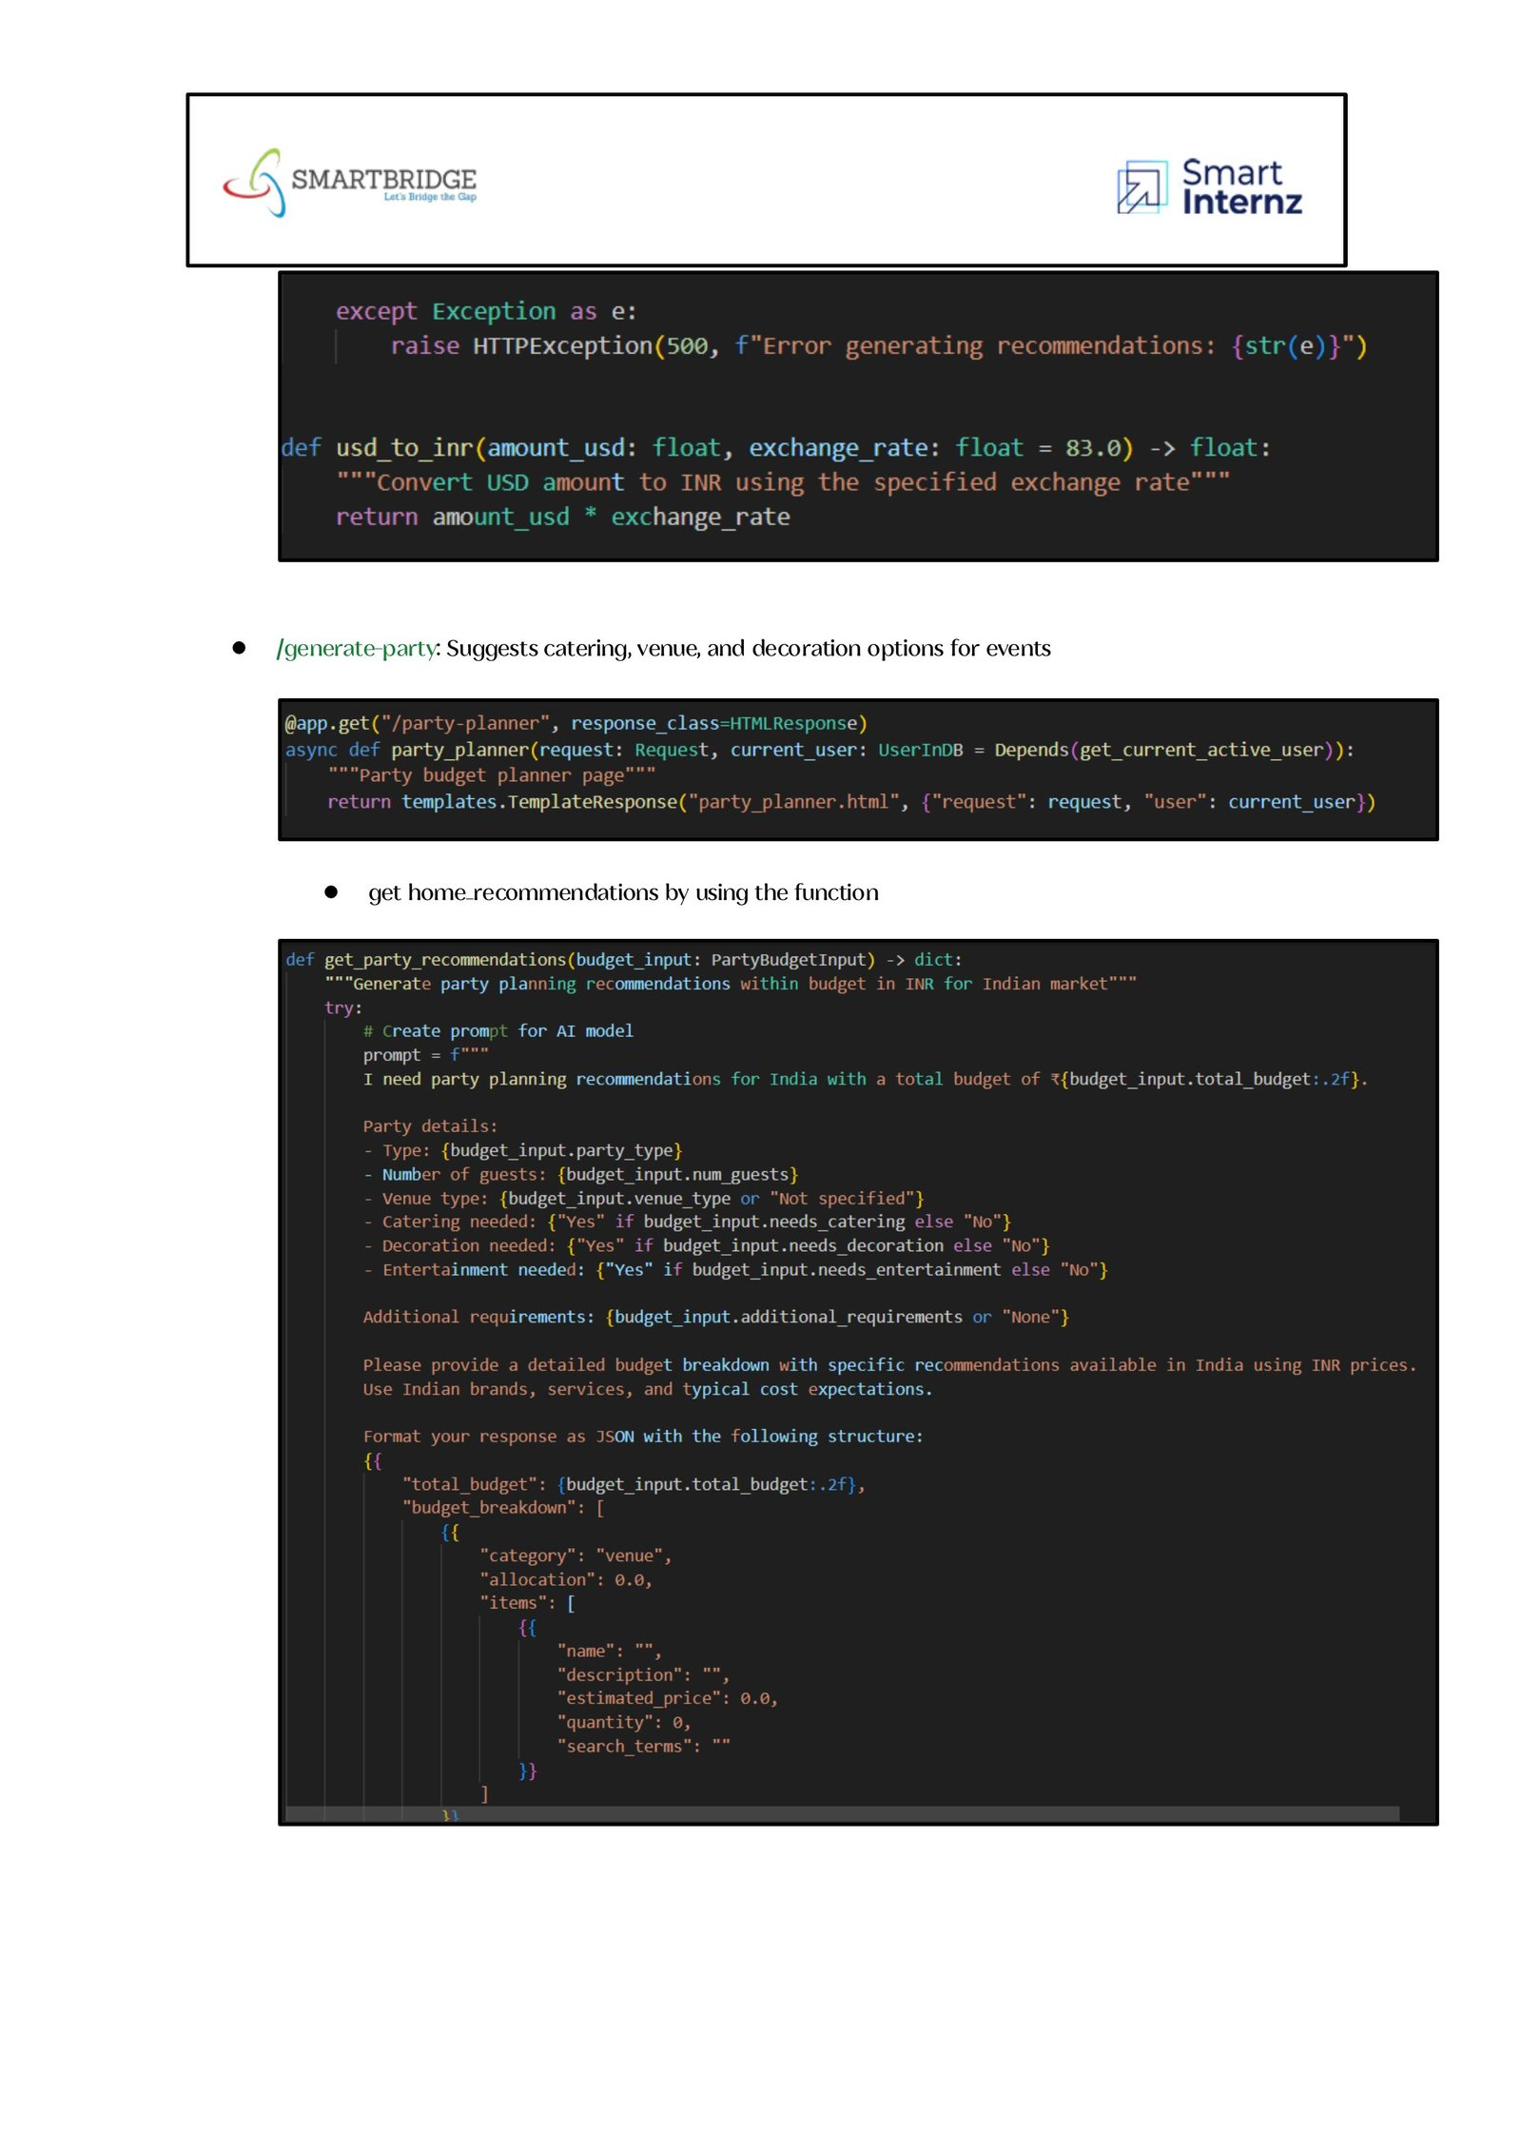

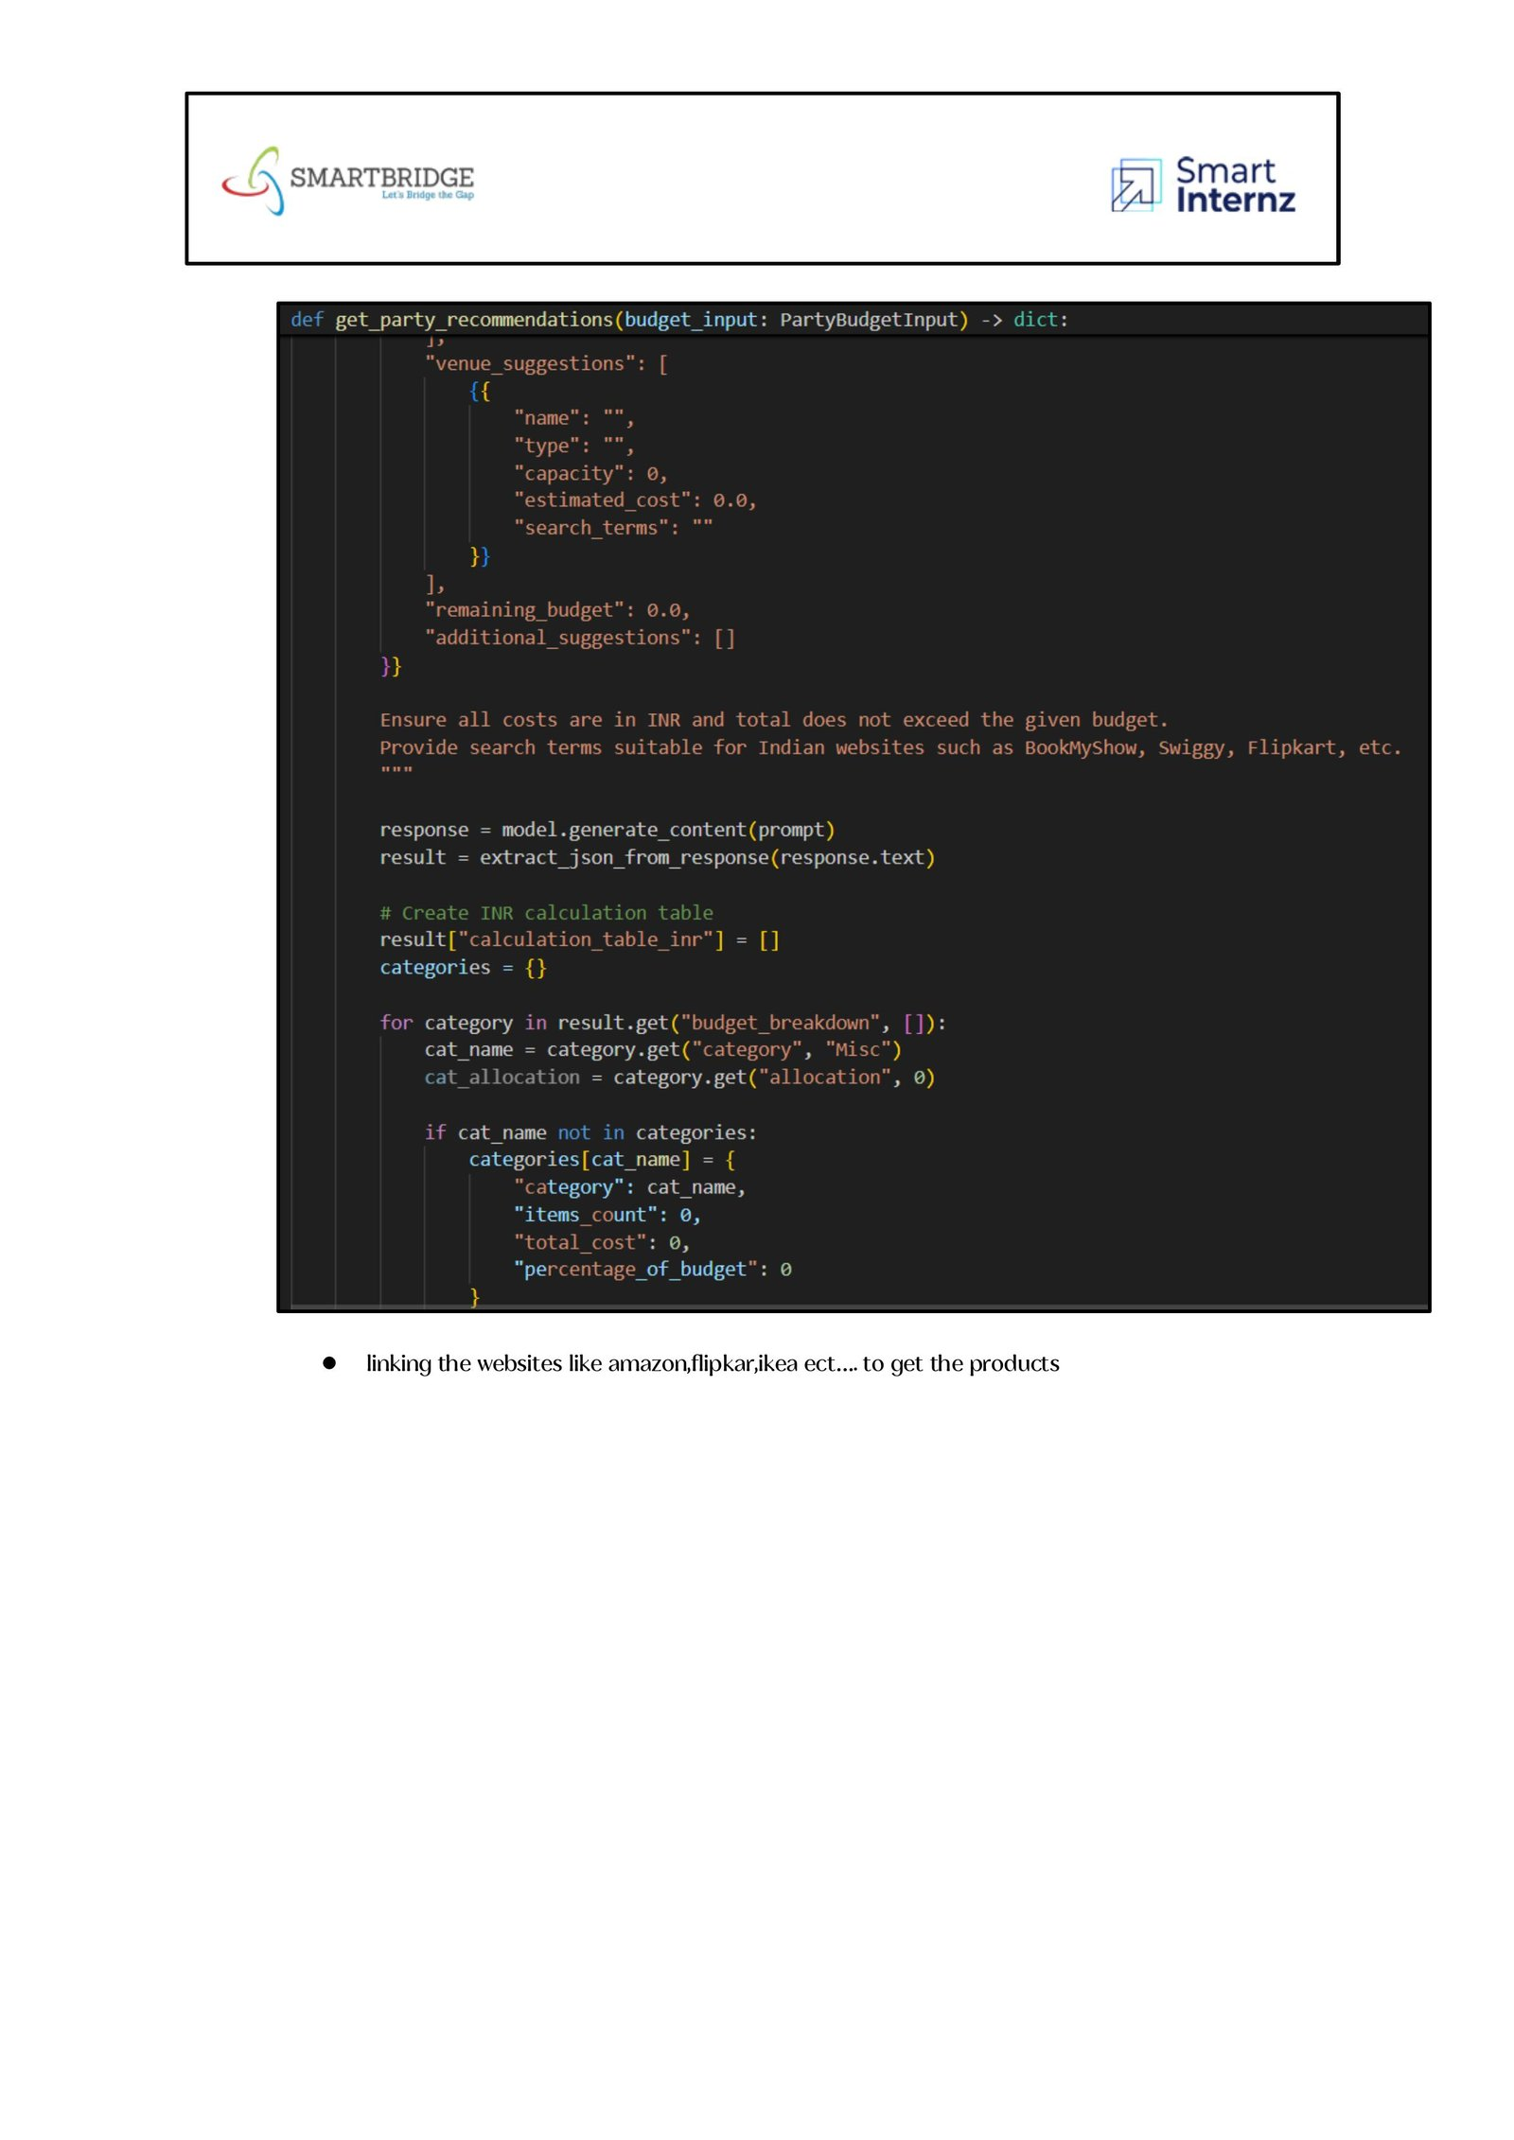

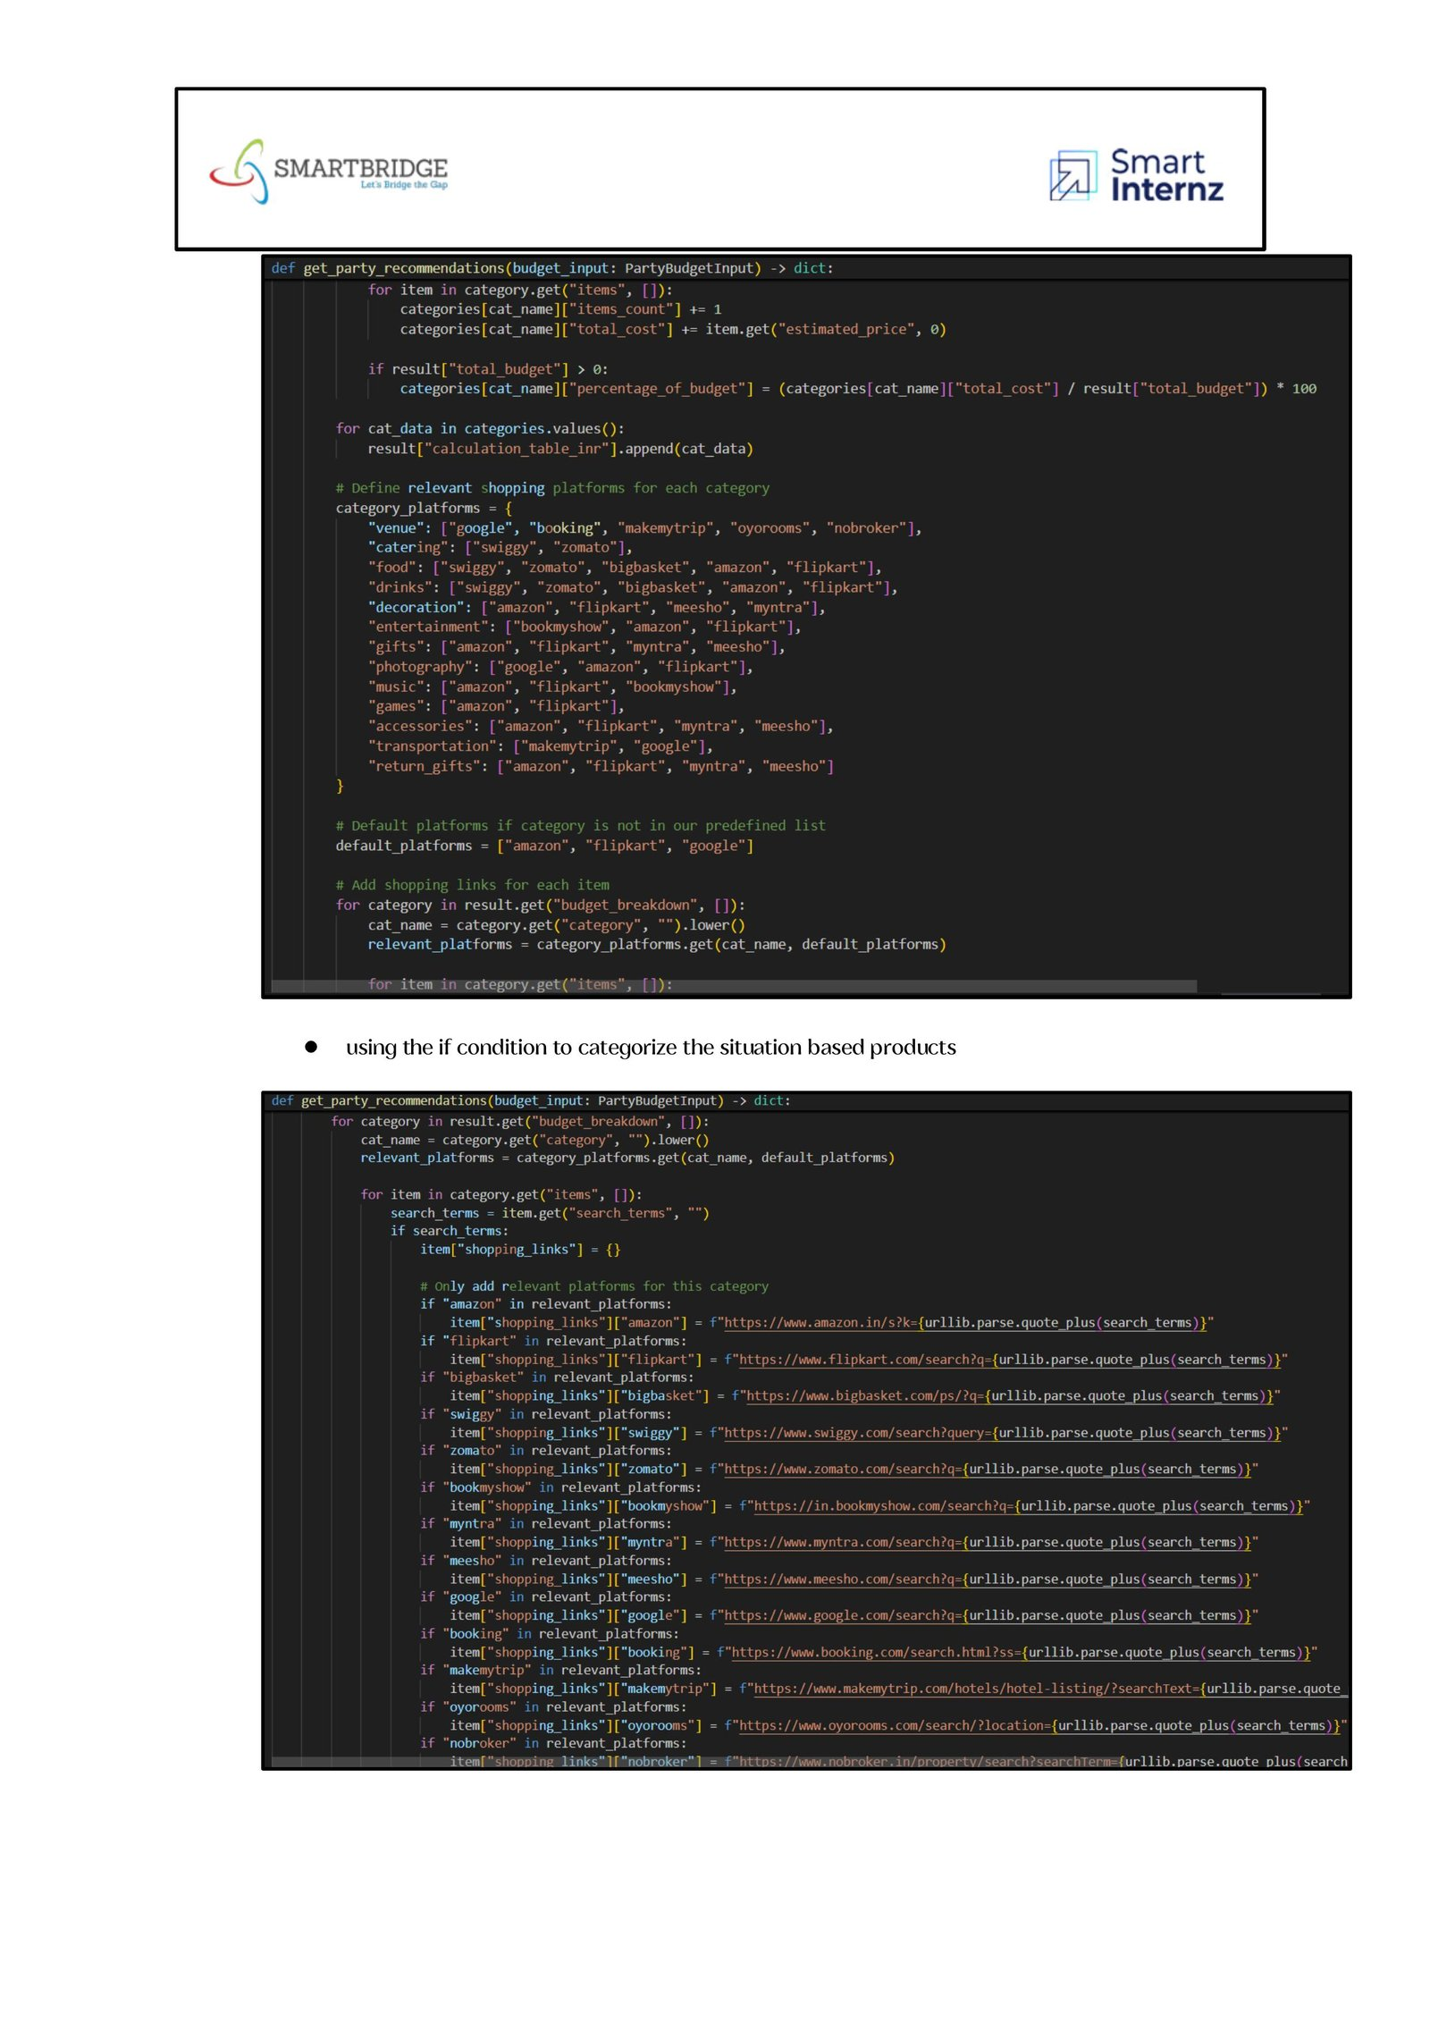

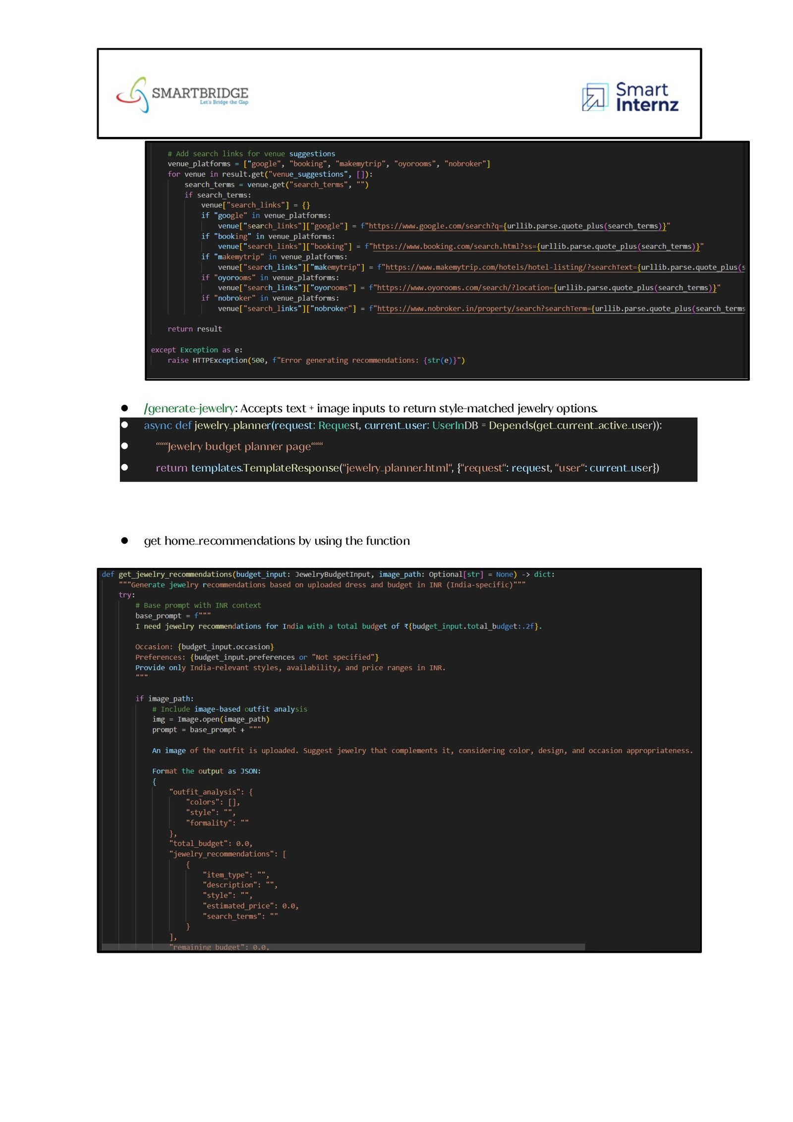

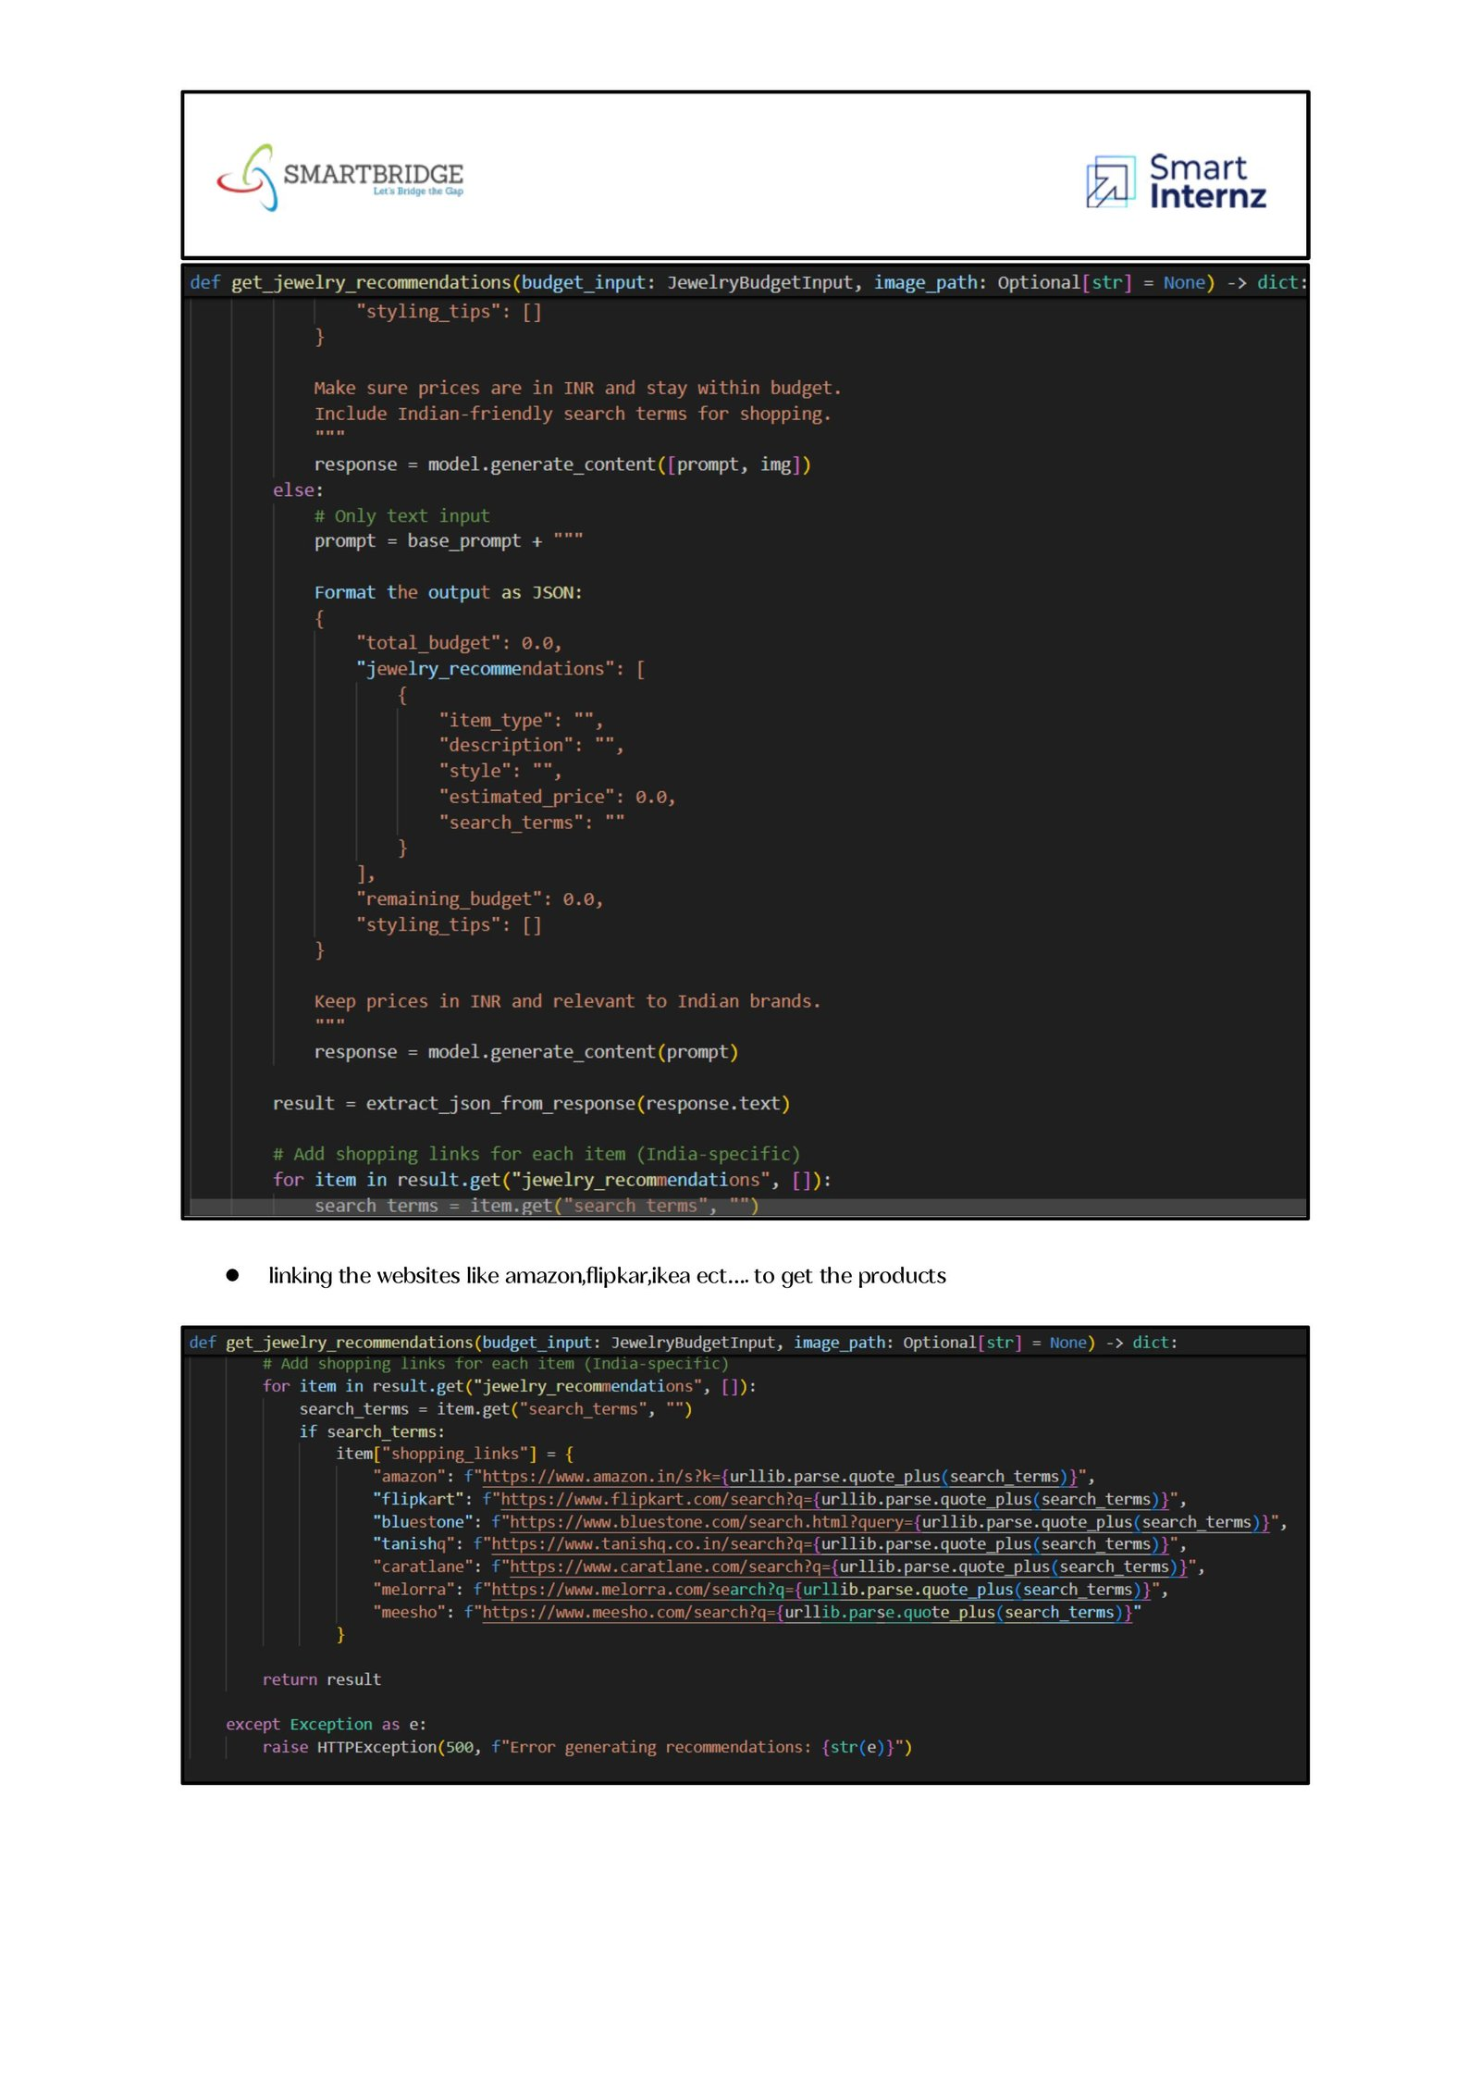

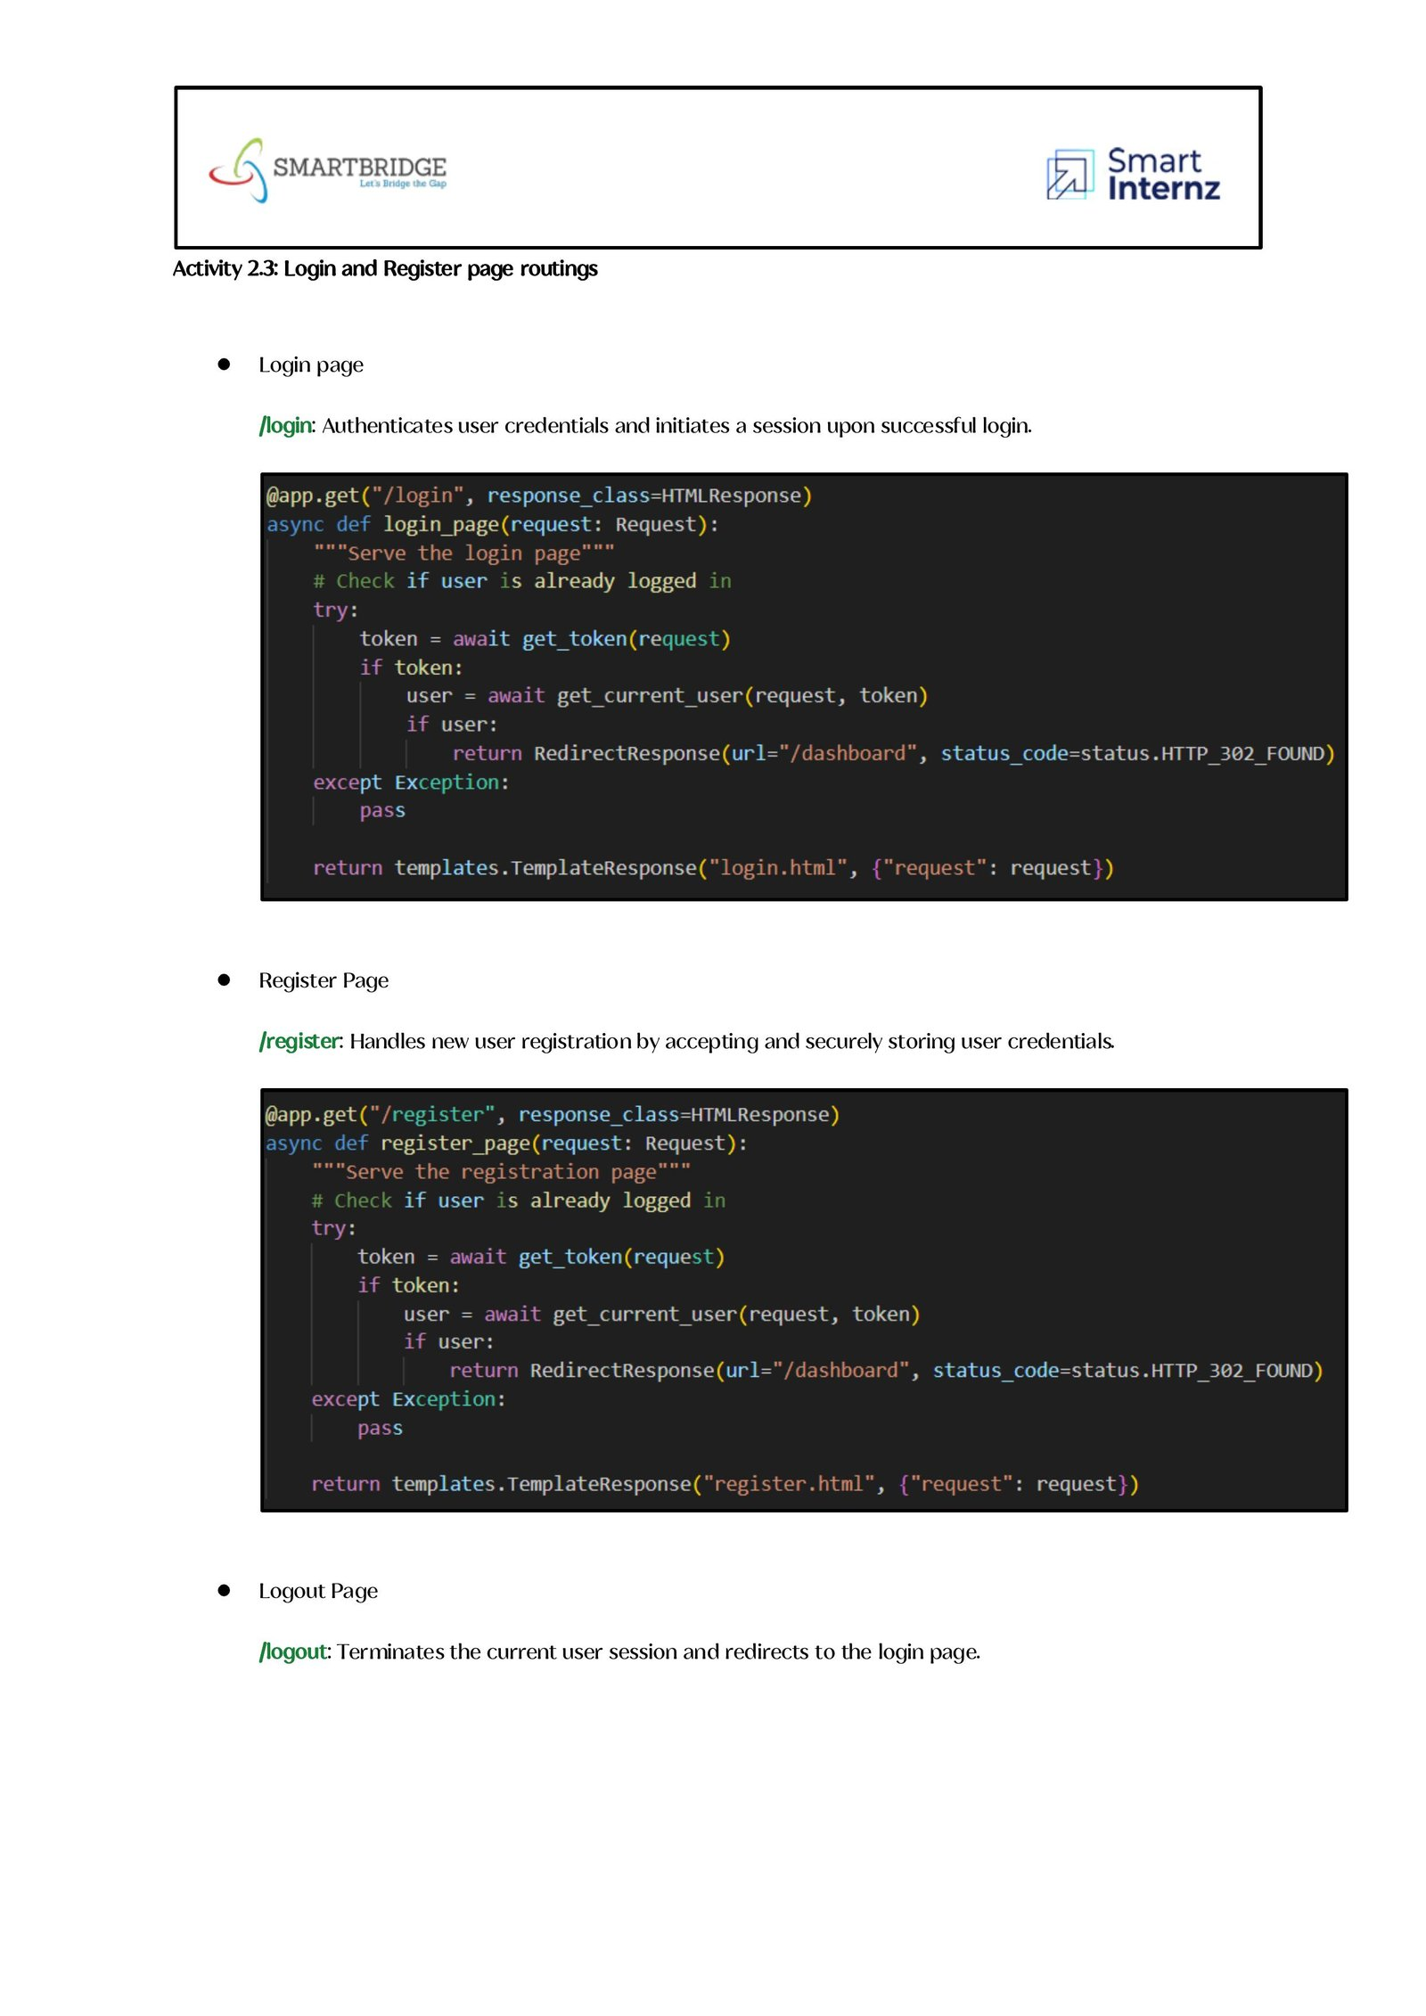

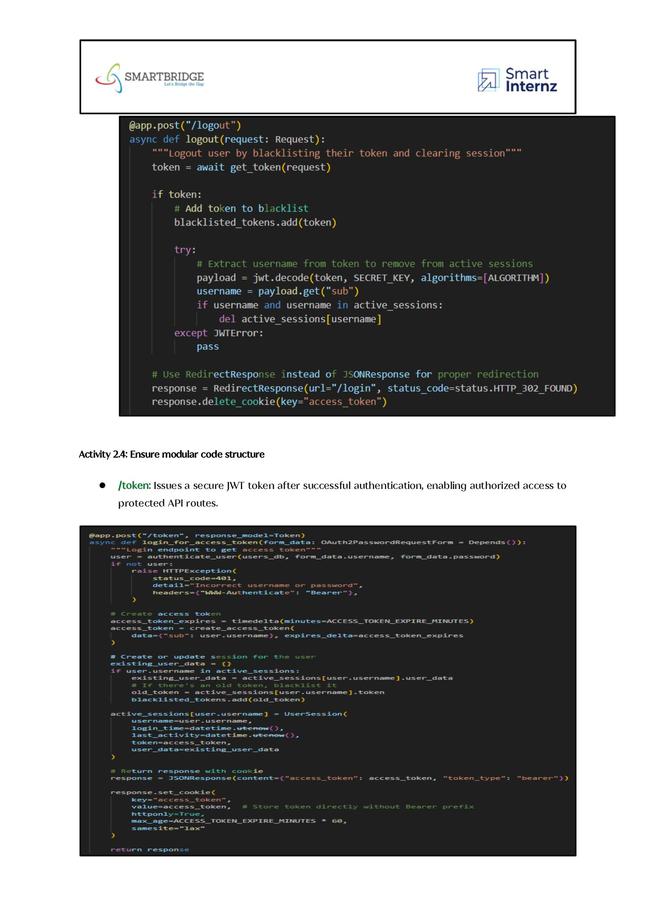

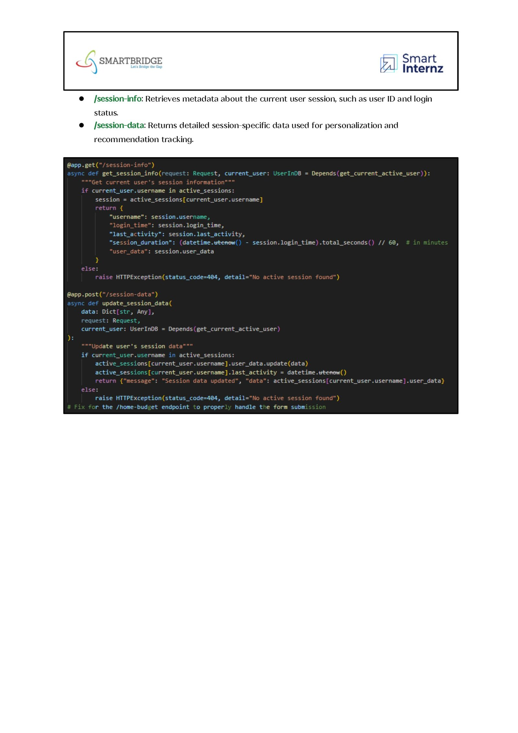

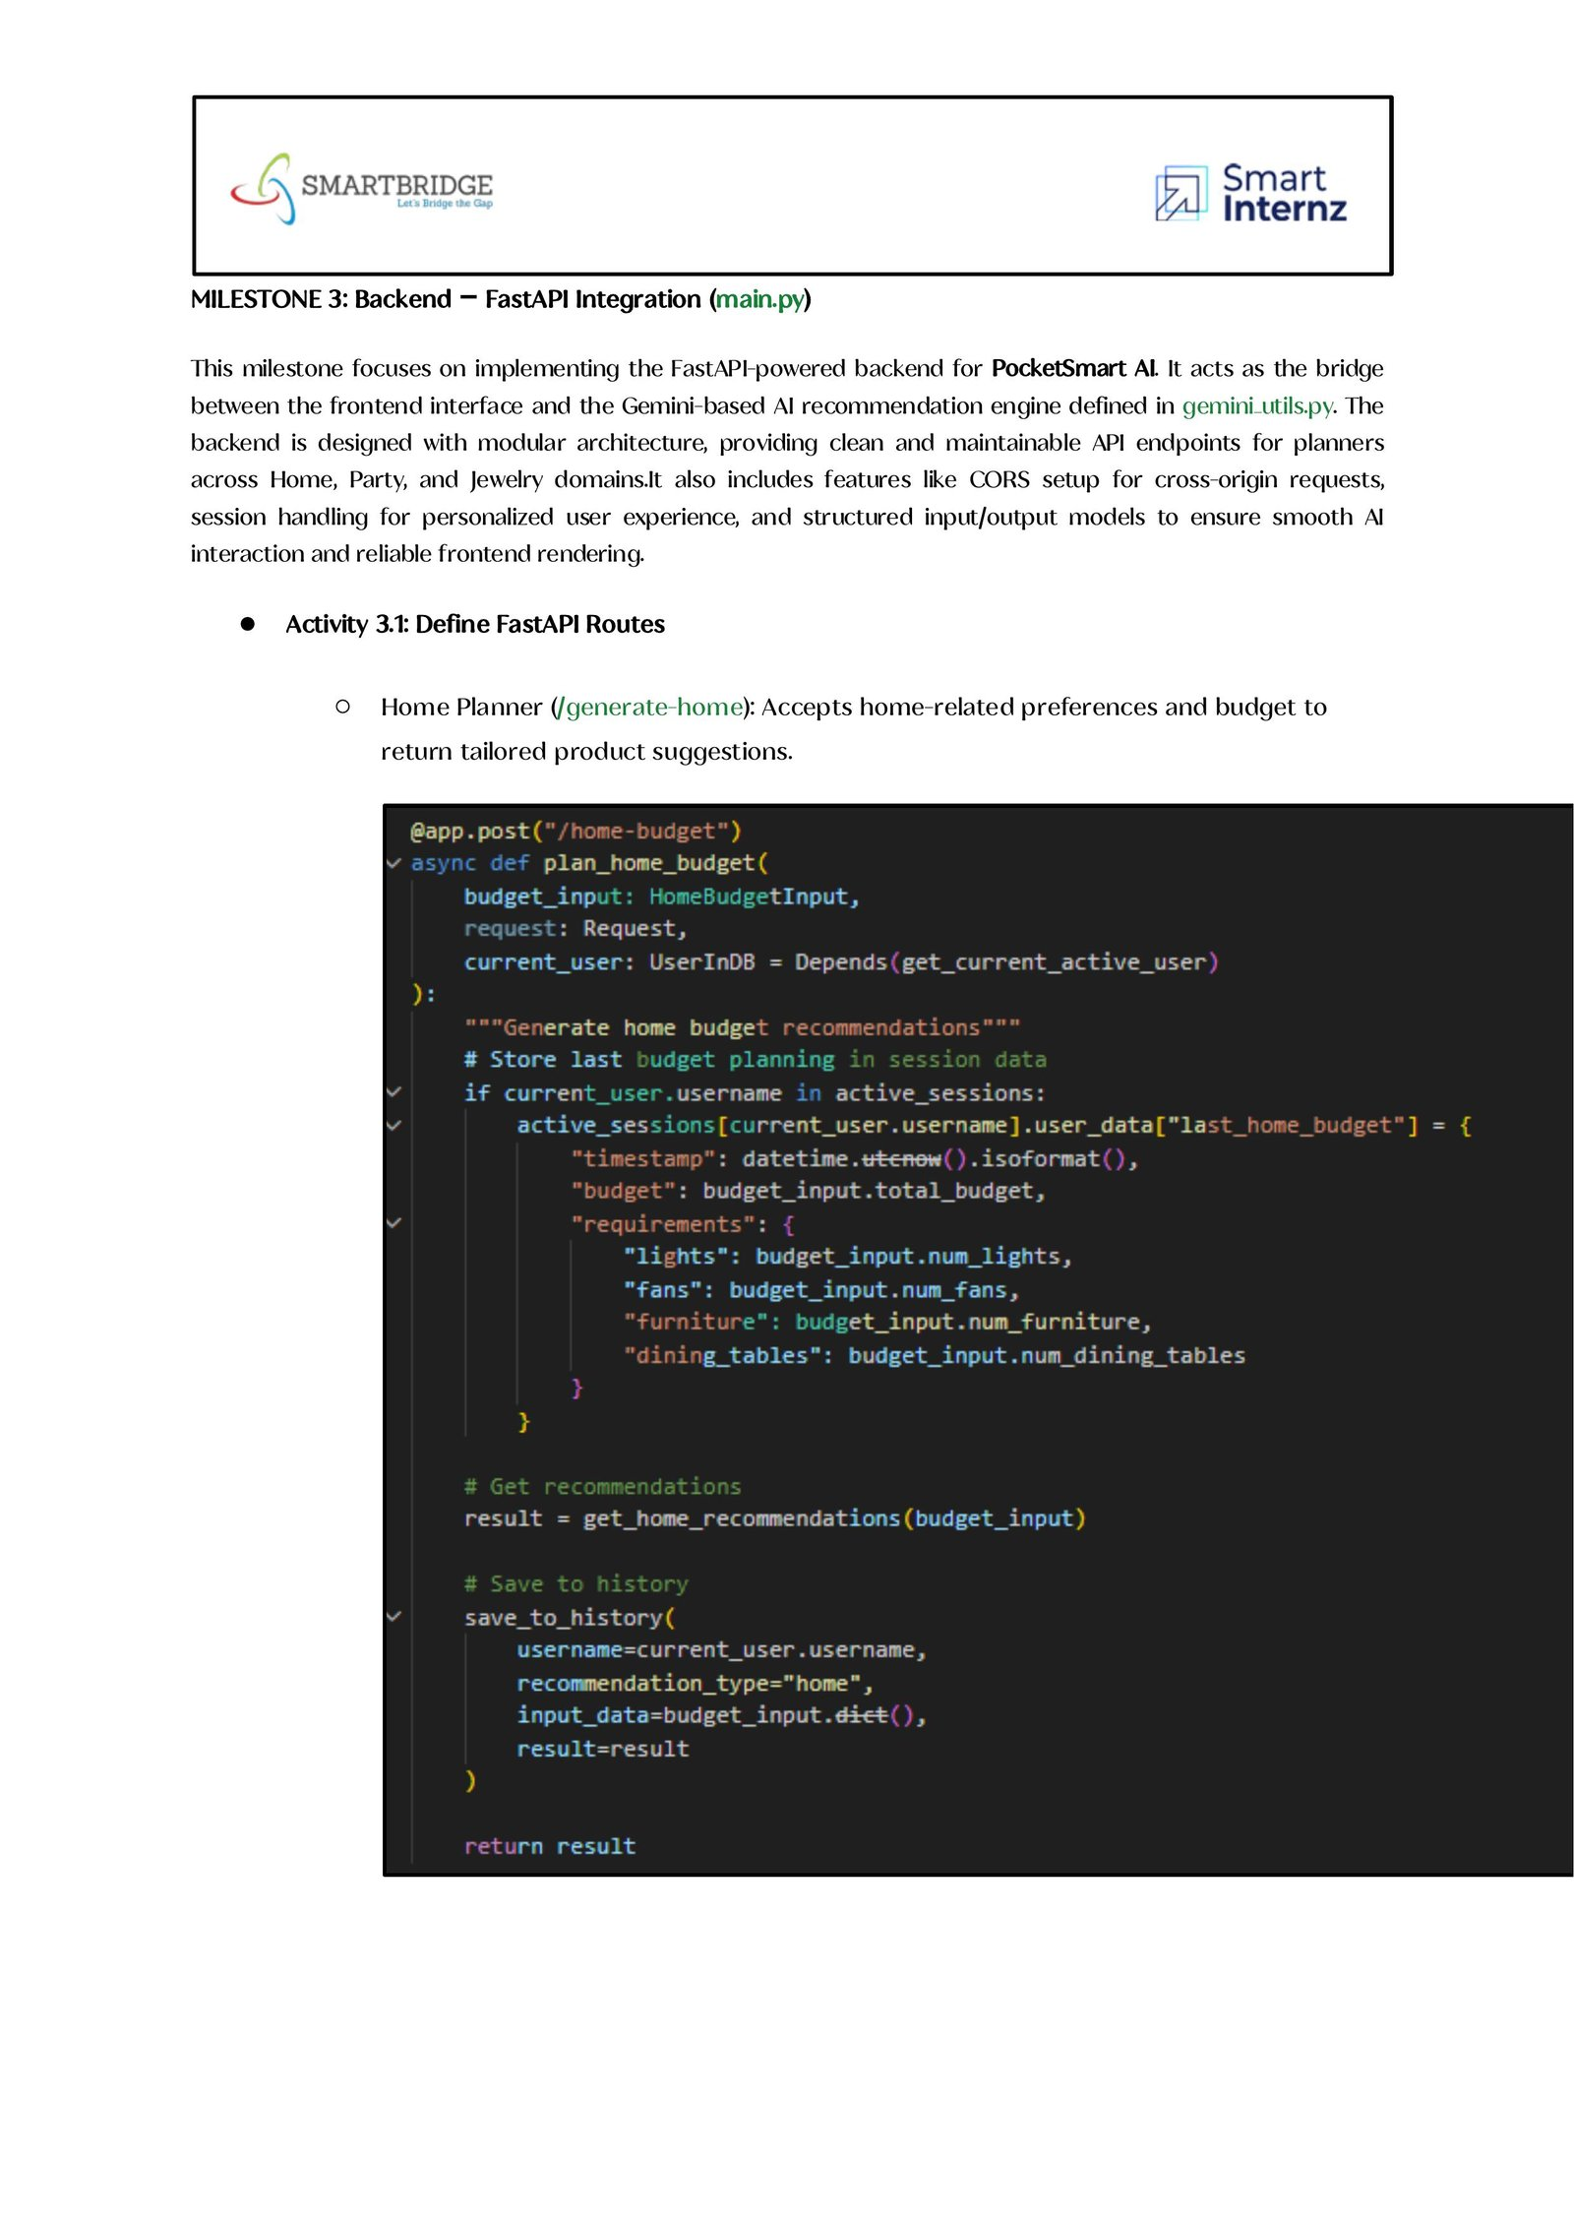

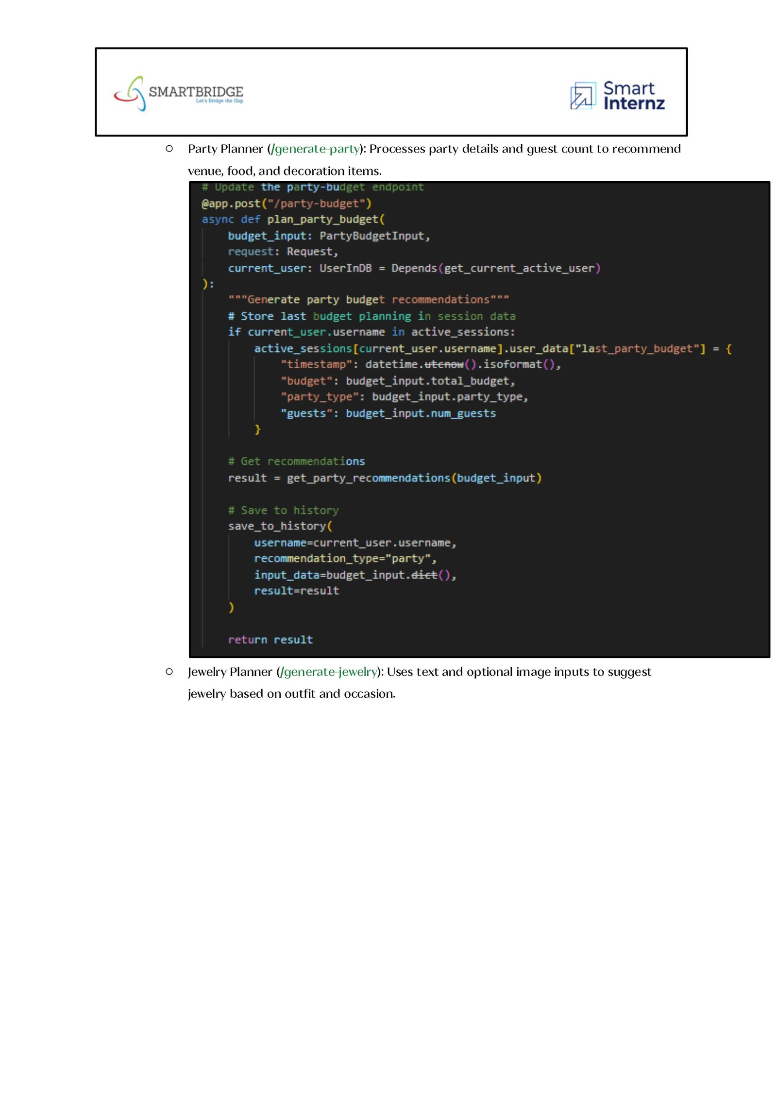

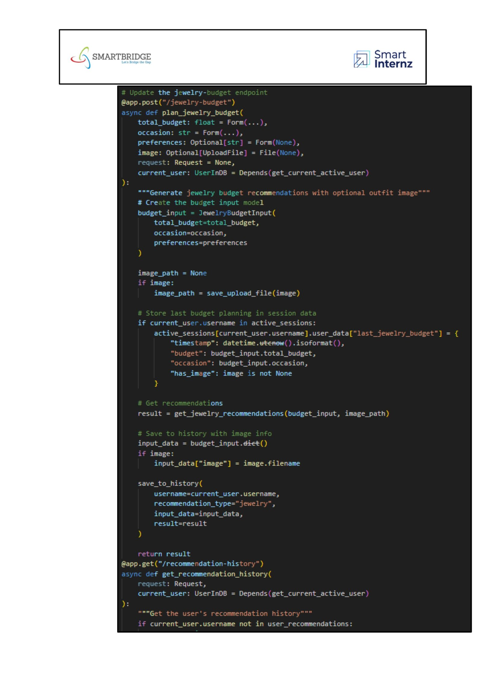

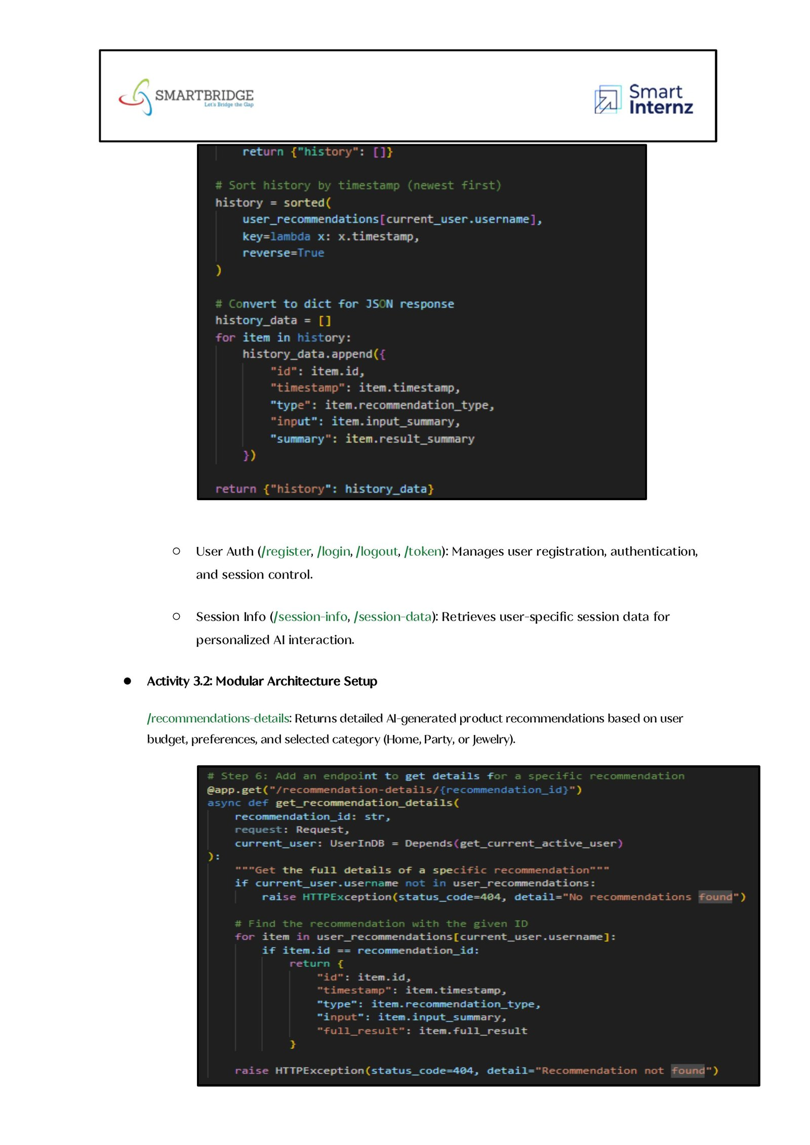

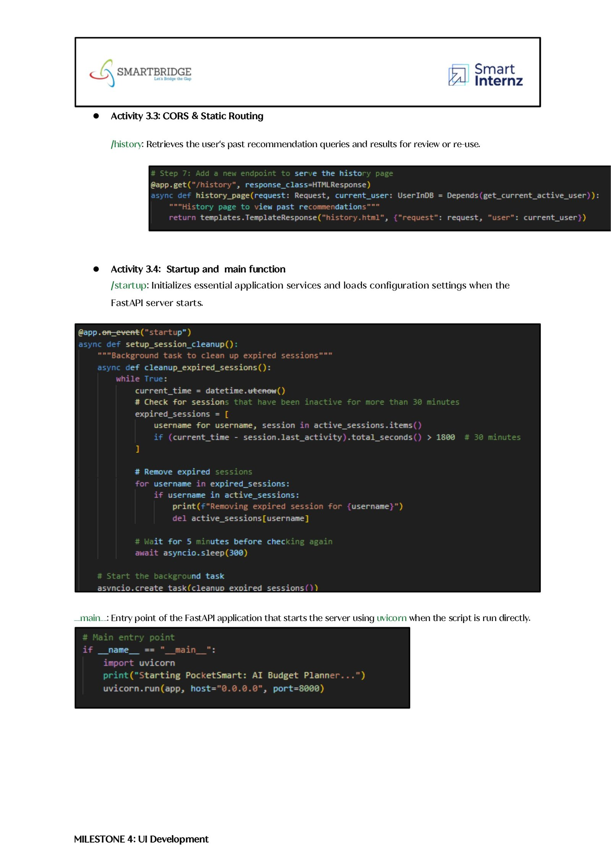

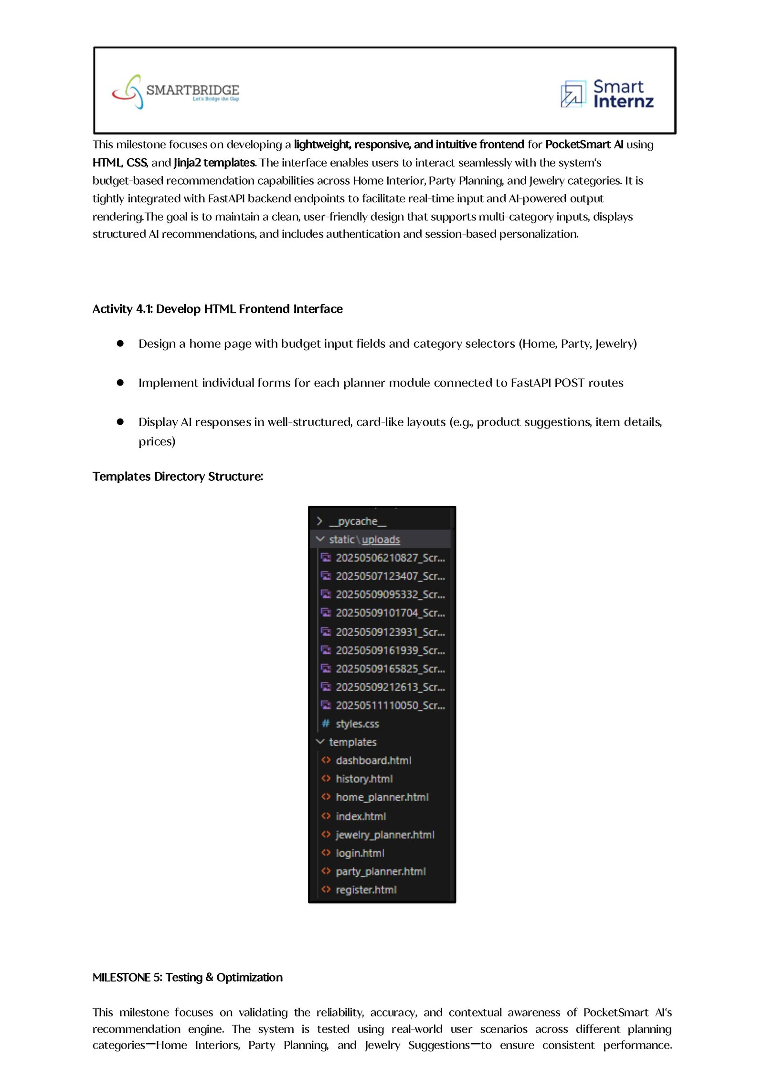

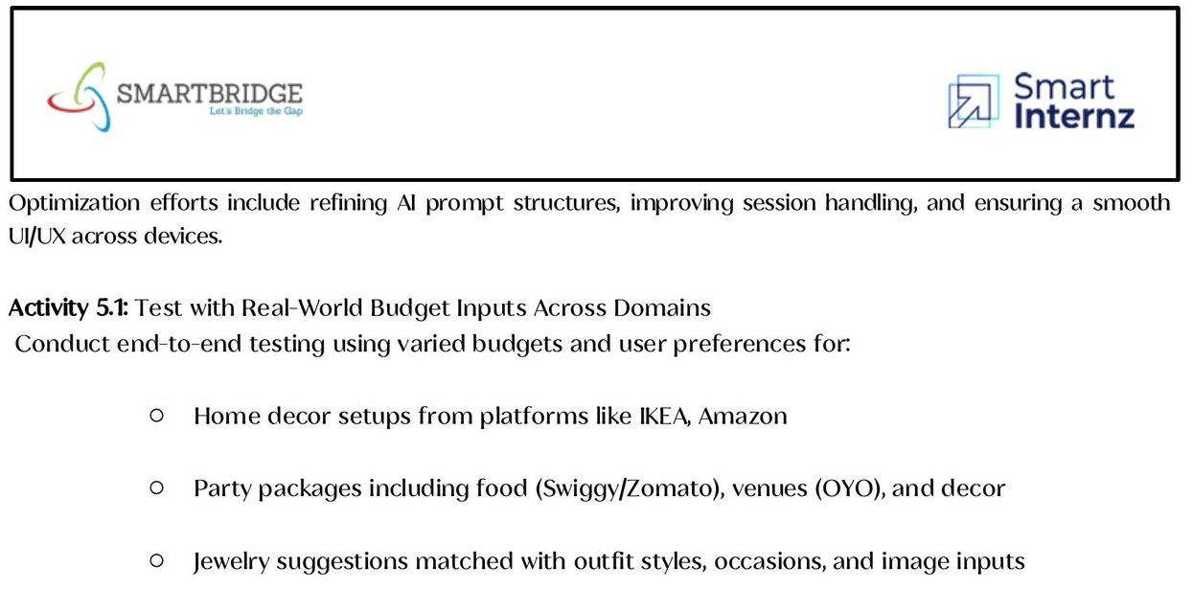
Home Page: Landing page of PocketSmart AI introducing the AI budget assistant, with Get Started and Explore AI options.
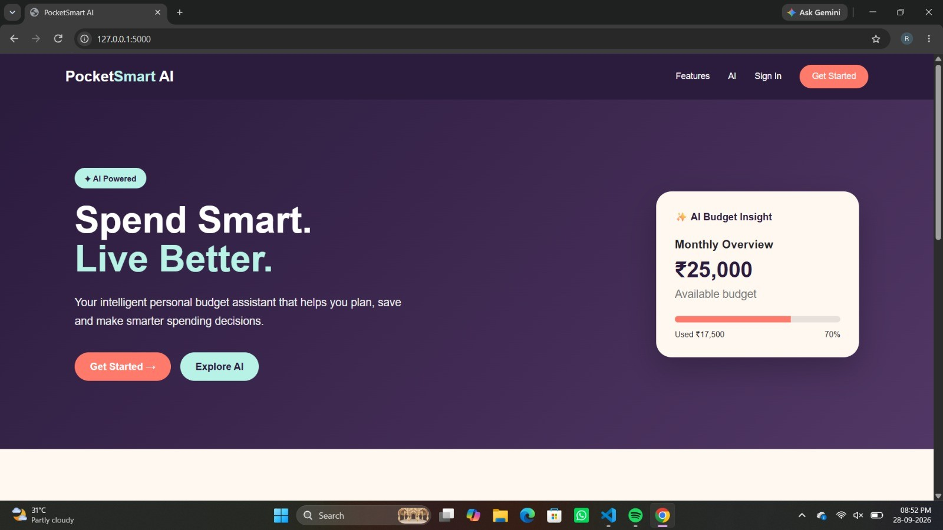
Smart Planning Modules: Shows the three planners - Home Planner, Party Planner and Jewellery Planner - available to the user.
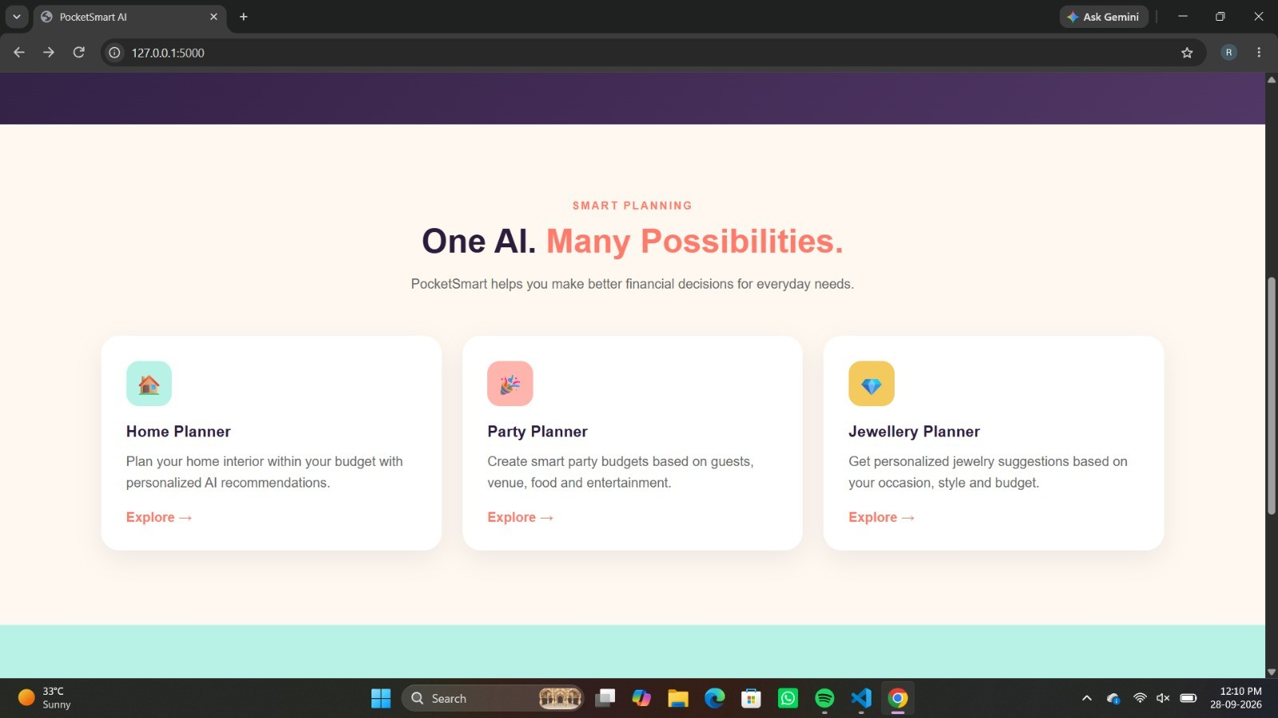


Register Page: Allows new users to create an account with name, email and password to access personalized budget plans.
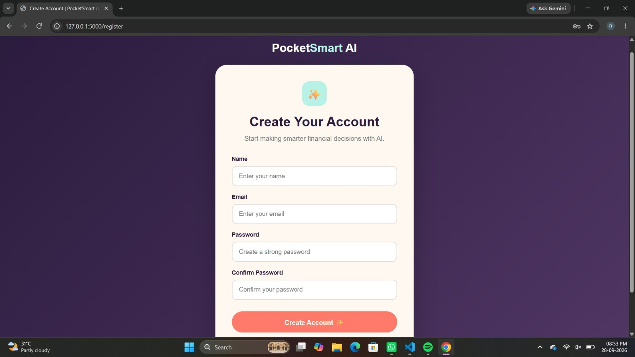
Home Planner Page: Collects home size, home type, number of rooms, budget, style and location to plan the home interior budget.
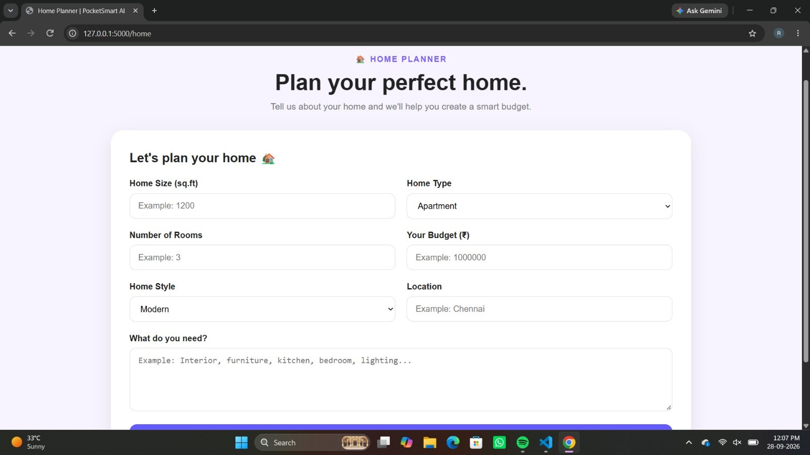

Home Plan Result: Displays the home details along with the budget breakdown for interior, furniture, kitchen, lighting and other needs.
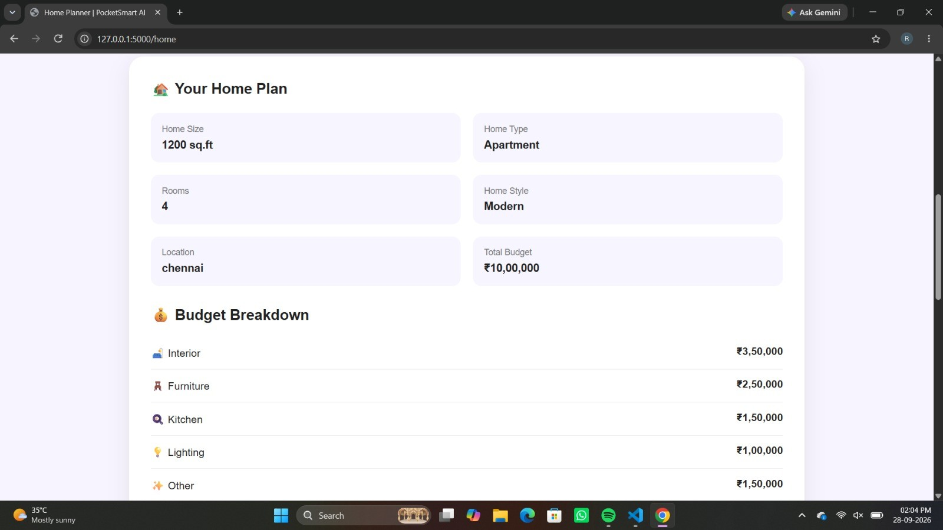
Party Planner Page: Lets users enter the number of guests, party type, budget and requirements to build a smart party budget.
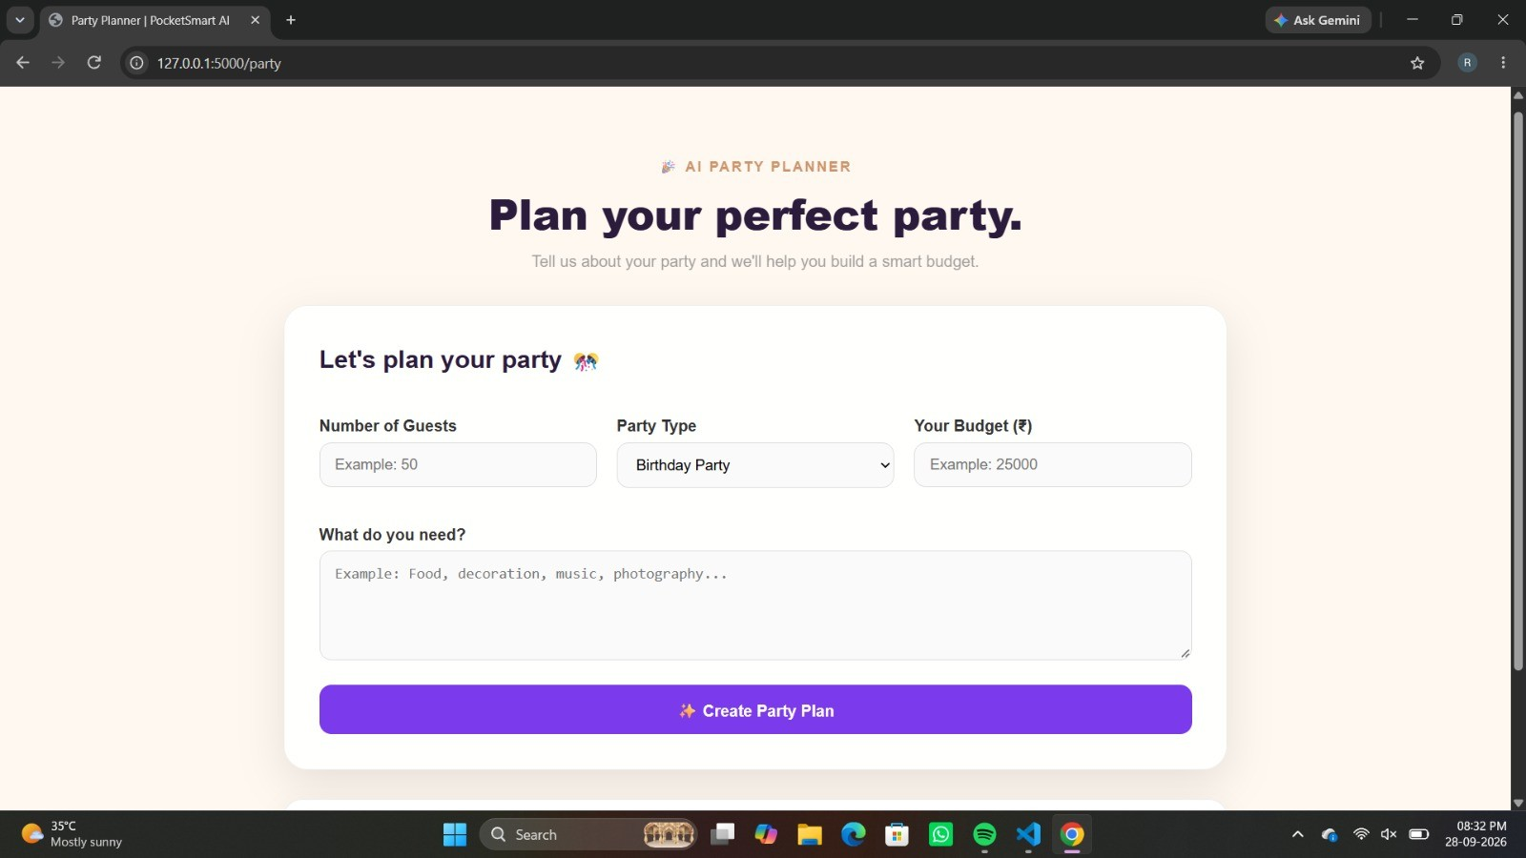

Party Plan Result: Shows the party budget breakdown for food, decoration, venue, photography and music with an AI party recommendation.
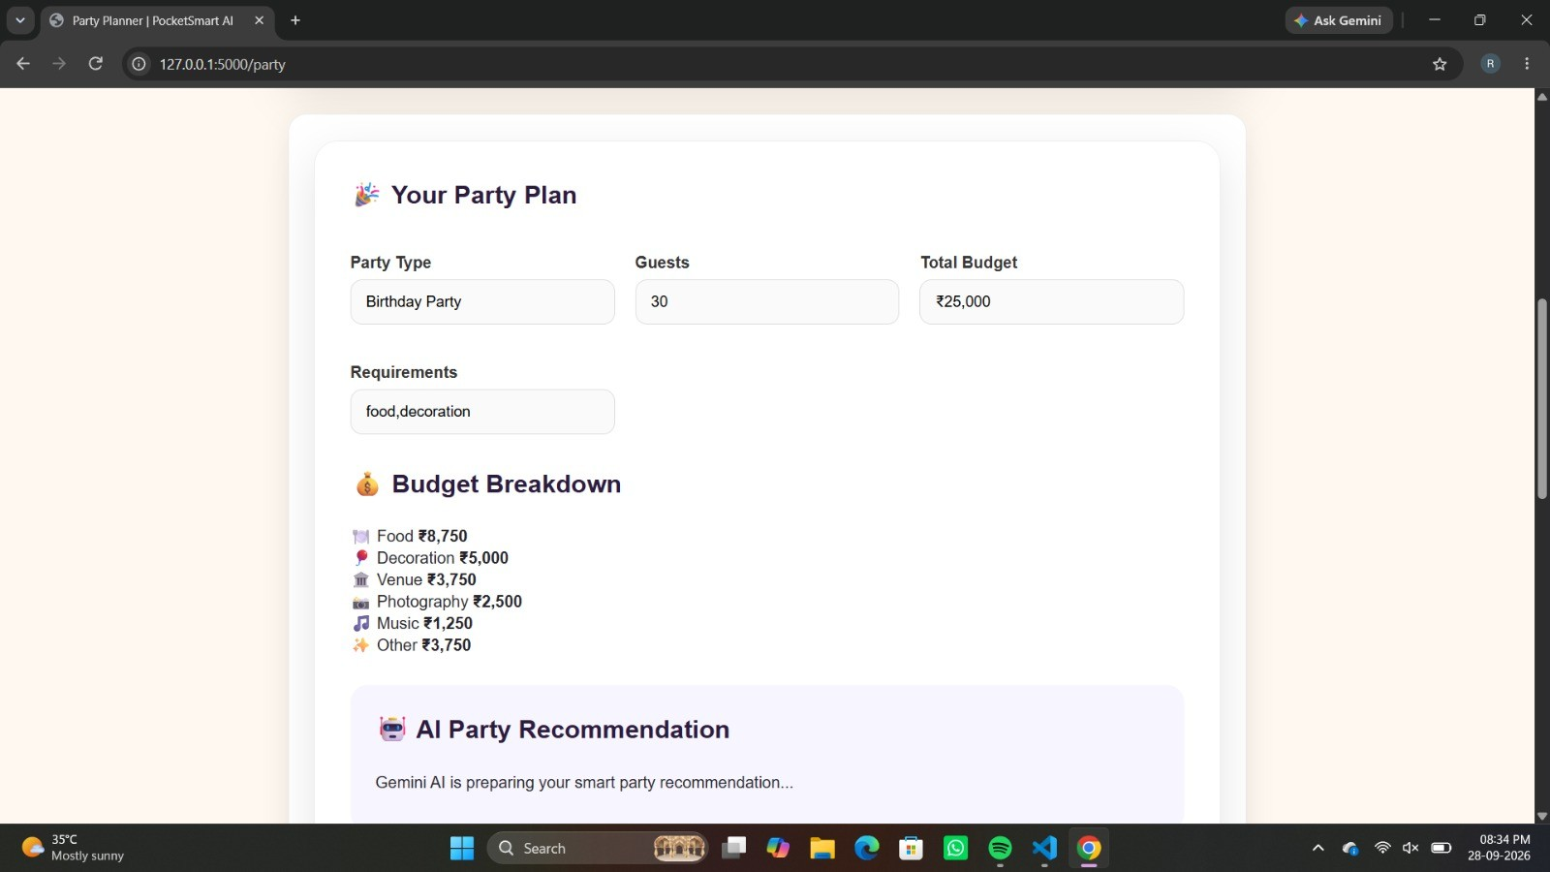
Jewellery Planner Page: Takes the jewellery type, number of items, total budget, preferred metal, requirements and an optional jewellery image.
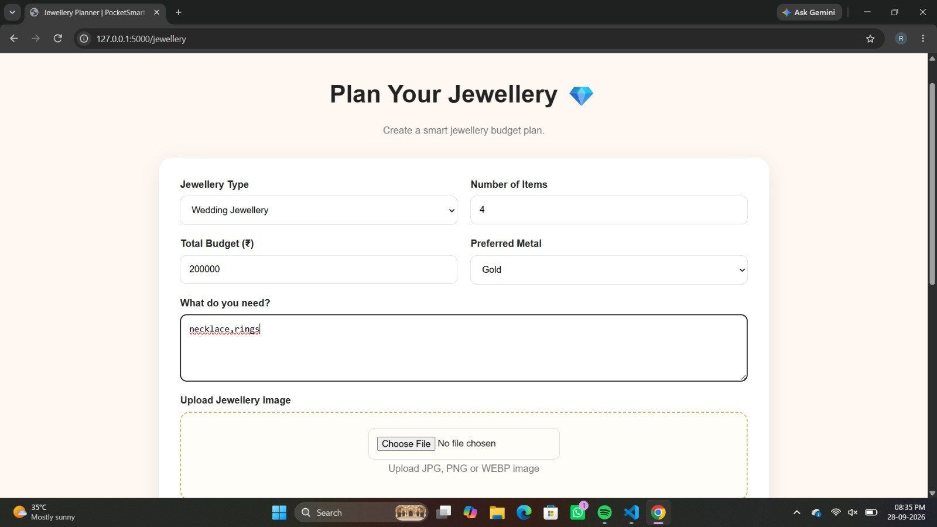

Jewellery Plan Result: Displays the jewellery budget breakdown for necklace, earrings, ring, bangles and other items.
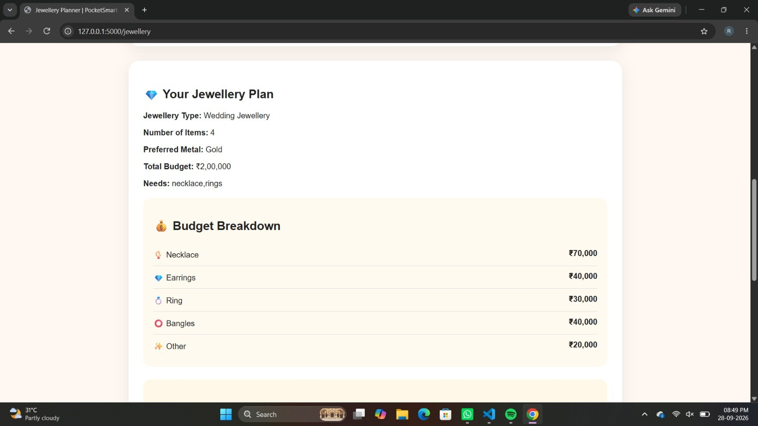
Planning History Page: Lists the user's previous planning requests and the AI-generated plans for quick review.
