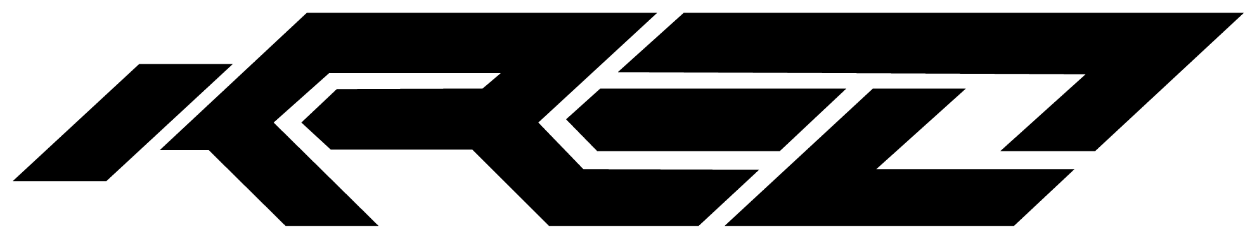 | Creative Studio

Your business deserves a brand
that actually does the work.
KREO Studio is a Plymouth-based creative studio specialising in graphic design, branding, and digital visuals.
We help local businesses look sharper, communicate more clearly, and stand out from the competition.

WHAT WE DO
Logo & Brand Identity  Logos, guidelines, full brand systems.  From £250 | Website Design  Custom, mobile-ready, built to convert.  From £900
Label & Packaging  Print-ready artwork for any product.  From £350 | Flyer & Brochure Design  Eye-catching print and digital collateral.  From £90
Social Media Design  Content packs sized and ready to post.  From £180 | Motion & 3D  Animation, renders, video-ready assets.  From £250

WHY WORK WITH US
Local & Accessible  Based in Plymouth — easy to meet, quick to respond, invested in your city. | Quality-First Design  Every project backed by real experience and genuine craft. No templates, no shortcuts. | Transparent Pricing  Clear quotes upfront. No hidden costs, no surprises when the invoice lands.

★★★★★ Rated 5.0 on Google · 50+ Happy Clients · 100+ Projects Delivered

Ready to talk?  Drop us a message and we'll get back  to you within 24 hours with a no-obligation quote. | Email: design@kreostudio.co.uk  Web: kreostudio.co.uk  Based: Plymouth, Devon

KREO Studio · Plymouth, Devon · design@kreostudio.co.uk · kreostudio.co.uk

