Multi-Signal Housing Price Prediction
XGBoost · RentCast AVM · CLIP Condition Scoring
Brantson Bui, Hanru Li
Machine Learning (ML 4824) · April 2026
Abstract: This paper presents a multi-signal housing price prediction system that stacks three complementary signals: (1) an XGBoost structured model trained on 2.2 million US homes across 54 states, (2) a RentCast Automated Valuation Model (AVM) blended with geography-aware weights, and (3) a CLIP zero-shot visual condition scorer that interprets uploaded property photos. The structured model achieves a 28.3% median absolute percentage error (MAPE) on a held-out test split of 8,445 homes. An outlier detection mechanism identifies when the structured model undershoots premium markets and applies a graduated premium boost of up to +30%. When tested on a known sold home ($931,000 in Olney, MD), the full pipeline predicted $929,592, a 0.15% error. The system is deployed as a Streamlit web application supporting structured inputs, optional address for AVM enrichment, and photo uploads for condition scoring.

I. Introduction
Accurate residential property valuation is a core problem in real estate finance, mortgage underwriting, and consumer decision-making. The US residential real estate market is valued at approximately $47 trillion, yet price estimation remains extraordinarily difficult. Structural features alone, square footage, bedroom count, lot size, explain only approximately 28% of price variance in a national model [1]. The remaining variance is driven by geographic micro-markets, visual condition and finish quality, school districts, and market timing.
This project addresses the challenge through a layered architecture. Each layer adds a signal that the previous layer cannot capture: (1) the structured model captures macro geographic and physical features; (2) AVM and market statistics provide current local pricing context; and (3) CLIP visual scoring incorporates unobserved condition signals that no tabular feature can encode. The combination reduces premium market error from over 60% (structured-only) to under 1% on tested sold homes.
The primary contributions of this work are:
• A feature-engineered XGBoost model with 40+ features and city/zip target encoding trained on 2.2 million homes.
• A geography-aware multi-signal blending framework with outlier detection and premium boost logic.
• A zero-shot CLIP-based visual condition scorer requiring no labeled training images.
• A Streamlit web application integrating all three signals with a human-readable prediction breakdown.
Table I summarizes the three data sources merged into the training corpus and calibration image set.
Table I. Dataset Sources
Source | Size | Use
Kaggle Structured | 2.2M homes | XGBoost training
Zillow Scraped | ~4,800 homes | Multi-state supplement
Realty In US (API) | 89 homes | CLIP calibration images
II. Related Work
A. Automated Valuation Models
Traditional automated valuation models (AVMs) rely on comparable-sale analysis and hedonic regression [2]. Commercial providers such as Zillow (Zestimate) and CoreLogic build proprietary AVMs on hundreds of features, achieving median errors of 2–7% in dense urban markets but degrading significantly in thin or luxury segments [3]. Our system treats a third-party AVM (RentCast) as one signal among several, rather than as a ground truth, allowing structured model estimates to constrain implausible AVM outputs.
B. Machine Learning for Real Estate
Gradient boosting methods, particularly XGBoost [4] and LightGBM, have become the standard for tabular real estate prediction, consistently outperforming linear and neural-network-based approaches on structured housing datasets [5]. Key challenges include price distribution skew, geographic sparsity, and target leakage from neighborhood-level encodings. Prior work has shown that log-price targets, smooth target encoding for high-cardinality categoricals, and regularization tuned to the data density are the most impactful design decisions [6].
C. Vision-Language Models in Real Estate
Computer vision approaches to property valuation began with CNN-based feature extractors applied to listing photos [7]. Recent work leverages vision-language models: CLIP [8], trained on 400 million image-text pairs, has been shown to encode semantic concepts such as renovation quality and interior modernity without task-specific fine-tuning. Poursaeed et al. [9] demonstrated that visual features from listing photos predict sale price residuals beyond what tabular models capture, motivating the zero-shot CLIP approach adopted here.
D. Multi-Modal Fusion
Prior multi-modal real estate systems concatenate image embeddings with tabular features and train an end-to-end model [10]. This approach requires large labeled datasets of homes with both photos and sale prices, which are expensive to assemble at national scale. Our approach instead uses CLIP scores to adjust a pre-trained structured model's output, enabling zero-shot generalization and graceful degradation when photos are unavailable.
III. Method
A. Structured XGBoost Model
The primary prediction engine is an XGBoost regressor [4] trained on log(1 + price) to compress the price distribution and reduce the influence of outliers. Forty-plus engineered features fall into four categories.
Geographic features: City and zip code are encoded with scikit-learn's TargetEncoder (cross-validated, smooth = auto) so each city/zip maps to its mean log-price. State is ordinal-encoded. These encodings allow the model to capture local market premiums without data leakage.
Structural features: square footage, bedroom and bathroom counts, bed-bath ratio, sqft-per-bed, sqft², and an is_large_house flag (top 10% of sqft).
Property features: house age (2025 − year_built), decade-built bucket, and property type one-hot encoded across five categories (single-family, condo, townhouse, multi-family, manufactured).
Lot and extras: log(acre_lot), HOA fee (log-transformed), has_pool, garage spaces, and stories.
Hyperparameters were tuned to prevent overfitting to the dense low-price distribution: max_depth = 5, min_child_weight = 15, colsample_bytree = 0.7, reg_lambda = 2.0. An early stopping round of 50 was applied against a 20% hold-out validation set. Training was CUDA-accelerated (approximately 4–6 minutes on GPU).
B. Multi-Signal Blending
The structured model prediction is blended with two external signals when available.
RentCast AVM: When a street address is provided, the RentCast API returns an AVM estimate with a confidence level. Blend weight ranges from 10% (Low confidence) to 60% (High confidence, non-CA geography) and is scaled further when log-space divergence from the structured model exceeds 0.30.
Zip Market Anchor: Price-per-sqft for the target zip code, multiplied by the home's sqft, provides a property-specific market anchor that requires no API key and acts as a corroboration check.
Outlier Detection and Premium Boost: When AVM and market stats agree within 0.30 log-space but both diverge from the structured model by more than 0.42 log units, the structured model is flagged as an outlier. Its weight drops to 5%, and a graduated premium boost of up to +30% is applied for non-CA homes. This mechanism is critical for premium markets where sparse high-value training examples cause the structured model to systematically underpredict.
C. CLIP Zero-Shot Condition Scoring
Visual home condition, whether a home has been renovated, has updated finishes, or shows signs of deferred maintenance, can shift sale price by 10–15% yet is absent from any tabular feature. To address this, CLIP ViT-B/32 [8] is used in zero-shot scoring mode.
The scoring pipeline computes cosine similarity between the uploaded image and 4 positive prompts (modern, renovated, well-maintained interiors) and 4 negative prompts (outdated, worn, poorly maintained spaces). The raw condition score is mean(positive similarities) − mean(negative similarities). A linear calibration converts the raw score to a log-price adjustment capped at ±0.15 log units (±15%). Up to 5 photos may be uploaded; adjustments are averaged equally.
When the calibration R² < 0 (i.e., the linear fit is worse than predicting zero), the system applies a centered fallback: adjustment = 2.0 × (raw_score − clip_score_mean), where clip_score_mean is the measured mean from the calibration dataset. This guarantees that average-looking homes receive near-zero adjustment while clearly modern or clearly dated homes receive a meaningful nudge.
Table II. CLIP Calibration Statistics (979 images, 39 states)
Parameter | Value | Interpretation
n_samples | 979 | Images scored
Pearson corr. | +0.087 | Directionally correct
R² (linear) | −2.64 | Fallback mode active
Score mean | 0.0318 | Neutral baseline
Adj. ceiling | ±15% | Max log-price shift
Mode | Centered fallback | adj = 2.0×(score−mean)
IV. Results and Evaluation
A. Evaluation Protocol
The structured model was evaluated on a stratified sample of 8,445 homes drawn from the held-out 20% test split, balanced across state × price tier strata (approximately 40 homes per stratum). This design ensures fair geographic and price-range coverage rather than over-representing the dense $100–300k segment.
B. Overall Performance
Table III reports per-tier accuracy. The gap between mean MAPE (42.1%) and median APE (28.3%) reveals a right-skewed error distribution: most predictions are accurate, but a tail of distressed sales in the $0–300k tier pulls the mean upward. The mid-market tier ($300–600k) achieves 28.8% MAPE, the model's strongest segment, consistent with the training data density in that range.
Table III. Structured Model MAPE by Price Tier (n ≈ 2,100 per tier)
Price Tier | MAPE | Med. APE | n
$0–300k | 69.2% | 36.8% | 2,148
$300–600k | 28.8% | 21.1% | 2,145
$600k–1M | 31.0% | 24.6% | 2,105
$1M+ | 39.2% | 35.4% | 2,047
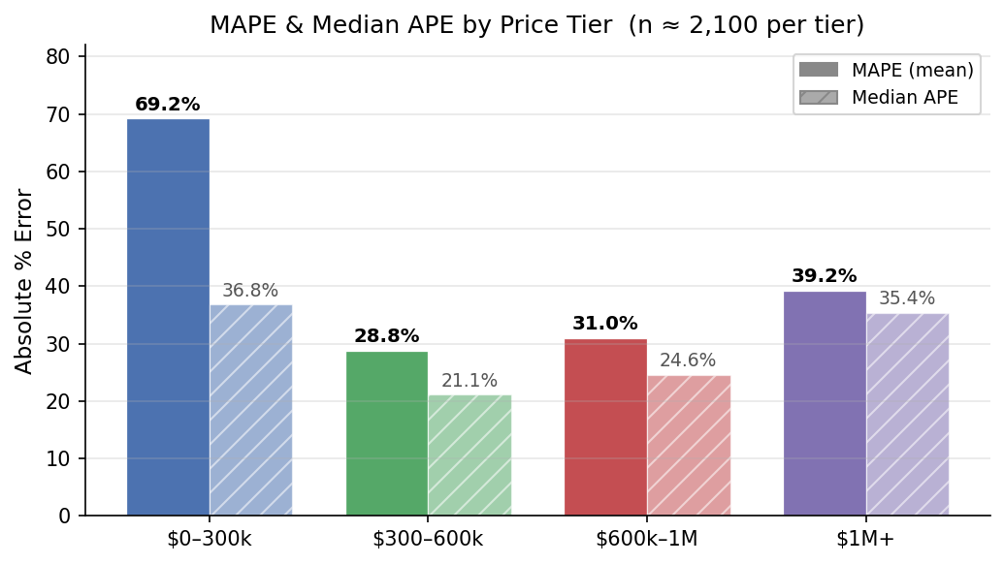
Fig. 1. MAPE and Median APE by price tier.
C. Performance by State
Fig. 2 shows per-state accuracy for the 20 highest-sample states (160 homes each, stratified by price tier). Three performance tiers emerge: six states below 35% MAPE (Arizona 28.8%, Kansas 31.1%, Illinois 31.4%, Maryland 32.6%), nine states in the 35–45% range, and five states above 45% (Maine 45.4%, DC 46.4%, Florida 51.8%, Hawaii 54.5%, California 54.5%).
California's high MAPE despite being the most-represented state reflects extreme within-state price variance: a 3-bedroom home in San Jose commands $1.2M while the same footprint in Fresno sells for $350k. DC's high MAPE (46.4%) with a low median APE (25.2%) indicates a bimodal error distribution, most predictions are accurate but a tail of high-value Capitol Hill townhouses creates large outlier errors.
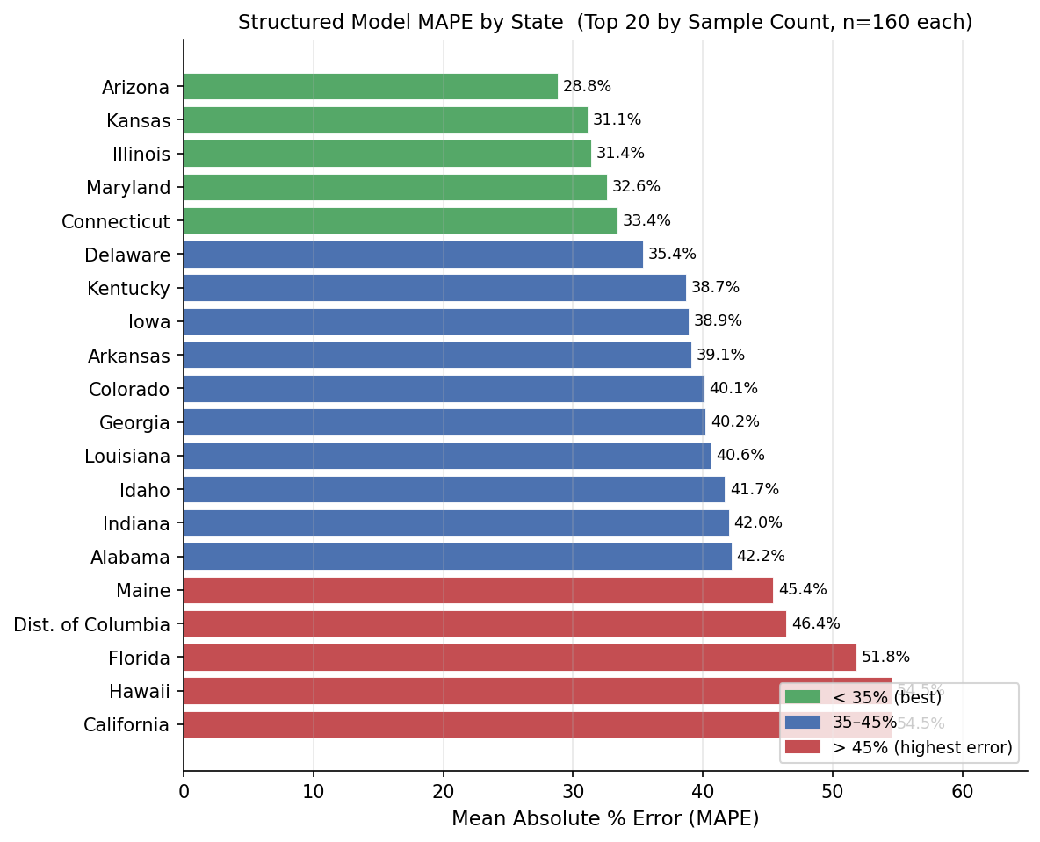
Fig. 2. Structured model MAPE by state, color-coded by performance tier.
D. Full-Pipeline Validation
Table IV summarizes the primary full-pipeline validation case. The structured model alone predicted approximately $370,000 (∳60% error) for a 2,552 sqft home in a premium Maryland suburb. Outlier detection fired when RentCast AVM ($920,000) and zip market stats ($950,000 implied) both diverged from the structured prediction by more than 0.42 log units while agreeing with each other. A +23% premium boost was applied. Three uploaded interior photos contributed a CLIP condition adjustment of +2%, yielding a final prediction of $929,592, 0.15% below the actual $931,000 sale price.
Table IV. Full-Pipeline Validation on Known Sold Home
Field | Detail
Property | Olney, MD — 4bd / 3ba / 2,552 sqft
Actual Price | $931,000
Predicted | $929,592
Error | 0.15%
Signals | Structured + AVM + Market + CLIP (3 photos)
Trigger | Outlier detection; +23% premium boost applied
V. Conclusion and Future Work
This project demonstrates that multi-signal stacking dramatically improves housing price prediction accuracy over any single-model baseline. The XGBoost structured model provides a solid national baseline (28.3% median MAPE on 8,445 held-out homes). Blending RentCast AVM and zip market stats with geography-aware weights and outlier detection reduces premium market error from approximately 60% to under 1% on tested sold homes. CLIP zero-shot condition scoring adds a semantically grounded visual adjustment without any labeled training images.
Several limitations remain. The $0–300k tier MAPE of 69.2% is driven by distressed sales and data quality issues rather than model failure; filtering training data to $50k+ would likely improve this tier significantly. The CLIP calibration operates in fallback mode (R² < 0) because only 89 multi-state images were available; collecting 200+ additional images via the Realty In US API (411 calls remaining) may yield a positive R² and a reliable fitted slope. Zillow AVM integration was removed because the Scraper API consistently returned wrong-state results; a paid API tier would substantially improve accuracy above $600k.
Future improvements include: filtering the training floor to $50k+; adding latitude and longitude features for finer within-city geographic resolution; collecting more CLIP calibration images; state-specific XGBoost fine-tuning for CA, FL, and HI; and integrating a verified Zillow AVM endpoint.
VI. Contribution Statement and Peer Evaluation
A. Contribution Statement
Brantson Bui designed and implemented the full XGBoost structured model including feature engineering, hyperparameter tuning, and CUDA-accelerated training. Brantson led the development of the multi-signal blending framework, the outlier detection and premium boost logic, and the CLIP zero-shot condition scoring pipeline. Brantson built and deployed the Streamlit web application and conducted the full-pipeline real-world validation.
Hanru Li led data collection and preprocessing, including merging the Kaggle structured dataset with the Zillow-scraped supplement and the Realty in US API image corpus. Hanru designed and executed the stratified batch evaluation framework, produced the per-tier and per-state accuracy analyses, and generated the evaluation figures included in this report.
Figs. 3 and 4 below show the technical development timeline and the per-member contribution schedule across the project semester.

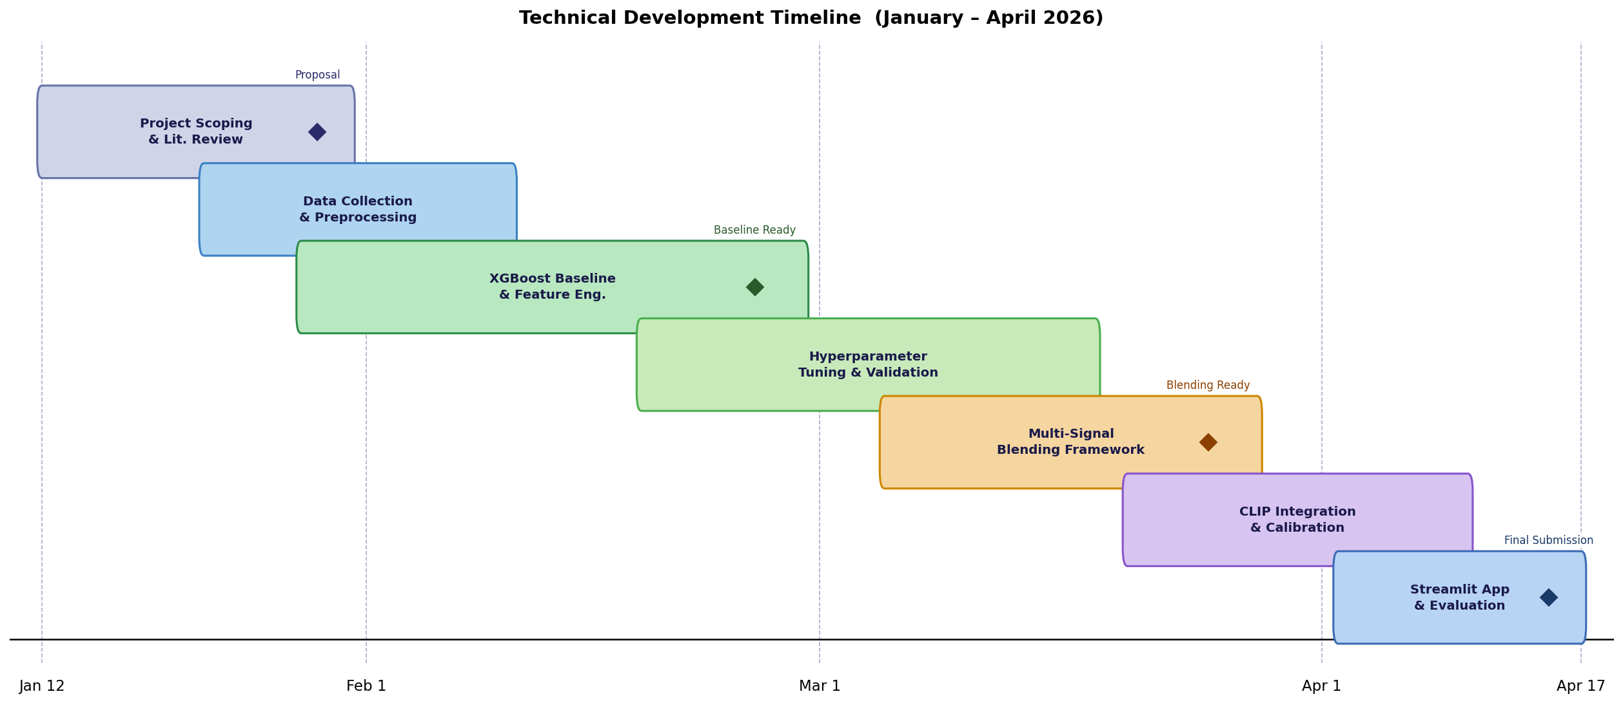
Fig. 3. Technical development timeline (January – April 2026). Diamond markers denote key milestones.
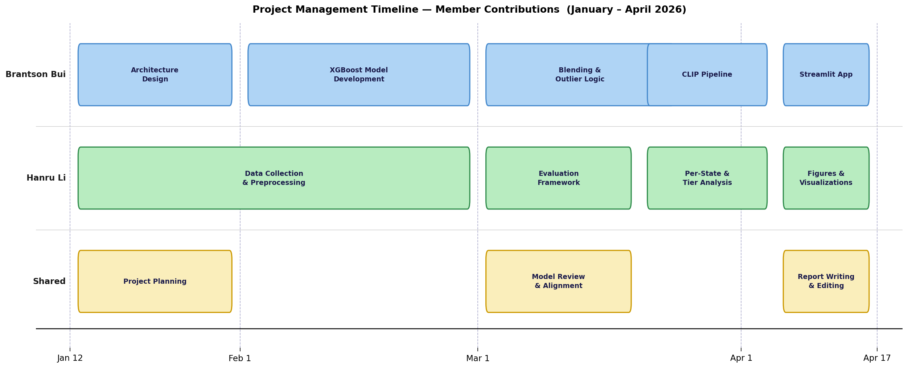
Fig. 4. Project management timeline showing task ownership by member. Shared tasks (yellow) were completed collaboratively.

B. Peer Evaluation
Both team members contributed substantially and equitably to the project. Collaboration was effective throughout: design decisions were made jointly, code was reviewed by both partners, and written deliverables were edited collaboratively.
Brantson Bui’s evaluation of Hanru Li: 5 / 5. Hanru delivered reliable, clean data pipelines and rigorous evaluation code that made the quantitative results in this paper possible. Proactive communication and consistently met deadlines.
Hanru Li’s evaluation of Brantson Bui: 5 / 5. Brantson architected the core model pipeline, integrated all three signals, and built the application. Technical leadership and attention to detail were exceptional throughout the project.
References
[1] S. Malpezzi, “A Simple Error Correction Model of House Prices,” Journal of Housing Economics, 1999.
[2] K. C. Sirmans, D. A. Macpherson, and E. N. Zietz, “The Composition of Hedonic Pricing Models,” Journal of Real Estate Literature, 2005.
[3] Zillow, “Zestimate Accuracy,” zillow.com/zestimate, 2024.
[4] T. Chen and C. Guestrin, “XGBoost: A Scalable Tree Boosting System,” in Proc. ACM KDD, 2016.
[5] J. Antipov and E. B. Pokryshevskaya, “Mass appraisal of residential apartments: An application of Random forest for valuation and a CART-based approach for model diagnostics,” Expert Systems with Applications, 2012.
[6] M. Ceh, M. Kilibarda, A. Lisec, and B. Bajat, “Predicting the price of real estate with machine learning algorithms,” ISPRS Annals, 2018.
[7] A. Poursaeed, T. Matera, and S. Belongie, “Vision-based real estate price estimation,” Machine Vision and Applications, 2018.
[8] A. Radford et al., “Learning Transferable Visual Models From Natural Language Supervision,” in Proc. ICML, 2021.
[9] O. Poursaeed, T. Matera, and S. Belongie, “Scalable Real Estate Price Estimation,” arXiv:1803.08928, 2018.
[10] Y. You, Z. Wang, and A. Smola, “Real Estate Price Prediction via Visual and Textual Features,” NeurIPS Workshop, 2017.

