Faculty of Electrical Engineering and Computing
Master programme

Heuristic Optimization Methods
Academic year 2021/2022

Student: Branimir Ričko (0036503132)

- Details and results

Programming language
C#

Best found results

Instance 1
Greedy algorithm
Score: 251
First team lineup: 61,622,618,532,521,534,529,277,273,274,275
Substitutions: 525,623,70,276
Local search
Score: 1527
First team lineup: 10,542,556,280,283,291,324,71,73,119,130
Substitutions: 532,622,70,277
Instance 2
Greedy algorithm
Score: 467
First team lineup: 41,468,469,377,383,374,398,206,210,201,199
Substitutions: 370,470,36,211
Local search
Score: 2151
First team lineup: 4,412,421,216,218,263,306,48,71,72,77
Substitutions: 377,468,41,206

Pseudocodes:
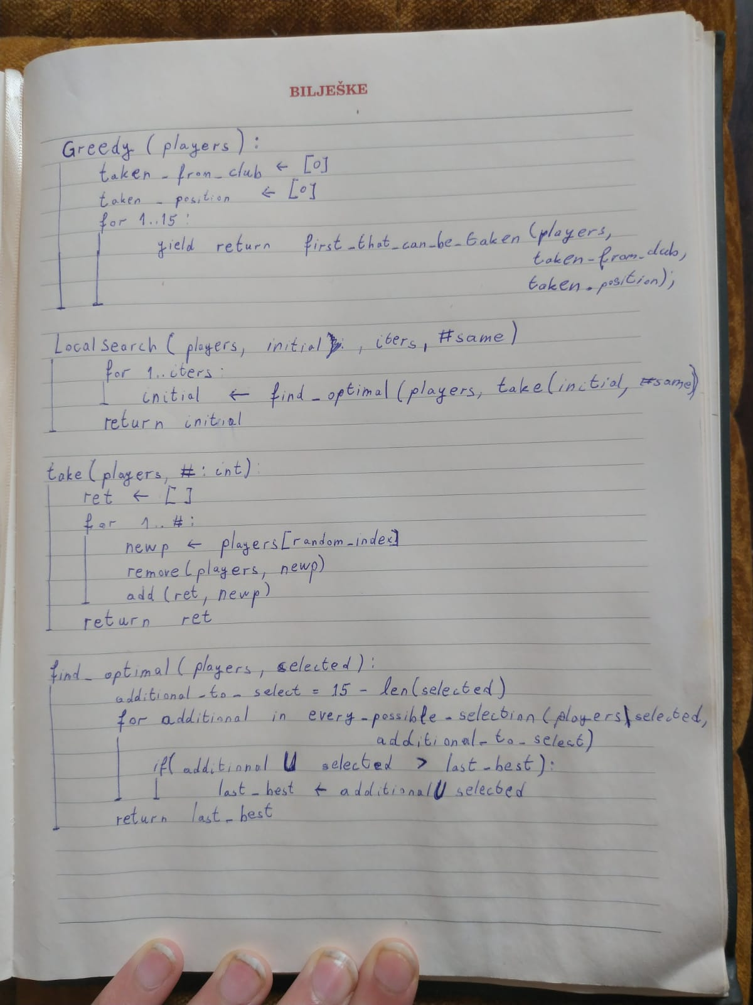

- Greedy algorithm search

Description
Greedy algorithm is an algorithm that always takes best player based on some players attribute, e.g. players price, players value, players price/value…
It does not find the optimal solution, but it does find valid solution quite quickly.

- Local search

Description
Local search is an algorithm that takes simplified version of a problem and generates optimaimal solution for that version of a problem. Then using the optimal solution for simplified problem, new simplified problem is generated.
It is not garenteed that local search algorithm will find the optimal solution for the original problem.
It is garanteed that the solution of Local Search will be better than the solution of Greedy algorithm, if the local search uses greedy algorithm for initial guess.
Analysis
Local search is a good algorithm for finding solutions that are better or equal to greedy solutions.

