/***********************************************************************

Program Name: ThreeArrayList.java

Programmer's Name: Brandt Lareau

Program Description: Calculate some numbers using arrays

***********************************************************************/

package app;

import java.awt.*;

import java.awt.event.*;

import javax.swing.*;

import java.text.DecimalFormat;

public class ThreeArrayLists {

private int length = 10;

private double[] priceList = { 4.0, 8.5, 6.0, 7.35, 9.0, 15.3, 3.0, 5.4, 2.9, 4.8 };;

private double[] quantityList = { 10.62, 14.89, 13.21, 16.55, 18.62, 9.47, 6.58, 18.32, 12.15, 3.98 };

private double[] amountList = new double[length];

DecimalFormat decimal_format = new DecimalFormat("#.##");

// Init

public static void main(String args[]) {

new ThreeArrayLists();

}

public void calculateTotals() {

int count = 0;

while ( count < length ) {

amountList[count] = priceList[count] * quantityList[count];

count++;

}

}

public void displayList() {

int count = 0;

while ( count < length ) {

System.out.println( (count + 1) + ") " + quantityList[count] + " * " + priceList[count] + " = " + decimal_format.format( amountList[count] ));

count++;

}

}

public ThreeArrayLists() {

calculateTotals();

displayList();

}

}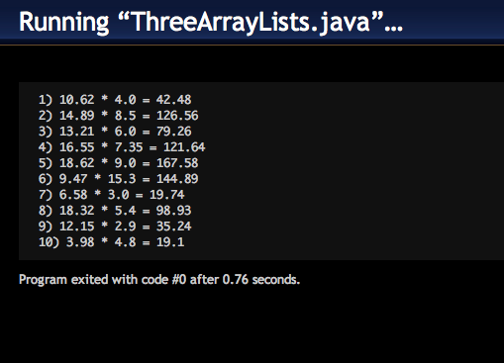

/***********************************************************************

Program Name: Index.java

Programmer's Name: Brandt Lareau

Program Description: Text search index location, count total number of a characters

***********************************************************************/

package app;

import java.awt.*;

import java.awt.event.*;

import javax.swing.*;

public class Index extends JFrame implements ActionListener {

// JFrame Varables

private JButton buttonOne = new JButton("Find");

private JTextField textFieldOne = new JTextField(2);

private JTextArea textArea = new JTextArea(6, 30);

private JLabel labelOne = new JLabel();

private JLabel labelTwo = new JLabel();

private JFrame frame = new JFrame("Character Finder");

private JScrollPane scrollPaneOne = new JScrollPane(textArea);

private static final long serialVersionUID = 7712717603765541383L;

// Varables

private String string = "";

// Init

public static void main(String args[]) {

new Index();

}

public void actionPerformed(ActionEvent e) {

string = textArea.getText();

String guess = textFieldOne.getText();

Integer characterCount = 0;

int index = string.indexOf(guess);

int total = 0;

while (index >= 0) {

total++;

index = string.indexOf(guess, index + 1);

}

JOptionPane.showMessageDialog(frame, "Number Of " + guess + "'s: " + total);

}

public void setLabels() {

labelOne.setText("Enter a Character");

labelTwo.setText("Enter Text to be searched");

}

public void setScrollPane(){

scrollPaneOne.setHorizontalScrollBarPolicy(20);

}

public void addElements() {

frame.add(labelTwo);

frame.add(scrollPaneOne);

frame.add(labelOne);

frame.add(textFieldOne);

}

public Index() {

frame.setDefaultCloseOperation(JFrame.EXIT_ON_CLOSE);

setLabels();

addElements();

frame.setBounds(300, 400, 400, 180);

frame.setResizable(false);

frame.setLayout(new FlowLayout());

frame.setVisible(true);

textFieldOne.addActionListener(this);

}

}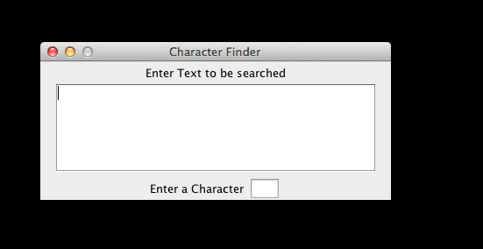

/***********************************************************************

Program Name: Index2.java

Programmer's Name: Brandt Lareau

Program Description: Count all the characters

***********************************************************************/

package app;

import java.awt.*;

import java.awt.event.*;

import javax.swing.*;

public class Index2 extends JFrame implements ActionListener {

// JFrame Varables

private JButton buttonOne = new JButton("Counter Occurrences of Each Letter");

private JTextField textFieldOne = new JTextField(2);

private JTextArea textAreaOne = new JTextArea(6, 30);

private JTextArea textAreaTwo = new JTextArea(6, 30);

private JLabel labelOne = new JLabel();

private JLabel labelTwo = new JLabel();

private JFrame frame = new JFrame("Character Counter");

private JScrollPane scrollPaneOne = new JScrollPane(textAreaOne);

private JScrollPane scrollPaneTwo = new JScrollPane(textAreaTwo);

private static final long serialVersionUID = 7712717603765531381L;

private String[] alphabet = { "a", "b", "c", "d", "e", "f", "g",

"h", "i", "j", "k", "l", "m", "n", "o", "p", "q", "r", "s", "t",

"u", "v", "w", "x", "y", "z" }; // Faster to create a array then it is to build a program that does it for me.

// Varables

private String string = "";

// Init

public static void main(String args[]) {

new Index2();

}

public void actionPerformed(ActionEvent e) {

string = textAreaOne.getText();

String guess = textFieldOne.getText();

Integer characterCount = 0;

String answer = "";

int index;

int total = 0;

for (int i = 0; i < alphabet.length; i++){

total = 0;

index = string.indexOf(alphabet[i]);

while (index >= 0) {

total++;

index = string.indexOf(alphabet[i], index + 1);

}

answer += alphabet[i] + " : " + total + "\n";

}

textAreaTwo.setText(answer);

}

public void setLabels() {

labelOne.setText("Enter some text");

}

public void addElements() {

frame.add(labelOne);

frame.add(scrollPaneOne);

frame.add(buttonOne);

frame.add(scrollPaneTwo);

}

public Index2() {

frame.setDefaultCloseOperation(JFrame.EXIT_ON_CLOSE);

setLabels();

addElements();

frame.setBounds(450, 300, 400, 300);

frame.setResizable(false);

frame.setLayout(new FlowLayout());

frame.setVisible(true);

buttonOne.addActionListener(this);

}

}

