Problem 1 (Ross 7.1,2)

100 iterations:

Avg customer time in system: 0.2153. Avg idle time: 2.3418. Avg overtime: 0.1892

1000 iterations:

Avg customer time in system: 0.2106. Avg idle time: 2.3369. Avg overtime: 0.1503

Problem 2 (Ross 7.3)

Avg time on break: 53.9884

Problem 3 (Ross 7.5,6)

Expected number of lost customers: 120.586

Problem 4 (Ross 7.11)

Probability always positive: 0.905

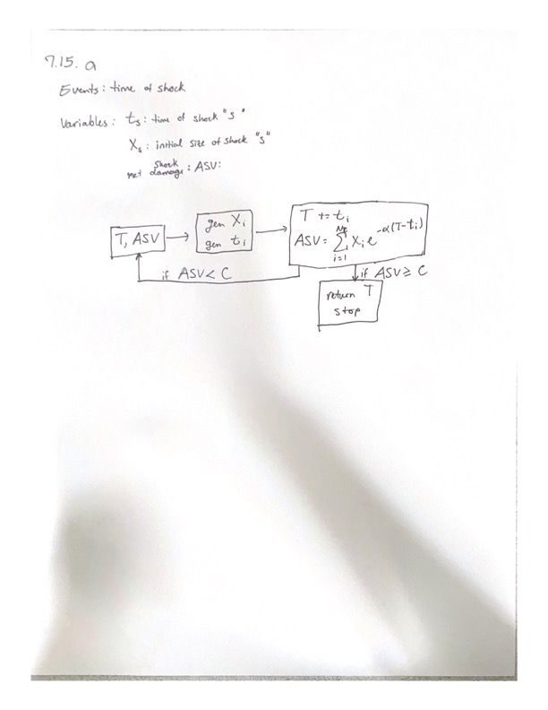Problem 5 (Ross 7.15)

b. Average time to system fail: 0.5092208923480627

Problem 6 (Ross 7.17)

Expected stock gain at beginning of day: {0: 0.0, 1: 0.0, 2: 0.51, 3: 1.2, 4: 2.06, 5: 3.17, 6: 4.77, 7: 6.71, 8: 8.78, 9: 11.05, 10: 13.51, 11: 16.06, 12: 18.73, 13: 21.48, 14: 24.24, 15: 27.24, 16: 30.4, 17: 33.66, 18: 36.99, 19: 40.49}

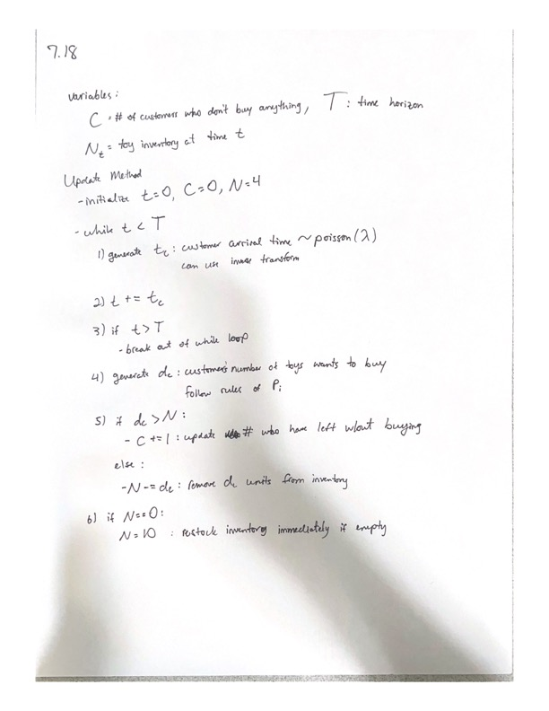Problem 7 (Ross 7.18)

Problem 9

Using homogeneous arrival process

1K simulations Mean of customers in system at time = 50: 0.07

1K simulations Variance of customers in system at time = 50: 0.06509999999999999

1K simulations Mean of customers in system at time = 100: 1.043

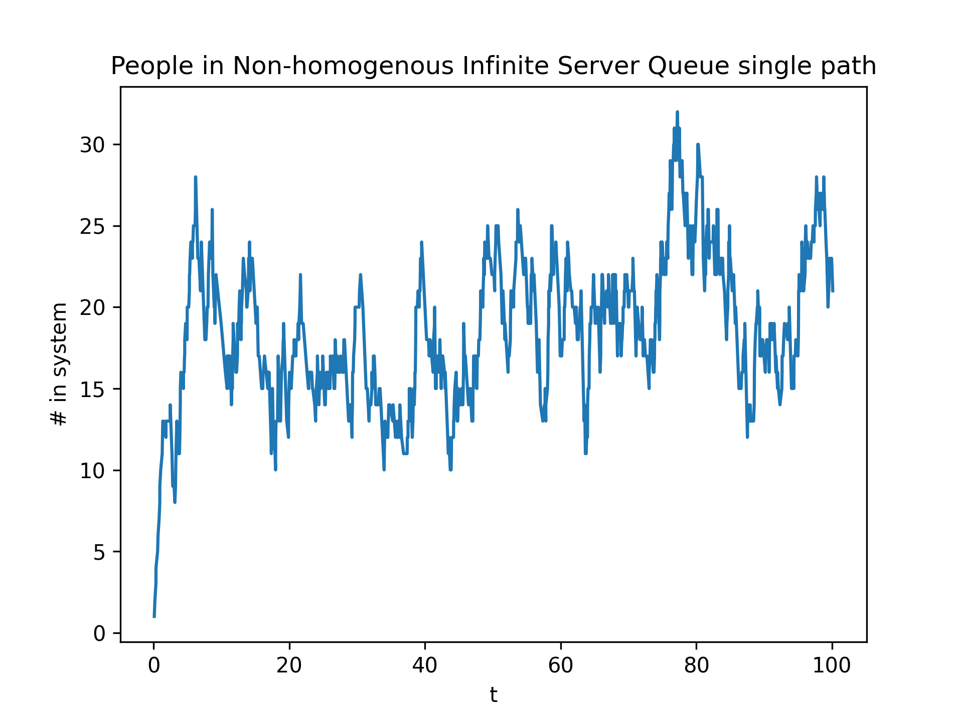1K simulations Variance of customers in system at time = 100: 0.04115099999999999