Brandon Alston

CAAM 586

HW 4

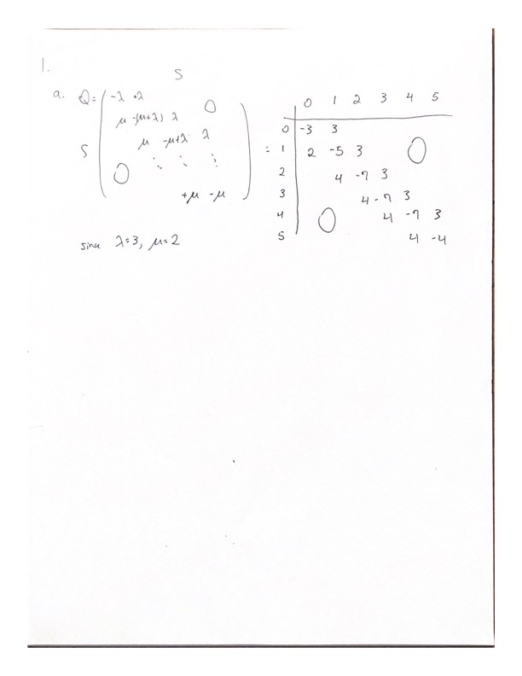Problem 1

DTMC Method IDC: 0.0054231130085212855

Uniformization Method IDC: 0.0023830598614701308

Problem 2

IDC: 0.03766

Problem 3

E[X_40]: 20.194048369165383

Var[X_40]: 13.434169436576234

Problem 4

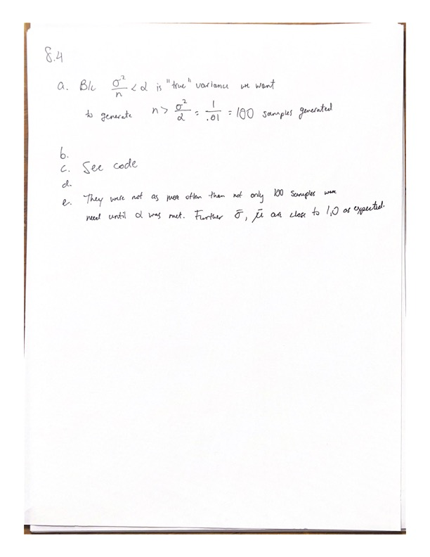

Number generated: 100

Sample mean: -0.009157738667097496

Sample var: 0.9824323963802654

Problem 5

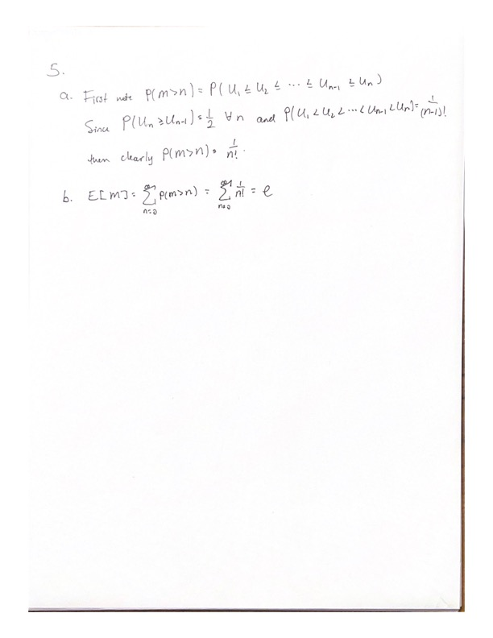

95% CI: [ 2.7179826765192265 , 2.818017323480773 ]

Problem 6

I couldn’t get my code to work properly

