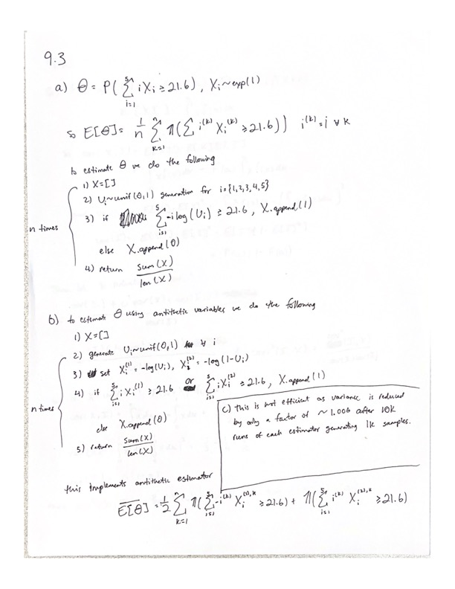

c.

Raw E: 0.038569, Antithetic E: 0.038298

Raw Var: 3.7e-05

Antithetic Var: 1.8e-05, Reduction over Raw: 2.0634

The use of antithetic variables is effective.

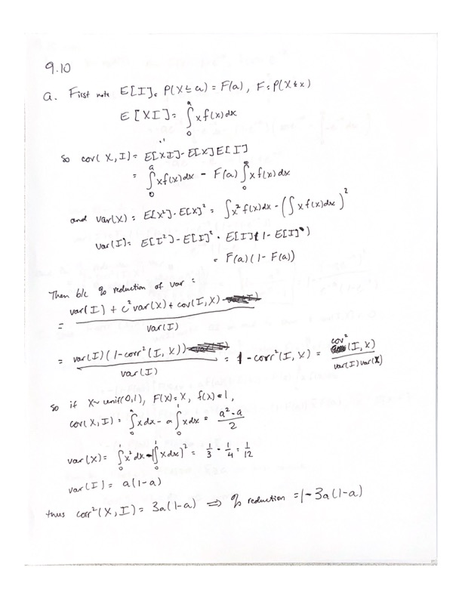

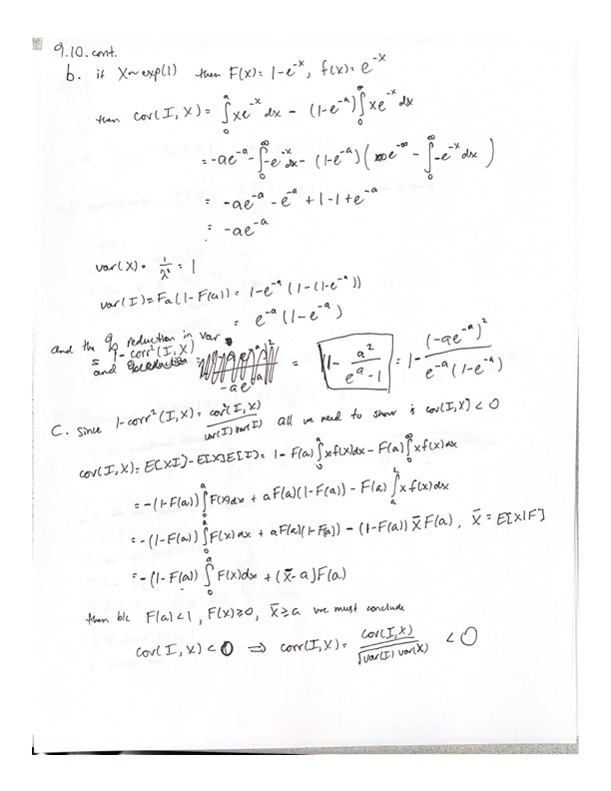

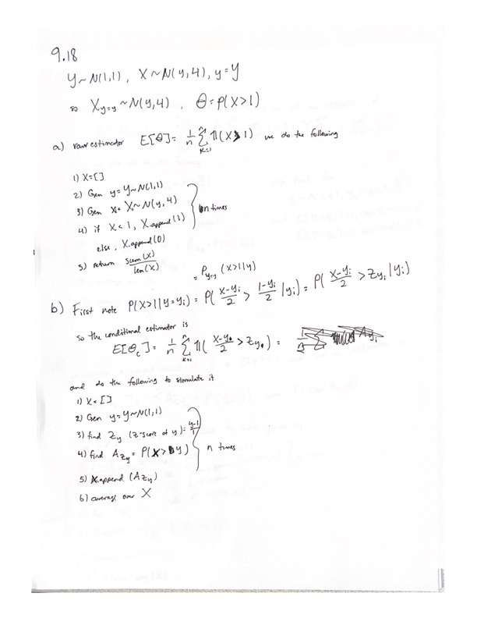

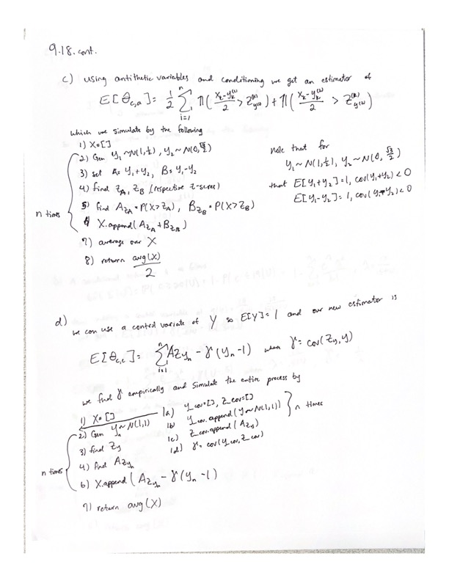

e) f) g) h)

Raw E: 0.50137, Conditional E: 0.498847

Conditional + Antithetic Var E: 0.499851, Conditional + Control Var E: 0.500073

Raw Var: 0.250001

Conditional Var: 0.083237, Reduction over Raw: 3.0035

Conditional + Antithetic Var: 0.041684, Reduction over Conditional: 5.9975

Conditional + Control Var: 0.003683, Reduction over Conditional: 67.8849

1. Exact value of θ = 0.5

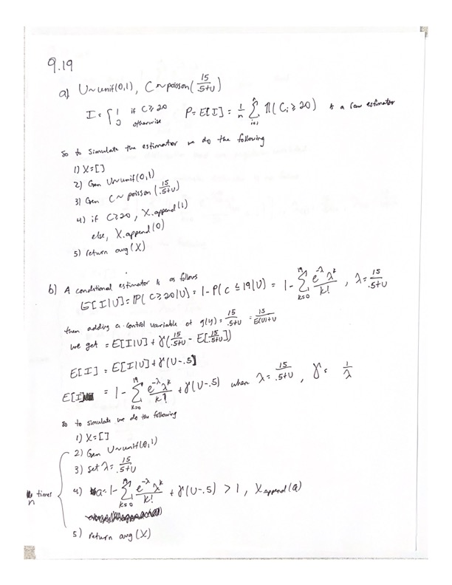

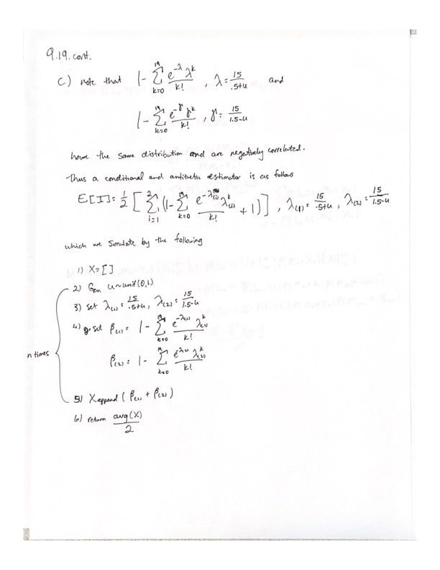

d)

Raw E: 0.29208, Conditional + Control Var E: 0.297733, Conditional + Antithetic Var E: 0.290481

Raw Var: 0.206771

Conditional + Control Var: 0.096605, Reduction over Raw: 2.1404

Conditional + Antithetic Var: 0.016109, Reduction over Raw: 12.8357

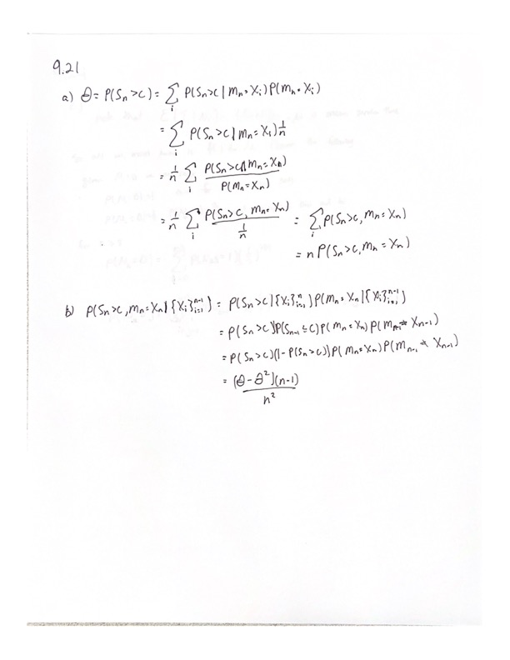

9.24

a), b), c), d)

Raw E: 35.75642 Antithetic E: 34.727933

Control of S E: 35.81240339742783, Control of S and I E: 35.810366

Raw Var: 356.785666

Antithetic Var: 76.625111, Reduction over Raw: 4.6562

Control of S Var: 76.625111, Reduction over Raw: 3.5848

Control on S and I Var: 76.625111, Reduction over Raw: 4.3727

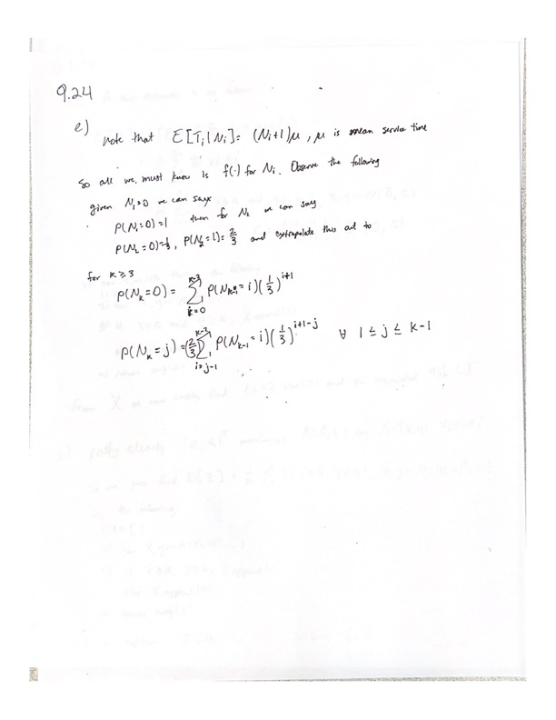

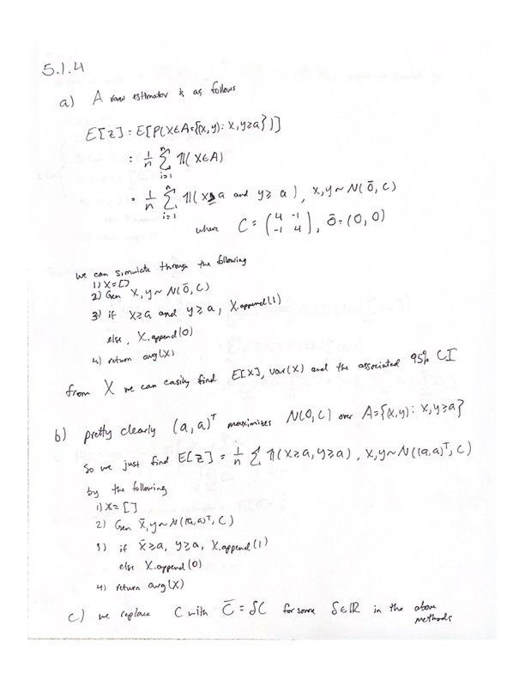

Crude MC simulation, a = 1

E: 0.06641, Var: 0.062000331903319036

95% CI: (0.06486670000476241, 0.06795329999523758)

Importance Sampling MC simulation, a = 1

Var: 0.01991542623748882

95% CI: (0.06422883527214322, 0.06597819105987184)

Crude MC simulation, a = 3

E: 0.00139, Var: 0.0013880817808178082

95% CI: (0.0011590803584807677, 0.0016209196415192322)

Importance Sampling MC simulation, a = 3

Var: 2.0454874191127908e-05

95% CI: (0.0013465624310992428, 0.0014026261302517906)

Crude MC simulation, a = 10

E: 0, Var: 0

95% CI: (nan, nan)

Importance Sampling MC simulation, a = 10

Var: 1.0093322023063004e-32

95% CI: (1.1200873995965199e-17, 1.244624975505494e-17)

Importance Sampling MC simulation, a = 1, delta = 0.001

Var: 3.5908585150546344e-294

95% CI: (6.386310202812891e-149, 8.735307354325856e-149)

Importance Sampling MC simulation, a = 1, delta = 2

Var: 0.039487006633100515

95% CI: (0.09565626437097965, 0.09811952547760372)

Importance Sampling MC simulation, a = 1, delta = 10

Var: 0.08920734914819273

95% CI: (0.14933945547357524, 0.15304185822852984)

Importance Sampling MC simulation, a = 3, delta = 0.001

Var: 0.0

95% CI: (nan, nan)

Importance Sampling MC simulation, a = 3, delta = 2

Var: 0.0007208506592266336

95% CI: (0.009701072039568772, 0.010033889416399955)

Importance Sampling MC simulation, a = 3, delta = 10

Var: 0.02263870018307892

95% CI: (0.06889521052734648, 0.0707603404399142)

Importance Sampling MC simulation, a = 10, delta = 0.001

Var: 0.0

95% CI: (nan, nan)

Importance Sampling MC simulation, a = 10, delta = 2

Var: 6.302214284788805e-18

95% CI: (3.848106698983523e-10, 4.159299775524978e-10)

Importance Sampling MC simulation, a = 10, delta = 10

Var: 9.539689167495977e-06

95% CI: (0.0008941180978331379, 0.0009324050200036513)

