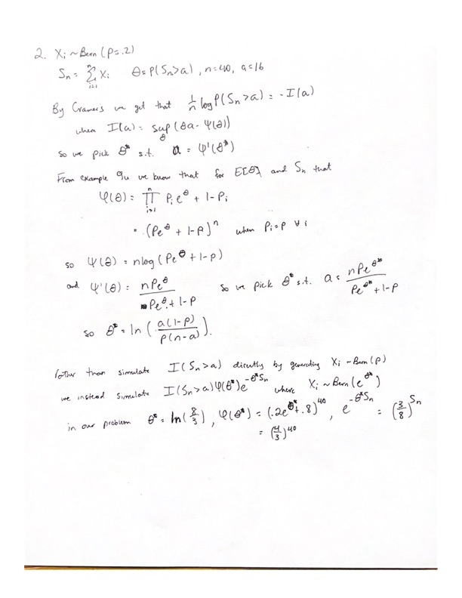Raw E: 0.002887. Tilted E: 0.002943

Raw Var: 2.9e-05. Tilted Var: 0.0

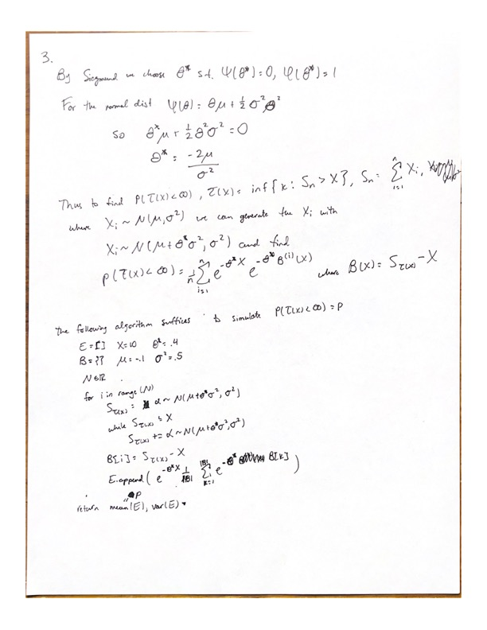

E: 0.015574615063278889, Var: 1.1624724272507568e-09

95% CI: (0.015574612068376651, 0.015574618058181127)

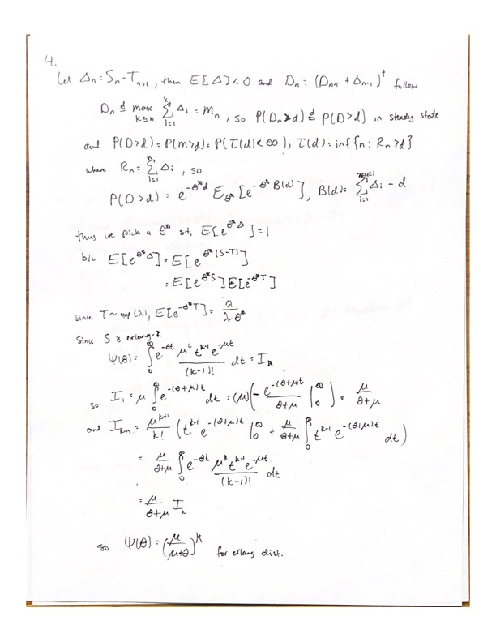

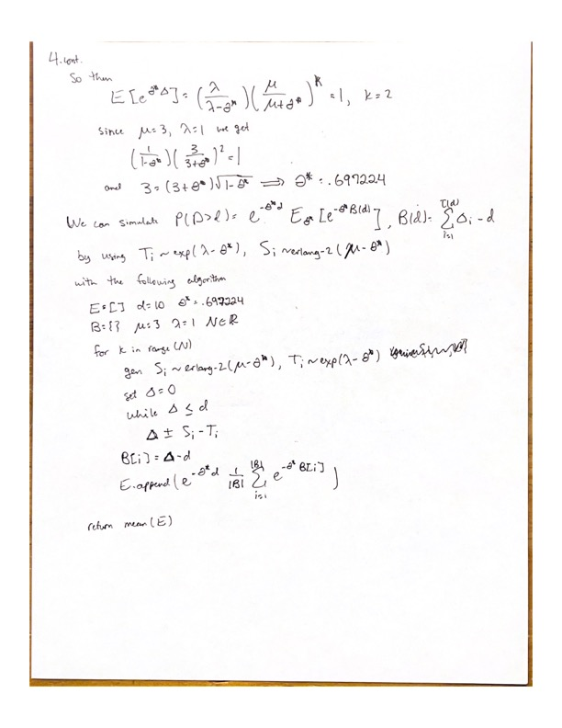

E: 0.005086344730696122