Brandan Haertel

Lab1 Report

# Shell.java

## Synopsis

While the program did not go as smoothly as I thought it would I eventually got it finished. I ran into some problems with my copy of ThreadOS being either incomplete or corrupted leaving me running around in circles for MANY hours before realizing it was not my code that was bad, it was the System...

## Testing

Testing of my Shell.java was done using ThreadOS on the UWB Linux Labs. my testing consisted of:

* PingPong abc 50
* PingPong abc 50 &
* PingPong abc 50 ; PingPong 123 50
* PingPong abc 50 & PingPong 123 50 &
* PingPong abc 50 ; PingPong 123 50 ;

## Algorithms

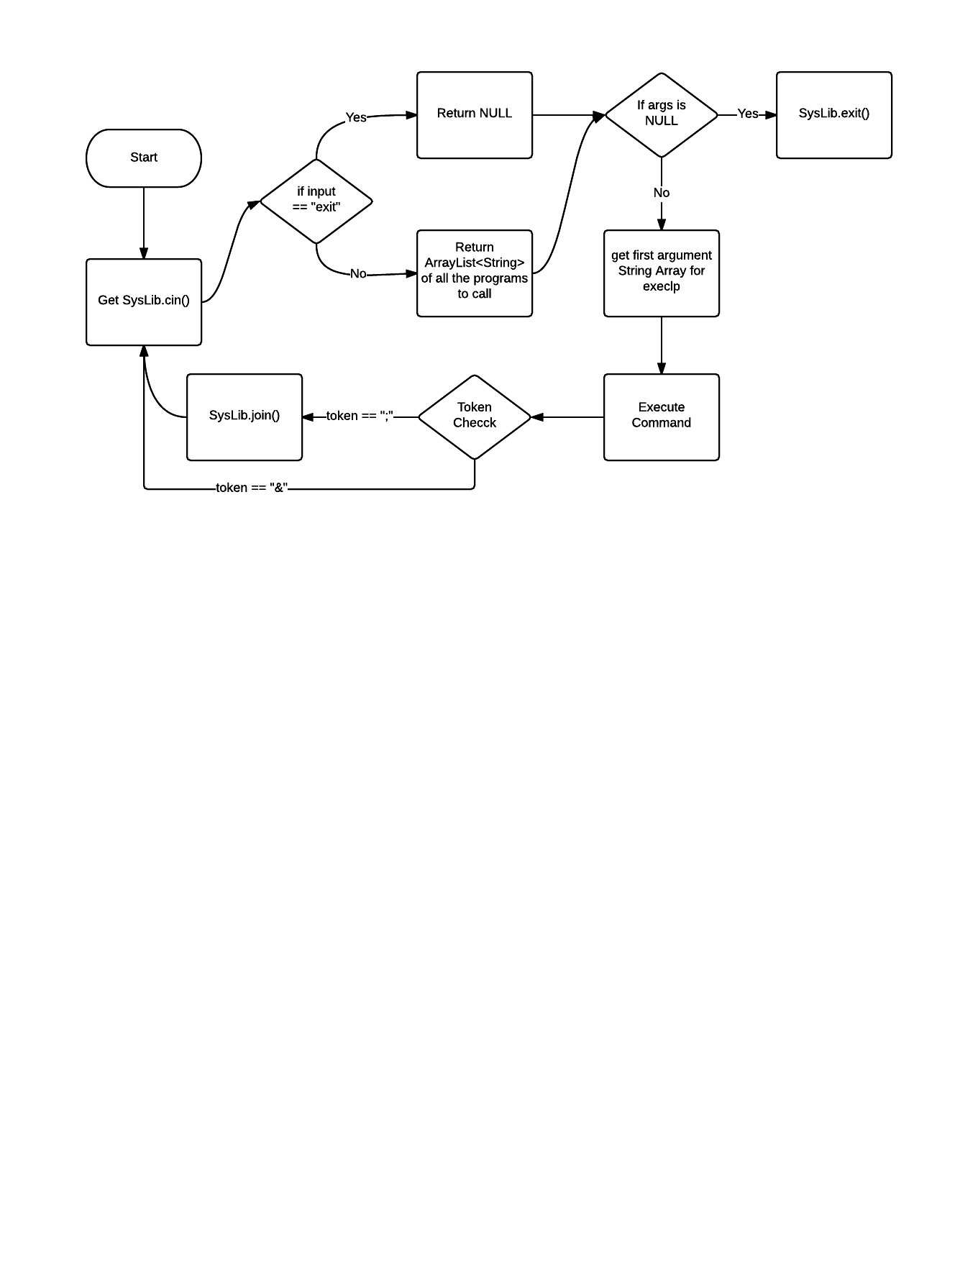

# 

# 

Brandan Haertel

Lab1 Report

# processess.cpp

## Synopsis

While I did not finish the project, I believe myself to be very close. I think I have an issue with my pipe file descriptors somewhere.

## Testing

while I could not perform much testing I did conclude that my overall structure was correct, and my execlp calls were correct. I could not test the dup2 calls.

## Diagram of Algorithm

