Main Supplemental File.

Figure S1. Number of snpEff annotations per SNV summed across all autosomes.

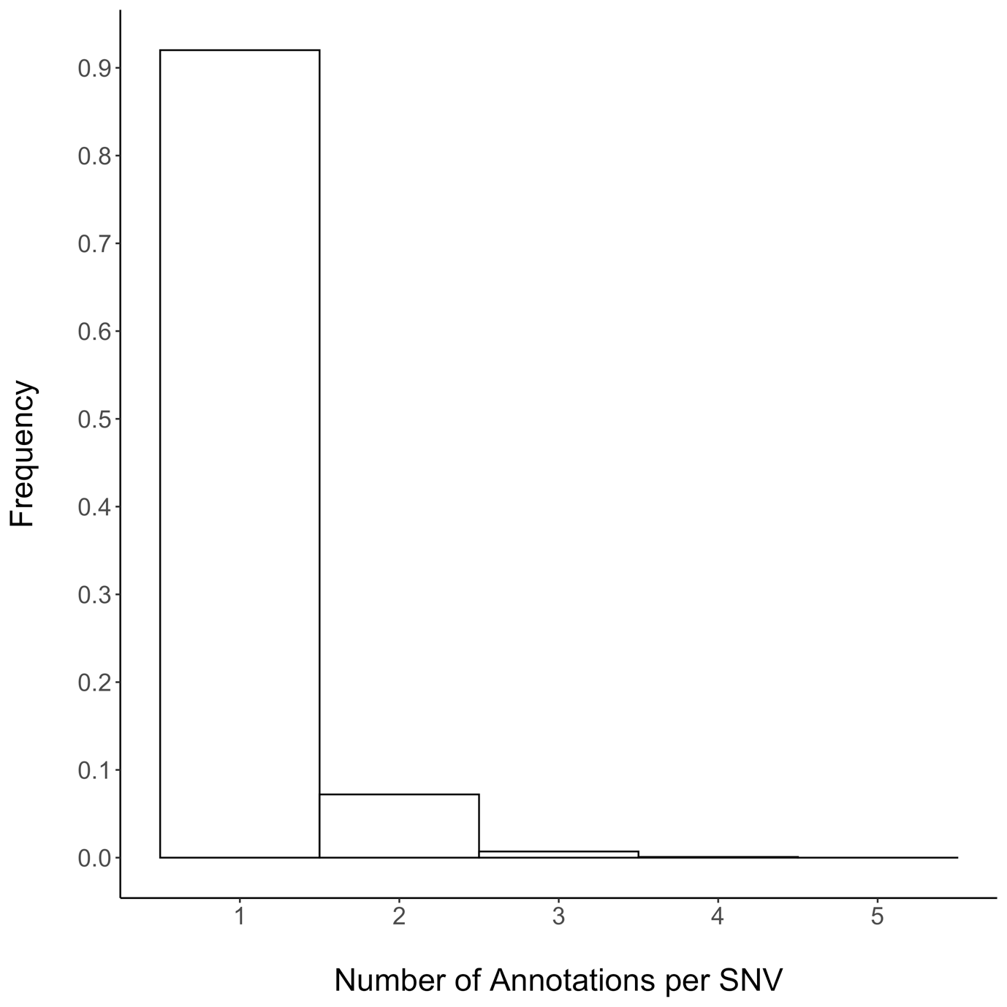

Figure S2. The rate of SNVs/bp per gene per lineage. The histogram represents the distribution of assessable genes and the dot plot displays the distribution of candidate genes under positive selection.

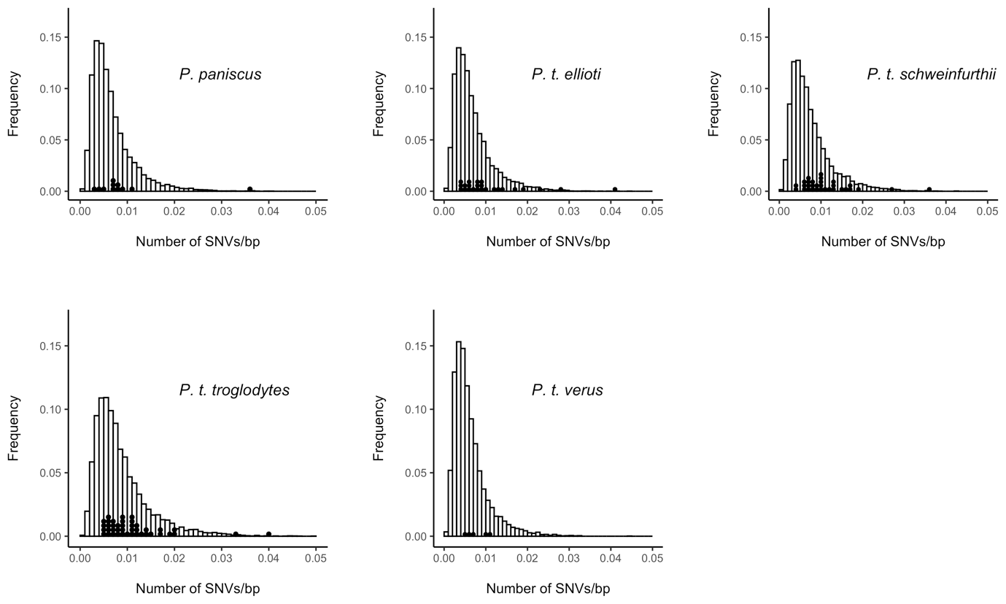

Figure S3. The rate of SNVs/bp per gene per lineage following MAF < 0.1 filtering. The histogram represents the distribution of assessable genes and the dot plot displays the distribution of candidate genes under positive selection.

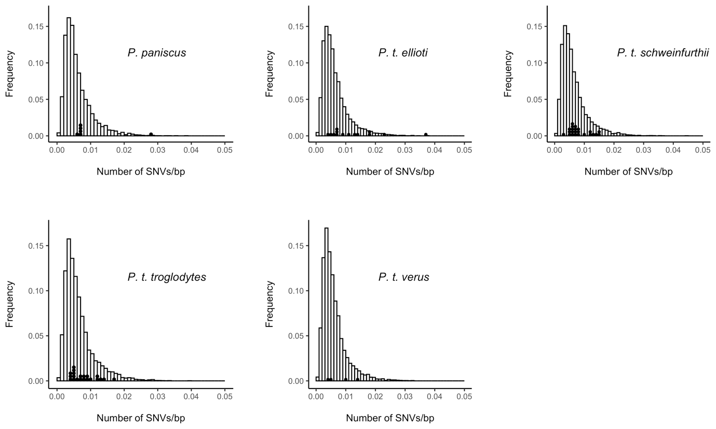

Figure S4. The rate of SNVs/bp per exon per lineage following MAF < 0.1 filtering. The histogram represents the distribution of assessable exon and the dot plot displays the distribution of candidate exons under positive selection.

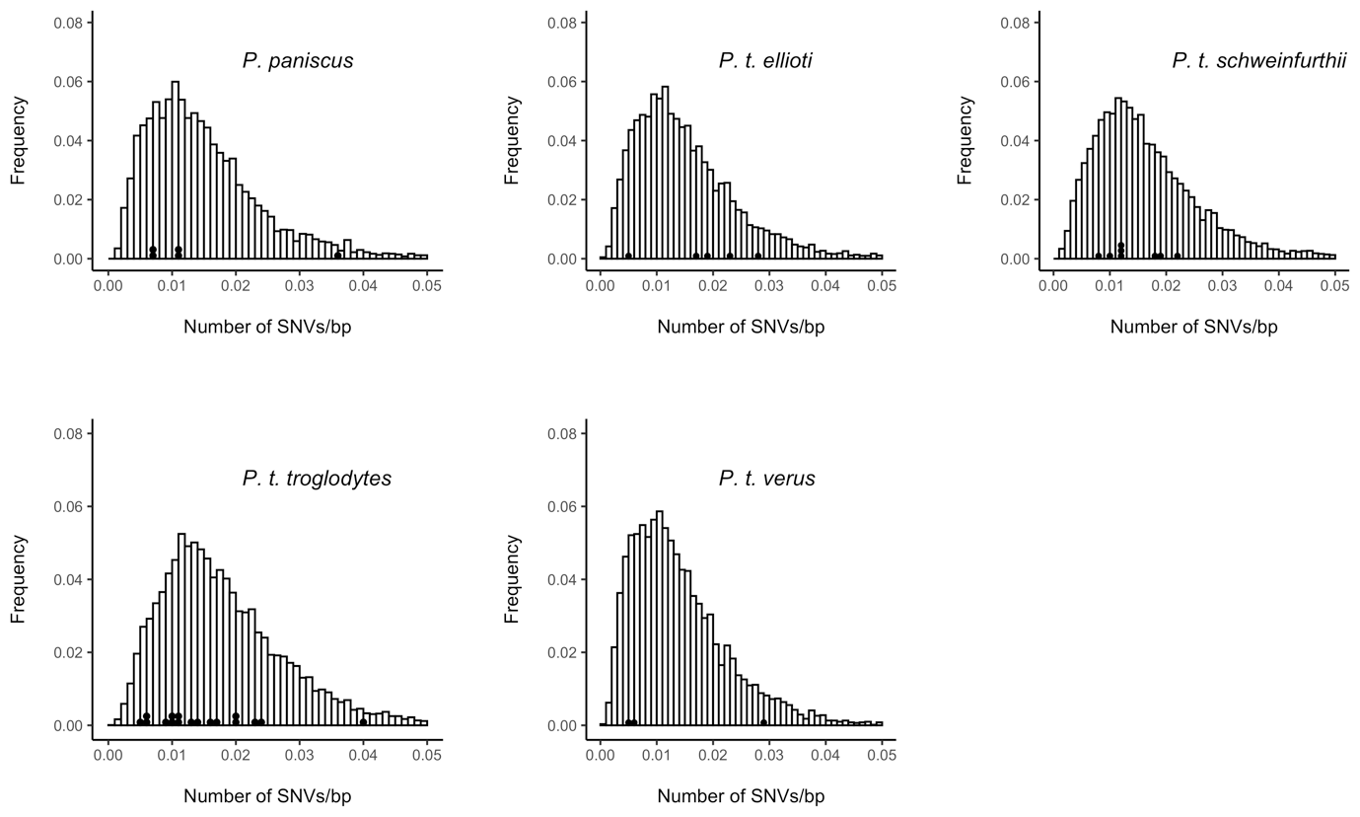

Figure S5. Upset plot of unique and shared candidate genes for positive selection without filtering SNVs with a minor allele frequency of < 0.1.

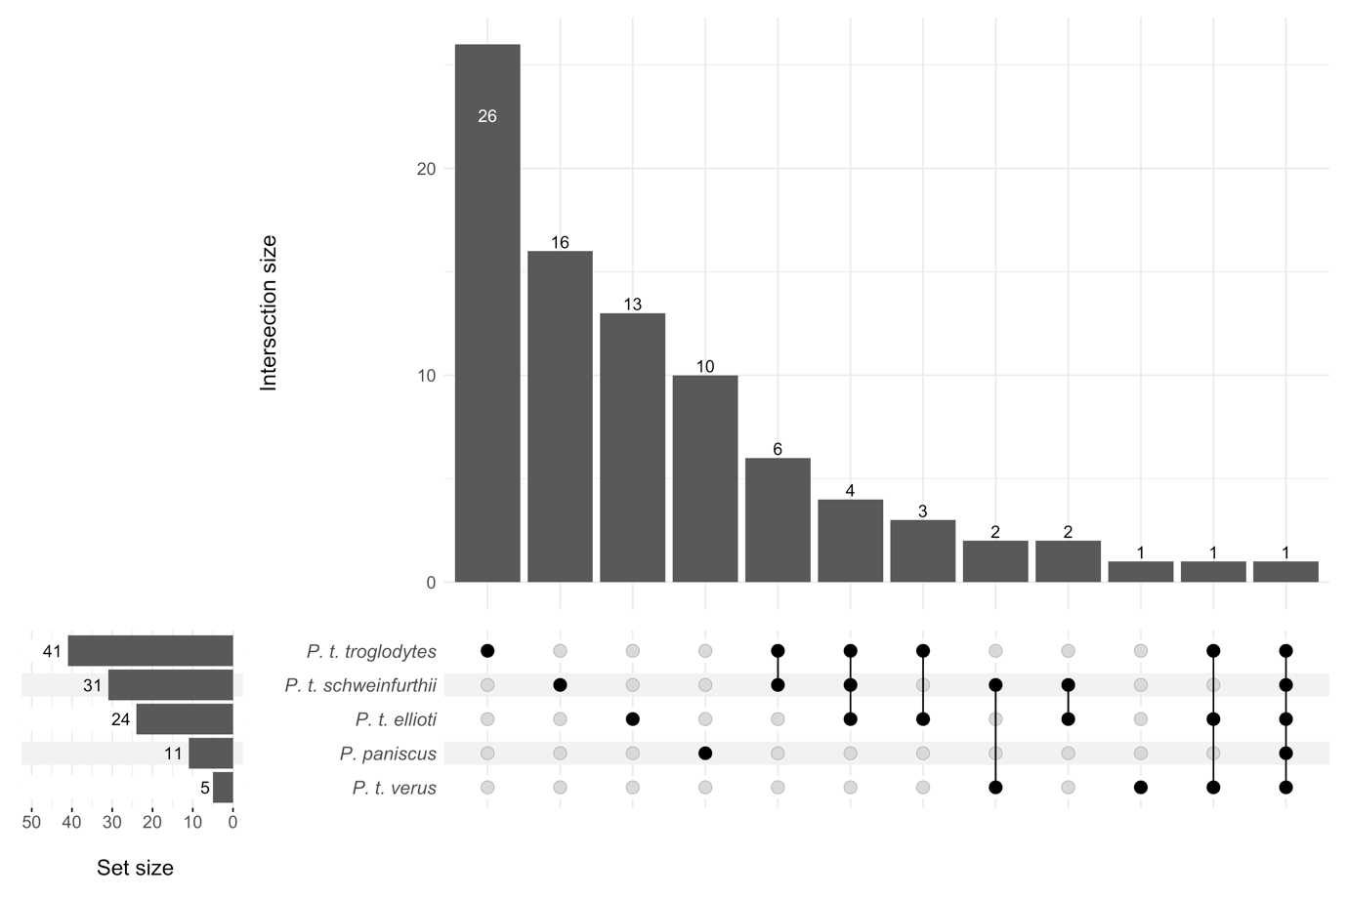

Figure S6. Upset plot of unique and shared candidate genes for positive selection after filtering SNVs with a minor allele frequency of < 0.1.

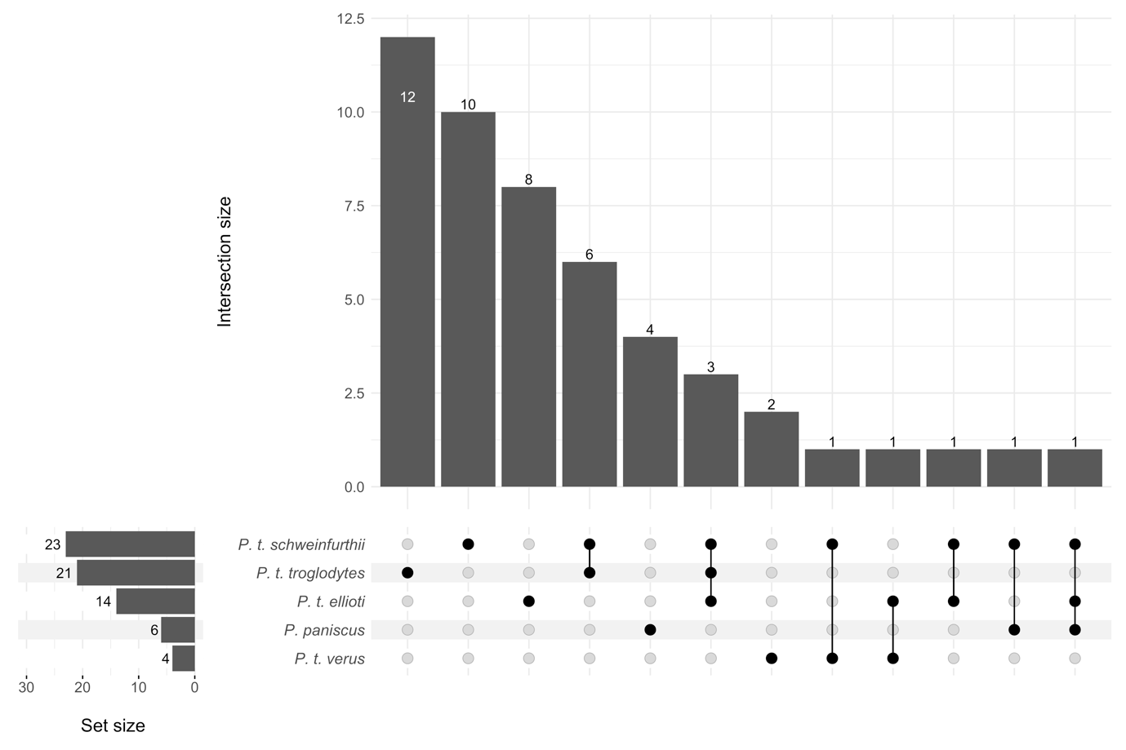

Table S1. Number of SNVs for analysis post filtering per chromosome.

|  |  |
| --- | --- |
| chromosome | SNVs post filtering (N) |
| 1 | 29505 |
| 2A | 10249 |
| 2B | 13470 |
| 3 | 18413 |
| 4 | 15397 |
| 5 | 13833 |
| 6 | 17773 |
| 7 | 15375 |
| 8 | 10413 |
| 9 | 11914 |
| 10 | 12852 |
| 11 | 21445 |
| 12 | 16094 |
| 13 | 7344 |
| 14 | 9967 |
| 15 | 9722 |
| 16 | 8232 |
| 17 | 12471 |
| 18 | 6192 |
| 19 | 17584 |
| 20 | 6082 |
| 21 | 3070 |
| 22 | 4385 |