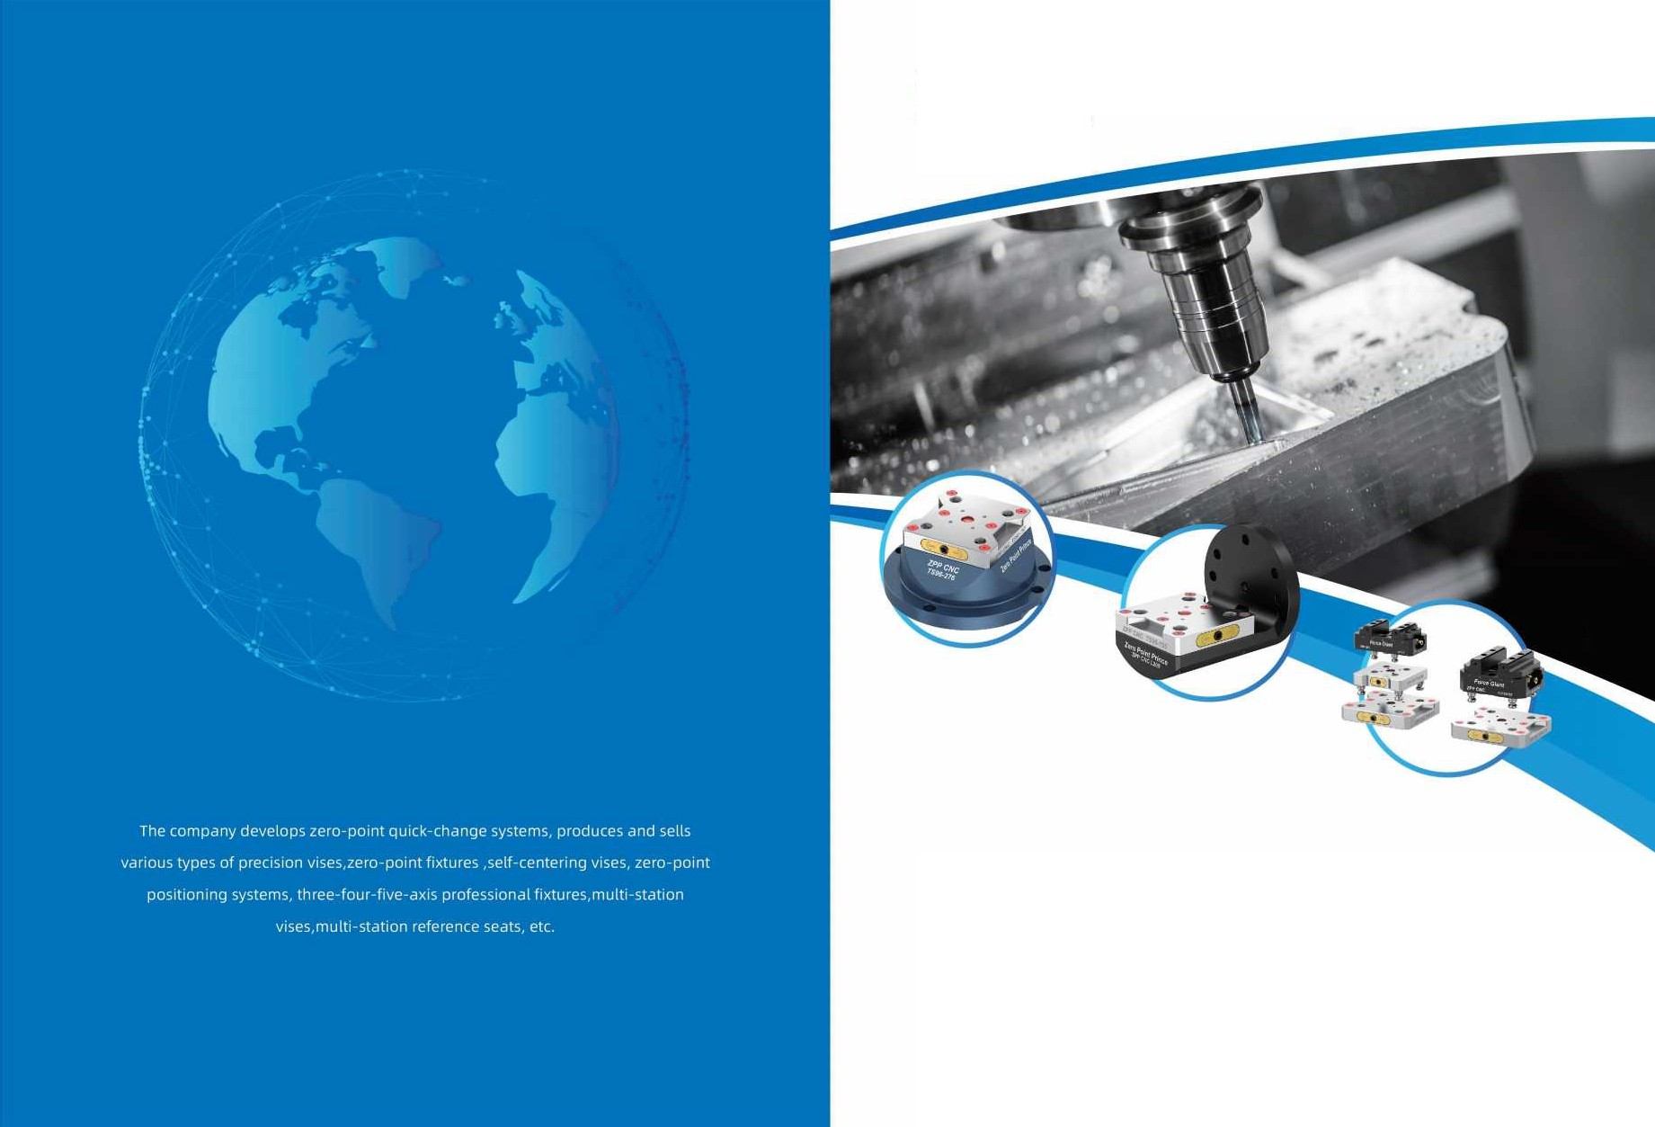
ZPPCNC
Zero Point Prince

ZERO POINT PRINCE
Vlnnovation Development· Cooperation • Vwin-win



ZERO POINT PRINCE �,,;1-.:Er ---
�
',I
,�
�/'
/�
..(
z
�,/✓
/.

CATALOGUE>>>

Introduction 03
Pneumatic zero point plate AR series 09
Manual Zero Point Plate 52 Series 10
Manual Zero Point Plate 96 Series 16
Self-centering vise 25
Pneumatic self-centering vise 30
ER Zero Point Chuck 32
4axis L Plate 34
Modular Combination 35
3 Jaws Series 37

Run out Tester 38



--- ZERO POINT PRINCE �.�IT ZERO POINT PRINCE �/;!i\IT ---


ZERO POINT PRINCE INTRODUCTION

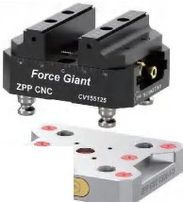
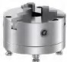
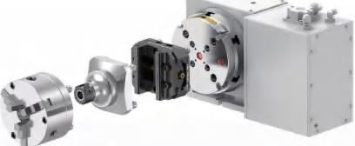
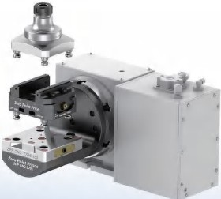

-- •

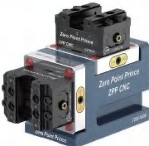
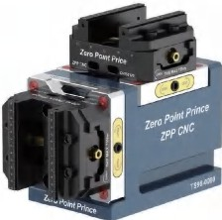
MODULAR INSTALLATION)))
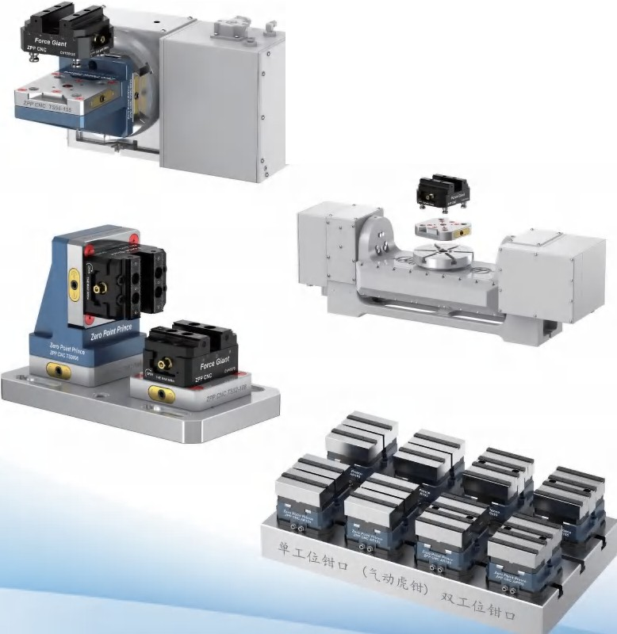
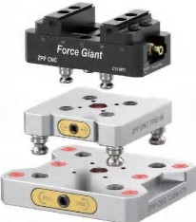
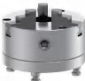
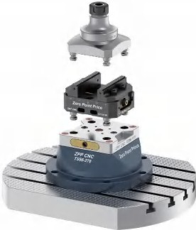
Three-axis, four-axis and five-axis high-precision zero-point fixtures can be compatible with quick-assembly L-bridge plates,self-centering vises, ER collet holders, three-jaw chucks, dovetail clamps, all kinds of self-made fixtures, etc to achieve quickchange and guick assembly, reduce the preparation time of the machine, and ensure extremely high precision in the repeatedclamping and changing processes of the product, which is an upgraded version of the traditional processing technology, and theproduct efficiency and quality are significantly improved
•
•
•
•
•



96MM/52MM HOLE SPACING ZERO POINT FIXTURE SYSTEM

ZERO POINT PLATE DESCRIPTION)))

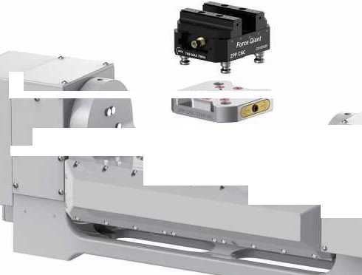
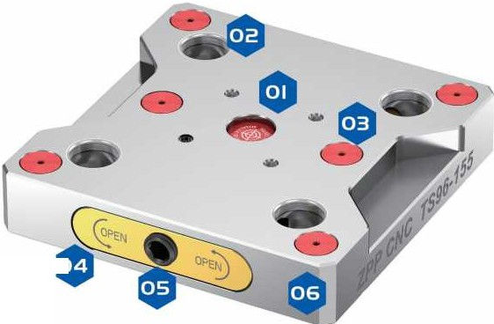
..
4
I>
I>
'--'
u
I>
--=,,o.
"
,.
u
i'
u
•
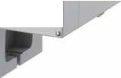
/..
"l
u
..

u
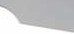

QAUICK OPERATION I FLEXIBLESWITCHING I PRECISE POSITIONING
- Datum holes $ Locating holes

THE ZERO-POINT QUICK-CHANGESYSTEM IS USED TO INCREASETHE CLAMPING STATION OF THE CNC MACHINE TO IMPROVE THE MACHININGCAPACITY AND REDUCEDOWNTIME
- Install dust cover • Cam


- Drive screw • Hardened stainless steel base



Pneumatic zero point plate Manual Zero Point Plate

AR52-108 ) ) )
Pneumatic Zero Point Quick Change Plate (Type 52)

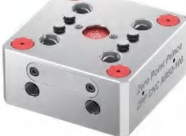
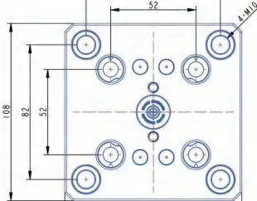
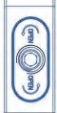
82
1552-120 >>>

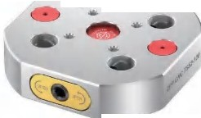
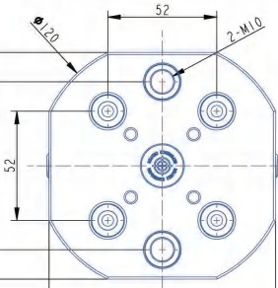
ge plate
Circular zero point quick-chan
-

Size: 108*1oa•somm
Material: Hardened stainless steel Weight: 3.3kg
Bolt: 4-Ml0
Locking force: l 2KN@7bar

AR96-155 )))

108

Size: Dl 20*25mm
Material: Hardened stainless steel Weight: 1.7kg
Bolt: 4-MlO Locking force: l BKN

1552-170 >>>
«> 0
� <X)

108 25
�O!

@OI
50

Pneumatic Zero Point Quick Change Plate (Type 96)
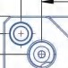
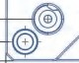
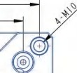

128
96
0
0
0
0
,-,.,
~-<X)
<D
a,
�
0
0
0
0
®�
155
25

55
Circular zero point quick-change plate

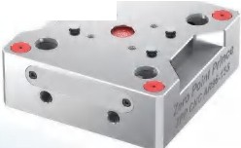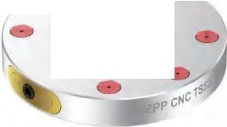
- -••
--
-•

Size: 1ss•1ss•ssmm
Material: Hardened stainless steel Weight: 7.9kg
Bolt: 4-Ml0 Locking force: 22KN
Size: Dl 70*2Smm
Material: Hardened stainless steel Weight: 3.7kg
Bolt: 6-MlO
Locking force: l 8KN@7bar

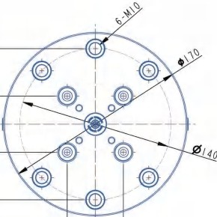
52



ZERO POINT PRINCE �//i\.3:-r ZERO POINT PRINCE �//i\.3:-r




Manual Zero Point Plate Manual Zero Point Plate
25

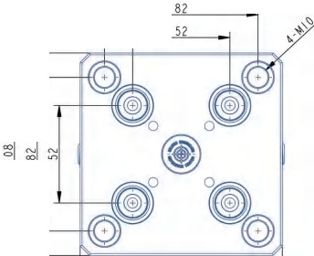
1552-108 >>>
Square zero point quick-change plate

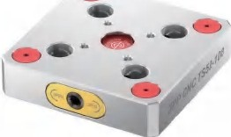

Size: 108*108*25mm
Material: Hardened stainless steel Weight: 1.9kg
Bolt: 4-Ml0 Locking force: 78KN

1552-96)))


52mm to 96mm Conversion plate
52
�--®
I I
I
®
,
-
---�--- -
�---·® I @
© I ©

125
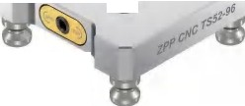
-
...
-
•
•
·•

Size: 125*125*25mm
Material: Hardened stainless steel Weight: 2.5kg
Bolt: 4-Ml0 Locking force: l 8KN

108

� I
25
1552-210 >>>
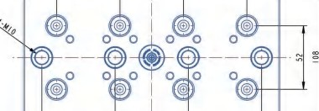
Multi-station zero point quick chgange plate

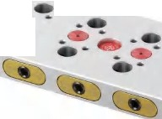
·- -•
. -
-
-
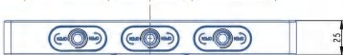
Size: 210*708*25mm
Material: Hardened stainless steel Weight: 3.6kg
Bolt: 4-Ml0 Locking force: l BKN

lA52-108)))
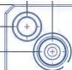
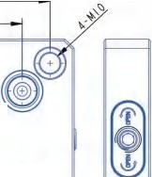
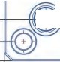
Square zero point quick chgange plate (aluminum)
52
.,
0
0
-= .",' .",.',
0
@)
�
�
�
108
5

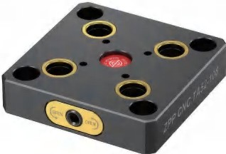

Size: 108*708*25mm
Material: Hardened aluminium+ ring Weight: 1.7kg
Bolt: 4-Ml0 Locking force: 77KN

10

82





Zero Point Pyramid Zero Point Workholding

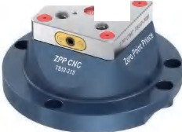
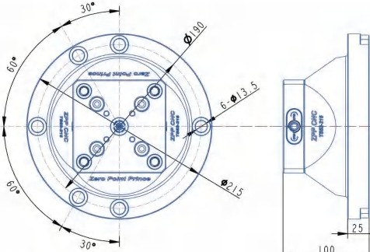
TS52-215 )))
ero Point Tower (Type 52)
-
•
•
. --
Z

Size: D275*100mm
Material: Aluminum+ hardened stainless steel Weight: 6.8kg
Bolt: 6-M12
Locking force: 18KN

TS52-9052)))


0-90° Zero Point Workholding (Type 52)
108
0
�@
0�
0
@�
�
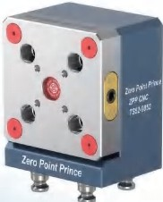

Size: 130*7 08*87 mm
Material: Aluminum+ hardened stainless steel Weight: 4.3kg
Locking force: 78KN
Locking method: 52pull studs

TS52-0090)))
0-90° Zero Point Workholding (Type 52)
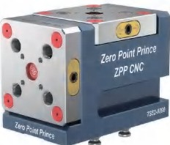
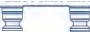
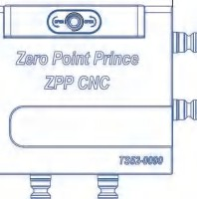
108
@@@
0
0
@
@a
@ @
0
0
�-
@
-
@
-
�
Z-N!fl'Wnce
176
Size: 176*137*108mm
Material: Aluminum+ hardened stainless steel Weight: 8.8kg
Locking force: 78KN
Locking method: 52pull studs

TS52-9096)))
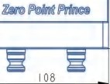


90° Zero Point Workholding (Type 52)
�@
0�
0
@
@
0
0
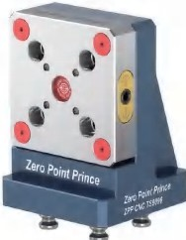
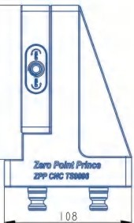
Size: 154*108*108mm
Material: Aluminum+ hardened stainless steel Weight: 4.2kg
Locking force: 1BKN
Locking method: 52pull studs

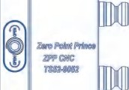
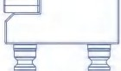
81





Zero point Rotation Base Manual Zero Point Plate

TS52-120R)))
0-90° Zero Swivel Seat (Type 52)
@ ®
0 0


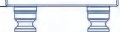
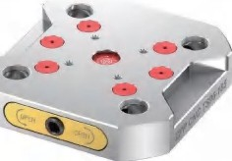
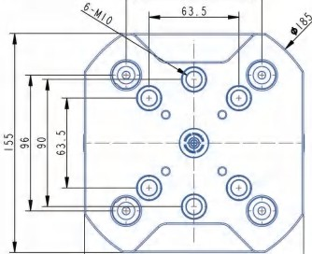
.•-
105
I
K
I
l'Mol"o!nfMlo.
Zl'PCl'4C
TSQ.fMt
,-..
'r 0 J;
"--"
30

TS96-185)))
Circular zero point quick-change plate

96

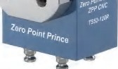
•• @ �:!,
0 0
® @
0
0-

� IP'@6Ufla�


Size: 760*720*70Smm
Material: Aluminum+ hardened stainless steel Weight: 7.2kg
Locking force: l 8KN
Locking method: 52pull studs

iiJ0-90flAtff iiJ0-90fl.ff
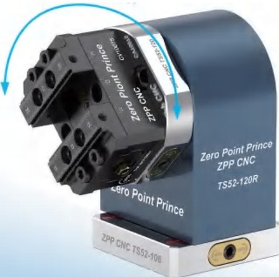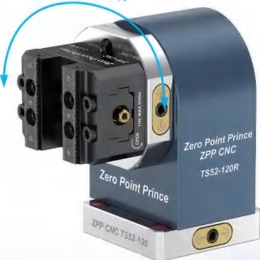
Size: Dl 85*30mm
Material: Hardened stainless steel Weight: 4.4kg
Bolt: 6-Ml0 Locking force: 22KN

TS96-200)))
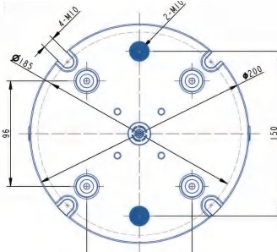
Circular zero point quick-change plate

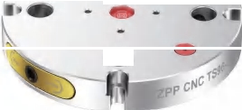
-
-

Size: D200*30mm
Material: Hardened stainless steel Weight: 6.5kg
Bolt: 2-Ml0 Locking force: 20KN

155

96

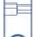

'i'
0
�

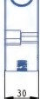





Manual Zero Point Plate TS/TA96 Series

1596-155 >>>
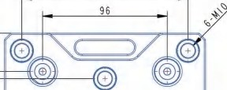
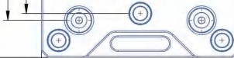
Square zero point quick-change plate

128

1596-340)))
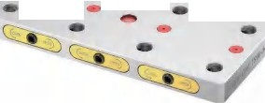
Multi-station zero point quick chgange plate
-- -

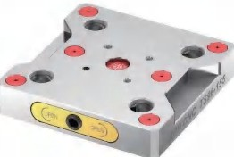
Size: 155*155*30mm
Material: Hardened stainless steel Weight: 4.8kg
Bolt: 6-Ml0 Locking force: 22KN

.,,
.,,

<D .,,
� 00

0 0

�
0 0

I 55

Size: 340*155*30mm
Material: Hardened stainless steel Weight: 11.2kg
Bolt: 4-Ml0
Locking force: 22KN

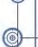

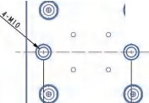
I
96
,o
96
I
96
@
I I
@
@
0 0
- �= -
�
0
0
0
11 <�0 ➔) <�$➔) <�0 ➔) 11 1
r--,
tr
0
JJ
'--'
30

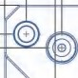
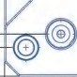
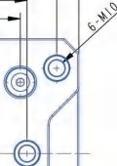
1596-175 ) ) )
Rectangular zero point quick-change plate
-I= ,I@,.,
i'o
I- I
,_ I
,_ I
I=
30

175
145
105
96

I
I I
o I o

lA9652-155) ))
Square zero Point Quick Change Plate (Aluminum)
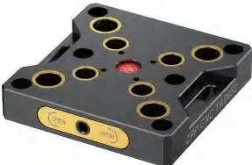
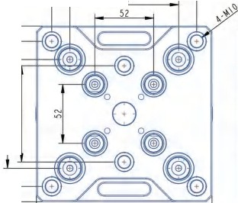
96

'i'
0
J.,

..r, (l0 CD ..r,

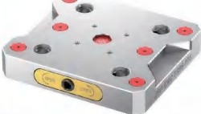
Size: 175*155*30mm
Material: Hardened stainless steel
�--♦-
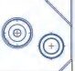
0 I o
I
I
I

Size: 155*155*30mm

..n �

('I> ¢0

Weight: 5kg Bolt: 6-Ml0
Locking force: 22KN
I
175
Material: Hardened aluminium+ Hardened steel ring Weight: 2.2kg
Bolt: 4-Ml0
Locking force: 78KN
155 30




TS96 Series  T096 Series
TS9652-155 } } ) TO96-200)})

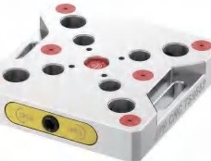
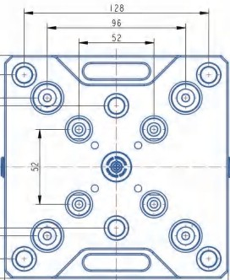
Compatible Zero point quick change plate
,,.......
'i'
0
JJ
"-"
,o

Thruogh hole zero point quick change plate
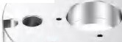
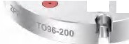
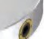
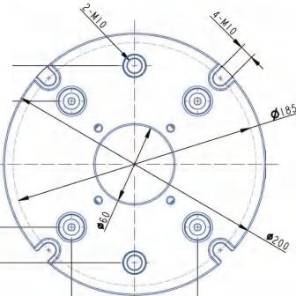
-
- -
30

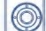

Size: 155*155*30mm
Material: Hardened stainless steel Weight: 4.6kg
Locking force: 20KN

TS9652-200)))
Compatible Zero point quick change plate

155
Size: D200*30mm
Material: Hardened stainless steel Weight: 6.2kg
Locking force: 20KN

TO9652-200)))
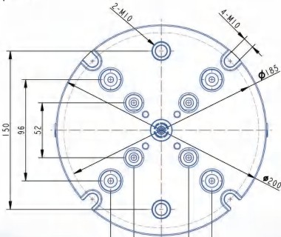
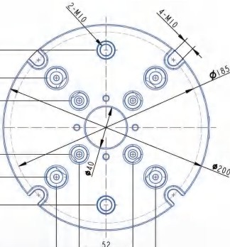
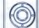
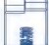
Thruogh hole compatible Zero point quick change plate
.0,.,�"' :;:; -

96

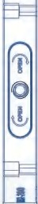
I I
•
-
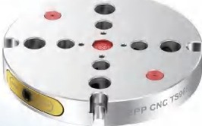
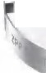
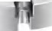
• •
·-
----
'165-2-200

Size: D200*30mm
Material: Hardened stainless steel Weight: 6.4kg
Locking force: 20KN

52
96
Size: D200*30mm
Material: Hardened stainless steel Weight: 6.4kg
Locking force: 20KN

96 30




TS96-276)))
Zero Point Tower (Type 96)
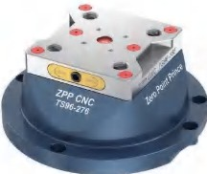

Size: D276*120mm
TS96 Series TS96 Series


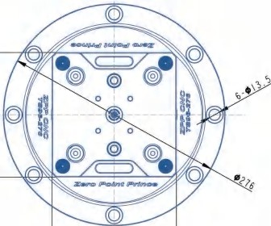
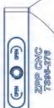
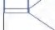
TS96-9690)))
25
120
0-90° Zero Point Workholding (Type 96)
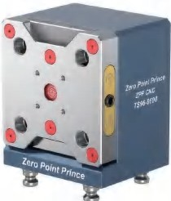


155
130
fj'
0
)
0 | •0
0 | •0
 | ~0

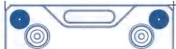

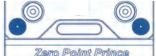
155

Material: Aluminum+ hardened stainless steel Weight: 15kg
Bolt: 6-Ml2 Locking force: 22KN
Size: l 80*155*130mm
Material: Aluminum+ hardened stainless steel Weight: 12.8kg
Locking force: 22KN
Locking method: 96pull studs

TO96-276)))
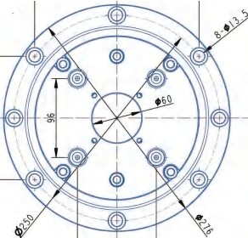
Thruogh hole Zero PointTower(Type 96)

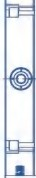
100 100
25
I 0

TS96-0090)))
0-90° Zero Point Workholding(Type 96)

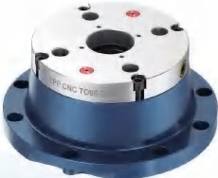

Size: D276*D60*120m m
Material: Aluminum+ hardened stainless steel Weight: 15.6kg
Bolt: 6-Ml2 Locking force: 20KN

I
I
II (�O➔) II
� IJ!>@luvi IM�
ilW1©U!J©
�
(
TIIII-
96

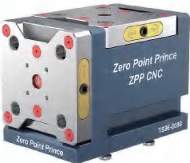


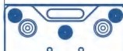
Size: 241*181*755mm
155
00
Material: Aluminum+ hardened stainless steel Weight: 24kg
locking force: 22KN
Locking method: 96pull studs
241




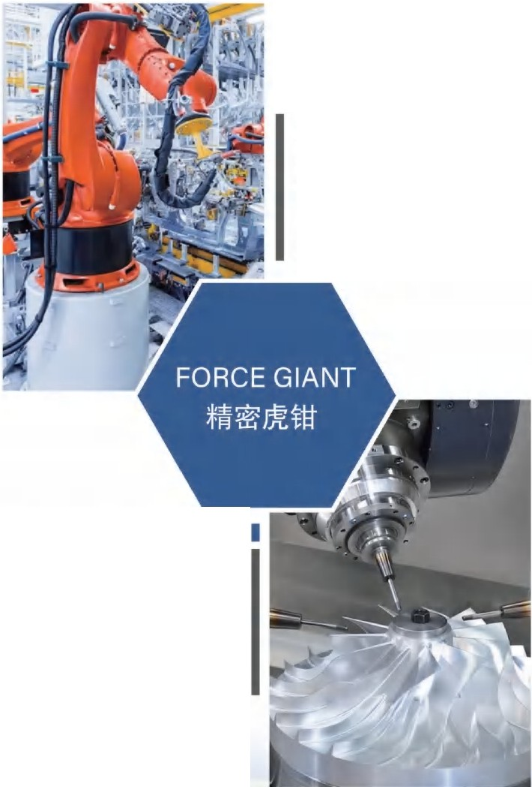
TS96 Series
MACHINING
I
The self-centering and no correction can significantly improve themachining accuracy and efficiency, ensuring that the center of theworkpiece and the jaw center coincide perfectly when clamping theworkpiece, thus effectively avoiding the problem of machining error andworkpiece offset, The high precision makes the self-centeringvise havea wide range of applications in the field of precision machining,especially in the case of extremely
high machining accuracy
MACHINE TOOL MACHINING
It is applied to different types of machining centers such as three-axis, four-axis, and five-axis, and can also be adapted to vertical, horizontaland other processing methods. lt is a precision clamping tool, compactstructure, can be used with a variety of modular jaws, suitable forclamping workpieces of various shapes and sizes, quick and simpleinstallation and use, accurate positioning, wide clamping
range, andimprove processing efficiency

1596-9096)))
90°Zero Point Workholding (Type 96)


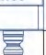
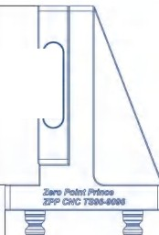
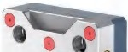
....
@
0 0
0 0
@
0
0
@ ( ) @ ~-
� /fl@6UilU ffeifl6�
@
(@)
....
155
'i' 0 J.,
155
•
•
�
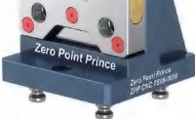
-
•
•

Size: 200*755*155mm
Material: Aluminum+ hardened stainless steel Weight: 9.4kg
Locking force: 22KN
Locking method: 96pull studs


DW-1)))

DW-1 Series
55
47
-
11,_
�
r--,_...,
0
40
00
$
00
$

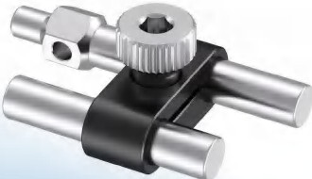
Size: 55*8mm
Material: 304 stainless steel +aluminum
ognr--------11□1 - -

Features: The positioning length and angle can be adjusted



ZERO POINT PRINCE �,'!i(.:E:T ZERO POINT PRINCE �,'!i(.:E:T

Vise description)))
Self-centering vise


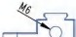
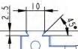
SV10075 )))
0
Zl'f'C#C (D) (D) 1Ytl071
/?@ff[J1}[] ffe>t;U[J1}©@
�
75 Self-Centering Vise (Economy)

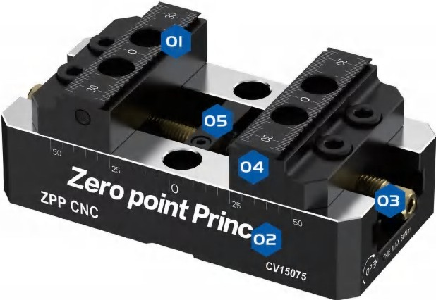
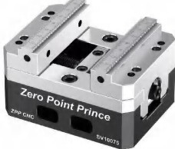
Size: 100*75*62mm Material: Hardened steel Weight: 2.6kg
Clamping force: 14KN@60Nm
Maximum torque: 60Nm
@I 2sjn I0--�
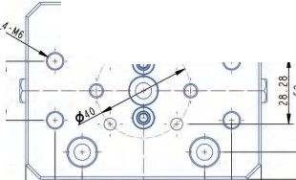
•0 • •0-....-;:>\r-ll---r
�~

52

Forward and reverse clamping: 0-46/45-S0mm
1
100

045° dovetail jaws

$ Visebase

SV150100)))
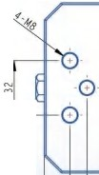
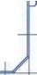
100Self-Centering Vise (Economy)
�
14
_/if
-
�"
~
x�<C
(
r
l
) �
�
AY1111N
�
6=:i)
� ffe>@6tm ffilf6fM:$
--
Q I

- Drive screw
- Locator mounting holes

Size: 1S0*100*76mm
@) 0
+
;

·0·
·0·

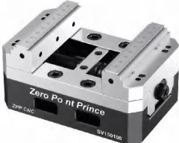
�~ :0 ::

- Screw retainers

Material: Hardened steel Weight: 5.5kg
Clamping force: 20KN@75Nm Maximum torque: 75Nm

Forward and reverse clamping: 0-80/57-120mm
@ 0
0 0

52
100
I 0
150

26///////.



Self-centering vise CV Series

SV170130)))
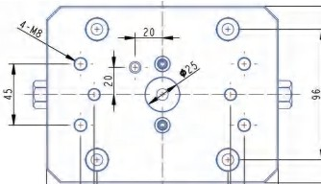
130 Self-Centering Vise (Economy)
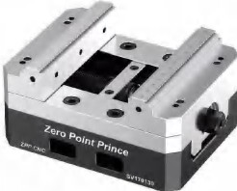
Size: 17O*13O*85mm Material: Hardened steel Weight: 9.3kg
Clamping force: 25KN@8ONm Maximumtorque: 8ONm
Forward and reverse clamping: O-86/71•152mm

CV10075 )))
75 self-centering vise (short)
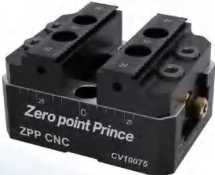
Size: 100*75*56mm Material: Hardened steel Weight: 2.3kg
Clamping force: 14KN@6ONm Maximum torque: 6ONm
Forward and reverse clamping: O-41/41-76mm

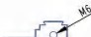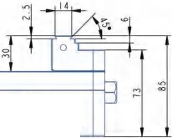

�afPJolrn(/a/Rrw:.e.......

170
96
100 120

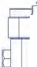
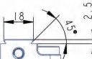
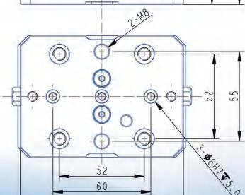
100
0
,.
0
,.
� lfiJIJ@f'Ofl !fiJo'IIl!D©®
�w�11-0� I <Mom
CV15075 )))
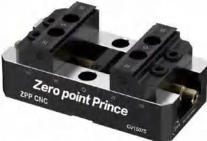
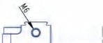
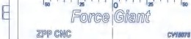
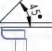
75 self-centering vise (long)
0
',-+,-�"'T"T"m"T"T"h"T..,......,l'"TT+r-,,--..,._,L...-.-.,, -
.,.,,,, ."..", .",',
...,
N

I
l
!<>
'
®
-0
'
'
�,o.OI��
""
� - @' )-
@) s
@)-0
..,,,, .~,,
�
�
�-
130
150
I
'
'
I
52
100
I
'

"'

Size: 15O*75*56mm Material: Hardened steel Weight: 3kg
Clamping force: 14KN@6ONm Maximum torque: 6ONm
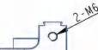
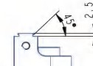
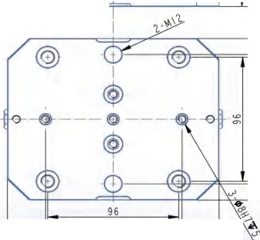
Forward and reverse clamping: O-9O/41-126mm
� ..................,"TT"T"T-+.,..,..,"T"T"...................-1-----.
- • 0
?l®tr@ IP@ffi fl1Po'61lil©®
,._ ,._
� ,,..
Zll't'CMC(cj) (cj)cwm21
100
155
0

0 .,.,
0 N

CV155125-I )))
125 self-centering vise (short)
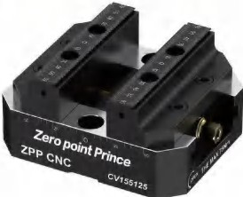
Size: 755*125*74.4mm Material: Hardened steel Weight: 7kg
Clamping force: 2OKN@75Nm Maximum torque: 75Nm
Forward and reverse clamping: 0-76/56-127mm




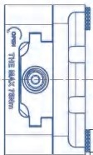
CV155125-II )))
l 15
74 I

CV Series TB Series


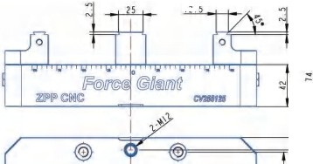
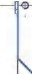
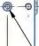
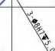
TB255125 ) ) )
I .
'
-@
$ •
0
'
-(l)--{@}==!==,,k,==4...-1.
96
255

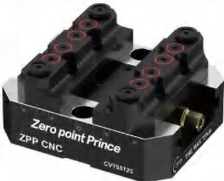
125 Self-Centering Vise {Clamping Cylinder)

I
/ �
.., 0
"' 0-
�'-
e
'-�-t- ---@
-.::di
©
0·
I
'
®
--
'e
, ""
✓
ih
142
�-:�
/
155
100
I
96
'\. '

Size: 7 55*125*74.4mm Material: Hardened steel Weight: 7kg
Clamping force: 20KN@75Nm Maximum torque: 75Nm
Forward and reverse clamping: 0-76/56-127mm
Double-station self-centering vise (long)
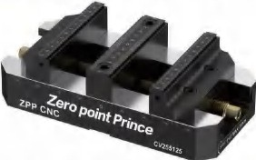
Size: 255*125*74.4mm Material: Hardened steel Weight: 9.6kg
Clamping force: 20KN@75Nm Maximum torque: 75Nm
Forward and reverse clamping: 0-74/32-110mm


AV Series

CV255125 ) ) )
125 self-centering vise (long)

_....,.,_,.,.....,.,...........,,......,.+,-,,...........,.,,.......,....,..,_.,. ._.-,-.,.. -"'.

AV0166)))
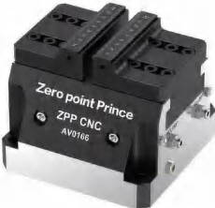
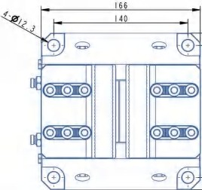
Pneumatic self-centering vise

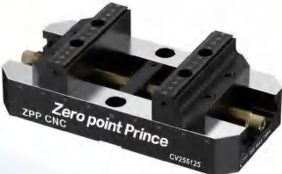
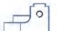
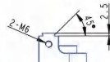
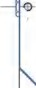
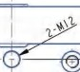
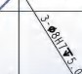
t¼®ll@ IP@8/ro(l /flWl!iJ@®
�� !Cli>i!IC I MIIIIJ
�- �

Size: 255*7 25*74.4mm Material: Hardened steel Weight: 9.8kg
Clamping force: 20KN@75Nm Maximum torque: 75Nm
@)
-@ @ -<l)
@)
0 .(i) Jl@======j,�:=L.l.

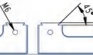
Size: 160*160*738mm Material: Hardened steel Weight: 19kg
..,
0
-
Clamping force: 20KN@7bar
Maximum torque: 75Nm

Forward and reverse clamping: 0-177/56-228mm
Forward and reverse clamping: 0-50/l 25-l 60mm Features: Lt is not locked by air pressure, and is self-locking





AR Series ER zero point chuck

�
74.5
,_;
-₋
-•
L_
�

111 I I
�
.~,,
-
00
I
I
l I
J
II
11
I I
I I
' t11
AR155-I )))
Single station Pneumatic vise
TS52-ER32))) 4 . 5
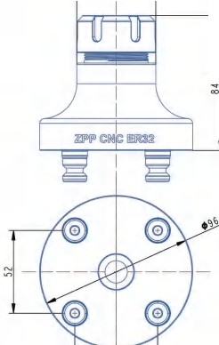
ER zero point chuck
00

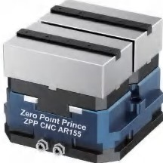

Size: 1SS*l55*126mm
Material: Aluminum+ hardened steel Jaw width: 130mm
Clamping range: 13O*145mm
Clampingforce: 8-1OKN@6-7bar Weight: 9.0kg

AR155-II )))
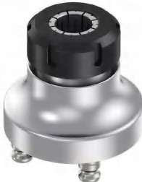
Double station Pneumatic vise

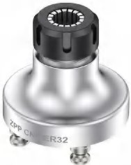
Size: D96*84.8mm Material: Hardened steel Weight: 2.1kg
Clamping range: 2-2Omm

TS52-ER40)))
ER zero point chuck

52
...
L-
I I
11 11
I
�---
11
.�,
I
l I
11
I
I I
' tll
I
J
- -
!":':
-
--
39.5
69
39.5

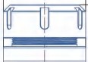

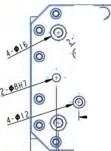
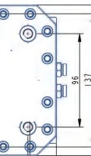
....
�.-�1
@..., •.
'-
. .
@ E)
@ .
52 , I
·@)
@-0
96
100
155
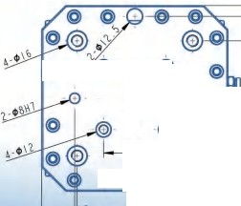
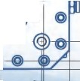
00
@
@-��
=0
"' ��
ffi
0
0..J..
@0
I 00
96

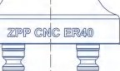

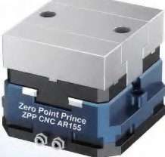
Size: 155*155*7 26mm
Material: Aluminum+ hardened steel Jaw width: 130mm
Clamping range: 13O*65mm Clampingforce: 8-1OKN@6-7bar Weight: 8.5kg

Size: D96*83mm Material: Hardened steel Weight: 3.5kg
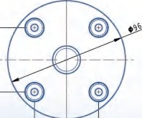
Clamping range: 3-26mm 52




ER zero point chuck Four-axis L plate series

TS96-ER32)))
ER zero point chuck
L170 )))
Four-axis L-plate

I
0 I -0

-
�I�
H---
- ~
<O :;::- --�-- 0
0
-
•
@0 =I0@
0 I 0
I
52

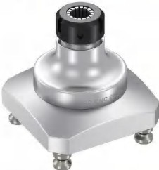
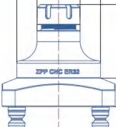
./
- 96
.49. 5
()0
;;;
�
()0
6..'

� I $
--:¢:--
@'@

.0..,

.<,D.,
IOA
-
114

22

Size: 130*130*117.8mm Material: Hardened steel Weight: 5.8kg
Clamping range: 2-20mm

TS96-ER40)))
ER zero point chuck
-
@,@ I
96

130

96
f63
Size: D170*190mm Material: Hardened steel Weight: 7.7kg
Scope of application: Match all ZPPCNC zero plates and self-centering vises

L200)))
Four-axis L-plate
� � II ,/ 0
I N
= ^{I} =
I
190

I

0
I
o I o
-�-
0 I o
I
I

9'6 155

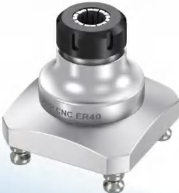
25
@
@ @
0

Size: 130*130*116mm Material: Hardened steel Weight: 6kg
Clamping range: 3-26mm
- --
@ @

96
I 0
-:J: M

Size: D200*225mm 0
Material: Hardened steel Weight: 14.6kg
Scope of application: Match all ZPPCNC zero plates and self-centering vises


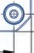
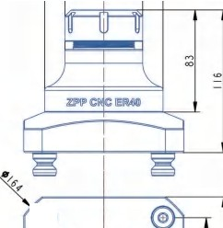

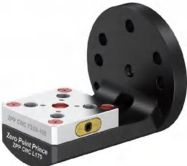
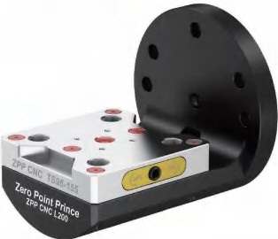
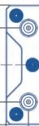
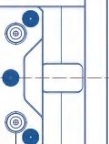
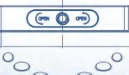



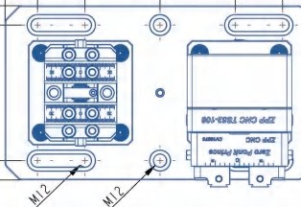
52combinations  96 combinations
320
49 77.5 77. 5 49
<O

0
...
49 77. 5 71. 5 49
- (+ - - +) •
.,.,
"'

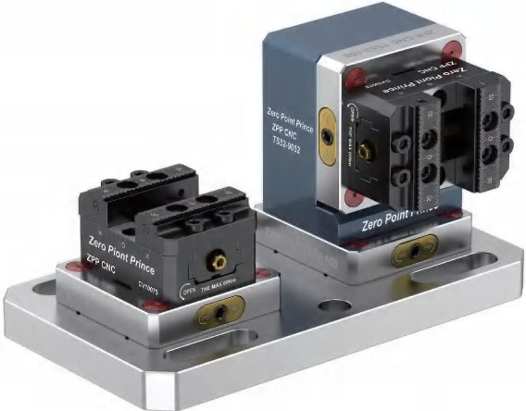
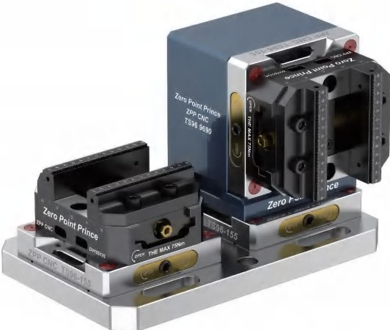
360

0
.,.,
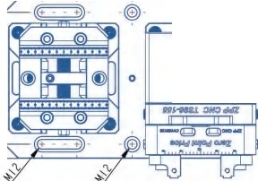
~~
130
,., N
"'
0-
-
; ...
,N.,
---
N
-
t;:JOI
-
--
,...
'i'
I0 J,
...:...
I ,f1-
.,.,
~
I 7
'Lr
.,.,
0
<O
N
-"'
I
-"-"-11"1
1)
ZIN ,.Z.,IIWce..
--(El) (El)-
...
0-
.",'.
0-

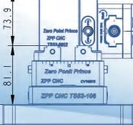
108
.,..,...,
137.
81
,.,..,
<7>
00 N
N
204 4

155

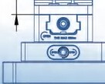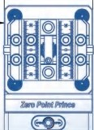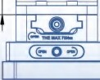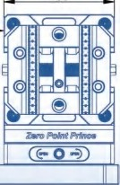
...
N
75
72.5
I 5
52



 Three Jaws series Run_out Tester)))
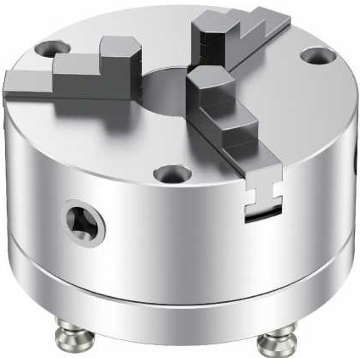
It is very necessary to measure the runout of the tool before the machine, and the calibration ofthe tool can improve the appearance of the product processing and the size of the processed tool is closer to the processing requirements, and at the same time, it can avoid checking the runout of the tool on the machine tool, save the preparation time of machine tool debugging,and improve the production efficiency for small and medium-sized machining enterprises

BT30/BT40 )))
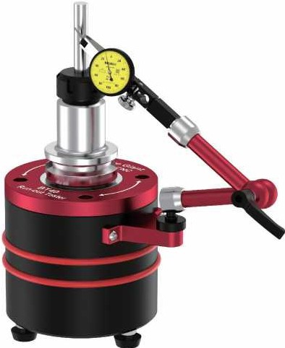
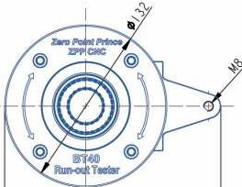
Run_out Tester

176

Size: D132*140.Smm
I
.,.,
0
-""
\�/ I
�
I
I
i
,.,,
"-'
.,.,
I
I
I I
I
Type | 5(96-125 | 5C96-160 | 5(96-200 | 5(52-80 | 5(52-100 | 5(52-130
Chuck OD(mm) | 125 | 160 | 200 | 80 | 100 | 130
Chuck ID(mm) | 30 | 40 | 65 | 16 | 22 | 30
Forward clamping(mm) | 2.5-40 | 3-55 | 4-85 | 2-22 | 2-30 | 2.5-40
Reverse clamping{mm) | 38-110 | 55-745 | 65-200 | 22-63 | 30-80 | 38-110
Internal stay(mm) | 38-125 | 50-160 | 65-200 | 25-70 | 30-90 | 38-125
Pull studs hole distance(mm) | 96x96 | 96x96 | 96x96 | 52x52 | 52x52 | 52X52

Material: Hardened steel+ POM Accuracy: 0.003/H240mm Weight: 4.5kg

Measuring range: BT30-BT40



