Telesales Registry Analysis (Last Week)

# 1. Weekly Sales Trend Analysis

This graph shows the total sales for each day of the last week. Total sales are calculated by multiplying the price of each product by the quantity ordered.

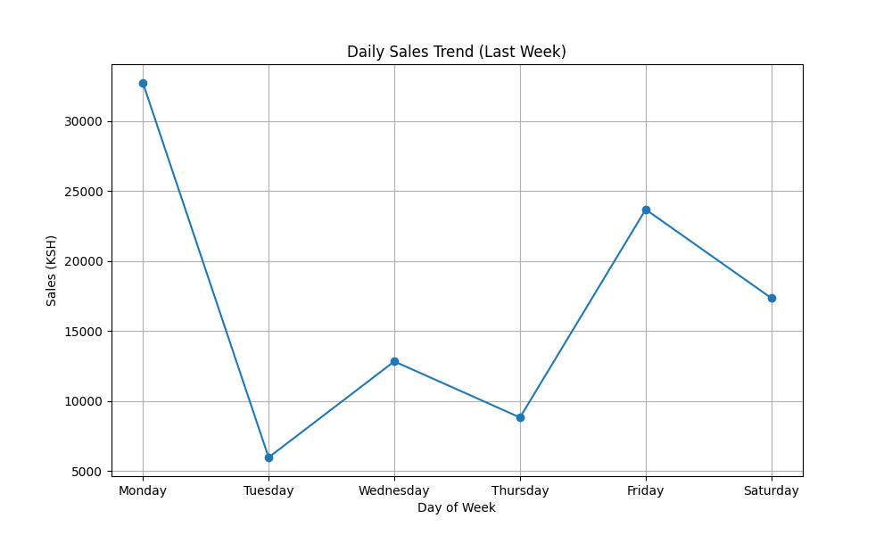

Daily Sales:

Monday: KSH 32729.00

Tuesday: KSH 5960.00

Wednesday: KSH 12823.00

Thursday: KSH 8816.00

Friday: KSH 23686.00

Saturday: KSH 17348.00

# 2. Call Outcome Distribution

This pie chart shows the distribution of call outcomes over the last week. It provides an overview of the results of the telesales calls.

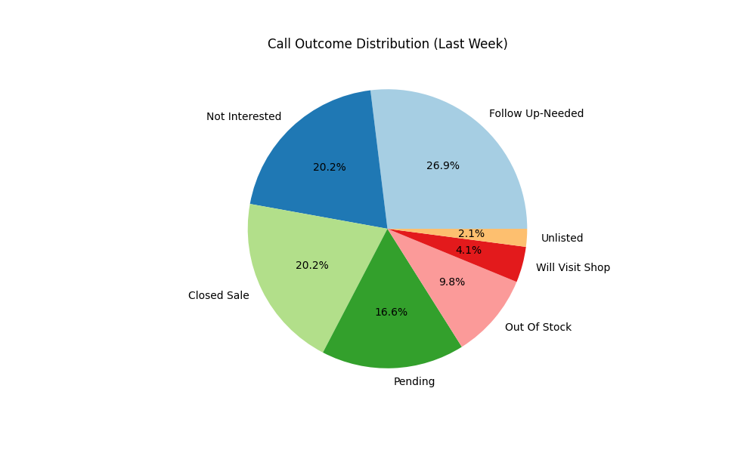

Call Outcome Counts:

Follow Up-Needed: 52

Not Interested: 39

Closed Sale: 39

Pending: 32

Out Of Stock: 19

Will Visit Shop: 8

Unlisted: 4

# 3. Top Selling Products

This bar chart shows the top 5 products by total sales over the last week. Total sales are calculated by multiplying the price of each product by the quantity ordered.

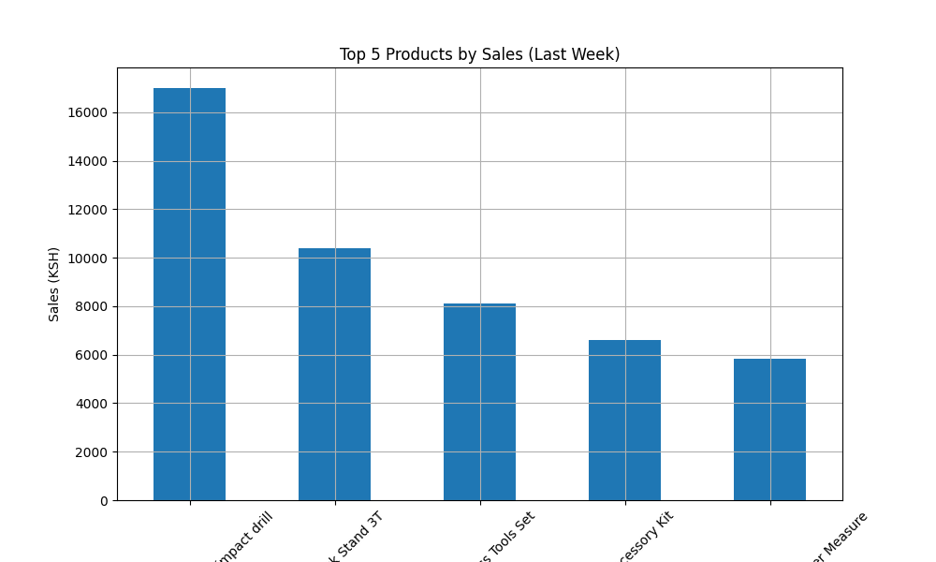

Top 5 Selling Products with Sales:

Total brushless cordless impact drill: KSH 17000.00

TOTAL Jack Stand 3T: KSH 10400.00

TOTAL 115Pcs Tools Set: KSH 8100.00

Go Pro Accessory Kit: KSH 6600.00

Bosch GLM 20 Professional Laser Measure: KSH 5849.00

Top 5 Selling Products with Quantities:

Hydrometer 20C - 750 - 800: 2.0

Anker PowerExtend USB 4 Strip: 1.0

Ankle weights 50kgs: 1.0

Asmaco 250ml Lighter Gas Butane: 1.0

Badminton shuttlecock: 1.0

# 4. Sales by Media

This pie chart shows the distribution of sales across different media channels over the last week. Sales are calculated by multiplying the price of each product by the quantity ordered.

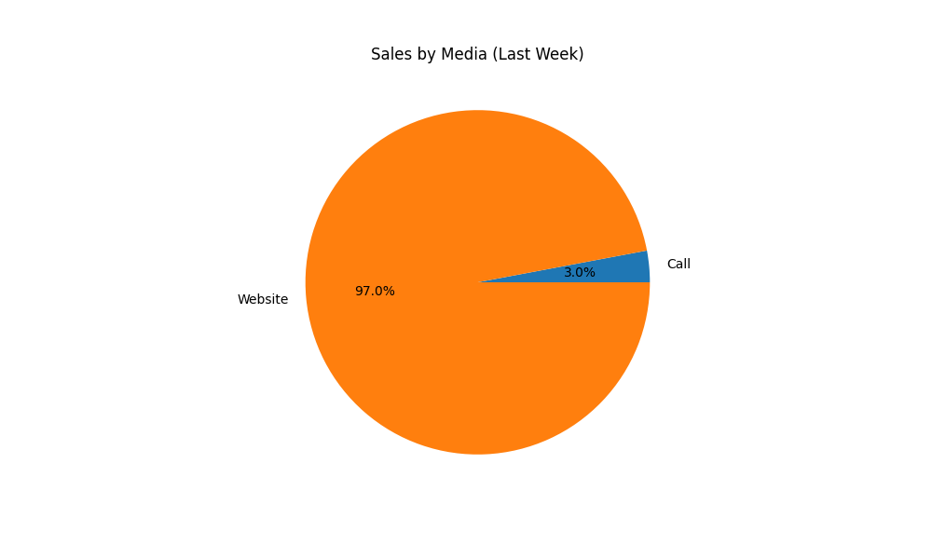

Sales by Media:

Call: KSH 2994.00

Website: KSH 98368.00

# 5. Average Order Value (AOV)

The Average Order Value (AOV) is calculated by dividing the total sales by the total number of orders.

Average Order Value (Last Week): KSH 2815.61

# 6. Top 5 Repetitive Numbers

This analysis identifies the top 5 most frequently called numbers over the last week.

Top 5 Repetitive Numbers:

712 592130: 4 calls

720 806666: 3 calls

713 970351: 3 calls

721 795814: 2 calls

740 926695: 2 calls

# 7. Profit Margin Analysis

The total profit margin is calculated as the sum of the margins for all sales made over the last week.

Total Profit Margin (Last Week): KSH 27698.00

# 8. Follow-up Needed Analysis

This analysis identifies the number of calls that need follow-up over the last week.

Number of Follow-up Needed Calls (Last Week): 52 out of 193 (26.94%)

# 9. Out of Stock Analysis

This analysis identifies the products that were out of stock over the last week.

Number of Out of Stock Products (Last Week): 19 out of 193 (9.84%)

Out of Stock Products (Last Week):

SONY DSC W810 CAMERA

Labels-Self Adhesive

Dartboard Nodor Supabull

GENERIC M.2 SSD BRACKET CADDY TRAY

Mk 540 Logitech

Whistle Fox 40 Plastic with Fingerloop

Logitech Wireless Mouse M171 Pink

P.V.C. Tubing Plain Clear 6MM - Meter

Javeline 400g

Discuss 1kg

Shotput 2kg

NIKON Z30 with 16-50mm LENS

Football Training BIBS Reversible Fine Knit (Senior)

Pros’kit 1PK-938B-1 Toolkit Network Installation 50pcs Set

Rolson 29183 Screwdriver Offset 3 pc

Hugo Boss

scotch mount double sided

Transcend 1TB External SSD

# 10. Sales by Day of the Week

This bar chart shows the sales distribution by day of the week over the last week. Sales are calculated by multiplying the price of each product by the quantity ordered.

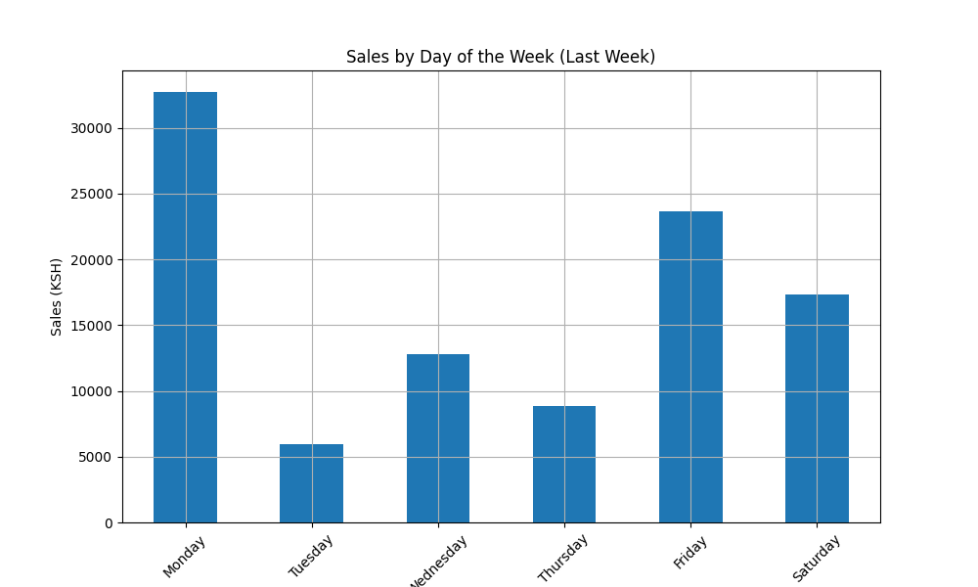

Sales by Day of the Week:

Monday: KSH 32729.00

Tuesday: KSH 5960.00

Wednesday: KSH 12823.00

Thursday: KSH 8816.00

Friday: KSH 23686.00

Saturday: KSH 17348.00

# 11. Day with the Most Calls

This analysis identifies the day with the most calls over the last week.

Day with the Most Calls: Monday

# 12. Day with the Least Calls

This analysis identifies the day with the least calls over the last week.

Day with the Least Calls: Saturday

# 13. Day with the Most Profit

This analysis identifies the day with the most profit over the last week. Profit is calculated as the difference between sales and cost.

Day with the Most Profit: Friday

# 14. Most Frequent Inquired Products

This analysis identifies the top 10 most frequently mentioned products in the product section over the last week.

Top 10 Most Frequent Products:

Samsung Galaxy A05s 128GB 4GB RAM New: 5 times

Popular Wooden Hockey Stick 30": 3 times

SONY DSC W810 CAMERA: 2 times

Circular Magnet with Hole: 2 times

Total Angle Grinder: 2 times

Labels-Self Adhesive: 2 times

Dartboard Nodor Supabull: 2 times

Asmaco Carpet Adhesive 750ML: 2 times

Rolson 42442 Dent Puller / Suction Cup 115MM 20-KG: 2 times

Colours Extra Thick Standard Dart Flights: 2 times

# 15. Category Sales Analysis

This analysis examines the total sales by category, providing insights into which product categories generated the most revenue during the week.

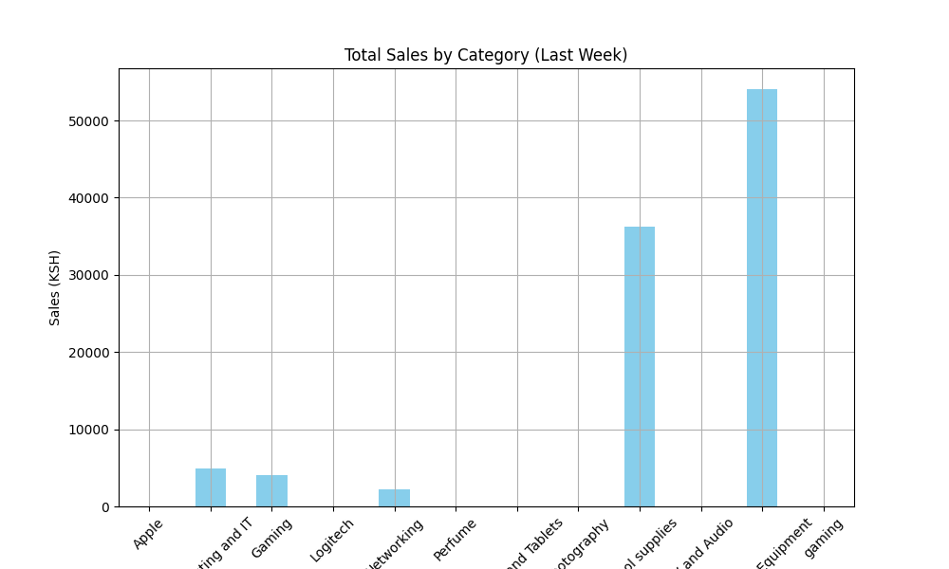

Sales by Category:

Apple: KSH 0.00

Computing and IT: KSH 4900.00

Gaming: KSH 4000.00

Logitech: KSH 0.00

Networking: KSH 2200.00

Perfume: KSH 0.00

Phones and Tablets: KSH 0.00

Photography: KSH 0.00

School supplies: KSH 36205.00

TV and Audio: KSH 0.00

Tools and Equipment: KSH 54057.00

gaming: KSH 0.00

# 16. Inquiries per Category

This analysis shows the number of inquiries for each product category over the last week.

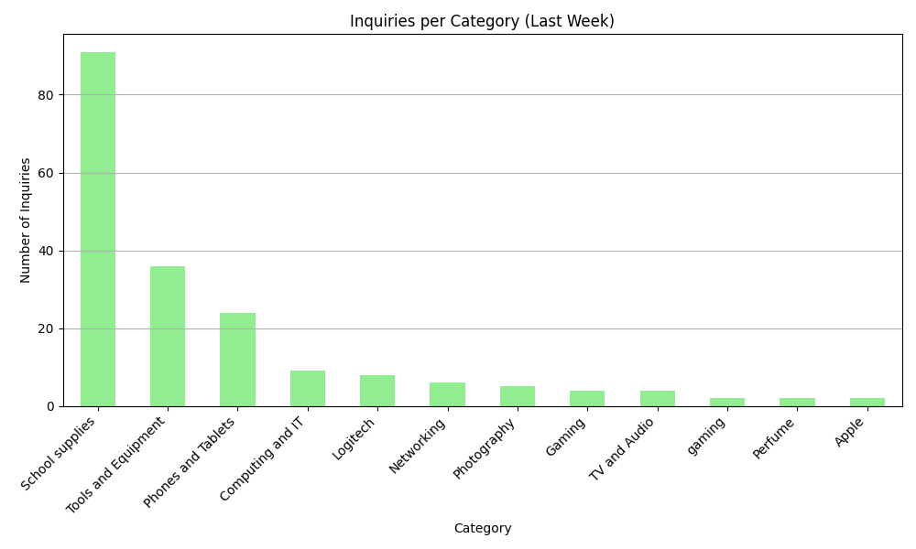

Inquiries per Category:

School supplies: 91 inquiries

Tools and Equipment: 36 inquiries

Phones and Tablets: 24 inquiries

Computing and IT: 9 inquiries

Logitech: 8 inquiries

Networking: 6 inquiries

Photography: 5 inquiries

Gaming: 4 inquiries

TV and Audio: 4 inquiries

gaming: 2 inquiries

Perfume: 2 inquiries

Apple: 2 inquiries

# 17. Inquiries vs Number of Sales per Category

This analysis compares the number of inquiries to the number of successful sales for each product category over the last week.

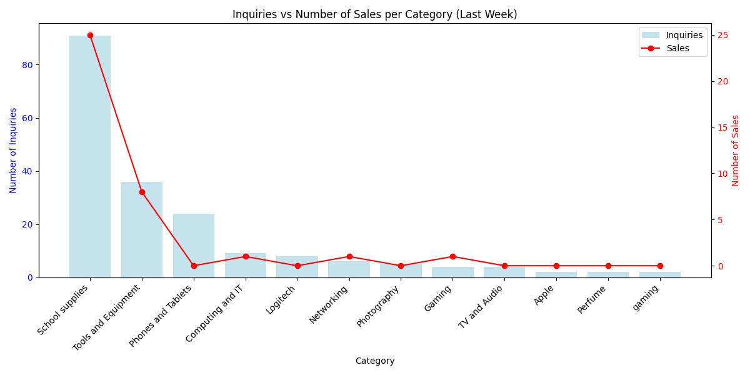

Inquiries vs Number of Sales per Category:

School supplies: 91 inquiries, 25 sales

Tools and Equipment: 36 inquiries, 8 sales

Phones and Tablets: 24 inquiries, 0 sales

Computing and IT: 9 inquiries, 1 sales

Logitech: 8 inquiries, 0 sales

Networking: 6 inquiries, 1 sales

Photography: 5 inquiries, 0 sales

Gaming: 4 inquiries, 1 sales

TV and Audio: 4 inquiries, 0 sales

Apple: 2 inquiries, 0 sales

Perfume: 2 inquiries, 0 sales

gaming: 2 inquiries, 0 sales

Conversion Rates:

School supplies: 27.47%

Tools and Equipment: 22.22%

Phones and Tablets: 0.00%

Computing and IT: 11.11%

Logitech: 0.00%

Networking: 16.67%

Photography: 0.00%

Gaming: 25.00%

TV and Audio: 0.00%

Apple: 0.00%

Perfume: 0.00%

gaming: 0.00%