Title

By Caden Ziskie (cmz7) & Branden Husted (blh94)

5/1/2024
CS-326

Project Summary:

Design Norms:
Transparency (Safety): seizure possibility
Trust (Security): secure MQTT; passwords and usernames left out of git repo
Privacy: doesn’t save/collect data
Stewardship: extra resistors, LEDs, and PWM are not RoHS compliant
Justice: could allow for the play-back of pirated music files

Data Flow Diagram & State Diagram:
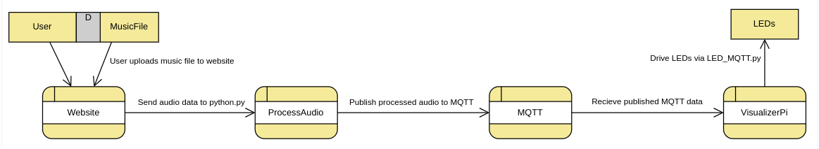

Fritzing Diagram & Photo:
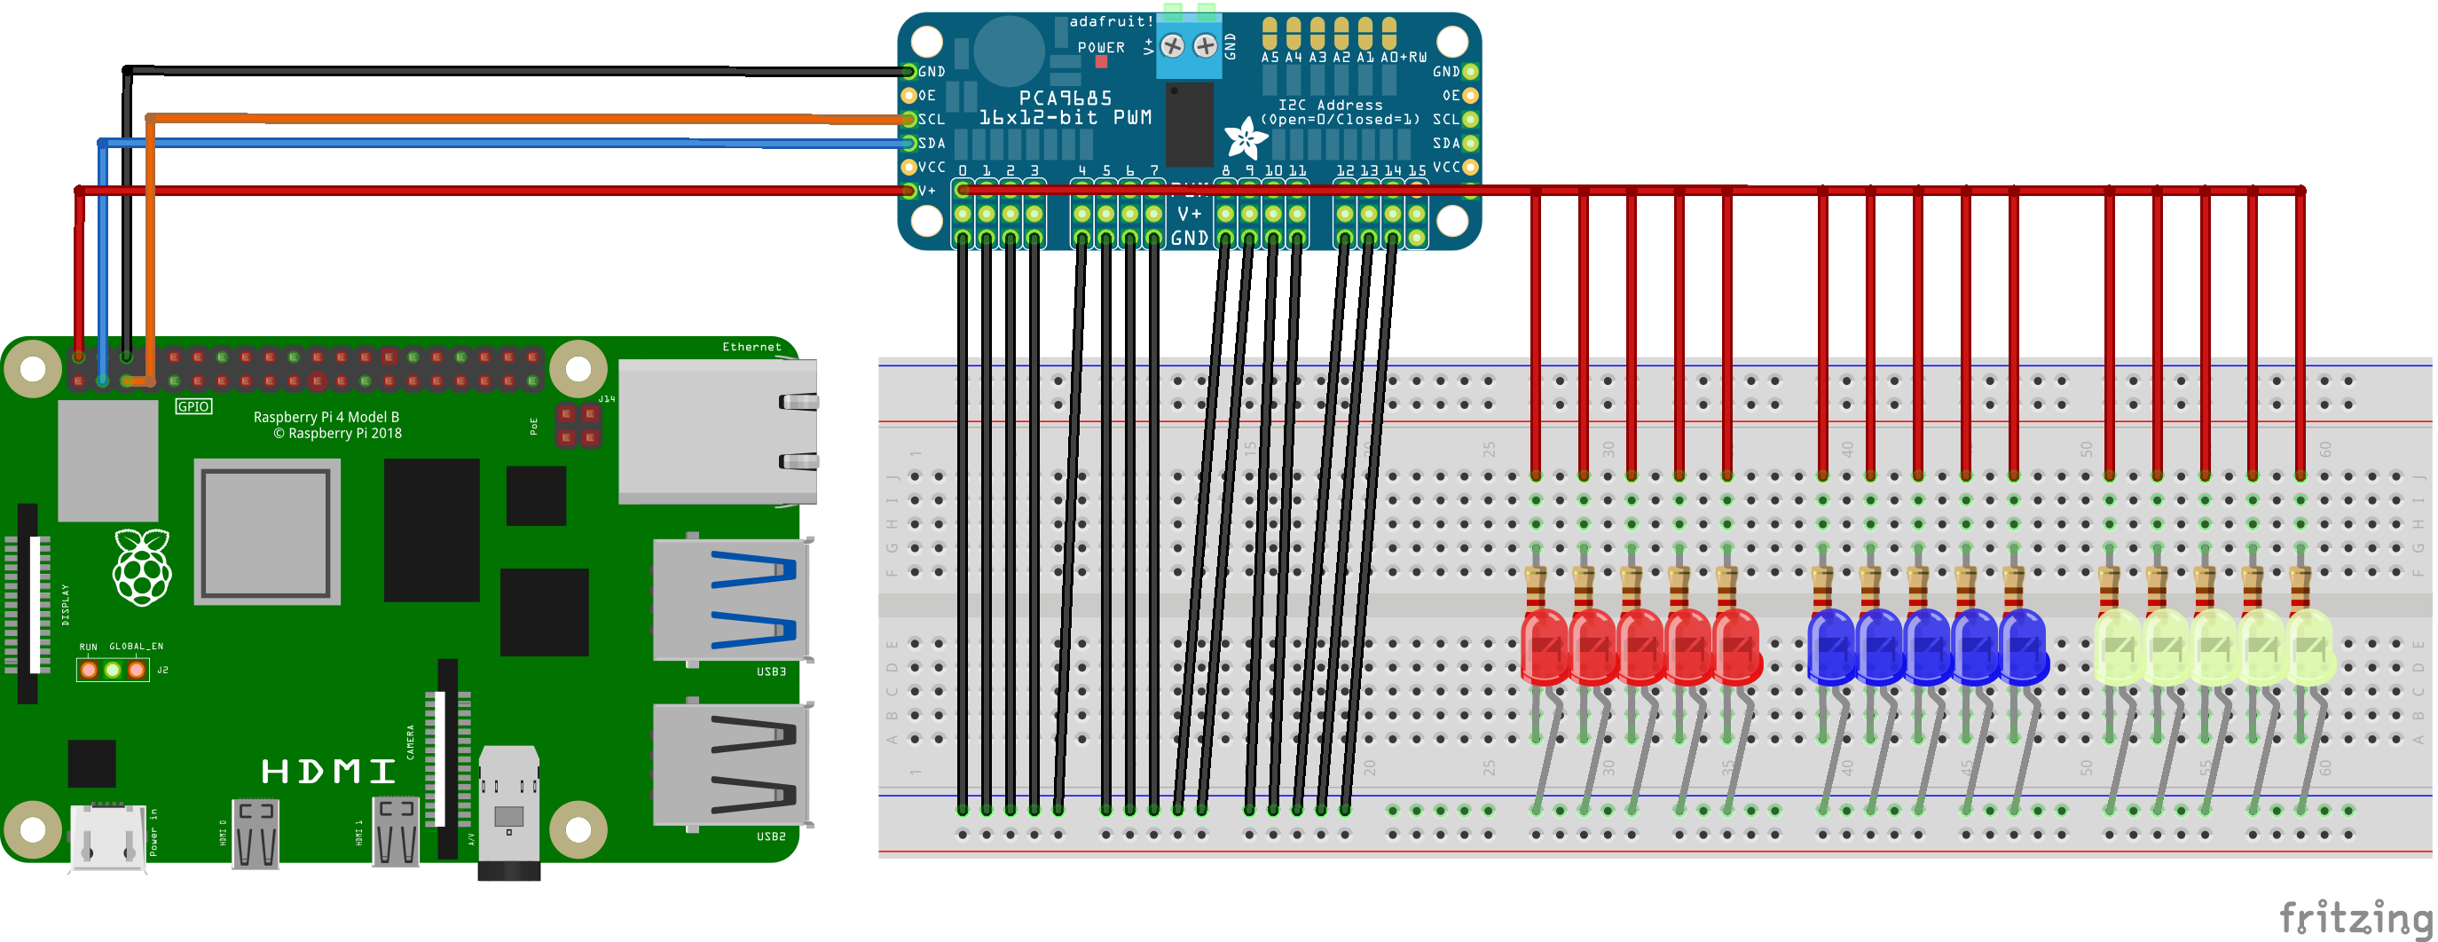

Code:
https://github.com/brandenHusted/AudioSpectrumVisualizer.git

