CANSLIM Setup Playbook
Trading Dashboard Strategy Knowledge Guide
Purpose: Use this document as the CANSLIM strategy knowledge source in Setup Builder. It is written so the AI review export can judge CANSLIM-tagged trades against objective setup, execution, risk, and exit rules.

1. Dashboard Use Rules
This playbook should be imported into the CANSLIM setup knowledge section. The checklist score remains the deterministic grade. This document gives the AI the qualitative strategy context behind that score.
- The AI must separate facts, inferences, and missing evidence.
- If required data is missing, the review should say “insufficient evidence” instead of assuming the trade was valid.
- A stock can be a strong company and still be a bad CANSLIM trade if it is bought extended, without volume, without a proper base, or in a poor market.
- The setup tag should be challenged. A trade tagged CANSLIM should be marked invalid if the evidence does not support the tag.

2. CANSLIM Definition
CANSLIM is | CANSLIM is not
A growth-stock framework combining fundamentals, new catalysts, leadership, institutional demand, proper technical setups, and market direction. | A generic label for any stock with a good story, large move, low valuation, or recent news.
A rules-based breakout/leadership strategy where the best trades come from proper bases, valid pivots, strong demand, and controlled risk. | An excuse to chase extended stocks, buy laggards, average down, or ignore market regime.
A strategy with offensive rules for winners and strict defensive rules for losses. | A buy-and-hope thesis after the setup has failed.

3. CANSLIM Components and Evidence Requirements
Letter | Meaning | Required dashboard evidence | Strong evidence | Weak / disqualifying evidence
C | Current quarterly earnings | Latest EPS growth, sales growth, EPS acceleration, earnings surprise. | EPS up 25%+ with sales confirmation and acceleration. | Flat/down EPS, weak sales, one-time gains, deceleration.
A | Annual earnings growth | 3Y/5Y annual EPS growth, ROE, forward estimates. | Consistent annual growth, ideally 25%+, with estimates intact. | Weak annual record, estimates falling, purely cyclical rebound.
N | New factor or new high | Product/service/management/industry catalyst, earnings inflection, new-high status. | Clear new driver plus price near or at highs. | Old story, vague theme, or only broad-market sympathy.
S | Supply and demand | Volume vs average, float, accumulation/distribution, tightness. | Breakout volume 40-50%+ above average with strong closes. | Weak-volume breakout, heavy distribution, wide/loose action.
L | Leader or laggard | RS Rating, RS line trend, industry rank, performance vs SPY/QQQ. | RS 80-90+, RS line near highs, leading stock in leading group. | RS below 70, lagging peers, below key moving averages.
I | Institutional sponsorship | Fund ownership trend, quality holders, sponsorship count. | Some sponsorship with increasing ownership. | No sponsorship, low-quality sponsorship, or signs of institutional selling.
M | Market direction | Market regime, index trend, distribution days, leading-stock health. | Confirmed uptrend with leaders breaking out and holding. | Correction, failed breakouts, distribution increasing.

4. CANSLIM Setup Grade Rubric
Market direction, leadership/relative strength, and technical entry quality should carry heavy weight. A catalyst alone does not make a CANSLIM trade valid.
Category | Weight | What to grade
Market direction | 20 | Confirmed uptrend, index trend, distribution days, leading-stock health, breadth.
Fundamentals | 20 | Current EPS/sales, annual EPS growth, profitability, estimates.
New factor / catalyst | 10 | Product, service, management, industry condition, earnings inflection, new price high.
Leadership / RS | 20 | RS Rating, RS line, sector leadership, peer leadership, price above key moving averages.
Technical setup quality | 20 | Base quality, pivot/early entry, handle/pullback, volume confirmation, tightness.
Institutional sponsorship / supply-demand | 10 | Fund ownership trend, float/supply, volume demand, accumulation/distribution.

Grade | Score | Meaning | Position-size implication
A+ | 90-100 | True CANSLIM leader, proper setup, supportive market, clean entry, no major flaws. | Full planned risk allowed.
A | 80-89 | High-quality setup with minor flaws only. | Normal risk allowed.
B | 70-79 | Valid but incomplete; missing one or two important confirmations. | Starter/smaller risk.
C | 60-69 | Research trade; too many missing pieces. | Tiny risk only or no trade.
No Trade | <60 or major disqualifier | Mislabeled, extended, weak market, weak RS, no valid setup, or no risk plan. | Should not be treated as CANSLIM.

5. Major Disqualifiers
These conditions should cap the grade at C or No Trade unless there is a documented exception.
- Bought during a market correction or while breakouts were broadly failing.
- Bought more than 5% above the proper pivot or buy point.
- No valid base, pivot, early-entry trigger, or controlled pullback setup.
- Weak or declining relative strength.
- Breakout without volume confirmation.
- No stop or invalidation plan before entry.
- Averaged down after the position moved against the entry.
- Held a failed breakout without a rule-based reason.
- Full risk taken on a B/C/research-quality setup.
- Trade was justified mainly by story, opinion, or “cheap” price rather than evidence.

6. Valid Entry Tactics
Entry tactic | Valid when | Invalid when
Standard breakout | Stock clears a proper pivot from a sound base with volume confirmation and market support. | Breakout is weak-volume, stock is extended, base is loose, or market is in correction.
Early entry | Trendline or tight-area break appears before the obvious pivot and risk can be defined tightly. | Used to force a trade before confirmation or without a stop.
Pullback to 21-day / 10-week / 50-day | Stock is already a proven leader and pullback is controlled with support. | Stock is broken below support or RS is deteriorating.
Breakaway / earnings gap | Gap follows major fundamental catalyst and risk can be defined by low of gap day or logical level. | Gap is already extended or size is too large for the actual risk.

7. Risk, Sell Rules, and Management
The sell rules are not optional. The AI should review exits as hard as entries.
Rule | Dashboard field | Review logic
Cut losses around 7-8% max from entry/proper buy point. | Stop price at entry, max adverse excursion, exit price. | If loss exceeded the allowed level without a documented reason, flag a major violation.
Protect profit near 20-25% from proper buy point unless exceptional power justifies holding. | Gain from pivot, partial exits, exit reason. | If stock hit profit zone and was round-tripped, flag profit-management failure.
Eight-week hold concept applies only to unusually powerful stocks. | Gain >20% in about 3 weeks, hold duration. | Do not use this rule to justify holding a failed trade.
Sell signals include failed breakout, heavy-volume reversal, distribution, key moving-average break. | Pivot fail/reclaim, 21/50-day breaks, volume on down days. | Exit review should identify whether sell signals appeared before the exit.
Never average down. | Adds after entry, add price vs initial entry/pivot, position size. | Adding below entry is a major CANSLIM violation unless explicitly tagged as a different strategy.

8. Model Patterns and Failure Patterns

Model CANSLIM patterns
- Strong current earnings and sales growth with acceleration, not just a vague growth story.
- Price emerging from a sound base near new-high territory, not bouncing from a deep decline because it looks cheap.
- RS line at or near new highs and stock outperforming SPY/QQQ and peers.
- Breakout volume materially above average and close near the upper part of the range.
- Entry inside the pivot buy zone or early entry with clearly defined tight risk.
- Market in confirmed uptrend with leaders breaking out and holding.

Failure patterns
- Late chase above the 5% buy zone.
- Weak-volume breakout that quickly loses the pivot.
- Declining RS line or weak RS Rating despite a good company story.
- Buying during market distribution or a correction.
- No written stop/invalidation before entry.
- Adding because price is down instead of because structure improved.
- Taking full risk on incomplete evidence.

9. Dashboard Field Checklist
Field group | Specific fields to add or verify
Fundamentals | EPS latest quarter %, sales latest quarter %, EPS acceleration flag, annual EPS growth 3Y/5Y, ROE, estimates trend.
Technical setup | Base type, base dates, base depth %, base length weeks, handle depth %, pivot price, buy-zone top, volume vs average.
Leadership | RS Rating, RS line new-high flag, sector rank, industry group rank, performance vs SPY/QQQ.
Market | Market regime at entry, index above/below 21/50/200-day, distribution day count, follow-through day flag, exposure level.
Execution | Entry price/date, entry extension %, initial stop, stop distance %, planned risk, actual risk, grade at entry.
Management | Partial exits, adds, add location vs entry/pivot, MA support/violation, max adverse/favorable excursion.
Exit | Exit reason, loss-rule compliance, profit-zone compliance, failed-breakout signal, MA-break signal, market sell signal.
Review output | Valid setup flag, grade, disqualifier flags, missing evidence, repeated mistake themes.

10. AI Review Instructions for CANSLIM Trades
For every trade tagged CANSLIM, determine whether the evidence supports the tag. Separate facts, inferences, and insufficient evidence.
- Market direction at entry.
- Current EPS/sales growth and annual earnings record.
- New product/service/management/industry condition or new price high.
- Supply-demand: volume vs average, accumulation/distribution, float/share count if available.
- Leadership: RS Rating, RS line, sector/industry leadership, performance vs SPY/QQQ.
- Institutional sponsorship if available.
- Technical setup: base type, base length/depth, pivot, handle/pullback quality, volume on breakout.
- Execution: entry vs pivot, extension %, stop defined, position size vs grade.
- Exit: 7-8% loss rule, 20-25% profit zone, sell signals, partial exits, round-trip behavior.
Required AI output for each CANSLIM trade:
- Valid CANSLIM? Yes / No / Insufficient evidence.
- Grade: A+, A, B, C, or No Trade.
- Best supporting evidence.
- Missing evidence.
- Biggest rule violation.
- What should be changed in future trades.
- Themes across all CANSLIM trades in the review period.

11. Source Guidance
Use Branden’s own notes, checklist criteria, and permitted public references as the operating knowledge. Avoid importing large copyrighted book excerpts into the dashboard. Summarize rules in your own words and cite source names/links where useful.
- Investor’s Business Daily / MarketSurge resources are useful for buy-zone, base, breakout, and sell-rule definitions.
- Fidelity’s cup-with-handle explanation can be used as a neutral pattern definition reference.
- Forum/Reddit discussions may identify common interpretation problems but should not be treated as authority.
- Book concepts should be converted into your own concise operating rules rather than pasted as long excerpts.

12. Setup Builder Import Notes
This document is intentionally structured with clear headings and compact tables so the dashboard can chunk it into useful strategy knowledge sections. After importing, keep the source active only if you want it used in AI reviews.
Improved for Branden Journal Setup Builder knowledge import

Appendix A - Original Visual References
These images were preserved from the original CANSLIM playbook so the setup knowledge source keeps the chart/diagram context. The rewritten sections above are the operating rules; these visuals are reference aids for review and future screenshot interpretation.
Original visual reference 1: CANSLIM setup / dashboard reference image from source document.
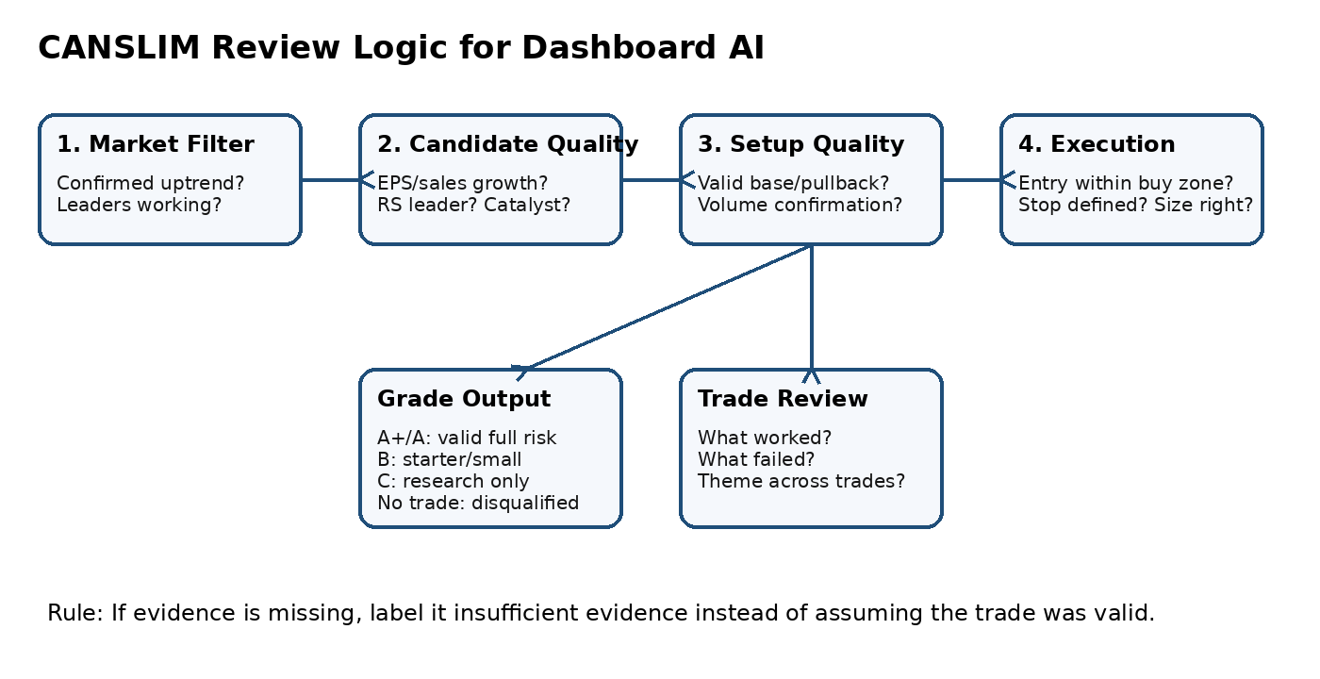

Original visual reference 2: proper base / pivot / buy-zone reference image from source document.
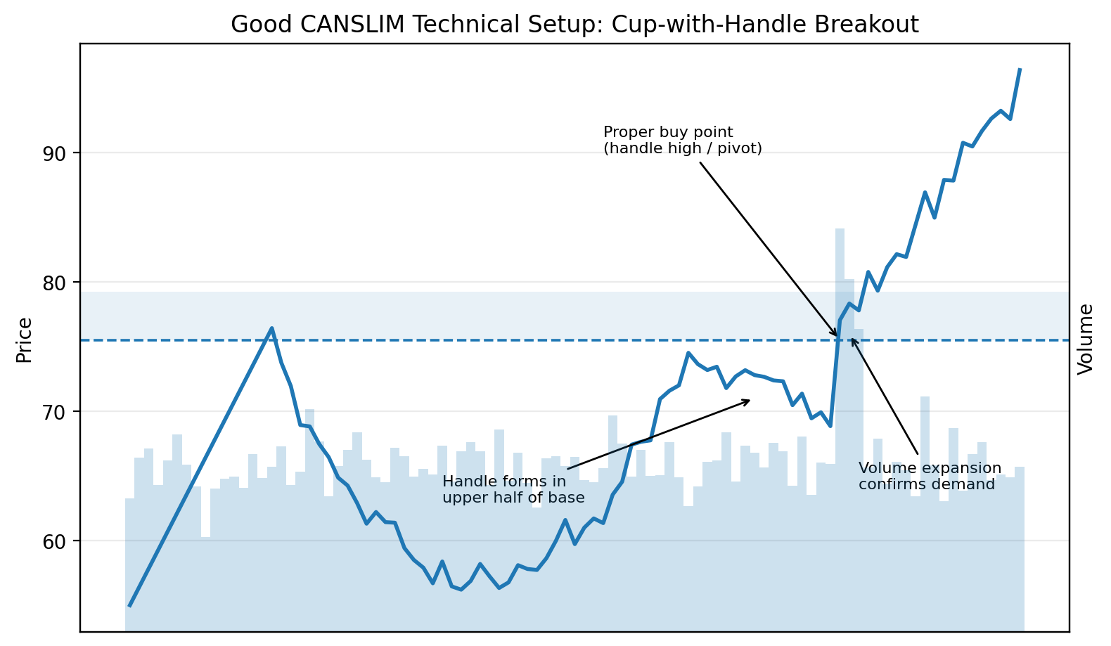

Original visual reference 3: strong earnings plus price/volume confirmation example.
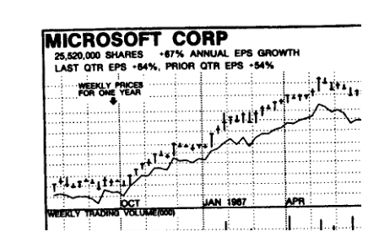

Original visual reference 4: buying near highs after proper consolidation example.
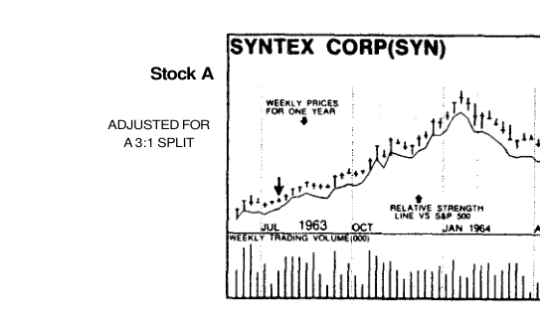

Original visual reference 5: base breakout / handle timing example.
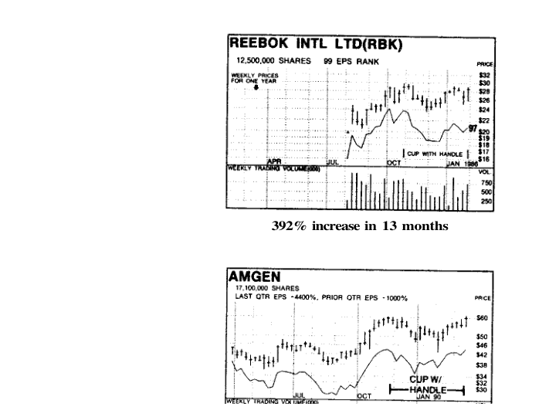

Original visual reference 6: online/reference model setup example.
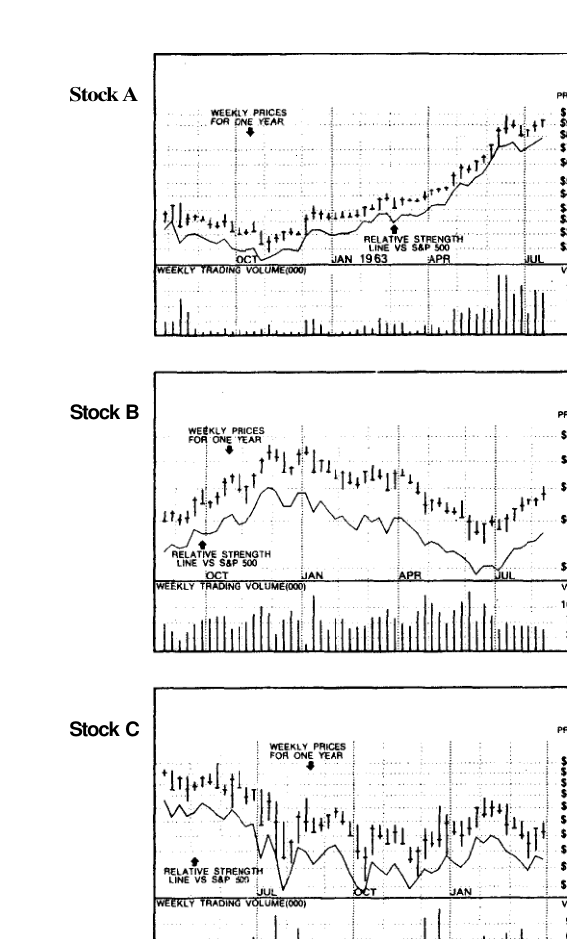

Original visual reference 7: laggard or weak-selection example.
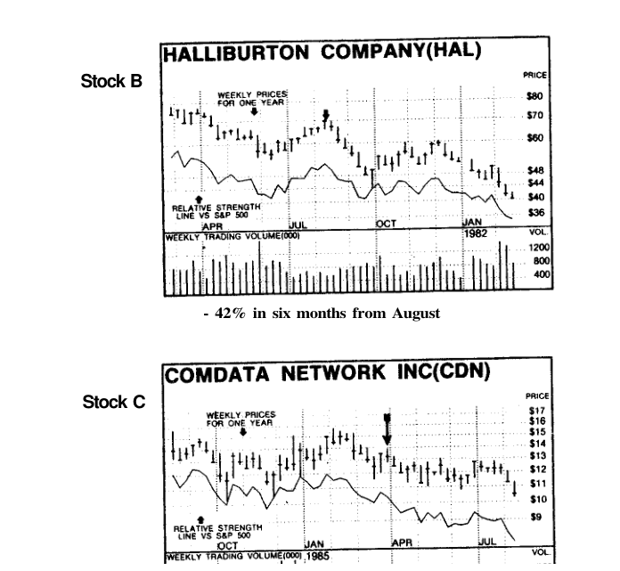

Original visual reference 8: late-entry / extended-buy-zone failure example.
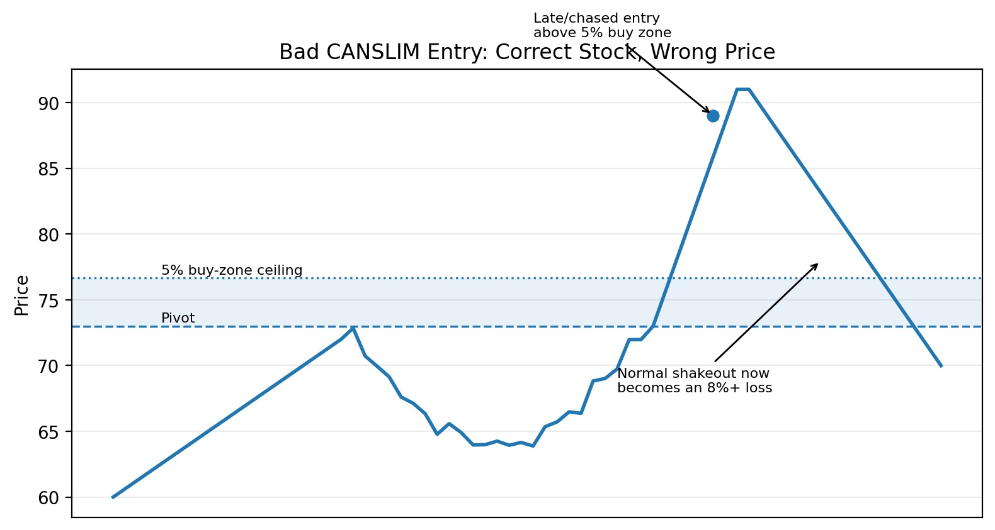

Original visual reference 9: weak-volume breakout failure example.
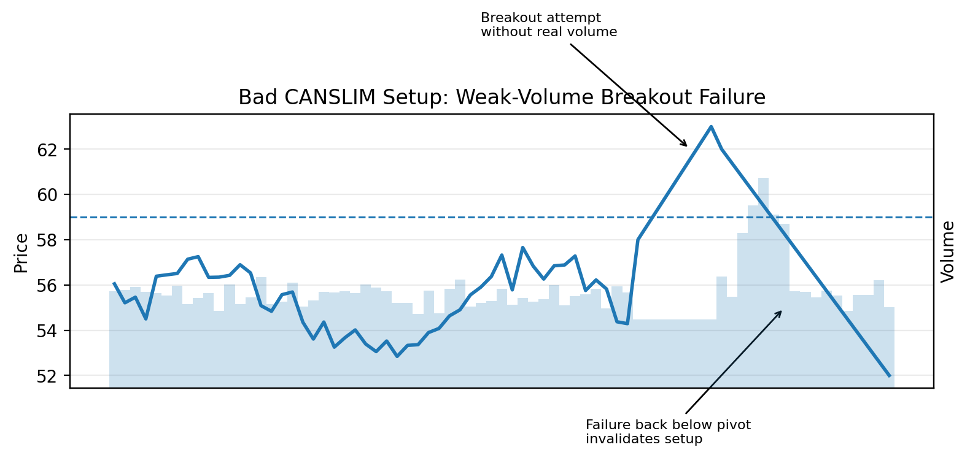

Original visual reference 10: market distribution / poor regime example.
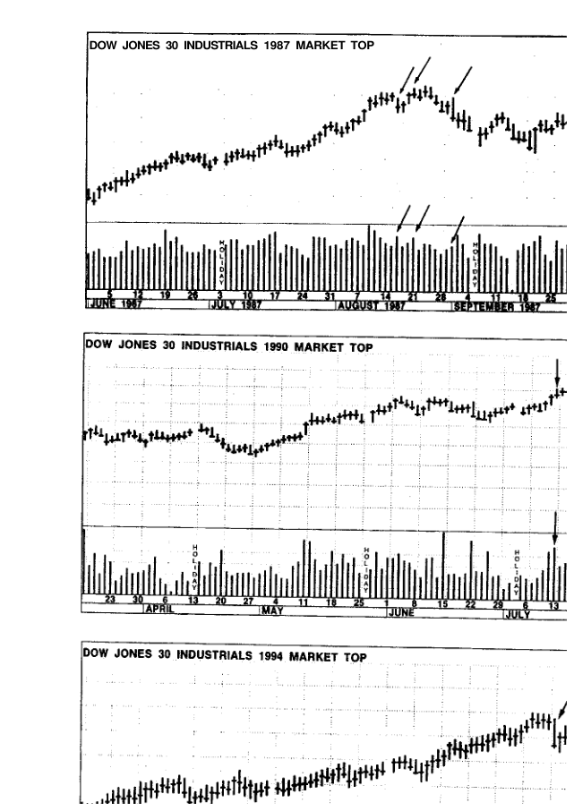

Original visual reference 11: follow-through / market turn reference example.
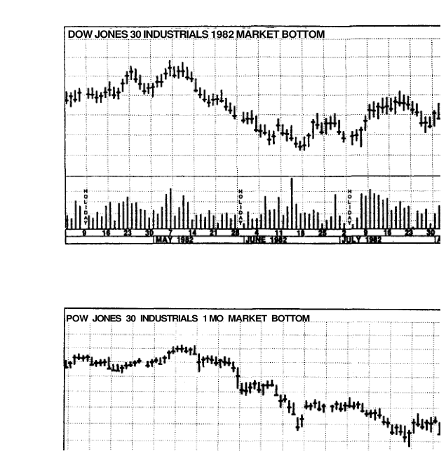

Original visual reference 12: sell rules / loss-profit management reference image.
