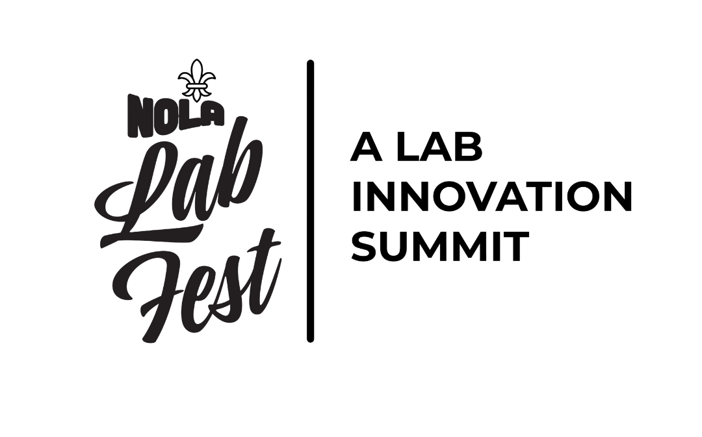

Speaker Information Packet
NOLA LabFest 2026
We’re thrilled to welcome you as a featured speaker at NOLA LabFest. This packet covers the key logistics, presentation requirements and event details you’ll need for a smooth experience on stage and throughout the weekend.
You’re part of the LabFest experience beyond your session, too. We hope you’ll join the labs and Nowak team for the sessions, networking and evening events — that time together is where a lot of the magic happens.

At a Glance
Recommended stay | Thursday, October 15 – Sunday, October 18

Hotel rate | $239/night | Booking deadline: September 15

Presentation due | September 25

Speaker check-in | October 16 at breakfast

Session length | 60 minutes

Speaker contact | Marybeth Starr | 816-914-7733 | marybeth@nowakdental.com

Travel & Accommodation

Hotel & Travel
Hotel room block: Book your room
- Booking deadline: September 15
- Rate: $239/night
- Valet and nearby self-parking are available.
- The hotel is approximately a 20-minute ride from the airport.
Recommended travel dates: Arrive Thursday, October 15, join us for the Seven Three Distillery Tour, and depart Sunday, October 18.
Speaker Survey: Complete the speaker survey ⬅️ due September 1

Onsite Event Details
- All sessions will be livestreamed and recorded for marketing and post-show content.
- Speaker check-in begins at breakfast on October 16.

Speaker Green Room
Speakers will have access to a dedicated space throughout the event to relax, prepare, review presentations and get ready before taking the stage. Think of it as your home base between sessions — a quiet place to regroup before showtime.
- We’ll be setting up on October 14 if you’d like to stop by and say hello.
- We encourage you to spend the weekend with us — attend sessions, network and enjoy the group events.
Event website: nolalabfest.com

NOLA LabFest App
New this year, the free NOLA LabFest app will serve as your event guidebook. It will include:
- Event agenda and personal schedule
- Digital badge and badge scanner
- Interactive vendor map with links to vendor websites
- Vendor passport game
- Voting for the best-decorated booth
- Photo Sharing

LabFest App Download Instructions:
Website for app: app.nolalabfest.com
Save on your phone
- iPhone: open the link in Safari, tap Share, then Add to Home Screen
- Android: open it in Chrome, tap the three dots, then Install App
- Open it from that icon from then on
- On a computer, same link, then click the install icon in the address bar
Sign in
- Email: the one this packet came to
- Password: Labfest26, and you will pick your own right away
Your profile (My Account, then My Speaker Profile)
- Headshot, title, company, LinkedIn and bio
- This is what attendees read when they choose which session to attend
- Change it any time, right up to the day you speak
App Questions: brandi@nowakdental.com

Meals & Group Activities
Speaker participation includes group activities and meals from October 15–17. Please refer to the event schedule for exact timing.
Thursday night: The Thursday evening event is a distillery tour at Seven Three distillery
Friday night: The evening event is masquerade-themed — bring your mask and energy!

NBC
Each of your classes have been approved for CE Credits in Professional Development. Your course numbers and titles are below.
Title: RRRPPPRRR: The REAPER Method for Business Growth and Operational Mastery with Jude Grayson
Course: 60417 - 4 hours of Professional Development credit

Title: Pivot or Plateau: Are You Majoring in the Minor? With Jude Grayson
Course: 60418 - 1 hours of Professional Development credit

Title: Turn Followers Into Customers: Converting Social Media Into Revenue with Bernard Ory
Course: 60419 - 1 hours of Professional Development credit

Title: Small Target, Big Growth: How Niching Down Fuels Scale with John Wilson
Course: 60420 - 1 hours of Professional Development credit

Title: Beyond the Bench: Building a Lab That Runs Like a Business with David Jackson
Course: 60421 - 1 hours of Professional Development credit

Title: AI Unlocked: Smarter Tools, Faster Workflows, Better Business with Brandi Nowak Dalton
Course: 60422 - 1 hours of Professional Development credit

Title: From Bench to Boardroom: The DSO Shift Reshaping Dental Labs with Blake Hibray
Course: 60423 - 1 hours of Professional Development credit

Title: The Talent Advantage: Winning the War for Great People with Bennett Napier
Course: 60424 - 1 hours of Professional Development credit

Title: Culture by Design: Building Teams and Labs That Actually Thrive with Rob Nazzal
Course: 60425 - 1 hours of Professional Development credit

Presentation & AV
- Standard AV setup includes a stage microphone, lavalier microphone, screen, clicker and projector.
- Please submit your presentation by September 25 so we can load and test a backup copy in advance.
- Presentations submitted onsite or immediately before a session cannot be guaranteed to work as intended.
- Wi-Fi will be available in the ballroom, but presentations should not depend on a live internet connection.
- We will have a confidence monitor and a notes monitor
- Each speaker is allotted 60 minutes.
The goal: consistency and zero “but it worked on my laptop” surprises five minutes before you take the stage.

NOLA LabFest PowerPoint Specs

File Format
- Submit a Microsoft PowerPoint (.PPTX) file.
- Do not submit a PDF, Keynote file, Canva link or Google Slides link as the final presentation.
- File name: LastName_FirstName_LabFest2026.pptx

Slide Size
- Use 16:9 widescreen.
- PowerPoint setting: Widescreen (13.333" × 7.5").
- Do not use 4:3.

Fonts
- Use standard/common fonts whenever possible: Arial, Aptos, Calibri, Helvetica, Georgia or Times New Roman.
- If using a specialty or branded font, embed it in the PowerPoint file.
- Avoid extremely thin or light font weights; they can disappear on projection screens.
- Recommended minimum: 24 pt for body copy and 32+ pt for headlines.

Images & Graphics
- Use high-resolution images.
- Avoid screenshots of text, charts or data whenever possible.
- Keep important text and logos away from the very edges of the slide.
- Do not rely on tiny footnotes being readable from the back of the room.

PowerPoint Specs, continued

Video & Audio
- Embed media in the PowerPoint rather than linking to files on your computer.
- Use MP4/H.264 for video whenever possible.
- Avoid streaming YouTube or Vimeo during the presentation unless absolutely necessary.
- Notify us in advance if your deck contains video, audio or other media so it can be tested.

Animations
- Standard PowerPoint animations and transitions are fine.
- Avoid complicated animations, unusual plug-ins, macros or anything requiring third-party software.
- Any critical animation should be tested on the event presentation computer.

Links & Internet
- Do not make the presentation dependent on live internet access.
- Any web-based content should have an offline backup.
- Test all QR codes before submission.

Local Favorites
A few New Orleans picks from the team for coffee, food and a little time around town.

Coffee & Classics
- PJ’s Coffee — 300 Canal Street, inside the DoubleTree
- Café du Monde — 800 Decatur Street
- Lucky Dog — hot dog carts throughout the city

Team Restaurant Picks
- Shawn: Mandina’s — 3800 Canal Street
- Brandi: Mr. B’s Bistro — 201 Royal Street
- Marybeth: Pat O’Brien’s — 718 St. Peter Street (and yes, the Hurricane is the classic order)
- Brett: Ruby Slipper — 204 Decatur Street
Honorable mentions: Acme Oyster House, Katie’s and Drago’s.

Sunday Brunch
- Muriel’s Jackson Square — Jazz Brunch, 801 Chartres Street (nicer; reservations usually recommended)
- Arnaud’s — Jazz Brunch, 813 Bienville Street (nicer; reservations usually recommended)
- Ruby Slipper — 204 Decatur Street (casual)

Casino
- Harrah’s — 8 Canal Street

