|  |
| --- |
| CMPS453 – University of Louisiana at Lafayette |
| Design |
| UL Housing Project |

|  |
| --- |
| Brandin Jefferson, Issa Samake, Zach Danjean, Yee Wong, Jaquincy Nelson, Brian Okoye  10-23-2014 |

# ABSTRACT

Table of Contents

STATIC MODEL SEQUENCE DIAGRAMS 1

DYNAMIC MODEL SEQUENCE DIAGRAMS 3

# LIST OF FIGURES

Figure 1 - Static Diagram: Room Change (Student) 2

Figure 2 - Static Diagram: Room Change (Admin) 3

Figure 3 – Dynamic Diagram: Create New ID 4

Figure 4 - Dynamic Diagram: Request New Room 5

Figure 5 – Dynamic Diagram: View Floor Map 6

Figure 6 – Dynamic Diagram: Decide Room Requests 6

# LIST OF TABLES

# INTRODUCTION

# GUI (Graphical User Interface) DESIGN

//Brandin – I can do this if someone else does Dynamic

# STATIC MODEL SEQUENCE DIAGRAMS

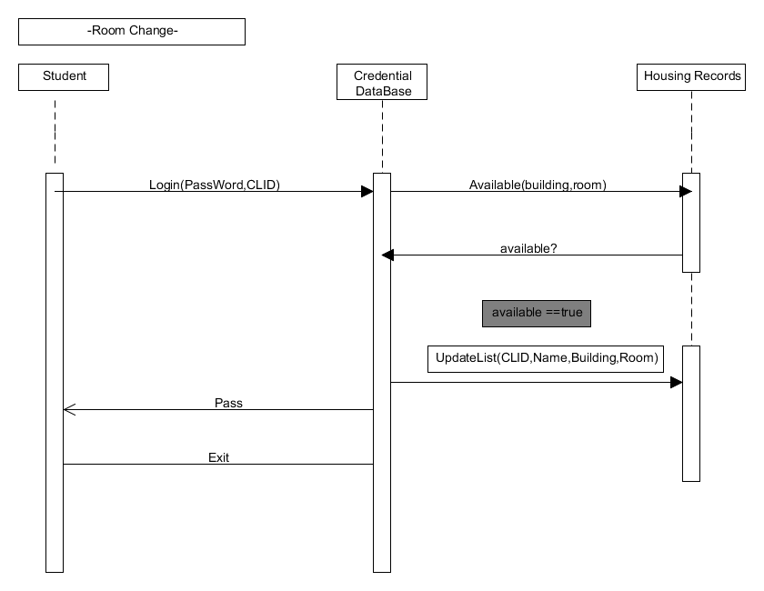

Figure - Static Diagram: Room Change (Student)

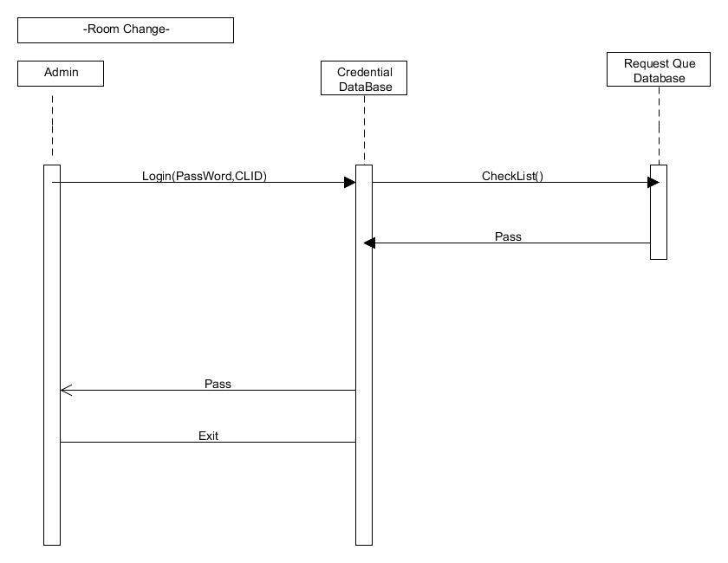

Figure - Static Diagram: Room Change (Admin)

# DYNAMIC MODEL SEQUENCE DIAGRAMS

sd Create New ID (void) : void

recordlist : StudentRecord

ids : StudentID

verifyID (id, password)

: boolean

*exists*

alt

[exists == false]

Login (id, password)

: void

mail : MailVerifier

createID(email, password)

: void

verifymail(email):

boolean

*valid*

alt

[valid == false]

notvalid() : void

errorMsg()

: void

else

AddID(): void

else

displayPage() :

void

Figure – Dynamic Diagram: Create New ID

sd Request Room Change (void) : void

holder : Interface

db : HousingRecord

selectRoomChange

displayOptions

available(building, room)

*available*

alt

[available == true]

updateAvailability(id)

successMsg

exit

[else]

updateAvailability(id)

notFirstMsg

exit

Figure - Dynamic Diagram: Request New Room

sd View Floor Map

ref

Login Admin

Option Manager

House DB

display options:void

*floors*

Map Interface

selection (floor)

exit : void

displaymap

(floor)

Figure – Dynamic Diagram: View Floor Map

sd Decide Room Requests

Interface Manager

DisplayRequests

Request Queue

*Request Queue*

DecideRequest

removeRequest

loop

Figure – Dynamic Diagram: Decide Room Requests

# RATIONALE FOR DETAILED DESIGN MODEL

# TRACEABILITY FROM REQUIREMENTS TO DETAILED DESIGN MODEL

# REFERENCES

Bell, Donald. *UML basics: The sequence diagram*. IBM Corporation, 14 Feb. 2004. Web. 26 Oct 2014.