Urbanization affects web aggregation and placement of a funnel-web spider, *Agelenopsis pennsylvanica*

Brandi J. Pessman, Madison Hays, Earl Agpawa, Eileen Hebets

2022-02-22

# R Markdown

## R Markdown

### RMarkdown

#### RMarkdown

This is an R Markdown document. Markdown is a simple formatting syntax for authoring HTML, PDF, and MS Word documents. For more details on using R Markdown see <http://rmarkdown.rstudio.com>.

When you click the Knit button a document will be generated that includes both content as well as the output of any embedded R code chunks within the document. You can embed an R code chunk like this:

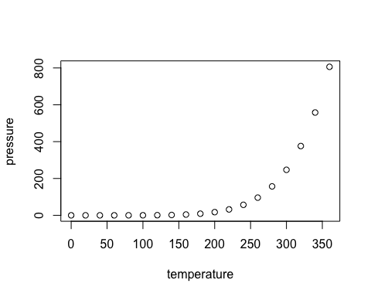

Figure 1. Something

Note that the echo = FALSE parameter was added to the code chunk to prevent printing of the R code that generated the plot.

## References

Here are some references set to have a hanging indent