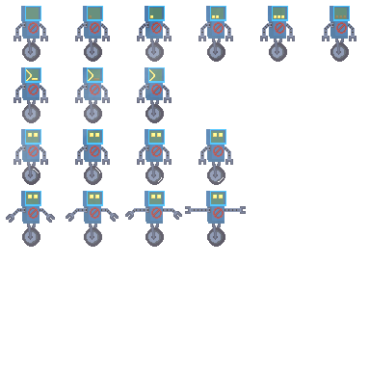

**Creation of “PixelPlatformer”[Tentative]**

**PREPARED BY:**

**The Codebot Creation Coalition**

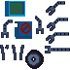

**The Codebot Coalition**

Brandon Catalano - Project Lead & Lead Programmer

Madison Goodwin - Documentation and Storyboard

Riley Gibson - Researcher & Asset Acquisition

Elric Flores - Assistant Programmer

**Table of Contents**

**1. Introduction** **4**

**2. The Problem/Application** **4**

**3. Style and Story** **4**

**4. Gameplay** **5**

**5. Movement Mechanics** **5**

**6. Audio** **5**

**7. Language** **6**

**8. Our Thoughts** **6**

**9. Source Code** **6**

**10. Sample Runs** **6**

**11. Functional Requirements** **6**

**12. Deliverable Plans** **7**

**Appendix A: Open Source Resources Used** **7**

# **1. Introduction**

This technical report centers around the creation of a 2D platformer internally titled PixelPlatformer. It focuses on the finalized and in-progress features of the PixelPlatformer game developed on the Godot Engine development environment in tandem with GDScript, Godot’s in-house programming language. Additionally, the game’s core focus on educating users on basic programming logic and its implementation into the 2d platformer’s level design is also detailed in the report.

# **2. The Problem/Application**

We plan to make an application with the goal of teaching users how to code by providing a foundation in logic. This will be done through movement commands in a terminal.

The game will include tile mapping and the character’s animations made with a sprite sheet. The character the user will control is a small robot. See sample image below; NOT FINAL CHARACTER DESIGN:

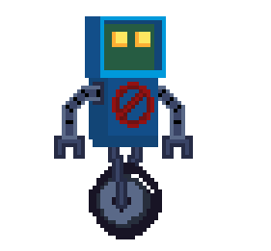

# **3. Style and Story**

The overall style of the game will be pixelated and have a storyline beyond the specific levels. As of right now, we plan to make 3 levels. The storyline will loosely be based off of the robot’s character escaping his old life(e.g. industrial background) and as the level progresses the background becomes more and more organic(e.g. cave and forest backgrounds).

# **4. Gameplay**

Gameplay will start with the robot being chased. The user can do simple movements with the robot using WASD and Spacebar. The robot will soon then trip and fall down a hole into a cavernous area. This new area means the pursuers have lost the robot and are no longer chasing him directly. The fall will hurt the robot character and the user will lose the WASD and Spacebar controls. The screen will fade to black and reappear with a command prompt UI, requiring the user to enter lines of code in order to control the robot.

In terms of camera angles we will have 2 options for the user to toggle from. There will be a zoomed out view of the entire level, which will be the default camera angle. Secondarily, there will be a zoomed in view of the character where the camera follows the character as it moves throughout the level during a run.

# **5. Movement Mechanics**

Below are listed the commands the robot is capable of.

| Command | Action |
| --- | --- |
| move_Right() | Moves the robot to the right until stop is specified by stop command. |
| move_Left() | Moves the robot to the left until stop is specified by stop command. |
| jump() | Makes the robot jump once. Movement is inherited from the moveRight() and moveLeft() command allowing for platforming. |
| stop() | Stops the robot from moving left or right using the moveLeft() and moveRight() commands respectively. Does not stop the jump() command as jumps naturally terminate via the forces of gravity. |

# **6. Audio**

This project will primarily use the .mp3 file format to store its audio. The game will feature a looping song to function as a background track, with a unique song featured in each level. Each of the differing areas will have a background track that corresponds with the environment. Additionally, most motions made by the player controlled character, such as jumping or moving left, will also have sound effects. When jumping, a thruster sound is made.

# **7. Language**

The application will be developed on the Godot Engine development environment in tandem with GDScript, Godot’s in-house programming language. We chose this environment for our project to explore its ease of use in terms of gaming development. None of the project contributors have worked with Godot Engine before, it will be a new experience for us.

# **8. Our Thoughts**

We expect this project will allow us to experience what it is like to collaborate as a team on a coding project. It will give us an idea of how best to approach communications and ideas. We expect the visual elements to be an easy part of this project whereas collaboration and setting realistic goals and expectations are expected to be a hard part of this project.

# **9. Sample Runs Screen Shots:**

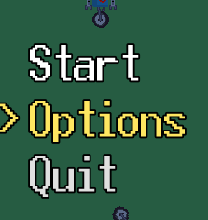

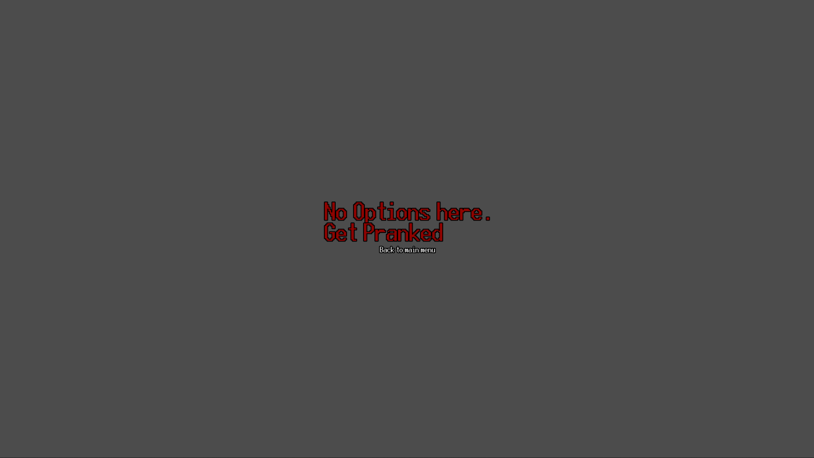

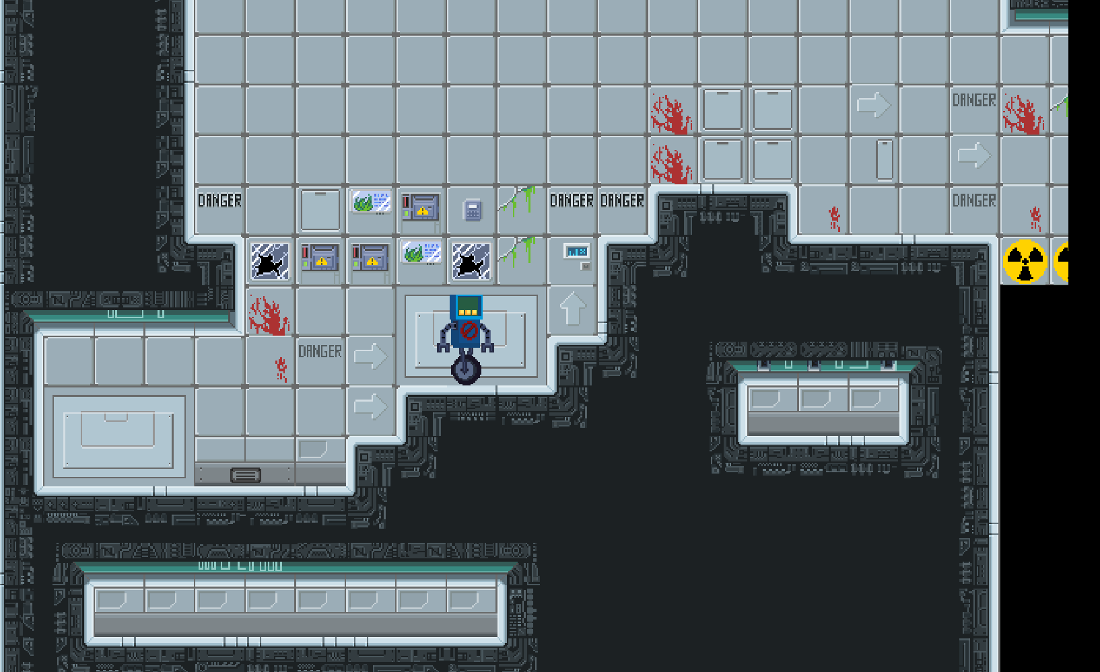

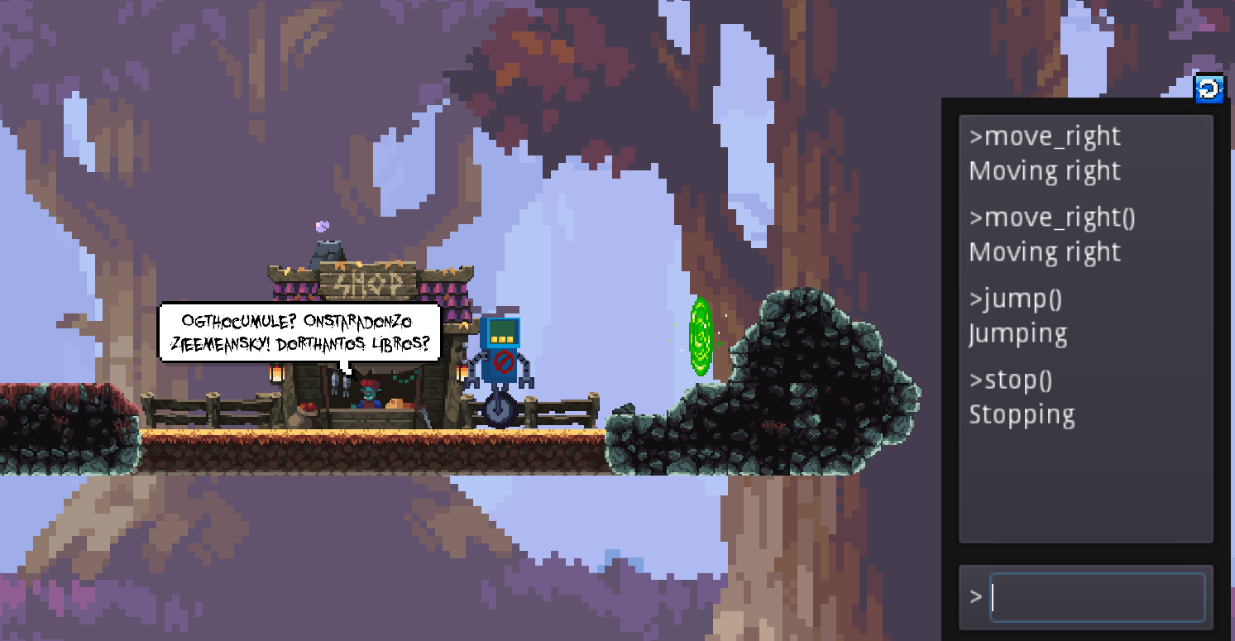

**Demo Video:**<https://youtu.be/6xF9RjMDQYI>

# **10. Functional Requirements**

Fully implemented:

* Parallax background
* Restart button
* Title screen and UI
* Teleporter for next level
* Lab floor tilemaps
* Background music
* Falling animation
* Jumping animation

Partially Implemented:

* Design levels
* Character design
* Sound design for the main character and enemies
* Custom mouse cursor

Not implemented:

* Implement level select
* Intro sequence/cutscene
* Enemies
* Pause menu

# **11. Deliverable Plans**

Set deadlines using project management software(Trello). Finish implementing all requirements listed.

Most of the base features required for the core features of the game have been implemented, leaving behind the less technical and easier to implement aspects that aren’t integral to the creation of the game.

# **Appendix A: Open Source Resources Used**

Below are listed the resources and assets we are using in this project:

| Title | Source |
| --- | --- |
| Oak Woods — Environment Asset | <https://brullov.itch.io/oak-woods> |
| Pixel Platformer World | <https://szadiart.itch.io/pixel-platformer-world> |
| Platformer Fantasy Set 1 | <https://szadiart.itch.io/platformer-fantasy-set1> |
| 2D Platformer Tileset - Laboratory | <https://exceptrea.itch.io/2d-platformer-tileset-laboratory> |
| 2D Pixel Art Portal Sprites | <https://elthen.itch.io/2d-pixel-art-portal-sprites> |
| UI Buttons | <https://kicked-in-teeth.itch.io/button-ui> |
| True Ghost Break (180 BPM) | <https://pixabay.com/sound-effects/true-ghost-break-180-bpm-102898/> |
| HoliznaCC0 - Blue Skies | <https://freemusicarchive.org/music/holiznacc0/lazy-summer-lofi-1/blue-skiesmp3/> |
| HoliznaCC0 - Spring At Last | <https://freemusicarchive.org/music/holiznacc0/spring-at-last-lofi-tape/spring-at-last/> |
| Cagey House - Shadow Time | <https://freemusicarchive.org/music/Cagey_House/Bottles_and_Bulletins/Shadow_Time_1063/> |
| Piano crash sound | <https://pixabay.com/sound-effects/piano-crash-sound-37898/> |
| large crash with cat | <https://pixabay.com/sound-effects/large-crash-with-cataiff-14490/> |
| Notification Sound | <https://pixabay.com/sound-effects/notification-sound-7062/> |
| Wooden Thud (Mono) | <https://pixabay.com/sound-effects/wooden-thud-mono-6244/> |
| Steve Combs - Hero | <https://freemusicarchive.org/music/Steve_Combs/Principal_Photography/Steve_Combs_-_Principal_Photography_-_01_Hero/> |
| Schemawound - Self-Surgery Manual | <https://freemusicarchive.org/music/Schemawound/Heart_Removal_kit/07-Schemawound-Self-Surgery_Manual/> |