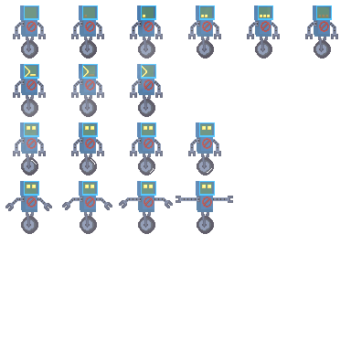

**Creation of “PixelPlatformer”[Tentative]**



**PREPARED BY:**

**The Codebot Creation Coalition**

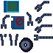

**The Codebot Coalition**

Brandon Catalano - Project Lead & Asset Creation

Madison Goodwin - Documentation and Storyboard

Riley Gibson - Researcher

Elric Flores - Lead Coder

**Table of Contents**

**1. Introduction** **4**

**2. The Problem/Application** **4**

**3. Style and Story** **4**

**4. Gameplay** **5**

**5. Movement Mechanics** **5**

**6. Audio** **5**

**7. Language** **5**

**8. Our Thoughts** **6**

**Appendix A: Open Source Resources Used** **6**

# **1. Introduction**

This technical report centers around the creation of a 2D platformer internally titled PixelPlatformer. It focuses on the finalized and in-progress features of the PixelPlatformer game developed on the Godot Engine development environment in tandem with GDScript, Godot’s in-house programming language. Additionally, the game’s core focus on educating users on basic programming logic and its implementation into the 2d platformer’s level design is also detailed in the report.

# **2. The Problem/Application**

We plan to make an application with the goal of teaching users how to code by providing a foundation in logic. This will be done through movement commands in a terminal.

The game will include tile mapping and the character’s animations made with a sprite sheet. The character the user will control is a small robot. See sample image below:

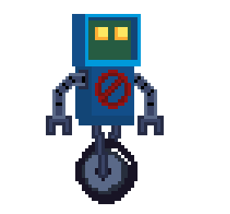

# **3. Style and Story**

The overall style of the game will be pixelated and have a storyline beyond the specific levels. As of right now, we plan to make 3 levels. The storyline will loosely be based off of the robot’s character escaping his old life with a valuable item(e.g. industrial background) and as the level progresses the background becomes more and more organic(e.g. cave and forest backgrounds).

# **4. Gameplay**

Gameplay will start with the robot being chased. The user can do simple movements with the robot using WASD and Spacebar. The robot will soon then trip and fall down a hole into a cavernous area. This new area means the pursuers have lost the robot and are no longer chasing him directly. The fall will hurt the robot character and the user will lose the WASD and Spacebar controls. The screen will fade to black and reappear with a command prompt UI, requiring the user to enter lines of code in order to control the robot.

In terms of camera angles we will have 2 options for the user to toggle from. There will be a zoomed out view of the entire level, which will be the default camera angle. Secondarily, there will be a zoomed in view of the character where the camera follows the character as it moves throughout the level during a run.

# **5. Movement Mechanics**

Below are listed the commands the robot is capable of.

| Command | Action |
| --- | --- |
| moveRight(parameter) | Moves the robot right a set length, but allows the user to specify a length through a parameter. |
| moveLeft(parameter) | Moves the robot left a set length, but allows the user to specify a length through a parameter. |
| jump | Makes the robot jump a set height. |
| use | Tells the robot to interact with or use objects on the map (i.e., a key to unlock an area). |

# **6. Audio**

This project will primarily use the .WAV file format to store its audio. The game will feature a looping song to function as a background track, with a unique song featured in each level. The soundtrack will be primarily composed of the Lo-Fi music genre. Additionally, most motions made by the player controlled character, such as jumping and moving, will also have sound effects that will also be in the .Wav file format.

# **7. Language**

The application will be developed on the Godot Engine development environment in tandem with GDScript, Godot’s in-house programming language. We chose this environment for our project to explore its ease of use in terms of gaming development. None of the project contributors have worked with Godot Engine before, it will be a new experience for us.

# **8. Our Thoughts**

We expect this project will allow us to experience what it is like to collaborate as a team on a coding project. It will give us an idea of how best to approach communications and ideas. We expect the visual elements to be an easy part of this project whereas collaboration and setting realistic goals and expectations are expected to be a hard part of this project.

# **Appendix A: Open Source Resources Used**

Below are listed the resources and assets we are using in this project:

| Title | Source |
| --- | --- |
| Oak Woods — Environment Asset | <https://brullov.itch.io/oak-woods> |
| Pixel Platformer World | <https://szadiart.itch.io/pixel-platformer-world> |
| Platformer Fantasy Set 1 | <https://szadiart.itch.io/platformer-fantasy-set1> |

.