Project Case | 
ISYS6200 | ISYS6200003
Data Warehouse
Information Systems | O252-ISYS6200-TO01-00
Valid on Odd Semester Year 2024/2025 | Revision 00

- Kelompok tidak diperkenankan untuk:
Members of the group are prohibited from:
    - Melihat sebagian atau seluruh jawaban kelompok lain,
Seeing a part or the whole answer from other groups,
    - Menyadur sebagian atau seluruh jawaban dari buku, catatan, video, dan jenis referensi lainnya,
Retell a part or the whole answer from books, notes, videos, and other references,
    - Menyadur sebagian atau seluruh jawaban dari internet,
Retell a part or the whole answer from the internet,
    - Mengumpulkan jawaban yang tidak sesuai dengan tema soal,
Submitting an answer with a different theme from the given case,
    - Melakukan tindakan yang menyebabkan jawaban dicontek oleh orang lain atau kelompok lain, baik disengaja maupun tidak disengaja,
Doing action that could result the answer being copied by someone or other groups, intentionally or unintentionally,
    - Melakukan tindakan kecurangan lainnya.
Committing other dishonest actions.

- Jika kelompok terbukti melakukan tindakan seperti yang dicantumkan pada butir ke-1, maka nilai mahasiswa dan/atau kelompok yang melakukan kecurangan, baik menyontek atau dicontek, akan dinolkan sesuai dengan peraturan yang berlaku.
If it has been proven that a group has committed dishonest actions outlined in point 1 above, the whole groups related to the incident, regardless of which one copies or has their answer copied, will be issued a score of zero according to the regulation.

- Jawaban yang dapat diterima dan dinilai adalah jawaban yang dikumpulkan sebelum batas waktu yang telah ditentukan.
The answer must be submitted before the designated deadline to be accepted and graded,

- Jawaban akan dinilai berdasarkan teknik atau metode yang diajarkan pada kelas praktikum dengan menggunakan software yang sudah ditentukan.
The scoring will be based on the materials taught during the practicum classes using the designated software. Using different software than requested may result in your answer not being graded.

- Jika Anda tidak membaca peraturan ini, maka Anda dianggap sudah membaca dan menyetujuinya.
By taking this exam, you agree to these regulations, regardless of whether you have read it or not.

- Persentase penilaian untuk matakuliah ini adalah sebagai berikut:
The score will be distributed as follows:
Tugas Mandiri  Assignment | Proyek  Project | UAP  Final Exam
30% | 30% | 40%

- Perangkat lunak yang digunakan pada matakuliah ini adalah sebagai berikut:
This course uses the following software:
Software
Software
Microsoft Office 365
SQL Server Developer 2019
SQL Server Management Studio 18.9.1
Visual Studio 2022
Visual Studio 2022 – Microsoft Analysis Service Projects 3.0.11
Visual Studio 2022 – Microsoft Reporting Service Projects 3.0.7
Visual Studio 2022 – SQL Server Integration Services Projects 1.0.1

- Ekstensi file yang harus dikumpulkan untuk matakuliah ini adalah sebagai berikut:
Your answers must be in the following file extensions:
Tugas Mandiri  Assignment | Proyek  Project | UAP  Final Exam
BAK, SQL, DOCX, Folder Project (SLN, ISPAC, PARAMS, DTSX, USER, DTPROJ, DATABASE, XML) | BAK, SQL, DOCX, XLSX, Folder Project (SLN, ISPAC, PARAMS, DTSX, USER, DTPROJ, XML, DATABASE, CUBE, PARTITIONS, DS, DSV, DIM, DWPROJ, ASDATABASE, CONFIGSETTING, DEPLOYMENTOPTIONS, DEPLOYMENTTARGETS) | BAK, SQL, DOCX, XLSX, Folder Project (SLN, ISPAC, PARAMS, DTSX, USER, DTPROJ, XML, DATABASE, CUBE, PARTITIONS, DS, DSV, DIM, DWPROJ, ASDATABASE, CONFIGSETTING, DEPLOYMENTOPTIONS, DEPLOYMENTTARGETS)

- File yang harus dikumpulkan adalah keseluruhan jawaban beserta dengan aset yang digunakan (gambar, audio, video, dll) dan dokumentasi proyek yang berisikan link referensi aset dan penjelasan mengenai aplikasi yang dibuat (terlampir bersama dengan soal).
Include other files that can support your project, such as: all files in your project, other files (image, audio, video, etc.) used in your project, *.doc file (documentation of your project) that contains all pages in your project, reference links of additional files (image, audio, video, etc.) used in your project, the description about how to use your application, etc.

Soal
Case

BarbershopTO
BarbershopTO is a dynamic establishment specializing in barber services, located in Tokyo. To improve the customer’s experience and efficiency of transactions, BarbershopTO needs a database system that can analyze the operational data for decision making. Therefore, you as BarbershopTO’s database administrator are asked to implement data warehousing in the shop using Microsoft SQL Server 2019. This initiative aims to consolidate and analyze operational data for informed decision-making and improved customer experience.
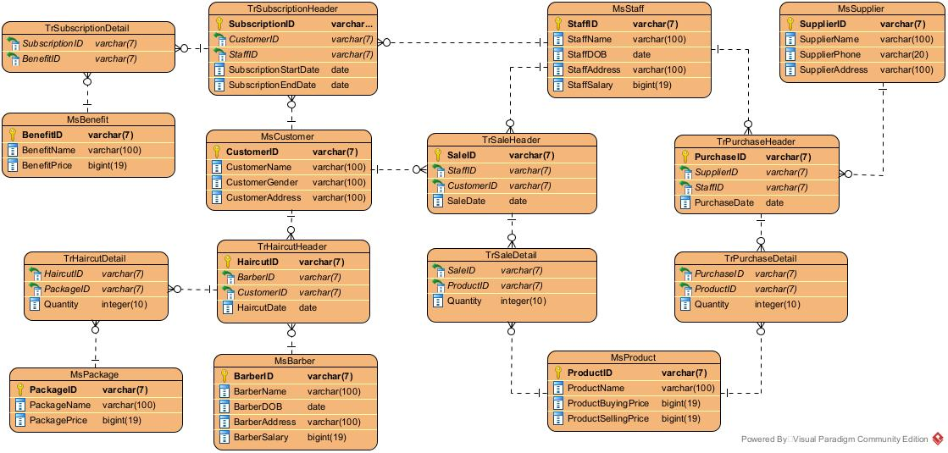
Figure 1. Entity Relational Diagram of BarbershopTO

After doing an interview with the CEO of BarbershopTO, you get lots of information. Here are the requirements obtained from the interview:
- There are four measurements that must be able to be created:
- There are two measurements for Sales Transaction, which are:
  - Calculate total sales earnings acquired from total of multiplication between haircare product price and quantity of products sold.
  - Calculate total haircare products sold which is acquired from total of quantity of products sold.
- There are two measurements for Purchase Transaction, which are:
  - Calculate total purchase expense which is acquired from total of multiplication between product buying price and quantity of products bought.
  - Calculate total material purchased which is acquired from total of quantity of products bought.
- There are two measurements for Subscription Transaction, which are:
  - Calculate total subscription earning which is acquired from total of benefit price.
  - Calculate total subscriber which is acquired from total count of subscription transaction that occurred.
- There are two measurements for Haircut Transaction, which are:
  - Calculate total haircut earning which is acquired from total of multiplication between haircut package price and quantity of ordered packages.
  - Calculate total barbers from total count of barbers that gave the haircuts.

- There are seven dimensions that must be able to be created:
- For product dimension requested as follows
  - The CEO needs data to analyze selling profit of haircare products.
  - The CEO needs data to analyze expenses needed to buy haircare products.
- For barber dimension requested as follows
  - The CEO needs data to analyze which barbers should be retired to decide how many barbers need to be hired in the future.
  - The CEO needs data to analyze the barbers’ performance and their salary to decide whether the barber is eligible for a raise.
  - The CEO needs data to analyze the location which has the greatest number of barbers to decide the location of the new branch.
- For staff dimension requested as follows
  - The CEO needs data to analyze which staff should be retired to decide how many staff need to be hired in the future.
  - The CEO needs data to analyze staff performance and their salary to decide whether staff are eligible for a raise.
  - The CEO needs data to analyze the location which has the greatest number of staff to decide the location of the new branch.
- For customer dimension requested as follows
  - The CEO needs data to analyze the location which has the greatest number of customers to decide the location of the new branch.
  - The CEO needs data to analyze which haircut packages are frequently bought by the customer based on gender to decide what kind of promo will be issued.
- For benefit dimension requested as follows
  - The CEO needs data to analyze the benefit that is most preferred by customers and its current price to decide the price of benefit in the future.
- For package dimension requested as follows
  - The CEO needs data to make decisions about selling profit.
- For supplier dimension requested as follows
  - The CEO needs data to analyze the location which has the greatest number of suppliers to decide the location of the new branch.
  - The CEO needs data to analyze the provider of telecommunications that has the greatest number of suppliers for the purpose of establishing cooperation with the provider company.

- There are four facts that must be able to be created:
  - The sales transaction report must be able to be viewed in terms of product, staff, and customer.
  - The purchase transaction report must be able to be viewed in terms of product, staff, and supplier.
  - The subscription transaction report must be able to be viewed in terms of customer, staff and benefit.
  - The haircut transaction report must be able to be viewed in terms of customer, package and barber.

- There are some requirements related with the table dimension:
  - Customer gender have Male or Female as its value with a varchar data type of transaction data, and will be replaced with a M for Male, otherwise is F on analytical data.
  - Customer address, supplier address, supplier phone, barber address, and staff address, can be updated and old data don’t have to be stored.
  - Barber salary, benefit price, product buying and selling price, staff salary, and haircut package price can be updated, but old data must be kept.

According to the information that you gained, here are your tasks:
- Create measurements with aggregate function that is used for the measure according to the requirement!
- Determine the attribute or field for each dimension and fact table!
- Create and design OLAP table based on your analysis!
- Create ETL process for each dimension and fact table using Visual Studio Integration Services Project!
- Create Cube using Visual Studio Multidimensional Project!
- Create Pivot using Microsoft Excel!
- Create documentation that consists of the design of the scheme and how to generate the ETL dimension, ETL fact, cube, and pivot!

