**Lab #1 – Introduction to Raspberry Pi and I/O**

Nathan Fant and Brandon Collings, Group #12, Friday 3:30PM

**Exercise 1**

1.1 Summary

This section consisted of several basic Unix/Linux operations to help ensure that we understood how to navigate around the directories inside the Raspberry Pi. We used commands such as list directory, make directory, move, and copy. We ended by creating a directory called group_12 that will contain all of our files for this class on the Raspberry Pi.

**Exercise 2**

2.1 Screenshots & Tables

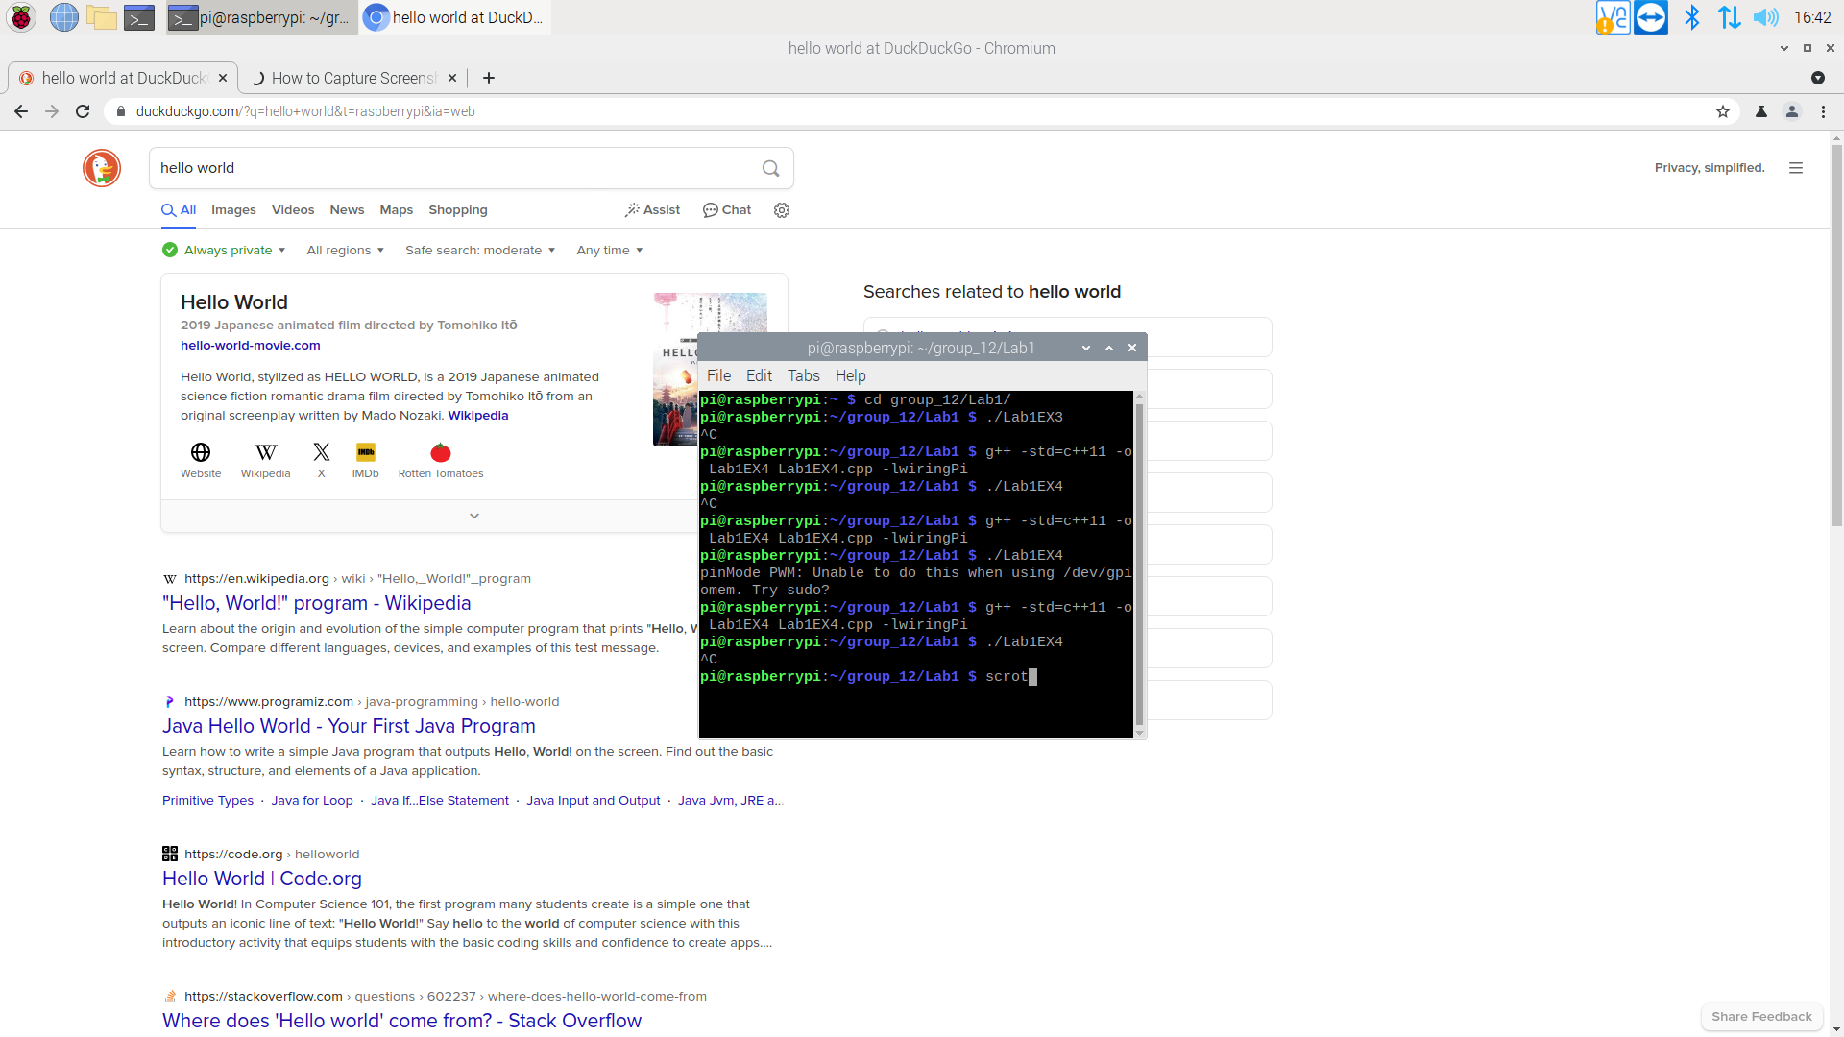

Internet Connection and the Directory Generated in Exercise 1

2.2 Summary

This section included setting up a wifi connection to eduroam on the Raspberry Pi and installing Visual Studio Code on the desktop. It also included setting up a remote connection from the desktop to the Raspberry Pi via ssh using Visual Studio Code.

**Exercise 3**

3.1.1 Circuit

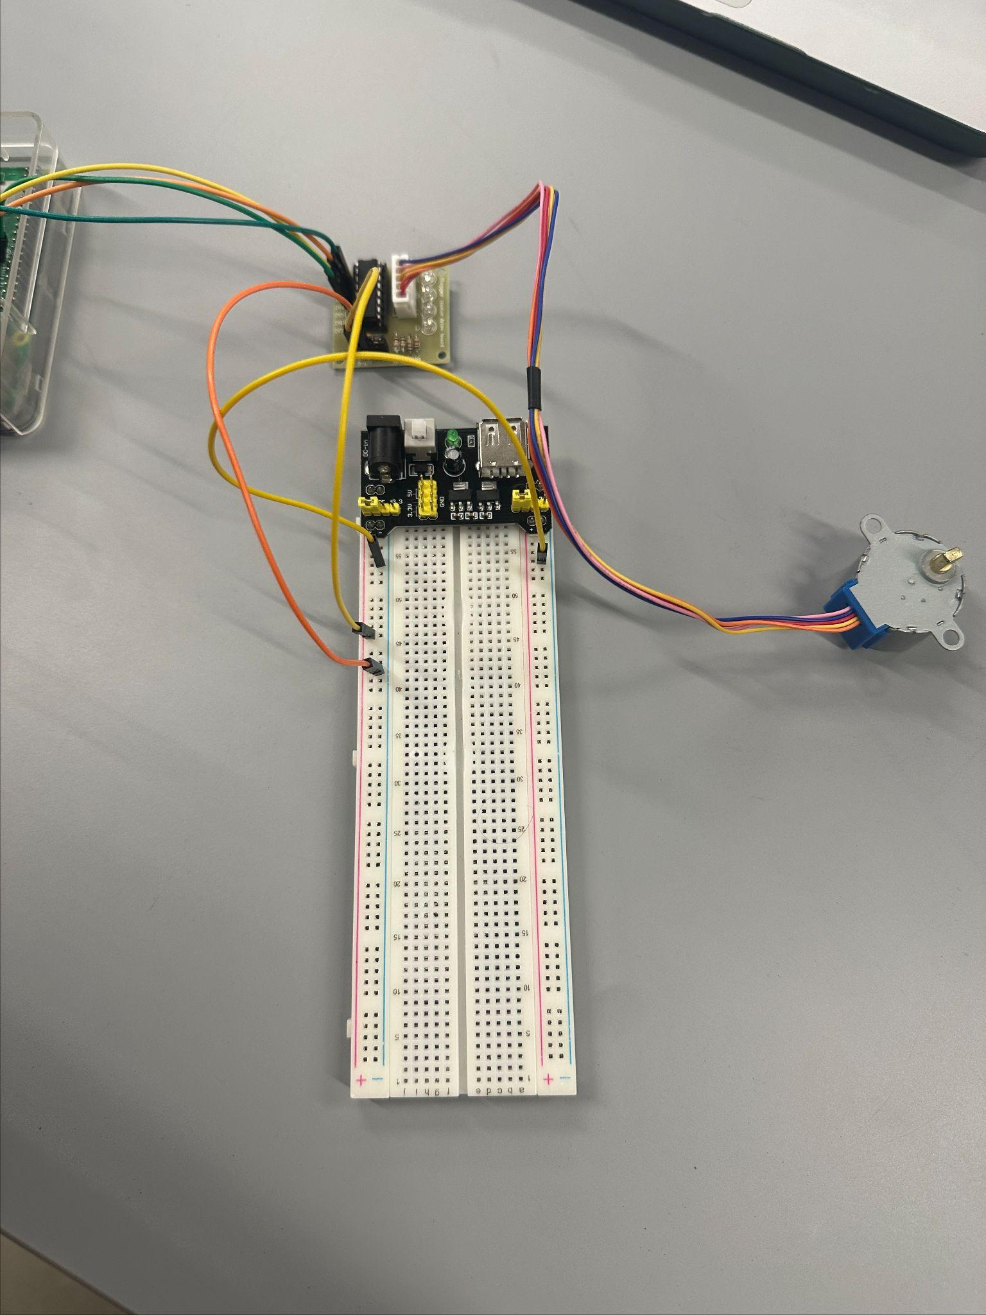

3.1.2 Summary

For Exercise 3, we generated control signals to rotate a stepper motor clockwise (CW) and counter-clockwise (CCW). We built the circuit as prescribed by the lab document. We then completed the code to get the stepper motor to rotate 360 degrees CW with the proper phase order and speed. We then did the same to have it go in the CCW direction. We utilized the wiringPi library to connect the stepper motor to the RaspberryPi and used the digitalWrite function within the library to send commands.

**Exercise 4**

4.1.1 Circuit

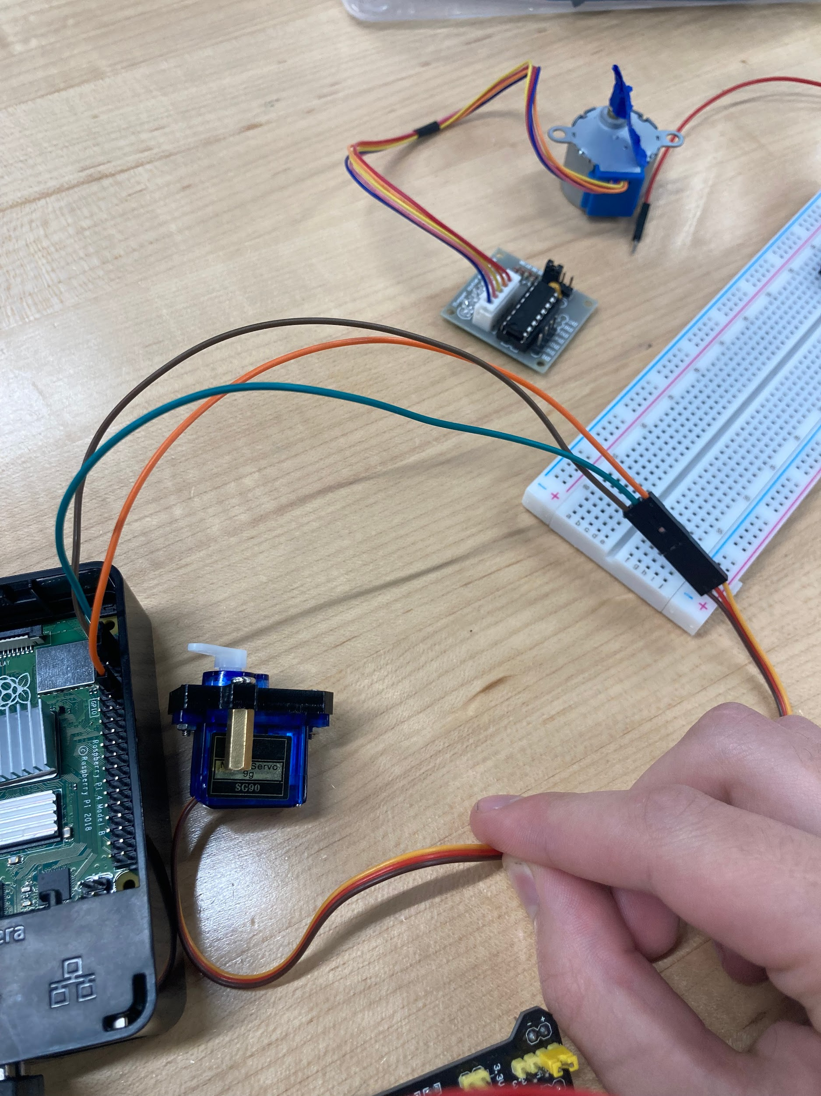

Servo Connected to the Raspberry Pi

4.1.2 Summary

In this section, we connected a servo to the Raspberry Pi’s GPIO pins. Using the WiringPi library, we set up the pins to output a pulse width modulation (PWM) signal and calculated the necessary PWM signal to rotate the servo from 0 to 180 degrees and back from 180 to 0 degrees.

**Exercise 5**

5.1.1 Circuit

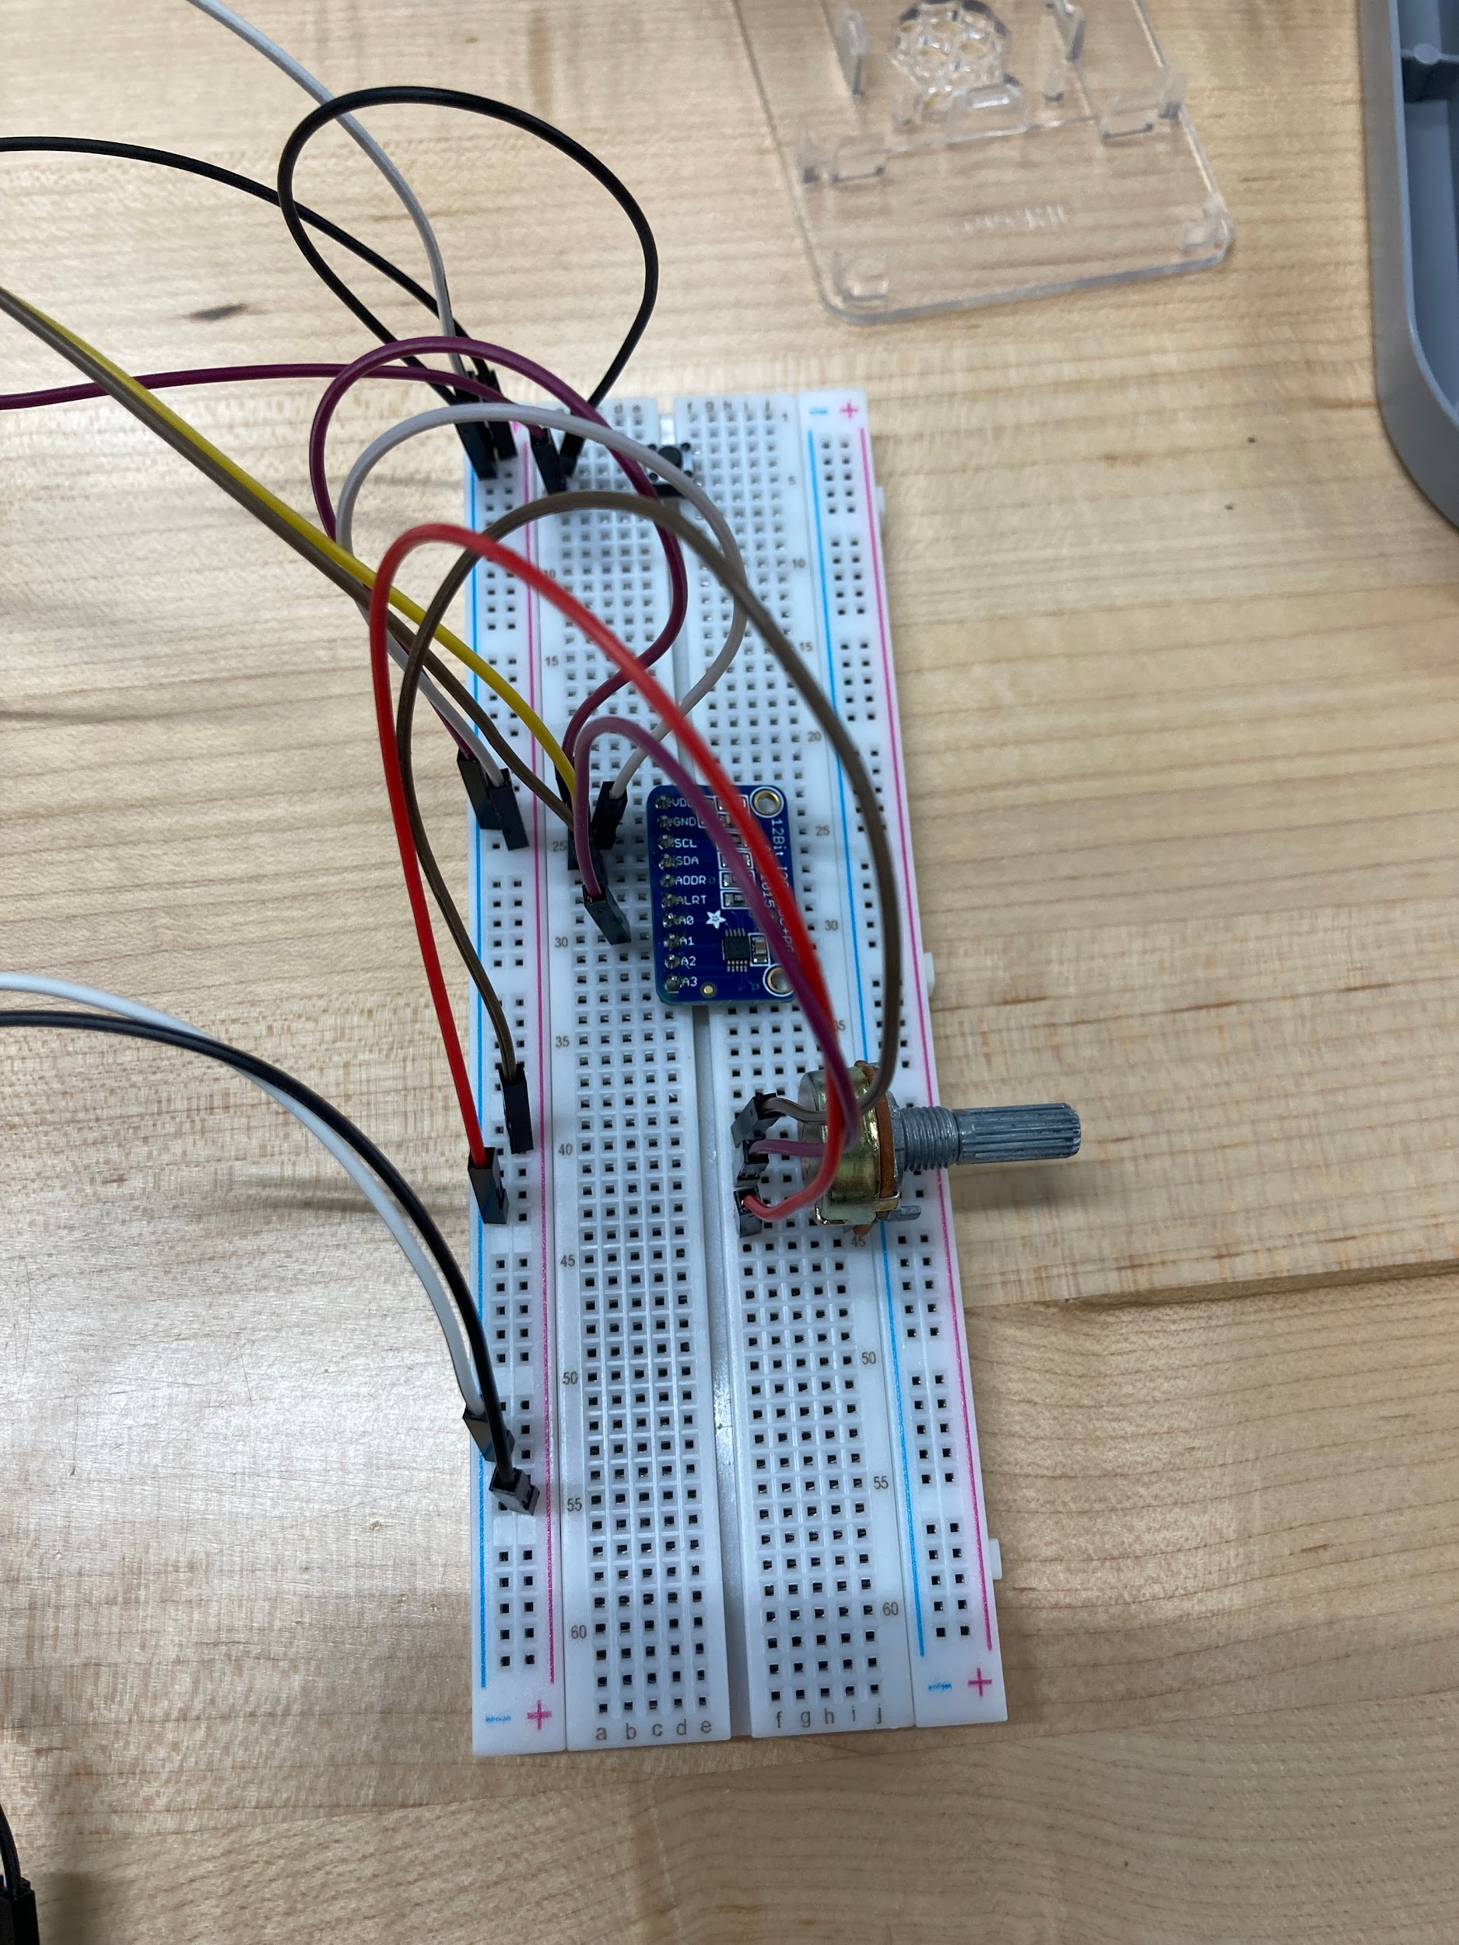

ADC, Button, and Potentiometer Connected to the Raspberry Pi

5.1.3 Summary

In this section, we connected a potentiometer to an ADC to vary the analog voltage. The ADC was connected to the Raspberry Pi using I2C. Based on the output digital value of the ADC, the Raspberry Pi would change the angle of a connected servo. A button connected to a different GPIO pin would select which direction the servo would turn.

**Supplemental Questions**

1. Briefly summarize what you learned from this lab.

In this lab, we gained a refresher on our Unix/Linux commands and all that we had learned about programming the Raspberry Pi in ECEN3213 Computer-Based Systems. In Particular, we relearned about the WiringPi library and its functions, interrupts, and the I2C protocol.

1. What is the advantage of using interrupts?

Using interrupts is less resource-intensive compared to active polling. The processor is not constantly checking for a change in signal to act but rather acts upon a change in signal.

1. Explain the differences between stepper motors and servo motors and DC motors.

Stepper motors have several dozen magnetic poles within them that guide the shaft to turn. Everything is done in phases, so to turn, you have to activate the next pair of magnets. The phases go in order to turn, so the A pair is activated, then the B, then the C, and so on. Servo motors are much more accurate in their positioning, but cannot continuously rotate. They are used in more precision-based applications (ex. arms instead of wheels). A PWM signal is sent and then received and interpreted as an angle. For example, 0 degrees is a 0.5 ms pulse width and 180 degrees is a 2.5 ms one. DC motors are more crude than stepper motors or servo motors. They consist of one or two permanent magnetic pairings in the housing, then the shaft is connected to an armature that is an electromagnet. A current is then sent through the armature that is opposite the current orientation as compared to the permanent magnets. This then causes a repulsive force that turns the shaft.

**Acknowledgements**

We certify that this report is our own work, based on our own personal study and research and that we have acknowledged all material sources used in its preparation, whether it be books, articles, reports, lecture notes, and any other kind of document, electronic or personal communication, We also certify that this report has not previously been submitted for assessment anywhere, except where specific permission has been granted from the coordinators involved.

Nathan P. Fant

Author 1

Brandon Collings

Author 2

**References**

1. Provided Lab Manual
2. Provided Supplemental Documentation