# MoteinoUSB_rfm69pi_JeeLib

This is firmware for a Motenio USB from Low Power Lab (lowpowerlab.com) with RFM69CW radio that allows it to act as an emonHub interfacer. This firmware uses the JeeLib “Classic” radio library. It can be a useful addition to an emonBase running the newer LowPowerLab radio library, allowing additional backwards-compatible communication with JeeLib devices (such as emonTx V3 or emonTh). See the diagram below.

This is the RFM2Pi/RFM69Pi firmware by Glyn Hudson and Trystan Lea compiled for use on a Moteino USB, which is an Arduino Uno-compatible board. The RFM69Pi Raspberry Pi hat requires a custom board due to its use of the internal 8Mhz oscillator. Thus, the same sketch will run on both devices, but must be compiled for each device in specific.

Here is the repository of the RFM69Pi firmare: [openenergymonitor/RFM2Pi: RFM12B to Raspberry Pi board (github.com)](https://github.com/openenergymonitor/RFM2Pi)

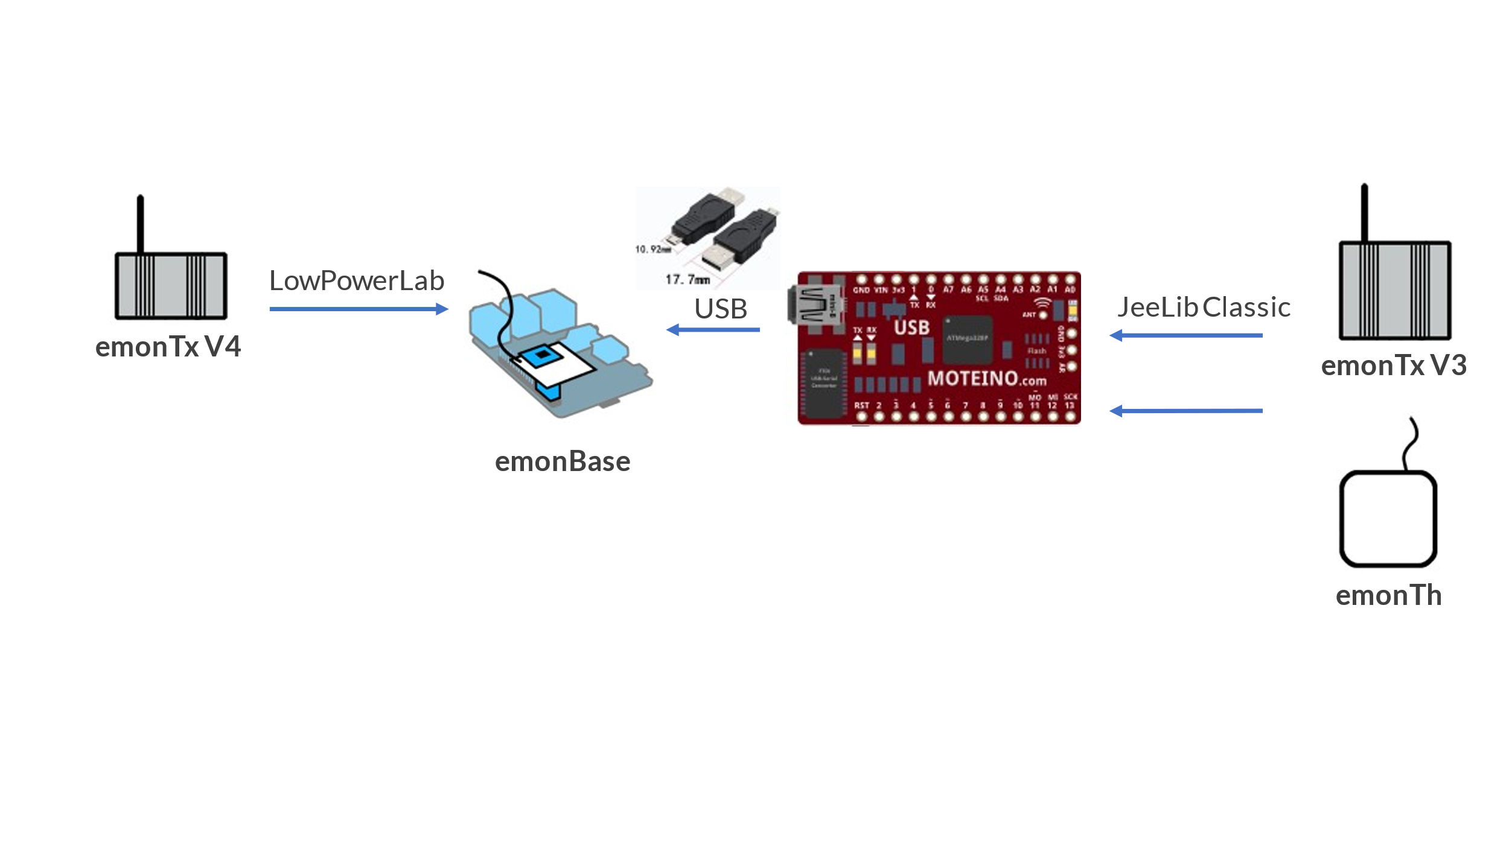

Add the following to the [interfacers] list in emonHub config, where ttyUSB0 is replaced by whatever device ID is assigned to your Moteino USB.

[[SerialDirect]]

Type = EmonHubJeeInterfacer

[[[init_settings]]]

com_port = /dev/ttyUSB0

com_baud = 38400

[[[runtimesettings]]]

pubchannels = ToEmonCMS,

subchannels = ToRFM12,