# MoteinoUSB_rfm69pi_LPL

This is firmware for a Motenio USB from Low Power Lab (lowpowerlab.com) with RFM69CW radio that allows it to act as an emonHub interfacer. This firmware uses the LowPowerLab radio library. It can be a useful addition to an existing emonBase running the JeeLib Classic radio library, allowing additional communication with a LPL-radio device (such as emonTx4). See the diagram below.

This is the emonBase_rfm69pi_LPL firmware by Glyn Hudson, Trystan Lea & Robert Wall compiled for use on a Moteino USB, which is an Arduino Uno-compatible board. The RFM69Pi Raspberry Pi hat requires a custom board due to its use of the internal 8Mhz oscillator. Thus, the same sketch will run on both devices, but must be compiled for each device in specific.

Here is the repository of the RFM69Pi firmare: [openenergymonitor/emonBase_rfm69pi_LPL: emonBase rfm69pi LowPowerLabs radio format (github.com)](https://github.com/openenergymonitor/emonBase_rfm69pi_LPL)

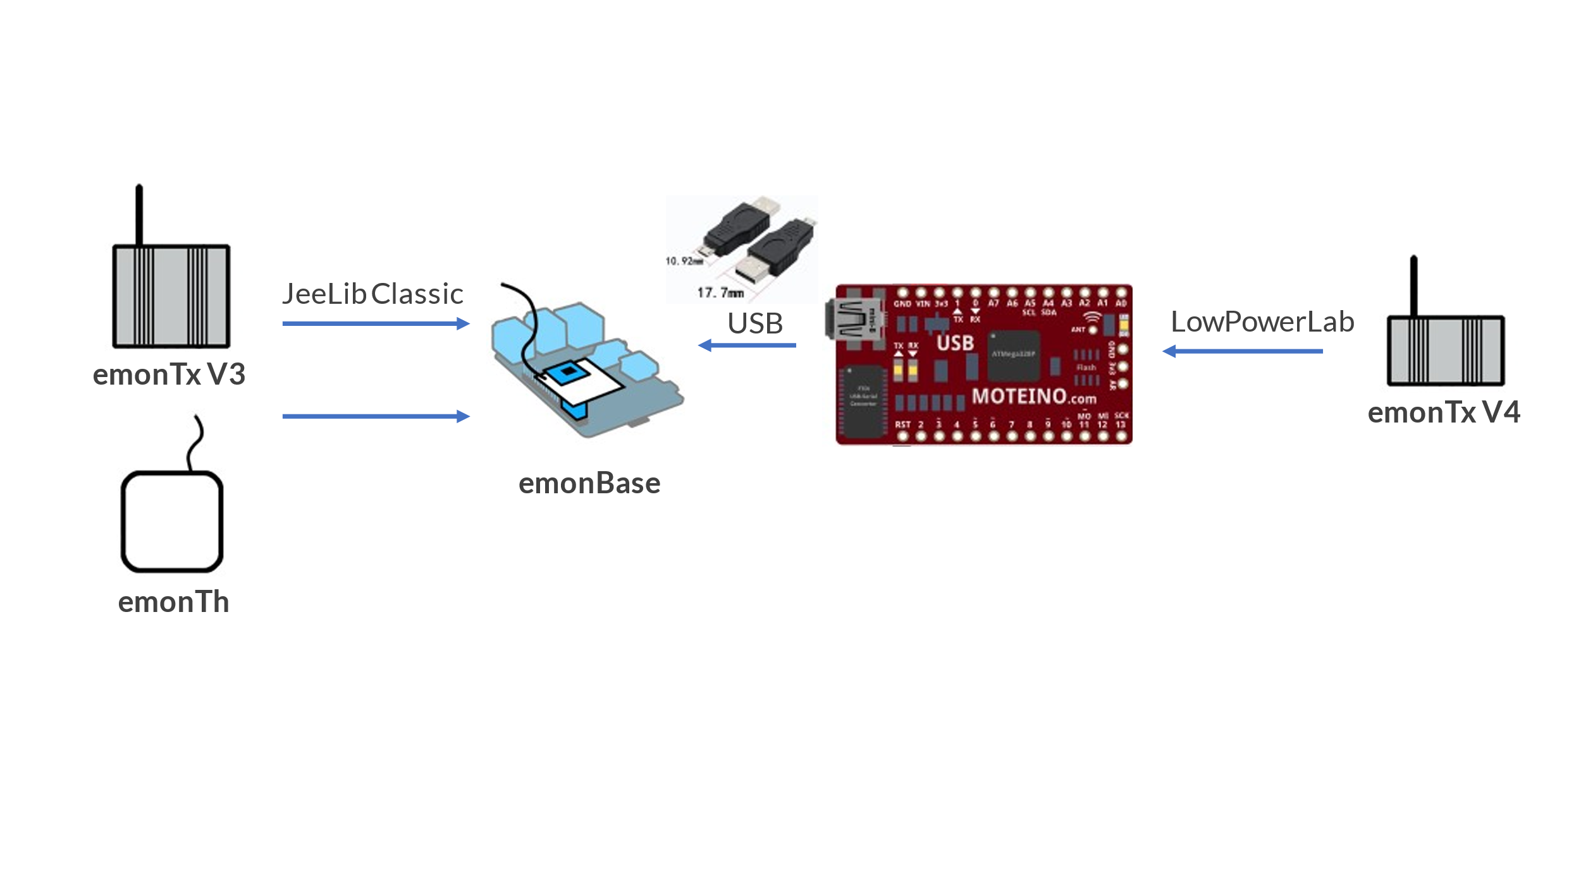

Add the following to the [interfacers] list in emonHub config, where ttyUSB0 is replaced by whatever device ID is assigned to your Moteino USB.

[[SerialDirect]]

Type = EmonHubJeeInterfacer

[[[init_settings]]]

com_port = /dev/ttyUSB0

com_baud = 38400

[[[runtimesettings]]]

pubchannels = ToEmonCMS,

subchannels = ToRFM12,