<Course Management System>

**Design Document**

|  |  |
| --- | --- |
| Version: |  |
| Print Date: | 04/06/2018 |
| Release Date: | 04/09/2018 |
| Release State: |  |
| Approval State: | Approved |
| Approved by: | Brandon Mathew, Sama Rahimian, Abdullah Khan, Moe Moselhy |
| Prepared by: | Brandon Mathew, Abdullah Khan |
| Reviewed by: | Sama Rahimian, Moe Moselhy |
| Path Name: | /CMS.doc |
| File Name: |  |

# Document Change Control

|  |  |  |  |
| --- | --- | --- | --- |
| **Version** | **Date** | **Authors** | **Summary of Changes** |
| 1.0 | 04/06/2018 | Brandon Mathew | Added introductions |
| 2.0 | 04/08/2018 | Brandon Mathew | Created diagrams and descriptions |
| 3.0 | 04/06/2018 | Abdullah Khan | Created diagrams and descriptions |

# Contents

1 Introduction 4

1.1 Overview 4

1.2 Resources - References 4

2 Major Design Decisions 5

3 Architecture 5

4 Detailed Class Diagrams 5

4.1 UML Class Diagrams 5

# Introduction

## Overview

*The sections and their corresponding content will be explained here. Section 1.2 references the SRS document, and includes important information surrounding non-functional requirements. Section 2 discusses the design decisions our team undertook in the construction of this software. Section 3 illustrates the architectural aspects of this software project via the use of component and deployment diagrams. Section 4 contains the class diagram containing all added methods, and created using ObjectAid.*

## Resources - References

*As outlined in the SRS, this project was built using the Java programming language with the Eclipse Oxygen IDE in a Windows environment. Since the project is cross-platform, it can be run on both Windows and Unix-like machines such as Linux. The software itself can be executed via command-line or terminal arguments. The user must have Java 8.0 installed on their machine prior to execution.*

# Major Design Decisions

*Included in the software project was a large class titled “Operations” that contained all the possible operations or functions available to the users as methods. A sample user database “loginDB” was also created to test the login functionality of the system.*

*The project was broken into several packages. Each package represented a specific functionality of the software’s backend, excluding the root (default package). Root contains the front-end of the software, as well classes that bridge data between other back-end classes and the front-end.*

# Architecture

*This software project is based on the Agile architecture framework. It follows several of the seven Agile architectural principles outlined by SAFe.*

## Component Diagram

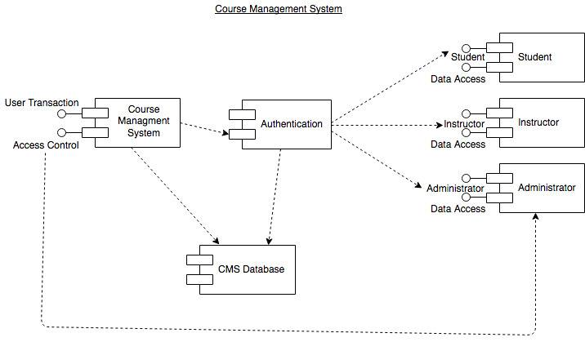

## Deployment Diagram

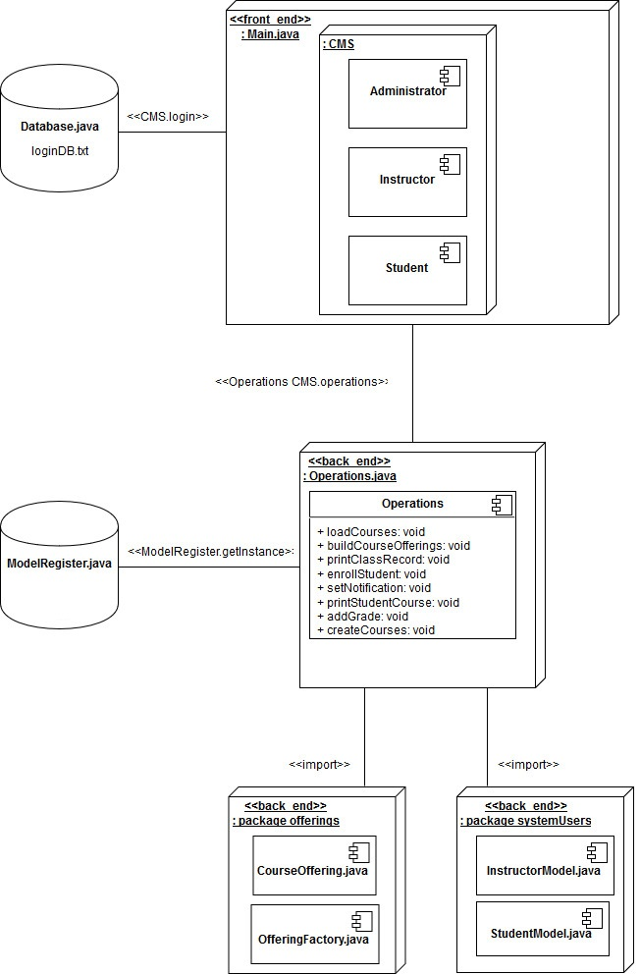

# Detailed Class Diagrams

## UML Class Diagrams

*The class diagrams were created using ObjectAid for Eclipse IDE.*

