Name: __Brandon Guo____ __Roland Wang

EID: __bmg3364_____ __rxw62

Semester: Spring 2026
Course: ECE445L

A) Objectives:
- Describe in a few sentences what the purpose of this lab is.
Learn how to use the logic analyzer. Learn how to identify and fix critical section errors. Practice using a scope. Understand CLT. Understand what causes jitter. Understand how interrupts work and how they cause critical section errors.
Both partners have agreed to the team contract (Check box if true). ☒ CHECK
https://docs.google.com/document/d/1b0H_l2s_C3Buwb_I0p0ZEJCIzjKjUqObAgL3oR6PWzI/edit?usp=sharing

B) Hardware Design Deliverables:
- Include the circuit used to produce the analog voltages you measured. For most students, this is simply a copy-paste of either Figure 2.1 or 2.2.

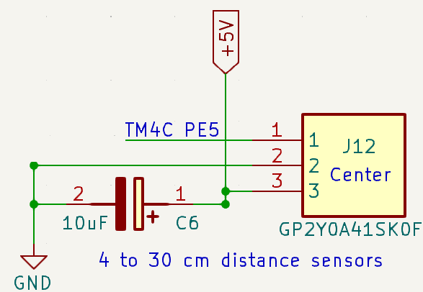

C) Software Design Deliverables:
- I have pushed my code to Git Hub for grading (Check box if true).
☒

D) Measurement Data:
- Measuring noise with the DVM.
Signal = 2.01
Noise = .018
SNR = 111.67
ENOB = 7

- Measuring noise with the oscilloscope.
Signal = 2.3
Noise = .0135
SNR = 170
ENOB = 8

- Observing the noise profile with a spectrum analyzer. Show photo or screen shot of amplitude versus frequency.

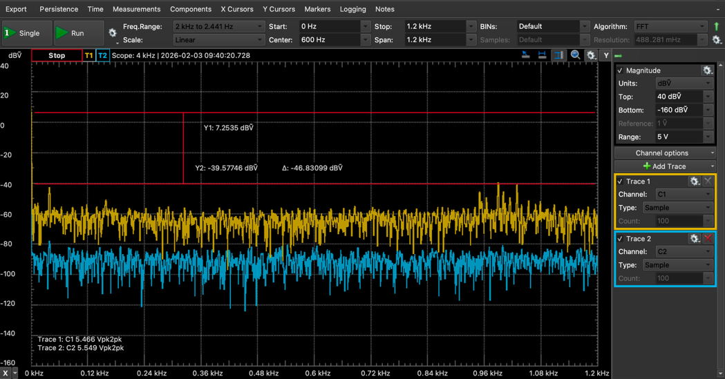

- Measuring noise using software (with no hardware averaging ADC0_SAC_R=0).
Signal = 2924
Noise = 25
SNR = 116
ENOB = 7
- Measuring time jitter.
Tmax = 80008 1.002
Tmin = 79992 .9998
Jitter = 4 micro second

- Observe the critical section. Take a screenshot or photo like Figure 2.5.
- Explore the behavior of the CLT.
Averaging | SAC | SNR | ENOB
1 | 0 | 128 | 6
2 | 1 | 114 | 6
4 | 2 | 112 | 6
8 | 3 | 119 | 6
16 | 4 | 134 | 6
32 | 5 | 184 | 7
64 | 6 | 289 | 8
Two PMF plots: one for SAC = 0 and another with your choice of SAC, like Figure 2.6.

Blue is Averaging 1. Orange is Averaging 64.

- Perform a calibration: show a table with truth, ADC, and measured value. Calculate the average error of the calibration.

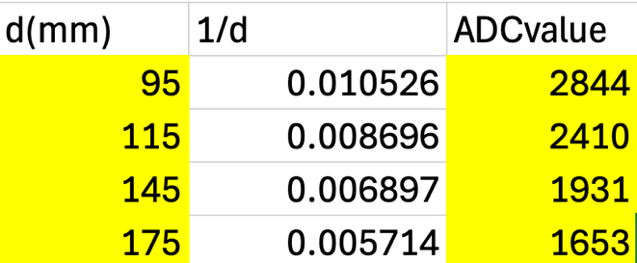

E) Analysis and Discussion Questions (1 or 2 sentences each):

- This system toggles GPIO pins to profile when and where the software is executing. Is this debugging intrusive, nonintrusive or minimally intrusive? Justify your answer.
It is minimally intrusive because the CPU must spend a cycle executing the instruction.

- Finish these 4 statements.
The advantage of the DVM to measure noise is that I provides precise measurements of voltage.
The advantage of the scope to measure noise is that it allows you to visualize the signal through time so you can see the variation.
The advantage of the spectrum analyzer to measure noise is that you can separate the signal by frequency allowing you to see which frequencies cause the noise.
The advantage of the software to measure noise is that you can customize it to calculate things like jitter to debug.

- Explain the method you used to remove the critical section. What other approaches could you have used?

I used bit specific addressing. This changes only the one bit you are trying to toggle and not the whole byte/register. You can also disable interrupts before the critical section and enable them after.

- This line of code involves a divide operation.
InvokesDivide = (InvokesDivide*12345678)/12345;
The divide instruction on the Cortex M4 requires 2 to 10 bus cycles to execute, and it is atomic. Explain why this line of C does not create a 10 bus-cycle sampling jitter. Hint: observe the assembly code created by the compiler. Note: the answer will depend on your compiler. I.e., your compiler might create a 10 bus-cycle jitter.

The compiler realizes the divide by 12345 is the same as multiply by 1/12345 so it becomes optimized and quicker.

- The PMF results will show hardware averaging is less noisy than not averaging. If it is so good, why don’t we always use it? Compare the following logic analyzer trace to Figure 2.6. Explain why this configuration required 65us to execute the ISR.
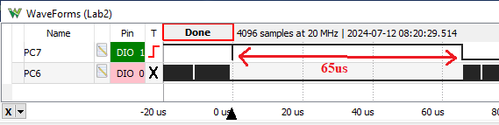

It is much slower when averaging increases because that is more time that has to be spent gathering a voltage to then average. So while it might be more accurate, it comes with the trade off that it will be slower and that your sampling rate is capped.

- ADC Resolution is defined as the change in analog input that can be reliably detected. A simple estimate of ADC resolution is the standard deviation your software calculated when the input is constant. Another estimate of ADC resolution uses the PMF. The following four PMFs were obtained with a precision analog reference voltage connected to the analog input of a TM4C123 LaunchPad. Hardware averaging of 64 was used. Using the PMF plots, if the input were to change from 1.6500V to 1.6505V it could not be reliably detected, because the PMFs overlap. However, if the input changes from 1.6500V to 1.6510V, it can be reliably detected, if we define reliably as “more likely than not”. Therefore, what is this ADC resolution?
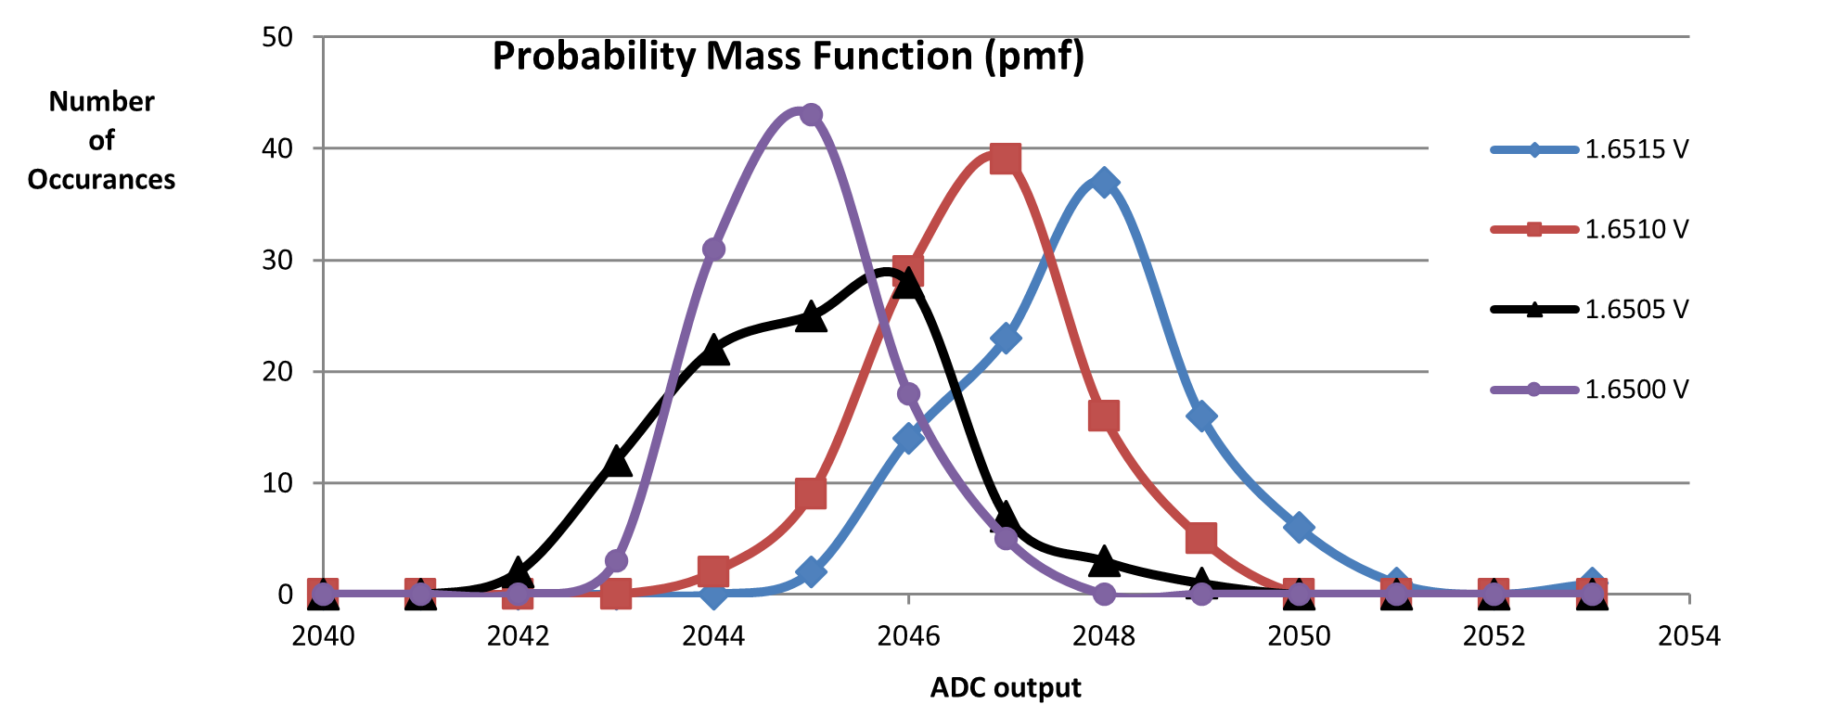

The resolution is .001V or 1 mV

