Name: __Replace with your name(s)____

EID: __Replace with your EID(s)_____

Semester: Spring 2026
Course: ECE445L

- Requirements Document:
- I have completed the Project Requirements Document at the end of this lab document (Check box if true). ☐
- Both partners have agreed to the team contract (Check box if true). ☐
https://docs.google.com/document/d/1b0H_l2s_C3Buwb_I0p0ZEJCIzjKjUqObAgL3oR6PWzI/edit?usp=sharing

B) Objectives:
- In a few sentences, describe the purpose of the lab and the features of your alarm clock.

C) Hardware Design Deliverables:
- Deliverable 1: Using KiCad, create a schematic or figure showing all external components connected to the TM4C123 board. You do not need to show hardware components on the TM4C123 LaunchPad board. Include a screenshot below.

D) Software Design Deliverables:
- I have pushed my code to GitHub for grading (Check box if true). ☐

- Briefly describe the system design. Include a data flow and call graph if your system is different than Figure 3.1 and 3.2.
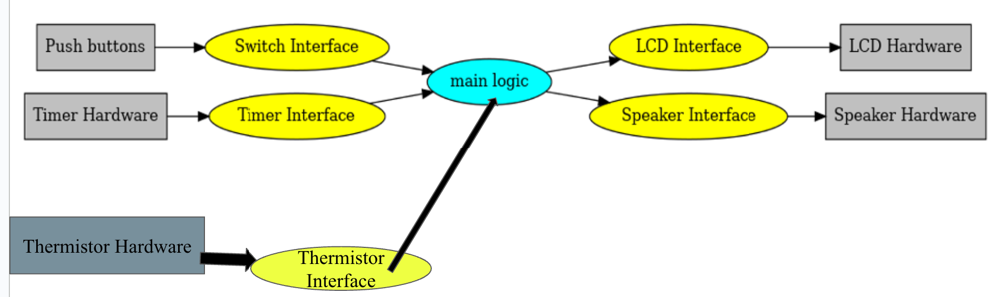

E) Measurement Data:
- Deliverable 2: LCD graphic update latency

- Deliverable 3: 3V3 RMS noise

- Deliverable 4: Speaker measurements without dampening

- Deliverable 5: Speaker measurements with dampening

- Deliverable 6: System current measurement

F) Analysis and Discussion Questions:
- Give two ways to remove a critical section.
Disable enable interrupts
Bid specific addressing

- What would be the disadvantage of updating the LCD in the background ISR?
ISR lags behind

- Did you redraw the entire clock for each output? If so, how could you have redesigned the LCD update to run much faster, and create a lot less flicker? If not, how did you decide which parts to redraw?
Whole clock,

- Assuming the system was battery powered, list three ways you could have saved power.

G) Project Requirements Document:
Included below is the base requirements document for this lab. Modifications to this requirements document is required. Please make any additions using highlighting, and removals using strikethrough. As always, feel free to adjust the syntax and format of your requirements document as you think appropriate. The goal of the document is to provide a clear an unambiguous description of what the project does. Note that at minimum, you must update sections 2.2 and 2.5 to reflect the features of your lab.

1. Overview
1.1. Objectives: Why are we doing this project? What is the purpose?
The objectives of this project are to design, build and test an alarm clock. Educationally, students are learning how to design and test modular software and how to perform switch/keypad input in the background.

1.2. Process: How will the project be developed?
The project will be developed using the TM4C123 board. There will be switches or a keypad. The system will be built on a solderless breadboard and run on the usual USB power. The system may use the on-board switches and/or the on-board LEDs. Alternatively, the system may include external switches. The speaker will be external. There will be at least four hardware/software modules: switch input, time management, LCD numerical graphics, and sound output. The process will be to design and test each module independently from the other modules. After each module is tested, the system will be built and tested.

1.3. Roles and Responsibilities: Who will do what? Who are the clients?
ECE445L students are the engineers, and the TA is the client. Students are expected to modify this document to clarify exactly what they plan to build. Students are allowed to divide responsibilities of the project however they wish, but, at the time of demonstration, both students are expected to understand all aspects of the design.

1.4. Interactions with Existing Systems: How will it fit in?
The system will use the TM4C123 board, a ST7735R color LCD, a solderless breadboard, and be powered using the USB cable. Note to students: if you do not have a ST7735R LCD, you can implement this lab with the SSD1306 black and white OLED on the RSLK robot.

1.5. Terminology: Define terms used in the document.
Power budget, device driver, critical section, latency, time jitter, and modular programming. See textbook for definitions.

1.6. Security: How will intellectual property be managed?
The system may include software from Tivaware and from the book. No software written for this project may be transmitted, viewed, or communicated with any other ECE445L student past, present, or future (other than the lab partner of course). It is the responsibility of the team to keep its ECE445L lab solutions secure.

2. Function Description
2.1. Functionality: What will the system do precisely?
The clock must be able to perform five functions. 1) It will display hours, minutes, and seconds in both numeric and graphical forms on the LCD. The numerical output will be easy to read. 2) It will allow the operator to set the current time using switches. 3) It will allow the operator to set the alarm time including enabling/disabling alarms. 4) It will make a sound at the alarm time. 5) It will allow the operator to stop the sound. An LED heartbeat will show when the system is running.

2.2. Scope: List the phases and what will be delivered in each phase.
Phase 1 is the preparation; phase 2 is the demonstration; and phase 3 is the lab report. Details can be found in the lab manual.

2.3. Prototypes: How will intermediate progress be demonstrated?
A prototype system running on the TM4C123 board and solderless breadboard will be demonstrated. Progress will be judged by the preparation, demonstration, and lab report.

2.4. Performance: Define the measures and describe how they will be determined.
The system will be judged by three qualitative measures. First, the software modules must be easy to understand and well-organized. Second, the clock display should be beautiful and effective in telling time. Third, the operation of setting the time and alarm should be simple and intuitive. The system should not have critical sections. All shared global variables must be identified with documentation that a critical section does not exist. Backward jumps in the ISR should be avoided if possible. The interrupt service routine used to maintain time must be completed in as short a time as possible. This means all LCD I/O occurs in the main program. The average current on the +3.3V power will be measured with and without the alarm sounding.

2.5. Usability: Describe the interfaces. Be quantitative if possible.
Minimum requirements: There will be two switch inputs from PF0, PF4 (you can add additional external switches as well). In the main menu, the switches can be used to activate 1) set time; 2) set alarm; 3) turn on/off alarm; and 4) display mode. The user should be able to set the time (hours, minutes, seconds) and be able to set the alarm (hour, minute). Exactly how the user interface works is up to you. After some amount of inactivity, the system reverts to the main menu. The user should be able to control some aspects of the display configuring the look and feel of the device. The switches MUST be debounced, so only one action occurs when the operator touches a switch once.
Minimum requirements: The LCD display shows the time using 12 numbers, the minute hand, and the hour hand are easy to see. The clock must display the time in numeric mode using numbers.
Minimum requirements: The alarm sound can be a simple square wave. The sound amplitude will be just loud enough for the TA to hear within 3 feet. 90% will be the maximum score for meeting all minimum requirements.

2.6. Safety: Explain any safety requirements and how they will be measured.
The alarm sound will be VERY quiet in order to respect other people in the room during testing. Connecting or disconnecting wires on the protoboard while power is applied may damage the board.

3. Deliverables
3.1. Reports: How will the system be described?
The lab report described below is due by the due date listed in the syllabus. This report includes the final requirements document.

3.2. Audits: How will the clients evaluate progress?
The preparation is due at the beginning of the lab period on the date listed in the syllabus.

3.3. Outcomes: What are the deliverables? How do we know when it is done?
There are three deliverables: preparation, demonstration, and report. (Note to students: you should remove all notes to students in your final requirements document).

