Name: __Replace with your name(s)____

EID: __Replace with your EID(s)_____

Semester: Fall 2025
Course: ECE445L

A) Objectives:
- In a few sentences, describe the purpose of the lab and the features of your alarm clock.

B) Hardware Design Deliverables:
- Deliverable 1: Using KiCad, create a schematic for your design. Include a screenshot in the space below.

- Deliverable 2: Using KiCad, create a Layout for your design. Include a screenshot in the space below.

C) Software Design Deliverables:
- I have pushed my project to GitHub for grading (Check box if true). ☐
D) Measurement Data:
- Deliverable 3: Cardboard mockup of the PCB

- Deliverable 4: I have updated the bill of materials (Check box if true). ☐

- Deliverable 5: Estimated current usage

- Deliverable 6: JLC PCB Quote

- Deliverable 7 (4 or 5pt EC): Custom Symbol and Footprint

E) Analysis and Discussion Questions:
- Estimate how long the system you created would run on the 2600mA battery.

- Estimate the power dissipated through the LDO regulator knowing the current draw from downstream components and voltage drop across the regulator.

- Examine the following excerpt from the datasheet for the MX1500 which has a nominal capacity of 2500mAh. Assuming you placed enough of these batteries in series to power your system, how long would the lifetime be? What happens to the lifetime of the battery when you double the current?
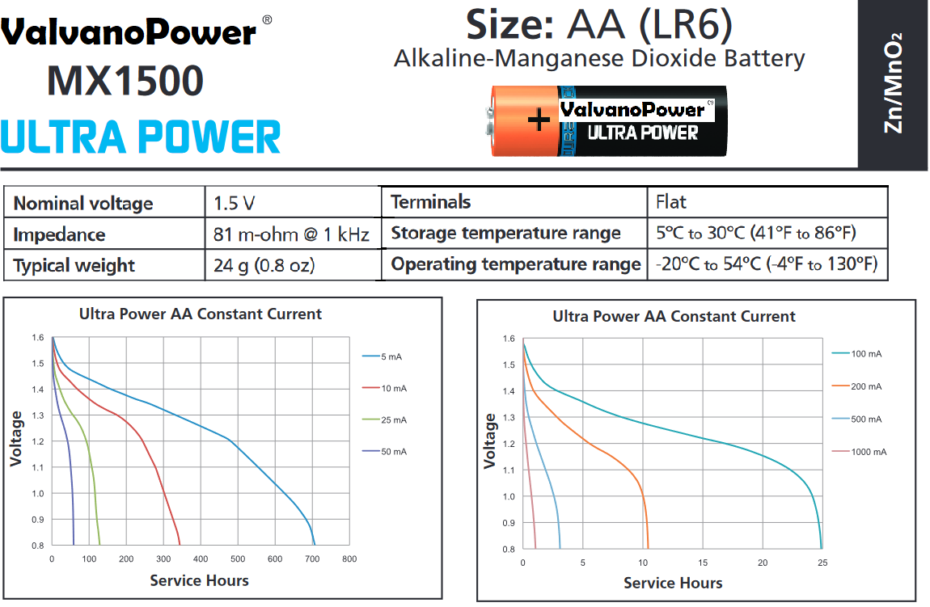

- Discuss the advantages and disadvantages of using an LDO versus a switching regulator.

