# GitHub Repository

<https://github.com/brandon-julio-t/minibr>

# Login

In this page, user can login with their email and password. There are 3 validations in this page, empty string, email must contain “@” symbol, and the credential must be valid. Below are dummy credentials which can be used to login to the application.

|  |  |
| --- | --- |
| Email | Password |
| ae@19-2 | ae |
| br@20-2 | br |
| cc@20-2 | cc |
| ga@20-2 | ga |
| st@20-2 | st |
| tc@20-2 | tc |
| vn@20-2 | vn |
| ll@20-2 | ll |
| jp@20-2 | jp |

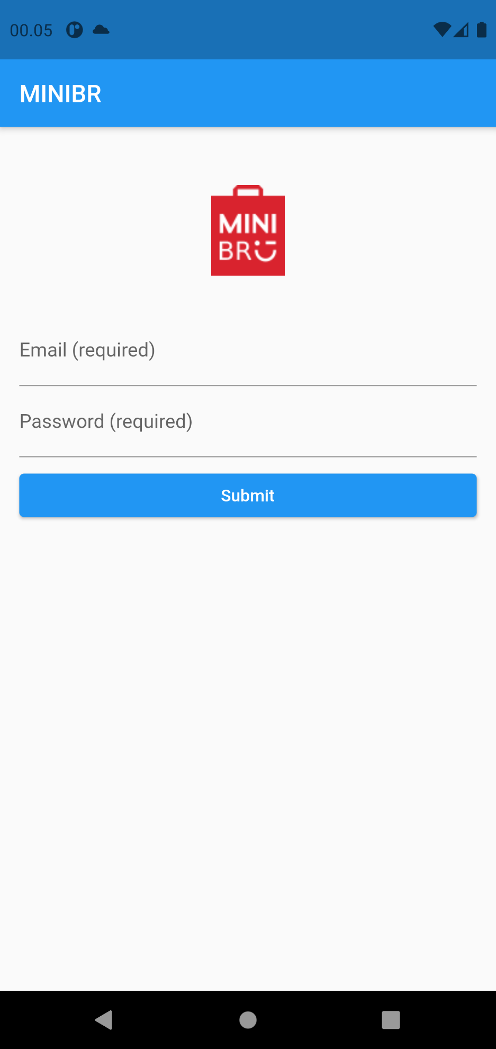

# Home

In this page, there are image carousel, brand profile which explains about the brand, and founder and CEO which explains briefly about minibr’s CEO. User can navigate to other page and logout by pressing the hamburger icon at top left corner of the screen. User can also change dark mode by pressing the triple dot icon at top right corner and toggle the provided switch.



# Items

User can view card of items in this page along with the items’ information such as name and price. When the user taps an item card, the user will be taken to the item detail page which will show the detail of the tapped item.

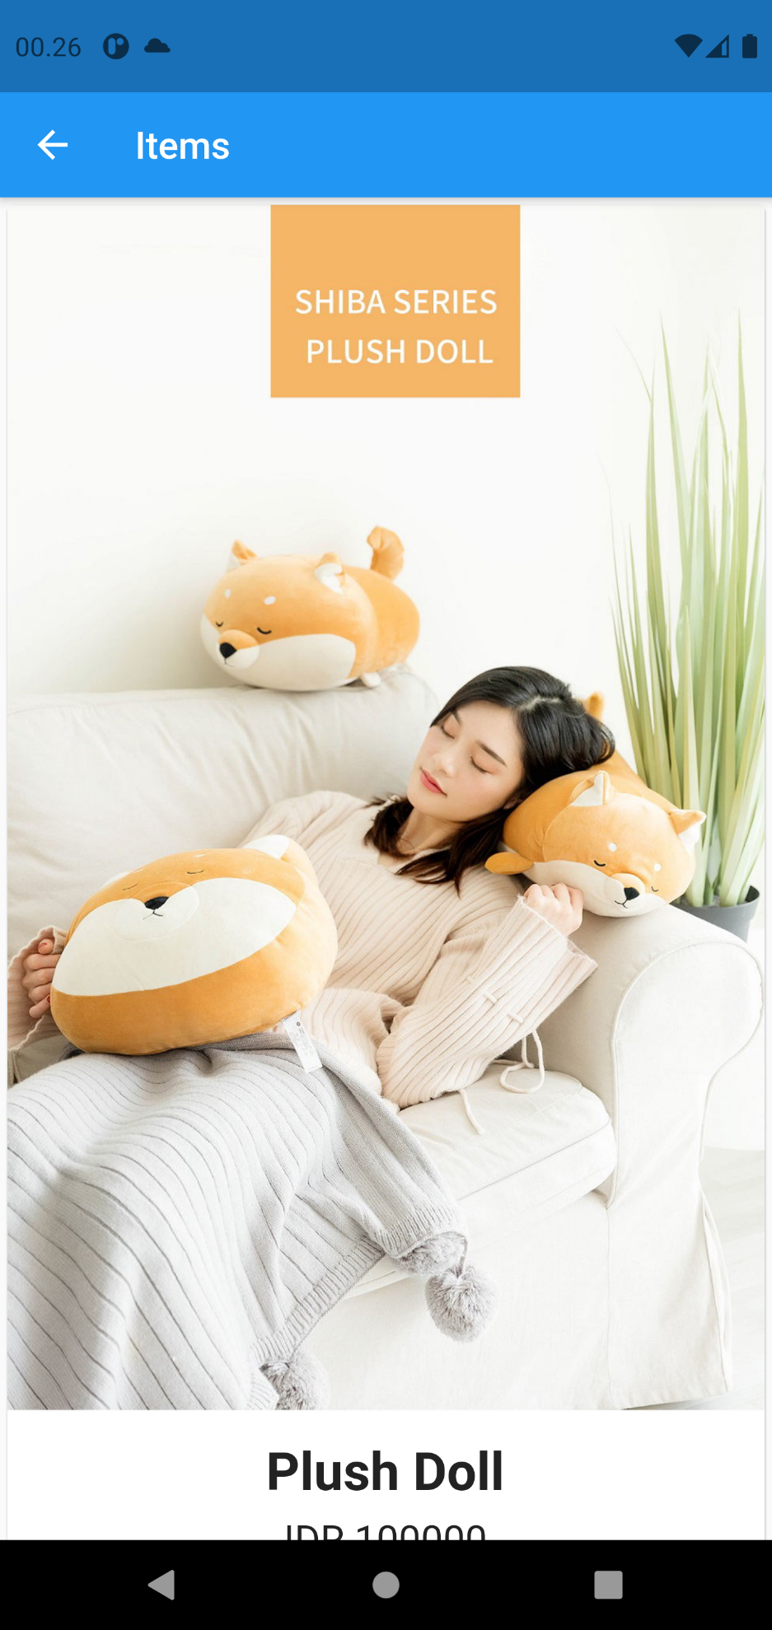

# Item Detail

This page will show the detail of an item. This page has two tabs: details and reviews. The details tab will display item’s information and a comment form for the user to submit their comment on the item. The reviews tab will display all comments on the item, along with current user’s comment, if any is submitted.

