# Metadata

GitHub: <https://github.com/brandon-julio-t/ships-x>

Netlify: <https://ships-x.netlify.app/>

GraphQL API: <https://api.spacex.land/graphql/>

# List Page

This page lists all the ships available with each card containing some information about the ship and a favorite button to add the selected ship to user’s favorite ships list. This page also contains a button which can take the user to the search page.

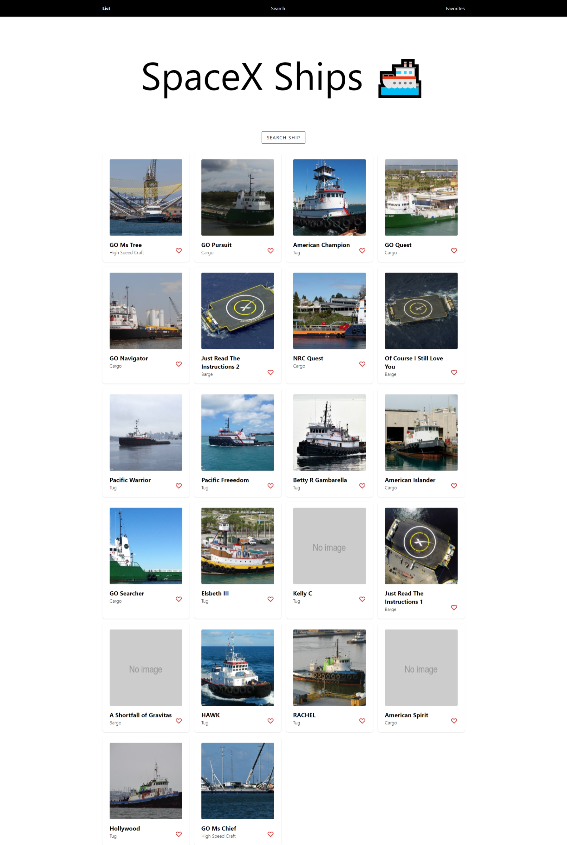

Figure 1. List Page.

# Search Page

This page is same as list page, but the button is replaced with a search field which can filter all ships based on the ship’s attribute values.

Figure 2. Search Page.

# Detail Page

This page contains details about the selected ship. The data is displayed in card and tabular form.

Figure 3. Detail Page.

# Favorite Page

This page lists all ships which are the user’s favorite. The favorite ships are stored in local storage.

Figure 4. Favorite Page.