1. Physics Simulator, Brandon Kmiec Section 1, Gary Young Section 2
2. Screenshot of game
   1. A video game with a blue box and a cone

      Description automatically generated
3. Instructions for compiling and running the game
   1. Run the compile.bat file
   2. If multiplayer
      1. Edit run.bat to include the IP and Port of the device the server is being run on.
      2. Run the runServer.bat file
      3. Run the run.bat file
   3. If singleplayer
      1. Run the run.bat file
4. Special device requirements
   1. Mouse is needed for selecting display options
   2. Keyboard or Gamepad are needed for gameplay
5. How to play the game
   1. After running the run.bat file, select the screen mode, avatar, and resolution. Then click ‘OK’
   2. Once the game starts, drive and collide with the various objects in the game
6. Player controls
   1. Keyboard
      1. Avatar
         1. W – move forward
         2. S – break
         3. A – turn left
         4. D – turn right
      2. Other
         1. 2 (number row) – toggle wireframe
         2. O – toggle xyz axis
         3. 3 (number row) – toggle avatar light
      3. Orbit Camera
         1. I – increase elevation
         2. K – decrease elevation
         3. J – move left around the avatar
         4. L – move right around the avatar
         5. RBRACKET (}/]) – zoom out
         6. LBRACKET ({/[) – zoom in
   2. Gamepad
      1. Avatar
         1. Y-axis – move forward/break
         2. X-axis – turn left/right
      2. Other
         1. Button 2 – toggle wireframe
         2. Button 0 – toggle xyz axis
         3. Button 3 – toggle avatar light
      3. Orbit Camera
         1. RY-axis – increase/decrease orbit camera elevation
         2. RX-axis – move orbit camera left/right around the avatar
         3. Z-axis – zoom orbit camera in/out
7. Network protocol changes
   1. Added a protocol for handling turning
   2. Added support for displaying selected avatars of other clients
      1. Does not fully work, sets the texture of other clients to a solid black color
8. Additions made to TAGE
   1. Avatar selector added to DisplaySettingsDialog.java
   2. Added a CameraOrbitController
   3. Added nodeControllers: TranslateController, StretchController, SpinController
      1. Not used in final project
   4. Added localPitch and globalYaw methods to GameObject
9. Genre, theme, dimensionality, and activities
   1. Genre: Simulation
   2. Theme: Physics simulator
   3. Dimensionality:
      1. Player motion: 3D
      2. Object motion: 3D
      3. Camera motion: 3D
      4. World dimensionality: Ground
   4. Activities: Exploration, Driving vehicles, Physics collisions
10. Where each requirement is satisfied
    1. External models
       1. Car avatar created by Brandon
       2. Traffic cone object created by Gary
    2. Networked Multi-player
       1. Running the runServer bat file and running the run bat file at least two times to get at least two clients
       2. Avatar selection is satisfied in the DisplaySettingsDialog popup menu
          1. Avatar selection is conveyed to other clients but for some reason displays the avatar as a solid black color
       3. Single-player mode works by running the game without the server running
    3. Skybox and terrain
       1. Skybox is visible in the distance
       2. Height mapped terrain appears throughout the game
          1. The avatar follows the y value of the terrain
    4. Lights
       1. Global ambient lighting
       2. Spotlight that follows the avatar
          1. Can be toggled (see player controls)
       3. Spotlight located at 0,0,0
    5. HUD
       1. Avatar position is located inside the right viewport in the bottom right corner
       2. Time since starting game is located in the bottom left corner
    6. 3D Sound
       1. A car startup sound plays when the game starts. This sound is attached to the avatar
       2. There is supposed to be a outside sound as background sound but it doesn’t appear to be playing for some reason
       3. There is supposed to be a crash sound that is played when the avatar collides with an object. For some reason the sound only plays when pressing space bar to toggle physics.
    7. Hierarchical Scenegraph
       1. Appears in the car for the avatar
          1. CarNoWheels.obj is the parent, FrontWheels and BackWheels are the children
          2. Both translation and rotation are propagated
    8. Animation
       1. Tires on the car are supposed to rotate when moving forward
       2. Unable to get working properly so we attempted to make the animation with a hierarchical scenegraph
          1. The blender file with what we were able to make is located at ./assets/models/carWithAnim.blend
    9. NPCs
       1. N/A
    10. Physics
        1. Physics appears in all game objects
           1. Collisions do not get conveyed across clients
11. Requirements we were unable to get working
    1. Networked multi-player fully works except for obtaining the avatar of other clients and applying it to ghosts
    2. Animation
       1. We were unable to get blender animations and exporting to work properly. Instead, we used a hierarchical scenegraph and three different 3D models (CarNoWheels, FrontWheels, BackWheels) and modified the rotation matrix
       2. The blender file with the animation we got working is titled carWithAnim.blend and is located in ./assets/models
    3. NPCs
    4. Sound
       1. Background sound either is not playing or is not loud enough to hear
       2. Crash sound only plays when physics gets toggled
12. Additions beyond the requirements
    1. N/A
13. Contributions of each team member
    1. Brandon
       1. All programming
       2. Car external model
       3. Blue car texture
       4. Red car texture
       5. Car animation in blender
       6. Other textures
          1. customTexture, customTexture2, blackboardPostcard, brickCubePostcard, customSpherePostcard, customTorusPostcard, silver, sun
       7. Heightmap texture
       8. Crash sound
    2. Gary
       1. Cone external model
       2. Cone texture
       3. Attempted exporting car animation
       4. Made two sound effects
14. List of assets created by us or distributed in CSC 155 or CSC 165
    1. Brandon
       1. blackboardPostcard
          1. 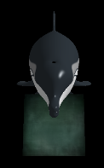
       2. brickCubePostcard
          1. 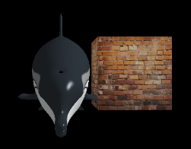
       3. CustomCarUV_wrap_blue
          1. 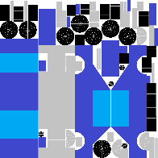
       4. CustomCarUV_wrap_red
          1. 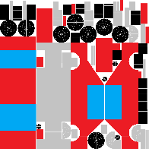
       5. customSpherePostcard
          1. 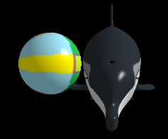
       6. customTexture
          1. 
       7. customTexture2
          1. 
       8. customTorusPostcard
          1. 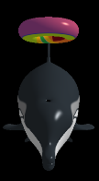
       9. ground_height_map
          1. 
       10. Silver
           1. 
       11. Sun
           1. 
       12. 3D models
           1. BackWheels
           2. CarNoWheels
           3. CustomCar
           4. FrontWheels
       13. Animation
           1. carWithAnim.blend
       14. Sound
           1. CrashSound
    2. Gary
       1. Cone
          1. 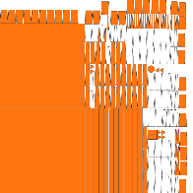
       2. Sounds
          1. car_engine
          2. outside
       3. 3D models
          1. cone
    3. Distributed in CSC 155 or CSC 165
       1. Dolphin_highPolyUV
          1. 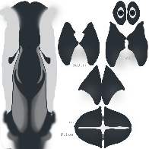
       2. Dolphin_HighPolyUV_wireframe
          1. 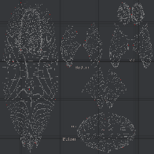
       3. Dolphin_LowPolyUV_wireframe
          1. 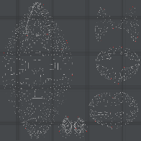
       4. fluffyClouds skybox
          1. 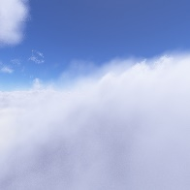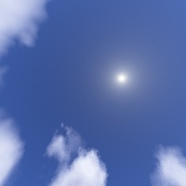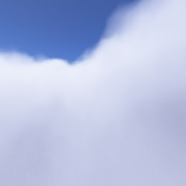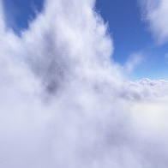
       5. lakeIslands skybox
          1. 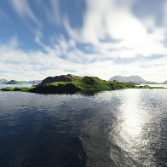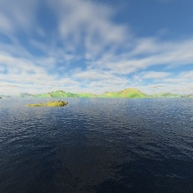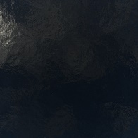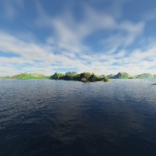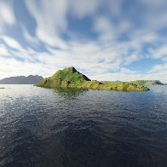
       6. All shaders
       7. 3D models
          1. dolphinHighPoly
          2. dolphinLowPoly
       8. defaultAssets
          1. 3D models
             1. capsule
             2. cone
             3. cylinder
             4. plane
          2. textures
             1. checkerboardSmall

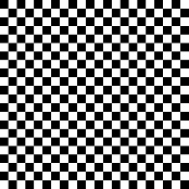

* + - * 1. defaultHeightMap



1. List of assets not created by us
   1. Brick Wall texture
      1. A close-up of a brick wall

         Description automatically generated
      2. Not made by me
      3. Obtained from <https://freestocktextures.com/texture/texture-of-a-background-made-of-aged-bricks,1641.html>
      4. Creative Commons Zero License: <https://freestocktextures.com/license/>, <https://freestocktextures.com/support/>
   2. Blackboard texture
      1. A green chalkboard with a white border

         Description automatically generated
      2. Not made by me
      3. Obtained from <https://freestocktextures.com/texture/old-green-school-blackboard,1654.html>
      4. Creative Commons Zero License: <https://freestocktextures.com/license/>, <https://freestocktextures.com/support/>
   3. Rippled sand texture
      1. 
      2. Not made by me
      3. Obtained from <https://freestocktextures.com/texture/rippled-sand-surface,874.html>
      4. Creative Commons Zero License: <https://freestocktextures.com/license/>, <https://freestocktextures.com/support/>
2. RVR-5029 machines tested on RAYMAN and PONG